**ANALYSIS________________________**

Client: Douy Singsamaran; Portfolio- <https://singsamran.artstation.com/>

**Background to the problem**

Douy is an artist, graduated from Kent university. Throughout the course of his degree he has made many art pieces and animations. He desires to enter the video game scene as an artist, however Douy is unsure whether his art style will be suitable for video games. In order to test the suitability for his art, he asked me to create a video game. If this test is successful, the game would be a great addition to his portfolio as an aspiring game artist. Although he did influence what the main frame of the game should be, I was given the freedom to add features which I thought would make the game more interesting as well as challenging when it comes to implementing these ideas to a program.

**Interview with Douy Singsamaran**

**Is there a certain type of game you would like to be made?**

DS: I don’t want the game to be very difficult. Something not too simple and not too complicated. Something that feels familiar like Pac-Man, but with a twist. I would like to be endless, so like the game lasts as long as the player’s character is alive.

**You want this game to be heavily influenced by Pac-Man, but how would you like it to**

**differ?**

DS: Pac-Man’s main target is just to collect those points and survive. I would like the game to have this as the basis however, in addition to this, if possible it would be good to add some sort of weapon to fight off against enemies and give it some horror aspects.

**How will this game be useful for you?**

DS: For artists, your portfolio is the most significant thing when applying for a job in art. Specifically for me, as I want to hopefully become a game artist, most companies will look through my portfolio to see if I am a suitable candidate. This game will be able to showcase my art to companies and show how my art, whether it fits or not, looks when situated in a game. This would make my portfolio unique.

**You said you want to showcase your art; do you have an idea of how you want this to be done?**

DS: I’m going to create all the necessary for this game whether that be the characters and enemies or the backgrounds and resources. So, however the game is played, the player would always be able to see some form of my art. The characters and enemies should be the most eye-catching. It’ll be good if the game has some sort of story behind it, but apart from that, there isn’t a specific way I want the game to showcase my art.

**Potential Ideas and Chosen Idea**

1. Project Lava

An endless side-scroller platform game, where the objective is to avoid falling. Collecting some sort of items (e.g.: coins) will determine the score. If the character touches the ground the game will end and a table of high scores will be displayed

* This project would have been too simple, and I believe it would have been difficult to think about how to implement high level skills in such a simple program
* This project would limit how much Douy’s art is shown, a side scroller would mean that only one side of the art would be shown
* Due to only one side being shown, a mutual agreement between me and the end user was that this project would not be effective enough for Douy in terms of the limited skills displayed whether it comes to programming or art

1. Project Playtime

An application consisting of 5 mini games such as: a simple platformer, an endless runner and others. I got this idea from Douy’s previous artwork. For his university project, he created 5 3D character models, which he based on children's games, like: the floor is lava, hide & seek, king of the hill and tag. I had the idea of basing my game around these 5 characters and give each character their own mini game.

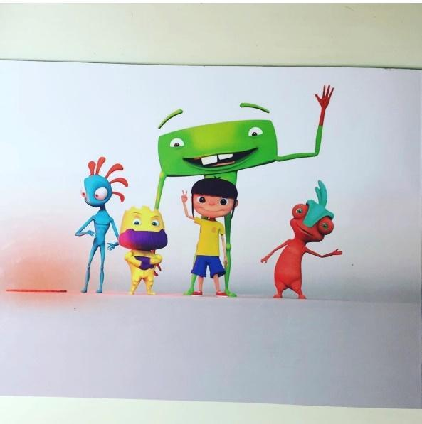

* This idea will require a lot of time, since I would be creating 5 separate games with different types of AI.
* Making this game very simple would make it suitable for the deadline, however doing this will decrease and minimize the high-level qualities my program could have.

1. [CHOSEN IDEA] Project Theseus

A survival maze game, heavily influenced by Pac-Man, where the objective is to find a certain number of keys and escape. This will be done whilst the player is getting tracked and chased down by monsters. To make this a game that last as long as you survive, each level will consist of a randomly generated maze, which would every level different whenever you play. A feature I personally wanted to add was to make every square in the maze accessible by the player. I think this would make the game more satisfying and will create many horror aspects with the use of dead ends.

* This project would be difficult; however, I think it would be more manageable than Project Playtime
* This project has potential for me to implement many useful A-Level techniques as it has some features that make it fascinating to program

**Users and Limitations**

This game will primarily be used by Douy and also by companies viewing Douy’s art, who will be the main source of feedback. However, this game is not just limited to a certain number of users, as anyone with an interest for the game will be able to play it and become a secondary source of feedback. I am going to make this game available for alpha testing so I can gather as much feedback as possible, which will enable me to have a list of improvements needed.

Creating this game would not be simple, there are some definite limitations which restrict me for creating this game to be the best quality.

This is the first time I will be attempting to create a game so my knowledge would be a limitation. I will be spending a lot of time researching different algorithms, traversals and C# functions which would allow me to make my game closer to what I actually want it to be. I’ll be creating this game using unity which I have also never used before however unity allows me to program in C# which I have prior programming experience in. To boost my knowledge on unity and game developing, I am going to watch and follow many tutorials on making simple games on unity and gain knowledge on specific features such as implementing character movement.

Time will also be a major limitation since I only have till Easter to complete this whole project Which includes researching, documentation and the development of the project

**Research**

**Most suitable software**

For the game, I had to decide which software to us to create the project. This was my first time creating a game so I did research on 2 game engines Unity and Unreal Engine. Unreal only allowed games to made with C++ or their own blueprints system which requires no programming. On the other hand, Unity allows games to made with C# which is the language I am most confident with, so I chose unity as the software I will be using to create my game.

**Player**

For the player, I needed to know how to make the character move. I watched many YouTube tutorials by professionals such as brackeys and learnt different ways this can be done

**AI and Maze**

When researching about how I could make my AI, I came across pathfinding algorithms, such as “Dijkstra’s Algorithm” which finds the shortest path from one node to another in a graph. I also researched about 2 traversal algorithms: breadth first and depth first traversals. Which can be used to make the AI decide where to move. Whilst researching I saw that these traversals can become as issue for the CPU if ran multiple times. So I found out how to potentially fix this problem with a method called multithreading, where instead of running all these traversals on only one of the CPU’s core, multithreading took advantage of multi core CPU by spreading these instructions between multiple cores.

**What I want my game to look like**

**My Objectives for the Game**

**(in priority order) (should be done or could be done)**

1. The game should be able to clearly showcase the end user’s art.

* Should be able to rotate around character to show all sides

1. The game should have a simple to understand user interface

* Should have a menu
* Could have a in game settings menu

1. The game should be playable with or without an objective.

* Should have smooth function player movement
* Should have implemented player collisions
* Should be able to pick up items
* Should have a functioning level system

1. The game should have a maze

* This maze should be randomly generated, so that every level there will be a completely different maze
* In this maze, every square should be accessible
* This maze could be interpreted as a graph so that it can be traversed for the AI

1. The game should have a fully functional enemy AI

* Should be able to follow the player (could be done by implementing a traversal algorithm)
* Shouldn’t get stuck between walls

1. The game should last as long as the player survives

* Could have a certain number of lives
* Should stop game as soon as player dies (or runs out of lives)

1. After the games finishes the game should save the score and display a table of high scores

* Should save only the top (5 or 10) high scores
* If player score is high enough to enter high scores, it should ask them for their names.
* Should save the score corresponding to the input given by player

**Existing System**

Using Pac-Man as a heavy influence, I decided to observe it as an existing system and see how it works.