NPM FOPID Tuner MATLAB APP

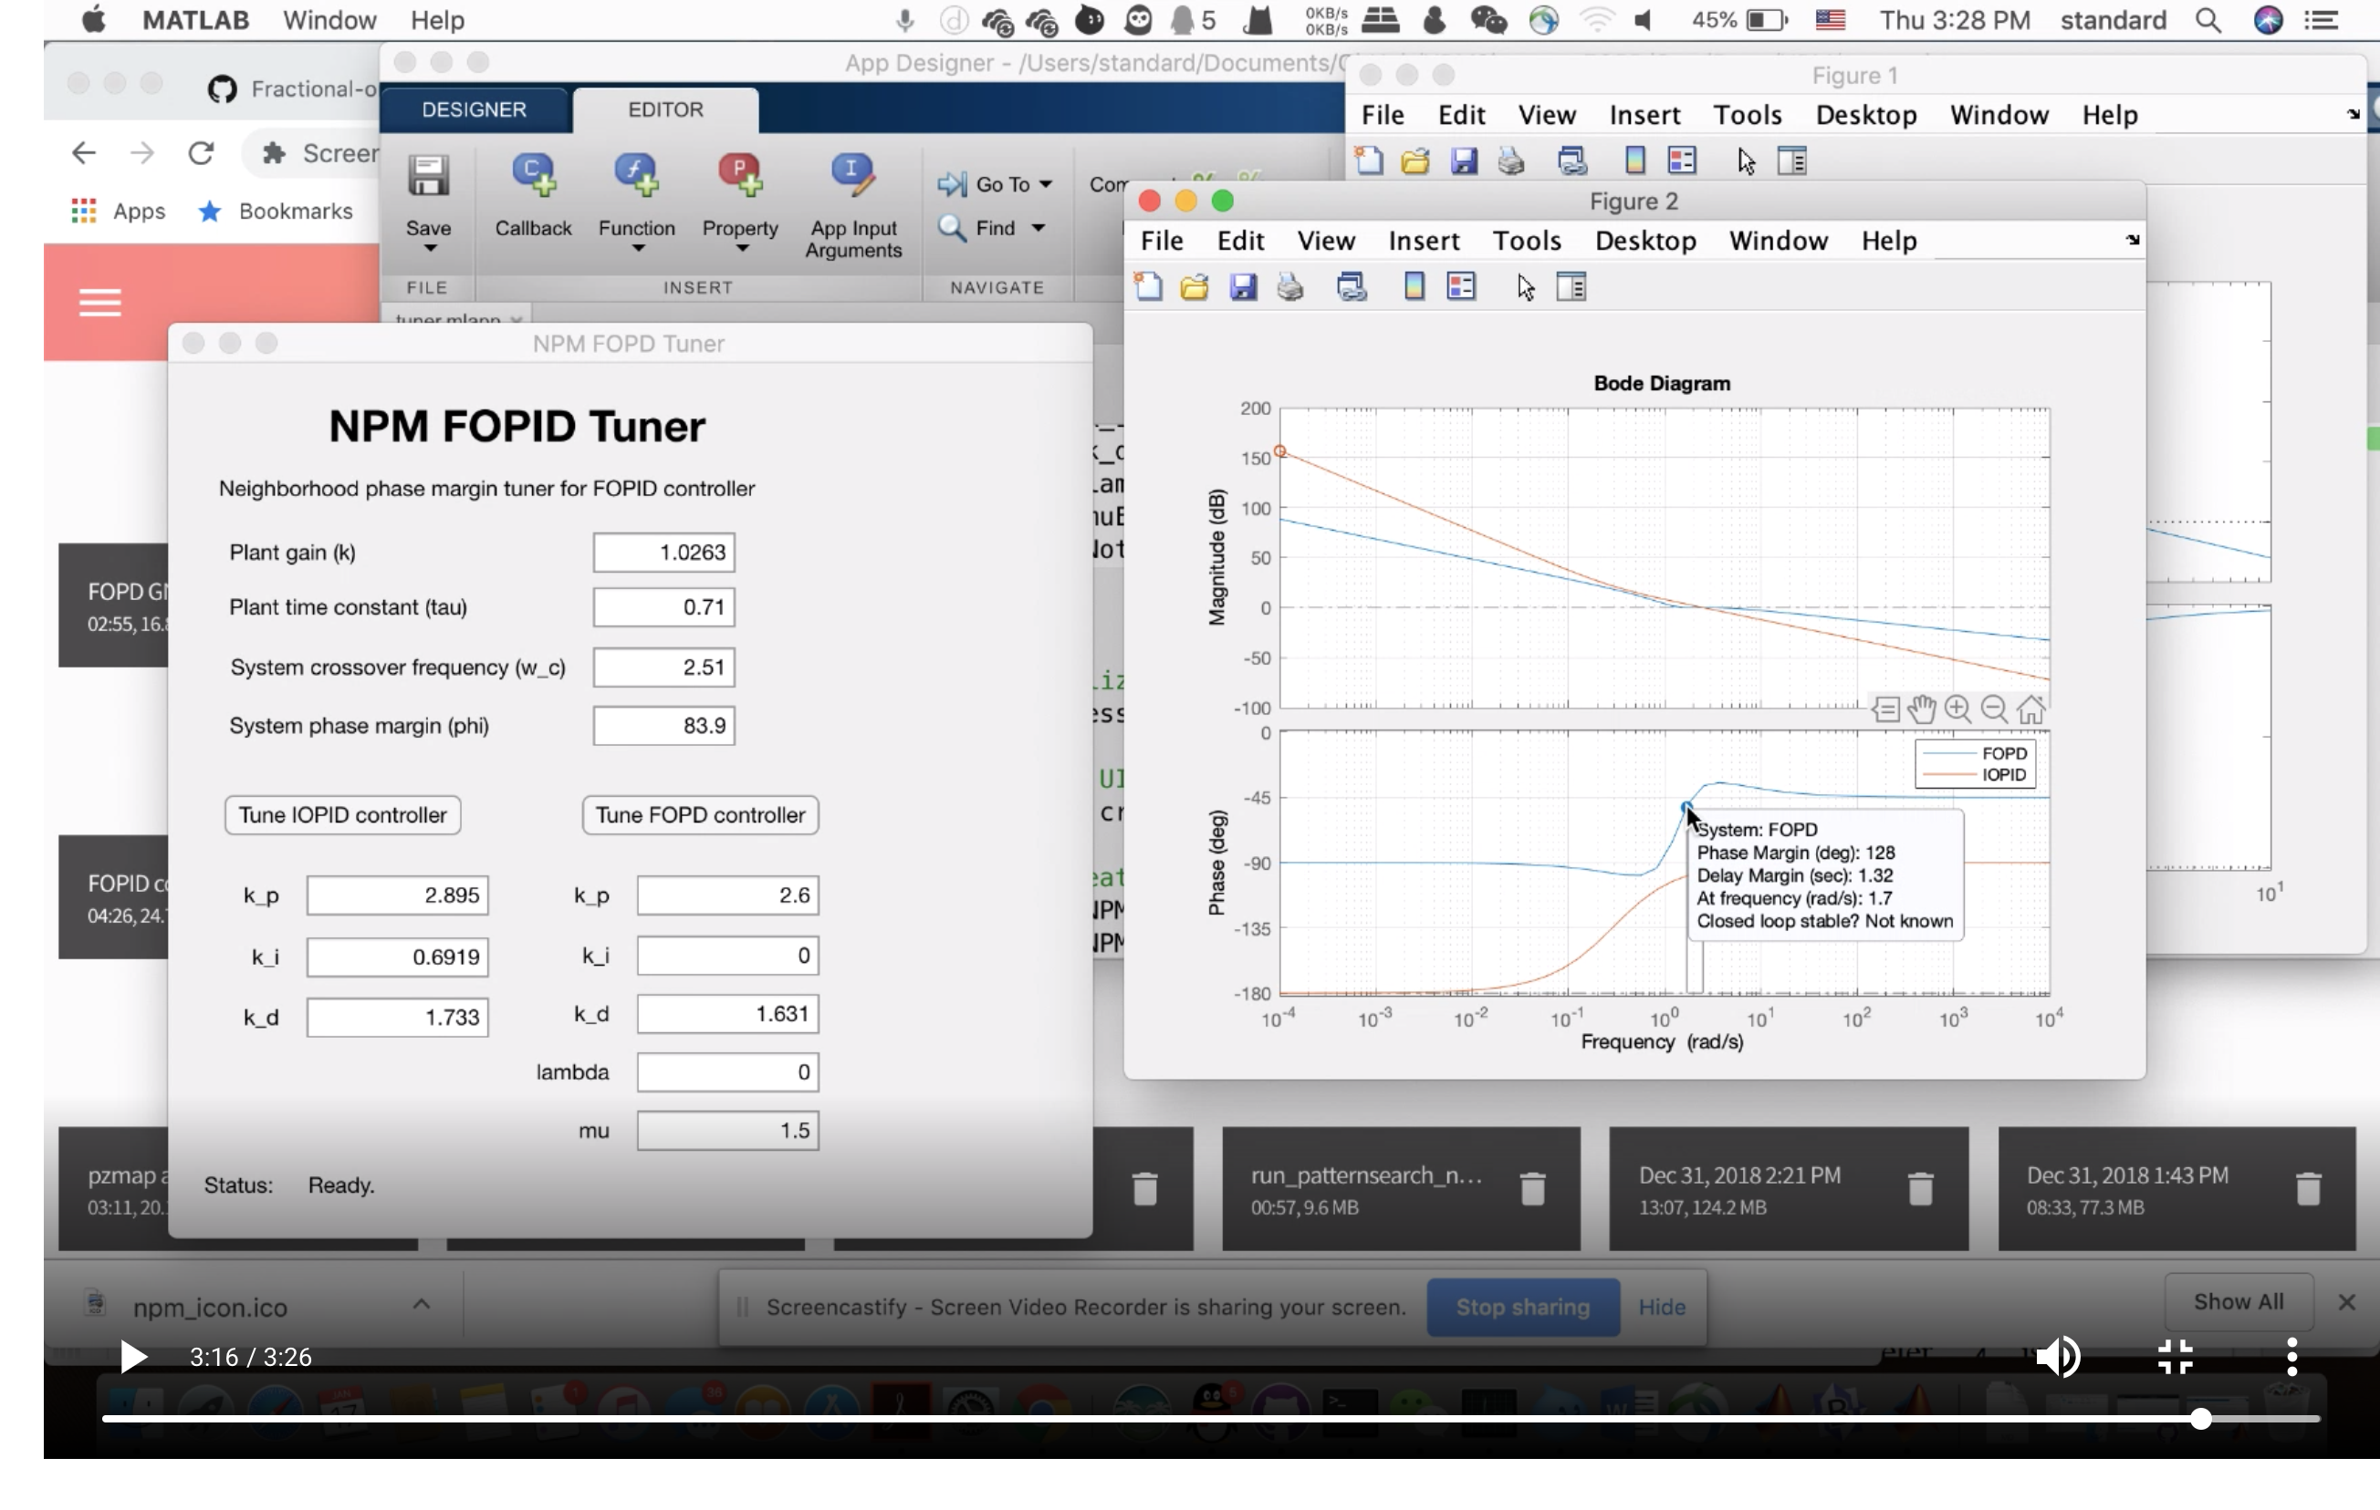

Crossover frequency is not met.

To try FOPD NPM tuner first.