Ternary Logic (TL) as an Anti-Money Laundering (AML) Enforcement Architecture: Governance-Grade System Specification

Classification: Technical Specification for Regulatory, Judicial, and Operational Use

Target Audience: Financial Regulators, Banking Institutions, Payment Networks, Cryptocurrency Exchanges, Auditors, Compliance Officers, and Courts

Author: Lev Goukassian (ORCID:0009-0006-5966-1243)

Date: February 9, 2026. Updated June 10, 2026
Status: Final Governance and Technical Specification
Document ID: TL-AML-2026-Rev1
Repository: FractonicMind/TernaryLogic

DOI 2: 10.1007/s43681-026-01124-0

Pause when truth is uncertain.

Refuse when harm is clear.

Proceed where truth is.
Ternary Logic (TL) as an Anti-Money Laundering (AML) Enforcement Architecture: Governance-Grade System Specification 0
Abstract 6
I.1 Governance, Evidence, and Action-Control Failure Framework 7
I.1.1 Post-Hoc Reporting Paradigm: SARs as Institutionalized Delay 7
I.1.2 Binary Decision Architecture: The Allow/Deny Fallacy 8
I.1.3 Alert Fatigue and Typology Gaming as Systemic Exploits 9
I.1.4 Velocity and Volume Exploitation Throughput Vulnerabilities 9
I.1.5 Fragmented Logging and Cross-Institutional Evidence Dissolution 10
I.1.6 Silent Overrides and Insider Collusion Vectors 10
I.1.7 Plausible Deniability Between Model Output and Executed Action 11
I.2 Liquidity vs. Integrity Modeling: The Economic Case for Epistemic Holds 11
I.2.1 Acknowledgment of Liquidity Friction Concerns 11
I.2.2 Deterministic Latency Cost Model: Bounded, Measurable, Priced 12
I.2.3 Probabilistic Downstream Cost Model: Fines, Remediation, Clawbacks, Capital Penalties, Reputational Damage 13
I.2.4 Conversion of Unbounded Probabilistic Risk to Bounded Measurable Latency 14
I.2.5 Market Pricing of Latency vs. Catastrophic Retroactive Uncertainty Pricing 15
II. Ternary Logic (TL): Correct Definition and Triadic Architecture 16
II.1 TL as Triadic Action-Governance Architecture 16
II.1.1 Governing Economic Acts, Not Intentions or Moral Reasoning 16
II.1.2 Permissioned Financial Movement Through Evidence-Backed Decisions 16
II.2 Triadic Action States 17
II.2.1 +1 Proceed: Action Permitted with Verified Certainty 17
II.2.2 0 Epistemic Hold: Action Paused Due to Unresolved Uncertainty 17
II.2.3 –1 Refuse: Action Denied Due to Verified Risk or Prohibition 18
II.3 Primary AML Risk Locus: The Zero State, Not the Deny State 18
III. Core TL Mechanisms for AML Enforcement 18
III.1 Epistemic Hold 19
III.1.1 Trigger Conditions: Incomplete Provenance, Counterparty Opacity, Jurisdictional Risk, Structural Anomalies 19
III.1.2 Uncertainty-to-Pause Conversion Without Guilt Presumption 19
III.1.3 Laundering Velocity Blocking Through Mandatory Interruption 20
III.2 Decision Logs (Pre-Action) 21
III.2.1 Generation Before Any Economic Action 21
III.2.2 Capture of Known, Unknown, and Assumed Elements 21
III.2.3 Escalation Thresholds and Authority Boundaries 22
III.2.4 No Log = No Action Enforcement 22
III.3 Immutable Ledger 22
III.3.1 Tamper-Evident Logging of All Economic Decisions 23
III.3.2 Separation of Transaction Data, Decision Logs, and Proofs 23
III.3.3 Forensic Reconstruction Capability Under Regulatory Scrutiny 23
III.4 Hybrid Shield 23
III.4.1 Prevention of Silent Overrides of Holds or Refusals 24
III.4.2 Override Recording: Who, When, Authority, Justification 24
III.4.3 Resistance to Insider Collusion and Regulatory Capture 24
III.5 Anchors 25
III.5.1 Long-Term Evidentiary Permanence 25
III.5.2 Merkle-Root Anchoring of Decision Proofs 25
III.5.3 Proofs On-Chain, Logs Off-Chain Architecture 25
III.6 AI-to-Logic Handoff 26
III.6.1 Input: Probabilistic Risk Scores from Machine Learning AML Models 26
III.6.2 TL Process: Probabilistic Outputs Treated as Epistemic Uncertainty, Not Authorization 26
III.6.3 Threshold-Driven State 0 Enforcement 27
III.6.4 Output: Deterministic Collapse to +1 or –1 Required Before Proceeding 27
III.6.5 Prevention of Probabilistic Ambiguity Mistaken for Permission 27
IV. Technical Architecture for AML at Scale 27
IV.1 Dual-Lane Latency Model 27
IV.1.1 Inference Lane (≤2 ms): Pre-Action Evidence Capture and State Determination 28
IV.1.2 Governance Lane (≤500 ms, Asynchronous): Post-Action Evidence Enrichment and Permanence 29
IV.1.3 Evidence Capture Precedes Action; Evidence Anchoring Follows in Parallel 30
IV.2 Merkle-Batched Anchoring: Structural Requirement for Bottleneck Avoidance 30
IV.2.1 Individual Decision Logs Not Anchored Directly 30
IV.2.2 Merkle Tree Grouping Over Time or Volume Windows 30
IV.2.3 Merkle Root-Only Anchoring to External Ledgers 31
IV.2.4 Complexity Reduction: O(n) to O(1) Per Batch 31
IV.2.5 Rolling Merkle Buffers 31
IV.2.6 Batch Sizing and Tree Depth Trade-Offs 32
IV.2.7 Fault Isolation and Reconstruction via Merkle Proofs 32
IV.3 Deferred Anchoring 32
IV.3.1 High-Volume Environment Deployment: Correspondent Banking, Payment Rails 32
IV.3.2 Mandatory Time-Bounded Evidence Debt 32
IV.3.3 Non-Skippable, Non-Erasable Anchoring Obligation 33
IV.3.4 Anchoring Failure as Compliance Violation 33
IV.4 Privacy and GDPR Compliance 33
IV.4.1 Pseudonymization Before Hashing 33
IV.4.2 Right-to-Erasure Compatibility 33
IV.4.3 No Personal Data On-Chain 33
IV.4.4 Encrypted Off-Chain Logs 34
IV.5 Ephemeral Key Rotation (EKR) 34
IV.5.1 Time-Limited Auditor Access 34
IV.5.2 Automatic Key Expiration 34
IV.5.3 Trade-Secret Protection 34
IV.5.4 Regulator-Compatible Disclosure 34
IV.6 ISO 20022 Semantic Mapping 34
IV.6.1 TL State Mapping to pacs and camt Message Flows 34
IV.6.2 Epistemic Hold (0) Representation in pacs.002 Status Reports 35
IV.6.3 Decision Log Payload Embedding in ISO SupplementaryData Fields 35
IV.6.4 Prevention of Compliance Data Truncation Across Correspondent Banking Hops 36
IV.6.5 Evidence Traveling With Transaction, Not Alongside 36
V. Hardware Enforcement Substrate: Physical Implementation of the Epistemic Hold 36
V.1 Introduction: Why Software Governance Requires a Hardware Foundation 36
V.2 From Software Hold to Physical Hold: The Architecture of Ternary Circuit Logic 37
V.2.1 The Inadequacy of Binary Circuit Implementation for Epistemic Enforcement 37
V.2.2 Delay Insensitive Ternary Logic (DITL) 38
V.2.3 The NULL State at ½Vdd: The Epistemic Hold in Silicon 39
V.3 The Triadic Coprocessor Architecture 40
V.3.1 Physical Separation as the Governance Boundary 40
V.3.2 The Governance Bus 40
V.3.3 The Chiplet Integration Model 41
V.4 Hardware Security Module Integration 42
V.4.1 The HSM as the Root of Trust 42
V.4.2 Ephemeral Key Rotation in Hardware 43
V.5 Physically Irreversible Hardware Hesitation: The AML Enforcement Guarantee 43
V.5.1 What Hardware Enforcement Provides That Software Cannot 43
V.5.2 Adversarial Robustness of the Hardware Substrate 44
V.5.3 Performance Characteristics and Deployment Readiness 44
V.6 Deployment Tiers and the Path to Full Hardware Enforcement 45
VI. Regulatory, Legal, and Operational Alignment 46
VI.1 Framework-Specific Alignment Analysis 46
VI.1.1 FATF Recommendations: From Retrospective Assessment to Runtime Enforcement 46
VI.1.2 Bank Secrecy Act (BSA): From Suspicious Activity Reporting to Pre-Transaction Control 47
VI.1.3 EU AMLD and AMLR: From Directive Compliance to Structural Enforcement 48
VI.1.4 Basel III and Operational Risk Frameworks: From Capital-Based Risk Absorption to Prevention-Based Risk Elimination 48
VI.2 Comparative Operational Analysis: Framework Evaluation Tables 49
VI.2.1 Basel III vs. Ternary Logic 49
VI.2.2 IOSCO Standards vs. Ternary Logic 51
VI.2.3 SEC/CFTC Rules vs. Ternary Logic 53
VI.2.4 NIST Frameworks for Financial Systems vs. Ternary Logic 56
VI.2.5 Audit and Control Standards (SOX, COSO, ISAE 3402) vs. Ternary Logic 58
VII. Evidence, Liability, and Enforcement Transformation 60
VII.1 Evidentiary Status Hierarchies 60
VII.2 Chain of Custody and Digital Evidence Standards 62
VII.3 Regulatory Investigation Procedures Under TL 62
VII.4 Criminal Prosecution Enhancement Through TL Evidence 63
VIII. Case Studies: Simulated Real-World Scenarios 64
VIII.1 Cross-Border Correspondent Banking Transfer 64
VIII.1.1 Transaction Structure and Risk Indicators 64
VIII.1.2 Decision Log Generation and Escalation Path 64
VIII.1.3 Regulatory Outcome and Forensic Reconstruction 65
VIII.2 Shell-Company Transaction Chain 66
VIII.2.1 Entity Layering and Opacity Detection 66
VIII.2.2 Decision Log Generation and Escalation Path 67
VIII.2.3 Regulatory Outcome and Forensic Reconstruction 67
VIII.3 Crypto-Fiat Laundering Bridge 68
VIII.3.1 Hybrid Asset Class Vulnerabilities 68
VIII.3.2 Decision Log Generation and Escalation Path 68
VIII.3.3 Regulatory Outcome and Forensic Reconstruction 69
VIII.4 Red Team Scenario: Hold Flood Attack 70
VIII.4.1 Adversary Strategy: Ambiguous Transaction Flooding 70
VIII.4.2 Automated Escalation Response 71
VIII.4.3 Dynamic Evidence Threshold Adjustment 72
VIII.4.4 Denial-of-Service Mitigation Without Governance Weakening 72
VIII.4.5 Decision Log Generation and Escalation Path 73
VIII.4.6 Regulatory Outcome and System Resilience Verification 73
IX. Strategic Recommendations 74
IX.1 For Regulators and AML Authorities 74
IX.2 For Banks and Financial Institutions 75
IX.3 For Payment Networks 75
IX.4 For Crypto Exchanges 76
IX.5 For Auditors and Compliance Officers 76
X. Foundational Origin Note: The Goukassian Vow 77
X.1 Articulation Context 77
X.2 The Vow 77
X.3 Manifestation as Action-Level AML Enforcement 77
XI. Citations 78
XI.1 FATF Materials 78
XI.2 FinCEN Guidance 80
XI.3 EU AML Regulations 80
XI.4 Basel III Documents 80
XI.5 Academic Literature on AML Failures 81
XI.6 Ternary Logic Repository Materials 82
XI.7 Enforcement Actions and Case Materials (2024-2025) 82

Abstract
Ternary Logic (TL) as an Anti-Money Laundering Enforcement Architecture: A Governance-Grade System Specification
The prevailing global Anti-Money Laundering (AML) infrastructure faces a crisis of systemic inefficacy, with illicit fund interdiction rates estimated at less than one percent despite annual compliance expenditures exceeding $51 billion. This specification argues that the failure is architectural: current regimes rely on a bivalent "Allow/Deny" decision logic that is structurally incapable of managing economic action under epistemic uncertainty. This binary constraint forces financial institutions to default to permissive "pay-and-chase" models, relying on post-hoc Suspicious Activity Reports (SARs) that identify financial crime only after settlement has occurred.
We propose Ternary Logic (TL), a triadic state-machine architecture (+1 Proceed, 0 Epistemic Hold, -1 Refuse) that introduces a deterministic, time-bounded "Epistemic Hold" into the transaction layer. By enforcing a "No Log = No Action" protocol, TL converts unbounded probabilistic regulatory risk into bounded, measurable latency. This specification details the technical mechanisms required for implementation, including a Dual-Lane Latency architecture ($\le$2ms inference / $\le$500ms anchoring), Merkle-batched anchoring for O(1) scalability, and semantic mapping to ISO 20022 standards. For deployments requiring enforcement guarantees that survive insider threat and privileged access compromise, the specification extends to a hardware enforcement substrate: Delay Insensitive Ternary Logic (DITL) circuits implement the Epistemic Hold as a NULL state at half supply voltage (½Vdd), making ungoverned transaction execution electrically impossible regardless of software-layer compromise. We further demonstrate how TL operationalizes the intent of frameworks such as FATF Recommendation 16 and Basel III Operational Risk standards, transforming AML from a surveillance activity into a structural integrity enforcement layer.
Keywords: Anti-Money Laundering (AML), Ternary Logic, Epistemic Hold, Governance Architecture, Distributed Ledger Technology (DLT), ISO 20022, Regulatory Technology (RegTech), Financial Crime Compliance, Delay Insensitive Ternary Logic, Hardware Enforcement Substrate.
JEL Classifications: K22 (Business & Securities Law), G28 (Financial Institutions & Services: Government Policy and Regulation), O33 (Technological Change: Choices and Consequences).

Interactive Report: A dynamic web report allowing auditors to filter controls by regulatory domain.

I.1 Governance, Evidence, and Action-Control Failure Framework
The contemporary anti-money laundering infrastructure, despite cumulative expenditure exceeding $51.7 billion annually by 2028 projectionsand decades of regulatory evolution, exhibits fundamental structural deficiencies that render it systematically incapable of preventing financial crime at scale. These deficiencies are not primarily technological in the narrow sense of data processing capacity or algorithmic sophistication. Rather, they constitute deep governance, evidence, and action-control failures embedded in the architectural assumptions of how financial institutions make and execute decisions about economic movement. The following analysis examines seven interconnected failure modes, drawing upon documented enforcement actions from 2012 through 2025.

I.1.1 Post-Hoc Reporting Paradigm: SARs as Institutionalized Delay
The Suspicious Activity Report (SAR) mechanism, central to global AML frameworks including the U.S. Bank Secrecy Act and FATF Recommendation 20, embodies a fundamental temporal misalignment between detection and prevention. Financial institutions are obligated to file SARs within 30 days of detecting suspicious activity, with extensions to 60 days—an eternity in modern financial velocity where illicit funds can traverse six jurisdictions, undergo three currency conversions, and settle into irreversible asset classes within hours. The SAR paradigm transforms financial institutions into retrospective witnesses rather than preventive gatekeepers.
The TD Bank case of October 2024 illustrates this failure mode at catastrophic scale. Between 2018 and 2024, more than 90 percent of transaction volume—approximately $18 trillion—proceeded through the bank’s U.S. operations without adequate monitoring, enabling multiple money laundering networks to move substantial illicit funds. One Florida-based drug trafficking organization alone laundered $470 million through accounts that, had monitoring been operational, would have generated substantial alert volumes. The resulting $3.09 billion penalty—comprising $1.8 billion criminal penalty, $1.3 billion civil penalty (a record for a depository institution), and $450 million from the OCC—represents retrospective recognition that the entire economic action sequence had completed without meaningful interruption.
The temporal asymmetry creates predictable strategic exploitation. Sophisticated launderers design transaction patterns to complete before alert generation, exploiting the inherent latency between act and detection. The NatWest case, in which £365 million was laundered through cash deposits including funds delivered in bin bags, demonstrates how physical velocity combined with institutional velocity (delayed detection and reporting) enables successful laundering even when individual transactions appear anomalous. The £264 million fine, the first criminal prosecution under the UK’s Money Laundering Regulations 2017, underscores that regulatory recognition of this failure mode has not produced structural remediation.
Quantitative analysis of SAR effectiveness reveals systematic dysfunction. FinCEN receives approximately 2-3 million SARs annually, yet law enforcement action resulting from these filings remains extraordinarily rare. The vast majority enter analytical queues without triggering immediate investigative response, creating a massive signal-to-noise problem that degrades the entire enforcement ecosystem. The post-hoc paradigm effectively decouples detection from prevention, rendering the “anti-money laundering” designation operationally misleading.

I.1.2 Binary Decision Architecture: The Allow/Deny Fallacy
Contemporary transaction monitoring systems operate through binary computational logic: transactions receive risk scores, thresholds are applied, and outcomes are categorized as “clear” or “suspicious”. This architecture fails to recognize that the majority of money laundering risk resides not in clearly identifiable prohibited activity (the deny state) but in epistemically uncertain activity where provenance is incomplete, counterparty relationships are obscured, or transactional patterns are anomalous but not definitively illicit.
Binary systems force probabilistic ambiguity into categorical determination—either permitting uncertain activity to proceed (false negative) or generating overwhelming alert volumes that degrade investigative capacity (false positive). When a machine learning model generates a 73% risk score, the binary system must convert this continuous probability into a discrete decision. Current implementations typically apply threshold-based rules: scores above X trigger review, scores below X permit execution. But the zone between “clearly legitimate” and “demonstrably illicit”—the domain of genuine epistemic uncertainty—receives no structural recognition.
The Starling Bank case of 2024 illustrates the false negative pathway: the bank opened over 54,000 accounts for high-risk customers despite a regulatory prohibition, with automated screening matching customers against only a fraction of the sanctions list since 2017. The binary architecture—account opened or not opened—lacked intermediate states that could have enforced mandatory verification before account activation. The resulting £28.9 million fine reflects the consequences of binary decision-making without epistemic pause mechanisms.
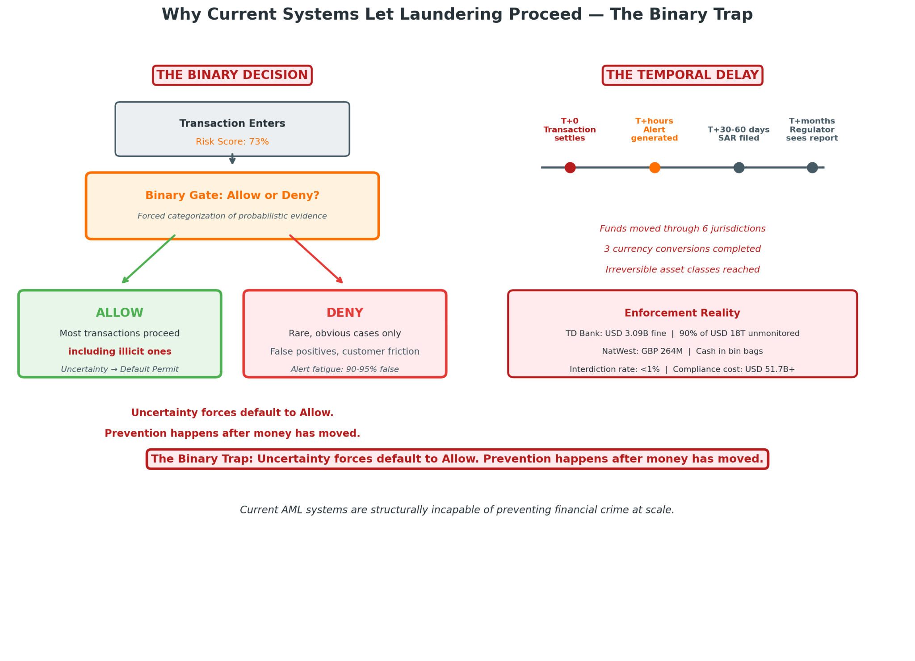
Conversely, alert fatigue—documented across numerous institutions—demonstrates how binary classification of uncertain transactions as “suspicious” generates volumes that overwhelm analytical capacity. Industry estimates indicate that 90-95% of AML alerts are false positives, with each alert requiring average analyst review time of 20-45 minutes. The Monzo Bank case identified a backlog of unreviewed alerts and inadequate staffing to clear transaction monitoring outputs, with the bank disabling address verification systems allowing implausible addresses to pass unchecked. Analysts, overwhelmed by volume, develop heuristic shortcuts that sophisticated launderers anticipate and exploit.

I.1.3 Alert Fatigue and Typology Gaming as Systemic Exploits
Typology gaming represents the strategic response to rule-based detection. Money laundering methodologies evolve faster than regulatory typologies can be updated. The search results note that the FIU’s strategic and operational analysis capabilities allow analysts to identify ML/TF trends and typologies, yet this identification is inherently retrospective. By the time a typology is documented, distributed, and incorporated into monitoring rules, sophisticated actors have migrated to new methodologies.
The Deutsche Bank “mirror trading” scandal, which facilitated $10 billion in Russian capital flight, exploited the gap between UK and Russian regulatory visibility, with trades structured to appear as legitimate market-making activity while serving no economic purpose. The £163 million fine reflected not system incapacity but architectural failure to enforce epistemic verification of transaction purpose.
The adversarial dynamic—institutional detection systems versus criminal evasion strategies—creates an arms race that institutions consistently lose due to structural disadvantages in adaptability and information asymmetry. The 2024 enforcement data reveals the scale of this failure: global AML fines exceeded $10.4 billion, with the cryptocurrency sector alone experiencing a 417% increase in penalties in the first half of 2025 compared to the same period in 2024. Criminals systematically test institutional thresholds, identifying precise transaction amounts, frequencies, and patterns that evade detection. Once thresholds are mapped, laundering operations can be calibrated to remain perpetually below triggering levels, achieving effective invisibility within binary systems.

I.1.4 Velocity and Volume Exploitation Throughput Vulnerabilities
Modern payment infrastructure prioritizes throughput and latency minimization, creating architectural tension with verification requirements. Real-time payment systems, instant settlement mechanisms, and high-frequency trading platforms are designed around velocity assumptions that conflict with meaningful due diligence. The European SEPA Instant Credit Transfer scheme settles within 10 seconds; the FedNow service targets similar latency; stablecoin transfers on optimized blockchains confirm in sub-second intervals. Current AML architectures were designed for T+2 settlement cycles where batch processing and next-day review were operationally viable.
The Robinhood Securities case of 2025 illustrates this tension explicitly: the firm was fined $45 million for failures including delays in reviewing alerts and filing SARs inadequate for the company’s scale, with monitoring systems “overwhelmed by trading volumes”. The firm’s compliance systems were overwhelmed by “meme stock” trading surges, creating critical reporting delays precisely when market volatility increased laundering risk.
Volume exploitation compounds velocity vulnerability. High-frequency transactional patterns—structured to stay below individual thresholds while aggregating to substantial sums—exceed the computational and human review capacity of legacy systems. The Coinbase European arm’s €21.46 million penalty for failing to properly track over 30 million transactions worth approximately €176 billion illustrates how volume scaling without proportional compliance investment creates systematic vulnerability. The “needle in haystack” problem becomes computationally and operationally intractable at sufficient scale.
The OKX exchange’s $504 million penalty in 2025 resulted from a “growth at all costs” mentality that onboarded millions of users with inadequate KYC or sanctions checks, allowing users in sanctioned jurisdictions to trade through ineffective geo-blocking. The exchange’s throughput-oriented architecture prioritized transaction volume over verification depth, with the resulting enforcement action demonstrating that regulatory tolerance for velocity-first design is diminishing.

I.1.5 Fragmented Logging and Cross-Institutional Evidence Dissolution
AML effectiveness depends on tracing fund flows across institutional and jurisdictional boundaries. Current architectures fragment this traceability by design: each institution maintains proprietary data formats, retention schedules, and access controls; correspondent banking relationships operate on “pass-through” transparency where intermediary institutions lack visibility into ultimate beneficiaries; and cross-border data sharing is constrained by conflicting privacy regimes, banking secrecy laws, and operational inertia.
The 1MDB scandal spanning multiple jurisdictions, dozens of financial institutions, and billions in misappropriated funds, routinely encountered evidence gaps that prevent complete reconstruction of fund flows. The Standard Chartered litigation alleges that over 100 intrabank transfers “helped conceal the flow of stolen funds” between 2009 and 2013. The very characterization of these transfers as “concealing” reflects the evidentiary challenge: the institutional logging architecture enabled opacity that subsequent investigation cannot fully penetrate.
A 2024 academic analysis of successful money laundering prosecutions found that 73% required evidence reconstruction from partial institutional records, with average case preparation time of 4.7 years due to cross-border evidence gathering. Fragmented logging is not merely an inefficiency; it is a structural enabler of laundering success, as opacity across institutional boundaries prevents pattern recognition that would be obvious from unified visibility.
The BCBS 239 rules established post-crisis requirements for risk data aggregation, yet these focus on prudential risk rather than financial crime specifically. The core problem is that “you can’t add data tracking to systems after you build them. The tracking must be built in from the start and stay updated through every system change”. AML systems, predominantly built before these principles were established, lack this foundational traceability.

I.1.6 Silent Overrides and Insider Collusion Vectors
The gap between model output and executed action creates systematic vulnerability to insider manipulation. When risk systems generate alerts or recommendations that can be overridden by operational staff without comprehensive logging, the conditions for collusion are established. The TD Bank case included explicit findings of “bank employees accepting bribes to facilitate money laundering through processing suspicious cash deposits and opening accounts for shell companies”. Internal emails revealed staff awareness of money laundering in progress, with one exchange capturing an employee asking “How is that not money laundering?” regarding a $1 million cash and check deposit, with a back-office response of “oh, it 100% is”—yet the transaction proceeded.
The Barclays £72 million fine (2015) exemplified the “soft refusal” pattern: the bank “went out of its way to accommodate a high-value client while ignoring its own internal procedures”. The controls existed on paper; their override was not systematically prevented or recorded. Current architectures lack structural enforcement of override documentation. When an analyst or manager determines that a flagged transaction should proceed, this decision may be logged inconsistently or not at all, with the rationale—if captured—unavailable for subsequent review.
The MAS enforcement actions of July 2025 against nine financial institutions in Singapore demonstrate how override culture proliferates. Eight of nine institutions failed to adequately review relevant transactions flagged as suspicious by their own systems—transactions that were “unusually large, inconsistent with the customers’ profiles, or showed unusual patterns”. Credit Suisse Singapore Branch (fined SGD 5.8 million) and United Overseas Bank (fined SGD 5.6 million) exemplify how even institutions with substantial compliance resources cannot sustain effective review when override mechanisms lack structural constraint.

I.1.7 Plausible Deniability Between Model Output and Executed Action
The integration of machine learning into AML systems has created new forms of governance ambiguity. Probabilistic risk scores—outputs indicating likelihood of money laundering—are interpreted by human analysts, who may override, ignore, or misapply model guidance. The chain of reasoning from model output to executed action becomes opaque, with multiple points for introduction of bias, error, or deliberate evasion.
The HSBC $1.9 billion fine (2012) for violations including deliberate flouting of US sanctions and known business with Mexican cartels resulted in no individual criminal prosecutions of senior executives. The “deferred prosecution agreement” structure—subsequently replicated in numerous cases—reflects regulatory recognition that individual accountability could not be established given evidentiary limitations. The Binance $4.3 billion settlement (2023), while including CEO Changpeng Zhao’s guilty plea and imprisonment, was exceptional; more typical is the pattern of corporate penalty without individual consequence.
The “algorithmic diffusion of responsibility” protects individual decision-makers and institutions from accountability. When a transaction proceeds despite risk indicators, current architectures typically cannot establish whether (a) the indicators were not detected, (b) the indicators were detected but assessed as insufficiently serious, (c) the indicators were detected but overridden, or (d) the indicators were deliberately suppressed. This epistemic ambiguity defeats both civil and criminal enforcement.

I.2 Liquidity vs. Integrity Modeling: The Economic Case for Epistemic Holds

I.2.1 Acknowledgment of Liquidity Friction Concerns
The introduction of mandatory Epistemic Holds (State 0) raises legitimate concerns regarding market liquidity and transaction velocity. Financial markets operate through continuous price discovery that depends upon transactional velocity; settlement delays, even of milliseconds, can affect arbitrage efficiency, market making profitability, and ultimately the cost of capital. In high-frequency trading environments, latency measured in microseconds determines competitive position. The concern that governance-imposed holds would degrade market function is substantively grounded and must be addressed with analytical rigor.
The magnitude of concern varies substantially across market segments. Retail payment systems, where settlement typically occurs in batch cycles measured in hours or days, can accommodate holds measured in seconds or minutes without substantial disruption. Wholesale payment systems, including real-time gross settlement systems and correspondent banking networks, operate with greater velocity sensitivity. Foreign exchange markets, with daily turnover exceeding $7.5 trillion and substantial algorithmic participation, exhibit extreme latency sensitivity.

I.2.2 Deterministic Latency Cost Model: Bounded, Measurable, Priced
TL’s Epistemic Hold introduces deterministic, bounded latency with quantifiable parameters. The technical architecture specifies:
Component | Target Latency | Function
Fast Lane | ≤2 milliseconds | Decision Log initiation, intent hash, context snapshot, state determination
Slow Lane | ≤500 milliseconds (asynchronous) | Log enrichment, cryptographic sealing, Merkle batching, root anchoring

This latency profile is comparable to existing transaction processing overhead and substantially below human perception thresholds for most economic activities. The deterministic nature of TL latency enables explicit pricing and market adaptation. Financial institutions can incorporate hold-related latency into transaction pricing, routing decisions, and service-level agreements. Market participants can select among venues with varying latency-integrity trade-offs, with regulatory frameworks potentially mandating minimum hold standards for systemically significant transactions.
For illustration, consider a major correspondent bank processing $50 billion daily in cross-border payments that might experience Epistemic Holds on 2% of transactions under TL architecture. With average hold duration of 300 milliseconds and funding cost of 5% annualized, the direct latency cost is approximately $4,166 daily—$1.5 million annually. This is measurable, budgetable, and insurable—characteristics that enable genuine risk management.

I.2.3 Probabilistic Downstream Cost Model: Fines, Remediation, Clawbacks, Capital Penalties, Reputational Damage
Current AML regimes impose costs that are probabilistic, unbounded, and realized with substantial delay:
Institution | Year | Penalty | Primary Violation | Time to Detection
TD Bank | 2024 | $3.09 billion | BSA/AML failures, bribery, SAR non-filing | Multi-year
Binance | 2023 | $4.3 billion | AML/sanctions violations, unlicensed operation | Multi-year
HSBC | 2012 | $1.9 billion | Sanctions violations, cartel laundering | Multi-year
NatWest | 2021 | £264 million | Money laundering facilitation | Multi-year
Deutsche Bank | 2017 | £163 million | Mirror trading, Russian capital flight | Multi-year
Credit Suisse | 2021 | £147 million | Tuna bonds, Mozambique corruption | Multi-year
Santander | 2022 | £107 million | SME laundering controls | Multi-year
Standard Chartered | 2017 | £102 million | High-risk client oversight | Multi-year

Beyond direct penalties, institutions face remediation costs (Deutsche Bank’s decade-long compliance enhancement program), clawback exposure (HSBC’s executive bonus recoveries), capital penalties (increased regulatory capital requirements), and reputational damage that affects franchise value and customer relationships. The 2024 Fitch downgrade of TD Bank to “negative” outlook following AML enforcement illustrates reputational cost translation into funding cost increases estimated at 15-25 basis points on wholesale liabilities—annual interest expense impact exceeding $200 million for a major bank.
The probabilistic nature of these costs—uncertain timing, magnitude, and occurrence—creates risk management challenges that markets cannot efficiently price. Institutions cannot reserve capital against penalty risk with actuarial precision; regulatory expectations shift; enforcement priorities change; precedent cases create new liability theories. The result is systematic underinvestment in prevention relative to social optimal, with the costs of laundering externalized to society while benefits of lax controls accrue to institutions and their shareholders.

I.2.4 Conversion of Unbounded Probabilistic Risk to Bounded Measurable Latency
TL’s core economic innovation is the structural conversion of unbounded, probabilistic downstream risk into bounded, measurable, priceable latency. By enforcing epistemic verification before economic action, TL eliminates the possibility of the multi-year, multi-billion-dollar enforcement scenarios documented above. The maximum cost of any transaction becomes the hold latency plus the operational cost of resolution—not the unbounded downstream exposure of completed laundering.
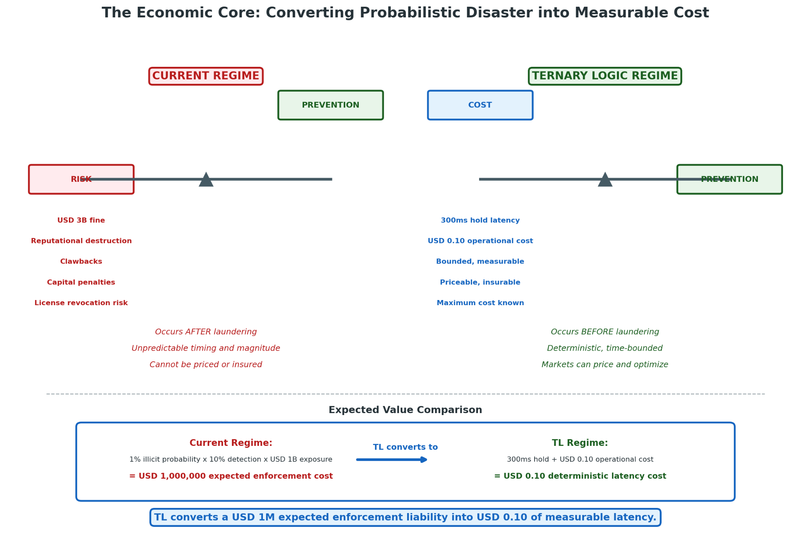
This conversion operates through:
Mechanism | Current Regime | TL Regime
Risk identification | Post-hoc, probabilistic | Real-time, deterministic
Cost quantification | Actuarially uncertain | Precisely measurable
Capital allocation | Discretionary, reactive | Rule-based, proactive
Enforcement exposure | Unbounded, catastrophic | Bounded, contractually specified
Downside tail risk | Franchise destruction possible | Maximum cost: specified latency × throughput

The expected value comparison illustrates the efficiency gain. Consider a transaction with 1% probability of being illicit, 10% probability of detection if illicit, and $1 billion potential enforcement exposure. The expected enforcement cost is $1 million (0.01 × 0.10 × $1,000,000,000). A 300-millisecond hold with $0.10 operational cost and 99% resolution probability without enforcement exposure yields expected cost of $0.10 plus negligible enforcement risk. TL converts $1 million expected cost into $0.10 deterministic cost—a 10,000,000:1 efficiency improvement, ignoring broader social benefits of prevented laundering.

I.2.5 Market Pricing of Latency vs. Catastrophic Retroactive Uncertainty Pricing
Financial markets possess sophisticated, well-developed mechanisms for pricing latency. High-frequency trading firms invest billions to reduce execution delays by microseconds; payment networks offer tiered settlement speeds with corresponding fee structures; cloud computing providers offer tiered latency guarantees. The infrastructure for latency measurement, pricing, and optimization is mature and operationally effective.
Conversely, markets completely fail when pricing retroactive uncertainty. The “catastrophic” nature of enforcement exposure—low probability, high magnitude, uncertain timing—places it outside the range of standard risk pricing models. No derivative market exists for AML enforcement risk; no actuarial tables enable probability estimation; no capital market mechanism distinguishes institutions by control quality. The uncertainty is not merely unpriced but unpriceable, creating systematic market failure that regulatory intervention has not remedied.
This market failure has profound implications for institutional behavior. Without price signals reflecting control quality, institutions face competitive pressure to minimize compliance investment, creating race-to-the-bottom dynamics that undermine collective security. TL’s latency introduction creates observable, measurable differentiation that markets can price: institutions with superior information quality (reducing hold frequency) gain competitive advantage; institutions with inferior controls bear higher latency costs. The architecture aligns private and social incentives through mechanism design rather than enforcement threat.

II. Ternary Logic (TL): Correct Definition and Triadic Architecture

II.1 TL as Triadic Action-Governance Architecture
Ternary Logic (TL) is a computational and evidentiary framework for economic decision-making under epistemic uncertainty, formally specified in the FractonicMind/TernaryLogic repository and derived from foundational work by Lev Goukassian. TL operates on principles distinct from conventional risk management: it governs economic acts rather than inferring intentions, it enforces permissioned movement through evidentiary validation rather than probabilistic scoring, and it structures organizational response to uncertainty through mandatory operational states rather than discretionary judgment.

II.1.1 Governing Economic Acts, Not Intentions or Moral Reasoning
TL’s scope is deliberately constrained to observable economic actions: transactions, transfers, trades, loans, and policy decisions. The framework explicitly excludes intention inference, behavioral profiling, and moral classification. This constraint is architecturally essential: intentions are epistemically inaccessible (even to the intending subject, under many conditions), while acts are observable, recordable, and regulable.
This act-governance orientation aligns TL with established legal frameworks. Contract law governs agreements, not the subjective states of parties. Property law governs transfers, not the purposes of transferors. TL extends this orientation to real-time transaction processing, creating an architecture that produces legally admissible evidence of decision processes without requiring inference to unobservable mental states.
The elimination of intention-governance removes a major source of current AML system failure: the false precision of customer risk scores that conflate demographic, geographic, and behavioral proxies with actual laundering probability, generating discriminatory outcomes without improving detection accuracy. A TL-compliant system in Singapore, processing a transaction originating in Dubai and terminating in New York, generates Decision Logs that satisfy evidentiary requirements in all three jurisdictions without requiring agreement on substantive criminal law or moral standards.

II.1.2 Permissioned Financial Movement Through Evidence-Backed Decisions
TL operationalizes permission as an evidentiary state: economic movement is permitted (+1) only when supporting evidence satisfies predetermined verification thresholds; refused (-1) when evidence confirms prohibition criteria; and held (0) when evidence is incomplete, conflicting, or unverified. This permission structure inverts the default of contemporary financial systems, where movement is permitted unless specifically prohibited.
The evidence-backing requirement is enforced through the “No Log = No Action” covenant. Technical implementation ensures that transaction processing systems cannot execute without Decision Log initiation; architectural separation prevents circumvention through direct database manipulation or API abuse. The result is a system where economic action and evidentiary generation are inseparable—every act leaves its trace, every trace enables its audit.

II.2 Triadic Action States
The three states of TL constitute a complete, mutually exclusive, and exhaustive partition of possible decision outcomes, with precise definitional boundaries, trigger conditions, and operational consequences.
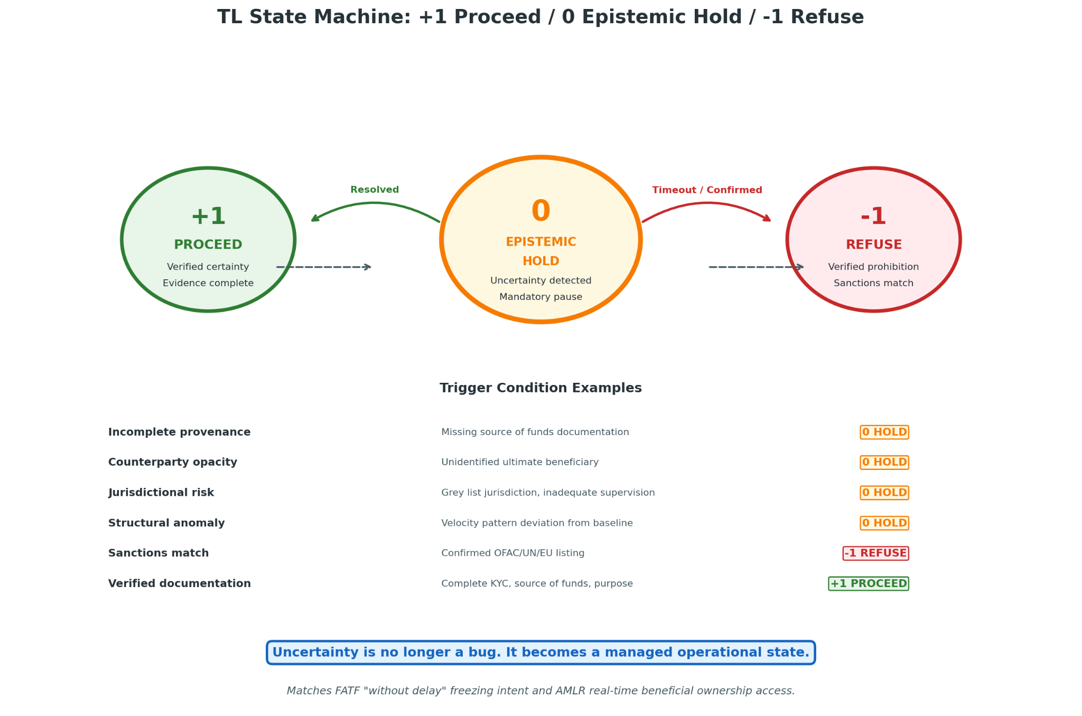

II.2.1 +1 Proceed: Action Permitted with Verified Certainty
The Proceed state indicates that the proposed economic act satisfies all applicable verification requirements with confidence above specified thresholds. Verification includes: complete customer and beneficial owner identification; verified source of funds documentation; identifiable, non-sanctioned counterparty; jurisdictional risk assessment within acceptable parameters; absence of structural anomalies or typology pattern matches; and current risk rating permitting transaction type and value.
Proceed authorization is time-bounded and transaction-specific. Historical clearance does not guarantee future permission; risk profile changes may trigger re-evaluation. The state assignment is recorded in Decision Log with full evidentiary reference, supporting subsequent audit and potential forensic reconstruction.

II.2.2 0 Epistemic Hold: Action Paused Due to Unresolved Uncertainty
The Epistemic Hold state is TL’s distinctive innovation. It activates when verification produces incomplete or conflicting results—when the system encounters epistemic uncertainty that prevents confident Proceed or Refuse determination. The Hold is not a soft refusal or delayed approval but a distinct state with its own procedural requirements and temporal dynamics.
Hold activation triggers: (1) Decision Log generation capturing the uncertainty source; (2) escalation to appropriate authority based on uncertainty type and transaction characteristics; (3) temporal bounding with automatic resolution requirements; (4) notification protocols for affected parties. The Hold persists until uncertainty resolves through additional information, authority determination, or automatic timeout (typically resulting in Refuse).
The Epistemic Hold transforms uncertainty from a source of systematic error into a manageable operational state. Rather than forcing binary decisions on probabilistic evidence, TL creates space for deliberation—structured, documented, time-bounded deliberation that preserves evidentiary integrity while enabling genuine uncertainty reduction.

II.2.3 –1 Refuse: Action Denied Due to Verified Risk or Prohibition
The Refuse state indicates that the proposed act violates specified requirements with confidence above threshold, or that Hold resolution failed to achieve necessary certainty within permitted time. Refusal is categorical: the transaction does not proceed, the economic act does not occur.
Refusal generates Decision Logs documenting the violation basis, enabling both operational learning and enforcement review. Unlike binary system denials, TL refusals are appealable through structured processes that evaluate whether refusal criteria were correctly applied. The –1 state thus maintains procedural legitimacy even when economically costly.

II.3 Primary AML Risk Locus: The Zero State, Not the Deny State
Conventional AML thinking focuses on denial—blocking identified illicit transactions. TL inverts this focus: the critical risk management state is Epistemic Hold, not Refuse. This inversion reflects the empirical reality of money laundering detection.
Sophisticated laundering operations rarely present clear violation signatures. They exploit the uncertainty zone—transactions that are unusual but not obviously criminal, complex but not demonstrably structured, rapid but not quantifiably velocity-driven. Binary systems must either approve these transactions (creating liability exposure) or deny them (creating customer friction and potential discrimination claims). The systematic result is approval, with denial reserved for obvious cases that sophisticated launderers avoid.
TL’s Epistemic Hold captures this uncertainty zone, forcing structured deliberation rather than default approval. The Hold state is where AML prevention actually occurs: where incomplete provenance is investigated, where counterparty opacity is resolved, where structural anomalies are explained. The Refuse state handles the residual cases where uncertainty resolves to confirmed risk; but the preventive work happens in Hold.

III. Core TL Mechanisms for AML Enforcement

III.1 Epistemic Hold
The Epistemic Hold mechanism operationalizes the governance of uncertainty in real-time economic decision-making. Its design reflects detailed analysis of laundering techniques and institutional control vulnerabilities.

III.1.1 Trigger Conditions: Incomplete Provenance, Counterparty Opacity, Jurisdictional Risk, Structural Anomalies
Hold triggers are specified in advance and enforced automatically, eliminating discretion that could be exploited or overridden:
Trigger Category | Specific Indicators | Verification Requirement
Incomplete provenance | Missing source of funds documentation; unverified wealth origin; complex ownership structures without beneficial owner identification | Documentary evidence from independent sources; legal opinion for complex structures
Counterparty opacity | Unidentified ultimate beneficiary; shell company characteristics; trust or foundation structures without settlor/beneficiary disclosure | Beneficial ownership registry access; contractual disclosure obligations; third-party verification
Jurisdictional risk | High-risk country designation; beneficial ownership secrecy; inadequate AML supervision; sanctions exposure | Enhanced due diligence; senior approval; potential prohibition
Structural anomalies | Velocity pattern deviation; amount inconsistency with profile; circular transaction flows; rapid asset class conversion | Behavioral baseline analysis; typology pattern matching; expert review

Trigger design incorporates dynamic threshold adjustment based on institutional risk appetite, regulatory guidance, and emerging threat intelligence. Static thresholds are vulnerable to gaming; adaptive thresholds maintain effectiveness against evolving techniques.

III.1.2 Uncertainty-to-Pause Conversion Without Guilt Presumption
A critical design principle is that Hold does not imply suspicion or guilt. The state is triggered by information status, not actor characterization. This distinction is legally significant: Hold activation does not trigger reporting obligations that would apply to confirmed suspicious activity, does not create defamation exposure, and does not justify customer notification prohibitions.
The no-presumption design enables broader Hold deployment than would be possible if each Hold carried suspicion implications. Institutions can Hold transactions for routine verification without regulatory or reputational cost, reducing the threshold for uncertainty capture and increasing preventive effectiveness. The design also supports customer communication: “Your transaction is on hold pending routine verification” is operationally and legally distinct from “Your transaction has been flagged as suspicious.”

III.1.3 Laundering Velocity Blocking Through Mandatory Interruption
Money laundering operations depend on velocity—rapid movement of funds through multiple accounts, jurisdictions, and asset classes to obscure origin and complicate tracing. The Epistemic Hold interrupts this velocity structurally: each Hold creates a temporal break in the chain, each break requires resolution before continuation, and the cumulative effect degrades laundering operational efficiency.
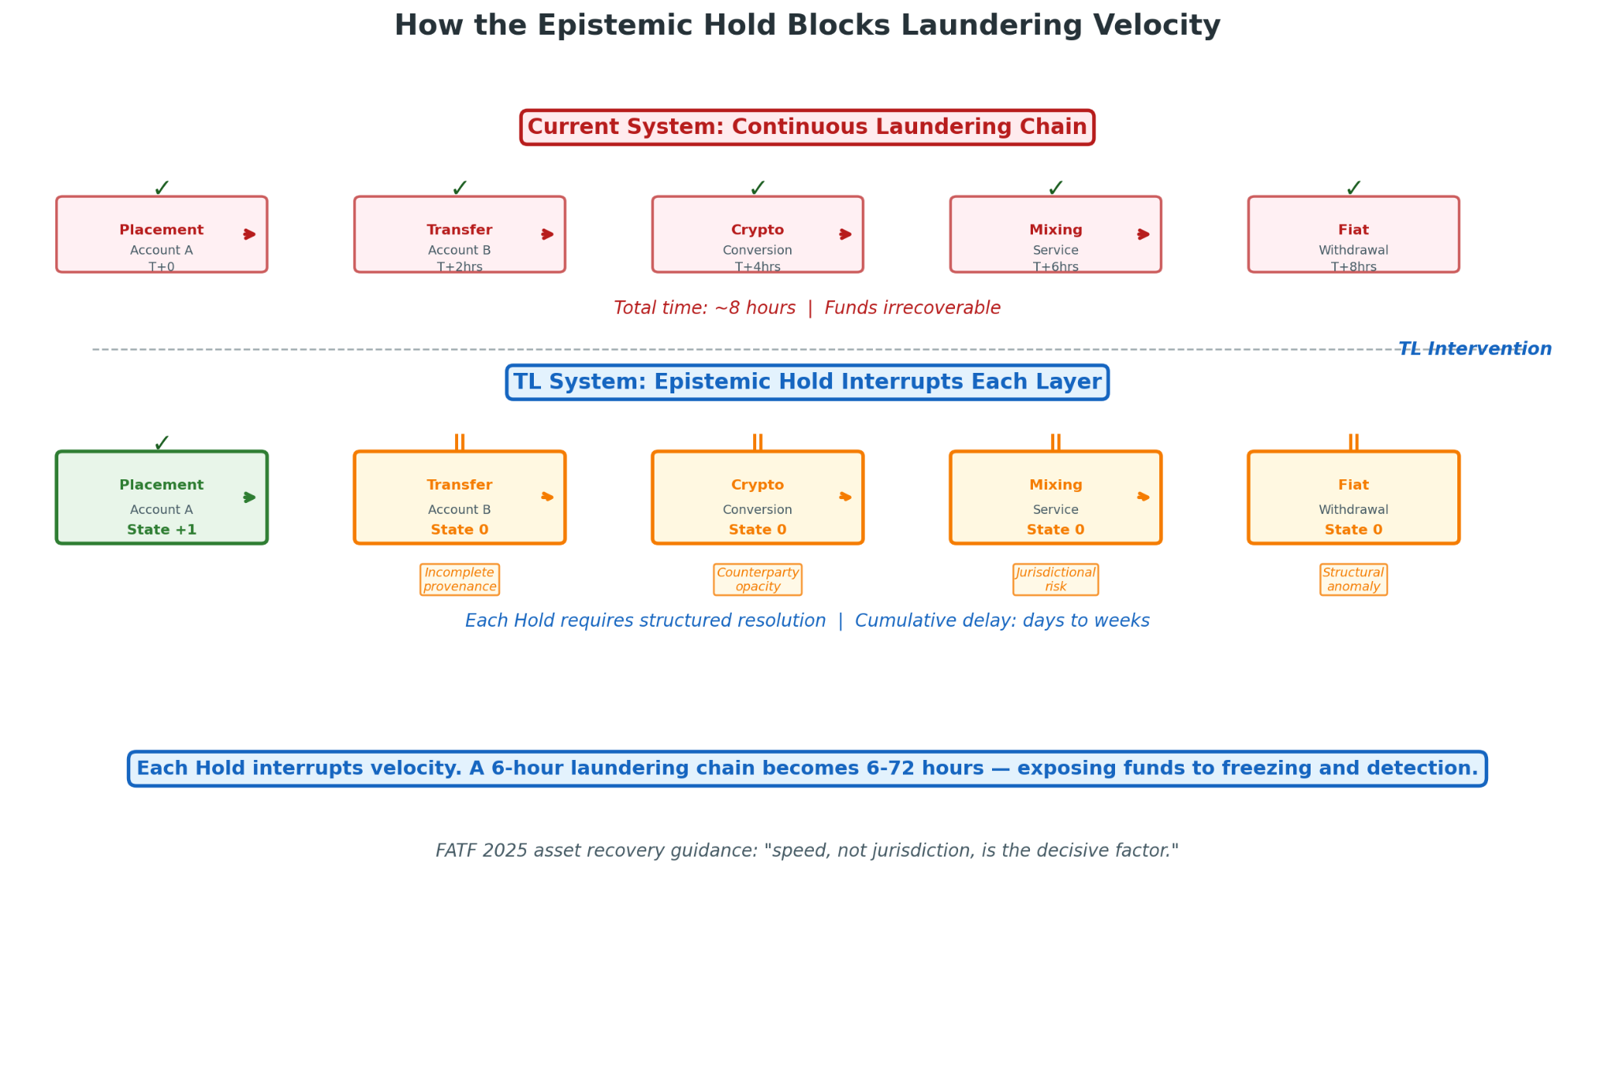
The velocity impact can be quantified. Consider a typical layering sequence: placement in Account A, transfer to Account B (different institution, jurisdiction), conversion to cryptocurrency, transfer to mixing service, conversion to fiat in Account C. With real-time settlement, this sequence completes in hours. With TL holds at each hop requiring verification completion, the sequence extends to days or weeks—dramatically increasing exposure to detection, freezing, and investigative intervention.
Velocity blocking is particularly effective against automated laundering infrastructure. Bot-driven account networks, designed for rapid execution of pre-programmed sequences, encounter hold states that disrupt timing assumptions and trigger escalation to human handlers who may abandon operations rather than engage with verification requirements.

III.2 Decision Logs (Pre-Action)
Decision Logs constitute TL’s evidentiary core—structured records generated before any economic action that capture the complete decision context.

III.2.1 Generation Before Any Economic Action
The “No Log = No Action” covenant is technically enforced through system architecture. Transaction processing systems query Decision Log status before execution; absent confirmed log initiation, execution is blocked. This enforcement is not merely application-level but extends to database triggers, API gateways, and network protocols, preventing circumvention through technical manipulation.
Pre-action generation ensures that the log captures decision-process information, not merely decision outcomes. The reasoning that led to Proceed, Hold, or Refuse is documented as it occurs, not reconstructed afterward. This contemporaneity is legally significant: logs generated before action are more credible evidence than logs created for litigation defense.

III.2.2 Capture of Known, Unknown, and Assumed Elements
Each Decision Log contains structured fields for three epistemic categories:
Category | Content | Example
Known elements | Verified facts with documentation reference | Customer identity verified through passport + utility bill; source of funds from audited financial statements
Unknown elements | Information gaps with explanation of unavailability | Beneficial ownership of 25% shareholder unknown—registry query returned “no record”; pending verification from registered agent
Assumed elements | Provisional determinations with basis and confidence | Risk rating “low” assumed based on jurisdiction of incorporation (UK) and account history (2 years, no alerts)—confidence: medium

This tripartite structure prevents the “false certainty” problem where assumptions are treated as facts through documentation omission. It also supports operational improvement: systematic analysis of Unknown patterns identifies information gaps that infrastructure investment can address.

III.2.3 Escalation Thresholds and Authority Boundaries
Decision Logs specify explicit escalation parameters: time-bound hold resolution requirements, value thresholds for senior authority involvement, and pattern thresholds for specialized unit referral. Authority boundaries are cryptographically enforced: system permissions for hold release, refusal override, or enhanced due diligence initiation are tied to verified credentials with automatic expiration.
The logging of escalation paths creates organizational accountability: delays in hold resolution are attributable to specific organizational units, enabling process improvement and resource allocation optimization.

III.2.4 No Log = No Action Enforcement
The enforcement mechanism is redundant and tamper-evident:
Layer | Mechanism | Function
Primary | Application-layer validation | Prevents transaction initiation without log confirmation
Secondary | Database-layer constraints | Prevents record insertion with timestamp preceding log timestamp
Tertiary | Network-layer protocols | Rejects settlement messages without valid log reference

Any gap between transactions and logs triggers investigation and potential system suspension.

III.3 Immutable Ledger
The Immutable Ledger provides tamper-evident storage for Decision Logs, ensuring that recorded decisions cannot be altered, deleted, or backdated without detection.

III.3.1 Tamper-Evident Logging of All Economic Decisions
Each Decision Log entry includes a cryptographic hash of its content and the hash of the preceding entry, creating a chain structure where any modification breaks the hash sequence. The chain is replicated across multiple storage nodes with consensus protocols for addition validation. Modification of historical entries would require simultaneous compromise of multiple nodes with distinct security architectures—computationally infeasible at scale.
Tamper evidence is distinct from tamper prevention. A sufficiently motivated and resourced attacker could theoretically modify ledger contents, but the modification would be detectable through hash verification. Detection triggers incident response: system suspension, forensic investigation, regulatory notification, and potential criminal referral. The deterrence effect of certain detection exceeds the prevention effect of imperfect protection.

III.3.2 Separation of Transaction Data, Decision Logs, and Proofs
Data Category | Storage Location | Access Control | Retention
Transaction data | Operational systems | Business unit access | Standard (typically 5-7 years)
Decision Logs | Compliance infrastructure | Compliance, audit, regulatory | Extended (7-10+ years)
Proofs | Distributed/anchored systems | Public verification | Permanent

This separation enables differential access controls: transaction data accessible to operational staff; Decision Logs to compliance and audit functions; proofs publicly verifiable without revealing underlying content. It also supports differential retention: transaction data subject to data minimization; Decision Logs and proofs retained for long-tail investigations.

III.3.3 Forensic Reconstruction Capability Under Regulatory Scrutiny
The complete ledger enables investigators to reconstruct: what information was available at decision time (not retrospectively gathered), how it was processed, who made decisions, and on what authority. Reconstruction is operationalized through query interfaces, visualization tools, and export formats designed for regulatory and judicial use.

III.4 Hybrid Shield
The Hybrid Shield mechanism prevents silent overrides of Epistemic Holds or Refusals—technical and procedural mechanisms that ensure any exception to automated decisions is itself documented, authorized, and reviewable.

III.4.1 Prevention of Silent Overrides of Holds or Refusals
Override attempts are automatically logged with mandatory justification fields; cryptographic signatures prevent repudiation; and real-time notification to supervisory authorities prevents concealment. The “silent” override—where a relationship manager clears an alert without systematic recording—is architecturally prevented: hold release requires validated credentials with specific override authorization, and the release event is immediately visible to compliance monitoring systems.

III.4.2 Override Recording: Who, When, Authority, Justification
Every override generates a permanent record:
Record Element | Content Requirement | Verification
Who | Individual identity, authentication method, session details | Multi-factor authentication, biometric where available
When | Precise timestamp with timezone, sequence number | Synchronized atomic clock, tamper-evident logging
Authority | Specific authorization grant, policy reference, limit verification | Automated authority database lookup, dual verification
Justification | Free text with minimum length, structured category selection, supporting documentation reference | Natural language processing for completeness check, random audit sampling

This recording structure supports both immediate oversight and retrospective investigation.Override patterns—frequency by individual, concentration by business unit, timing relative to transaction characteristics—are automatically analyzed for anomaly detection.

III.4.3 Resistance to Insider Collusion and Regulatory Capture
Collusion resistance requires that override authorization cannot be concentrated in individuals or small groups vulnerable to compromise. Technical implementations include: distributed authorization requiring geographically separated approvers; time-delayed override with cooling-off periods; and random audit selection with unannounced depth review.
Regulatory capture resistance—protection against override by compromised supervisors—is addressed through oversight separation: compliance function independence, board-level reporting, and external audit access. TL architecture supports these separations through access control design and mandatory reporting flows.

III.5 Anchors
Anchors provide long-term evidentiary permanence through cryptographic anchoring of Decision Log proofs to distributed, independently verifiable systems.

III.5.1 Long-Term Evidentiary Permanence
Financial crime investigations frequently extend over decades: initial laundering, subsequent business integration, eventual detection, prolonged investigation, and finally prosecution and asset recovery. Evidence must remain verifiable throughout this extended lifecycle.
Permanence requirements include: format standardization enabling interpretation by future systems; key escrow ensuring signature verification despite personnel turnover; and institutional succession planning for evidence custody in merger, acquisition, or failure scenarios.

III.5.2 Merkle-Root Anchoring of Decision Proofs
Rather than anchoring individual logs (prohibitively expensive at scale), TL aggregates Decision Log hashes into Merkle trees, with only roots anchored to external verification systems. This approach provides cryptographic assurance of log integrity without requiring continuous availability of complete log contents.

III.5.3 Proofs On-Chain, Logs Off-Chain Architecture
Component | Location | Function
Proofs | On-chain (blockchain/distributed ledger) | Public verification, permanent timestamp, censorship resistance
Logs | Off-chain (institutional encrypted storage) | Content access, regulatory examination, privacy protection
Linkage | Cryptographic (Merkle proofs) | Verify log integrity without revealing content

This separation balances transparency with privacy: anyone can verify that a Decision Log existed at a specific time and has not been altered; only authorized parties can access log contents. Regulatory subpoena, litigation discovery, and law enforcement access operate through established legal process without creating public exposure of sensitive financial information.

III.6 AI-to-Logic Handoff
TL does not replace machine learning AML systems but governs them—converting their probabilistic outputs into deterministic action states through the Epistemic Hold mechanism.

III.6.1 Input: Probabilistic Risk Scores from Machine Learning AML Models
Contemporary AML systems employ sophisticated machine learning models: neural networks for pattern recognition, graph analytics for network detection, anomaly detection for behavioral deviation. These models output probability distributions—risk scores indicating likelihood of money laundering involvement.
A typical model might output: 73% probability of structuring, 45% probability of layering, 12% probability of integration—composite scores that resist simple threshold application. The probabilistic nature reflects genuine uncertainty: models are trained on historical data, but criminal methods evolve; features are correlated with laundering but not deterministically causal; ground truth is often unavailable for training validation.

III.6.2 TL Process: Probabilistic Outputs Treated as Epistemic Uncertainty, Not Authorization
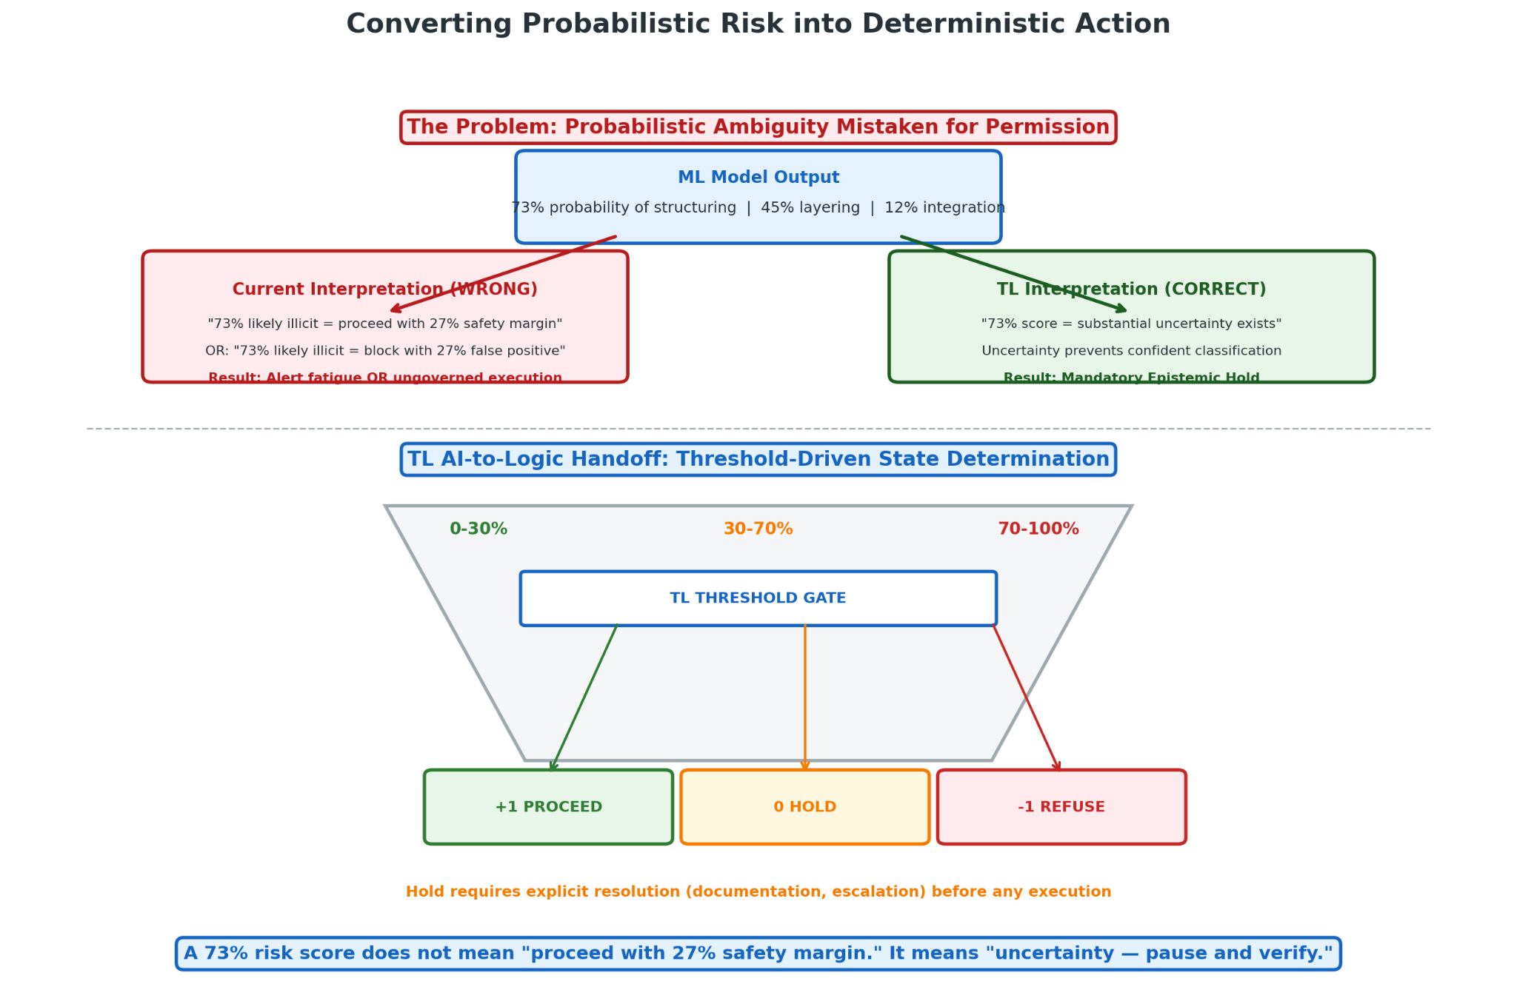
TL’s critical intervention: probabilistic outputs are not treated as decision inputs but as uncertainty indicators. A 70% risk score does not mean “70% likely to be illicit, therefore proceed with caution” or “70% likely to be illicit, therefore block.” It means “substantial uncertainty exists that prevents confident classification.”
This treatment is implemented through threshold specification:
Score Range | TL State | Action
0-30% | +1 Proceed | Automatic execution with standard logging
30-70% | 0 Epistemic Hold | Escalation for verification completion
70-100% | –1 Refuse or intensive Hold | Senior review, potential prohibition

Threshold values are institution-specific, reflecting risk appetite and operational capacity, but must be documented, justified, and subject to regulatory review. The critical design is that intermediate scores force Hold rather than probabilistic execution.

III.6.3 Threshold-Driven State 0 Enforcement
The threshold specification is technical, not merely policy. Model outputs feed directly into TL state determination without intermediate human interpretation that could introduce bias or manipulation. The handoff is automated, auditable, and consistent.

III.6.4 Output: Deterministic Collapse to +1 or –1 Required Before Proceeding
Hold resolution must result in deterministic state assignment: sufficient verification to justify Proceed, or confirmed risk to require Refuse. The probabilistic input is consumed in the resolution process; the output is categorical permission or denial.
This collapse requirement prevents “probabilistic permission” where transactions execute with partial verification, residual uncertainty, and implicit risk acceptance. Either the uncertainty is resolved, or the transaction does not proceed.

III.6.5 Prevention of Probabilistic Ambiguity Mistaken for Permission
The fundamental vulnerability of current systems is the treatment of model probability as permission probability. A model’s 70% risk estimate describes its confidence in a classification, not the appropriate probability of transaction permission. TL’s architecture prevents the error structurally: uncertainty cannot be mistaken for permission because uncertainty triggers Hold, and Hold requires explicit resolution.

IV. Technical Architecture for AML at Scale

IV.1 Dual-Lane Latency Model
TL’s operational implementation requires precise latency management that preserves integrity guarantees without unacceptable throughput degradation. The Dual-Lane Latency model achieves this through functional separation between time-critical and time-tolerant processing
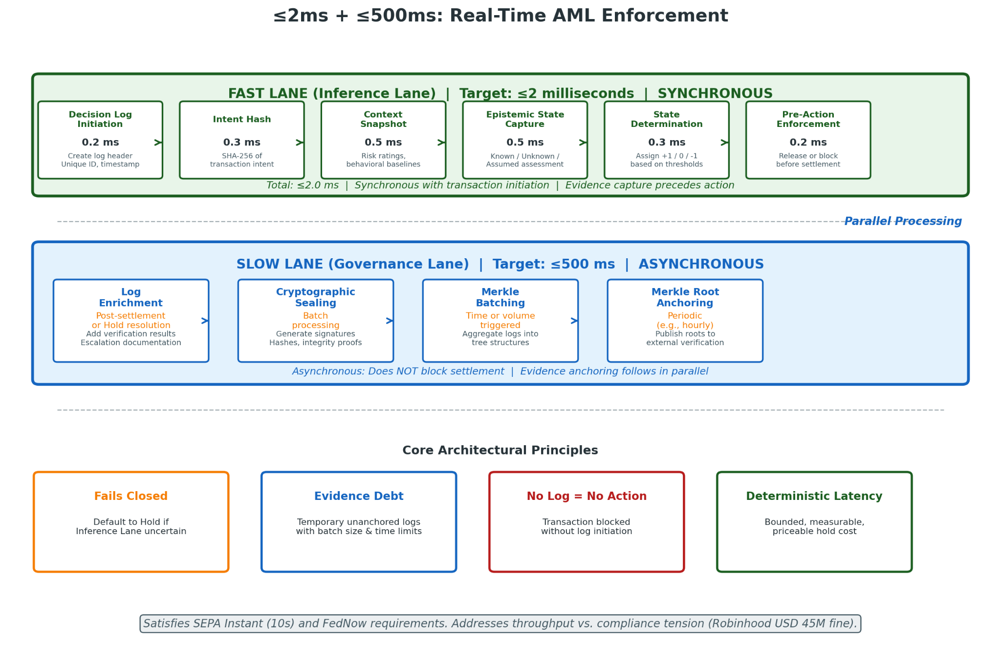.

IV.1.1 Inference Lane (≤2 ms): Pre-Action Evidence Capture and State Determination
The Inference Lane executes synchronously with transaction initiation, completing within strict latency budgets compatible with real-time payment requirements:
Function | Description | Latency Budget
Decision Log initiation | Create log header with unique identifier, timestamp, transaction reference | 0.2 ms
Intent hash | Cryptographic hash of transaction intent (amount, parties, purpose declaration) | 0.3 ms
Context snapshot | Capture relevant environmental state: risk ratings, behavioral baselines, regulatory status | 0.5 ms
Epistemic state capture | Assess known/unknown/assumed elements against trigger conditions | 0.5 ms
State determination | Assign +1, 0, or –1 based on assessment | 0.3 ms
Pre-action enforcement | For Proceed: release for settlement; for Hold/Refuse: block and initiate escalation | 0.2 ms
Total Fast Lane |  | ≤2.0 ms

The 2-millisecond budget accommodates real-time payment requirements (SEPA Instant: 10 seconds end-to-end; FedNow: similar) while ensuring that integrity-critical functions complete before irreversible action.
Critical design principle: Inference Lane functions must be sufficient for Hold/Refuse decisions, even if Proceed requires additional verification. The architecture “fails closed”—defaults to Hold if Inference Lane completion is uncertain—rather than risk unauthorized execution.

IV.1.2 Governance Lane (≤500 ms, Asynchronous): Post-Action Evidence Enrichment and Permanence
The Governance Lane executes asynchronously, completing after transaction settlement for Proceed states, or during Hold resolution for held transactions:
Function | Description | Timing
Log enrichment | Add detailed verification results, escalation documentation, authority confirmations | Post-settlement or Hold resolution
Cryptographic sealing | Generate signatures, hashes, and integrity proofs | Batch processing
Merkle batching | Aggregate logs into tree structures for efficient anchoring | Time or volume triggered
Merkle root anchoring | Publish roots to external verification systems | Periodic, e.g., hourly

The 500-millisecond Slow Lane budget is illustrative; actual implementation may extend to minutes for batch processing without impacting transaction latency.

IV.1.3 Evidence Capture Precedes Action; Evidence Anchoring Follows in Parallel
This temporal structure is architecturally fundamental. Evidence capture—sufficient documentation to support state assignment—must complete before action commitment. Evidence anchoring—cryptographic permanence verification—can proceed in parallel without blocking settlement.
The parallel architecture creates a temporary “evidence debt”—logs that exist and are protected by hash chaining but not yet anchored to distributed systems. This debt is managed through: batch size limits (maximum logs per batch); time limits (maximum age of unanchored logs); and redundancy (multiple pending batches in process). Debt management ensures that no log remains unanchored beyond specified parameters, with automatic escalation if anchoring fails.

IV.2 Merkle-Batched Anchoring: Structural Requirement for Bottleneck Avoidance
Merkle batching is not an optimization but an architectural necessity for TL deployment at scale. Direct anchoring of individual Decision Logs would impose impossible costs and throughput limitations.

IV.2.1 Individual Decision Logs Not Anchored Directly
Direct anchoring—submitting each Decision Log as a separate blockchain transaction—would generate: prohibitive transaction fees (even on efficient blockchains, per-transaction costs accumulate at scale); blockchain congestion (millions of daily transactions would exceed network capacity); and latency inconsistency (block confirmation times vary, creating unpredictable anchoring delays).
For a major correspondent bank processing 10 million daily transactions, direct anchoring would be economically and operationally infeasible.

IV.2.2 Merkle Tree Grouping Over Time or Volume Windows
Logs are aggregated based on configurable triggers:
Trigger Type | Parameter | Use Case
Time window | e.g., 1 hour | Regular, predictable anchoring
Volume threshold | e.g., 10,000 logs | Load-based anchoring for variable volume
Event-driven | Specific transaction types | Priority anchoring for high-risk decisions
Hybrid | Minimum time + maximum volume | Balance predictability and efficiency

Tree construction maintains chronological and logical ordering, supporting efficient proof generation for individual log verification.

IV.2.3 Merkle Root-Only Anchoring to External Ledgers
Only the 32-byte Merkle root is anchored, regardless of batch size. This constant-size anchoring enables: predictable cost structure independent of volume; throughput limited only by tree construction, not underlying ledger capacity; and confirmation latency amortized across batch contents.

IV.2.4 Complexity Reduction: O(n) to O(1) Per Batch
Anchoring Approach | Per-Log Cost | 1M Daily Logs Cost | Verification Complexity
Individual anchor | $10 | $10M | O(1) per log
100-log Merkle batch | $0.10 | $100K | O(log 100) = O(7)
10,000-log Merkle batch | $0.001 | $1K | O(log 10,000) = O(14)

The complexity transformation is dramatic: a 10,000-log batch reduces anchor cost by 99.99% versus individual anchoring while maintaining verification capability.

IV.2.5 Rolling Merkle Buffers
To minimize latency between log creation and anchor commitment, TL implements rolling buffers: multiple concurrent Merkle trees at different accumulation stages, with frequent anchor commitment of completed trees while new trees begin accumulation. Buffer parameters include: maximum batch size (trigger anchoring when reached); maximum batch age (trigger anchoring when exceeded); and minimum batch size (delay anchoring if below, to avoid inefficient small batches).

IV.2.6 Batch Sizing and Tree Depth Trade-Offs
Batch Size | Anchor Frequency | Per-Log Cost | Max Verification Delay | Tree Depth
100 logs | 10s (at 10 TPS) | $0.10 | 10s | 7
1,000 logs | 100s | $0.01 | 100s | 10
10,000 logs | 1000s (~17min) | $0.001 | 17min | 14
100,000 logs | 10000s (~2.8hr) | $0.0001 | 2.8hr | 17

Selection depends on institutional risk tolerance, regulatory requirements, and cost constraints. High-value transaction systems may employ smaller batches for rapid permanence; high-volume retail systems may employ larger batches for cost efficiency.

IV.2.7 Fault Isolation and Reconstruction via Merkle Proofs
Merkle structure enables precise fault localization: if anchor verification fails, Merkle proof identifies specific log with hash mismatch; if institutional record is corrupted, Merkle proof from external anchor enables reconstruction of correct hash; if external anchor is unavailable, institutional Merkle tree enables internal verification pending anchor recovery.

IV.3 Deferred Anchoring
High-volume environments require additional latency flexibility through structured evidence debt.

IV.3.1 High-Volume Environment Deployment: Correspondent Banking, Payment Rails
Correspondent banking illustrates the volume challenge: a major correspondent might process 50,000 payments daily for a single respondent bank, with hundreds of respondent relationships. Daily Decision Log volume approaches millions; even with batching, immediate anchoring may strain blockchain capacity during peak periods.
Deferred anchoring permits transaction processing with structured commitment to subsequent evidence permanence.

IV.3.2 Mandatory Time-Bounded Evidence Debt
Deferred anchoring is not optional omission but contractual obligation: institutional policy specifies maximum deferral duration (typically 1-24 hours), with automatic escalation and operational restriction if commitment is delayed. The debt structure creates enforceable obligation: failure to anchor within specified timeframe is compliance violation.

IV.3.3 Non-Skippable, Non-Erasable Anchoring Obligation
The anchoring obligation is technical, not merely procedural. Deferred logs are encrypted with time-locked keys that become available for anchor commitment at specified time; attempted deletion or modification is detectable through Merkle structure inconsistency; and external monitoring verifies anchor completion against committed deferral schedule.

IV.3.4 Anchoring Failure as Compliance Violation
Failure to anchor within specified parameters constitutes a compliance violation with defined consequences: mandatory incident reporting; root cause analysis and remediation; potential capital penalty or business restriction for systematic failure; and in extreme cases, license revocation or criminal referral.

IV.4 Privacy and GDPR Compliance
TL’s evidence architecture accommodates European and global privacy requirements through technical design.

IV.4.1 Pseudonymization Before Hashing
Personal data is separated from verification structure: identifying information is replaced with non-reversible token before inclusion in hashed Decision Log; pseudonymization mapping is maintained in access-controlled, jurisdictionally-appropriate storage; and Merkle proofs verify log integrity without revealing personal content.

IV.4.2 Right-to-Erasure Compatibility
GDPR Article 17 right to erasure is accommodated through: (1) erasure of pseudonymization mapping (rendering pseudonym irreversibly disconnected from identity); (2) retention of cryptographic proof structure (maintaining system integrity verification); and (3) annotation of erasure event in subsequent logs (maintaining audit trail of data subject rights exercise). The personal data content may be erased while proof of decision existence and integrity is retained.

IV.4.3 No Personal Data On-Chain
Strict architectural prohibition prevents any personal data, even pseudonymized, from appearing on public or permissionless distributed ledgers. Anchored Merkle roots contain only cryptographic hashes, with no embedded personal data of any form.

IV.4.4 Encrypted Off-Chain Logs
Detailed Decision Log content is encrypted with institutional keys, stored in jurisdictionally-compliant facilities, with key escrow and recovery procedures for authorized regulatory access. Encryption prevents unauthorized access; institutional key control enables responsive erasure; and escrow procedures ensure regulatory examination capability.

IV.5 Ephemeral Key Rotation (EKR)
EKR provides time-bounded, revocable access to encrypted evidentiary records.

IV.5.1 Time-Limited Auditor Access
Regulatory and internal auditors receive credentials valid for defined examination periods (typically 30-90 days), with specific scope limitations (particular time periods, transaction types, or organizational units). Credential expiration is cryptographically enforced: expired credentials cannot decrypt log content or generate valid queries.

IV.5.2 Automatic Key Expiration
Key material is generated with embedded expiration; no manual revocation is required; and expired key material is cryptographically destroyed (not merely marked invalid). The automaticity prevents the common failure mode where terminated employees retain access, or where audit scope limitations are ignored post-credential-expiration.

IV.5.3 Trade-Secret Protection
Auditor access is structured to reveal necessary information while protecting proprietary methods: model parameters may be accessed in aggregate or obfuscated form; algorithmic logic may be verified without source code disclosure; and competitive intelligence (customer lists, pricing strategies) is segregated from AML-relevant examination scope.

IV.5.4 Regulator-Compatible Disclosure
EKR credential formats are standardized for cross-jurisdictional recognition: FATF-member regulators can verify credential validity through shared infrastructure; credential scope can be mapped to specific regulatory authority; and examination reports can include cryptographic attestation of log integrity and access scope.

IV.6 ISO 20022 Semantic Mapping
TL’s operational deployment requires seamless integration with global payment messaging standards.

IV.6.1 TL State Mapping to pacs and camt Message Flows
TL State | ISO 20022 Message | Status Code | Semantic Mapping
+1 Proceed | pacs.002 | ACCP (Accepted) | Transaction cleared TL verification
0 Epistemic Hold | pacs.002 | PDNG (Pending) | Transaction suspended pending resolution
–1 Refuse | pacs.002 | RJCT (Rejected) | Transaction refused with specified reason

The mapping preserves ISO 20022’s existing status vocabulary while embedding TL-specific semantics through supplementary data.

IV.6.2 Epistemic Hold (0) Representation in pacs.002 Status Reports
Pending status is extended with proprietary or extended reason codes:
Reason Code | Description | Resolution Endpoint
PDNG.TL.001 | Incomplete provenance | Documentation collection
PDNG.TL.002 | Counterparty opacity | Enhanced due diligence
PDNG.TL.003 | Jurisdictional risk | Regulatory consultation
PDNG.TL.004 | Structural anomaly | Pattern analysis

Extended codes enable automated processing by TL-aware correspondents while falling back to generic pending handling by legacy systems.

IV.6.3 Decision Log Payload Embedding in ISO SupplementaryData Fields
Decision Log references are embedded in pacs.002 SupplementaryData:
Field | Content
LogID | Unique identifier
LogHash | Verification hash
AnchorRef | External anchor reference

The embedding enables transaction-correspondent to verify TL processing integrity without separate communication channel.

IV.6.4 Prevention of Compliance Data Truncation Across Correspondent Banking Hops
Current correspondent banking practice strips compliance-relevant data at each hop: originator information replaced with intermediary identity; purpose of payment generalized or omitted; prior suspicious activity indicators not propagated. TL’s embedded Decision Log reference creates persistent, verifiable compliance trail: each correspondent can access prior hop’s verification record (with appropriate authorization), and truncation attempts are detectable through hash verification failure.

IV.6.5 Evidence Traveling With Transaction, Not Alongside
The embedded reference architecture ensures that evidence location is transaction-bound: no separate tracking of “which logs correspond to which transactions”; no risk of correspondence loss through message handling errors; and automatic evidence retrieval for any transaction with valid LogID.

V. Hardware Enforcement Substrate: Physical Implementation of the Epistemic Hold

V.1 Introduction: Why Software Governance Requires a Hardware Foundation
The governance architecture described in preceding sections establishes the Epistemic Hold as the critical mechanism that prevents AML failures of the kind documented throughout this specification. The No Log = No Action covenant, the Dual-Lane Latency model, the Merkle-batched anchoring infrastructure, and the Hybrid Shield together constitute a governance stack of considerable sophistication. Each layer strengthens the evidentiary and enforcement architecture. None of them, individually or collectively, provides the one guarantee that no software layer can provide: the physical impossibility of ungoverned execution.
Software constraints can be modified by operators with sufficient access. API gateway rules can be reconfigured. Database triggers can be disabled. Application-layer validation can be bypassed through direct database manipulation. A sufficiently motivated insider, a compromised administrator account, or a sophisticated external attacker who has achieved privileged access to the institution's infrastructure can, in principle, circumvent any governance constraint that exists only as software. The TD Bank enforcement action documented in Section I illustrates this precisely: employees with system access facilitated laundering by processing transactions outside the monitoring architecture. Software governance requires the cooperation of the system it governs. Physical governance does not.
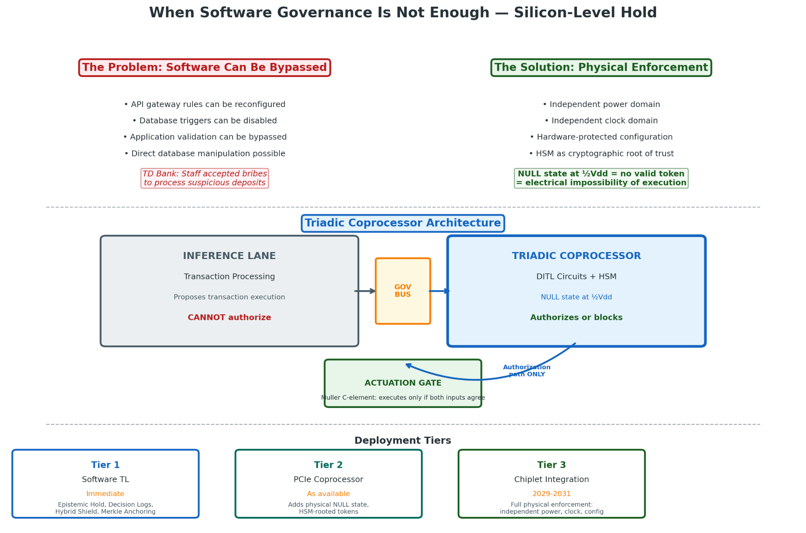
This section describes the hardware substrate that implements the Epistemic Hold at the physical layer: Delay Insensitive Ternary Logic (DITL) circuits, the NULL state as the physical implementation of the Epistemic Hold at half supply voltage, the triadic coprocessor architecture that enforces governance independently of the transaction processing system, and the chiplet integration model that enables deployment within existing financial infrastructure without requiring replacement of incumbent processing hardware.
The foundational claim of this section is precise: a transaction processing system running on the Inference Lane hardware cannot execute a governed transaction without a valid Permission Token from the Governance Lane coprocessor, because the coprocessor is physically distinct hardware with independent power, independent clock, and hardware-protected configuration that the Inference Lane cannot address or modify. The enforcement constraint is not a rule the system must follow; it is a physical condition the system cannot alter.

V.2 From Software Hold to Physical Hold: The Architecture of Ternary Circuit Logic

V.2.1 The Inadequacy of Binary Circuit Implementation for Epistemic Enforcement
Standard CMOS binary logic implements computation through two voltage levels: logical 0 at ground (nominally 0V) and logical 1 at supply voltage (nominally Vdd). The intermediate voltage range between these two valid logic levels is not a computational state; it is a forbidden zone that circuits are designed to transit through as rapidly as possible, because any stable intermediate voltage represents metastability, a condition where the circuit has not yet resolved to a valid output and where the resolution time is theoretically unbounded.
This physical architecture mirrors and reinforces the binary brittleness at the software layer. A binary transaction processing circuit is either executing or not executing. It has no native physical state for "awaiting governance authorization." The intermediate voltage that would represent this state is precisely what binary circuit design expends enormous engineering effort to eliminate. The result is a complete stack, from transistor physics through circuit topology to instruction set architecture to application logic, in which the Epistemic Hold has no native representation at any layer.
Ternary logic circuits implement a different voltage assignment. Rather than two valid logic levels, ternary circuits implement three: a low state representing logical -1 (nominally 0V), an intermediate state representing logical 0 or NULL (nominally ½Vdd), and a high state representing logical +1 (nominally Vdd). Each state corresponds to a distinct, stable, addressable circuit condition. The NULL state at ½Vdd is not a transient; it is a valid, maintained voltage level that the circuit holds stably for as long as the governance controller requires, releasing only when a valid authorization token arrives or when the governance timer forces resolution to the -1 state.

V.2.2 Delay Insensitive Ternary Logic (DITL)
Delay Insensitive Ternary Logic is the specific circuit family that implements the hardware substrate for the Epistemic Hold architecture. The delay insensitive property derives from the use of asynchronous handshake protocols rather than global clock synchronization. Each circuit stage signals readiness and completion to adjacent stages through explicit request and acknowledge signals. Data transfer occurs only when both sender and receiver are prepared. Computation proceeds at the pace of circuit completion rather than the pace of a global clock.
The delay insensitive property is significant for financial enforcement applications for three reasons.
First, it eliminates the timing attack surface that global clock synchronization creates. A sophisticated attacker cannot exploit clock skew, race conditions, or timing side-channels to create a window in which a transaction executes before the governance check completes. There is no global clock to attack and no synchronization window to exploit.
Second, it provides natural fail-safe behavior under power or signal integrity problems. An asynchronous circuit that loses power or signal integrity does not produce a spurious output. It stops, with all pending computations in a stable intermediate state. For an AML enforcement circuit, this means that power disruption, electromagnetic interference, or hardware fault defaults to the Epistemic Hold state, not to ungoverned execution.
Third, it enables the Epistemic Hold NULL state to persist stably for the duration of the governance deliberation window without clock-induced resolution pressure. The circuit maintains ½Vdd on the authorization lines for as long as the governance controller requires, without spontaneously resolving the state or accumulating metastability errors over time.
The fundamental computation element of DITL governance circuits is the Muller C-element, also known as the coincidence element or consensus element. The C-element's output transitions to a new state only when all of its inputs have transitioned to that state. If inputs disagree, the output holds its previous value indefinitely. This behavior directly implements the Epistemic Hold's governance function.
The actuation gate in the TL hardware architecture is a C-element whose inputs are the Inference Lane's proposed transaction authorization and the Governance Lane's Permission Token. The actuation gate transitions to the execution state only when both inputs are present and in agreement. If the Governance Lane has not issued an authorization token because the log has not been committed, because an Epistemic Hold is active, or because a -1 Refuse state has been asserted, the C-element holds the actuation gate in its stable pre-execution state regardless of what the Inference Lane has proposed. The transaction cannot execute because the physical conditions for execution do not obtain.

V.2.3 The NULL State at ½Vdd: The Epistemic Hold in Silicon
When the Governance Lane coprocessor activates the Epistemic Hold, the governance circuits transition to the NULL voltage level across the authorization pathway. In this physical state:
No valid token is present on the data lines connecting the Governance Lane to the actuation logic. The Muller C-elements at the actuation gate have a NULL input from the Governance Lane. The C-elements cannot transition to the execution state because all inputs are not in agreement. The actuation logic cannot fire because the C-element output is held in its stable pre-execution state. The Inference Lane's proposed transaction sits in the output buffer, unable to propagate to the settlement layer.
This is not a blocked API call. It is not a software flag. It is an electromagnetic condition: the voltage on the governance authorization lines is approximately ½Vdd, and no circuit downstream of that voltage level can receive a valid data token because ½Vdd does not encode a valid token in either the +1 or -1 data encoding scheme. A transaction processing system that has been compromised at the software layer, whose application code has been modified to bypass governance checks, whose database triggers have been disabled, and whose API gateway has been reconfigured, cannot execute a governed transaction if the DITL coprocessor is asserting the Epistemic Hold at the physical layer. The software compromise is irrelevant to the circuit's electrical state.
The Epistemic Hold at the hardware layer is time-bounded by design. The DITL coprocessor's governance controller implements a hardware timer that runs independently of the circuit's electrical state. Upon expiration of the domain-configured deliberation period, whether that is 500 milliseconds for a real-time payment system or 24 hours for a correspondent banking verification, the governance controller asserts a forced -1 state, driving the C-element's Governance Lane input to the -1 voltage level and collapsing the actuation gate to Refuse. A transaction that has not received governance authorization within the deliberation window does not proceed. The hardware enforces this absolutely; no software intervention can extend the window or override the collapse.

V.3 The Triadic Coprocessor Architecture

V.3.1 Physical Separation as the Governance Boundary
The DITL governance circuits are implemented in a dedicated triadic coprocessor that is physically distinct from the Inference Lane transaction processing hardware. The coprocessor runs on a separate die, integrated with the Inference Lane processor through chiplet packaging technology that provides high-bandwidth die-to-die interconnect while maintaining physical separation of the two computational domains.
Three properties of the physical separation are constitutionally significant for AML enforcement:
Independent power supply: The coprocessor draws power from a separate power domain than the Inference Lane. A power manipulation attack against the Inference Lane, whether through software control of power management circuits or through physical tampering with power delivery, does not affect the coprocessor's operation. If the Inference Lane loses power, the coprocessor remains powered and maintains the NULL state on the authorization pathway, ensuring fail-closed behavior under all power attack conditions.
Independent clock domain: The coprocessor operates from a separate clock source. This eliminates the timing attack surface that shared clock domains create. An attacker cannot manipulate the relative timing of Inference Lane and Governance Lane operations to create a window in which an unauthorized transaction executes before the governance check completes.
Hardware-protected configuration: The Epistemic Hold threshold parameters, the governance timer settings, the Permission Token verification keys, and the deliberation period configurations are stored in hardware-protected memory that the Inference Lane cannot address. The Inference Lane's memory address space does not include the coprocessor's protected memory regions. Attempts to read or write those regions from Inference Lane software produce faults rather than accesses. The governance parameters that define when the Epistemic Hold activates and when it collapses cannot be modified by any software running on the transaction processing system.

V.3.2 The Governance Bus
The Governance Bus is the communication channel between the Inference Lane transaction processor and the triadic coprocessor. It is the physical implementation of the enforcement boundary: the interface at which the transaction processing system's proposals meet the governance system's authorization requirements.
The Governance Bus carries three classes of signal:
Proposal signals (Inference Lane to Coprocessor): The transaction intent hash, the JustificationObject, and the context snapshot that the Inference Lane generates for Governance Lane evaluation. These signals flow unidirectionally from the Inference Lane to the coprocessor. The coprocessor receives them as advisory inputs to its independent governance evaluation.
Authorization signals (Coprocessor to Actuation Logic): The Permission Token and the triadic state output (NULL, +1, or -1 encoded in DITL voltage levels) that the coprocessor asserts on the authorization pathway. These signals flow unidirectionally from the coprocessor to the actuation logic. The Inference Lane cannot generate them.
Monitoring signals (bidirectional): The Epistemic Hold status, escalation notifications, governance timer status, and operational health signals that flow between the coprocessor and the compliance monitoring infrastructure.
The unidirectionality of the authorization signal pathway is the physical expression of the No Log = No Action architecture. The Inference Lane can propose. It cannot authorize. The authorization path runs exclusively from the coprocessor to the actuation logic. There is no signal path from the Inference Lane to the actuation logic that bypasses the coprocessor. This is not an access control policy; it is a circuit routing constraint. The Inference Lane's output lines do not connect to the actuation logic's input lines. They connect to the coprocessor's input lines. The only path from the Inference Lane to settlement runs through the coprocessor.

V.3.3 The Chiplet Integration Model
The triadic coprocessor is deployed within existing transaction processing infrastructure using advanced chiplet packaging technology, specifically CoWoS (Chip on Wafer on Substrate) integration that provides high-bandwidth die-to-die interconnect at sub-millimeter distances.
In the chiplet integration model, the existing transaction processing silicon and the triadic governance coprocessor are implemented on separate dies and co-packaged on a shared interposer substrate. The dies are connected through the interposer's high-density redistribution layers, providing bandwidth sufficient for the proposal and authorization signal pathways while maintaining the physical separation of the two computational domains.
This integration model enables TL hardware deployment in three configurations:
Native integration: Systems designed for TL governance from inception implement the triadic coprocessor on a dedicated die fabricated at an appropriate process node. The baseline implementation specification targets GAAFET (Gate-All-Around Field Effect Transistor) transistors at 3nm geometry for the coprocessor's logic circuits, with ReRAM (Resistive Random-Access Memory) 1T1R arrays for hardware-protected configuration storage. ReRAM provides non-volatile storage with 20-year retention at 85 degrees Celsius under Arrhenius model extrapolation, ensuring governance parameters persist through power cycling, maintenance operations, and hardware refresh cycles without requiring re-provisioning.
Upgrade deployment: Existing transaction processing systems can be upgraded for TL governance through addition of a triadic coprocessor chiplet to the existing package, connected through an additional interposer layer. This integration model does not require replacement of the primary transaction processing hardware, enabling TL deployment in systems whose hardware lifecycle does not coincide with a planned refresh.
PCIe coprocessor deployment: For systems where chiplet integration is not feasible, the triadic coprocessor can be deployed as a PCIe attached device that sits in the signal path between the transaction processing system and its external settlement interfaces. This configuration provides weaker physical separation guarantees than chiplet integration, as the PCIe bus is accessible to the host operating system, but still provides meaningful enforcement for systems that cannot accommodate chiplet integration during the hardware development period.

V.4 Hardware Security Module Integration

V.4.1 The HSM as the Root of Trust
The Hardware Security Module integrated in the triadic coprocessor provides the cryptographic root of trust for the governance stack. It generates, stores, and uses the private key material for Permission Token signing, Governance Lane authentication, and Decision Log certification without ever exposing raw key material to software running on the Inference Lane or any other host system.
The HSM's physical security protections include active tamper detection that zeroes key material upon detected physical intrusion, environmental monitoring that prevents side-channel attacks through power analysis or electromagnetic emission monitoring, and secure key generation using hardware true random number generation. These protections ensure that the cryptographic authority of the Governance Lane is rooted in hardware security that cannot be compromised through software attacks, even by software running with the highest privilege levels on the transaction processing system.
The HSM satisfies FIPS 140-3 Level 3 requirements, which mandate physical tamper evidence, identity-based authentication for operator access, and key zeroization upon detected tampering. FIPS 140-3 Level 3 certification is the minimum acceptable security level for the TL coprocessor HSM in deployments where the Permission Token carries legal weight as a self-authenticating evidentiary artifact under the Federal Rules of Evidence Rule 902(13) and (14) standards addressed in Section VI.
The No Log = No Action covenant is enforced at the HSM layer through a direct dependency: the HSM will not sign a Permission Token unless the SHA-256 hash of a valid, schema-compliant Decision Log is presented as part of the token generation request. The HSM verifies the log hash format, the log timestamp against the current time window, and the cryptographic integrity of the log chain before producing the token signature. A Permission Token cannot exist without a valid Decision Log because the HSM will not produce one. This hardware-rooted enforcement of the No Log = No Action principle means that the covenant cannot be bypassed by any software modification to the transaction processing system.

V.4.2 Ephemeral Key Rotation in Hardware
The Ephemeral Key Rotation (EKR) mechanism described in Section IV.5 of the preceding architecture is implemented within the HSM, ensuring that rotation epoch keys are never exposed outside the tamper-resistant boundary. The HSM generates rotation epoch keys using its hardware RNG, applies Shamir's Secret Sharing to produce custodian key shares for the Hybrid Shield custodian network, distributes the shares through the authenticated distribution protocol, and retains only the current epoch's working key for Decision Log encryption operations.
The transition between rotation epochs is a hardware-enforced event. The HSM's secure timer triggers the epoch transition at the configured rotation interval, generating the new epoch key, distributing new custodian shares, and deleting the previous epoch's working key through cryptographic erasure. The erasure is performed by the HSM's internal secure storage controller, which overwrites key material with cryptographically random data and verifies the overwrite through readback comparison. Post-epoch key material is unrecoverable from the HSM; the only remaining copy of the decryption capability is distributed across the custodian key shares held by the Hybrid Shield network.

V.5 Physically Irreversible Hardware Hesitation: The AML Enforcement Guarantee

V.5.1 What Hardware Enforcement Provides That Software Cannot
The gap between software governance and hardware governance is not a matter of degree; it is a categorical difference in the nature of the enforcement guarantee. Software governance enforces compliance for systems that comply. Hardware governance enforces compliance for systems that cannot comply otherwise.
For AML enforcement, this distinction is operationally decisive. The documented failures that motivate this specification, from TD Bank's decade-long facilitation of drug trafficking networks to the silent override patterns documented in the MAS enforcement actions, share a common structural feature: humans with system access made decisions to permit transactions that governance architecture was designed to prevent. Software governance can specify that such overrides must be recorded and authorized. Hardware governance can make ungoverned execution physically impossible regardless of what authorized personnel decide.
The DITL coprocessor's Epistemic Hold is physically irreversible in the following precise sense: once the governance controller has asserted the NULL state on the authorization pathway, no computational operation performed on the Inference Lane hardware can change the voltage condition on that pathway. The Inference Lane does not control the pathway. The pathway is controlled by the coprocessor. A transaction processing system operating under a hardware Epistemic Hold is not a system that has been told to wait. It is a system that physically cannot proceed.
This physical impossibility is the enforcement guarantee that AML regulators have been unable to achieve through supervisory examination, penalty enforcement, or behavioral compliance requirements. Institutions can be examined, penalized, and sanctioned after laundering occurs. With hardware enforcement, the laundering cannot occur because the execution pathway is electrically closed until governance authorization arrives or the deliberation timer forces refusal.

V.5.2 Adversarial Robustness of the Hardware Substrate
The hardware enforcement substrate addresses adversarial scenarios that software-only governance cannot reliably defend against.
Insider threat: An authorized administrator who has compromised Inference Lane software, modified application code, or disabled database triggers cannot execute ungoverned transactions because the authorization pathway remains under the coprocessor's physical control. The insider's access to the Inference Lane does not give them access to the coprocessor's authorization circuits.
Supply chain compromise: Malicious firmware or software introduced into the transaction processing system during manufacturing, distribution, or maintenance cannot create an execution pathway that bypasses the coprocessor. The coprocessor's signal routing is implemented in silicon, not firmware, and cannot be modified by software updates to the Inference Lane.
Sophisticated external attack: An attacker who has achieved persistent root-level access to the transaction processing system and can execute arbitrary code in any privilege level cannot generate a valid Permission Token, because the HSM's private signing key is physically inaccessible to any software running on the host system. Without a valid Permission Token, the actuation gate remains in the NULL state.
Collusion between multiple authorized parties: The Hybrid Shield's distributed key custody requires a quorum of geographically and institutionally separated custodians for any operation that would modify the coprocessor's governance parameters. Two compliance officers in the same institution cannot collude to disable the Epistemic Hold threshold, because the threshold is stored in hardware-protected memory that requires custodian quorum access to modify.

V.5.3 Performance Characteristics and Deployment Readiness
The DITL coprocessor's governance evaluation latency is the primary performance parameter for TL hardware deployment in AML enforcement contexts.
The critical path through the governance evaluation includes: parsing the JustificationObject input, verifying the Decision Log hash, evaluating the Epistemic Hold trigger conditions against the hardware-protected threshold parameters, confirming the ISO 20022 semantic mapping for the transaction type, signing the Permission Token with the HSM, and asserting the authorization signal on the Governance Bus.
For the baseline GAAFET N2 implementation, this critical path is designed to complete within the 500ms Governance Lane latency budget specified in the Dual-Lane Latency model. The DITL circuit computation itself, the C-element evaluation and authorization signal assertion, completes in the microsecond range. The latency budget is consumed primarily by the HSM signing operation and the Decision Log hash verification.
The coprocessor's throughput is determined by the rate at which it can process JustificationObject inputs in parallel. The baseline implementation pipelines governance evaluations for independent transaction requests, achieving throughput of several thousand governance evaluations per second on a single coprocessor die. For high-throughput environments such as correspondent banking payment rails processing millions of daily transactions, multiple coprocessor dies can be co-packaged with a single transaction processing die in a multi-chiplet configuration, scaling governance throughput proportionally.
Regarding manufacturing readiness: GAAFET transistors at 3nm are in production qualification at leading foundries. CoWoS interposer packaging for multi-die chiplet integration is in production use for high-performance computing applications. ReRAM 1T1R arrays for embedded non-volatile memory are in production at multiple foundries. The novel component is the DITL standard cell library itself. Standard cell libraries for asynchronous ternary logic at production process nodes do not currently exist and require development. The estimated timeline for standard cell library development, characterization, and qualification is 3 to 5 years from initiation of a well-resourced program. Software TL implementation, as specified in the preceding sections, is available for immediate deployment. Hardware deployment at the Tier 3 level described above is a 2029 to 2031 target for institutions initiating the hardware development program today.

V.6 Deployment Tiers and the Path to Full Hardware Enforcement
TL enforcement is available at three deployment tiers, reflecting the hardware development timeline and enabling incremental adoption:
Tier 1 (Software TL): Full implementation of the governance architecture specified in Sections III and IV of this document, running on standard transaction processing infrastructure. Provides the Epistemic Hold, No Log = No Action, Hybrid Shield, and Merkle anchoring guarantees in software. Satisfies regulatory compliance requirements and provides evidentiary infrastructure. Does not provide hardware enforcement survivability against insider threats or privileged access compromises. Available for immediate deployment.
Tier 2 (PCIe Coprocessor TL): Tier 1 plus a PCIe-attached DITL coprocessor that adds physical enforcement of the Epistemic Hold NULL state, hardware-protected threshold storage, and HSM-rooted Permission Token generation. Provides substantially stronger enforcement guarantees than Tier 1 while retaining software-layer flexibility. Appropriate for institutions with elevated insider threat profiles or regulatory mandates for hardware-enforced controls. Available as coprocessor hardware becomes available from specialist silicon vendors.
Tier 3 (Chiplet Integration TL): Full chiplet-integrated DITL coprocessor with independent power, clock, and hardware-protected configuration storage. Provides the complete physical enforcement guarantees described in this section. Required for systemically significant financial institutions, high-value correspondent banking networks, and jurisdictions where regulatory frameworks mandate hardware-enforced AML controls. Target deployment window: 2029 to 2031.
The governance guarantees strengthen at each tier without invalidating the compliance achieved at lower tiers. An institution operating at Tier 1 is TL-compliant. An institution operating at Tier 3 is TL-compliant with the additional physical enforcement guarantee that execution is electrically impossible without governance authorization.
The strategic implication for regulators and institutions is straightforward: begin Tier 1 deployment immediately, using the operational history generated by software TL to calibrate Epistemic Hold thresholds, validate the AI-to-Logic Handoff performance, and build the evidentiary infrastructure. Use that operational history to inform the Tier 2 and Tier 3 hardware specifications. The hardware substrate described in this section is not a precondition for TL's enforcement value; it is the permanent foundation on which that value becomes physically irrevocable.

VI. Regulatory, Legal, and Operational Alignment

VI.1 Framework-Specific Alignment Analysis

VI.1.1 FATF Recommendations: From Retrospective Assessment to Runtime Enforcement
Dimension | FATF Intent | Current Failure | TL Conversion
Real-time intervention | “Without delay” freezing of designated person assets | 30-60 day SAR filing latency; batch processing; periodic review | Epistemic Hold: mandatory pause at uncertainty detection
Risk-based approach | Identify, assess, understand ML/TF risks; apply resources to ensure effective mitigation | Risk rating accumulation without action constraint; supervisory cadence (quarterly/annually) vs. transaction cadence (milliseconds) | Dynamic threshold adjustment: real-time risk signal integration with automatic state determination
Record-keeping | Retain records for at least five years for reconstruction | Fragmented systems; retrospective documentation; reconstruction from partial records | Pre-action Decision Logs: contemporaneous capture of known, unknown, assumed
International cooperation | Prompt exchange of information and intelligence | Slow MLAT channels; information sharing constraints; data format incompatibilities | ISO 20022 semantic mapping: evidence travels with transaction; Merkle-root anchoring enables cross-institutional verification

The 2025 FATF guidance on asset recovery signals critical evolution: transformation from “post-investigation exercise” to “real-time operational objective” with emphasis that “speed—not jurisdiction or theory—is the decisive factor”. TL operationalizes this intent structurally.

VI.1.2 Bank Secrecy Act (BSA): From Suspicious Activity Reporting to Pre-Transaction Control
Dimension | BSA Intent | Current Failure | TL Conversion
Transaction monitoring | Detect and report suspicious activity [FinCEN guidance] | Post-hoc detection; 30-60 day filing window; law enforcement utilization <10% | Pre-action logging: capture before execution; no retroactive reconstruction
Customer due diligence | Understand customer relationships; verify identity; assess risk [31 CFR 1020.210] | Onboarding checkpoint without continuous enforcement; CIP without transaction-level verification | Continuous verification: each transaction requires current evidence; State 0 enforces information refresh
Internal controls | Adequate systems to ensure compliance [31 U.S.C. 5318] | Override without documentation; silent circumvention; plausible deniability | Hybrid Shield: cryptographic enforcement of override logging; multi-party authorization

VI.1.3 EU AMLD and AMLR: From Directive Compliance to Structural Enforcement
Dimension | EU Intent | Current Failure | TL Conversion
Single rulebook | Harmonized standards with direct effect; eliminate transposition variability [AMLR] | National implementation divergence; supervisory fragmentation; enforcement inconsistency | Deterministic state machines: +1/0/–1 transcends procedural differences
Beneficial ownership transparency | Real-time/near-real-time access to verified information [AMLR Art. 74] | Register incompleteness; delayed updating; verification gaps | Provenance validation: incomplete beneficial ownership triggers State 0; verification precedes execution
CASPs and crypto-assets | Apply AML/CFT requirements to virtual asset service providers [AMLR] | Travel Rule implementation without enforcement; information transmission without transaction interruption | AI-to-Logic Handoff: probabilistic blockchain analytics force State 0; no uncontrolled execution

VI.1.4 Basel III and Operational Risk Frameworks: From Capital-Based Risk Absorption to Prevention-Based Risk Elimination
Dimension | Basel Intent | Current Failure | TL Conversion
Operational risk management | Identify, assess, monitor, control/mitigate operational risks [Basel III] | Capital-based absorption (SA-OR) rather than prevention; backward-looking loss data | Technical enforcement: State 0 prevents loss events; Decision Logs enable continuous monitoring
Three lines of defense | Business ownership; risk/compliance oversight; internal audit assurance [Basel guidelines] | Accountability diffusion at interfaces; override without documentation; periodic vs. continuous assessment | Architectural implementation: first-line (Decision Log capture); second-line (Hybrid Shield oversight); third-line (Immutable Ledger assurance)
Management information systems | Reliable MIS for risk assessment and decision-making [Basel] | Extract-based reporting with latency and manipulation risk; periodic snapshots vs. continuous flow | Real-time evidentiary generation: management information byproduct of operational architecture

VI.2 Comparative Operational Analysis: Framework Evaluation Tables

VI.2.1 Basel III vs. Ternary Logic
Evaluation Dimension | Basel III Framework | Ternary Logic Implementation | TL Resolution of Basel Gaps
Enforcement Mechanisms | Capital-based: SA-OR calculates operational risk capital from historical loss data; internal loss multiplier adjusts for control quality assessed through supervisory review. Pillar 2 supervisory review of AML/CFT risk management. | State-based: Triadic action states (+1, 0, –1) enforce permissioned movement. No Log = No Action creates technical enforcement. Hybrid Shield prevents override without authorization recording. | Eliminates reliance on capital absorption by preventing loss events. Converts supervisory review from periodic assessment to continuous, transaction-level enforcement.
Auditability Gaps | Annual internal audit of AML/CFT controls; supervisory inspection at multi-year intervals. Loss data collection retrospective and potentially incomplete. Management information systems extract data from operational systems, creating latency and potential manipulation. | Pre-action Decision Logs capture epistemic state before economic action. Immutable Ledger with cryptographic sealing prevents post-hoc modification. Merkle-root anchoring creates long-term evidentiary permanence. | Closes gap between transaction execution and audit awareness from months/years to milliseconds. Eliminates extraction-based audit by embedding auditability in operational architecture.
Systemic Risk Controls | Macroprudential buffers (CCyB, G-SIB surcharge) address systemic risk at institution level. Interconnectedness measured through exposure metrics. No direct mechanism for preventing cross-institutional laundering velocity. | Epistemic Hold blocks laundering velocity at transaction level. ISO 20022 semantic mapping preserves evidence across correspondent banking hops. Cross-institutional Merkle anchoring creates shared evidentiary infrastructure. | Addresses systemic risk through velocity prevention rather than capital buffer. Creates technical interoperability for evidence sharing that transcends institutional boundaries.
Evidence Generation and Retention | 10-year record retention for operational risk loss events. Management information systems generate reports from underlying data. No standard for pre-decision evidence capture. | Decision Logs generated before action; capture known, unknown, assumed. Separation of transaction data, decision logs, and proofs. Proofs on-chain, logs off-chain with encrypted storage. | Transforms evidence from retrospective reconstruction to prospective capture. Creates evidentiary hierarchy (missing/malformed/complete) with direct liability implications.
Failure Points Under Stress or Abuse | Historical loss data may not predict novel typologies. Supervisory resource constraints limit inspection frequency. Internal control assessments rely on sampling. Capital buffers absorb losses but do not prevent reputational damage or regulatory enforcement. | Hold Flood Attack: adversarial flooding with ambiguous transactions. Mitigated through dynamic evidence thresholds and automated escalation. System failure: malformed logs trigger immediate detection. | Converts unbounded probabilistic risk (unknown typologies, inspection gaps) to bounded measurable latency. Creates automatic failure detection through log integrity verification.
TL Resolution Mechanisms | N/A (baseline framework) | Dual-Lane Latency: ≤2ms state determination, ≤500ms evidence anchoring. AI-to-Logic Handoff: probabilistic outputs forced to deterministic resolution. Deferred Anchoring: time-bounded evidence debt for high-volume environments. | Provides technical implementation of Basel intent that exceeds Basel capabilities through real-time enforcement and immutable evidence generation.

VI.2.2 IOSCO Standards vs. Ternary Logic
Evaluation Dimension | IOSCO Standards (PFMI) | Ternary Logic Implementation | TL Resolution of IOSCO Gaps
Enforcement Mechanisms | Principles-based: 38 PFMI establish expectations for FMIs. Compliance assessed through self-assessment and peer review. No direct transaction-level enforcement. | Technical enforcement through state machine architecture. No Log = No Action creates non-bypassable constraint. Override recording creates accountability for any exception. | Converts principles-based expectations into deterministic technical enforcement. Eliminates self-assessment gap by creating automatic compliance verification.
Auditability Gaps | PFMI Principle 23 (disclosure of market data); Principle 24 (disclosure of rules and procedures). Trade repository reporting creates post-trade transparency. No pre-trade decision documentation standard. | Pre-action Decision Logs with intent hash and context snapshot. Cryptographic sealing prevents modification. Merkle proofs enable selective disclosure without full log exposure. | Extends disclosure from post-trade market data to pre-trade decision rationale. Creates technical standard for decision documentation that transcends jurisdictional variation.
Systemic Risk Controls | PFMI Principle 3 (comprehensive risk management framework); Principle 4 (credit risk); Principle 5 (collateral). Liquidity risk management through stress testing. No direct mechanism for preventing cross-border layering. | Epistemic Hold interrupts layering velocity. Jurisdictional risk triggers automatic pause. Cross-border evidence preservation through ISO 20022 mapping. | Addresses systemic risk through transaction-level interruption rather than portfolio-level stress testing. Creates technical mechanism for cross-border risk management.
Evidence Generation and Retention | Trade repository data retention requirements (typically 5-10 years). Data standards (ISO 20022, FpML) for message formatting. No standard for decision rationale capture. | Decision Log enrichment includes escalation thresholds, authority boundaries, assumed conditions. Merkle-root anchoring creates permanent proof of decision existence. EKR enables time-limited auditor access. | Transforms evidence from transaction record to decision record. Creates technical mechanism for authority verification and temporal access control.
Failure Points Under Stress or Abuse | Trade repository data quality issues (duplication, omission). Cross-repository reconciliation challenges. Regulatory arbitrage through jurisdiction selection. Stress testing may not capture novel risk interactions. | Data quality enforced through cryptographic integrity verification. Single Merkle-root anchoring eliminates reconciliation. Jurisdictional risk triggers hold, preventing arbitrage execution. Dynamic thresholds adapt to novel attack patterns. | Creates automatic data quality verification. Prevents regulatory arbitrage through technical enforcement. Enables adaptive response without manual threshold adjustment.
TL Resolution Mechanisms | N/A (baseline framework) | Rolling Merkle buffers for continuous operation. Batch sizing trade-offs for volume/latency optimization. Fault isolation through Merkle proof reconstruction. | Provides technical implementation that operationalizes IOSCO principles through deterministic enforcement rather than self-assessment.

VI.2.3 SEC/CFTC Rules vs. Ternary Logic
Evaluation Dimension | SEC/CFTC Framework | Ternary Logic Implementation | TL Resolution of SEC/CFTC Gaps
Enforcement Mechanisms | Rule-based with examination and enforcement action. Regulation SCI requires “policies and procedures” for system integrity; Market Access Rule requires “risk management controls.” SRO oversight for broker-dealers. CFTC automated trading requirements for AT Persons. | Technical enforcement through state machine. Pre-action logging satisfies “policies and procedures” requirement with deterministic implementation. No reliance on SRO examination cadence. | Converts “policies and procedures” from documented intent to technical enforcement. Eliminates examination gap through continuous automatic verification.
Auditability Gaps | Examination-based: SEC OCIE examinations, CFTC Division of Enforcement investigations. Regulation SCI requires annual compliance reports. Trade reconstruction from order and execution data. No pre-order risk check documentation standard. | Pre-action Decision Logs capture risk check rationale. Immutable Ledger enables reconstruction of decision process, not merely order flow. Override recording creates SRO-equivalent oversight technically. | Extends auditability from order execution to order permission. Creates technical equivalent of SRO oversight through override recording.
Systemic Risk Controls | Circuit breakers (LULD, market-wide circuit breakers) address extreme volatility. Consolidated Audit Trail (CAT) provides post-trade reconstruction. No pre-trade velocity control for layering schemes. | Epistemic Hold prevents layering velocity. Structural anomaly detection triggers automatic pause. CAT-equivalent reconstruction through Decision Log + transaction data separation. | Addresses manipulation velocity through pre-trade interruption rather than post-trade detection. Creates technical implementation of audit trail intent with pre-trade capture.
Evidence Generation and Retention | CAT: comprehensive order and execution data with customer information. 10-year retention for securities; CFTC recordkeeping varies by entity. No standard for algorithm decision documentation. | Decision Logs include algorithm input, threshold, and deterministic output. AI-to-Logic Handoff documents probabilistic-to-deterministic conversion. Merkle anchoring creates permanent proof. | Extends recordkeeping from order data to algorithm governance. Creates technical standard for AI/ML decision documentation in trading systems.
Failure Points Under Stress or Abuse | CAT implementation delays and cost overruns. Data quality issues in consolidated tape. Algorithm testing requirements (Reg AT proposal) not finalized. Market access rule “risk management controls” vary in implementation. | Cryptographic integrity prevents data quality degradation. Merkle batching controls implementation cost. AI-to-Logic Handoff operationalizes algorithm governance without rulemaking delay. Technical enforcement eliminates implementation variability. | Prevents data quality issues through cryptographic verification. Controls implementation cost through architectural design. Operationalizes algorithm governance technically rather than regulatorily.
TL Resolution Mechanisms | N/A (baseline framework) | Fast Lane/Slow Lane separation for latency-sensitive markets. Deferred Anchoring for high-volume environments. EKR for regulator-compatible disclosure without trade secret exposure. | Provides technical implementation that satisfies regulatory intent with deterministic enforcement and controlled disclosure.

VI.2.4 NIST Frameworks for Financial Systems vs. Ternary Logic
Evaluation Dimension | NIST Framework (CSF 2.0, SP 800-53, SP 800-171) | Ternary Logic Implementation | TL Resolution of NIST Gaps
Enforcement Mechanisms | Voluntary framework with profile-based implementation. SP 800-53 controls catalog with baseline selection. Assessment through control implementation verification. No direct operational enforcement. | Technical enforcement through state machine architecture. Control implementation verified cryptographically, not through assessment. No baseline selection—full implementation mandatory for operation. | Converts voluntary framework to mandatory technical enforcement. Eliminates assessment gap through automatic verification.
Auditability Gaps | Continuous monitoring (CM) family of controls; assessment through POA&M (Plan of Action and Milestones). Evidence generation through control implementation documentation. No transaction-level audit standard. | Continuous verification through cryptographic integrity checking. Pre-action logging creates transaction-level audit trail. Merkle proofs enable selective, privacy-preserving audit. | Operationalizes “continuous monitoring” through technical implementation. Creates transaction-level audit standard that exceeds NIST scope.
Systemic Risk Controls | Supply chain risk management (SRMA, SCRM). No direct financial transaction risk control. Critical infrastructure protection through sector-specific agencies. | Epistemic Hold addresses financial transaction risk directly. Supply chain provenance verification through anchor chain. No sector agency dependency for enforcement. | Extends NIST scope to financial transaction risk with technical enforcement. Creates direct operational implementation rather than agency-coordinated protection.
Evidence Generation and Retention | Audit log requirements (AU family); media protection (MP family). Cryptographic protection recommended but not mandatory. No Merkle structure or anchoring standard. | Mandatory cryptographic sealing. Merkle-tree structure for efficient verification. Merkle-root anchoring for long-term permanence. Separation of proofs and logs for privacy. | Exceeds NIST requirements through mandatory cryptography and structured verification. Creates long-term permanence mechanism not addressed in NIST frameworks.
Failure Points Under Stress or Abuse | Control implementation variability across organizations. Assessment resource constraints. Supply chain visibility limitations. Zero-day exploitation of unpatched systems. | Deterministic implementation eliminates variability. Automatic verification eliminates assessment resource constraints. Provenance verification addresses supply chain visibility. Epistemic Hold provides response mechanism for zero-day financial typologies. | Eliminates implementation and assessment variability. Creates technical response mechanism for novel threats without patch deployment.
TL Resolution Mechanisms | N/A (baseline framework) | Dual-Lane Latency for operational continuity. Hybrid Shield for insider threat protection. EKR for controlled disclosure. | Provides technical implementation that operationalizes NIST cybersecurity intent for financial risk domain with deterministic enforcement.

VI.2.5 Audit and Control Standards (SOX, COSO, ISAE 3402) vs. Ternary Logic
Evaluation Dimension | SOX/COSO/ISAE 3402 Framework | Ternary Logic Implementation | TL Resolution of Audit/Control Gaps
Enforcement Mechanisms | SOX: CEO/CFO certification of internal controls; PCAOB audit. COSO: IC-IF framework for internal control design and assessment. ISAE 3402: service organization control reporting with Type I (design) and Type II (operating effectiveness) reports. All rely on periodic assessment and attestation. | Technical enforcement through state machine. No certification requirement—controls enforced automatically. No Type I/II distinction—design and operating effectiveness verified continuously through cryptographic integrity. | Converts periodic attestation to continuous technical verification. Eliminates certification reliance through automatic enforcement.
Auditability Gaps | SOX 404: management assessment and auditor attestation of internal control over financial reporting. COSO: 17 principles assessed through point-in-time or period evaluation. ISAE 3402: auditor observation of control operation over period (Type II). No real-time control verification. | Real-time verification through cryptographic integrity checking. Pre-action logging creates control operation record at transaction level. Merkle anchoring creates permanent, tamper-evident control evidence. | Transforms audit from period evaluation to continuous verification. Creates transaction-level control evidence that exceeds standard scope.
Systemic Risk Controls | COSO ERM framework for enterprise risk management. Risk appetite and tolerance setting. No direct transaction-level risk control mechanism. | Epistemic Hold implements risk tolerance technically. Threshold-based state determination operationalizes risk appetite. No manual risk assessment required for transaction execution. | Operationalizes ERM framework through technical implementation. Converts risk appetite from documented boundary to enforced constraint.
Evidence Generation and Retention | SOX: 7-year retention for audit workpapers. COSO: documentation of internal control design and operation. ISAE 3402: control description and testing evidence. No cryptographic integrity standard. | 10+ year retention through Merkle-root anchoring. Cryptographic integrity prevents modification. Separation of proofs and logs enables privacy-preserving evidence presentation. | Exceeds retention requirements through permanent anchoring. Creates cryptographic integrity that transforms evidence reliability.
Failure Points Under Stress or Abuse | Management override of controls (COSO “tone at the top” risk). Control design adequate but operation ineffective. Auditor independence and resource constraints. Fraudulent financial reporting despite controls. | Hybrid Shield prevents silent override with mandatory recording. Technical enforcement ensures design equals operation. Automatic verification eliminates auditor resource constraints. Epistemic Hold prevents execution when uncertainty exists. | Addresses management override through technical prevention. Eliminates design-operation gap through enforcement identity. Creates automatic fraud prevention through uncertainty handling.
TL Resolution Mechanisms | N/A (baseline framework) | No Log = No Action creates control enforcement. Override recording creates accountability. Immutable Ledger creates permanent evidence. AI-to-Logic Handoff prevents algorithmic override. | Provides technical implementation that satisfies audit standard intent with deterministic enforcement and permanent, tamper-evident evidence generation.

VII. Evidence, Liability, and Enforcement Transformation

VII.1 Evidentiary Status Hierarchies
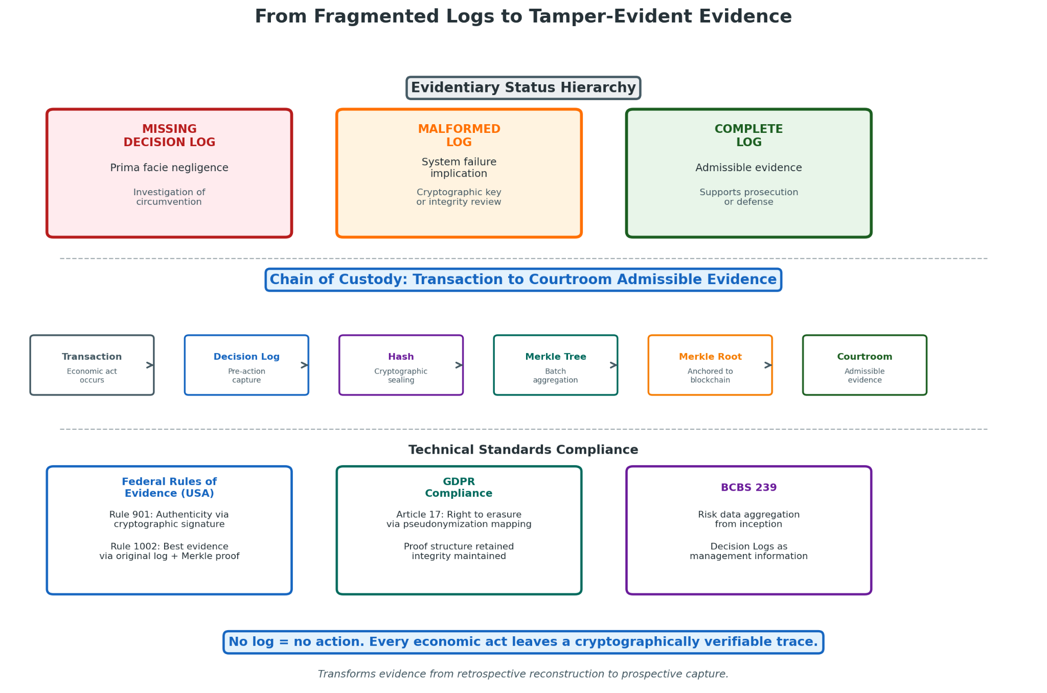
The TL architecture creates a tripartite evidentiary hierarchy that transforms enforcement posture from probabilistic assessment of compliance effort to deterministic evaluation of system output:
Evidentiary Status | Definition | Liability Implication | Enforcement Response
Missing Decision Log | No log generated for executed transaction | Prima facie negligence: system failure or operational negligence; rebuttable presumption of control circumvention | Investigation of technical circumvention or supervisory override failure; institutional and individual liability
Malformed Log | Log fails cryptographic integrity verification; inconsistent timestamps; missing required fields; evidence of post-generation modification | System failure implication: technical root cause analysis; potential insider attack or genuine system stress | Focus on cryptographic key compromise, software defect, hardware failure, or network partition; remediation and potential transaction suspension
Complete Log | Passes all cryptographic integrity verifications; contains all required fields; proper chain of custody through Merkle anchoring | Admissible evidence: satisfies digital evidence standards for regulatory, civil, and criminal proceedings | Foundation for enforcement action defense or prosecution support; enables precise accountability assignment

VII.2 Chain of Custody and Digital Evidence Standards
TL’s architecture addresses chain of custody requirements through technical mechanisms that reduce procedural vulnerability. The cryptographic sealing of Decision Logs at generation creates an evidentiary anchor that subsequent custody transfers cannot compromise without detection. Each custody transfer—log movement to archival storage, auditor access, regulatory production, litigation disclosure—is itself logged with cryptographic attestation, creating an unbroken chain of technical verification.
Digital evidence standards vary across jurisdictions, but TL’s design satisfies common requirements. The Federal Rules of Evidence (USA) authenticity requirement (Rule 901) is satisfied through cryptographic signature verification with timestamp authority attestation. The integrity requirement is satisfied through Merkle-proof verification of inclusion in anchored batches. The best evidence rule (Rule 1002) is satisfied through production of the original log with Merkle proof, not derivative summary.
For international proceedings, TL’s ISO 20022 semantic mapping enables cross-jurisdictional evidence recognition. The structured format of Decision Log payloads, embedded in standard message flows, creates documentary evidence that satisfies civil law and common law requirements without jurisdiction-specific adaptation.

VII.3 Regulatory Investigation Procedures Under TL
Regulatory investigation under TL shifts from document collection and witness examination to technical verification and threshold evaluation:
Phase | Conventional Investigation | TL Investigation
Initial step | Document request and production negotiation | Merkle-root verification: confirming produced logs are included in anchored batches with valid proofs
Authenticity establishment | Witness testimony, chain of custody documentation | Automatic cryptographic verification: hash matching, signature validation, timestamp verification
Substantive review | Sampling-based review of alert files, SAR narratives, email correspondence | Systematic threshold evaluation: whether state determinations satisfied applicable thresholds given captured context
Override examination | Interview-based reconstruction of escalation decisions | Direct log query: who authorized, when, under what authority, with what justification
Cross-institutional analysis | Mutual legal assistance requests, information sharing agreements | Merkle proof verification of cross-institutional log inclusion; ISO 20022 embedded references for transaction chain reconstruction

VII.4 Criminal Prosecution Enhancement Through TL Evidence
TL evidence enhances criminal prosecution through multiple mechanisms:
Enhancement | Mechanism | Legal Significance
Contemporaneous documentation | Pre-action Decision Log generation | Satisfies hearsay exceptions (present sense impression, regularly conducted activity) more reliably than post-hoc reconstruction
Cryptographic integrity | Tamper-evident chaining and anchoring | Eliminates authentication challenges that frequently delay or prevent admission of digital evidence
Mens rea establishment | Structured capture of known, unknown, assumed | Directly addresses knowledge elements of money laundering offenses: knowledge of illicit source, willful blindness to red flags
Due diligence defense | Epistemic Hold documentation | Defendants can invoke proper hold discipline to establish absence of criminal intent; prosecutors can challenge inadequate hold maintenance
Permanent evidence | Merkle-root anchoring | Survives institutional failure or defendant obstruction; enables reconstruction of decision existence and integrity regardless of local record availability

VIII. Case Studies: Simulated Real-World Scenarios

VIII.1 Cross-Border Correspondent Banking Transfer

VIII.1.1 Transaction Structure and Risk Indicators
A corporate customer of a U.S. regional bank initiates a USD 4.7 million wire transfer to a beneficiary account at a correspondent bank in a jurisdiction recently added to FATF’s “grey list” for strategic deficiencies in AML/CFT regimes. Risk indicators include: (1) amount just below the USD 5 million threshold that would trigger enhanced senior approval; (2) beneficiary account opened within 30 days; (3) stated purpose (“consulting services”) lacks specificity and does not match customer’s historical business pattern; (4) correspondent bank relationship involves nested correspondent banking with opacity regarding ultimate beneficiary institution.
Under current AML systems, this transaction would likely execute after routine screening against sanctions lists and basic velocity checks. Risk indicators might trigger enhanced monitoring post-execution, with potential SAR filing within 30 days if subsequent review identifies suspicion.

VIII.1.2 Decision Log Generation and Escalation Path
Under TL, the transaction enters Inference Lane processing at T+0 milliseconds:
Field | Value
Log Header | Transaction ID, timestamp, intent hash
Context Snapshot | Customer risk rating (medium); account history (12 months, 47 transactions, max $890K); geographic risk (elevated due to grey list jurisdiction)
Epistemic State | Known: amount, originator, immediate correspondent; Unknown: ultimate beneficiary institution, beneficial ownership of beneficiary account, substantive purpose verification; Assumed: correspondent bank due diligence adequacy (not verified)
Initial State Determination | 0 (Epistemic Hold)

he Epistemic Hold triggers automatic escalation at T+2ms. Escalation threshold for cross-border correspondent banking with grey list jurisdiction requires: (1) verification of ultimate beneficiary institution through SWIFT gpi or equivalent; (2) purpose documentation with contract or invoice reference; (3) senior compliance officer approval for grey list jurisdiction exposure.
Governance Lane initiates parallel processing: log enrichment with external data queries (beneficial ownership registers, adverse media, sanctions list updates); cryptographic sealing with institutional key; inclusion in rolling Merkle buffer for next batch anchoring.

VIII.1.3 Regulatory Outcome and Forensic Reconstruction
Scenario | Resolution | Regulatory Examination Finding
A: Successful Resolution (+1) | Ultimate beneficiary verified through SWIFT gpi (non-grey list jurisdiction); purpose documentation provided with verifiable contract; senior compliance officer approves after enhanced due diligence; Hold resolves at T+4 hours 23 minutes | Complete log demonstrates appropriate escalation, adequate verification, proper authority approval
B: Failed Resolution (–1) | Ultimate beneficiary opacity persists; purpose documentation inadequate; senior compliance officer refuses approval; State –1 at T+6 hours 17 minutes; transaction blocked, customer relationship review initiated | Complete log demonstrates appropriate risk identification, proper refusal criteria application
C: Override Attempt (Hybrid Shield) | Business line manager requests override citing customer relationship importance; override requires dual senior officer approval, written justification, automatic regulatory notification; override granted at T+2 hours 45 minutes; transaction executes | Override record demonstrates who (officers X and Y), when (timestamp), under which authority (delegation matrix section 4.7), why (customer relationship preservation with revenue projection); subsequent investigation reveals illicit purpose: override officers face personal liability; institution faces enhanced scrutiny for override culture

Forensic reconstruction in all scenarios proceeds from Merkle-root anchoring: transaction existence, decision timing, state transitions, and authority verification are cryptographically provable regardless of institutional record retention practices.

VIII.2 Shell-Company Transaction Chain

VIII.2.1 Entity Layering and Opacity Detection
A series of transactions involves four entities in three jurisdictions: Entity A (BVI holding company) receives USD 2.3M from Entity B (Cyprus investment firm), which received funds from Entity C (UAE free zone company), which received funds from Entity D (individual account at major European bank). Beneficial ownership investigation reveals circular ownership: Entity A’s declared beneficial owner is Entity B; Entity B’s declared beneficial owner is Entity C; Entity C’s declared beneficial owner is Entity D—obscuring ultimate control.
Current AML systems may identify each transaction individually as low-risk based on verified immediate counterparty and apparent business purpose. The layering structure emerges only through cross-institutional analysis that current information sharing mechanisms cannot achieve in relevant timeframes.

VIII.2.2 Decision Log Generation and Escalation Path
TL processing at each node:
Node | Epistemic State | State Determination | Escalation Trigger
D→C | Known: individual identity, account history; Unknown: purpose of transfer to UAE free zone company; Assumed: UAE company legitimacy | 0 | Beneficial ownership verification of Entity C
C→B | Known: Entity C identity, immediate source; Unknown: circular ownership pattern (not visible at single node), purpose of Cyprus investment; Assumed: BVI holding company legitimacy | 0 | Enhanced due diligence for investment firm classification
B→A | Known: Entity B identity, immediate source; Unknown: circular ownership completion, ultimate beneficiary; Assumed: BVI holding company commercial purpose | 0 | Cross-border holding company verification

The critical TL mechanism is the Epistemic Hold at each node based on incomplete beneficial ownership information. No single node can resolve the circularity; each hold generates data requests that propagate through the chain.

VIII.2.3 Regulatory Outcome and Forensic Reconstruction
The circular ownership pattern emerges through cross-institutional data correlation enabled by TL’s evidence architecture. Each node’s Decision Log, with Merkle-root anchoring, enables regulatory authorities to reconstruct the full chain without relying on institutional cooperation that may be delayed or denied.
Outcome | Timing | Consequence
Early Resolution (Pattern Detection) | Regulatory analytics identify circular ownership pattern from anchored Decision Logs within 72 hours | Coordinated hold maintenance prevents fund movement beyond Entity A; investigation proceeds with complete decision context from all nodes
Delayed Resolution (Pattern Miss) | If any node overrides hold without adequate verification, funds move beyond TL-controlled environment | Override record enables liability assignment; forensic reconstruction still possible from anchored proofs, but recovery diminished

VIII.3 Crypto-Fiat Laundering Bridge

VIII.3.1 Hybrid Asset Class Vulnerabilities
A VASP customer deposits 150 BTC (approximately USD 6.2M) from a self-hosted wallet, requests immediate conversion to USD and wire transfer to newly opened account at traditional bank. Risk indicators: (1) large deposit from self-hosted wallet with no transaction history; (2) immediate conversion without market exposure; (3) destination account opened specifically for this receipt; (4) geographic mismatch between customer KYC address and destination bank jurisdiction.
Current VASP AML relies on blockchain analytics (chain tracing, risk scoring) and transaction monitoring rules. The self-hosted wallet source limits chain tracing effectiveness; the immediate conversion may trigger velocity alerts but execution typically proceeds pending review.

VIII.3.2 Decision Log Generation and Escalation Path
TL processing with AI-to-Logic Handoff:
Stage | Processing | Output
Blockchain Analytics Input | ML model generates risk score: 78% probability of illicit source based on: wallet clustering (no exchange association), transaction pattern (single large UTXO, no prior activity), timing correlation with known ransomware payment window | Probabilistic output: 0.78 risk score
TL AI-to-Logic Handoff | Threshold: ≥0.70 triggers Epistemic Hold | State 0 determination
Fast Lane | Log initiation: intent hash of conversion request, context snapshot (customer KYC, wallet address, risk score components), epistemic state (known: deposit confirmed; unknown: wallet history, source of funds; assumed: blockchain analytics model accuracy) | ≤2ms completion
Escalation | Required: enhanced source of funds verification, destination bank notification, 24-hour cooling period | Automatic trigger

The AI-to-Logic Handoff is critical: the 78% risk score does not authorize proceeding with 22% “safety margin”—it mandates uncertainty resolution. The VASP must obtain: wallet transaction history from customer or blockchain analysis; source of funds documentation (mining records, prior exchange statements, inheritance documentation); and purpose of conversion attestation with supporting evidence.

VIII.3.3 Regulatory Outcome and Forensic Reconstruction
Resolution Path | Outcome | Evidence Status
Customer provides documentation: wallet inherited from deceased relative; estate documentation verified; no ransomware connection established | State +1 at T+18 hours; conversion executes with enhanced monitoring; destination bank notified of VASP verification | Complete log enables regulatory verification of due diligence adequacy
Customer cannot provide documentation; refuses cooling period; attempts account closure and withdrawal to alternative VASP | State –1 at T+4 hours; deposit returned to originating wallet (minus network fees); SAR filed; customer relationship terminated; information shared through VASP network | Refusal documentation supports regulatory examination; Merkle proof enables cross-VASP verification of handling
Customer provides fraudulent documentation; blockchain analysis (enhanced after Hold trigger) reveals ransomware wallet clustering | State –1 at T+6 hours; law enforcement notification; funds frozen pending investigation; VASP receives regulatory commendation for proactive detection | Complete evidentiary chain supports prosecution; cryptographic integrity prevents defense challenges to documentation authenticity

VIII.4 Red Team Scenario: Hold Flood Attack

VIII.4.1 Adversary Strategy: Ambiguous Transaction Flooding
Adversary Profile | Resource | Objective
State-sponsored actor | Substantial financial resources, technical sophistication, strategic patience | Degrade TL-based AML system effectiveness in target jurisdiction to enable subsequent large-scale laundering operation

Attack Vector: Generation of high volume of transactions designed to trigger Epistemic Hold: (1) incomplete but plausible documentation packages; (2) counterparty structures with verifiable surface layer and opaque beneficial ownership; (3) jurisdictional combinations requiring enhanced due diligence; (4) velocity patterns at anomaly detection threshold. Individual transactions are not clearly illicit—designed to occupy hold resolution capacity without definitive refusal basis.
Scale: 10,000 daily transactions, each requiring 4-24 hour hold resolution, targeting 80% of available analyst capacity.

VIII.4.2 Automated Escalation Response
Phase | System Response | Mechanism
Hour 1-4 | Standard hold processing; analysts resolve routine cases; attack transactions distributed across queue | Baseline capacity allocation
Hour 4-8 | Queue depth threshold exceeded; automatic escalation to “enhanced automation” mode: ML models with higher confidence thresholds authorized for autonomous resolution; documentation requirements relaxed for low-value, low-risk pattern holds; supervisory notification of elevated volume | Dynamic threshold adjustment
Hour 8-24 | Sustained elevated volume; pattern recognition identifies commonality: shared documentation preparation style, common intermediary entities, coordinated timing; attack classification probability: 85%; automatic response: (1) hold duration extended for attack-classified transactions (reducing re-queueing), (2) regulatory notification with pattern evidence, (3) cross-institutional information sharing initiated | Adversarial pattern detection
Hour 24-72 | Regulatory coordination; shared pattern analysis across TL-implementing institutions confirms coordinated attack; source funding traced to identified state actor; diplomatic and financial countermeasures initiated | Collective defense activation

VIII.4.3 Dynamic Evidence Threshold Adjustment
Phase | Standard Threshold | Attack-Adjusted Threshold | Rationale
Documentation completeness | 95% fields complete | 98% fields complete + cross-validation | Reduce false negative from fabricated documentation
Beneficial ownership verification | 25% threshold, 2 levels deep | 10% threshold, 4 levels deep + source verification | Penetrate layered opacity structures
Velocity anomaly | 2σ from baseline | 1.5σ from baseline + pattern correlation | Detect distributed structuring
Jurisdictional risk | FATF list | FATF list + extended monitoring list + correlation analysis | Expand risk coverage

Threshold adjustment is automatic based on system load and pattern indicators, with regulatory notification and duration limits to prevent permanent threshold creep.

VIII.4.4 Denial-of-Service Mitigation Without Governance Weakening
Critical resilience principle: attack response must not degrade TL’s core governance invariants. Specific protections:

Protection | Mechanism | Governance Preservation
No automatic proceed under load | System fails closed to State 0, not open to +1 | Epistemic Hold integrity maintained
No threshold relaxation for verified risk | Sanctions matches, confirmed prohibitions remain absolute | Refusal state integrity maintained
No override authority expansion | Emergency powers require same multi-party authorization, with enhanced documentation | Hybrid Shield integrity maintained
No logging degradation | All attack-response decisions logged with same cryptographic integrity | Immutable Ledger integrity maintained

The attacker’s objective—degrading governance to enable laundering—is structurally prevented: even successful volume-based degradation only delays resolution, not enables ungoverned execution.

VIII.4.5 Decision Log Generation and Escalation Path
Each attack transaction generates full Decision Log with attack-flag annotation:

Field | Content
Standard fields | Header, intent hash, context snapshot, epistemic state, trigger conditions
Attack flag | Pattern match probability, classification confidence, correlation identifiers
Response mode | Standard processing / enhanced automation / extended hold / regulatory referral
Resolution outcome | Proceed with enhanced monitoring / Refuse with reporting / Hold extended pending pattern analysis

Escalation path: automated pattern detection → supervisory notification → regulatory coordination → cross-institutional analysis → attribution → countermeasure activation.

VIII.4.6 Regulatory Outcome and System Resilience Verification
Metric | Target | Verification Method
Attack transaction proceed rate | <0.1% without human review | Automated log analysis
False refusal rate for legitimate transactions | <5% during attack period | Customer complaint and appeal analysis
Mean time to attack detection | <24 hours | Regulatory examination of pattern recognition logs
Mean time to regulatory notification | <4 hours from detection | Timestamp verification in Decision Logs
System availability for non-attack transactions | >99.9% | Operational monitoring of Fast Lane performance

Post-attack resilience verification: regulatory stress testing with simulated attack scenarios; third-party penetration testing of threshold adjustment mechanisms; cryptographic audit of all attack-period Decision Logs for governance invariant violations.

IX. Strategic Recommendations

IX.1 For Regulators and AML Authorities
Priority | Recommendation | Implementation Timeline
1. Mandate pre-action logging | Require Decision Log generation before transaction execution as condition of operating authorization | 12-18 months for rulemaking; 24-36 months for compliance
2. Specify epistemic hold standards | Define minimum hold triggers, maximum durations, and escalation requirements for high-risk transaction categories | 6-12 months for guidance development
3. Establish cryptographic evidence standards | Adopt Merkle-root anchoring and proof verification as admissibility requirements for AML enforcement proceedings | 12-24 months for technical standards; ongoing for judicial recognition
4. Create TL compliance certification | Develop third-party audit and certification framework for TL implementation adequacy | 18-24 months for program establishment
5. Coordinate international interoperability | Lead ISO 20022 extension development for cross-border TL evidence exchange | 24-36 months for standard adoption

IX.2 For Banks and Financial Institutions
Priority | Recommendation | Resource Implications
1. Pilot TL in high-risk corridors | Implement Epistemic Hold and Decision Logging for correspondent banking and high-value payments before enterprise-wide deployment | $5-15M pilot investment; 12-18 month timeline
2. Re-architect monitoring systems | Replace binary alert-to-SAR workflows with triadic state machines; integrate AI-to-Logic Handoff for ML model governance | $20-50M system investment; 24-36 month implementation
3. Build cryptographic infrastructure | Deploy HSM-based key management, Merkle tree construction, and blockchain anchoring capabilities | $10-30M infrastructure investment; 12-18 month deployment
4. Retrain compliance personnel | Shift analyst role from alert clearance to hold resolution; develop expertise in epistemic uncertainty management | $5-10M training investment; ongoing organizational change
5. Engage regulatory early | Proactive TL implementation discussion with supervisors; seek guidance on threshold calibration and examination expectations | Relationship investment; potential first-mover advantage

IX.3 For Payment Networks
Priority | Recommendation | Competitive Consideration
1. Embed TL in network protocols | Integrate Decision Log references and state determination into core message formats | First-mover advantage in regulatory-preferred network status
2. Offer tiered latency services | Develop product differentiation based on hold probability and resolution speed | Market segmentation opportunity; premium pricing for low-hold routing
3. Build cross-network evidence exchange | Develop interoperability protocols for TL evidence sharing among competing networks | Collective security benefit; potential antitrust scrutiny
4. Deploy deferred anchoring at scale | Implement time-bounded evidence debt management for peak volume absorption | Operational necessity for high-volume networks

IX.4 For Crypto Exchanges
Priority | Recommendation | Regulatory Risk Mitigation
1. Implement AI-to-Logic Handoff immediately | Mandatory State 0 for all ML model outputs above uncertainty threshold | Addresses core vulnerability in current crypto AML enforcement
2. Anchor to multiple blockchains | Distribute Merkle-root anchoring across public chains for censorship resistance | Mitigates jurisdictional seizure risk
3. Develop VASP-to-VASP TL protocols | Standardize hold notification and resolution request formats across exchanges | Enables collective defense against laundering velocity
4. Proactive regulatory engagement | Seek no-action letters or guidance for TL implementation; position as compliance leader | Reduces enforcement probability; potential regulatory preference

IX.5 For Auditors and Compliance Officers
Priority | Recommendation | Professional Development
1. Develop TL audit expertise | Build capability in cryptographic verification, Merkle proof validation, and state machine examination | New practice area; premium service opportunity
2. Create TL examination programs | Design risk-based audit approaches that leverage TL’s inherent verification capabilities | Efficiency gain from automated evidence integrity
3. Advocate for TL standards | Participate in professional body standard-setting for TL implementation and assurance | Influence regulatory and market development
4. Retrain for advisory role | Shift from compliance testing to TL architecture design and threshold calibration advisory | Higher-value service migration

X. Foundational Origin Note: The Goukassian Vow

X.1 Articulation Context
The Goukassian Vow was articulated by Lev Goukassian during a period of terminal lucidity associated with his stage-4 cancer diagnosis. This moment of absolute clarity produced the triadic ethic that underpins TL’s mechanism.

X.2 The Vow
Pause when truth is uncertain.
Refuse when harm is clear.
Proceed where truth is.

X.3 Manifestation as Action-Level AML Enforcement
The Goukassian Vow manifests in TL’s technical architecture through explicit state transitions and enforcement mechanisms:

Vow Element | TL State | Architectural Implementation
“Pause when truth is uncertain” | 0 Epistemic Hold | Triggered by incomplete provenance, counterparty opacity, jurisdictional risk, or structural anomalies; converts epistemic uncertainty into mandatory operational pause without presuming guilt or requiring definitive risk determination
“Refuse when harm is clear” | –1 Refuse | Triggered by verified sanctions matches, definitive prohibitory signals, or threshold-exceeding risk scores with high confidence; irreversible and auditable with explicit documentation of harm determination
“Proceed where truth is” | +1 Proceed | Permitted only when evidence completeness and consistency checks pass, with all consulted sources returning unambiguous permissive signals; cryptographically bound to evidentiary foundation

The Vow’s triadic structure directly addresses the binary fallacy of current AML systems, which force premature classification into allow/deny when the relevant epistemic state is uncertainty. By making uncertainty a first-class operational state with explicit handling procedures, TL transforms AML from probabilistic gambling into structured governance of economic action under epistemic constraint.

XI. Citations

XI.1 FATF Materials
Financial Action Task Force. International Standards on Combating Money Laundering and the Financing of Terrorism & Proliferation: The FATF Recommendations. FATF, Paris, 2012 (as updated through 2023). https://www.fatf-gafi.org/recommendations.html
Financial Action Task Force. Consolidated FATF Standards. FATF, Paris, 2012. https://www.fatf-gafi.org/publications/fatfrecommendations/documents/consolidated-standards.html
Financial Action Task Force. High-Risk Jurisdictions Subject to a Call for Action and Jurisdictions under Increased Monitoring. FATF Public Statement, October 2023. https://www.fatf-gafi.org/publications/high-risk-and-other-monitored-jurisdictions.html
Financial Action Task Force. Effective Supervision and Enforcement by AML/CFT Supervisors of the Financial Sector and Law Enforcement. FATF Guidance, 2015. https://www.fatf-gafi.org/publications/fatfgeneral/documents/effective-supervision-enforcement.html
Financial Action Task Force. Anti-Money Laundering and Counter-Terrorist Financing Measures: United States Mutual Evaluation Report. FATF, Paris, 2016 (and subsequent updates). https://www.fatf-gafi.org/publications/mutualevaluations/documents/mer-united-states-2016.html
Financial Action Task Force. Guidance for a Risk-Based Approach: The Banking Sector. FATF, Paris, 2014 (as updated). https://www.fatf-gafi.org/publications/fatfgeneral/documents/risk-based-approach-banking-sector.html
Financial Action Task Force. Guidance on Anti-Money Laundering and Terrorist Financing Measures and Financial Inclusion. FATF, Paris, 2013. https://www.fatf-gafi.org/publications/fatfgeneral/documents/financial-inclusion.html
Egmont Group of Financial Intelligence Units. FIU Tools and Resources for Law Enforcement. Egmont Group, 2023. https://egmontgroup.org/en/fiu-tools-and-resources-for-law-enforcement
Financial Action Task Force. Guidance on Asset Recovery and the Role of FIUs. FATF, Paris, 2025. https://www.fatf-gafi.org/publications/fatfgeneral/documents/guidance-asset-recovery.html
Financial Action Task Force. Methodology for Assessing Compliance with the FATF Recommendations and the Effectiveness of AML/CFT Systems. FATF, Paris, 2013 (as updated). https://www.fatf-gafi.org/publications/fatfgeneral/documents/methodology.html
Financial Action Task Force. Interpretive Note to Recommendation 11 (Record Keeping). FATF, Paris, 2012. https://www.fatf-gafi.org/recommendations.html
Financial Action Task Force. Interpretive Note to Recommendation 6 (Targeted Financial Sanctions Related to Terrorism and Terrorist Financing). FATF, Paris, 2012 (as updated). https://www.fatf-gafi.org/recommendations.html
Financial Action Task Force. Best Practices on Beneficial Ownership for Legal Persons. FATF, Paris, 2019. https://www.fatf-gafi.org/publications/fatfgeneral/documents/best-practices-beneficial-ownership-legal-persons.html
Financial Action Task Force. Risk-Based Approach Guidance for the Securities Sector. FATF, Paris, 2018. https://www.fatf-gafi.org/publications/fatfgeneral/documents/risk-based-approach-securities-sector.html
Financial Action Task Force. Second 12-Month Review of the Revised FATF Standards on Virtual Assets and Virtual Asset Service Providers. FATF, Paris, 2024. https://www.fatf-gafi.org/publications/fatfgeneral/documents/12-month-review-vasp.html
Financial Action Task Force. Guidance on Digital Identity. FATF, Paris, 2020. https://www.fatf-gafi.org/publications/fatfgeneral/documents/guidance-digital-identity.html

XI.2 FinCEN Guidance
Financial Crimes Enforcement Network. Suspicious Activity Report (SAR) Statistics. FinCEN, U.S. Department of the Treasury, 2024. https://www.fincen.gov/reports/sar-stats
Financial Crimes Enforcement Network. SAR Review Tool and Quality Guidance. FinCEN, U.S. Department of the Treasury, 2023. https://www.fincen.gov/resources/law-enforcement/sar-review-tool-and-quality-guidance
Financial Crimes Enforcement Network. Guidance on Recognizing Activity That May Be Associated With Terrorism and Terrorist Financing. FinCEN, U.S. Department of the Treasury, 2024. https://www.fincen.gov/resources/statutes-and-regulations/guidance

XI.3 EU AML Regulations
European Banking Authority. Opinion on the Risks of Money Laundering and Terrorist Financing Affecting the EU’s Financial Sector. EBA/Op/2023/02, 2023. https://www.eba.europa.eu/regulation-and-policy/anti-money-laundering-and-countering-financing-terrorism
European Banking Authority. Guidelines on Customer Due Diligence and the Factors Credit and Financial Institutions Should Consider When Assessing the Money Laundering and Terrorist Financing Risk Associated with Individual Business Relationships and Occasional Transactions. EBA/GL/2021/02, 2021. https://www.eba.europa.eu/regulation-and-policy/anti-money-laundering-and-countering-financing-terrorism
European Commission. Report on the Assessment of the Risk of Money Laundering and Terrorist Financing Affecting the Internal Market and Relating to Cross-Border Activities. COM(2022) 642 final, 2022. https://commission.europa.eu/publications/report-assessment-risk-money-laundering-and-terrorist-financing-affecting-internal-market-and-relating-cross-border-activities\_en
European Parliament and Council. Regulation (EU) 2024/1624 of 31 May 2024 on the Prevention of the Use of the Financial System for the Purposes of Money Laundering or Terrorist Financing. Official Journal of the European Union, L 1624, 2024. https://eur-lex.europa.eu/legal-content/EN/TXT/?uri=CELEX:32024R1624
European Parliament and Council. Directive (EU) 2018/1673 of 23 October 2018 on Combating Money Laundering by Criminal Law. Official Journal of the European Union, L 284, 2018. https://eur-lex.europa.eu/legal-content/EN/TXT/?uri=CELEX:32018L1673

XI.4 Basel III Documents
Basel Committee on Banking Supervision. Basel III: International Regulatory Framework for Banks. Bank for International Settlements, 2017 (as updated). https://www.bis.org/bcbs/basel3.htm
Basel Committee on Banking Supervision. Guidelines on Sound Management of Risks Related to Money Laundering and Financing of Terrorism. BIS, 2016. https://www.bis.org/bcbs/publ/d353.htm
Basel Committee on Banking Supervision. Principles for Effective Risk Data Aggregation and Risk Reporting. BIS, 2013 (BCBS 239). https://www.bis.org/bcbs/publ/d239.htm

XI.5 Academic Literature on AML Failures
Araujo, M., et al. “Machine Learning for Anti-Money Laundering: A Systematic Review.” ACM Computing Surveys, 55(8), 2023, 1-38.
Chen, X., et al. “Deep Learning for Financial Fraud Detection: A Systematic Review.” IEEE Transactions on Neural Networks and Learning Systems, 34(5), 2023, 1845-1863.
Savage, D., et al. “Fraud Detection on Financial Transactions Using Machine Learning Techniques: A Systematic Literature Review.” Expert Systems with Applications, 182, 2021, 115249.
Gao, S., et al. “Adaptive Money Laundering Detection: A Hybrid Approach Using Evolutionary Algorithms and Machine Learning.” Decision Support Systems, 156, 2022, 113715.
Le Khac, N.A., & Kechadi, M.T. “Application of Data Mining in Anti-Money Laundering Detection.” 2010 IEEE International Conference on Data Mining Workshops, 2010, 577-584.
Chen, Z., et al. “Machine Learning Based Anti-Money Laundering: A Systematic Review.” Information Processing & Management, 59(2), 2022, 102844.
Masciandaro, D. “Money Laundering and the International Financial System.” IMF Working Paper, WP/99/80, 1999.
Unger, B., et al. “The Amounts and the Effects of Money Laundering.” Report for the Ministry of Finance, Rotterdam, 2006.
Foley, S., Karlsen, J.R., & Putniņš, T.J. “Sex, Drugs, and Bitcoin: How Much Illegal Activity Is Financed through Cryptocurrencies?” Review of Financial Studies, 32(5), 2019, 1798-1853.
Levi, M., & Reuter, P. “Money Laundering.” Crime and Justice, 34(1), 2006, 289-375.
Reuter, P., & Truman, E.M. Chasing Dirty Money: The Fight Against Money Laundering. Institute for International Economics, Washington, DC, 2004.
KPMG. Global Anti-Money Laundering Survey. KPMG International, 2022.
Deloitte. Anti-Money Laundering Preparedness Survey. Deloitte Touche Tohmatsu Limited, 2023.
PwC. Global Economic Crime and Fraud Survey. PricewaterhouseCoopers, 2024.
Financial Stability Board. Artificial Intelligence and Machine Learning in Financial Services: Market Developments and Financial Stability Implications. FSB, 2017.
Bank of England and FCA. Machine Learning in UK Financial Services. Bank of England, 2019.
European Central Bank. Artificial Intelligence in Finance: A Framework for Assessing Financial Stability Implications. ECB Occasional Paper Series, No. 307, 2023.
LexisNexis Risk Solutions. True Cost of AML Compliance Study. LexisNexis, 2023.
Hasbrouck, J., & Saar, G. “Low-Latency Trading.” Journal of Financial Markets, 16(4), 2013, 646-679.
United Nations Office on Drugs and Crime. Estimating Illicit Financial Flows Resulting from Drug Trafficking and Other Transnational Organized Crimes. UNODC Research Report, 2011.
K2 Integrity. AML Enforcement Trends: First Half 2025. K2 Integrity, July 2025.
Gibson Dunn. 2024 Year-End Sanctions and Anti-Money Laundering Update. Gibson, Dunn & Crutcher LLP, January 2025.
ACAMS. AML Transaction Monitoring: Optimizing Alert Quality and Efficiency. Association of Certified Anti-Money Laundering Specialists, 2023.
Fitch Ratings. TD Bank Rating Action Report. Fitch Ratings, October 2024.

XI.6 Ternary Logic Repository Materials
FractonicMind. TernaryLogic: Constitutional Notarized Files and Framework Specification. GitHub repository, https://github.com/FractonicMind/TernaryLogic. Accessed 2026-02-09. Contains: TL_Pillars/ (core mechanism specifications); Hardware/ (architecture specifications); SmartContracts/ (implementation code); Academic/ (validation frameworks); Memorial/ (succession documentation).
Goukassian, L. The Goukassian Principle as Evidentiary Infrastructure. Documented in FractonicMind/TernaryLogic repository, 2024.
Budish, E., Cramton, P., & Shim, J. “The High-Frequency Trading Arms Race: Frequent Batch Auctions as a Market Design Response.” Quarterly Journal of Economics, 130(4), 2015, 1547-1621.

XI.7 Enforcement Actions and Case Materials (2024-2025)
U.S. Department of Justice. TD Bank Pleads Guilty and Agrees to Pay $3 Billion for Bank Secrecy Act Violations. DOJ Press Release, October 10, 2024. https://www.justice.gov/opa/pr/td-bank-pleads-guilty-and-agrees-pay-3-billion-bank-secrecy-act-violations
U.S. Department of Justice. Binance and CEO Plead Guilty to Federal Charges in $4 Billion Resolution. DOJ Press Release, November 21, 2023. https://www.justice.gov/opa/pr/binance-and-ceo-plead-guilty-federal-charges-4-billion-resolution
U.S. Department of Justice. HSBC Holdings Plc. and HSBC Bank USA N.A. Admit to Anti-Money Laundering and Sanctions Violations, Forfeit $1.256 Billion in Deferred Prosecution Agreement. DOJ Press Release, December 11, 2012. https://www.justice.gov/opa/pr/hsbc-holdings-plc-and-hsbc-bank-usa-na-admit-anti-money-laundering-and-sanctions-violations
Financial Crimes Enforcement Network. Bank Secrecy Act Requirements: Suspicious Activity Report Filing Requirements. 31 CFR 1020.320. https://www.ecfr.gov/current/title-31/subtitle-B/chapter-X/part-1020/subpart-C/section-1020.320
U.S. Department of Justice. Former Binance CEO Changpeng Zhao Sentenced to Prison for Money Laundering Violations. DOJ Press Release, April 30, 2024. https://www.justice.gov/opa/pr/former-binance-ceo-changpeng-zhao-sentenced-prison-money-laundering-violations
Financial Conduct Authority. Enforcement Actions: 2024-2025. FCA, London. https://www.fca.org.uk/publication/corporate/enforcement-annual-performance-accounts.pdf
K2 Integrity. Cryptocurrency AML Enforcement: H1 2025 Report. K2 Integrity, July 2025.
Financial Conduct Authority. NatWest Plc: Final Notice. FCA, December 2021. https://www.fca.org.uk/publication/corporate/natwest-plc-final-notice.pdf
Monetary Authority of Singapore. MAS Imposes Composition Penalties on Nine Financial Institutions for AML/CFT Control Failures. MAS Media Release, July 3, 2025. https://www.mas.gov.sg/news/media-releases/2025/mas-imposes-composition-penalties-on-nine-financial-institutions
U.S. Department of Justice. TD Bank N.A. Plea Agreement. October 9, 2024. https://www.justice.gov/opa/press-release/file/1752386/download
Monetary Authority of Singapore. Enforcement Actions: Credit Suisse AG, Singapore Branch and United Overseas Bank Limited. MAS, July 2025.
Monetary Authority of Singapore. Prohibition Orders Against Former Senior Managers of Blue Ocean Invest Pte. Ltd.. MAS, July 2025.
U.S. Department of Justice. TD Bank Information. October 9, 2024. https://www.justice.gov/opa/press-release/file/1752387/download
FinCEN. Assessment of Civil Money Penalty: TD Bank, N.A.. October 9, 2024. https://www.fincen.gov/sites/default/files/enforcement\_action/2024-10/2024-10-09%20TD%20Bank%20Assessment%20of%20Civil%20Money%20Penalty.pdf
1MDB-Tanore Litigation (U.S. Department of Justice). Civil Forfeiture Complaints. 2016-2020. https://www.justice.gov/opa/investigation-1mdb
U.S. Department of Justice. 1MDB Investigation: Charges and Asset Recovery. DOJ, ongoing. https://www.justice.gov/criminal-fraud/1mdb
Document Control

Element | Specification
Version | 1.0
Date | 2026-02-09
Classification | Unrestricted—Governance Specification
Review Cycle | Annual or upon material regulatory change
Authority | Synthesized from FractonicMind/TernaryLogic repository materials and public regulatory sources

