FAC SIMILE EXAM

(3-a) Model with a class diagram the following software system: Voting System.
The voting system supports voting procedures with answer yes - no. The system should run on a PC and support voting procedures on one site only. The site is characterized by a number of people having the right to vote. Each person is characterized by a code (social security number), name, surname, PIN (Personal Identification Number).
The system should provide the following functions:
- Support voting for a person. The system should control that the person has the right to vote in the site, and has not already voted. Identification of a person shall be done via social security number and PIN.
- Keep track of votes, provide final results of the vote, provide partial results of the vote, provide percentage of people having voted vs. total number of potential voters.

0…1
1…N_Voters
Person (Voter)
+ SSN
+ Name
+ Surname
+ PIN
+ HasVoted
System
+ N_Voters
+ N_Votes
+ N_Yes
+ N_No
Boolean identifyPers (SSN, PIN)
Person search (SSN)
Boolean hasRight (SSN, PIN)
Boolean hasVoted (SSN, PIN)
Void vote()
Int partialResults ()
Int finalResults ()
Int percVoters ()
Int totalVoters ()

Another possible solution can contain the class Vote, but the introduction of this class is quite useless since it can be replaced by attributes in the class System (as effectively done above).

(3-b) Enrich the model of the voting system with use case diagram. At least two actors are envisaged: voter and administrator.
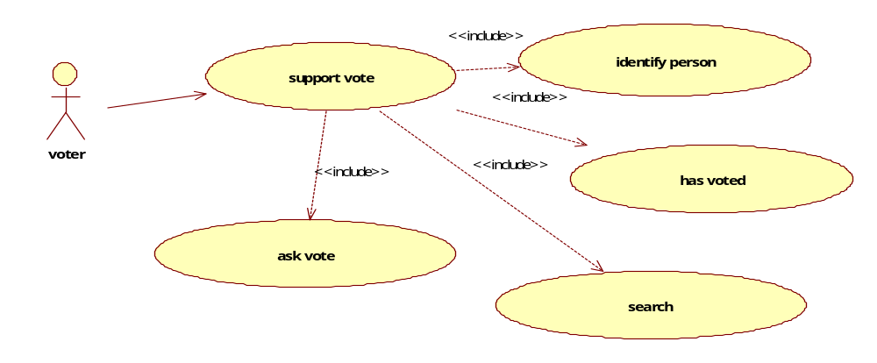
We can avoid putting Support Vote (that is there only for sake of clarity) and so we can connect directly Person to identifyPers… and we avoid using << include >>.

partialResults
percVoters
finalResults
Admin
totalVoters

(3 c) Enrich the model of the voting system with one scenario describing a successful voting procedure.

Scenario name: Successful voting operation
Precondition: person has right to vote and not voted before

Step | Description
1 | Identify person
2 | Search person in list of voters
3 | Check if already voted
4 | Ask vote and record it

Postcondition: Person is tagged ‘hasvoted’

