**How To Make**

First,After installation is complete we need to install the compiler tool chain and make GPL file. Please use root login system

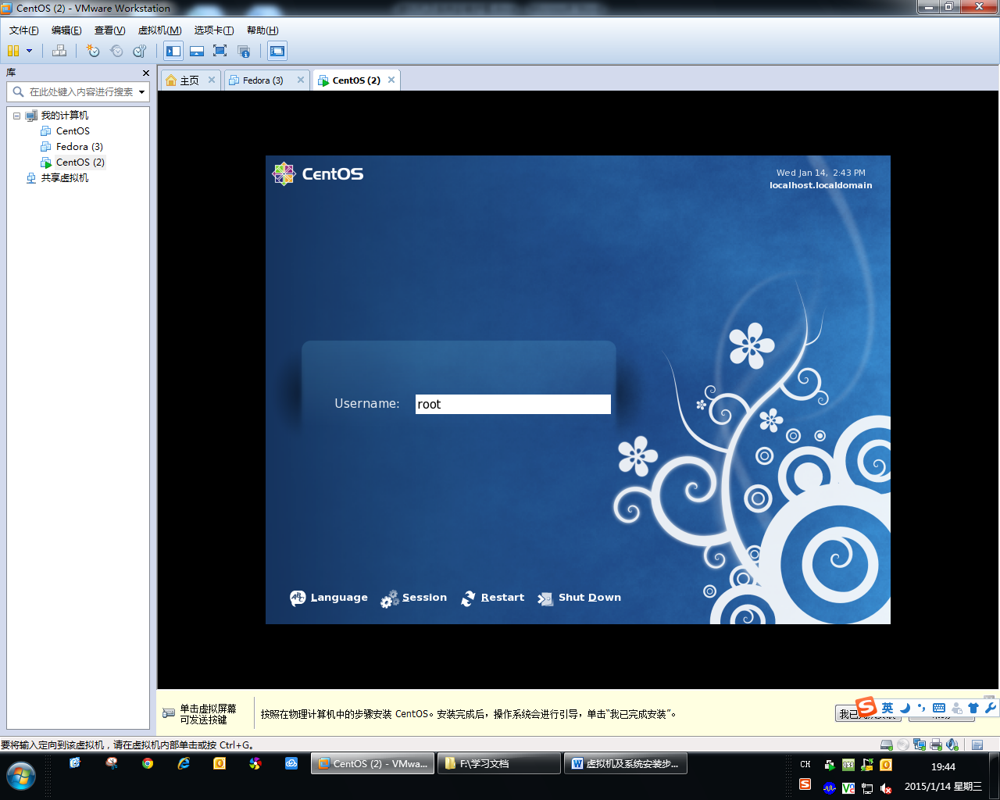

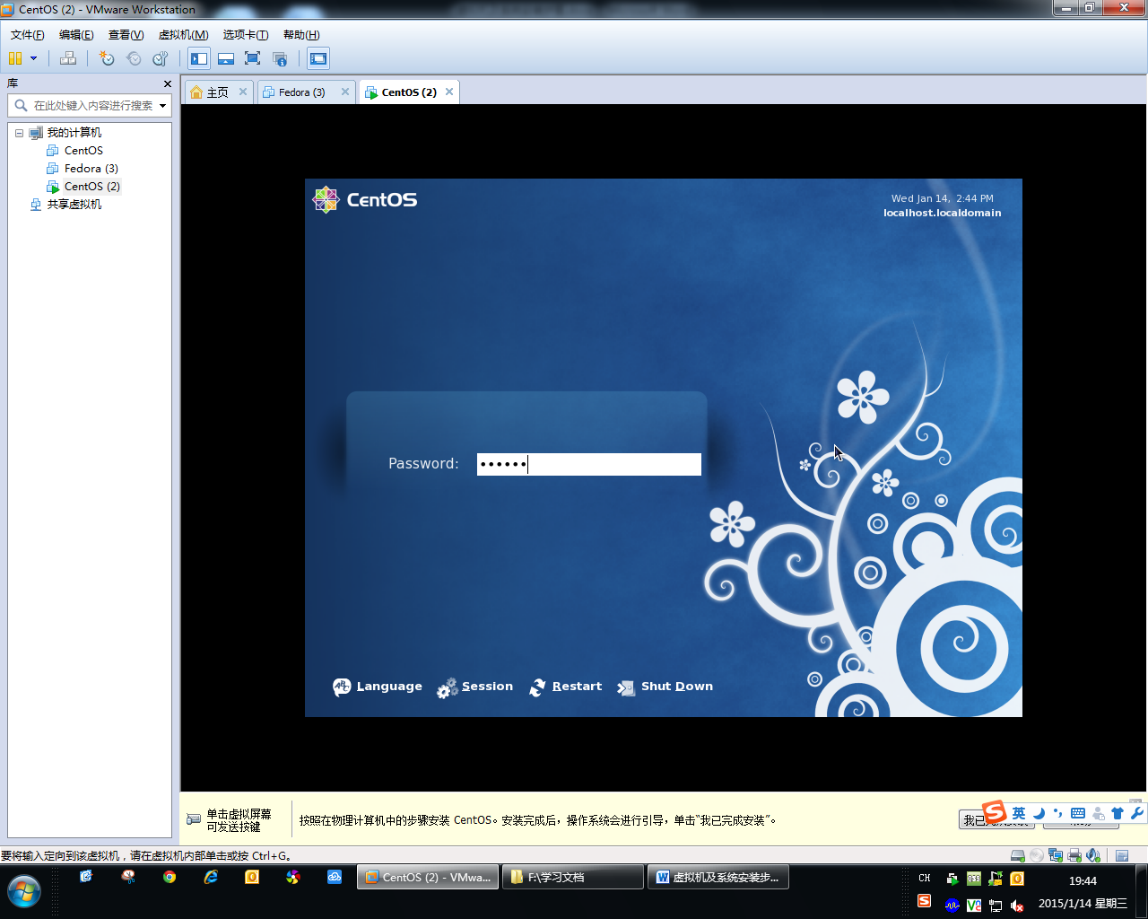

Second, when you logic success, you will see the following screen.

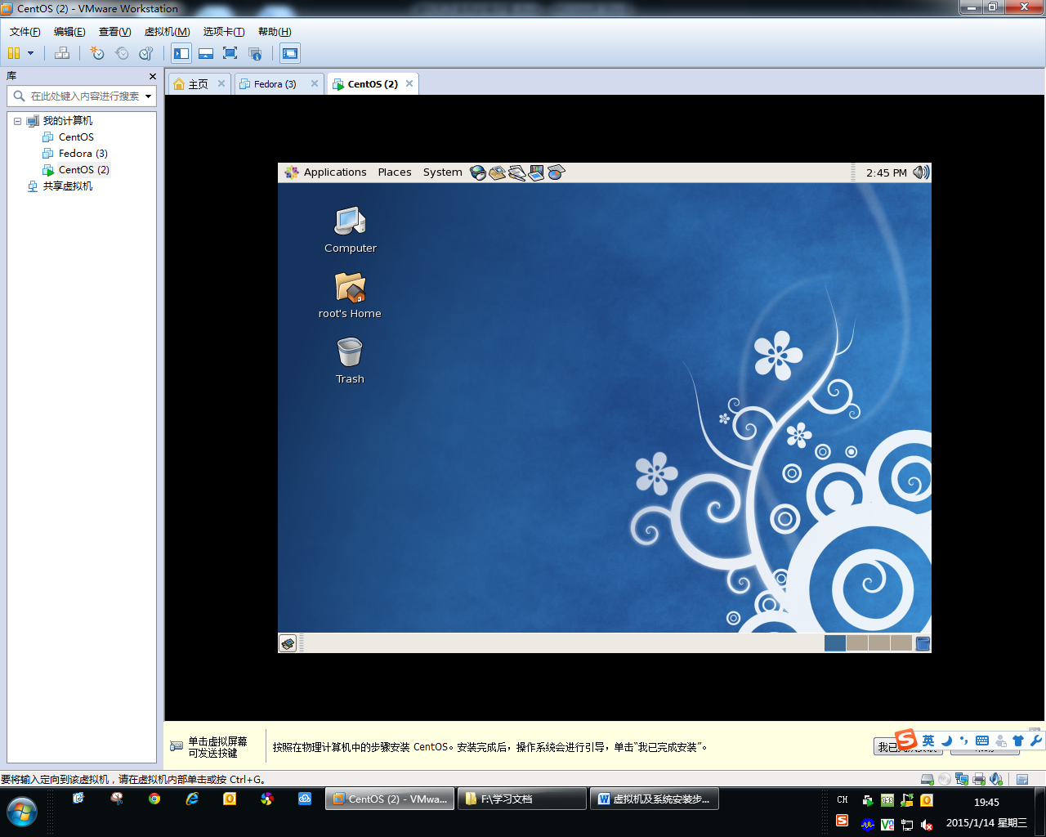

Third, copy the file “rsdk-1.5.6-5281-EB-2.6.30-0.9.30.3-110915.tar.bz2” and “DSL2750U_U1_GPL_ME_1.09_ME.tar.bz2” to the “root’s home” folder from you external device.

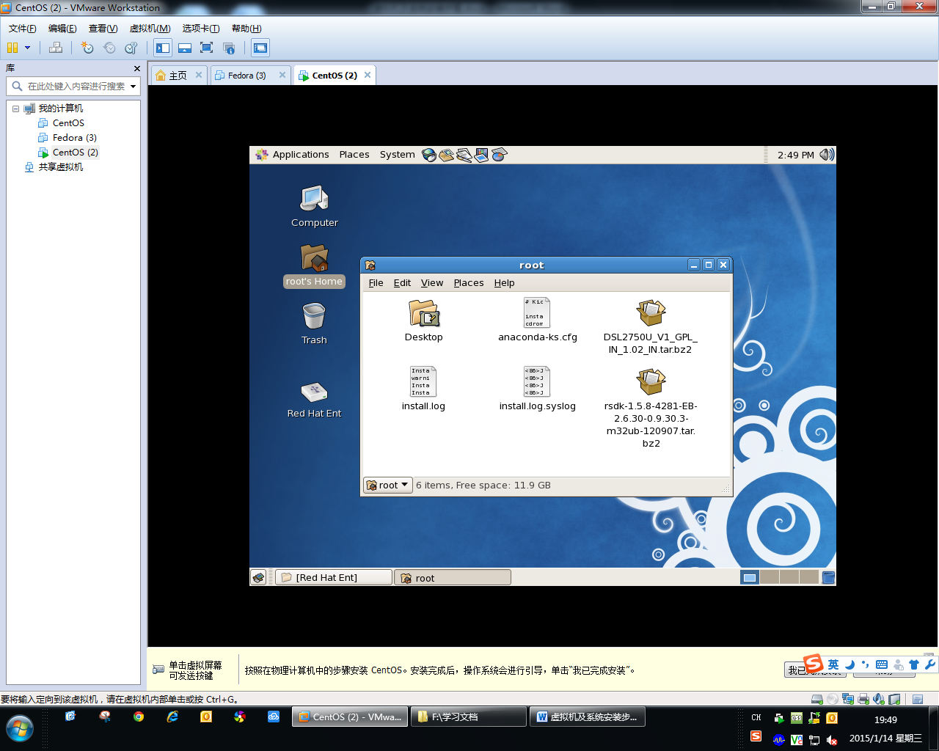

Note1: " rsdk-1.5.8-4281-EB-2.6.30-0.9.30.3-m32ub-120907.tar.bz2" is tool chains tarball, If your product is the other models, please replace it with another tool chains tarball.

example: “rsdk-1.5.6-5281-EB-2.6.30-0.9.30.3-110915.tar.bz2”

Note2: "DSL2750U_V1_GPL_IN_1.02_IN.tar.bz2" is code tarball. If your product is other models, please replace it with another code tarball.

example: “DSL2750U_U1_GPL_ME_1.09_ME.tar.bz2”.

Fourth, Open a terminal, follow these steps.

(1), Create directory “/opt/tbs_toolchains/realtek”.

use command:

*cd /opt/*

*mkdir tbs_toolchains*

*cd tbs_toolchains/*

*mkdir realtek*

*cd realtek/*

(2), copy the “rsdk-1.5.6-5281-EB-2.6.30-0.9.30.3-110915.tar.bz2” to the directory “/opt/tbs_toolchains/realtek”.

use command:

*cp /root/rsdk-1.5.6-5281-EB-2.6.30-0.9.30.3-110915.tar.bz2 /opt/tbs_toolchains/realtek*

(3),untar “rsdk-1.5.6-5281-EB-2.6.30-0.9.30.3-110915.tar.bz2” in the directory “/opt/tbs_toolchains/realtek”.

use command:

*tar -jxf rsdk-1.5.6-5281-EB-2.6.30-0.9.30.3-110915.tar.bz2*

(4), go to directory “/root/” .

use command:

*cd /root/*

(5), untar GPL “DSL2750U_U1_GPL_ME_1.09_ME.tar.bz2”.

use command:

*tar -jxf DSL2750U_U1_GPL_ME_1.09_ME.tar.bz2*

(6), Set execute permissions.

use command:

*chmod 777 DSL2750U_U1_GPL_ME_1.09_ME -R*

(7),go to make directory .

use command:

*cd DSL2750U_U1_GPL_ME_1.09_ME/RTL8676xx/*

(8), make GPL,

use command:

*make autobuild AUTOPRODUCT=DSL2750U*

(DSL2750U is product name, if the product is DSL2730U , you can use the command “make autobuild AUTOPRODUCT=DSL2730U”)

The screenshot below is the complete procedure

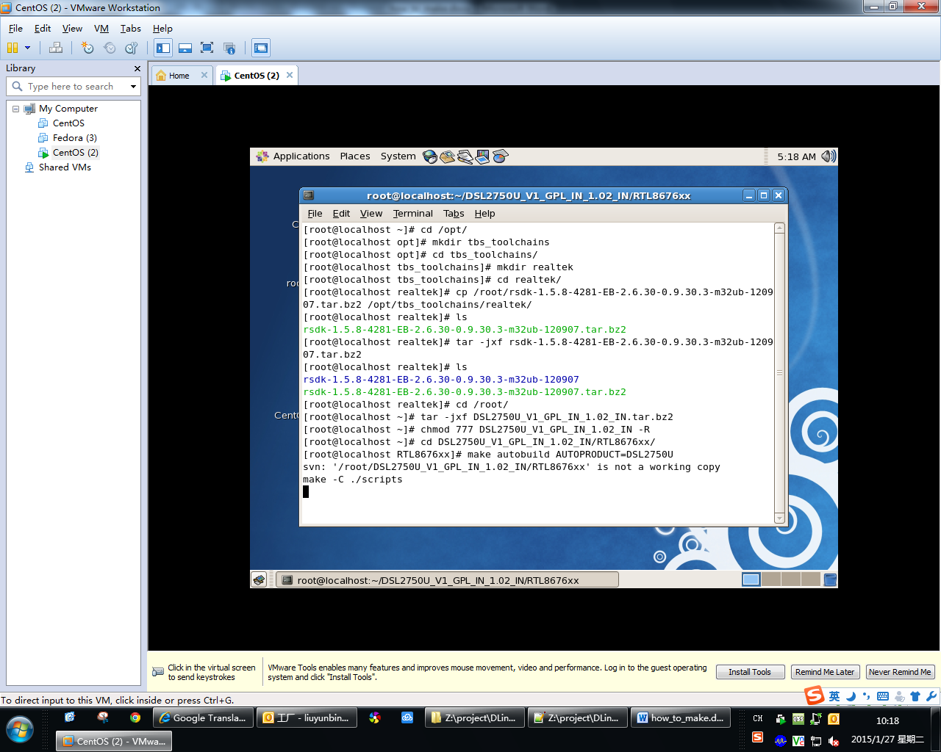

Note1: " rsdk-1.5.8-4281-EB-2.6.30-0.9.30.3-m32ub-120907.tar.bz2" is tool chains tarball, “rsdk-1.5.8-4281-EB-2.6.30-0.9.30.3-m32ub-120907" is a file folder after extracting. If your product is the other models, please replace it with another name.

example: “rsdk-1.5.6-5281-EB-2.6.30-0.9.30.3-110915.tar.bz2” and “rsdk-1.5.6-5281-EB-2.6.30-0.9.30.3-110915”

Note2: "DSL2750U_V1_GPL_IN_1.02_IN.tar.bz2" is code tarball, “DSL2750U_V1_GPL_IN_1.02_IN" is a file folder after extracting. If your product is the other models, please replace it with another name.

example: “DSL2750U_U1_GPL_ME_1.09_ME.tar.bz2” and “DSL2750U_U1_GPL_ME_1.09_ME”

Fifth, Wait compiled. Then go to see “readme” to the next step.