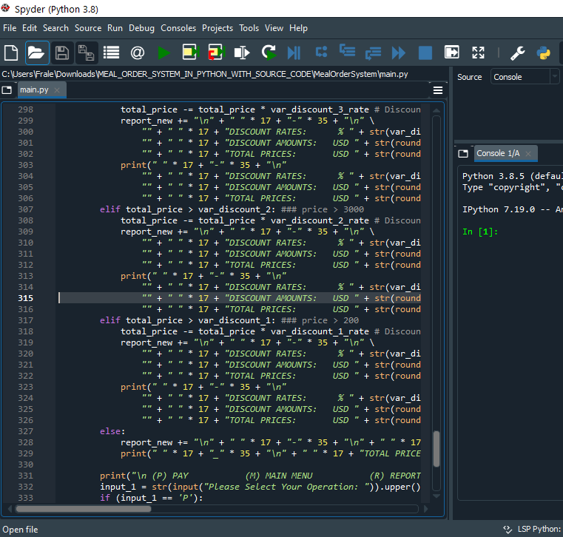

Bringit.Me Report

Capstone

Michael Fraley | Capstone | 1/18/2021

# Deciding on the Logic

When it came to deciding on how this application was going to work wasn’t easy. With the experience I had and the knowledge I had I knew the only way to come at this project was to think hard and dedicate my time to understanding how this works. The great thing about my time on earth, is that I have experienced other forms of this project implemented by multiple companies so I can understand how it works from previous engagements. I knew the only way I can break this down was to put it into steps.

* First, I had to go ahead and understand the variables that I am working with. I noticed that they had no food/clothing/services so I knew I had to go ahead and create my own version of that list that can be easily changed base on the data I had previously. Then I had to go ahead and create discounts that were mentioned in the form given to me.
* Second, I had to understand how to make this item available to different operating systems such as Linux and windows and understand how to make the files readable no matter the type of operating system that it is.
* Third I had to plan out how to create my menu and how to follow through with the payments and how to navigate through the menu flawlessly. The menu has been created to mention Bringit.me in every part of the step so that the people know that they are using bringit.me application. The Menu needed to be separated and organized so through code I was able to put that together so that no matter how that enter it in .fsd file it will organize it without an issue.
* Fourth, Developing a File report. This is the important part so that way we keep track of every time and report of the files that have been created. Every order will be in the report record and when using the datetime import we will be able to see what exactly is going on with our records.
* Finally adding the taxes and discounts to the end is very important so that way we can influence them to spend more money then have to, to help the business in a better way and improve revenue.

## Putting the project together

Finally, we had to put the project together by involving all the steps we have taken into precaution. It is good for me working on the backend because I need to know how this is going to work and then we can make it pretty. After numerous testing and debugging we were able to create a successful project and make it work with a successful report ratio.