# How to Use BOSS:

1. Find out if you are using 32-bit or 64-bit Windows. To find out which one you are running, open the Start Menu, go to the Control Panel, click on the System item, and look at the system type (“64-bit Operating System” or “32-bit Operating System”).

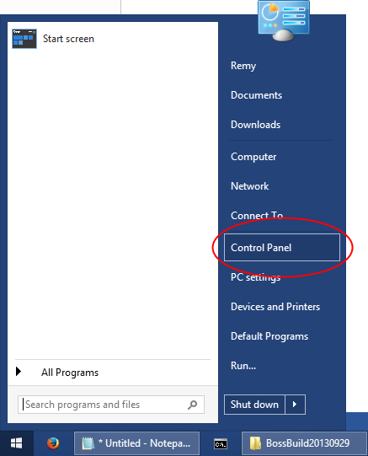

Figure : Open the Start menu and click on the Control Panel.

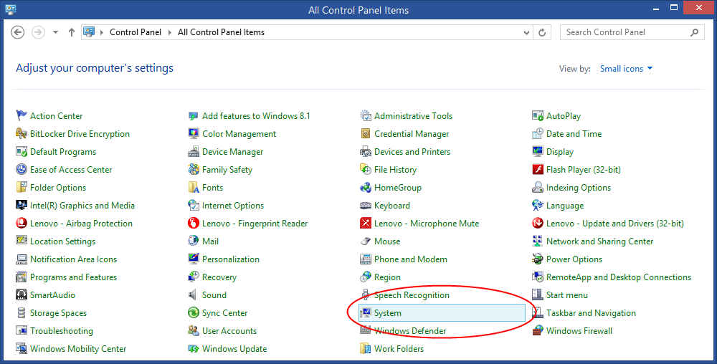

Figure : Click on the System item in the Control Panel.

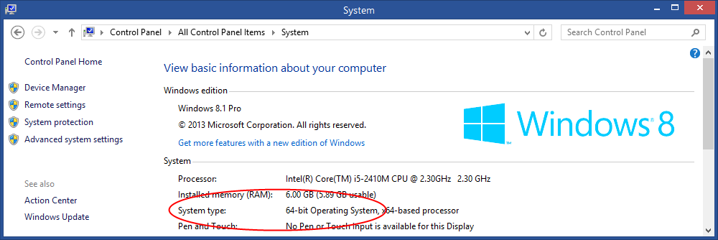

Figure : Look at the system type: 64-bit or 32-bit Operating System.

2. Hold down Shift and right-click the x86 folder if you are using 32-bit Windows, or the x64 folder if you are using 64-bit Windows. Click “Open command window here” on the context menu.

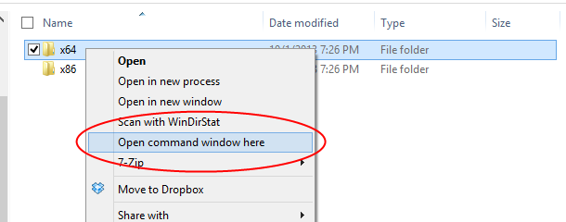

Figure : Hold down Shift and right-click the folder, then click “Open command window here.”

3. Type “dir” in the command window and press Enter to see a list of the files in the directory.

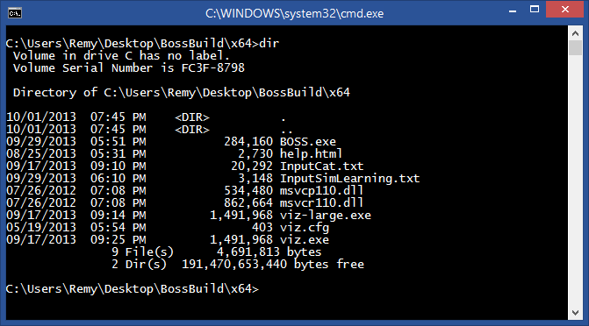

Figure : Type “dir” in the command window.

The files you should see are:

* BOSS.exe: The program file to run BOSS (INIT and RUNSIM).
* InputCat.txt: An input file for BOSS that defines a cat cerebellar model.
* InputSimLearning.txt: An input file for BOSS that defines an artificial model for learning.
* viz.exe: The program file to run Viz (the brain visualizer for BOSS output).
* viz-large.exe: The program file to run Viz with larger text and icons.
* viz.cfg: The configuration file for Viz.
* help.html: The help file for Viz.
* msvcp110.dll: A DLL needed to run BOSS and Viz.
* msvcr110.dll: Another DLL needed to run BOSS and Viz.

4. Type a BOSS command line and press Enter to run BOSS.

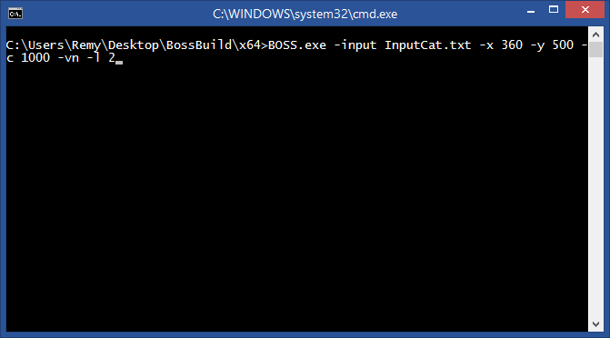

Figure : Type a BOSS command line and press Enter to run BOSS.

Here are some example command lines for BOSS:

* BOSS.exe -help:  
  Show help information for BOSS.
* BOSS.exe -input InputCat.txt -x 360 -y 500 -c 1000 -vn -l 2:  
  Initialize and simulate a 360 µm by 500 µm cat cerebellar model for 1,000 cycles. The “-vn” flag makes BOSS output a model file for Viz to visualize. The “-l 2” flag specifies the logging level.
* BOSS.exe -input InputSimLearning.txt -x 100 -y 100 -c 800 -vn -l 3:  
  Initialize and simulate a 100 µm by 100 µm artificial learning model for 800 cycles. The “-l 3” flag specifies a higher logging level.
* BOSS.exe -input InputCat.txt -x 1000 -y 500 -c 1000 -vn -l 2:  
  Initialize and simulate a 1,000 µm by 500 µm cat cerebellar model for 1,000 cycles.

# How to Use Viz:

1. Double-click on viz.exe or viz-large.exe (if you want larger text and icons) to run Viz. As with BOSS, be sure to use the correct 32-bit or 64-bit version.

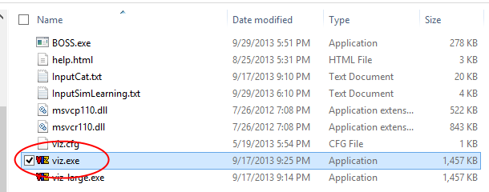

Figure : Double-click viz.exe or viz-large.exe to run Viz.

2. Click the “Open Model” button on the toolbar and pick a model file to open.

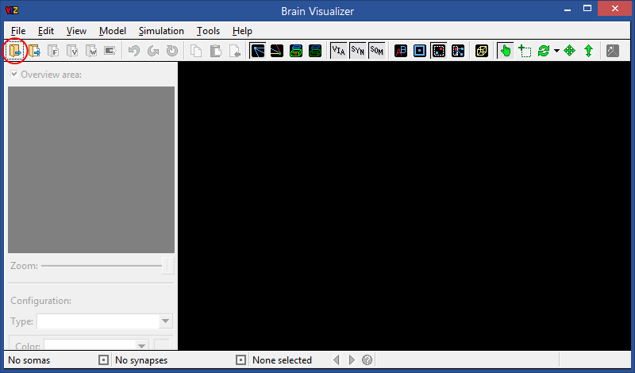

Figure : Click the “Open Model” button and choose a model file to open.

3. Click on some somas of interest to select them, then click the “Report Selected Somas” button on the status bar to create viz_selected_cells.txt. If you run BOSS with this file in the folder, it will output voltage and weight data for the selected somas, as well as their parents and children.

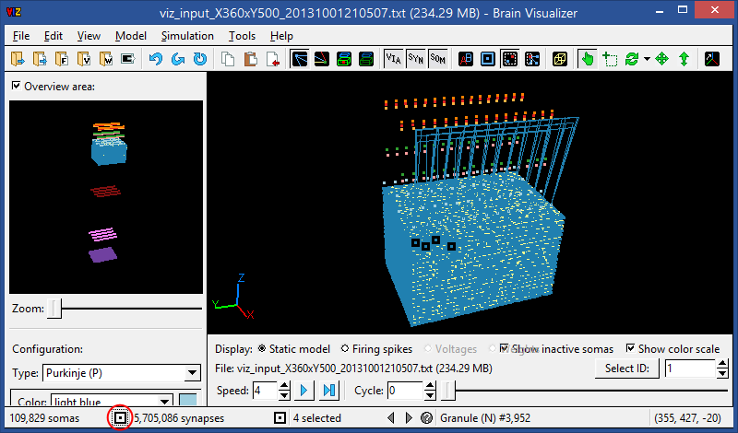

Figure : Click the “Report Selected Somas” button to create viz_selected_cells.txt.

4. Now if you click the “Open and Load All” button to open the new model file, its corresponding firing spike, soma voltage, and synapse weight data files will be loaded at the same time.

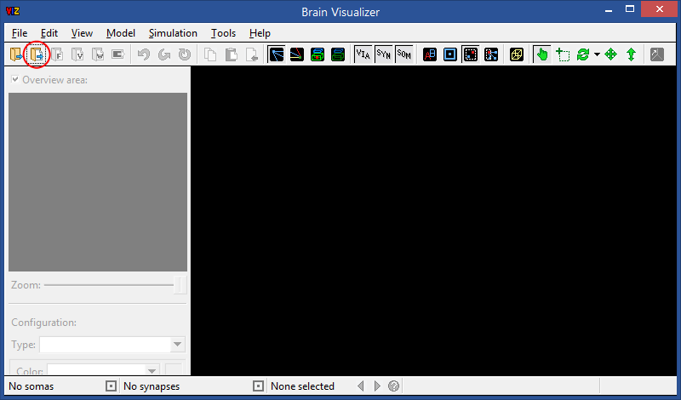

Figure : Click the “Open and Load All” button and choose the new model file to open it and load its corresponding firing, voltage, and weight files.

5. For more help with using Viz, double-click the viz_documentation.pdf file to open and read the complete documentation for Viz.

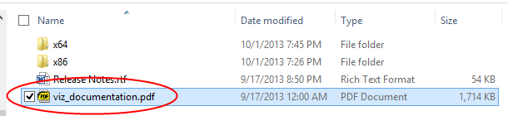

Figure : Double-click viz_documentation.pdf to open the Viz documentation.