**Welcome to the “Runtime Map Maker 3D” .**

**V1.0.0**

Copyright (c) LouYaoMing. All Right Reserved.

Licensed under the MIT License.

“Runtime Map Maker 3D” is a a design tool for generating Map/Level/Puzzle at runtime.

Dependence:

- Extenject Dependency Injection IOC

- JsonDotNet

- TextMesh Pro

- HSVPicker https://github.com/judah4/HSV-Color-Picker-Unity

- RuntimeTransformHandle https://github.com/pshtif/RuntimeTransformHandle

**Thanks to all of you guys.**

Features:

- Snapping from the 3D grid

- Brush placement

- Area Selection

- Move selected

- Brush Deletion

- Area Deletion

- Change Y axis Base

- Save/Load

- Undo/Redo all of action

- Auto generate item preview image

**On editor mode:**

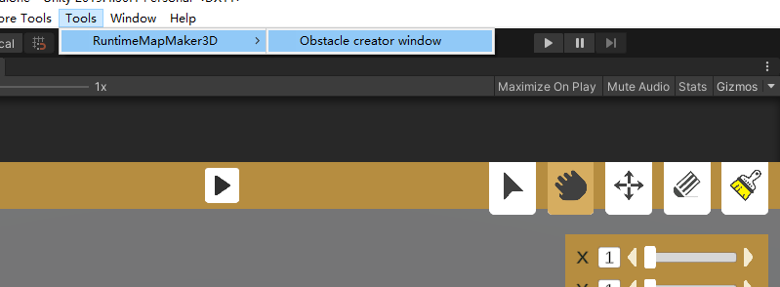

1. Open “Tools/RuntimeMapMaker3D/Obstacle creator window”.
2. Build Asset bundle, at “Obstacle creator window”.
3. Now, you can join it.

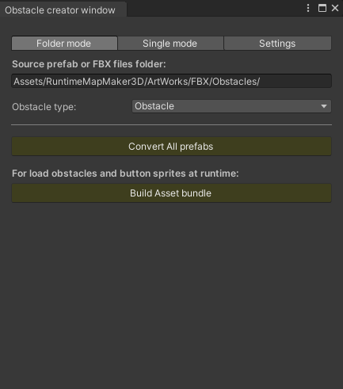

**On play mode:**

- At persistent group panel:

You can save, load, reset, undo, redo your design.

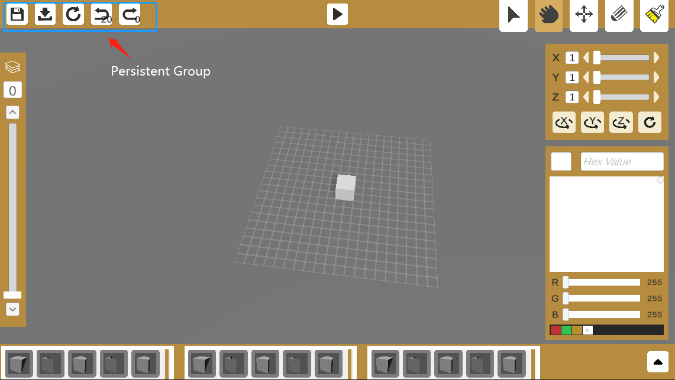

- At tools group panel:

You can Brush/Select/Delete/Move your obstacle

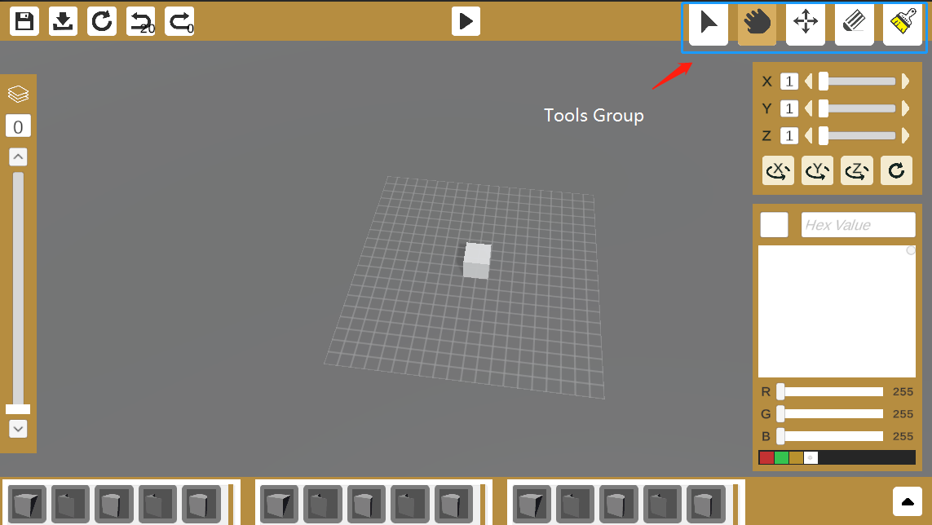

- At obstacle group panel:

You can select different type of obstacle.

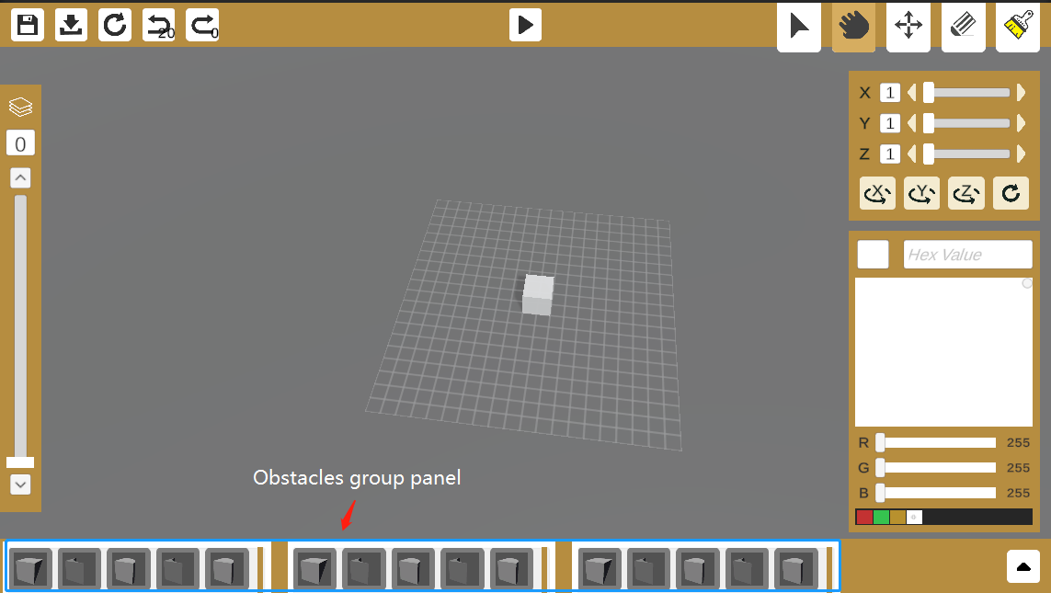

- At layer group panel:

You can brush obstacle at different y axis.

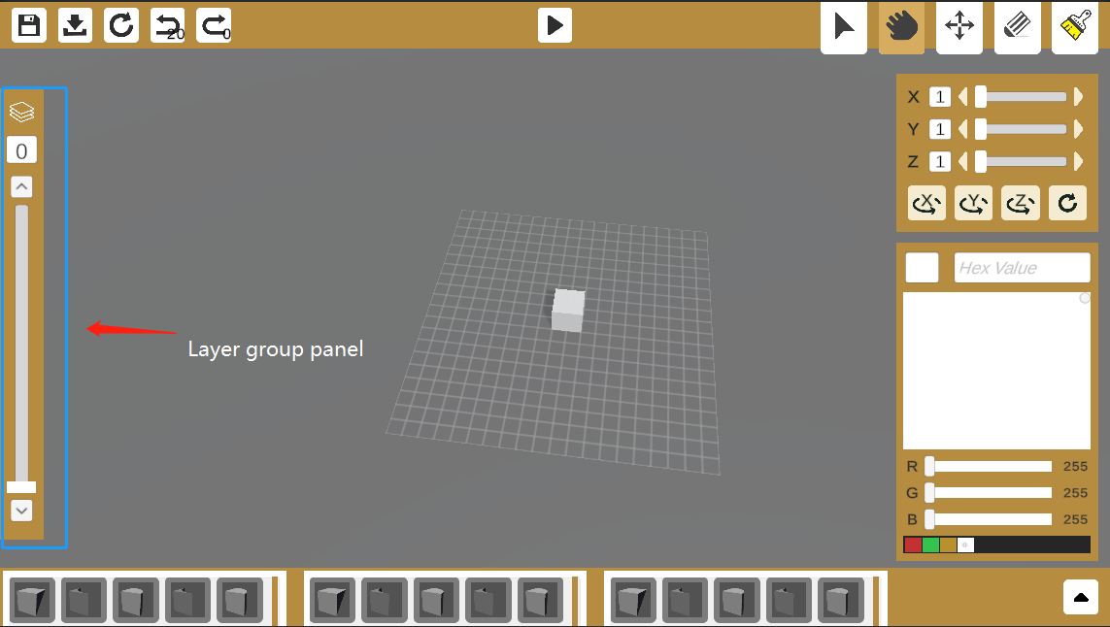

- Handler panel

You can resize handler size, and rotate handler.

