horizontal line

**RIT CROATIA**

Ul. Damira Tomljanovića 15

Zagreb, 10000

01 6439 100

Site Content

**25th February 2021**

**ARCHITECTURAL BLUEPRINT**

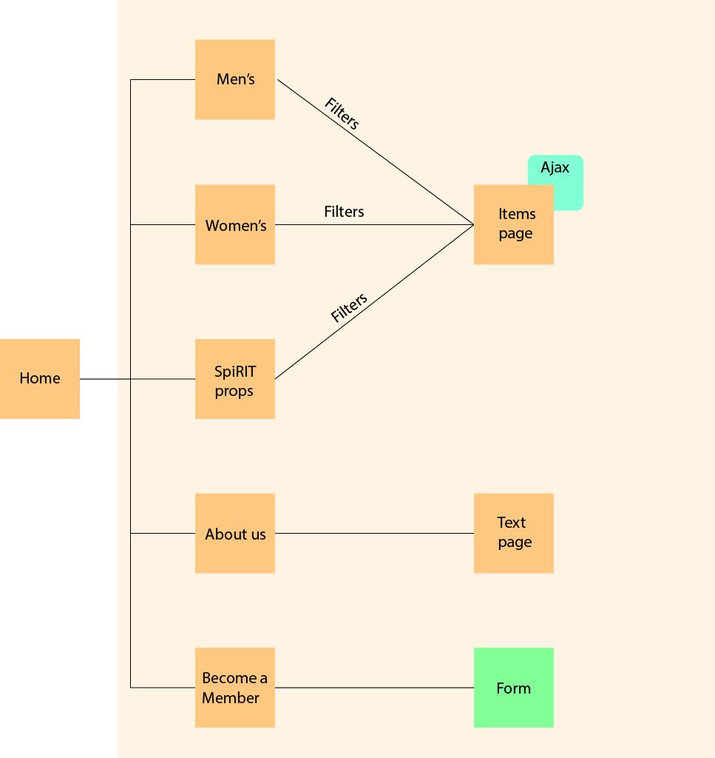

**GLOBAL AND LOCAL NAVIGATION SYSTEMS**

**Global Navigation:**

* Clickable logo which sends the user to the home page
* Main navigation bar
* Local navigation bar (for webshop)
* Cart icon – when clicked shows items that are in the shopper’s cart
* OPTIONAL – Search bar
* Footer with copyright

**Local Navigation:**

* **Men’s:**
  + Hoodies
  + T-shirts
  + Sweatshirts
  + Sweatpants
  + Accessories
* **Women’s:**
  + Hoodies
  + T-shirts
  + Sweatshirts
  + Sweatpants
  + Accessories
* **SpiRIT props:**
  + Flags
  + Bags
  + Hats
  + Mugs
  + Other
* **About us**
  + Text
* **Become a member**
  + Application form