Predicating sales for different departments in a chain of stores

Introduction and Aims
Predicting sales is of upmost importance in the retail industry, not only for predicting profits or potential losses but for planning purposes such as stocking stores, employment of staff. Furthermore the ability to predict future sales enables the company to identify and subsequently create innovative ways of increasing sales.

Data overview

variable description and evaluation
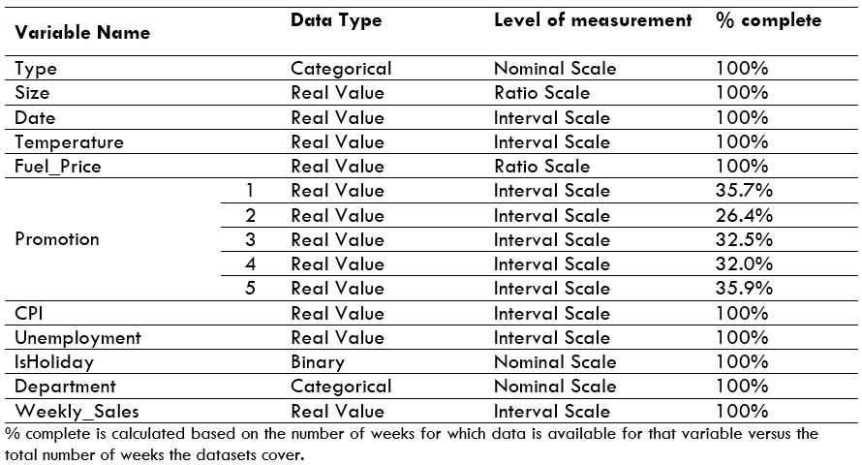
The datasets collectively contains 15 variables which all correspond to the 45 stores for which the sales are to be predicted. These are described in Table _.

From this initial overview we can discount using the promotion variables to predict sales, as not only is at least 64% of the data missing for each promotion. Taking into account there is no data available before November 2011, there is still only between 72% and 98% completeness for each promotion in the period commencing November 2011. Furthermore as the data only ‘mainly’ relates to price reductions but may also relate to other data related to promotions it is not an accurate variable to use, as data collection has not been completed inconsistently. Furthermore it is not known which stores will be running promotions during the future period for which sales are being predicted.

Created variables:
A week_number variable has been created from the date to better compare year on year. Created using the week('date'd, 'w') function in SAS enterprise, to allow easier comparison of week year on year.

Variable Selection
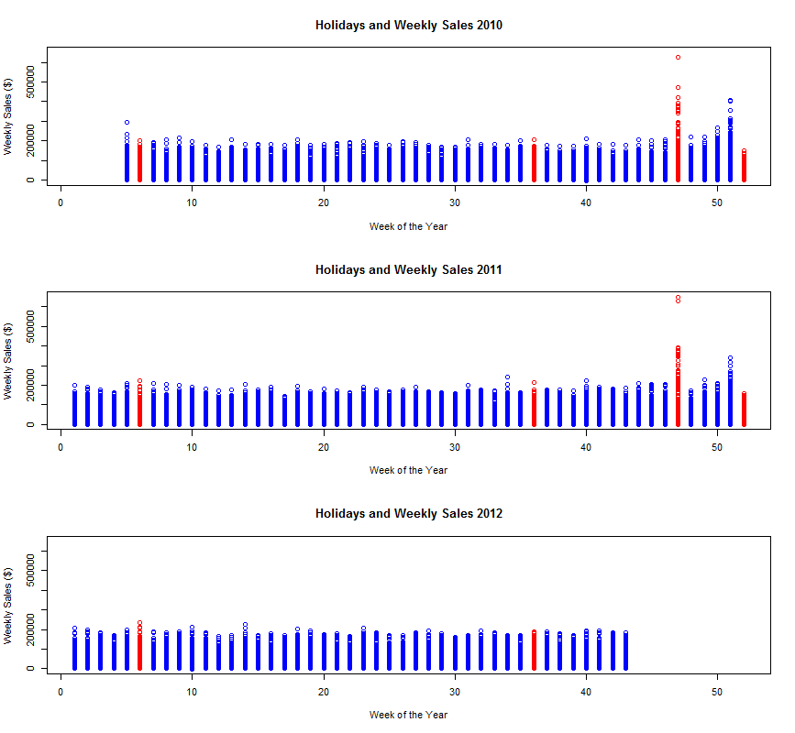
Figure_: Weekly sales for every store by week of the year, with weeks containing the holidays highlighted in red.

With the newly created variable, week number, we can easily compare sales in the same week on different years.
From figure_ the weeks where there are a significant increase in sales which occur during the week of thanksgiving, which is held on the fourth Thursday of November so falls in the 47th of 48th week of the year (Silverman, 2018), and the week before Christmas, usually week 51 but occasionally week 50. Whereas the other holidays seemingly have no or only a very limited effect on sales. Hence ISHoliday alone does not seem a clear indicator of a consistent change in weekly sales. Hence a new variable will be created that takes into account which holiday is in that week and if, to any, influence it has on sales.
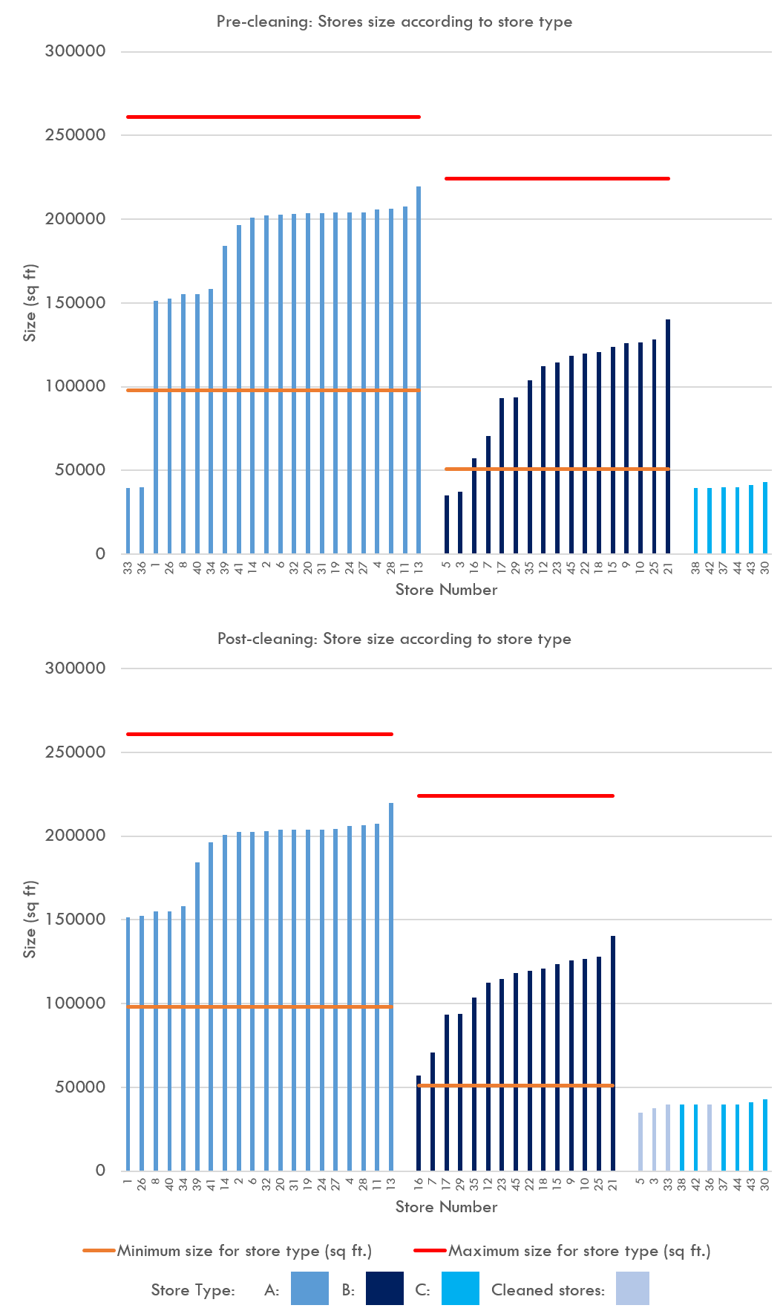
From initial visualization of the stores data set, it seems that some of the store types have been misclassified, as their size does not correlate to the expected size of that Walmart store type. Figure __A illustrates the square footage of each store, as well as which type of store it is for example, Store type A is a supercentre, B is a superstore; also known as a Walmart discount store and Store type C is a supermarket, also called a Walmart neighbourhood market. The minimum size for a Supercentre is 98,000 square feet (USinfo, 2012), hence store 33 and 36 which have a square footage of 39,690 and 39,910 respectively are supermarkets, as they are also too small to be classed as superstores. Similarly stores 3 and 5 have too small a square footage to be classed as supercentres. Therefore these stores can be cleaned so the store types correspond to the size of the store as expected. The cleaned store types are illustrated in figure_B. This is an important cleaning stage as different store types, especially of different sizes are likely to have different weekly sales and be affected by the other variables to different extents. For example you would expect Supercentres to have a higher sales and stock more seasonal goods, therefore have higher sales through the year that are greater affected by the holiday periods than the other store types.
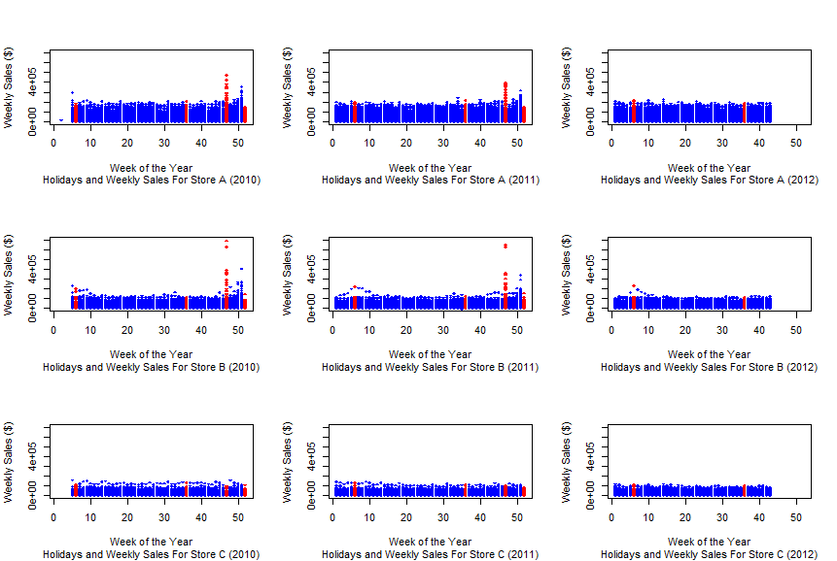
Indeed, from visualisation of weekly sales for each store type, figure __, it is evident that the different store types have different sales patterns and therefore sales may well be affected to different extents by different variables. Hence three separate models will be built for the three different store types as too more accurately predict sales. For example supermarkets, store type C, sales are seemingly not affected by holiday periods, as illustrated in figure __.
TITLE:
Figure__:

Pre-processing of the data

Data linkage
Data was linked using the SAS Enterprise Guide tool. Stores and features data files were linked to the train data set using a left join based on store ID number and date, (JUSTIFY WHY LEFT JOIN). The linkage was checked by ensuring the IsHoliday data from the features file matched the train file, using the following logic expression to fill in an additional column during the data linkage process:
$$(IFN((t1.IsHoliday = t2.IsHoliday), 1, 0, 2))$$
Where “1” is TRUE, “0” is FALSE and “2” indicates missing data.
At the data linkage stage some additional summary columns were also added. The week number, i.e week of the year and the year as . This was done for quicker comparison when predicting sales, as most sales forecasting uses the previous year’s sales at the same point that year’s sales (https://www.thebalance.com/sales-forecasting-2948317 ). Often this is done on a month by month basis, however weeks instead of month have been included as week also gives more detailed information about where the holidays lie.

Summarising and visualising the data

Data reduction and transformation

Data Discretisation and Generalisation

Variable selection

Predictive modelling

Reasoning for model chosen

Process of building the model

Results from the model

Conclusion

Limitations

Future Studies

SILVERMAN, D., J; 2018. Thanksgiving Day. Encyclopædia Britannica. Encyclopædia Britannica, inc.
USINFO. 2012. Walmart [Online]. USNook, . Available: http://www.usnook.com/english/Living/house/malls/2012/1219/18502.html [Accessed 27/02/2017 2018].

