

# Category

Forensics

# Challenge description

I’m so obsessed with Green Day!! I can hear their music the entire day.

# Hints

* {LEVEL 1} Take a look at the package protocol.
* {LEVEL 2} I think you are interested in the files mentioned in the packages. Why don’t you try to export them?
* {LEVEL 3} Have you listened to the songs? I think there’s something weird in one of them…

# Write Up

You need to open the file *capture.pcapng* with Wireshark. There, you will see a lot of lines with FTP and FTP-DATA protocol, where we’re trying to log into an FTP server and we download some files. To obtain the files, we just need to export them in File -> Export Objects -> FTP-DATA.

All the downloaded files will be .mp3. We can listen to all of them (mostly to *flag.mp3* 😉) and we will detect something weird in *wake_me_up_when_september_ends.mp3*. If we check the spectrogram, we will see the flag.

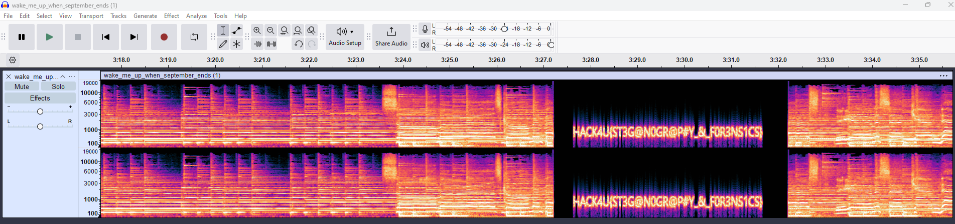

# Flag

HACK4U{ST3G@N0GR@P#Y_&_F0R3NS1CS}