

# Category

Web

# Challenge description

Hasta la vista, baby

# Hints

* {LEVEL 1} Hint 1: You didn't see the movies? Terminator is a **robot**!

# Write Up

In a secure webpage, we need to implement the Robots Exclusion Protocol to indicate to visiting web crawlers and robots with portions they are allowed to visit from the webpage.

To check this info, we left a backdoor to enter there, just by typing into the url */robots.txt*.

This is a very common vulnerability in web pages, letting the users know their configuration related to this standard.

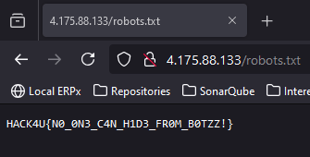

# Flag

HACK4U{N0_0N3_C4N_H1D3_FR0M_B0TZZ!}