

# Category

Web

# Challenge description

We need to access into the admin panel… but I can’t remember the password!! Our super safe web is lost!!

# Hints

* {LEVEL 1} Have you checked the HTML code of the pages?
* {LEVEL 2} The encoding for the cookie looks familiar… Maybe you can decode to check the value?
* {LEVEL 3} I think there’s a way to trick the page with the cookie…

# Write Up

Inside the login page, you can check the HTML code to find the username and password for a regular user.

When you are logged in, you will see in the cookies a new cookie called *login_cookie*. The value of it’s cookie is in *base64*. To decode it, you can use many tools like Cyberchef.

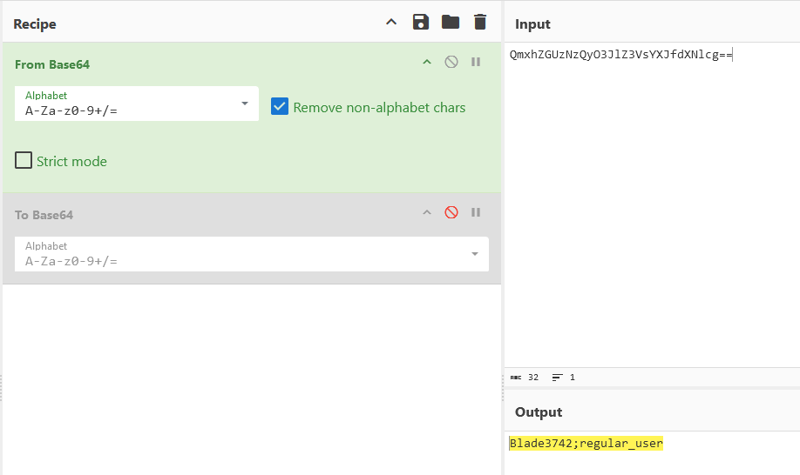

To give the user the access to the Admin Panel, you just need to change the value of the cookie to set him the *admin* role. To do that, we will encode that in *base64* and change the value of *login_cookie*

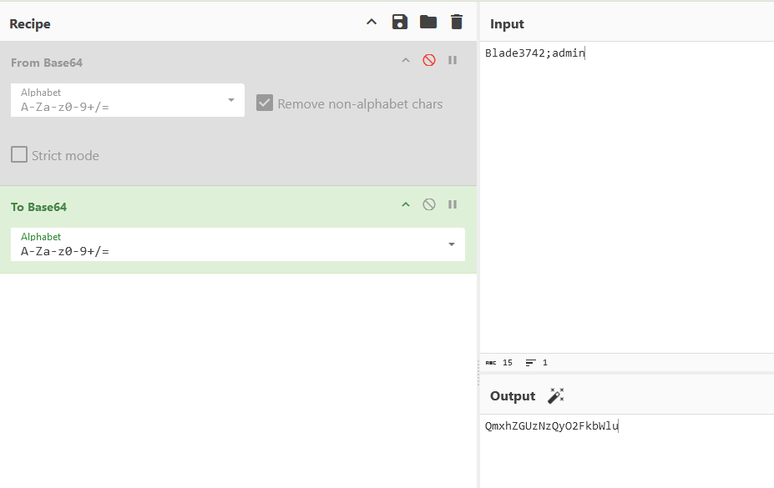

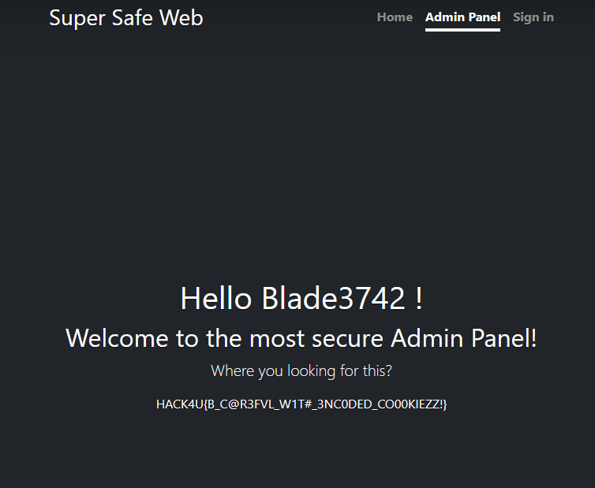

# Flag

HACK4U{B_C@R3FVL_W1T#_3NC0DED_CO00KIEZZ!}