1. What is Frame Synchronization in TDM technique? Why are guard bands used in FDM?
2. What is TDM? What is the difference between Synchronous and Statistical TDM? Which technique is more efficient and why?
3. Eight sources, six with a bit rate of 100kbps and two with a bit rate of 200kbps are to be combined using multilevel TDM with no synchronizing bits. Answer the following questions about the final stage of multiplexing:
4. How many channels we have now?
5. What is the size of a frame in bits?
6. What is frame rate?
7. What is the duration of a frame?
8. What is the data rate?
9. Between twisted pair and coaxial cable which is better in terms of speed and range coverage? Why are the wires in a twisted pair cable not kept in parallel?
10. Assume there are 3 voice channels, each occupying a bandwidth of 32 kHz. These 3 voice channels need to be combined into a link with a minimum bandwidth of 136 kHz, from 160 to 296 kHz. There are guard bands of 20 kHz between the channels to prevent interference. Show the configuration using the frequency domain.
11. Find the digital data from the given analog signal using Delta Modulation (DM) technique.

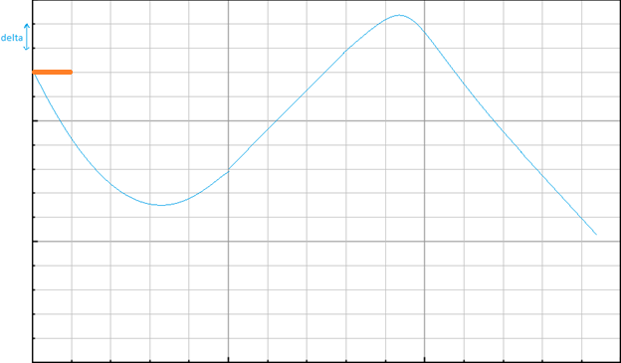

1. Suppose you want to transmit the message 11011011 and protect it from errors using the CRC generator polynomial x3 + 1. Using binary division, show the message that should be transmitted.

Later, corrupt the left-most third bit of the transmitted message and show that the error is detected by the receiver using CRC technique.

1. Classify the medium access protocols which are collision-free. Why the efficiency of pure ALOHA is half of slotted ALOHA technique?