**Password Checker - Testing Documentation**

**TEST DATA #1**

Not accepting password less than 6 characters “**pw123**”.

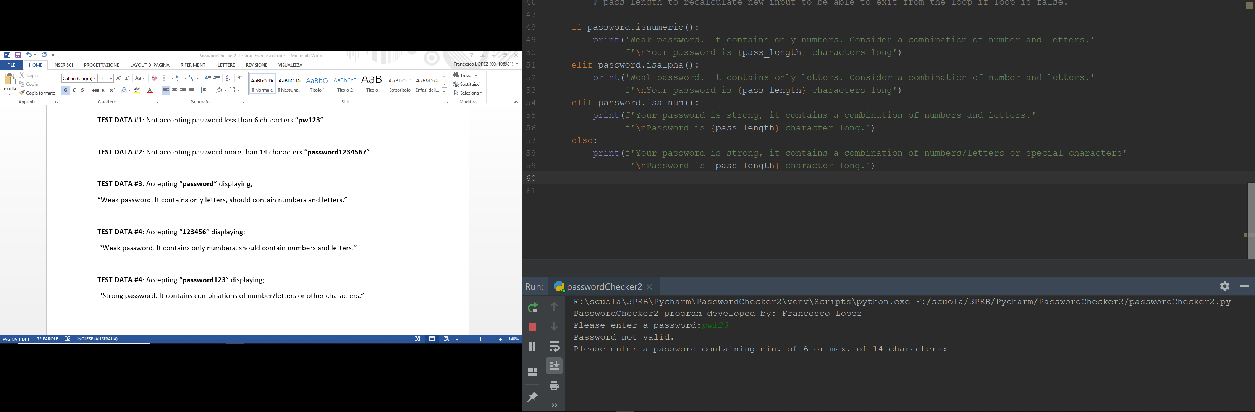

**TEST DATA #2**:

Not accepting password more than 14 characters “**password1234567**”.

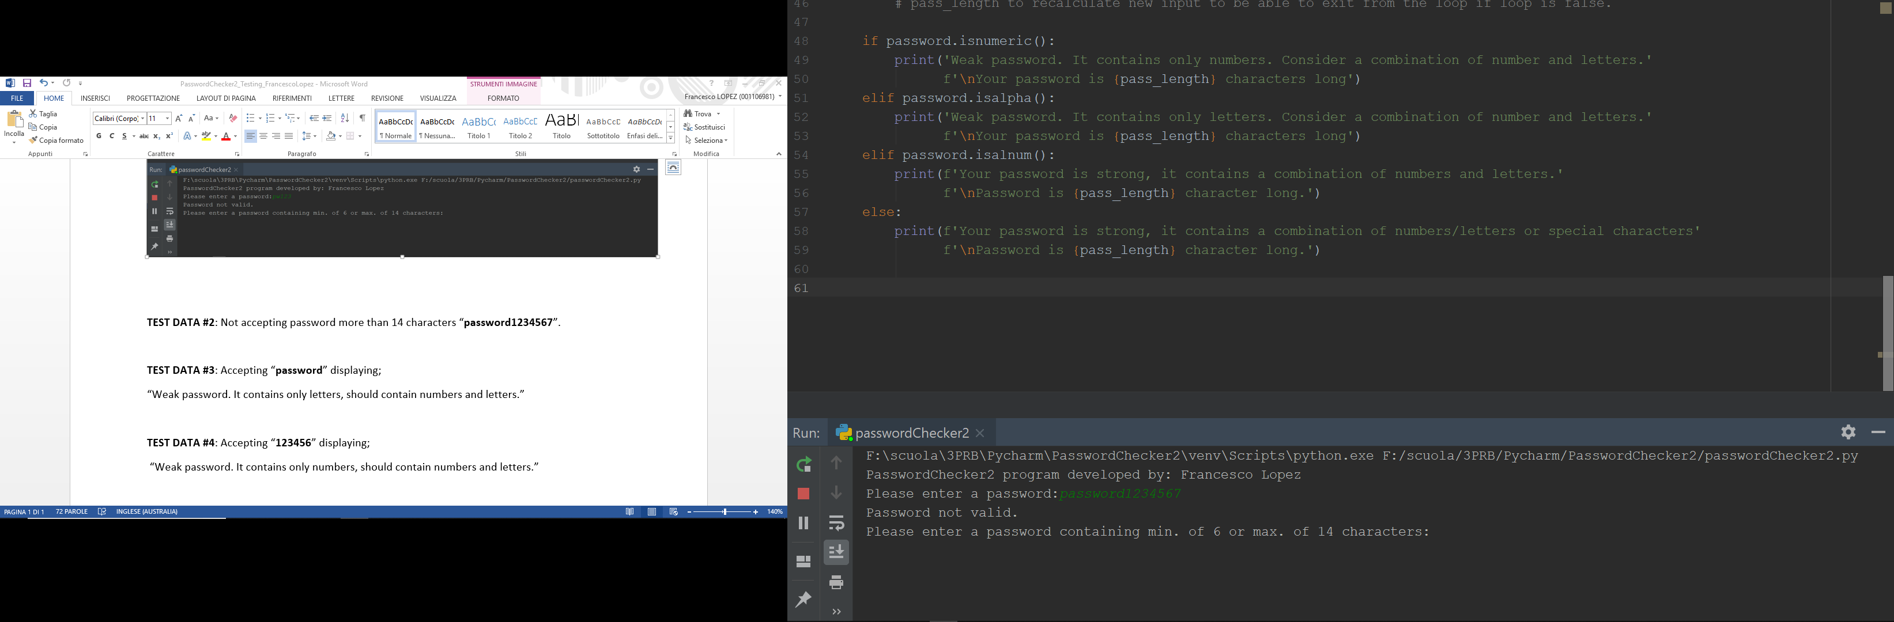

**TEST DATA #3**:

Accepting “**password**” displaying;

“Weak password. It contains only letters, should contain numbers and letters.”

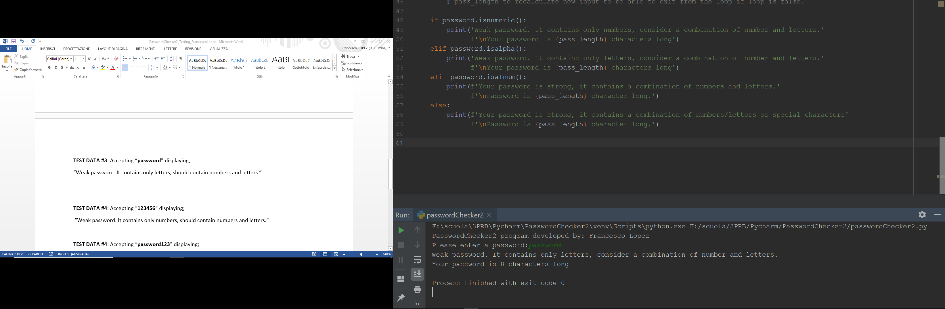

**TEST DATA #4**:

Accepting “**123456**” displaying;

“Weak password. It contains only numbers, should contain numbers and letters.”

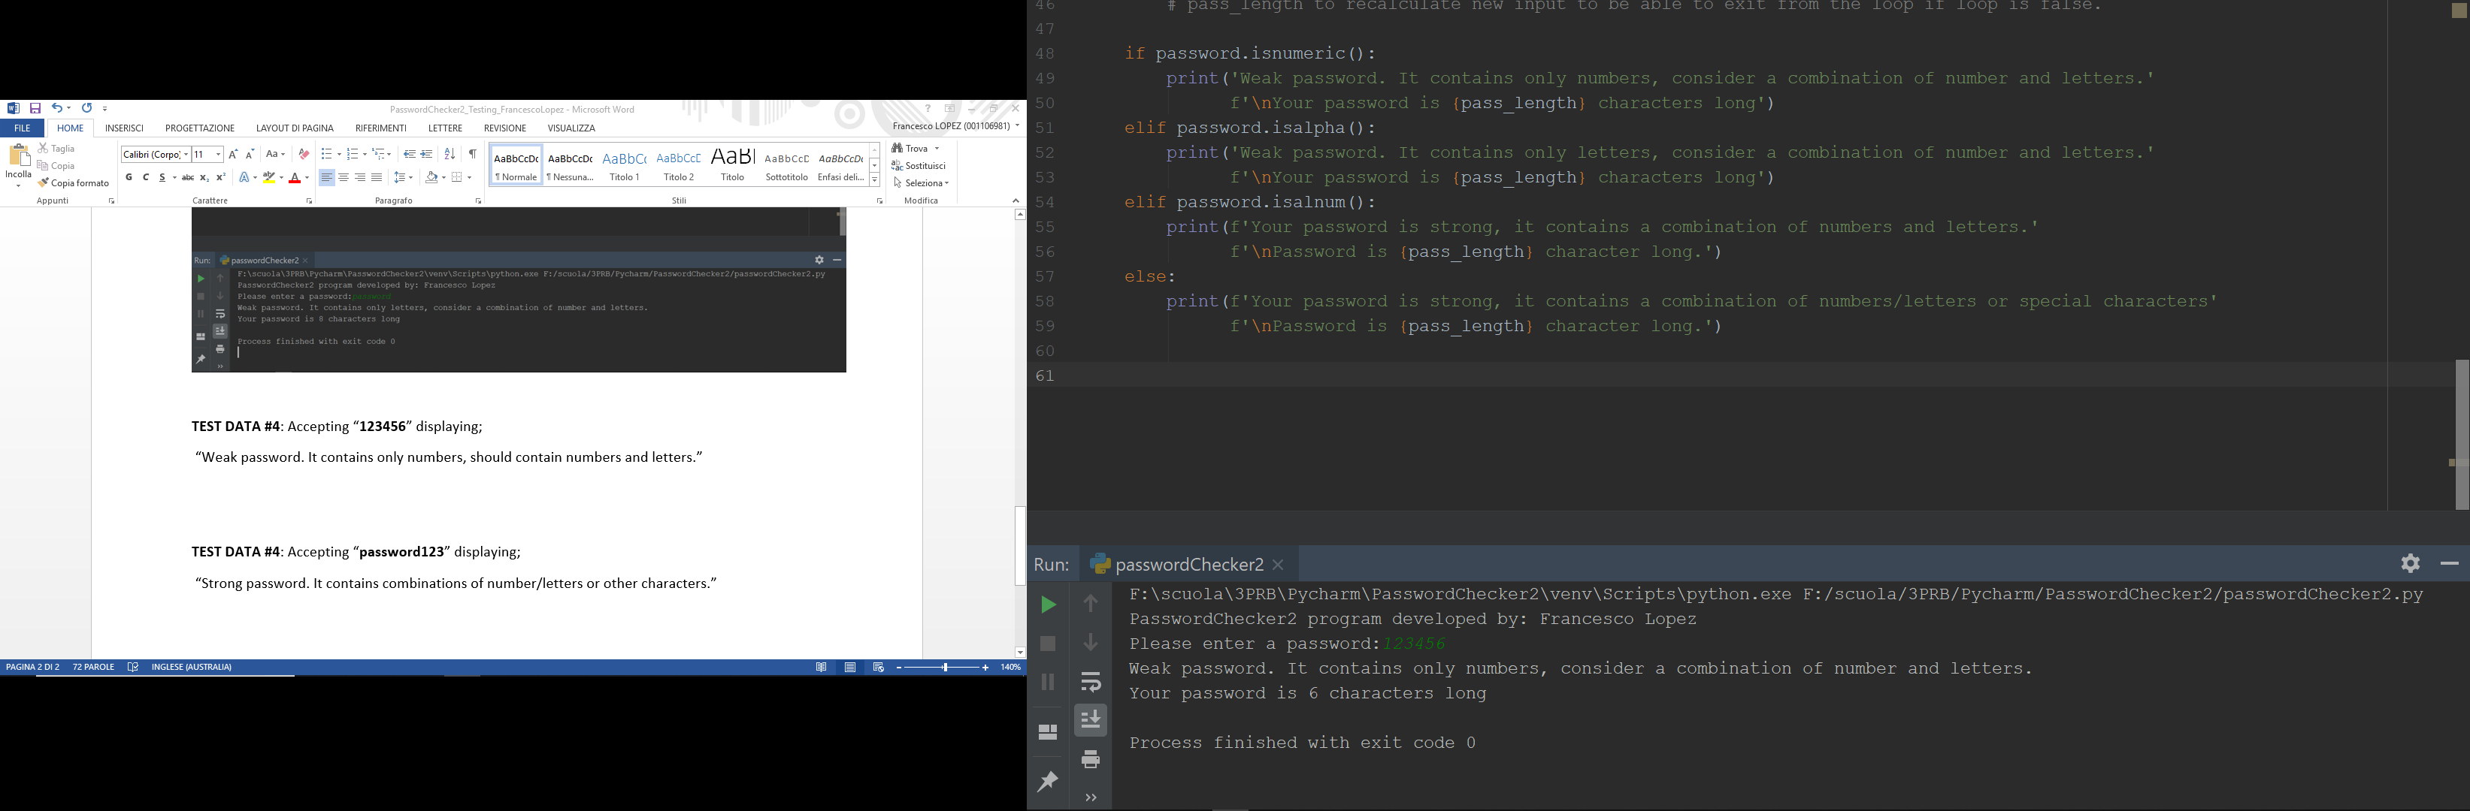

**TEST DATA #5**:

Accepting “**password123**” displaying;

“Strong password. It contains combinations of number and letters.”

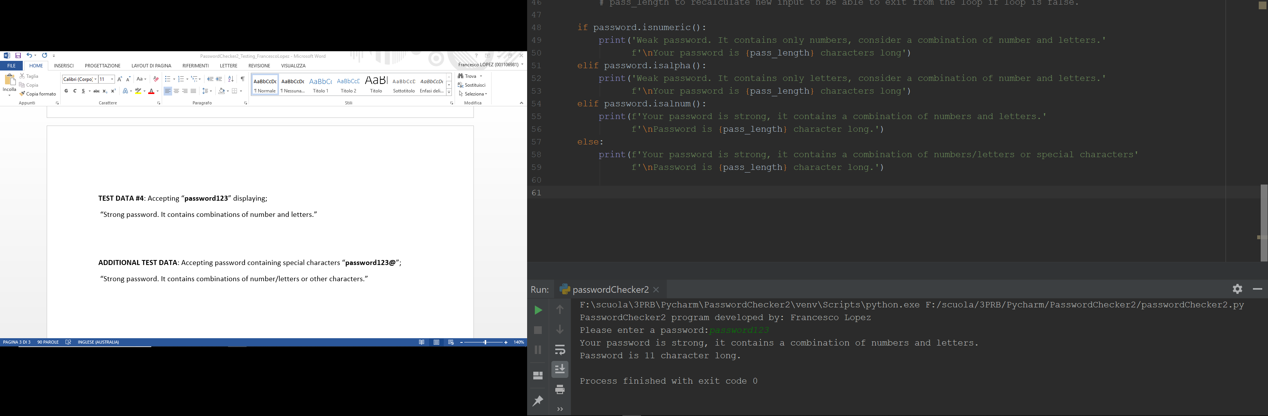

**ADDITIONAL TEST DATA**:

Accepting password containing special characters “**password123@**”;

“Strong password. It contains combinations of number/letters or other characters.”

