JOI 2014-2015 Qualification contest

Authors: JCIOI (Japanese Committee for the IOI)

Translators: Jasmine Chua, France-ioi

License: Creative Commons Attributions-ShareAlike 4.0 International License (CC BY-SA 4.0)

**Water Rate**

**QUESTION**

There are 2 water companies in JOI's city, Company X and Company Y. The water rates for each month of usage is determined by the following:

* Company X: 1 liter costs A yen.
* Company Y: There is a base charge of B yen. If water used per month is ≤C liters, the total cost is B yen. If water used per month is >C liters, the total cost is B yen plus an additional charge. The additional charge is D yen for every 1 liter above C liters.

JOI's household uses P liters of water in 1 month.

What is the monthly water rate for JOI's household, assuming he chooses the company with the cheaper rate?

**INPUT**

The input has 5 rows, with 1 integer written in each row.

In the first row, Company X's price for 1 liter, A, is written.

In the second row, Company Y's base charge, B, is written.

In the third row, Company Y's maximum usage before additional charge, C, is written.

In the fourth row, Company Y's price for 1 liter, D, is written.

In the fifth row, the amount of water JOI's household uses in 1 month, E, is written.

All integers, A, B, C, D, and E, are 1 ≦ A/B/C/D/E ≦ 10000.

**OUTPUT**

Output the monthly water rate for JOI's household in one row.

**INPUT/OUTPUT EXAMPLES**

**INPUT 1**

9

100

20

3

10

**OUTPUT 1**

90

**INPUT 2**

8

300

100

10

250

**OUTPUT 2**

1800

In INPUT EXAMPLE 1, JOI's household uses 10 liters of water in 1 month.

* The water rate charged by Company X is 9 × 10 = 90 yen.
* Since JOI's household uses less than 20 liters of water, the water rate charged by Company Y is the base charge of 100 yen.

JOI's household will choose Company X as it is the cheaper option. In this case, JOI's household's monthly water rate is 90 yen.

In INPUT EXAMPLE 2, JOI's household uses 250 liters of water in 1 month.

* The water rate charged by Company X is 8 × 250 = 2000 yen.
* Since JOI's household uses more than 100 liters of water, the additional charge will apply to 250 - 100 = 150 liters. Therefore, the water rate charged by Company Y is base charge 300 yen, plus 10 × 150 = 1500 yen of additional charge. The total water rate is 300 + 1500 = 1800 yen.

JOI's household will choose Company Y as it is the cheaper option. In this case, JOI's household's monthly water rate is 1800 yen.

※Save each example's input/output data as a file by right-clicking the links.

**Christmas Party**

**QUESTION**

JOI invited N friends to his Christmas party, ranging from friend 1 to friend N. During the party, JOI and his friends played the following game:

1. First, JOI chooses 1 friend out of N friends. That friend is labeled the 'target'.
2. JOI tells the 'target' that they have been chosen. Aside from JOI and the 'target', none of the other friends know who the 'target' is.
3. Aside from the 'target', all the other friends think of a person who may be the 'target' and write their name down on a piece of paper. The 'target' will write their own name on their piece of paper.
4. After everyone has written down a name, JOI will reveal who the 'target' is.
5. Friends who had predicted the correct person gets 1 point. Since the 'target' has written their own name, they will also get 1 point. Friends who predicted wrongly gets no points.
6. In addition, the 'target' gets an additional X points, X being the number of friends who predicted wrongly.

JOI and his friends played the game for M rounds. What are the scores for each friend after M rounds?

**INPUT**

The input has (3 + M) rows.

In the first row, the number of friends, N, where 3 ≦ N ≦ 100, is written.

In the second row, the number of rounds played in the game, M, where 3 ≦ M ≦ 100, is written.

In the third row, M integers, A1, A2, ..., AM, are written with a space between them. Friend Ai, where 1 ≦ Ai ≦ N, represents the friend that has been chosen as the target in the ith round, where 1 ≦ i ≦ M.

For the next M rows, in the ith row, where 1 ≦ i ≦ M, N integers, Bi,1, Bi,2, ..., Bi,N, are written with a space between them. This represents that friend j, where 1 ≦ j ≦ N, wrote friend Bi,j's name, where 1 ≦ Bi,j ≦ N, on a piece of paper, in round i. Since the 'target' writes down their own name, when j = Ai, Bi,j = j.

**OUTPUT**

Output the scores for each friend after M rounds. The output has N rows. The jth row, where 1 ≦ j ≦ N, shows the score for friend j.

**INPUT/OUTPUT EXAMPLES**

**INPUT 1**

3

4

1 2 3 2

1 1 2

3 2 2

1 1 3

2 2 2

**OUTPUT 1**

3

4

5

**INPUT 2**

5

3

3 3 1

2 4 3 3 3

4 3 3 3 1

1 3 4 1 1

**OUTPUT 2**

3

1

6

3

2

In INPUT EXAMPLE 1, 3 friends play the game for 4 rounds.

* Friend 1 is the 'target' in round 1. Friend 1 gets 2 points, friend 2 gets 1 point, and friend 3 gets 0 points.
* Friend 2 is the 'target' in round 2. Friend 1 gets 0 points, friend 2 gets 2 points, and friend 3 gets 1 point.
* Friend 3 is the 'target' in round 3. Friend 1 gets 0 points, friend 2 gets 0 points, and friend 3 gets 3 points.
* Friend 2 is the 'target' in round 4. Friend 1 gets 1 point, friend 2 gets 1 point, and friend 3 gets 1 point.

The scores for each friend after 4 rounds is: 3 points for friend 1, 4 points for friend 2, and 5 points for friend 3.

※Save each example's input/output data as a file by right-clicking the links.

**Weather Forecaster**

**QUESTION**

JOI City forms a rectangle, stretching H kilometers in the North-South direction and W kilometers in the East-West direction. It is divided into a grid with H × W 1-kilometer squares. The square that is ith from the North and jth from the West is known as (i, j).

The weather condition in each square can be divided into 2 categories: cloudy or clear. All clouds move 1 kilometer towards the East in 1 minute. Clouds from outside JOI City cannot move into JOI City.

The current weather condition in each square is known. As a weather forecaster, your job is to predict when each square will become cloudy for the first time.

How many minutes will pass before each square becomes cloudy for the first time?

**INPUT**

The input has (1 + H) rows.

In the 1st row, two integers are written with a space between them.

* H, where 1 ≦ H ≦ 100. This represents that JOI City is divided into a grid with H 1-kilometer rows.
* W, where 1 ≦ W ≦ 100. This represents that JOI City is divided into a grid with W 1-kilometer columns.

For the next H rows, strings composed of W characters are written in row i, where 1 ≦ i ≦ H. The jth character, where 1 ≦ j ≦ W, represents the weather condition in square (i, j). One of the following characters is written:

* 'c' represents a cloudy condition.
* '.' represents a clear condition.

**OUTPUT**

The output has H rows, with strings composed of W characters written with a space between them. The jth character in the ith row, where 1 ≦ i ≦ H and 1 ≦ j ≦ W, represents the number of minutes that will pass before square (i, j) becomes cloudy for the first time. If square (i, j) starts off cloudy, 0 is written. If square (i, j) stays clear, -1 is written.

Take note not to insert unnecessary blank spaces at the beginning and end of each row.

**INPUT/OUTPUT EXAMPLES**

**INPUT 1**

3 4

c..c

..c.

....

**OUTPUT 1**

0 1 2 0

-1 -1 0 1

-1 -1 -1 -1

**INPUT 2**

6 8

.c......

........

.ccc..c.

....c...

..c.cc..

....c...

**OUTPUT 2**

-1 0 1 2 3 4 5 6

-1 -1 -1 -1 -1 -1 -1 -1

-1 0 0 0 1 2 0 1

-1 -1 -1 -1 0 1 2 3

-1 -1 0 1 0 0 1 2

-1 -1 -1 -1 0 1 2 3

In INPUT EXAMPLE 1, JOI City is divided into 3 × 4 squares. The current weather condition is shown below:

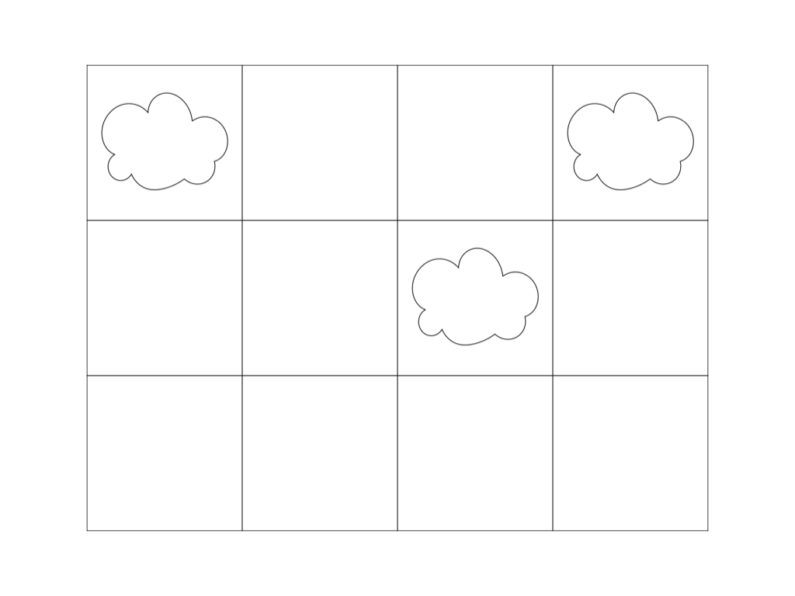

The movement of clouds after 1-minute intervals is shown below:

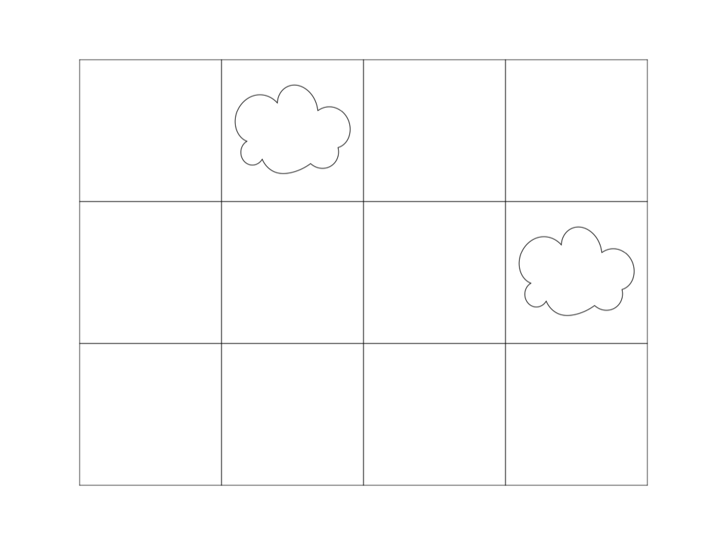

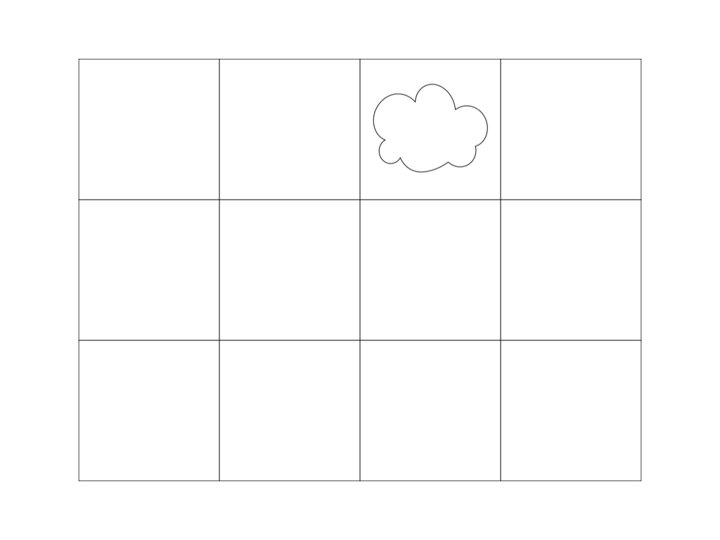

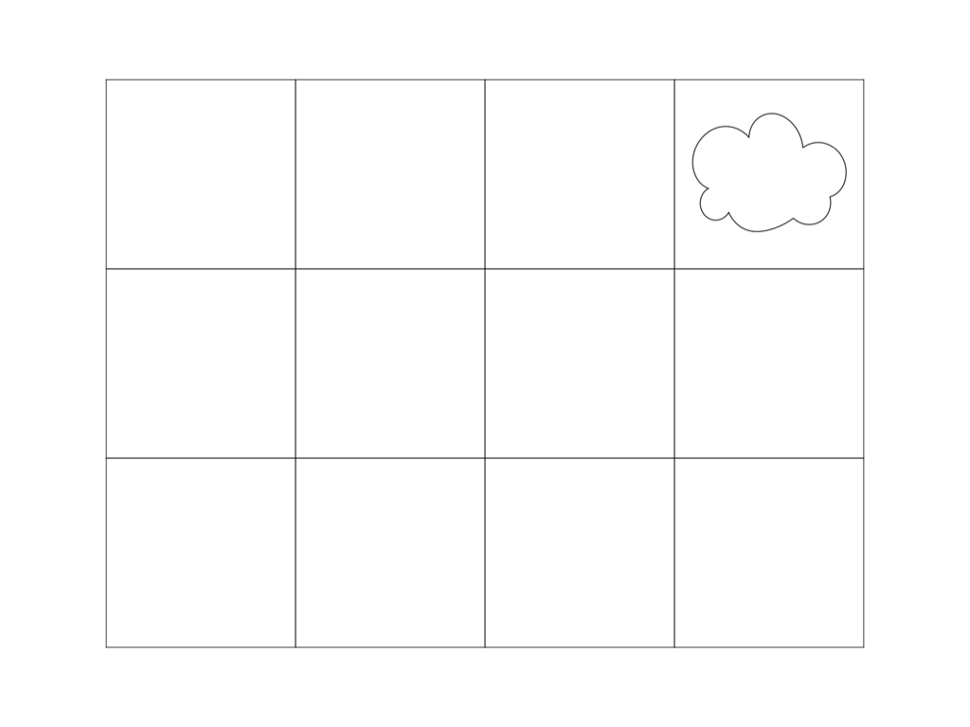

※Save each example's input/output data as a file by right-clicking the links.

**Silk Road**

**QUESTION**

In the area now known as Kazakhstan, there used to be an old trade route called the 'Silk Road'.

There are (N + 1) cities along the Silk Road, labeled as City 1 to City N. The distance between City (i - 1), where 1 ≦ i ≦ N, and City i, is Di.

JOI is a merchant who sets off from City 0, traveling through each city in sequence until he reaches City N, to sell his silk goods. He must move from City 0 to City N in M days. JOI can choose to do one of the following activities in each day:

* Travel: He will take 1 day to travel from the current city to the next one towards the East. If he is in City (i - 1), where 1 ≦ i ≦ N, he will travel to City i.
* Wait: He will not travel, but wait for 1 day in the current city.

Traveling is hard work, and JOI's exhaustion level increases every time he travels. The weather conditions along the silk road also change from day to day. It is especially hard to travel during bad weather.

The weather condition on the jth day of JOI's journey, where 1 ≦ j ≦ M, is known as Cj. If JOI travels from City (i - 1), where 1 ≦ i ≦ N, to City i on the jth day, his exhaustion will increase by Di × Cj. If he chooses to wait, his exhaustion will not increase.

JOI wants to minimize his exhaustion as much as possible during his journey. What is the minimum amount of exhaustion JOI accumulates by traveling to City N in M days?

**INPUT**

The input has (1 + N + M) rows.

In the first row, two integers are written with a space between them.

* N, where 1 ≦ N ≦ M ≦ 1000. This represents that there are (N + 1) cities along the Silk Road.
* M, where 1 ≦ N ≦ M ≦ 1000. This represents that JOI will take M days to travel from City 0 to City N.

For the next N rows, in the ith row, where 1 ≦ i ≦ N, one integer is written.

* Di, where 1 ≦ Di ≦ 1000. This represents the distance between City (i - 1) and City i.

For the next M rows, in the jth row, where 1 ≦ j ≦ M, one integer is written.

* Cj, where 1 ≦ Cj ≦ 1000. This represents the weather condition on the jth day.

**OUTPUT**

Output the minimum amount of exhaustion JOI accumulates by traveling to City N in M days in one row.

**INPUT/OUTPUT EXAMPLES**

**INPUT 1**

3 5

10

25

15

50

30

15

40

30

**OUTPUT 1**

1125

**INPUT 2**

2 6

99

20

490

612

515

131

931

1000

**OUTPUT 2**

31589

In INPUT EXAMPLE 1, the minimum amount of exhaustion JOI accumulates is shown below:

* He will wait on Day 1.
* He will travel from City 0 to City 1 on Day 2. He will gain 10 × 30 = 300 units of exhaustion.
* He will travel from City 1 to City 2 on Day 3. He will gain 25 × 15 = 375 units of exhaustion.
* He will wait on Day 4.
* He will travel from City 2 to City 3 on Day 5. He will gain 15 × 30 = 450 units of exhaustion.

The total amount of exhaustion JOI accumulates is 300 + 375 + 450 = 1125. This is the minimum amount.

※Save each example's input/output data as a file by right-clicking the links.

**Sandcastle**

**QUESTION**

JOI and his family are at the beach. After swimming in the sea, JOI decides to build a sandcastle. After a while, he got bored of playing with the sand, and returns to the sea.

The sandcastle JOI built takes up a rectangular space that can be divided into a grid. Each square can be part of the castle (known as 'castle squares') or part of the surrounding castle grounds (known as 'grounds squares'). Each 'castle square' has a strength level of 1 to 9. None of the 'castle squares' are built on the outer edge of the rectangular space, that is, squares that are in contact with the outside of JOI's play area.

Finally, the tide came in and started to erode the sandcastle. A wave that hits the sandcastle can destroy any 'castle squares' and turn them into 'grounds squares' immediately if the following condition is met.

* Condition: The number of 'grounds squares' in all 8 directions around (to the north, south, east, west, north-east, north-west, south-east, and south-west) exceeds the strength level of the 'castle square'.

Once a wave recedes, the next wave hits the sandcastle immediately.

After some time, either the entire sandcastle is destroyed, or some parts are left standing, not being destroyed even as waves hit it. How many waves will it take before the sandcastle reaches such a stable condition?

**INPUT**

The input has (1 + H) rows.

In the first row, two integers are written with a space between them.

* H, where 2 ≦ H ≦ 1000. This represents that the sandcastle is divided into a grid with H rows.
* W, where 2 ≦ W ≦ 1000. This represents that the sandcastle is divided into a grid with W columns.

The rows are from North to South, while the columns are from West to East.

For the next H rows, strings composed of W characters are written. This represents the condition of the sandcastle before the first wave hits. The jth character in the ith row, where 1 ≦ i ≦ H and 1 ≦ j ≦ W, represents the square that is ith from the North and jth from the West. One of the following characters is written:

* '.' represents a 'grounds square'.
* '1', '2', ..., '9' represents a 'castle square' with strength level depicted by the integer.

Ensure all squares on the outer edge of the rectangular space are 'grounds squares'. In other words, the input for Row 1, Row H, Column 1, and Column W, are all '.'.

For the given data,

* For Input 1, H ≦ 50 and W ≦ 50.

**OUTPUT**

Output the number of waves it will take before the sandcastle reaches a stable condition in one row.

**INPUT/OUTPUT EXAMPLES**

**INPUT 1**

5 6

......

.939..

.3428.

.9393.

......

**OUTPUT 1**

3

**INPUT 2**

10 10

..........

.99999999.

.9.323239.

.91444449.

.91444449.

.91444449.

.91444449.

.91232329.

.99999999.

..........

**OUTPUT 2**

35

In INPUT EXAMPLE 1, the first wave will destroy the 'castle squares' with strength level 3 immediately, and yield the following condition:

......

.9.9..

..428.

.9.9..

......

The next wave will destroy the 'castle square' with strength level 2 immediately, and yield the following condition:

......

.9.9..

..4.8.

.9.9..

......

The next wave will destroy the 'castle square' with strength level 4 immediately, and yield the following condition:

......

.9.9..

....8.

.9.9..

......

Subsequent waves cannot destroy the sandcastle any further. Therefore, the output is 3.

※Save each example's input/output data as a file by right-clicking the links.

**Treasures**

**QUESTION**

Bandits Anna and Bruno have infiltrated a millionaire's mansion, and found N treasures, labeled from Treasure 1 to Treasure N. Anna and Bruno are discussing how to steal the treasures. Anna will steal some treasures, while Bruno will steal others. The two bandits cannot steal the same treasure. There is a chance that Anna or Bruno will steal no treasures. In addition, there are some treasures which neither of them will steal, and thus will be left in the mansion.

Each treasure has a 'market value' and 'rarity'. Anna will be satisfied if the difference in total 'market value' of the treasures she steals versus the treasures Bruno steals is lower than D. On the other hand, Bruno hopes the total 'rarity' of the treasures he steals will be higher than Anna's.

What is the maximum difference between the total 'rarity' of Anna's versus Bruno's treasures, assuming the treasures also meet Anna's 'market value' condition?

**INPUT**

The input has (1 + N) rows.

In the first row, two integers are written with a space between them.

* N, where 1 ≦ N ≦ 30. This represents that there are N treasures.
* D, where 0 ≦ D ≦ 1015. This represents the minimum difference in total market value of the treasures she steals versus the treasures Bruno steals, that will satisfy her.

For the next N rows, in the ith row, where 1 ≦ i ≦ N, two integers are written with a space between them.

* Xi, where 0 ≦ Xi ≦ 1015. This represents that Treasure i has a 'market value' of Xi.
* Yi, where 0 ≦ Yi ≦ 1015. This represents that Treasure i has a 'rarity' of Yi.

For the 5 input data given:

* For Input 1, N ≦ 10.
* For Input 2, D = 0.

**OUTPUT**

Output the maximum difference between the total 'rarity' of Anna's versus Bruno's treasures, assuming the treasures also meet Anna's 'market value' condition in one row.

**INPUT/OUTPUT EXAMPLES**

**INPUT 1**

6 15

50 900

30 200

40 100

80 600

60 100

70 700

**OUTPUT 1**

1200

**INPUT 2**

5 0

0 1000000000000000

0 1000000000000000

1 1

1000000000000000 0

1000000000000000 0

**OUTPUT 2**

2000000000000000

In INPUT EXAMPLE 1, Anna will steal Treasures 2, 3, and 5, while Bruno will steal Treasures 1 and 6. The total 'market value' of the treasures is 130 for Anna, and 120 for Bruno. The difference of 10 is lower than D = 15, so Anna is satisfied. The total 'rarity' of the treasures is 400 for Anna, and 1600 for Bruno. The difference is 1200. This is the maximum output.

※Save each example's input/output data as a file by right-clicking the links.