NYSL USER PERSONAS

Agnes   | Agnes is a 45 years old mom of five sons who is very busy in organizing her sons’ different schedules. She is the one who accompanies her youngest child to training and football matches so that she has to get organized on time and quickly with the times and days of the events. During the day she is often around with the car to do all her tasks so that she needs an intuitive site where she can easily see all the information relative to her son's games and trainings.
Sebastian   | Sebastian is a 13 years old player and he is very passionate about the sport. He is very friendly with the others players and they like a lot to chat about their upcoming games on whatsapp. He loves to play around on his own team’s website, knowing everything about its team and he wants to share all the info about the matches and the trainings with his friends to discuss about whom they will play against the next events and to organize some team's dinner after the game in places close to the event location.
Uncle Rick  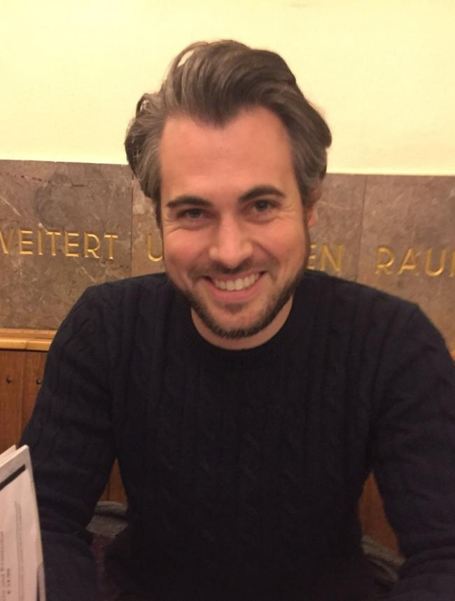 | He is the young and soccer expert uncle of one of the player and he really likes to watch his nephew’s soccer matches on weekends. He usually ask for info about the games to the parents’ kid and as he just need to know the location of the game and how to get there he wants to be sent a unique link with those info.

