Worked example 1: random sample
Francesca Mancini
2025-05-08

Simulations
In this worked example I simulated 10 species distributions (Figure 1) according to some environmental variables. I then simulated the sampling to generate the occurrence data. The sites to sample were chosen at random locations in Great Britain and each site was resampled in each of ten years. In each site and year, the species could be detected according to a probability of detection, which was less than 1 (imperfect detection). This could be considered a “high quality” dataset as the sites are randomly distributed, and sampling effort is even across the time period.
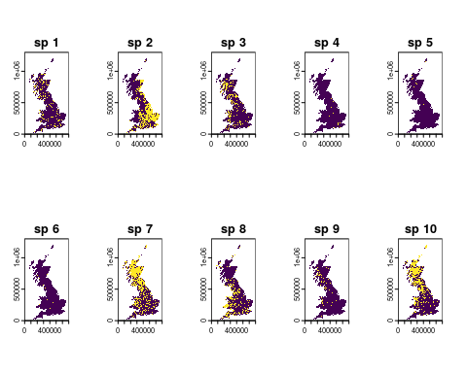
Figure 1. Distribution of 10 virtual species. Species presences are in yellow and absences are in purple.

Bias assessment

Temporal bias
The first metric we will assess is the number of records through time (Figure 2).
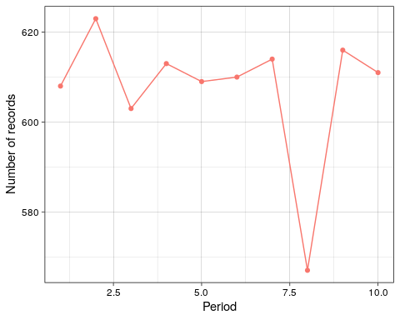
Figure 2. Number of records in each time period.
Number of records are quite stable over time, ranging from 608 in the first year to 611 in the last year with a slight drop in year 8. This tells us that sampling intensity is even across the time period and should not confound estimates of e.g. species occupancy.

Taxonomic bias
Now we will look at the number of species that have been recorded in each time period (Figure 3). Although not a direct proxy, appreciable variation in the number of species sampled over time implies that there has been at least some change in the composition of species that have been recorded. If species that are faring better were sampled in, say, the early portion of the time-series, and species that are faring poorly were sampled in later years, then one might erroneously conclude that species are declining over time.
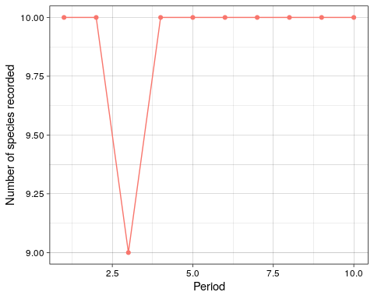
Figure 3. Number of species recorded in each time period.
All 10 species were recorded every year except for year 3 when only 9 species were recorded. This shows that taxonomic coverage is essentially constant across time periods.
It has been speculated that apparent changes in taxonomic coverage could, in fact, reflect a change in taxonomic expertise over time. For example, if fewer individuals have the skill to identify certain species, then it may not appear in the dataset in the later periods. Or conversely, if a field guide was published that allowed easier identification of some species, more records may be identified to species level in subsequent years. Figure 4 shows the proportion of species identified to species level as a proxy for taxonomic expertise.
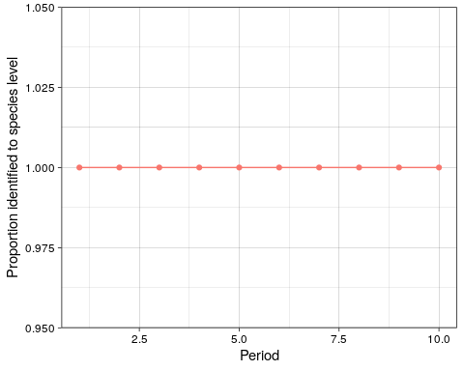
Figure 4. Proportion of records identified at species level in each time period.
In this case, all records have been identified at species level in each year, suggesting no change in taxonomic expertise over the time period.
A number of studies have defined taxonomic bias in a dataset as the degree of proportionality between species’ range sizes (usually proxied by the number of grid cells on which it has been recorded) and the total number of records. In other words, we would expect a very common species with a large range size to have a high number of records. If rare species are recorded proportionally more often than common species, we have taxonomic bias. One can calculate the correlation between the size of the area over which the species has been recorded and the number of records for that species. This correlation coefficient gives an index of how over- or under-sampled a species is given its prevalence. Figure 5 shows an index of proportionality between range sizes and number of records.
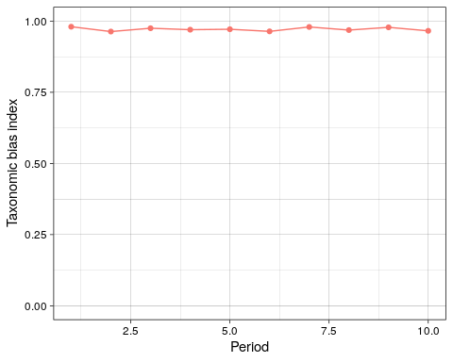
Figure 5. Rarity bias index.
The taxonomic bias index is very close to 1, indicating that sampling is proportional to species commonness, in other words, there is no rarity bias.

Spatial bias
Next we will look at the dataset’s spatial coverage. Figure 6 shows the density of records in each time period to assess if the spatial distribution of recprds has changed over time.
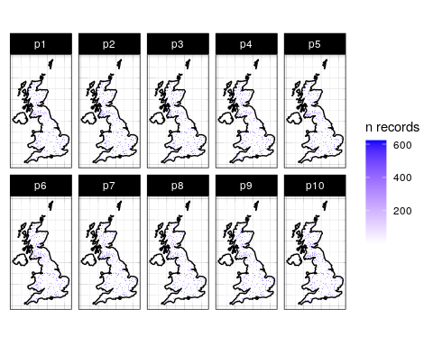
Figure 6. Density of records in each period. Data is aggregated to 10km resolution.
The maps in Figure 6 do not show any change in the spatial coverage over time.
In order to derive temporal trends in species’ distributions we need to have a high degree of resampling over time, in other words, sites need to be sampled in more than one year. Otherwise, change in species occupancy over space might be confounded with change over time. Figure 7 shows the number of years in which each 10km site has been sampled.
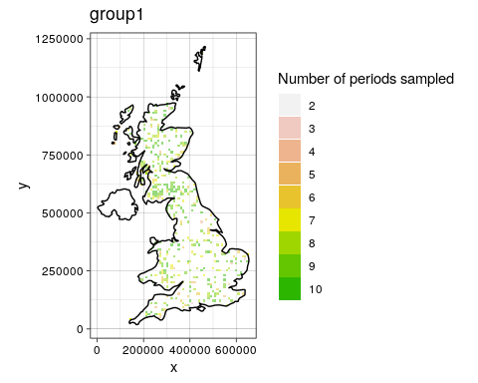
Figure 7. Number of years in which each site has been sampled.
All sites have been sampled in at least two years and most have been sampled in 6 or more years.
Even if your data has good spatial coverage, it may be geographically biased; that is to say, it may deviate from a random distribution in space. Since simple random samples are geographically unbiased in expectation, they can be used as a benchmark against which to compare the sample in hand. What makes simple random samples unbiased is that every site has the same probability of being included in the sample. Consequently, sampled sites should not be geographically clustered (at least not in expectation). On the other hand, when sample inclusion is affected by, say, accessibility or the environment, then we would expect some clustering around accessible and environmentally suitable locations. One way to measure the degree to which a sample is geographically clustered, and by extension the extent to which it deviates from a simple random sample, is using the Nearest Neighbor Index (NNI). This is calculated as the mean of the nearest neighbour distances of the empirical data divided by the mean of the nearest neighbour distances of a random sample. Figure 8 shows the NNI for this dataset.
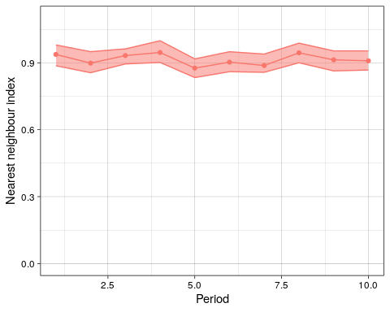
Figure 8. Spatial bias index. Points are the Nearest Neighbour Indices for each time period and shaded areas are the 90% confidence interval derived from the simulations.
The Nearest Neighbour Index is very close to 1, indicating that the spatial distribution of the data is very close to a random distribution.

Environmental bias
Spatial bias in your dataset does not necessarily tell you anything about environmental bias. This last function compares the distribution of some environmental variable in the sample (your data) to its distribution in the population (i.e. the whole geographic domain). It is based on the fact that a sample is representative, at least in terms of the focal variable, if the sample and population distributions are similar.
Here we are comparing the distribution of average monthly temperatures in the data vs the whole of Great Britain.
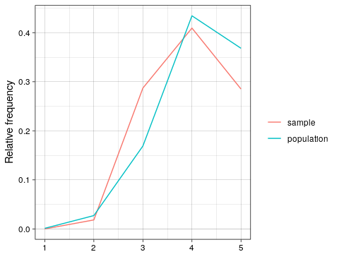
Figure 9. Dsitribution of average monthly temperatures in the sample (in pink) and the population (in blue).
The distribution of average monthly temperatures is similar in the sample and the population, with a slight mismatch in the middle and higher temperatures. The data seems to contain more sites with average monthly temperature in the middle of the rage and less sites with temperatures in the higher part of the range compared to the population. Given that the sampling locations were generated randomly in this dataset, this is probably due to the actual species distributions. The non detections were removed from the dataset to obtain a presence-only dataset and this process may have slighly biased the data.

