Worked example 3: environmental bias
Francesca Mancini
2025-05-09

Simulations
In this worked example I simulated 10 species distributions (Figure 1) according to some environmental variables. I then simulated the sampling to generate the occurrence data. 200 sites in Great Britain were selected to be sampled in the first year. The number of sites sampled then increased every year to a total of 1200 in the last year. I introduced a bias towards certain land cover classes in the probability that a site was sampled, with woodland and semi-natural grassland having a sampling probability of 0.6, coastal areas having a probability of 0.4, built-up areas and gardens a probability of 0.9 and all the other classes a probability of 0.2. Each year the sampling was done with replacement so that the same sites from the previous years could be resampled. In each site and year, the species could be detected according to a probability of detection, which was less than 1 (imperfect detection).
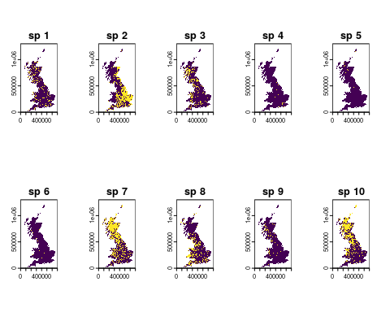
Figure 1. Distribution of 10 virtual species. Species presences are in yellow and absences are in purple.

Bias assessment

Temporal bias
The first metric we will assess is the number of records through time (Figure 2).
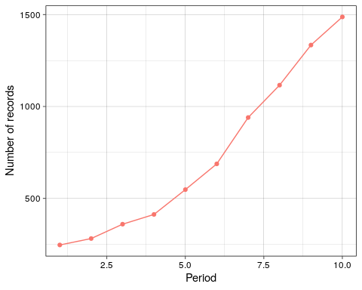
Figure 2. Number of records in each time period.
Number of records increase significantly over time, ranging from a minimum of 247 in the first year to a maximum of 1487 in the last year. This increase in sampling intensity over time is likely to bias temporal trends in species distribution if not accounted for analytically.

Taxonomic bias
Now we will look at the number of species that have been recorded in each time period (Figure 3). Although not a direct proxy, appreciable variation in the number of species sampled over time implies that there has been at least some change in the composition of species that have been recorded. If species that are faring better were sampled in, say, the early portion of the time-series, and species that are faring poorly were sampled in later years, then one might erroneously conclude that species are declining over time.
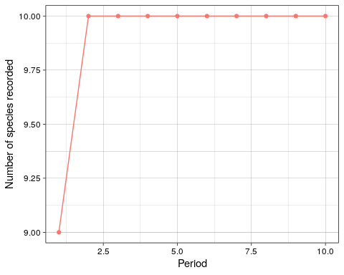
Figure 3. Number of species recorded in each time period.
Except for the first year, all 10 species were recorded in each year. This shows that taxonomic coverage is essentially constant across the time period.
A number of studies have defined taxonomic bias in a dataset as the degree of proportionality between species’ range sizes (usually proxied by the number of grid cells on which it has been recorded) and the total number of records. In other words, we would expect a very common species with a large range size to have a high number of records. If rare species are recorded proportionally more often than common species, we have taxonomic bias. One can calculate the correlation between the size of the area over which the species has been recorded and the number of records for that species. This correlation coefficient gives an index of how over- or under-sampled a species is given its prevalence. Figure 4 shows an index of proportionality between range sizes and number of records.
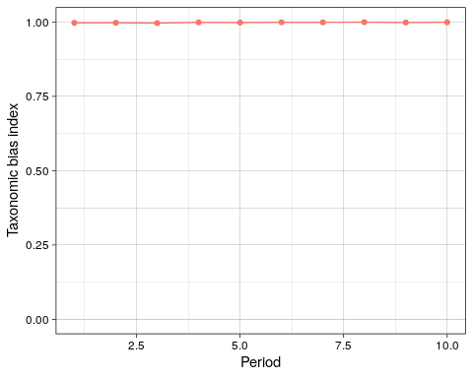
Figure 4. Rarity bias index.
The taxonomic bias index is 1, indicating that sampling is proportional to species commonness, in other words, there is no rarity bias.

Spatial bias
Next we will look at the dataset’s spatial coverage. Figure 5 shows the density of records in each time period to assess if the spatial distribution of recprds has changed over time.
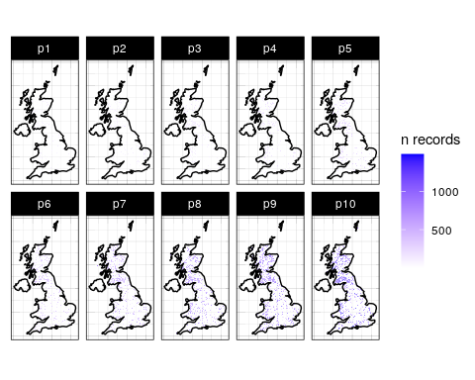
Figure 5. Density of records in each period. Data is aggregated to 10km resolution.
The maps in Figure 5 show that spatial coverage is not even across the time periods, with many areas of the country not being well sampled in the early years. The maps also show that records are not distributed randomly across the geographic domain, with clusters of records in Scotland and Wales.
In order to derive temporal trends in species distribution we need to have a high degree of resampling over time, in other words, sites need to be sampled in more than one year. Otherwise, change in species occupancy over space might be confounded with change over time. Figure 6 shows the number of years in which each 10km site has been sampled.
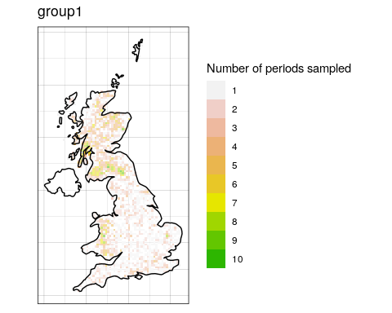
Figure 6. Number of years in which each site has been sampled.
Figure 6 shows low levels of resampling. Only 2 sites have been sampled in all 10 year, with the majority being sampled in only 1 or 2 years. This is after aggregating the data at 10km, if we wanted to analyse the data at a finer resolution, the level of resampling would be even lower.
Even if your data has good spatial coverage, it may be geographically biased; that is to say, it may deviate from a random distribution in space. Since simple random samples are geographically unbiased in expectation, they can be used as a benchmark against which to compare the sample in hand. What makes simple random samples unbiased is that every site has the same probability of being included in the sample. Consequently, sampled sites should not be geographically clustered (at least not in expectation). On the other hand, when sample inclusion is affected by, say, accessibility or the environment, then we would expect some clustering around accessible and environmentally suitable locations. One way to measure the degree to which a sample is geographically clustered, and by extension the extent to which it deviates from a simple random sample, is using the Nearest Neighbor Index (NNI). This is calculated as the mean of the nearest neighbour distances of the empirical data divided by the mean of the nearest neighbour distances of a random sample. Figure 7 shows an index of spatial bias, which represents how far your data deviates from a random distribution.
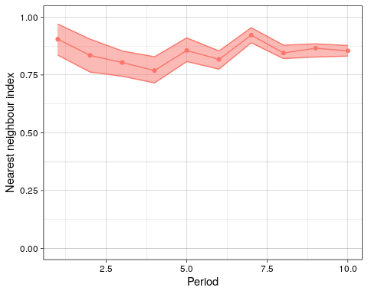
Figure 7. Spatial bias index. Points are the Nearest Neighbour Indices for each time period and shaded areas are the 90% confidence interval derived from the simulations.
The NNI could take values between 0 and 1, indicating the data is more clustered than a random distribution, or above 1, indicating the data is more dispersed than a random distribution. In this case, the NNI is lower than 1, although not too far off, indicating a distribution slightly more clustered than a random sample. The NNI is fairly constant across time periods, indicating that this spatial bias does not get better or worse with time.

Environmental bias
Spatial bias in your dataset does not necessarily tell you anything about environmental bias. This last function compares the distribution of some environmental variable in the sample (your data) to its distribution in the population (i.e. the whole geographic domain). It is based on the fact that a sample is representative, at least in terms of the focal variable, if the sample and population distributions are similar.
Here we are comparing the distribution of different land cover classes in the data vs all 1km cells in Great Britain.
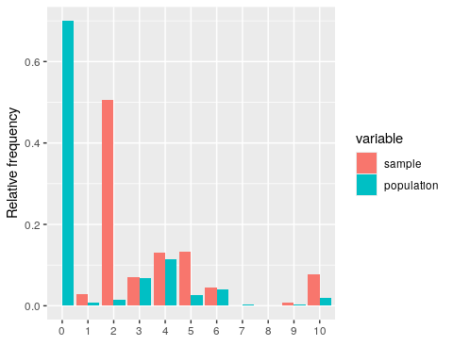
Figure 9. Dsitribution of average monthly temperatures in the sample (in pink) and the population (in blue).
The distribution of the different land cover classes differs between the sample and the population. The data has proportionally more observations in coniferous woodland (class 1), semi-natural grassland (class 5) and urban areas (class 10) compared to the population, while class 7 (saltwater) is not represented at all in the data. This is due to the different sampling probabilities that were assigned to each land cover class when simulating the data collection. Because we excluded the non detections from the datasets, the resulting distribution is also a function of the species distributions, which explains why coniferous woodland is so much more oversampled compared to broadleaf woodland, despite having the same sampling probability.
Figure 9 shows that the data is biased towards certain land cover classes and therefore any conclusions drawn from the analysis of the data (not accounting for this bias) will be more indicative of what happens in those habitats.

