Introduction
This project focuses on the classification and analysis of taboo language in Sinhala text data. Sinhala, being a low-resource language, lacks extensive datasets and tools for natural language processing (NLP), particularly in the domain of offensive language detection. This creates challenges in building accurate and reliable systems for identifying harmful content.

The primary aim of this project is to modify existing dataset of offensive Sinhala words, categorize them based on their nature, and analyse their distribution and characteristics. This work contributes toward improving content moderation and supporting future NLP research in low-resource languages.

Objectives
The primary goal of this project is to systematically analyze offensive Sinhala language data. The specific objectives are as follows:
- To collect and organize a dataset of Sinhala taboo and offensive words
- To classify offensive terms into meaningful semantic categories such as insults, gender-based, disability-related, and race-related expressions
- To design and implement a target-type classification framework to identify whether offensive language is directed toward:
  - Individuals (IND)
  - Groups (GRP)
  - Untargeted entities (UNT)
  - Organizations or events (OTH)
- To perform exploratory data analysis (EDA) to uncover patterns and trends in offensive language usage
- To visualize key findings using appropriate graphical representations
- To identify challenges associated with processing and analyzing Sinhala text data

Dataset Description

Source dataset is SOLD language dataset. It consists of Sinhala offensive words along with their associated attributes. Each entry in the dataset includes the following columns:

Original dataset columns
['post_id', 'text', 'tokens', 'rationales', 'label']

Updated columns
['post_id', 'text', 'target_type', 'target_group', 'tokens', 'label','stereotype', 'category', 'text_length', 'off_word_count', 'rationales','offensive_words', 'target_type_expanded']

Column | Values
post_id | unique ID
text | actual text(sentence)
label | OFF-Offensive NOT- Not offensive
target_type | IND → individual  GRP → group  UNT → no target  OTH → organization/event
category | only for GRP  (Gender | Politics |Race Religion| Citizenship | Age | Disability |National Origin)
offensive_span (Offensive_words) | The exact word/phrase causing offense ("stupid" |"idiot" |"damn")
tokens
Stereotype | What is being said about the group  (lazy |terrorist | dirty |weak)
Text_length
Rationales

Data Preprocessing

Before performing analysis, the dataset was cleaned and transformed to ensure consistency and usability.

Approach in Sinhala Language
Identify the taboo language words
Use SOLD language dataset and add manual and AI based changes
Add a few new columns and change existing data available on the dataset.
Sinhala is law resource language and difficult to find the dataset 100% fit to the task hence did above changes

Methodology
Use basic python scripts and for final analysis notebook
- Data
Original SOLD project included few important files
But for this project purpose use offensive language train and test dataset
- Data Modification
Original columns =>post_id, text, tokens, label
New columns
- Target_type (IND, UNT…)
- Target_group
- Stereotype
- Category

Data Analysis and Visualization

- Distribution between taboo and non taboo words
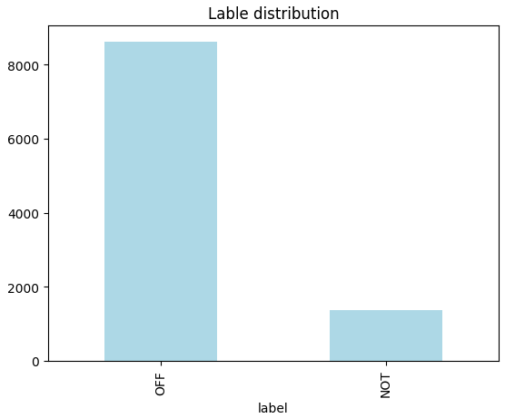

Dataset has majority taboo words related records .
- Identify most offensive / taboo words in the dataset
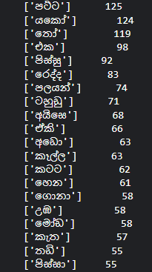

- Offensive word count per row
General count how many words in the context(row). Mostly one word per context

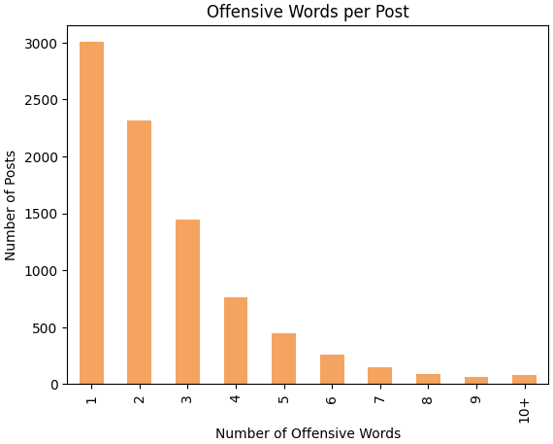

- Top offensive words and word count

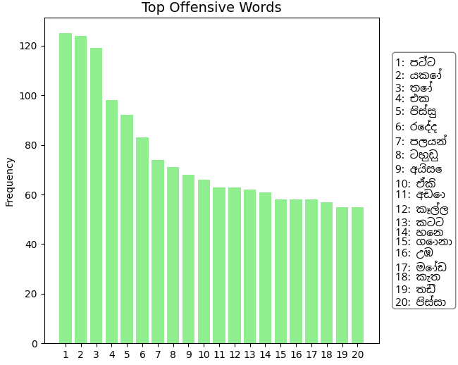

Result and Findings

Challenges

Reference
Sinhala-NLP/SOLD: Sinhala Offensive Language Identification Dataset

