Taboo Language Classification and Analysis in Sinhala Text Data

1. Introduction
The rapid expansion of digital communication platforms, particularly social media, has significantly increased the prevalence of offensive and harmful language online. Taboo language, which includes insults, hate speech, and derogatory expressions, poses serious challenges to online communities, as it can negatively impact individuals and groups by promoting discrimination, harassment, and social division.
Offensive language detection has therefore become a critical area of research within Natural Language Processing (NLP). While substantial progress has been made for high-resource languages such as English, low-resource languages like Sinhala remain underexplored. Sinhala, primarily spoken in Sri Lanka, lacks large-scale annotated datasets and robust NLP tools, making it difficult to develop effective automated systems for detecting harmful content.
Another key challenge in offensive language analysis is the context-dependent nature of meaning. A word may be considered offensive in one context but neutral in another. Additionally, offensive expressions often target different entities, such as individuals, social groups, or institutions, further complicating classification.
This project addresses these challenges by developing a structured dataset of Sinhala taboo language and performing a comprehensive analysis of its characteristics. The study focuses on categorizing offensive words, identifying their targets, and examining patterns in their usage. By doing so, it aims to contribute to the development of better content moderation systems and support future research in low-resource language processing.

2. Objectives
The primary goal of this project is to systematically analyze offensive Sinhala language data. The specific objectives are as follows:
- To collect and organize a dataset of Sinhala taboo and offensive words
- To classify offensive terms into meaningful semantic categories such as insults, gender-based, disability-related, and race-related expressions
- To design and implement a target-type classification framework to identify whether offensive language is directed toward:
  - Individuals (IND)
  - Groups (GRP)
  - Untargeted entities (UNT)
  - Organizations or events (OTH)
- To perform exploratory data analysis (EDA) to uncover patterns and trends in offensive language usage
- To visualize key findings using appropriate graphical representations
- To identify challenges associated with processing and analyzing Sinhala text data

3. Dataset Description
The dataset used in this project consists of a curated collection of Sinhala offensive words along with their associated metadata. The dataset is structured in a tabular format and includes the following attributes:
- id: A unique identifier assigned to each entry
- word: The offensive or taboo term in Sinhala
- category: The type of offensiveness (e.g., insult, gender, disability)
- offensiveness_level: The severity of the term (e.g., low, medium, high)
- language: The language of the term (Sinhala)

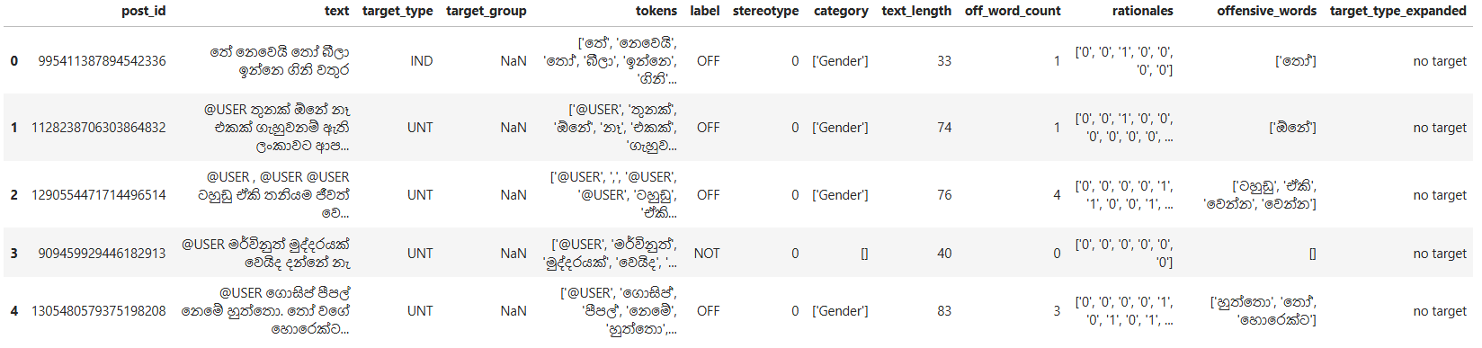
3.1 Target-Type Annotation
To enhance the analytical value of the dataset, an additional column named target_type was introduced. This column categorizes offensive language based on its intended target:
- IND (Individual): Offensive language directed at a specific person
- GRP (Group): Language targeting a group defined by shared characteristics (e.g., gender, race)
- UNT (Untargeted): General offensive expressions without a specific target
- OTH (Organization/Event): Language targeting institutions, organizations, or events
3.2 Multi-Category Entries
A notable characteristic of the dataset is that some entries belong to multiple categories. For example:
- "Disability, Gender"
Such cases reflect the overlapping nature of offensive language, where a single term may simultaneously target multiple social dimensions. Handling these entries required additional preprocessing steps to ensure accurate analysis.

4. Data Preprocessing
Data preprocessing is a crucial step in ensuring the quality and reliability of analysis. Several preprocessing techniques were applied to the dataset.
4.1 Data Cleaning
The dataset was cleaned to remove inconsistencies and improve readability:
- Removal of unwanted characters such as brackets and extra whitespace
- Standardization of text formatting
- Correction of inconsistent category labels
4.2 Handling Multi-Label Categories
To properly analyze entries with multiple categories, the category column was transformed:
df_off["category_updated"] = df_off["category"].str.split(",")
df_off_exploded = df_off.explode("category_updated")
This process:
- Converts category strings into lists
- Expands each category into a separate row
- Enables accurate frequency analysis of individual categories
4.3 Encoding and Font Handling
Since the dataset contains Sinhala characters, special attention was given to encoding and visualization:
- UTF-8 encoding was ensured throughout the dataset
- Font issues in visualization libraries were handled to correctly display Sinhala text
4.4 Target-Type Assignment
A rule-based approach was used to assign values to the target_type column. This involved analyzing the meaning and usage context of each word and mapping it to the appropriate target category.

5. Methodology
The methodology adopted in this project is primarily analytical and rule-based.
5.1 Classification Strategy
- Offensive words were categorized based on predefined semantic labels
- Target types were assigned using linguistic interpretation and contextual understanding
5.2 Frequency Analysis
Frequency analysis was conducted to understand the distribution of offensive language:
df_off['off_word_count'].value_counts().sort_index()
This operation:
- Counts the number of occurrences of offensive word counts
- Sorts the results in ascending order
- Helps identify common and rare patterns in the dataset
5.3 Analytical Approach
The analysis focused on:
- Category frequency distribution
- Target-type distribution
- Co-occurrence of multiple categories

6. Data Analysis and Visualization
Exploratory Data Analysis (EDA) was performed to extract meaningful insights.
6.1 Category Distribution Analysis
The frequency of each category was computed to identify dominant types of offensive language. The use of exploded data ensured that multi-category entries were accurately represented.
6.2 Target-Type Distribution
The distribution of target types (IND, GRP, UNT, OTH) was analyzed to understand how offensive language is directed. This provides insight into whether offensive expressions are more personalized or generalized.
6.3 Visualization Techniques
Several visualization techniques were used:
- Bar charts to display category frequencies
- Histograms to show distribution of offensive word counts
- Annotated graphs to display exact values for clarity
Visualization enhances interpretability and helps communicate findings effectively.

7. Results and Findings
The analysis produced several important findings:
- Gender-related offensive language was the most frequent category, indicating a strong presence of gender-based insults
- A significant number of entries contained multiple categories, highlighting overlapping forms of discrimination
- The majority of offensive expressions were directed toward individuals (IND) and groups (GRP)
- The dataset showed a balanced distribution of offensiveness levels, with a concentration in the medium category
These findings demonstrate that offensive language is complex, multi-dimensional, and often context-dependent.

8. Challenges
Several challenges were encountered during the project:
- Ambiguity in classification: Some words could belong to multiple categories depending on context
- Limited resources: Lack of existing Sinhala NLP tools and annotated datasets
- Data complexity: Multi-label entries required additional processing
- Technical issues: Encoding and font rendering problems during visualization

9. Conclusion
This project successfully developed and analyzed a structured dataset of Sinhala taboo language. By categorizing offensive words and introducing a target-type classification system, the study provides valuable insights into the nature and distribution of offensive language in Sinhala.
The findings highlight the importance of considering multiple dimensions—such as category and target—when analyzing harmful language. This work serves as a foundational step toward building automated systems for offensive language detection in low-resource languages.

10. Future Work
Future research directions include:
- Developing machine learning and deep learning models for automated detection
- Expanding the dataset with contextual sentences and real-world data
- Incorporing context-aware and semantic analysis techniques
- Extending the approach to multilingual datasets
- Building real-time moderation tools for online platforms

References
- Academic literature on offensive language detection
- NLP research on low-resource languages
- Python libraries such as Pandas and Matplotlib

Appendix
- Sample dataset entries
- Code snippets for preprocessing and analysis
- Additional visualizations

