**Overview and Vision Statement**

Reading the news has never been so funny! Play as a stickman doing unbelievable stunts jumping from one letter to another inside a newspaper page. Parkour News is a parkour 2D platform game where the goal is to perform as many tricks as possible, get points doing it, and reach the end of the page alive. You can jump, flip, crawl and slide on the big letters of the titles, and run above the columns of text or the boxes in the page, but be aware to not finish in a dangerous zone or you will have to restart!

**Audience, platform, and marketing**

|  |  |
| --- | --- |
| **Genre** | 2D Platformer  Level Based  Side Scroller |
| **Platform** | Pc |
| **Market Analysis** | Type Rider  Super Meat Boy |

**Gameplay**

The main gameplay consists in being a stickman that has to move on a map where the solid surfaces are letters and the player has to find a way to proceed in the map in order to reach a final object. The stimulating part of this is guaranteed by the fact that passing the map is not trivial, the player has to find a way to pass an obstacle and it is not trivial, with the difficulty increased level by level.

**Mechanics**

There are three main dynamics that push the action of the player:

1. **Find a correct set of actions to pass the level**

In order to increase the dynamicity of the map there are some elements that can help or hinder the player in doing his actions.

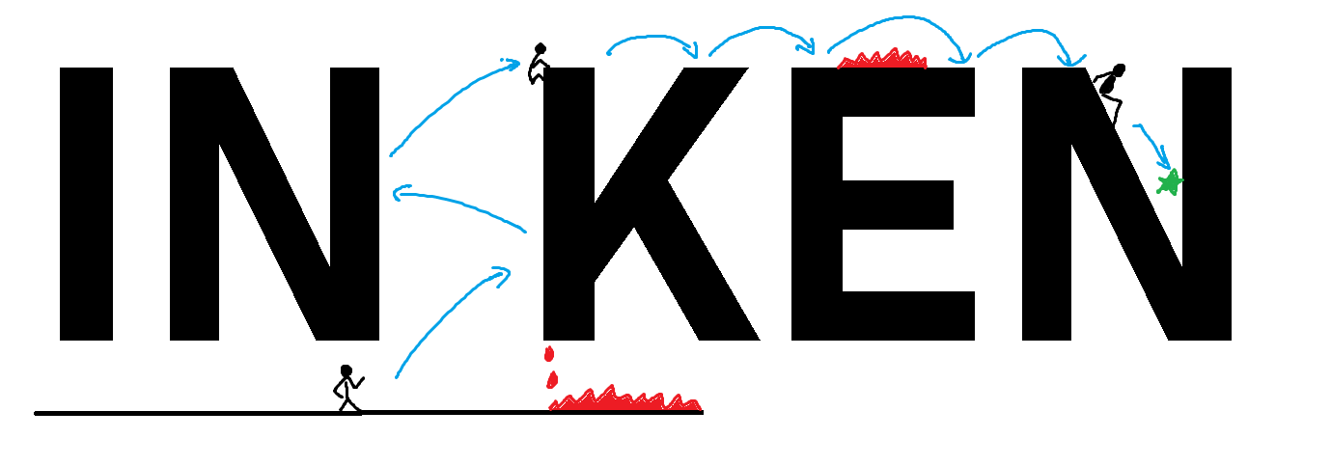

As obstacles there are falling drops from the above objects and spines on the ground that kills the character if it touches them, every **dangerous object is red,** in this way they are always recognizable. Also on the map almost every round surface is an object that can give the player a bouncing effect that can be useful to pass the map as shown in the image below for the “i”, which the player can use to reach the above surface, otherwise impossible.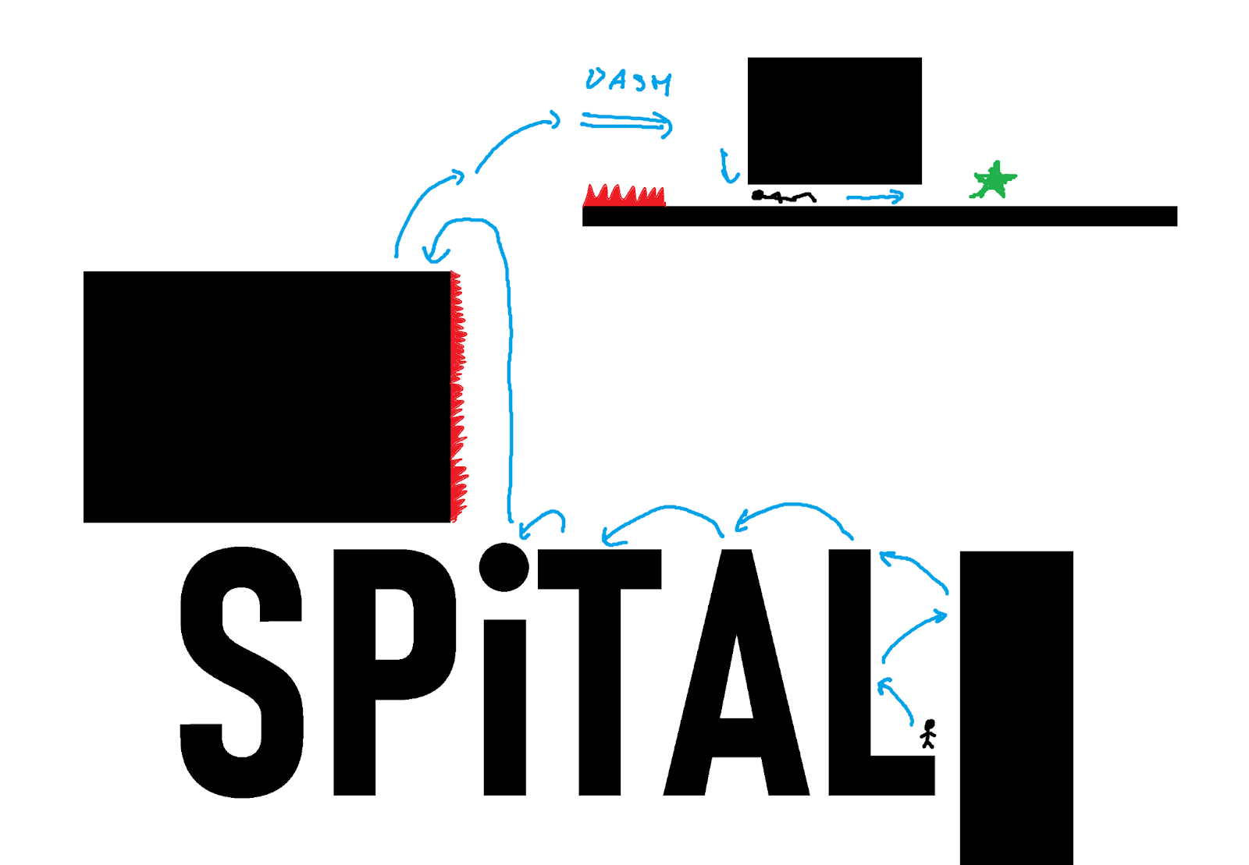

This is also valid for bigger round object like the “O” which can be also rotating in order to increase the difficulty as shown below

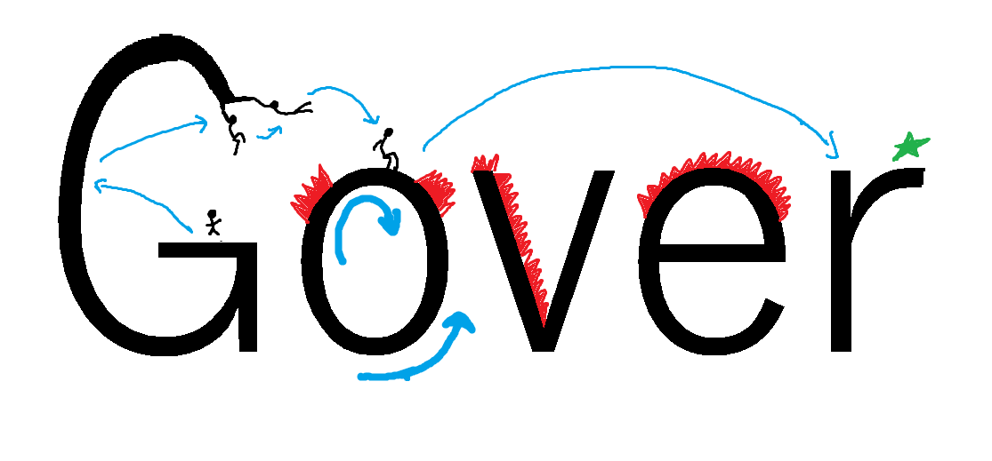

The bouncing is also possible for “P” or “B” that provides just lateral forces but that can be useful anyway.

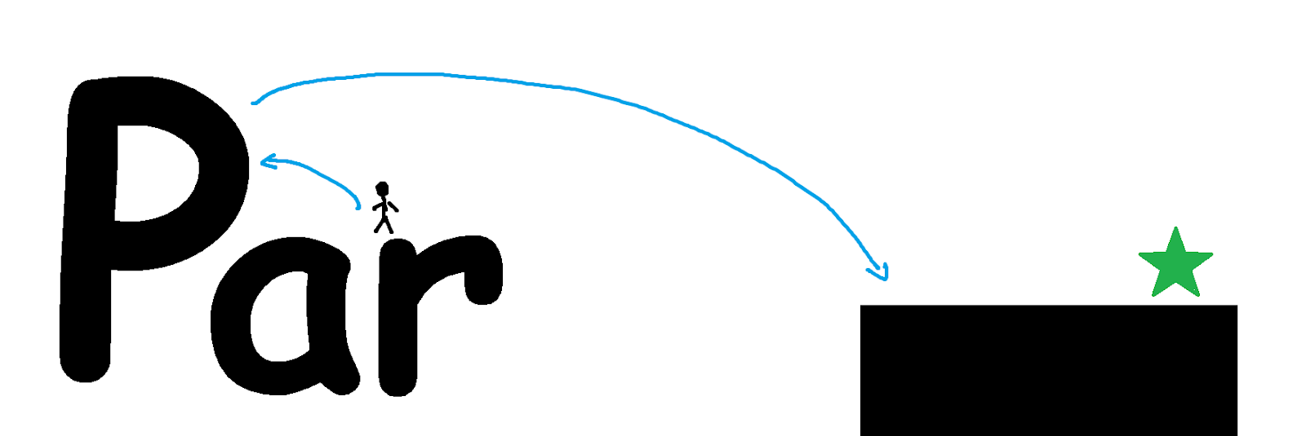  
  
Other mechanics are that the letters are not always of the same dimension, so to extend the possibilities of the map, it is possible to slide on oblique surfaces,there are holds somewhere as showed for the ”G” case in the image above and that the letters can be deformed in order to make possible to pass through it as shown for the ”N” in the image below.

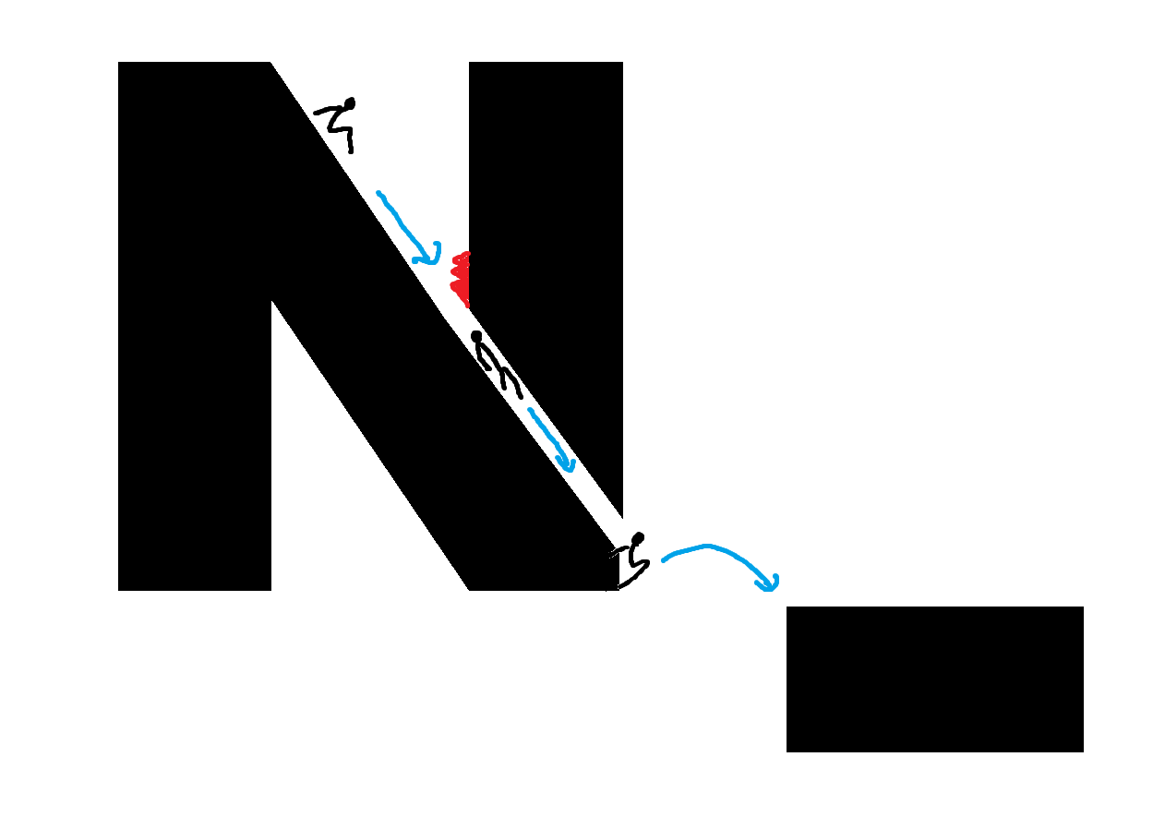

1. **Pass a piece of map before it is cancelled**

There is also a temporal limit, the player can stay on a determined surface until it is cancelled by a red sinusoidal line that, with constant speed, proceed through the map and reaches the various surfaces in it deactivating them.

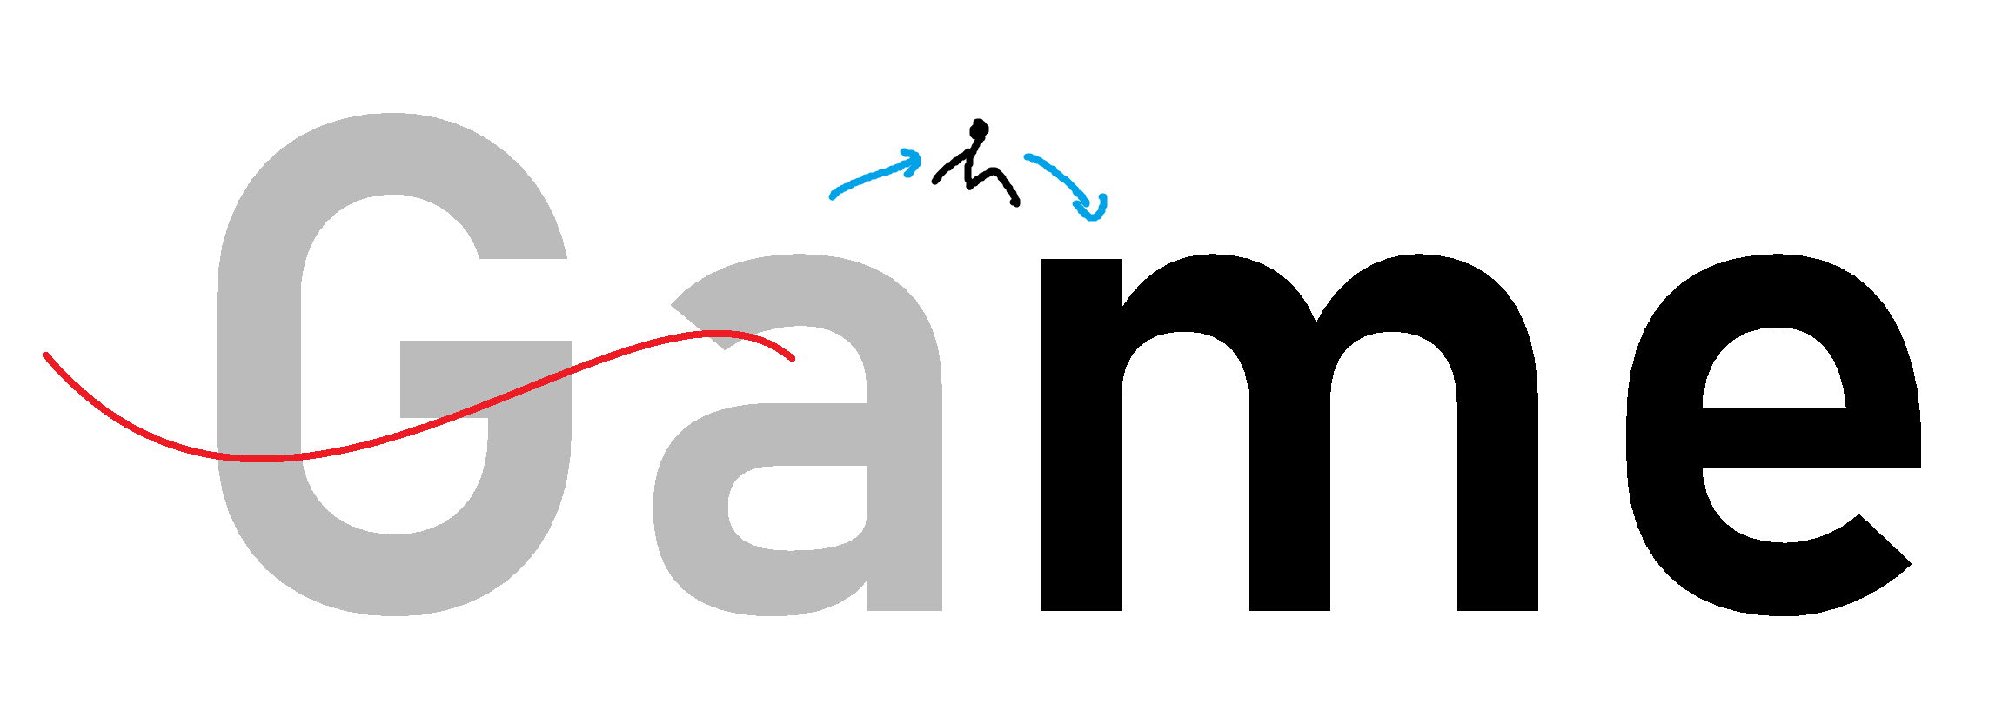

Every time a letter is touched by the red line it changes colour and if the character is still on its surface, it just falls down, dying in it.

1. **Follow the perfect path in order to get the maximum score**

In the maps there are some collectibles that suggest the right path that the player has to follow in order to get the maximum score, the score that the player gets at the end of a level is the percentage of collectibles that the player has collected during the level.

The player could pass the level even without getting any collectible, they are useful only for the sore, to give the player the possibility to verify his improvement in the same level and to increase his skills in the game.

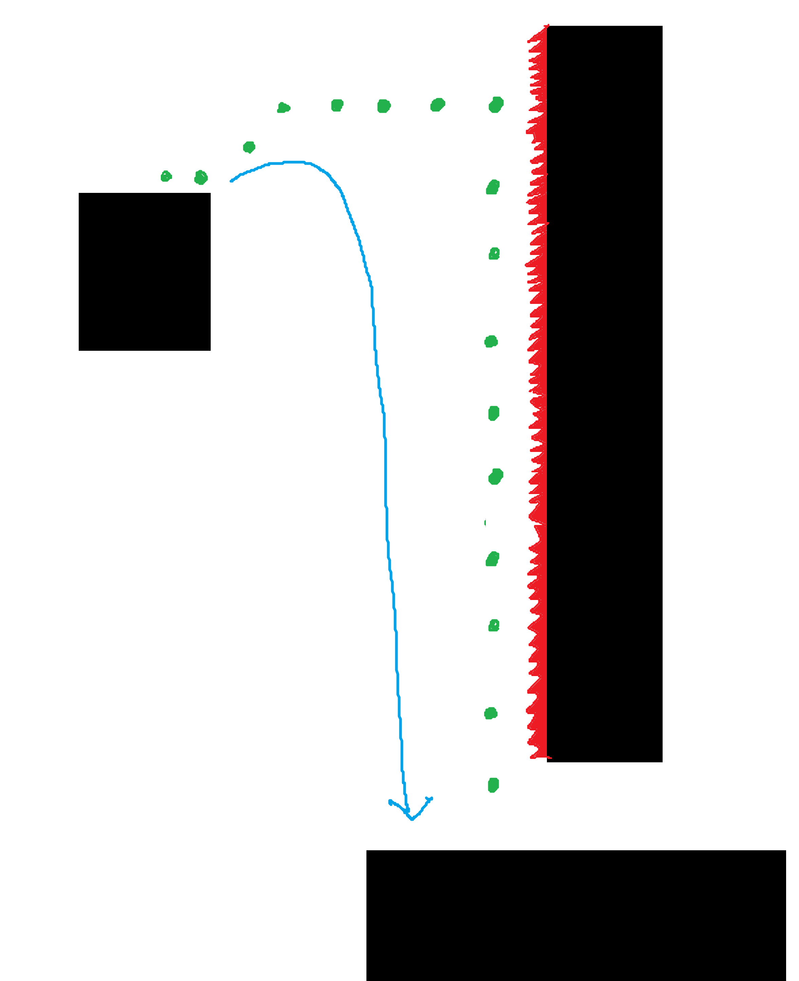The image on the right is an example of gameplay where the player can choose to follow a personal path (much easier) or the perfect path in order to collect all the collectibles, the higher is the percentage of the collectibles on the total the player gets, the higher is the total score in the end.   
In order to move in such a specific way in the air they have been inserted specific commands that will be showed in the section below.  
The maps are designed on the perfect sequence of moves that the player has to perform in order to get all the coins, but obviously they allow also more free movements as the blue path in the image shows so to be approachable also to players with less experience

**Actions and Controls**

The possibility to do such specific moves when in air as shown for the perfect path in the image above is guaranteed by a set of specific actions that the player can do, each one of them has a particular movement effect.

|  |  |  |
| --- | --- | --- |
| **Command** | **Description** | **Keyboard** |
| Move left | The character moves left, if the player keep pressing and the character is on ground it goes faster and it goes in “run” mode |  |
| Move right | The character moves right, if the player keep pressing and the character is on ground it goes faster and it goes in “run” mode |  |
| Jump | The character jumps | Spacebar |
| Double jump | If the player presses the spacebar while the character is in air, it can perform another jump, as if it was on the ground, this can be done only once, to redo this action the character has to touch the ground again first | Spacebar in air |
| Wall grappling | If the character is in contact with a vertical wall it remains partially attached to it, falling down very slowly because of the friction, in this way if it’s performed the jump a lateral force is given by the wall in order to provide the wall jump |  |
| Crouch | If the player is stopped or is in Walk mode it can crouch down in order to pass under low surfaces, in this mode the speed is very reduced | Ctrl during Walk or when stopped |
| Slide | If the player performs the Crouch while is running it performs a slide, getting down and proceeding with much more speed than the normal crouch, using the inertia given by the run, it becomes slower with the friction of the ground until it stops, if the player keeps pressing ctrl the when it’s stopped it’s possible to proceed in crouch mode | Ctrl during run |
| Dash | The character (both in air or on the ground) gets a strong acceleration in the direction he is watching, in this way he can perform almost horizontal trajectories even in air, it’s not possible perform the dash during the crouch, but it can be done just before the slide to have a greater speed at the beginning of it. The dash has a cooldown before getting used again | Shift |
| Flip | If the player press CRTL while the character is in air, it performs a flip and it immediately stops the horizontal speed, in this way a fast trajectory in air (during a dash for example) can be brutally stopped and translated in a purely vertical one. | Ctrl in air |

Especially with the use of dash, flip and double jump the player, combining them could potentially follow very specific trajectories in air, allowing it to pass through maps with a structure like the one below (in advanced levels of course)

