Scenario 1

User Goal / AI Task: Answer a given question on an image.

Task Context Description: Since the image is very cluttered, you have access to an AI system which can help you with sifting through it, answering the question. Below you’ll find an answer found by the AI system. Please verify whether it’s correct or not.

Question: Where are the tennis items (bag, balls, racket, shoes, visor) that Mary is looking for?

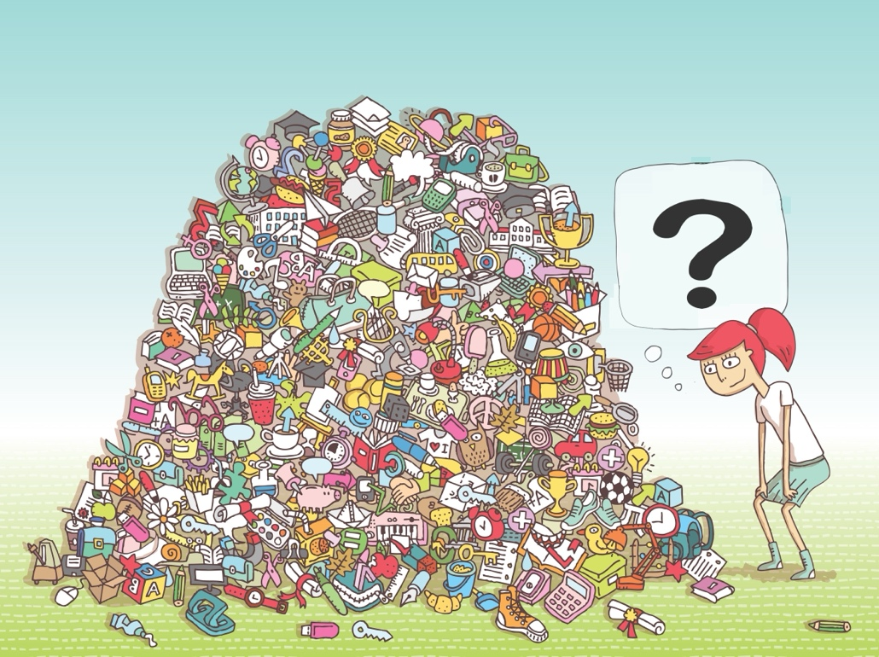

—
AI Output (Correct Answer): Centre: balls; Top-centre: racket and bag; Right-bottom: shoes; Left-bottom: visor.

MAGIX-defined Explanation (Q1: Rule based + How):
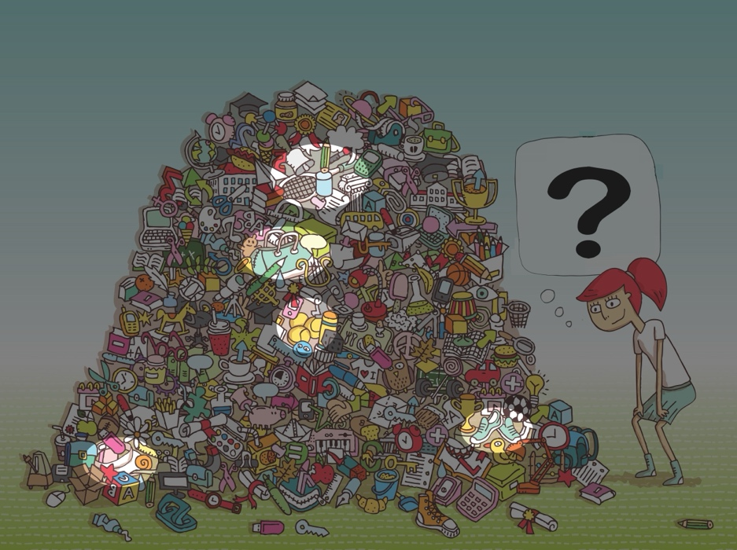

Non-MAGIX defined Explanation (Q3: Rule-based + How + Why):
Tennis Racket:
- The tennis racket is at the top-centre because there is an item with: handle, stringed surface, oval frame.
Tennis Balls
- The tennis balls are at the centre because there is an item with: spherical shape, small size, bright yellow, seams.
Tennis Shoes
- The tennis shoes are at the right-bottom because there is an item with: lace-up sneakers, reinforced sole, sporty silhouette.
Hat / Visor
- The visor is at the left-bottom because there is an item with: open top, curved brim.
Tennis Bag
- The tennis bag is at the centre because there is an item with: elongated soft bag, strap handles, fits rackets.
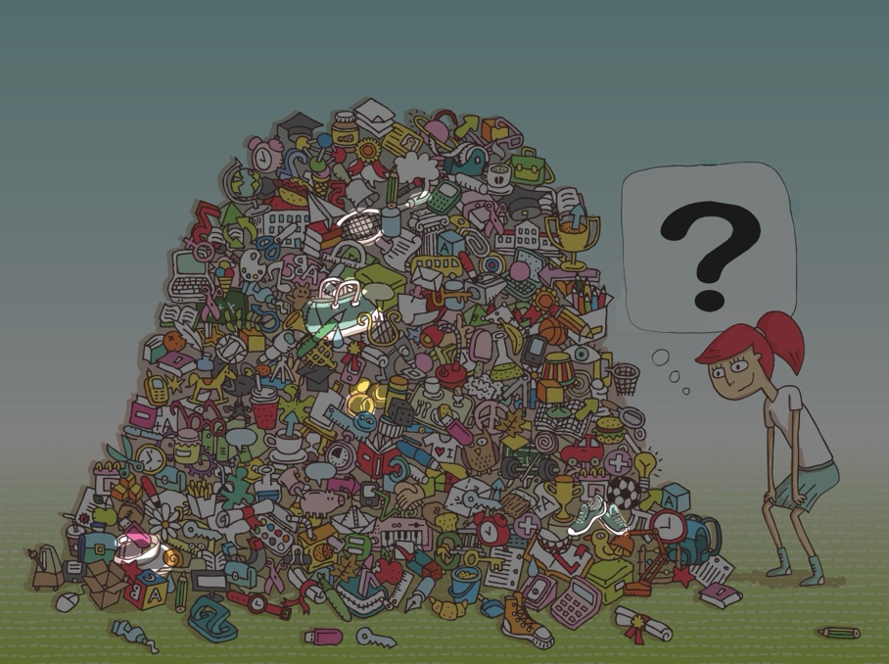

—
AI Output (Incorrect Answer): Centre: balls; Top-centre: racket; Top-right: hat; Right-bottom: backpack; Bottom: sneaker.

MAGIX-defined Explanation (Q1: Rule based + How):
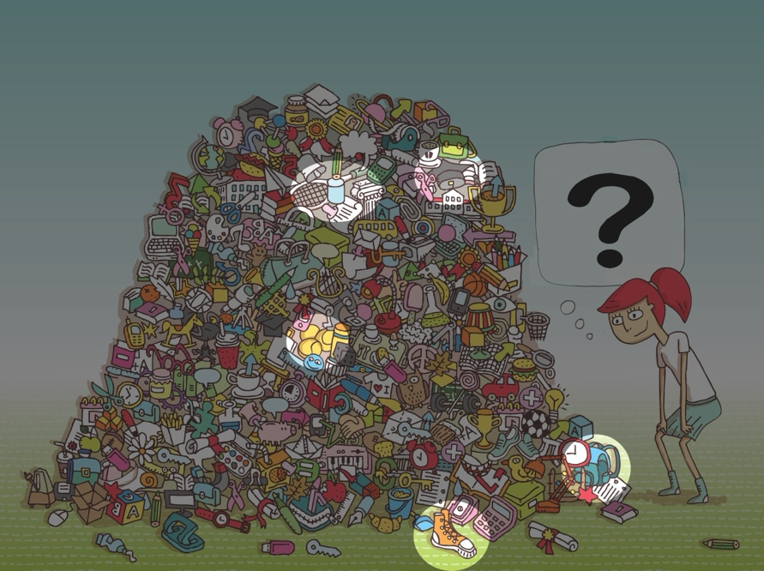

Non-MAGIX defined Explanation (Q3: Rule based + How + Why):
Tennis Racket:
- The tennis racket is at the top-centre because there is an item with: handle, stringed surface, oval frame.
Tennis Balls
- The tennis balls are at the centre because there is an item with: spherical shape, small size, bright yellow, seams.
Sneaker
- The sneaker is at the bottom because there is an item with: lace-up design, rubber sole, ankle height.
Hat
- The hat is at the top-right because there is an item with: tall cylindrical crown, flat circular brim, dark color.
Backpack
- The backpack is at the right-bottom because there is an item with: rounded shape, zipper outline, strap handle.
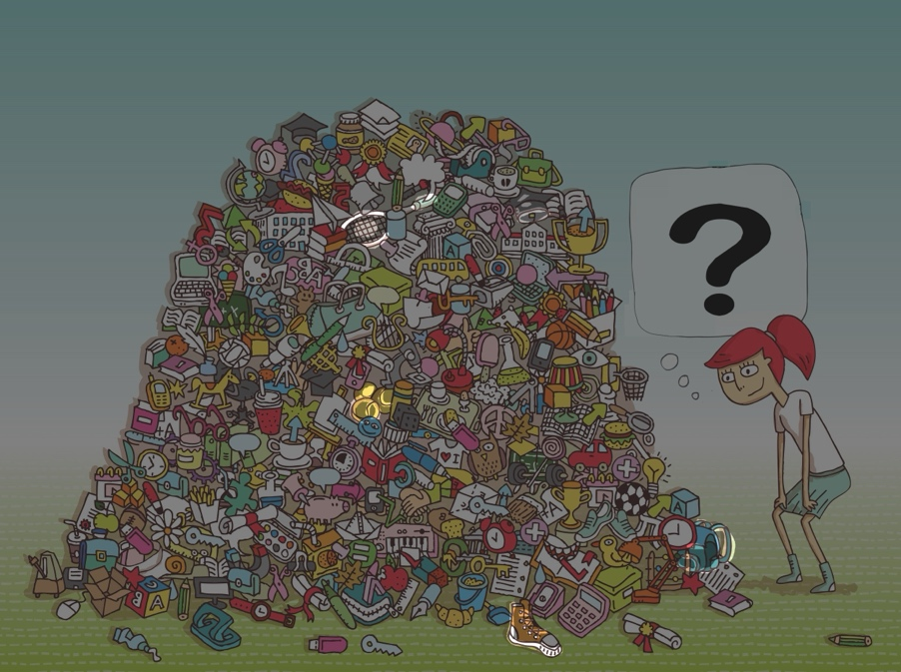

Scenario 2

User Goal: “Understand what digits is written on paper as part of a digitalization process of handwritten notes”

Task Context Description: Since the handwritten digit is not very clear, you can use an AI to help you better understand what’s the correct digit.

Question: “What digit is in the handwritten note below?”
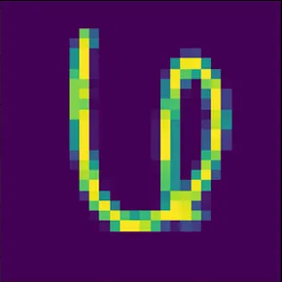

—
AI Output (Correct Answer): It’s a “6”

MAGIX-defined Explanation (Q2: Case based + How):

Here are past input digits that were correctly labeled and are similar to yours:

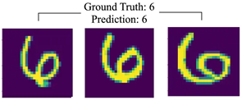

Non-MAGIX defined Explanation (Q4: Case based + How + Why):

Here are past input digits that were correctly labeled and are similar to yours:
- Left: Closed lower loop with open top → a “6”.
- Middle: Same bottom loop plus a small upward tail; top stays open.
- Right: Looser spiral, but the loop is at the bottom and the top doesn’t close.


—
AI Output (Incorrect Answer): It’s a “4”

MAGIX-defined Explanation (Q2: Case based + How):

Here are past input digits that were correctly labeled and are similar to yours:

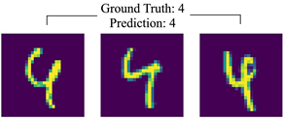

Non-MAGIX defined Explanation (Q4: Case based + How + Why):

Here are past input digits that were correctly labeled and are similar to yours:
- Left: An open-top 4 — diagonal meets a vertical stem with a mid crossbar, leaving an open counter at the top.
- Middle: Same open-top pattern: clear crossbar crossing the stem with the diagonal “leg” anchoring it — the typical three-stroke structure of a handwritten 4.
- Right: A closed-top 4 — the diagonal and bar form a triangular, closed counter at the top, alongside the right stem.



Scenario 2-bis

User Goal: “Understand what ancient character is written on paper as part of a digitalization process of historical documents”

Task Context Description: Since the ancient character is not very clear, you can use an AI to help you better understand what’s the correct associated character.

Question: “What ancient character is represented in the image below?”

—
AI Output (Correct Answer): It’s a “next 翌”

MAGIX-defined Explanation (Q2: Case based + How):

Here are past input digits that were correctly labeled and are similar to yours:

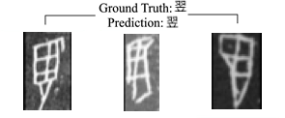

Non-MAGIX defined Explanation (Q4: Case based + How + Why):

Here are past input digits that were correctly labeled and are similar to yours:
- Left: Clear top ‘head’ (立) at the lower end (short flipped roof + descending spine). Above it, the wing section (羽) appears as a stacked, boxy grid attached to the spine, ending in a tapering lower stroke—a common oracle-style way to render the feathers and tail.
- Middle: The vertical spine (立) is straighter and more central, with two internal crossbars. The upper half shows a segmented wing (羽); although the cells are elongated, you still see three stacked compartments and a slight curved tail at the top.
- Right: Most compressed variant: the bottom head (立) is compact, split into small upper cells; above it the wing (羽) shows as two boxes plus a pointed lower panel, with a pronounced downward taper along the left edge—the same spine/tail geometry of 翌.


—
AI Output (Incorrect Answer): It’s a “field 田”

MAGIX-defined Explanation (Q2: Case based + How):

Here are past input digits that were correctly labeled and are similar to yours:

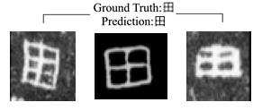

Non-MAGIX defined Explanation (Q4: Case based + How + Why):

Here are past input digits that were correctly labeled and are similar to yours:
- Left: Skewed but still a boxed enclosure with an off-center cross; all four compartments remain legible despite the diagonal slant. The left wall bows slightly and the corners close cleanly; the inner vertical runs nearly top-to-bottom with a faint curve, and the horizontal reaches both sides. No tail above the box (so not 由), just stroke thickening from quick writing.
- Middle: The canonical 田: nearly square outer frame, clear vertical and horizontal split, producing balanced 2×2 panes with closed corners. Proportions are regular, edges are straight, and there’s no open top or dangling stroke.
- Right: Compact, ink-heavy rendering: the outer box is tight and the vertical midline is strong; the inner horizontal is lighter but runs through the center, yielding four shallow cells.


Scenario 3

User Goal / AI Task: “Analyse a figure and determine whether a specific specimen of monkey is present.”

Task Context Description: The AI has access to a trusted database of monkeys, along with related information on species identification, which it can use to support accurate identification and verification.

Question: Does this image contain a hamadryas baboon monkey? (DON’T GOOGLE IT!!)
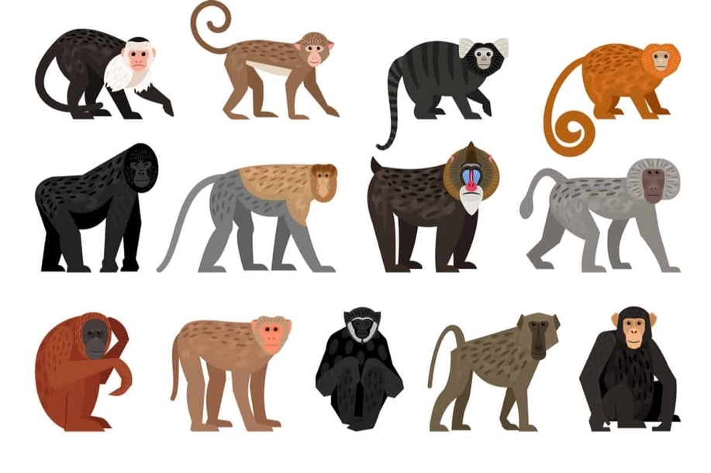
—
AI Output (Correct): Yes, the left-centre monkey is a hamadryas baboon.

MAGIX-defined Explanation (Q3: Rule based + How + Why):
Hamadryas baboon:
- The hamadryas baboon is at the left-centre monkey because it has: light grey body, grey mane around head, quadrupedal stance, elongated snout.
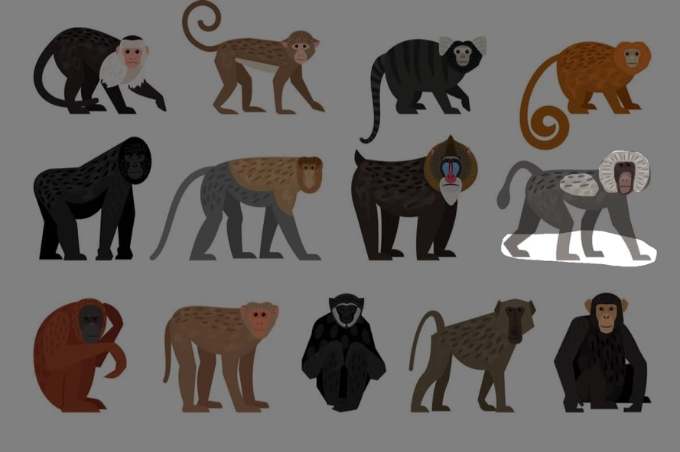
Non-MAGIX defined Explanation (Q1: Rule based + How)
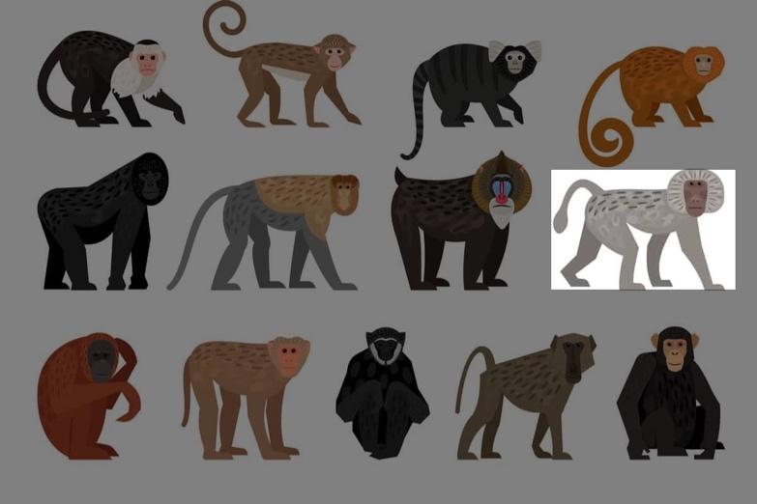
—
AI Output (Incorrect): Yes, the second monkey from the left on the bottom is a hamadryas baboon.

MAGIX-defined Explanation (Q3: Rule based + How + Why):
Hamadryas baboon:
- The hamadryas baboon is at the second monkey from the left on the bottom because it has: four legs, a tail, a head, two eyes, quadrupedal stance.
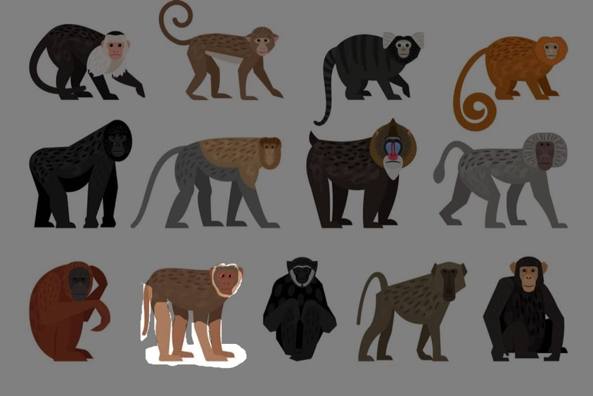

Non-MAGIX defined Explanation (Q1: Rule based + How):
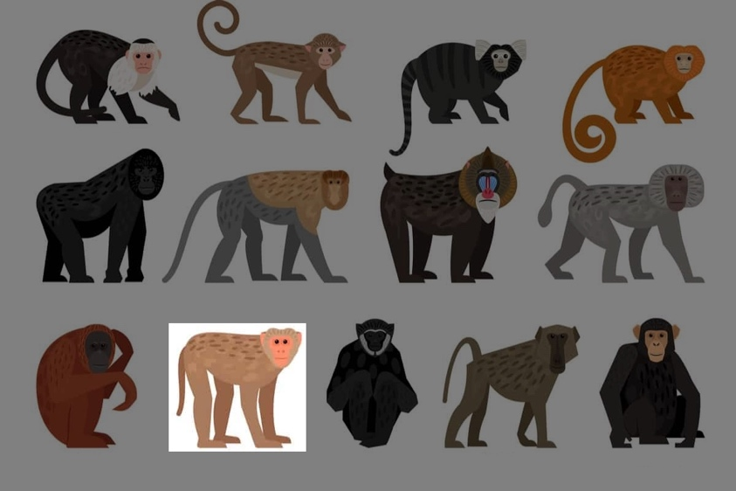

Scenario 4

User Goal: “Understand whether a given map can be safely used to compare the sizes of continents.”

Task Context Description: The AI has access to a trusted online cartography resources, along with related information on map properties, which it can use to provide the right answer.

Question: “I wanna see the true size of continents. Does this world projection map preserve area and size?”
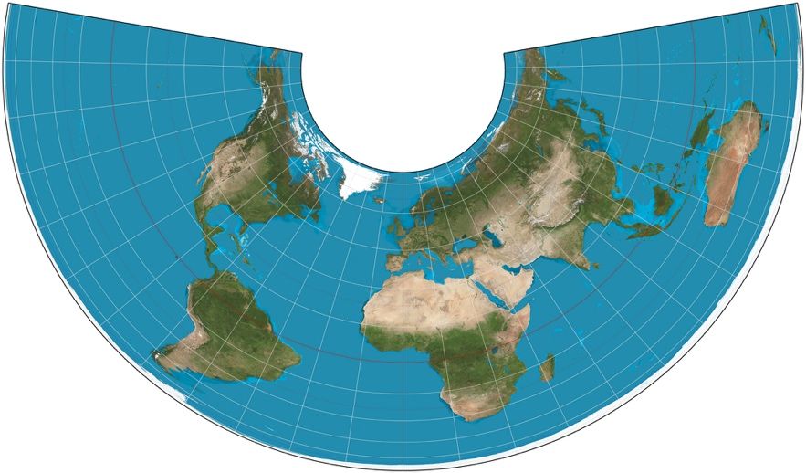

—
AI Output (Correct Answer): Yes

MAGIX-defined Explanation (Q4: Case based + How + Why):
Here are past queries that were correctly answered and are similar to yours:
- Similar Past Query: "I want a visualization that doesn’t inflate or shrink continents. Is this map using an area-preserving method?" 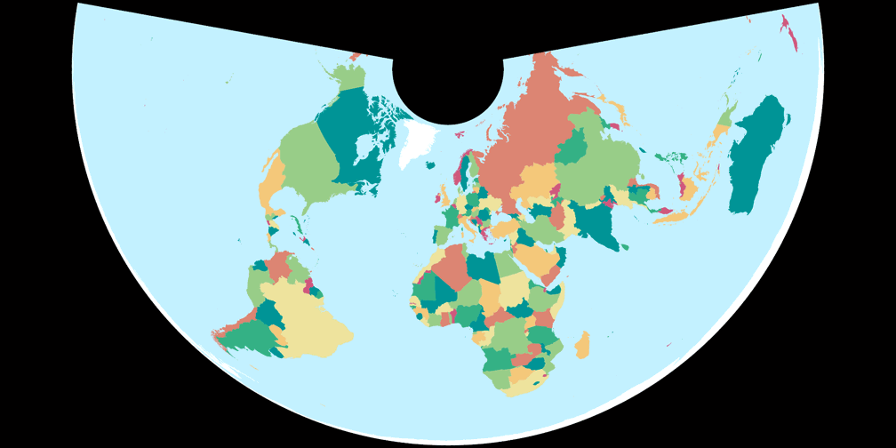
- Correct Answer: Yes.
- Justification: The image provided in input is an Albers projection. The Albers projection preserves area, so continents keep their true size. Distortion is minimal between the chosen latitude lines, but near the pole Antarctica looks stretched east–west and squashed north–south, creating the illusion it’s “too big” even though area is mathematically correct.

Non-MAGIX defined Explanation (Q2: Case based + How):
Here are past queries that were correctly answered and are similar to yours:
- Similar Past Query: "I want a visualization that doesn’t inflate or shrink continents. Is this map using an area-preserving method?" 
- Correct Answer: Yes.

—
AI Output (Incorrect Answer): No

MAGIX-defined Explanation (Q4: Case based + How + Why):
Here are past queries that were correctly answered and are similar to yours:
- Similar Past Query: "I want to compare one continent to another. Does this map preserve area, shape, and angles?" 
- Correct Answer: No.
- Justification: The image provided in input is an Albers projection. The Albers projection preserves area, so continents keep their true size. However shapes are distorted. For example, near the pole Antarctica is stretched east–west and squashed north–south, losing its original shape.

Non-MAGIX defined Explanation (Q2: Case based + How):
Here are past queries that were correctly answered and are similar to yours:
- Similar Past Query: "I want to compare one continent to another. Does this map preserve area, shape, and angles?" 
- Correct Answer: No.

