Scenario 1

User Goal / AI Task: Answer a given question on an image.

Task Context Description: Since the image is very cluttered, you have access to an AI system which can help you with sifting through it, answering the question. Below you’ll find an answer found by the AI system. Please verify whether it’s correct or not.

Question: Where are the tennis items (bag, balls, racket, shoes, visor) that Mary is looking for?

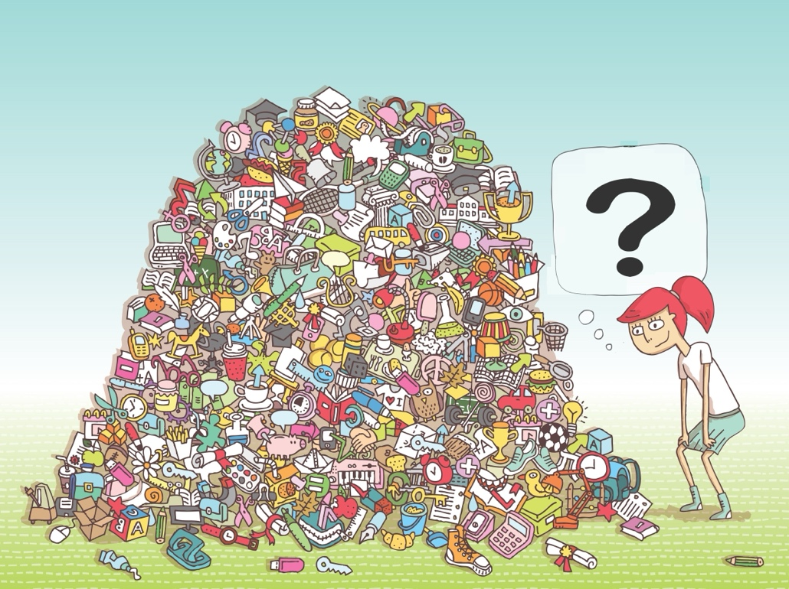

—
AI Output (Correct Answer): Centre: balls; Top-centre: racket and bag; Right-bottom: shoes; Left-bottom: visor.

MAGIX-defined Explanation (Q1: Rule based + How):
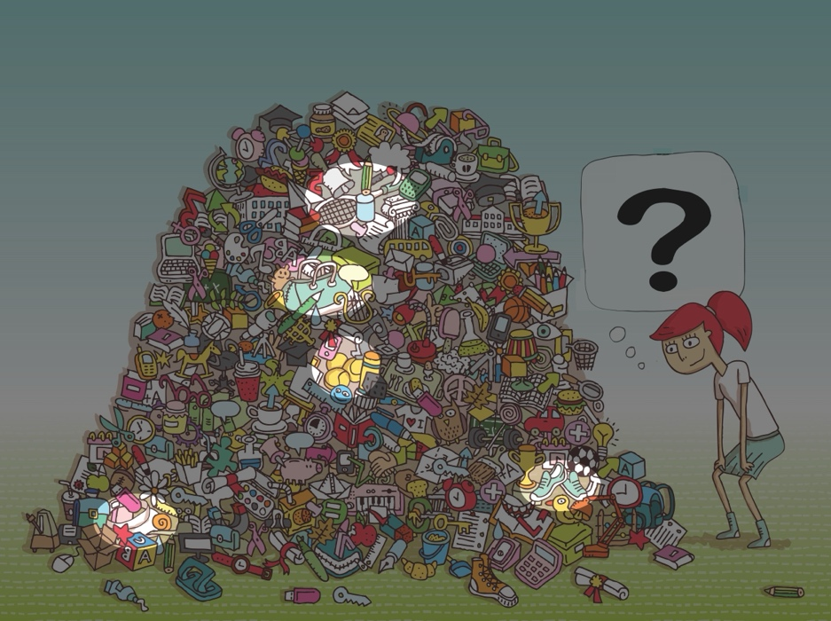

Non-MAGIX defined Explanation (Q3: Rule-based + How + Why):
Tennis Racket:
- The tennis racket is at the top-centre because there is an item with: handle, stringed surface, oval frame.
Tennis Balls
- The tennis balls are at the centre because there is an item with: spherical shape, small size, bright yellow/green felt.
Tennis Shoes
- The tennis shoes are at the right-bottom because there is an item with: lace-up sneakers, reinforced sole, sporty silhouette.
Hat / Visor
- The visor is at the left-bottom because there is an item with: headgear, curved brim, lightweight fabric.
Tennis Bag
- The tennis bag is at the centre because there is an item with: elongated soft bag, strap handles, fits rackets.
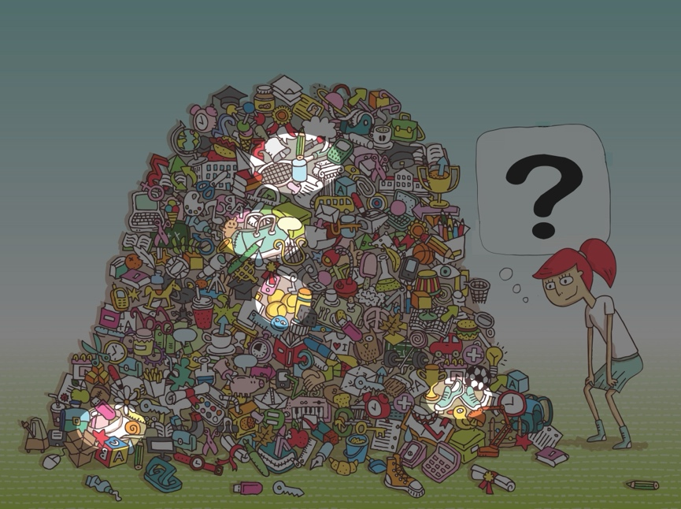

—
AI Output (Incorrect Answer): Centre: balls; Top-centre: racket; Top-right: hat; Right-bottom: backpack; Bottom: sneaker.

MAGIX-defined Explanation (Q1: Rule based + How):
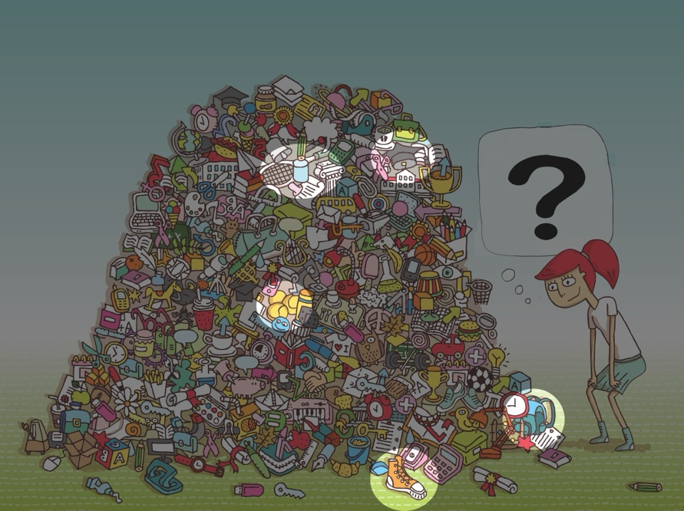

Non-MAGIX defined Explanation (Q3: Rule based + How + Why):
Tennis Racket:
- The tennis racket is at the top-centre because there is an item with: handle, stringed surface, oval frame.
Tennis Balls
- The tennis balls are at the centre because there is an item with: spherical shape, small size, bright yellow/green felt.
Sneaker
- The sneaker is at the bottom because there is an item with: lace-up design, rubber sole, athletic silhouette, ankle height.
Hat
- The hat is at the top-right because there is an item with: tall cylindrical crown, flat circular brim, dark color.
Backpack
- The backpack is at the right-bottom because there is an item with: elongated, rounded shape, zipper outline, strap handle.
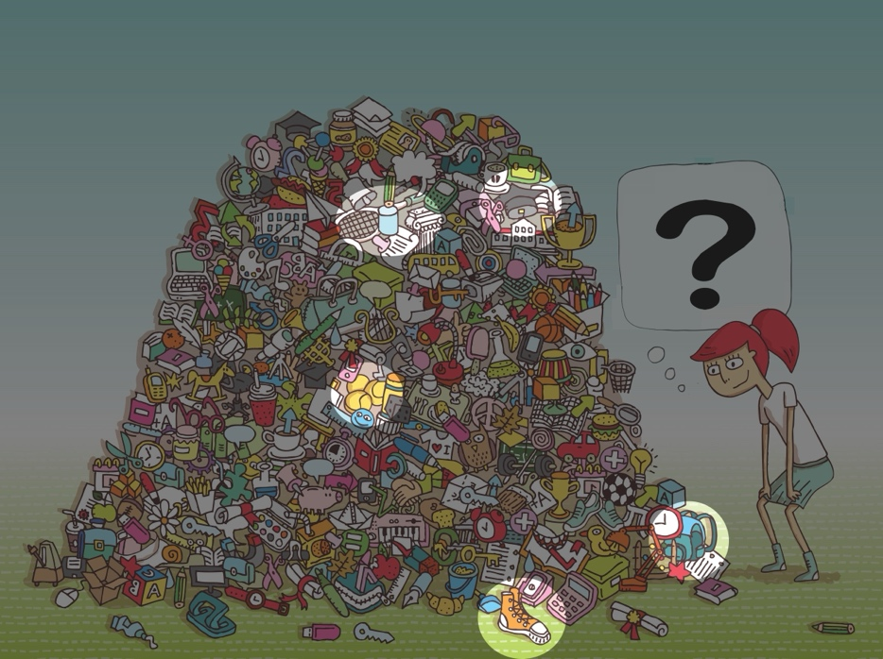

Scenario 2

User Goal: “TBD”

Task Context Description: TBD

AI Task: “TBD”

—
AI Output (Correct Answer): TBD

MAGIX-defined Explanation (Q2: Case based + How):
- TBD

Non-MAGIX defined Explanation (Q4: Case based + How + Why):
- TBD

—
AI Output (Incorrect Answer): TBD

MAGIX-defined Explanation (Q2: Case based + How):
- TBD

Non-MAGIX defined Explanation (Q4: Case based + How + Why):
- TBD

Scenario 3

User Goal / AI Task: “Analyse a figure and determine whether a specific specimen of monkey is present.”

Task Context Description: The AI has access to a trusted database of monkeys, along with related information on species identification, which it can use to support accurate identification and verification.

Question: Does this image contain a hamadryas baboon monkey? (DON’T GOOGLE IT!!)
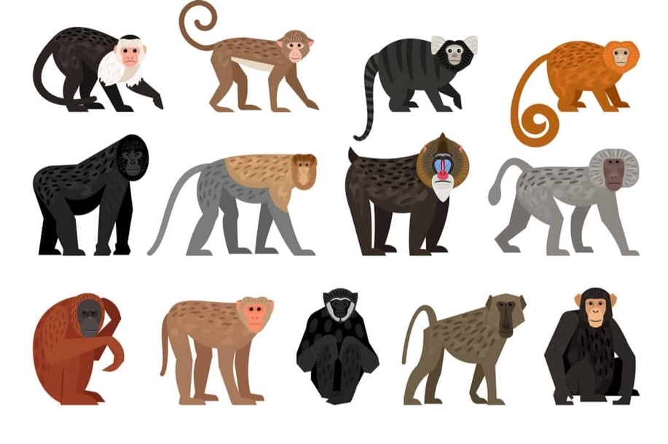
—
AI Output (Correct): Yes, the left-centre monkey is a hamadryas baboon.

MAGIX-defined Explanation (Q3: Rule based + How + Why):
Hamadryas baboon:
- The hamadryas baboon is at the left-centre monkey because it has: light grey body, grey mane around head, quadrupedal stance, elongated snout, heavy jawline.
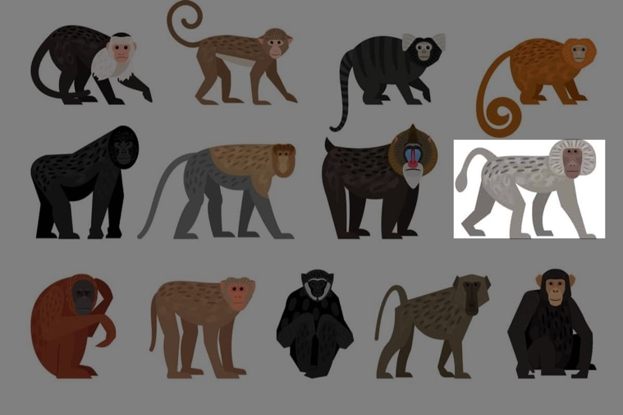
Non-MAGIX defined Explanation (Q1: Rule based + How)
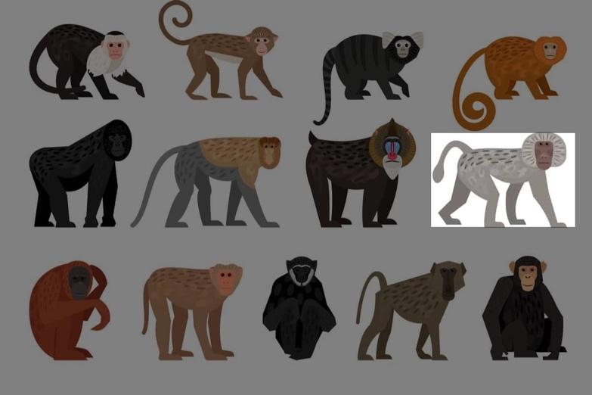
—
AI Output (Incorrect): Yes, the second monkey from the left on the bottom is a hamadryas baboon.

MAGIX-defined Explanation (Q3: Rule based + How + Why):
Hamadryas baboon:
- The hamadryas baboon is at the second monkey from the left on the bottom because it has: four legs, a tail, a head, two eyes, quadrupedal stance.
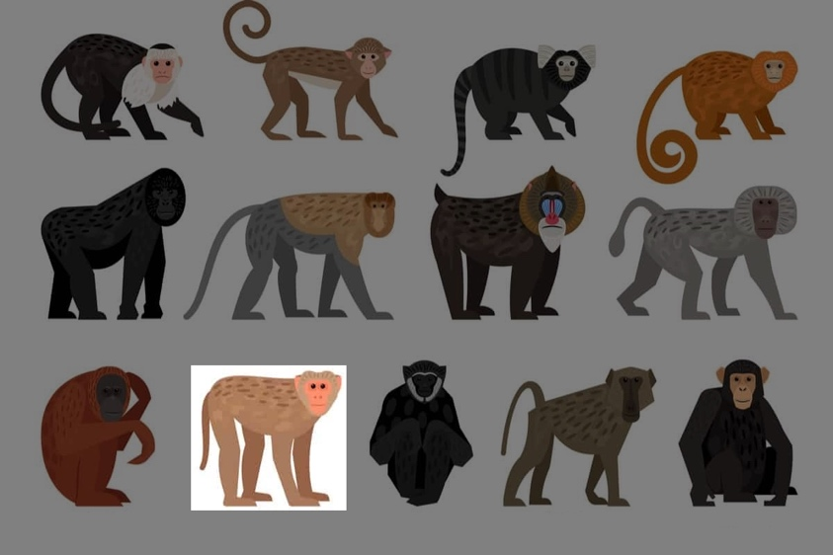

Non-MAGIX defined Explanation (Q1: Rule based + How):


Scenario 4

User Goal: “TBD”

Task Context Description: TBD

AI Task: “TBD”

—
AI Output (Correct Answer): TBD

MAGIX-defined Explanation (Q4: Case based + How + Why):
- TBD

Non-MAGIX defined Explanation (Q2: Case based + How):
- TBD

—
AI Output (Incorrect Answer): TBD

MAGIX-defined Explanation (Q4: Case based + How + Why):
- TBD

Non-MAGIX defined Explanation (Q2: Case based + How):
- TBD

