20.12.2012 EN Official Journal of the European Union L 351/1



I

*(Legislative acts)*

REGULATIONS

**REGULATION (EU) No 1215/2012 OF THE EUROPEAN PARLIAMENT AND OF THE COUNCIL**

**of 12 December 2012**

**on jurisdiction and the recognition and enforcement of judgments in civil and commercial matters**

**(recast)**

THE EUROPEAN PARLIAMENT AND THE COUNCIL OF THE EUROPEAN UNION,

Having regard to the Treaty on the Functioning of the European Union, and in particular Article 67(4) and points (a), (c) and (e) of Article 81(2) thereof,

Having regard to the proposal from the European Commission,

After transmission of the draft legislative act to the national parliaments,

Having regard to the opinion of the European Economic and Social Committee ( 1 ),

Acting in accordance with the ordinary legislative procedure ( 2),

Whereas:

1. On 21 April 2009, the Commission adopted a report on the application of Council Regulation (EC) No 44/2001 of 22 December 2000 on jurisdiction and the recog­ nition and enforcement of judgments in civil and commercial matters ( 3 ). The report concluded that, in general, the operation of that Regulation is satisfactory, but that it is desirable to improve the application of certain of its provisions, to further facilitate the free circulation of judgments and to further enhance access



( 1 ) OJ C 218, 23.7.2011, p. 78.

|  |  |
| --- | --- |
| ( 2 ) | Position of the European Parliament of 20 November 2012 (not yet |
|  | published in the Official Journal) and decision of the Council of |
| ( 3 ) | 6 December 2012. |
| OJ L 12, 16.1.2001, p. 1. |

to justice. Since a number of amendments are to be made to that Regulation it should, in the interests of clarity, be recast.

1. At its meeting in Brussels on 10 and 11 December 2009, the European Council adopted a new multiannual programme entitled ‘The Stockholm Programme – an open and secure Europe serving and protecting citizens’ ( 4). In the Stockholm Programme the European Council considered that the process of abolishing all intermediate measures (the exequatur) should be continued during the period covered by that Programme. At the same time the abolition of the exequatur should also be accompanied by a series of safeguards.
2. The Union has set itself the objective of maintaining and developing an area of freedom, security and justice, inter alia, by facilitating access to justice, in particular through the principle of mutual recognition of judicial and extra-judicial decisions in civil matters. For the gradual estab­ lishment of such an area, the Union is to adopt measures relating to judicial cooperation in civil matters having cross-border implications, particularly when necessary for the proper functioning of the internal market.
3. Certain differences between national rules governing jurisdiction and recognition of judgments hamper the sound operation of the internal market. Provisions to unify the rules of conflict of jurisdiction in civil and commercial matters, and to ensure rapid and simple recognition and enforcement of judgments given in a Member State, are essential.
4. Such provisions fall within the area of judicial cooperation in civil matters within the meaning of Article 81 of the Treaty on the Functioning of the European Union (TFEU).



( 4 ) OJ C 115, 4.5.2010, p. 1.

L 351/2 EN Official Journal of the European Union 20.12.2012



1. In order to attain the objective of free circulation of judgments in civil and commercial matters, it is necessary and appropriate that the rules governing juris­ diction and the recognition and enforcement of judgments be governed by a legal instrument of the Union which is binding and directly applicable.
2. On 27 September 1968, the then Member States of the European Communities, acting under Article 220, fourth indent, of the Treaty establishing the European Economic Community, concluded the Brussels Convention on Juris­ diction and the Enforcement of Judgments in Civil and Commercial Matters, subsequently amended by conventions on the accession to that Convention of new Member States ( 1 ) (‘the 1968 Brussels Convention’). On 16 September 1988, the then Member States of the European Communities and certain EFTA States concluded the Lugano Convention on Jurisdiction and the Enforcement of Judgments in Civil and Commercial Matters ( 2 ) (‘the 1988 Lugano Convention’), which is a parallel convention to the 1968 Brussels Convention. The 1988 Lugano Convention became applicable to Poland on 1 February 2000.
3. On 22 December 2000, the Council adopted Regulation (EC) No 44/2001, which replaces the 1968 Brussels Convention with regard to the territories of the Member States covered by the TFEU, as between the Member States except Denmark. By Council Decision 2006/325/EC ( 3), the Community concluded an agreement with Denmark ensuring the application of the provisions of Regulation (EC) No 44/2001 in Denmark. The 1988 Lugano Convention was revised by the Convention on Jurisdiction and the Recognition and Enforcement of Judgments in Civil and Commercial Matters ( 4 ), signed at Lugano on 30 October 2007 by the Community, Denmark, Iceland, Norway and Switzerland (‘the 2007 Lugano Convention’).
4. The 1968 Brussels Convention continues to apply to the territories of the Member States which fall within the territorial scope of that Convention and which are excluded from this Regulation pursuant to Article 355 of the TFEU.
5. The scope of this Regulation should cover all the main civil and commercial matters apart from certain well-defined matters, in particular maintenance obligations, which should be excluded from the scope of this Regu­ lation following the adoption of Council Regulation (EC)



( 1 ) OJ L 299, 31.12.1972, p. 32, OJ L 304, 30.10.1978, p. 1, OJ L 388, 31.12.1982, p. 1, OJ L 285, 3.10.1989, p. 1, OJ C 15, 15.1.1997, p. 1. For a consolidated text, see OJ C 27, 26.1.1998, p. 1.

( 2 ) OJ L 319, 25.11.1988, p. 9.

( 3 ) OJ L 120, 5.5.2006, p. 22.

( 4 ) OJ L 147, 10.6.2009, p. 5.

No 4/2009 of 18 December 2008 on jurisdiction, applicable law, recognition and enforcement of decisions and cooperation in matters relating to main­ tenance obligations ( 5).

1. For the purposes of this Regulation, courts or tribunals of the Member States should include courts or tribunals common to several Member States, such as the Benelux Court of Justice when it exercises jurisdiction on matters falling within the scope of this Regulation. Therefore, judgments given by such courts should be recognised and enforced in accordance with this Regulation.
2. This Regulation should not apply to arbitration. Nothing in this Regulation should prevent the courts of a Member State, when seised of an action in a matter in respect of which the parties have entered into an arbitration agreement, from referring the parties to arbitration, from staying or dismissing the proceedings, or from examining whether the arbitration agreement is null and void, inoperative or incapable of being performed, in accordance with their national law.

A ruling given by a court of a Member State as to whether or not an arbitration agreement is null and void, inoperative or incapable of being performed should not be subject to the rules of recognition and enforcement laid down in this Regulation, regardless of whether the court decided on this as a principal issue or as an incidental question.

On the other hand, where a court of a Member State, exercising jurisdiction under this Regulation or under national law, has determined that an arbitration agreement is null and void, inoperative or incapable of being performed, this should not preclude that court’s judgment on the substance of the matter from being recognised or, as the case may be, enforced in accordance with this Regulation. This should be without prejudice to the competence of the courts of the Member States to decide on the recognition and enforcement of arbitral awards in accordance with the Convention on the Recog­ nition and Enforcement of Foreign Arbitral Awards, done at New York on 10 June 1958 (‘the 1958 New York Convention’), which takes precedence over this Regu­ lation.

This Regulation should not apply to any action or ancillary proceedings relating to, in particular, the estab­ lishment of an arbitral tribunal, the powers of arbitrators, the conduct of an arbitration procedure or any other aspects of such a procedure, nor to any action or judgment concerning the annulment, review, appeal, recognition or enforcement of an arbitral award.



( 5 ) OJ L 7, 10.1.2009, p. 1.

20.12.2012 EN Official Journal of the European Union L 351/3



1. There must be a connection between proceedings to which this Regulation applies and the territory of the Member States. Accordingly, common rules of juris­ diction should, in principle, apply when the defendant is domiciled in a Member State.
2. A defendant not domiciled in a Member State should in general be subject to the national rules of jurisdiction applicable in the territory of the Member State of the court seised.

However, in order to ensure the protection of consumers and employees, to safeguard the jurisdiction of the courts of the Member States in situations where they have exclusive jurisdiction and to respect the autonomy of the parties, certain rules of jurisdiction in this Regulation should apply regardless of the defendant’s domicile.

1. The rules of jurisdiction should be highly predictable and founded on the principle that jurisdiction is generally based on the defendant’s domicile. Jurisdiction should always be available on this ground save in a few well-defined situations in which the subject-matter of the dispute or the autonomy of the parties warrants a different connecting factor. The domicile of a legal person must be defined autonomously so as to make the common rules more transparent and avoid conflicts of jurisdiction.
2. In addition to the defendant’s domicile, there should be alternative grounds of jurisdiction based on a close connection between the court and the action or in order to facilitate the sound administration of justice. The existence of a close connection should ensure legal certainty and avoid the possibility of the defendant being sued in a court of a Member State which he could not reasonably have foreseen. This is important, particularly in disputes concerning non-contractual obligations arising out of violations of privacy and rights relating to personality, including defamation.
3. The owner of a cultural object as defined in Article 1(1) of Council Directive 93/7/EEC of 15 March 1993 on the return of cultural objects unlawfully removed from the territory of a Member State ( 1) should be able under this Regulation to initiate proceedings as regards a civil claim for the recovery, based on ownership, of such a cultural object in the courts for the place where the cultural object is situated at the time the court is seised. Such proceedings should be without prejudice to proceedings initiated under Directive 93/7/EEC.



( 1 ) OJ L 74, 27.3.1993, p. 74.

1. In relation to insurance, consumer and employment contracts, the weaker party should be protected by rules of jurisdiction more favourable to his interests than the general rules.
2. The autonomy of the parties to a contract, other than an insurance, consumer or employment contract, where only limited autonomy to determine the courts having jurisdiction is allowed, should be respected subject to the exclusive grounds of jurisdiction laid down in this Regu­ lation.
3. Where a question arises as to whether a choice-of-court agreement in favour of a court or the courts of a Member State is null and void as to its substantive validity, that question should be decided in accordance with the law of the Member State of the court or courts designated in the agreement, including the conflict-of-laws rules of that Member State.
4. In the interests of the harmonious administration of justice it is necessary to minimise the possibility of concurrent proceedings and to ensure that irreconcilable judgments will not be given in different Member States. There should be a clear and effective mechanism for resolving cases of *lis pendens* and related actions, and for obviating problems flowing from national differences as to the determination of the time when a case is regarded as pending. For the purposes of this Regulation, that time should be defined autonomously.
5. However, in order to enhance the effectiveness of exclusive choice-of-court agreements and to avoid abusive litigation tactics, it is necessary to provide for an exception to the general *lis pendens* rule in order to deal satisfactorily with a particular situation in which concurrent proceedings may arise. This is the situation where a court not designated in an exclusive choice-of-court agreement has been seised of proceedings and the designated court is seised subsequently of proceedings involving the same cause of action and between the same parties. In such a case, the court first seised should be required to stay its proceedings as soon as the designated court has been seised and until such time as the latter court declares that it has no jurisdiction under the exclusive choice-of-court agreement. This is to ensure that, in such a situation, the designated court has priority to decide on the validity of the agreement and on the extent to which the agreement applies to the dispute pending before it. The designated court should be able to proceed irrespective of whether the non-designated court has already decided on the stay of proceedings.

L 351/4 EN Official Journal of the European Union 20.12.2012



This exception should not cover situations where the parties have entered into conflicting exclusive choice-of-court agreements or where a court designated in an exclusive choice-of-court agreement has been seised first. In such cases, the general *lis pendens* rule of this Regulation should apply.

1. This Regulation should provide for a flexible mechanism allowing the courts of the Member States to take into account proceedings pending before the courts of third States, considering in particular whether a judgment of a third State will be capable of recognition and enforcement in the Member State concerned under the law of that Member State and the proper administration of justice.
2. When taking into account the proper administration of justice, the court of the Member State concerned should assess all the circumstances of the case before it. Such circumstances may include connections between the facts of the case and the parties and the third State concerned, the stage to which the proceedings in the third State have progressed by the time proceedings are initiated in the court of the Member State and whether or not the court of the third State can be expected to give a judgment within a reasonable time.

That assessment may also include consideration of the question whether the court of the third State has exclusive jurisdiction in the particular case in circum­ stances where a court of a Member State would have exclusive jurisdiction.

1. The notion of provisional, including protective, measures should include, for example, protective orders aimed at obtaining information or preserving evidence as referred to in Articles 6 and 7 of Directive 2004/48/EC of the European Parliament and of the Council of 29 April 2004 on the enforcement of intellectual property

rights ( 1). It should not include measures which are not of a protective nature, such as measures ordering the hearing of a witness. This should be without prejudice to the application of Council Regulation (EC) No 1206/2001 of 28 May 2001 on cooperation between the courts of the Member States in the taking of evidence in civil or commercial matters ( 2 ).

1. Mutual trust in the administration of justice in the Union justifies the principle that judgments given in a Member State should be recognised in all Member States without



( 1 ) OJ L 157, 30.4.2004, p. 45.

( 2 ) OJ L 174, 27.6.2001, p. 1.

the need for any special procedure. In addition, the aim of making cross-border litigation less time-consuming and costly justifies the abolition of the declaration of enforceability prior to enforcement in the Member State addressed. As a result, a judgment given by the courts of a Member State should be treated as if it had been given in the Member State addressed.

1. For the purposes of the free circulation of judgments, a judgment given in a Member State should be recognised and enforced in another Member State even if it is given against a person not domiciled in a Member State.
2. Where a judgment contains a measure or order which is not known in the law of the Member State addressed, that measure or order, including any right indicated therein, should, to the extent possible, be adapted to one which, under the law of that Member State, has equivalent effects attached to it and pursues similar aims. How, and by whom, the adaptation is to be carried out should be determined by each Member State.
3. The direct enforcement in the Member State addressed of a judgment given in another Member State without a declaration of enforceability should not jeopardise respect for the rights of the defence. Therefore, the person against whom enforcement is sought should be able to apply for refusal of the recognition or enforcement of a judgment if he considers one of the grounds for refusal of recognition to be present. This should include the ground that he had not had the opportunity to arrange for his defence where the judgment was given in default of appearance in a civil action linked to criminal proceedings. It should also include the grounds which could be invoked on the basis of an agreement between the Member State addressed and a third State concluded pursuant to Article 59 of the 1968 Brussels Convention.
4. A party challenging the enforcement of a judgment given in another Member State should, to the extent possible and in accordance with the legal system of the Member State addressed, be able to invoke, in the same procedure, in addition to the grounds for refusal provided for in this Regulation, the grounds for refusal available under national law and within the time-limits laid down in that law.

The recognition of a judgment should, however, be refused only if one or more of the grounds for refusal provided for in this Regulation are present.

20.12.2012 EN Official Journal of the European Union L 351/5



1. Pending a challenge to the enforcement of a judgment, it should be possible for the courts in the Member State addressed, during the entire proceedings relating to such a challenge, including any appeal, to allow the enforcement to proceed subject to a limitation of the enforcement or to the provision of security.
2. In order to inform the person against whom enforcement is sought of the enforcement of a judgment given in another Member State, the certificate established under this Regulation, if necessary accompanied by the judgment, should be served on that person in reasonable time before the first enforcement measure. In this context, the first enforcement measure should mean the first enforcement measure after such service.
3. Where provisional, including protective, measures are ordered by a court having jurisdiction as to the substance of the matter, their free circulation should be ensured under this Regulation. However, provisional, including protective, measures which were ordered by such a court without the defendant being summoned to appear should not be recognised and enforced under this Regulation unless the judgment containing the measure is served on the defendant prior to enforcement. This should not preclude the recognition and enforcement of such measures under national law. Where provisional, including protective, measures are ordered by a court of a Member State not having juris­ diction as to the substance of the matter, the effect of such measures should be confined, under this Regulation, to the territory of that Member State.
4. Continuity between the 1968 Brussels Convention, Regu­ lation (EC) No 44/2001 and this Regulation should be ensured, and transitional provisions should be laid down to that end. The same need for continuity applies as regards the interpretation by the Court of Justice of the European Union of the 1968 Brussels Convention and of the Regulations replacing it.
5. Respect for international commitments entered into by the Member States means that this Regulation should not affect conventions relating to specific matters to which the Member States are parties.
6. Without prejudice to the obligations of the Member States under the Treaties, this Regulation should not affect the application of bilateral conventions and agreements between a third State and a Member State concluded before the date of entry into force of Regu­ lation (EC) No 44/2001 which concern matters governed by this Regulation.
7. In order to ensure that the certificates to be used in connection with the recognition or enforcement of judg­ ments, authentic instruments and court settlements under this Regulation are kept up-to-date, the power to adopt acts in accordance with Article 290 of the TFEU should be delegated to the Commission in respect of amendments to Annexes I and II to this Regulation. It is of particular importance that the Commission carry out appropriate consultations during its preparatory work, including at expert level. The Commission, when preparing and drawing up delegated acts, should ensure a simultaneous, timely and appropriate transmission of relevant documents to the European Parliament and to the Council.
8. This Regulation respects fundamental rights and observes the principles recognised in the Charter of Fundamental Rights of the European Union, in particular the right to an effective remedy and to a fair trial guaranteed in Article 47 of the Charter.
9. Since the objective of this Regulation cannot be suffi­ ciently achieved by the Member States and can be better achieved at Union level, the Union may adopt measures in accordance with the principle of subsidiarity as set out in Article 5 of the Treaty on European Union (TEU). In accordance with the principle of propor­ tionality, as set out in that Article, this Regulation does not go beyond what is necessary in order to achieve that objective.
10. The United Kingdom and Ireland, in accordance with Article 3 of the Protocol on the position of the United Kingdom and Ireland, annexed to the TEU and to the then Treaty establishing the European Community, took part in the adoption and application of Regulation (EC) No 44/2001. In accordance with Article 3 of Protocol No 21 on the position of the United Kingdom and Ireland in respect of the area of freedom, security and justice, annexed to the TEU and to the TFEU, the United Kingdom and Ireland have notified their wish to take part in the adoption and application of this Regulation.
11. In accordance with Articles 1 and 2 of Protocol No 22 on the position of Denmark annexed to the TEU and to the TFEU, Denmark is not taking part in the adoption of this Regulation and is not bound by it or subject to its application, without prejudice to the possibility for Denmark of applying the amendments to Regulation (EC) No 44/2001 pursuant to Article 3 of the Agreement of 19 October 2005 between the European Community and the Kingdom of Denmark on juris­ diction and the recognition and enforcement of judgments in civil and commercial matters ( 1 ),



( 1 ) OJ L 299, 16.11.2005, p. 62.

L 351/6 EN Official Journal of the European Union 20.12.2012



HAVE ADOPTED THIS REGULATION:

CHAPTER I

**SCOPE AND DEFINITIONS**

*Article 1*

1. This Regulation shall apply in civil and commercial matters whatever the nature of the court or tribunal. It shall not extend, in particular, to revenue, customs or administrative matters or to the liability of the State for acts and omissions in the exercise of State authority (*acta iure imperii*).
2. This Regulation shall not apply to:
3. the status or legal capacity of natural persons, rights in property arising out of a matrimonial relationship or out of a relationship deemed by the law applicable to such relationship to have comparable effects to marriage;
4. bankruptcy, proceedings relating to the winding-up of insolvent companies or other legal persons, judicial arrange­ ments, compositions and analogous proceedings;
5. social security;
6. arbitration;
7. maintenance obligations arising from a family relationship, parentage, marriage or affinity;
8. wills and succession, including maintenance obligations arising by reason of death.

*Article 2*

For the purposes of this Regulation:

1. ‘judgment’ means any judgment given by a court or tribunal of a Member State, whatever the judgment may be called, including a decree, order, decision or writ of execution, as well as a decision on the determination of costs or expenses by an officer of the court.

For the purposes of Chapter III, ‘judgment’ includes provisional, including protective, measures ordered by a court or tribunal which by virtue of this Regulation has jurisdiction as to the substance of the matter. It does not

include a provisional, including protective, measure which is ordered by such a court or tribunal without the defendant being summoned to appear, unless the judgment containing the measure is served on the defendant prior to enforcement;

1. ‘court settlement’ means a settlement which has been approved by a court of a Member State or concluded before a court of a Member State in the course of proceedings;
2. ‘authentic instrument’ means a document which has been formally drawn up or registered as an authentic instrument in the Member State of origin and the authenticity of which:
   * 1. relates to the signature and the content of the instrument; and
     2. has been established by a public authority or other authority empowered for that purpose;
   1. ‘Member State of origin’ means the Member State in which, as the case may be, the judgment has been given, the court settlement has been approved or concluded, or the authentic instrument has been formally drawn up or registered;
3. ‘Member State addressed’ means the Member State in which the recognition of the judgment is invoked or in which the enforcement of the judgment, the court settlement or the authentic instrument is sought;
   1. ‘court of origin’ means the court which has given the judgment the recognition of which is invoked or the enforcement of which is sought.

*Article 3*

For the purposes of this Regulation, ‘court’ includes the following authorities to the extent that they have jurisdiction in matters falling within the scope of this Regulation:

1. in Hungary, in summary proceedings concerning orders to pay (fizetési meghagyásos eljárás), the notary (közjegyző);
2. in Sweden, in summary proceedings concerning orders to pay (betalningsföreläggande) and assistance (handräckning), the Enforcement Authority (Kronofogdemyndigheten).

20.12.2012 EN Official Journal of the European Union L 351/7



CHAPTER II

**JURISDICTION**

*SECTION 1*

***General provisions***

*Article 4*

1. Subject to this Regulation, persons domiciled in a Member State shall, whatever their nationality, be sued in the courts of that Member State.
2. Persons who are not nationals of the Member State in which they are domiciled shall be governed by the rules of jurisdiction applicable to nationals of that Member State.

*Article 5*

1. Persons domiciled in a Member State may be sued in the courts of another Member State only by virtue of the rules set out in Sections 2 to 7 of this Chapter.
2. In particular, the rules of national jurisdiction of which the Member States are to notify the Commission pursuant to point (a) of Article 76(1) shall not be applicable as against the persons referred to in paragraph 1.

*Article 6*

1. If the defendant is not domiciled in a Member State, the jurisdiction of the courts of each Member State shall, subject to Article 18(1), Article 21(2) and Articles 24 and 25, be determined by the law of that Member State.
2. As against such a defendant, any person domiciled in a Member State may, whatever his nationality, avail himself in that Member State of the rules of jurisdiction there in force, and in particular those of which the Member States are to notify the Commission pursuant to point (a) of Article 76(1), in the same way as nationals of that Member State.

*SECTION 2*

***Special jurisdiction***

*Article 7*

A person domiciled in a Member State may be sued in another

Member State:

1. (a) in matters relating to a contract, in the courts for the

place of performance of the obligation in question;

* 1. for the purpose of this provision and unless otherwise agreed, the place of performance of the obligation in question shall be:

— in the case of the sale of goods, the place in a Member State where, under the contract, the goods were delivered or should have been delivered,

— in the case of the provision of services, the place in a Member State where, under the contract, the services were provided or should have been provided;

* 1. if point (b) does not apply then point (a) applies;

1. in matters relating to tort, delict or quasi-delict, in the courts for the place where the harmful event occurred or may occur;
2. as regards a civil claim for damages or restitution which is based on an act giving rise to criminal proceedings, in the court seised of those proceedings, to the extent that that court has jurisdiction under its own law to entertain civil proceedings;
3. as regards a civil claim for the recovery, based on ownership, of a cultural object as defined in point 1 of Article 1 of Directive 93/7/EEC initiated by the person claiming the right to recover such an object, in the courts for the place where the cultural object is situated at the time when the court is seised;
4. as regards a dispute arising out of the operations of a branch, agency or other establishment, in the courts for the place where the branch, agency or other establishment is situated;
5. as regards a dispute brought against a settlor, trustee or beneficiary of a trust created by the operation of a statute, or by a written instrument, or created orally and evidenced in writing, in the courts of the Member State in which the trust is domiciled;
6. as regards a dispute concerning the payment of remun­ eration claimed in respect of the salvage of a cargo or freight, in the court under the authority of which the cargo or freight in question:
   1. has been arrested to secure such payment; or
   2. could have been so arrested, but bail or other security has been given;

provided that this provision shall apply only if it is claimed that the defendant has an interest in the cargo or freight or had such an interest at the time of salvage.

L 351/8 EN Official Journal of the European Union 20.12.2012



*Article 8*

A person domiciled in a Member State may also be sued:

1. where he is one of a number of defendants, in the courts for the place where any one of them is domiciled, provided the claims are so closely connected that it is expedient to hear and determine them together to avoid the risk of irreconcilable judgments resulting from separate proceedings;
2. as a third party in an action on a warranty or guarantee or in any other third-party proceedings, in the court seised of the original proceedings, unless these were instituted solely with the object of removing him from the jurisdiction of the court which would be competent in his case;
3. on a counter-claim arising from the same contract or facts on which the original claim was based, in the court in which the original claim is pending;
4. in matters relating to a contract, if the action may be combined with an action against the same defendant in matters relating to rights *in rem* in immovable property, in the court of the Member State in which the property is situated.

*Article 9*

Where by virtue of this Regulation a court of a Member State has jurisdiction in actions relating to liability from the use or operation of a ship, that court, or any other court substituted for this purpose by the internal law of that Member State, shall also have jurisdiction over claims for limitation of such liability.

*SECTION 3*

***Jurisdiction in matters relating to insurance***

*Article 10*

In matters relating to insurance, jurisdiction shall be determined by this Section, without prejudice to Article 6 and point 5 of Article 7.

*Article 11*

1. An insurer domiciled in a Member State may be sued:

(a) in the courts of the Member State in which he is domiciled;

1. in another Member State, in the case of actions brought by the policyholder, the insured or a beneficiary, in the courts for the place where the claimant is domiciled; or
2. if he is a co-insurer, in the courts of a Member State in which proceedings are brought against the leading insurer.
3. An insurer who is not domiciled in a Member State but has a branch, agency or other establishment in one of the Member States shall, in disputes arising out of the operations of the branch, agency or establishment, be deemed to be domiciled in that Member State.

*Article 12*

In respect of liability insurance or insurance of immovable property, the insurer may in addition be sued in the courts for the place where the harmful event occurred. The same applies if movable and immovable property are covered by the same insurance policy and both are adversely affected by the same contingency.

*Article 13*

1. In respect of liability insurance, the insurer may also, if the law of the court permits it, be joined in proceedings which the injured party has brought against the insured.
2. Articles 10, 11 and 12 shall apply to actions brought by the injured party directly against the insurer, where such direct actions are permitted.
3. If the law governing such direct actions provides that the policyholder or the insured may be joined as a party to the action, the same court shall have jurisdiction over them.

*Article 14*

1. Without prejudice to Article 13(3), an insurer may bring proceedings only in the courts of the Member State in which the defendant is domiciled, irrespective of whether he is the policyholder, the insured or a beneficiary.
2. The provisions of this Section shall not affect the right to bring a counter-claim in the court in which, in accordance with this Section, the original claim is pending.

*Article 15*

The provisions of this Section may be departed from only by an agreement:

1. which is entered into after the dispute has arisen;
2. which allows the policyholder, the insured or a beneficiary to bring proceedings in courts other than those indicated in this Section;
3. which is concluded between a policyholder and an insurer, both of whom are at the time of conclusion of the contract domiciled or habitually resident in the same Member State, and which has the effect of conferring jurisdiction on the courts of that Member State even if the harmful event were to occur abroad, provided that such an agreement is not contrary to the law of that Member State;

20.12.2012 EN Official Journal of the European Union L 351/9



1. which is concluded with a policyholder who is not domiciled in a Member State, except in so far as the insurance is compulsory or relates to immovable property in a Member State; or
2. which relates to a contract of insurance in so far as it covers one or more of the risks set out in Article 16.

*Article 16*

The following are the risks referred to in point 5 of Article 15:

1. any loss of or damage to:
   1. seagoing ships, installations situated offshore or on the high seas, or aircraft, arising from perils which relate to their use for commercial purposes;
   2. goods in transit other than passengers’ baggage where the transit consists of or includes carriage by such ships or aircraft;
2. any liability, other than for bodily injury to passengers or loss of or damage to their baggage:
   1. arising out of the use or operation of ships, installations or aircraft as referred to in point 1(a) in so far as, in respect of the latter, the law of the Member State in which such aircraft are registered does not prohibit agreements on jurisdiction regarding insurance of such risks;
   2. for loss or damage caused by goods in transit as described in point 1(b);
3. any financial loss connected with the use or operation of ships, installations or aircraft as referred to in point 1(a), in particular loss of freight or charter-hire;
4. any risk or interest connected with any of those referred to in points 1 to 3;
5. notwithstanding points 1 to 4, all ‘large risks’ as defined in Directive 2009/138/EC of the European Parliament and of the Council of 25 November 2009 on the taking-up and pursuit of the business of Insurance and Reinsurance (Solvency II) ( 1 ).



( 1 ) OJ L 335, 17.12.2009, p. 1.

*SECTION 4*

***Jurisdiction over consumer contracts***

*Article 17*

1. In matters relating to a contract concluded by a person, the consumer, for a purpose which can be regarded as being outside his trade or profession, jurisdiction shall be determined by this Section, without prejudice to Article 6 and point 5 of Article 7, if:
2. it is a contract for the sale of goods on instalment credit terms;
3. it is a contract for a loan repayable by instalments, or for any other form of credit, made to finance the sale of goods; or
4. in all other cases, the contract has been concluded with a person who pursues commercial or professional activities in the Member State of the consumer’s domicile or, by any means, directs such activities to that Member State or to several States including that Member State, and the contract falls within the scope of such activities.
5. Where a consumer enters into a contract with a party who is not domiciled in a Member State but has a branch, agency or other establishment in one of the Member States, that party shall, in disputes arising out of the operations of the branch, agency or establishment, be deemed to be domiciled in that Member State.
6. This Section shall not apply to a contract of transport other than a contract which, for an inclusive price, provides for a combination of travel and accommodation.

*Article 18*

1. A consumer may bring proceedings against the other party to a contract either in the courts of the Member State in which that party is domiciled or, regardless of the domicile of the other party, in the courts for the place where the consumer is domiciled.
2. Proceedings may be brought against a consumer by the other party to the contract only in the courts of the Member State in which the consumer is domiciled.
3. This Article shall not affect the right to bring a counter-claim in the court in which, in accordance with this Section, the original claim is pending.

L 351/10 EN Official Journal of the European Union 20.12.2012



*Article 19*

The provisions of this Section may be departed from only by an agreement:

1. which is entered into after the dispute has arisen;
2. which allows the consumer to bring proceedings in courts other than those indicated in this Section; or
3. which is entered into by the consumer and the other party to the contract, both of whom are at the time of conclusion of the contract domiciled or habitually resident in the same Member State, and which confers jurisdiction on the courts of that Member State, provided that such an agreement is not contrary to the law of that Member State.

*SECTION 5*

***Jurisdiction over individual contracts of employment***

*Article 20*

1. In matters relating to individual contracts of employment, jurisdiction shall be determined by this Section, without prejudice to Article 6, point 5 of Article 7 and, in the case of proceedings brought against an employer, point 1 of Article 8.
2. Where an employee enters into an individual contract of employment with an employer who is not domiciled in a Member State but has a branch, agency or other establishment in one of the Member States, the employer shall, in disputes arising out of the operations of the branch, agency or estab­ lishment, be deemed to be domiciled in that Member State.

*Article 21*

1. An employer domiciled in a Member State may be sued:
2. in the courts of the Member State in which he is domiciled; or
3. in another Member State:
   1. in the courts for the place where or from where the employee habitually carries out his work or in the courts for the last place where he did so; or
   2. if the employee does not or did not habitually carry out his work in any one country, in the courts for the place where the business which engaged the employee is or was situated.
4. An employer not domiciled in a Member State may be sued in a court of a Member State in accordance with point (b) of paragraph 1.

*Article 22*

1. An employer may bring proceedings only in the courts of the Member State in which the employee is domiciled.
2. The provisions of this Section shall not affect the right to bring a counter-claim in the court in which, in accordance with this Section, the original claim is pending.

*Article 23*

The provisions of this Section may be departed from only by an agreement:

1. which is entered into after the dispute has arisen; or
2. which allows the employee to bring proceedings in courts other than those indicated in this Section.

*SECTION 6*

***Exclusive jurisdiction***

*Article 24*

The following courts of a Member State shall have exclusive jurisdiction, regardless of the domicile of the parties:

1. in proceedings which have as their object rights *in rem* in immovable property or tenancies of immovable property, the courts of the Member State in which the property is situated.

However, in proceedings which have as their object tenancies of immovable property concluded for temporary private use for a maximum period of six consecutive months, the courts of the Member State in which the defendant is domiciled shall also have jurisdiction, provided that the tenant is a natural person and that the landlord and the tenant are domiciled in the same Member State;

1. in proceedings which have as their object the validity of the constitution, the nullity or the dissolution of companies or other legal persons or associations of natural or legal persons, or the validity of the decisions of their organs, the courts of the Member State in which the company, legal person or association has its seat. In order to determine that seat, the court shall apply its rules of private international law;
2. in proceedings which have as their object the validity of entries in public registers, the courts of the Member State in which the register is kept;

20.12.2012 EN Official Journal of the European Union L 351/11



1. in proceedings concerned with the registration or validity of patents, trade marks, designs, or other similar rights required to be deposited or registered, irrespective of whether the issue is raised by way of an action or as a defence, the courts of the Member State in which the deposit or registration has been applied for, has taken place or is under the terms of an instrument of the Union or an international convention deemed to have taken place.

Without prejudice to the jurisdiction of the European Patent Office under the Convention on the Grant of European Patents, signed at Munich on 5 October 1973, the courts of each Member State shall have exclusive jurisdiction in proceedings concerned with the registration or validity of any European patent granted for that Member State;

1. in proceedings concerned with the enforcement of judg­ ments, the courts of the Member State in which the judgment has been or is to be enforced.

jurisdiction in any proceedings brought against a settlor, trustee or beneficiary, if relations between those persons or their rights or obligations under the trust are involved.

1. Agreements or provisions of a trust instrument conferring jurisdiction shall have no legal force if they are contrary to Articles 15, 19 or 23, or if the courts whose jurisdiction they purport to exclude have exclusive jurisdiction by virtue of Article 24.
2. An agreement conferring jurisdiction which forms part of a contract shall be treated as an agreement independent of the other terms of the contract.

The validity of the agreement conferring jurisdiction cannot be contested solely on the ground that the contract is not valid.

*SECTION 7*

***Prorogation of jurisdiction***

*Article 25*

1. If the parties, regardless of their domicile, have agreed that a court or the courts of a Member State are to have jurisdiction to settle any disputes which have arisen or which may arise in connection with a particular legal relationship, that court or those courts shall have jurisdiction, unless the agreement is null and void as to its substantive validity under the law of that Member State. Such jurisdiction shall be exclusive unless the parties have agreed otherwise. The agreement conferring jurisdiction shall be either:
2. in writing or evidenced in writing;
3. in a form which accords with practices which the parties have established between themselves; or
4. in international trade or commerce, in a form which accords with a usage of which the parties are or ought to have been aware and which in such trade or commerce is widely known to, and regularly observed by, parties to contracts of the type involved in the particular trade or commerce concerned.
5. Any communication by electronic means which provides a durable record of the agreement shall be equivalent to ‘writing’.
6. The court or courts of a Member State on which a trust instrument has conferred jurisdiction shall have exclusive

*Article 26*

1. Apart from jurisdiction derived from other provisions of this Regulation, a court of a Member State before which a defendant enters an appearance shall have jurisdiction. This rule shall not apply where appearance was entered to contest the jurisdiction, or where another court has exclusive juris­ diction by virtue of Article 24.
2. In matters referred to in Sections 3, 4 or 5 where the policyholder, the insured, a beneficiary of the insurance contract, the injured party, the consumer or the employee is the defendant, the court shall, before assuming jurisdiction under paragraph 1, ensure that the defendant is informed of his right to contest the jurisdiction of the court and of the consequences of entering or not entering an appearance.

*SECTION 8*

***Examination as to jurisdiction and admissibility***

*Article 27*

Where a court of a Member State is seised of a claim which is principally concerned with a matter over which the courts of another Member State have exclusive jurisdiction by virtue of Article 24, it shall declare of its own motion that it has no jurisdiction.

*Article 28*

1. Where a defendant domiciled in one Member State is sued in a court of another Member State and does not enter an appearance, the court shall declare of its own motion that it has no jurisdiction unless its jurisdiction is derived from the provisions of this Regulation.

L 351/12 EN Official Journal of the European Union 20.12.2012



1. The court shall stay the proceedings so long as it is not shown that the defendant has been able to receive the document instituting the proceedings or an equivalent document in sufficient time to enable him to arrange for his defence, or that all necessary steps have been taken to this end.
2. Article 19 of Regulation (EC) No 1393/2007 of the European Parliament and of the Council of 13 November 2007 on the service in the Member States of judicial and extra­ judicial documents in civil or commercial matters (service of documents) ( 1 ) shall apply instead of paragraph 2 of this Article if the document instituting the proceedings or an equivalent document had to be transmitted from one Member State to another pursuant to that Regulation.
3. Where Regulation (EC) No 1393/2007 is not applicable, Article 15 of the Hague Convention of 15 November 1965 on the Service Abroad of Judicial and Extrajudicial Documents in Civil or Commercial Matters shall apply if the document insti­ tuting the proceedings or an equivalent document had to be transmitted abroad pursuant to that Convention.

*SECTION 9*

***Lis pendens — related actions***

*Article 29*

1. Without prejudice to Article 31(2), where proceedings involving the same cause of action and between the same parties are brought in the courts of different Member States, any court other than the court first seised shall of its own motion stay its proceedings until such time as the jurisdiction of the court first seised is established.
2. In cases referred to in paragraph 1, upon request by a court seised of the dispute, any other court seised shall without delay inform the former court of the date when it was seised in accordance with Article 32.
3. Where the jurisdiction of the court first seised is estab­ lished, any court other than the court first seised shall decline jurisdiction in favour of that court.

*Article 30*

1. Where related actions are pending in the courts of different Member States, any court other than the court first seised may stay its proceedings.
2. Where the action in the court first seised is pending at first instance, any other court may also, on the application of



( 1 ) OJ L 324, 10.12.2007, p. 79.

one of the parties, decline jurisdiction if the court first seised has jurisdiction over the actions in question and its law permits the consolidation thereof.

1. For the purposes of this Article, actions are deemed to be related where they are so closely connected that it is expedient to hear and determine them together to avoid the risk of irrec­ oncilable judgments resulting from separate proceedings.

*Article 31*

1. Where actions come within the exclusive jurisdiction of several courts, any court other than the court first seised shall decline jurisdiction in favour of that court.
2. Without prejudice to Article 26, where a court of a Member State on which an agreement as referred to in Article 25 confers exclusive jurisdiction is seised, any court of another Member State shall stay the proceedings until such time as the court seised on the basis of the agreement declares that it has no jurisdiction under the agreement.
3. Where the court designated in the agreement has estab­ lished jurisdiction in accordance with the agreement, any court of another Member State shall decline jurisdiction in favour of that court.
4. Paragraphs 2 and 3 shall not apply to matters referred to in Sections 3, 4 or 5 where the policyholder, the insured, a beneficiary of the insurance contract, the injured party, the consumer or the employee is the claimant and the agreement is not valid under a provision contained within those Sections.

*Article 32*

1. For the purposes of this Section, a court shall be deemed to be seised:
2. at the time when the document instituting the proceedings or an equivalent document is lodged with the court, provided that the claimant has not subsequently failed to take the steps he was required to take to have service effected on the defendant; or
3. if the document has to be served before being lodged with the court, at the time when it is received by the authority responsible for service, provided that the claimant has not subsequently failed to take the steps he was required to take to have the document lodged with the court.

The authority responsible for service referred to in point (b) shall be the first authority receiving the documents to be served.

20.12.2012 EN Official Journal of the European Union L 351/13



1. The court, or the authority responsible for service, referred to in paragraph 1, shall note, respectively, the date of the lodging of the document instituting the proceedings or the equivalent document, or the date of receipt of the documents to be served.

*Article 33*

1. Where jurisdiction is based on Article 4 or on Articles 7,
2. or 9 and proceedings are pending before a court of a third State at the time when a court in a Member State is seised of an action involving the same cause of action and between the same parties as the proceedings in the court of the third State, the court of the Member State may stay the proceedings if:
3. it is expected that the court of the third State will give a judgment capable of recognition and, where applicable, of enforcement in that Member State; and
4. the court of the Member State is satisfied that a stay is necessary for the proper administration of justice.
5. The court of the Member State may continue the proceedings at any time if:
6. the proceedings in the court of the third State are them­ selves stayed or discontinued;
7. it appears to the court of the Member State that the proceedings in the court of the third State are unlikely to be concluded within a reasonable time; or
8. the continuation of the proceedings is required for the proper administration of justice.
9. The court of the Member State shall dismiss the proceedings if the proceedings in the court of the third State are concluded and have resulted in a judgment capable of recognition and, where applicable, of enforcement in that Member State.
10. The court of the Member State shall apply this Article on the application of one of the parties or, where possible under national law, of its own motion.

*Article 34*

1. Where jurisdiction is based on Article 4 or on Articles 7,
2. or 9 and an action is pending before a court of a third State at the time when a court in a Member State is seised of an

action which is related to the action in the court of the third State, the court of the Member State may stay the proceedings if:

1. it is expedient to hear and determine the related actions together to avoid the risk of irreconcilable judgments resulting from separate proceedings;
2. it is expected that the court of the third State will give a judgment capable of recognition and, where applicable, of enforcement in that Member State; and
3. the court of the Member State is satisfied that a stay is necessary for the proper administration of justice.
4. The court of the Member State may continue the proceedings at any time if:
5. it appears to the court of the Member State that there is no longer a risk of irreconcilable judgments;
6. the proceedings in the court of the third State are them­ selves stayed or discontinued;
7. it appears to the court of the Member State that the proceedings in the court of the third State are unlikely to be concluded within a reasonable time; or
8. the continuation of the proceedings is required for the proper administration of justice.
9. The court of the Member State may dismiss the proceedings if the proceedings in the court of the third State are concluded and have resulted in a judgment capable of recognition and, where applicable, of enforcement in that Member State.
10. The court of the Member State shall apply this Article on the application of one of the parties or, where possible under national law, of its own motion.

*SECTION 10*

***Provisional, including protective, measures***

*Article 35*

Application may be made to the courts of a Member State for such provisional, including protective, measures as may be available under the law of that Member State, even if the courts of another Member State have jurisdiction as to the substance of the matter.

L 351/14 EN Official Journal of the European Union 20.12.2012



CHAPTER III

**RECOGNITION AND ENFORCEMENT**

*SECTION 1*

***Recognition***

*Article 36*

1. A judgment given in a Member State shall be recognised in the other Member States without any special procedure being required.
2. Any interested party may, in accordance with the procedure provided for in Subsection 2 of Section 3, apply for a decision that there are no grounds for refusal of recog­ nition as referred to in Article 45.
3. If the outcome of proceedings in a court of a Member State depends on the determination of an incidental question of refusal of recognition, that court shall have jurisdiction over that question.

*Article 37*

1. A party who wishes to invoke in a Member State a judgment given in another Member State shall produce:
2. a copy of the judgment which satisfies the conditions necessary to establish its authenticity; and
3. the certificate issued pursuant to Article 53.
4. The court or authority before which a judgment given in another Member State is invoked may, where necessary, require the party invoking it to provide, in accordance with Article 57, a translation or a transliteration of the contents of the certificate referred to in point (b) of paragraph 1. The court or authority may require the party to provide a translation of the judgment instead of a translation of the contents of the certificate if it is unable to proceed without such a translation.

*Article 38*

The court or authority before which a judgment given in another Member State is invoked may suspend the proceedings, in whole or in part, if:

1. the judgment is challenged in the Member State of origin; or
2. an application has been submitted for a decision that there are no grounds for refusal of recognition as referred to in Article 45 or for a decision that the recognition is to be refused on the basis of one of those grounds.

*SECTION 2*

***Enforcement***

*Article 39*

A judgment given in a Member State which is enforceable in that Member State shall be enforceable in the other Member States without any declaration of enforceability being required.

*Article 40*

An enforceable judgment shall carry with it by operation of law the power to proceed to any protective measures which exist under the law of the Member State addressed.

*Article 41*

1. Subject to the provisions of this Section, the procedure for the enforcement of judgments given in another Member State shall be governed by the law of the Member State addressed. A judgment given in a Member State which is enforceable in the Member State addressed shall be enforced there under the same conditions as a judgment given in the Member State addressed.
2. Notwithstanding paragraph 1, the grounds for refusal or of suspension of enforcement under the law of the Member State addressed shall apply in so far as they are not incom­ patible with the grounds referred to in Article 45.
3. The party seeking the enforcement of a judgment given in another Member State shall not be required to have a postal address in the Member State addressed. Nor shall that party be required to have an authorised representative in the Member State addressed unless such a representative is mandatory irre­ spective of the nationality or the domicile of the parties.

*Article 42*

1. For the purposes of enforcement in a Member State of a judgment given in another Member State, the applicant shall provide the competent enforcement authority with:
2. a copy of the judgment which satisfies the conditions necessary to establish its authenticity; and
3. the certificate issued pursuant to Article 53, certifying that the judgment is enforceable and containing an extract of the judgment as well as, where appropriate, relevant information on the recoverable costs of the proceedings and the calculation of interest.

20.12.2012 EN Official Journal of the European Union L 351/15



1. For the purposes of enforcement in a Member State of a judgment given in another Member State ordering a provisional, including a protective, measure, the applicant shall provide the competent enforcement authority with:
2. a copy of the judgment which satisfies the conditions necessary to establish its authenticity;
3. the certificate issued pursuant to Article 53, containing a description of the measure and certifying that:
   1. the court has jurisdiction as to the substance of the matter;
   2. the judgment is enforceable in the Member State of origin; and
4. where the measure was ordered without the defendant being summoned to appear, proof of service of the judgment.
5. The competent enforcement authority may, where necessary, require the applicant to provide, in accordance with Article 57, a translation or a transliteration of the contents of the certificate.
6. The competent enforcement authority may require the applicant to provide a translation of the judgment only if it is unable to proceed without such a translation.

*Article 43*

1. Where enforcement is sought of a judgment given in another Member State, the certificate issued pursuant to Article 53 shall be served on the person against whom the enforcement is sought prior to the first enforcement measure. The certificate shall be accompanied by the judgment, if not already served on that person.
2. Where the person against whom enforcement is sought is domiciled in a Member State other than the Member State of origin, he may request a translation of the judgment in order to contest the enforcement if the judgment is not written in or accompanied by a translation into either of the following languages:
3. a language which he understands; or
4. the official language of the Member State in which he is domiciled or, where there are several official languages in that Member State, the official language or one of the official languages of the place where he is domiciled.

Where a translation of the judgment is requested under the first subparagraph, no measures of enforcement may be taken other than protective measures until that translation has been provided to the person against whom enforcement is sought.

This paragraph shall not apply if the judgment has already been served on the person against whom enforcement is sought in one of the languages referred to in the first subparagraph or is accompanied by a translation into one of those languages.

1. This Article shall not apply to the enforcement of a protective measure in a judgment or where the person seeking enforcement proceeds to protective measures in accordance with Article 40.

*Article 44*

1. In the event of an application for refusal of enforcement of a judgment pursuant to Subsection 2 of Section 3, the court in the Member State addressed may, on the application of the person against whom enforcement is sought:
2. limit the enforcement proceedings to protective measures;
3. make enforcement conditional on the provision of such security as it shall determine; or
4. suspend, either wholly or in part, the enforcement proceedings.
5. The competent authority in the Member State addressed shall, on the application of the person against whom enforcement is sought, suspend the enforcement proceedings where the enforceability of the judgment is suspended in the Member State of origin.

*SECTION 3*

***Refusal of recognition and enforcement***

S u b s e c t i o n 1

**R e f u s a l o f r e c o g n i t i o n**

*Article 45*

1. On the application of any interested party, the recognition of a judgment shall be refused:
2. if such recognition is manifestly contrary to public policy (ordre public) in the Member State addressed;
3. where the judgment was given in default of appearance, if the defendant was not served with the document which instituted the proceedings or with an equivalent document in sufficient time and in such a way as to enable him to arrange for his defence, unless the defendant failed to commence proceedings to challenge the judgment when it was possible for him to do so;

L 351/16 EN Official Journal of the European Union 20.12.2012



1. if the judgment is irreconcilable with a judgment given between the same parties in the Member State addressed;
2. if the judgment is irreconcilable with an earlier judgment given in another Member State or in a third State involving the same cause of action and between the same parties, provided that the earlier judgment fulfils the conditions necessary for its recognition in the Member State addressed; or
3. if the judgment conflicts with:
   1. Sections 3, 4 or 5 of Chapter II where the policyholder, the insured, a beneficiary of the insurance contract, the injured party, the consumer or the employee was the defendant; or
   2. Section 6 of Chapter II.
4. In its examination of the grounds of jurisdiction referred to in point (e) of paragraph 1, the court to which the appli­ cation was submitted shall be bound by the findings of fact on which the court of origin based its jurisdiction.
5. Without prejudice to point (e) of paragraph 1, the juris­ diction of the court of origin may not be reviewed. The test of public policy referred to in point (a) of paragraph 1 may not be applied to the rules relating to jurisdiction.
6. The application for refusal of recognition shall be made in accordance with the procedures provided for in Subsection 2 and, where appropriate, Section 4.

S u b s e c t i o n 2

**R e f u s a l o f e n f o r c e m e n t**

*Article 46*

On the application of the person against whom enforcement is sought, the enforcement of a judgment shall be refused where one of the grounds referred to in Article 45 is found to exist.

*Article 47*

1. The application for refusal of enforcement shall be submitted to the court which the Member State concerned has communicated to the Commission pursuant to point (a) of Article 75 as the court to which the application is to be submitted.
2. The procedure for refusal of enforcement shall, in so far as it is not covered by this Regulation, be governed by the law of the Member State addressed.
3. The applicant shall provide the court with a copy of the judgment and, where necessary, a translation or transliteration of it.

The court may dispense with the production of the documents referred to in the first subparagraph if it already possesses them or if it considers it unreasonable to require the applicant to provide them. In the latter case, the court may require the other party to provide those documents.

1. The party seeking the refusal of enforcement of a judgment given in another Member State shall not be required to have a postal address in the Member State addressed. Nor shall that party be required to have an auth­ orised representative in the Member State addressed unless such a representative is mandatory irrespective of the nationality or the domicile of the parties.

*Article 48*

The court shall decide on the application for refusal of enforcement without delay.

*Article 49*

1. The decision on the application for refusal of enforcement may be appealed against by either party.
2. The appeal is to be lodged with the court which the Member State concerned has communicated to the Commission pursuant to point (b) of Article 75 as the court with which such an appeal is to be lodged.

*Article 50*

The decision given on the appeal may only be contested by an appeal where the courts with which any further appeal is to be lodged have been communicated by the Member State concerned to the Commission pursuant to point (c) of Article 75.

*Article 51*

1. The court to which an application for refusal of enforcement is submitted or the court which hears an appeal lodged under Article 49 or Article 50 may stay the proceedings if an ordinary appeal has been lodged against the judgment in the Member State of origin or if the time for such an appeal has not yet expired. In the latter case, the court may specify the time within which such an appeal is to be lodged.
2. Where the judgment was given in Ireland, Cyprus or the United Kingdom, any form of appeal available in the Member State of origin shall be treated as an ordinary appeal for the purposes of paragraph 1.

20.12.2012 EN Official Journal of the European Union L 351/17



*SECTION 4*

***Common provisions***

*Article 52*

Under no circumstances may a judgment given in a Member State be reviewed as to its substance in the Member State addressed.

*Article 53*

The court of origin shall, at the request of any interested party, issue the certificate using the form set out in Annex I.

*Article 54*

1. If a judgment contains a measure or an order which is not known in the law of the Member State addressed, that measure or order shall, to the extent possible, be adapted to a measure or an order known in the law of that Member State which has equivalent effects attached to it and which pursues similar aims and interests.

Such adaptation shall not result in effects going beyond those provided for in the law of the Member State of origin.

1. Any party may challenge the adaptation of the measure or order before a court.
2. If necessary, the party invoking the judgment or seeking its enforcement may be required to provide a translation or a transliteration of the judgment.

*Article 55*

A judgment given in a Member State which orders a payment by way of a penalty shall be enforceable in the Member State addressed only if the amount of the payment has been finally determined by the court of origin.

*Article 56*

No security, bond or deposit, however described, shall be required of a party who in one Member State applies for the enforcement of a judgment given in another Member State on the ground that he is a foreign national or that he is not domiciled or resident in the Member State addressed.

*Article 57*

1. When a translation or a transliteration is required under this Regulation, such translation or transliteration shall be into the official language of the Member State concerned or, where there are several official languages in that Member State, into the official language or one of the official languages of court proceedings of the place where a judgment given in another Member State is invoked or an application is made, in accordance with the law of that Member State.
2. For the purposes of the forms referred to in Articles 53 and 60, translations or transliterations may also be into any other official language or languages of the institutions of the Union that the Member State concerned has indicated it can accept.
3. Any translation made under this Regulation shall be done by a person qualified to do translations in one of the Member States.

CHAPTER IV

**AUTHENTIC INSTRUMENTS AND COURT SETTLEMENTS**

*Article 58*

1. An authentic instrument which is enforceable in the Member State of origin shall be enforceable in the other Member States without any declaration of enforceability being required. Enforcement of the authentic instrument may be refused only if such enforcement is manifestly contrary to public policy (ordre public) in the Member State addressed.

The provisions of Section 2, Subsection 2 of Section 3, and Section 4 of Chapter III shall apply as appropriate to authentic instruments.

1. The authentic instrument produced must satisfy the conditions necessary to establish its authenticity in the Member State of origin.

*Article 59*

A court settlement which is enforceable in the Member State of origin shall be enforced in the other Member States under the same conditions as authentic instruments.

*Article 60*

The competent authority or court of the Member State of origin shall, at the request of any interested party, issue the certificate using the form set out in Annex II containing a summary of the enforceable obligation recorded in the authentic instrument or of the agreement between the parties recorded in the court settlement.

CHAPTER V

**GENERAL PROVISIONS**

*Article 61*

No legalisation or other similar formality shall be required for documents issued in a Member State in the context of this Regulation.

L 351/18 EN Official Journal of the European Union 20.12.2012



*Article 62*

1. In order to determine whether a party is domiciled in the Member State whose courts are seised of a matter, the court shall apply its internal law.
2. If a party is not domiciled in the Member State whose courts are seised of the matter, then, in order to determine whether the party is domiciled in another Member State, the court shall apply the law of that Member State.

*Article 63*

1. For the purposes of this Regulation, a company or other legal person or association of natural or legal persons is domiciled at the place where it has its:
2. statutory seat;
3. central administration; or
4. principal place of business.
5. For the purposes of Ireland, Cyprus and the United Kingdom, ‘statutory seat’ means the registered office or, where there is no such office anywhere, the place of incorporation or, where there is no such place anywhere, the place under the law of which the formation took place.
6. In order to determine whether a trust is domiciled in the Member State whose courts are seised of the matter, the court shall apply its rules of private international law.

*Article 64*

Without prejudice to any more favourable provisions of national laws, persons domiciled in a Member State who are being prosecuted in the criminal courts of another Member State of which they are not nationals for an offence which was not intentionally committed may be defended by persons qualified to do so, even if they do not appear in person. However, the court seised of the matter may order appearance in person; in the case of failure to appear, a judgment given in the civil action without the person concerned having had the opportunity to arrange for his defence need not be recognised or enforced in the other Member States.

*Article 65*

1. The jurisdiction specified in point 2 of Article 8 and Article 13 in actions on a warranty or guarantee or in any

other third-party proceedings may be resorted to in the Member States included in the list established by the Commission pursuant to point (b) of Article 76(1) and Article 76(2) only in so far as permitted under national law. A person domiciled in another Member State may be invited to join the proceedings before the courts of those Member States pursuant to the rules on third-party notice referred to in that list.

1. Judgments given in a Member State by virtue of point 2 of Article 8 or Article 13 shall be recognised and enforced in accordance with Chapter III in any other Member State. Any effects which judgments given in the Member States included in the list referred to in paragraph 1 may have, in accordance with the law of those Member States, on third parties by application of paragraph 1 shall be recognised in all Member States.
2. The Member States included in the list referred to in paragraph 1 shall, within the framework of the European Judicial Network in civil and commercial matters established by Council Decision 2001/470/EC ( 1 ) (‘the European Judicial Network’) provide information on how to determine, in accordance with their national law, the effects of the judgments referred to in the second sentence of paragraph 2.

CHAPTER VI

**TRANSITIONAL PROVISIONS**

*Article 66*

1. This Regulation shall apply only to legal proceedings insti­ tuted, to authentic instruments formally drawn up or registered and to court settlements approved or concluded on or after
2. January 2015.
3. Notwithstanding Article 80, Regulation (EC) No 44/2001 shall continue to apply to judgments given in legal proceedings instituted, to authentic instruments formally drawn up or registered and to court settlements approved or concluded before 10 January 2015 which fall within the scope of that Regulation.

CHAPTER VII

**RELATIONSHIP WITH OTHER INSTRUMENTS**

*Article 67*

This Regulation shall not prejudice the application of provisions governing jurisdiction and the recognition and enforcement of judgments in specific matters which are contained in instruments of the Union or in national legislation harmonised pursuant to such instruments.



( 1 ) OJ L 174, 27.6.2001, p. 25.

20.12.2012 EN Official Journal of the European Union L 351/19



*Article 68*

1. This Regulation shall, as between the Member States, supersede the 1968 Brussels Convention, except as regards the territories of the Member States which fall within the terri­ torial scope of that Convention and which are excluded from this Regulation pursuant to Article 355 of the TFEU.
2. In so far as this Regulation replaces the provisions of the 1968 Brussels Convention between the Member States, any reference to that Convention shall be understood as a reference to this Regulation.

*Article 69*

Subject to Articles 70 and 71, this Regulation shall, as between the Member States, supersede the conventions that cover the same matters as those to which this Regulation applies. In particular, the conventions included in the list established by the Commission pursuant to point (c) of Article 76(1) and Article 76(2) shall be superseded.

*Article 70*

1. The conventions referred to in Article 69 shall continue to have effect in relation to matters to which this Regulation does not apply.
2. They shall continue to have effect in respect of judgments given, authentic instruments formally drawn up or registered and court settlements approved or concluded before the date of entry into force of Regulation (EC) No 44/2001.

*Article 71*

1. This Regulation shall not affect any conventions to which the Member States are parties and which, in relation to particular matters, govern jurisdiction or the recognition or enforcement of judgments.
2. With a view to its uniform interpretation, paragraph 1 shall be applied in the following manner:
3. this Regulation shall not prevent a court of a Member State which is party to a convention on a particular matter from assuming jurisdiction in accordance with that convention, even where the defendant is domiciled in another Member State which is not party to that convention. The court hearing the action shall, in any event, apply Article 28 of this Regulation;
4. judgments given in a Member State by a court in the exercise of jurisdiction provided for in a convention on a

particular matter shall be recognised and enforced in the other Member States in accordance with this Regulation.

Where a convention on a particular matter to which both the Member State of origin and the Member State addressed are parties lays down conditions for the recognition or enforcement of judgments, those conditions shall apply. In any event, the provisions of this Regulation on recognition and enforcement of judgments may be applied.

*Article 72*

This Regulation shall not affect agreements by which Member States, prior to the entry into force of Regulation (EC) No 44/2001, undertook pursuant to Article 59 of the 1968 Brussels Convention not to recognise judgments given, in particular in other Contracting States to that Convention, against defendants domiciled or habitually resident in a third State where, in cases provided for in Article 4 of that Convention, the judgment could only be founded on a ground of jurisdiction specified in the second paragraph of Article 3 of that Convention.

*Article 73*

1. This Regulation shall not affect the application of the 2007 Lugano Convention.
2. This Regulation shall not affect the application of the 1958 New York Convention.
3. This Regulation shall not affect the application of bilateral conventions and agreements between a third State and a Member State concluded before the date of entry into force of Regulation (EC) No 44/2001 which concern matters governed by this Regulation.

CHAPTER VIII

**FINAL PROVISIONS**

*Article 74*

The Member States shall provide, within the framework of the European Judicial Network and with a view to making the information available to the public, a description of national rules and procedures concerning enforcement, including auth­ orities competent for enforcement, and information on any limitations on enforcement, in particular debtor protection rules and limitation or prescription periods.

The Member States shall keep this information permanently updated.

L 351/20 EN Official Journal of the European Union 20.12.2012



*Article 75*

By 10 January 2014, the Member States shall communicate to the Commission:

1. the courts to which the application for refusal of enforcement is to be submitted pursuant to Article 47(1);
2. the courts with which an appeal against the decision on the application for refusal of enforcement is to be lodged pursuant to Article 49(2);
3. the courts with which any further appeal is to be lodged pursuant to Article 50; and
4. the languages accepted for translations of the forms as referred to in Article 57(2).

The Commission shall make the information publicly available through any appropriate means, in particular through the European Judicial Network.

*Article 76*

1. The Member States shall notify the Commission of:
2. the rules of jurisdiction referred to in Articles 5(2) and 6(2);
3. the rules on third-party notice referred to in Article 65; and
4. the conventions referred to in Article 69.
5. The Commission shall, on the basis of the notifications by the Member States referred to in paragraph 1, establish the corresponding lists.
6. The Member States shall notify the Commission of any subsequent amendments required to be made to those lists. The Commission shall amend those lists accordingly.
7. The Commission shall publish the lists and any subsequent amendments made to them in the *Official Journal* *of the European Union*.
8. The Commission shall make all information notified pursuant to paragraphs 1 and 3 publicly available through any other appropriate means, in particular through the European Judicial Network.

*Article 77*

The Commission shall be empowered to adopt delegated acts in accordance with Article 78 concerning the amendment of Annexes I and II.

*Article 78*

1. The power to adopt delegated acts is conferred on the Commission subject to the conditions laid down in this Article.
2. The power to adopt delegated acts referred to in Article 77 shall be conferred on the Commission for an indeterminate period of time from 9 January 2013.
3. The delegation of power referred to in Article 77 may be revoked at any time by the European Parliament or by the Council. A decision to revoke shall put an end to the delegation of the power specified in that decision. It shall take effect the day following the publication of the decision in the *Official* *Journal of the European Union* or at a later date specifiedtherein. It shall not affect the validity of any delegated acts already in force.
4. As soon as it adopts a delegated act, the Commission shall notify it simultaneously to the European Parliament and to the Council.
5. A delegated act adopted pursuant to Article 77 shall enter into force only if no objection has been expressed either by the European Parliament or the Council within a period of two months of notification of that act to the European Parliament and the Council or if, before the expiry of that period, the European Parliament and the Council have both informed the Commission that they will not object. That period shall be extended by two months at the initiative of the European Parliament or of the Council.

*Article 79*

By 11 January 2022 the Commission shall present a report to the European Parliament, to the Council and to the European Economic and Social Committee on the application of this Regulation. That report shall include an evaluation of the possible need for a further extension of the rules on jurisdiction to defendants not domiciled in a Member State, taking into account the operation of this Regulation and possible devel­ opments at international level. Where appropriate, the report shall be accompanied by a proposal for amendment of this Regulation.

*Article 80*

This Regulation shall repeal Regulation (EC) No 44/2001. References to the repealed Regulation shall be construed as references to this Regulation and shall be read in accordance with the correlation table set out in Annex III.

20.12.2012 EN Official Journal of the European Union L 351/21



*Article 81*

This Regulation shall enter into force on the twentieth day following that of its publication in the *Official* *Journal of the European Union*.

It shall apply from 10 January 2015, with the exception of Articles 75 and 76, which shall apply from 10 January 2014.

This Regulation shall be binding in its entirety and directly applicable in the Member States in accordance with the Treaties.

|  |  |  |
| --- | --- | --- |
| Done at Strasbourg, 12 December 2012. |  |  |
| *For the European Parliament* |  | *For the Council* |
| *The President* |  | *The President* |
| M. SCHULZ |  | A. D. MAVROYIANNIS |
|  |  |  |

L 351/22 EN Official Journal of the European Union 20.12.2012



*ANNEX I*



20.12.2012 EN Official Journal of the European Union L 351/23

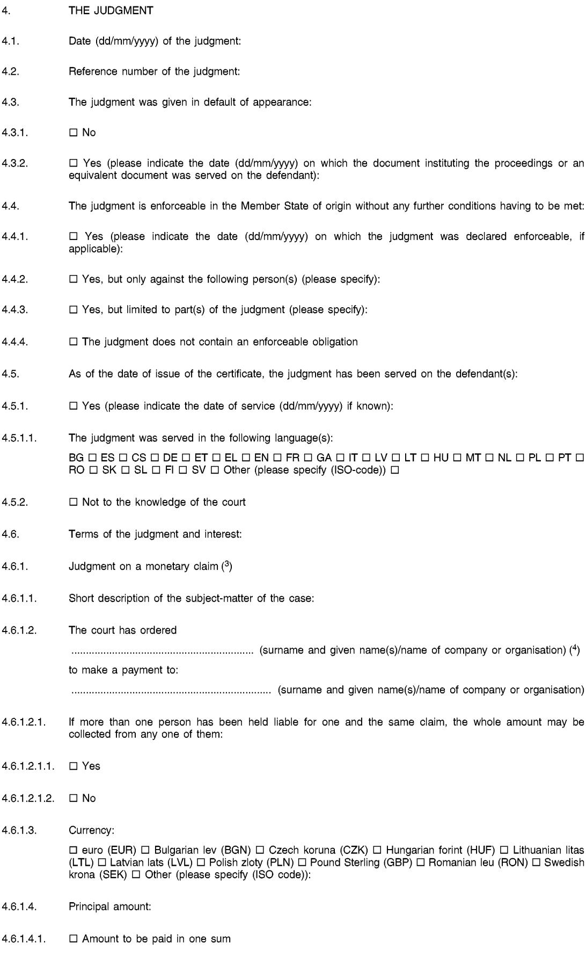

L 351/24 EN Official Journal of the European Union 20.12.2012

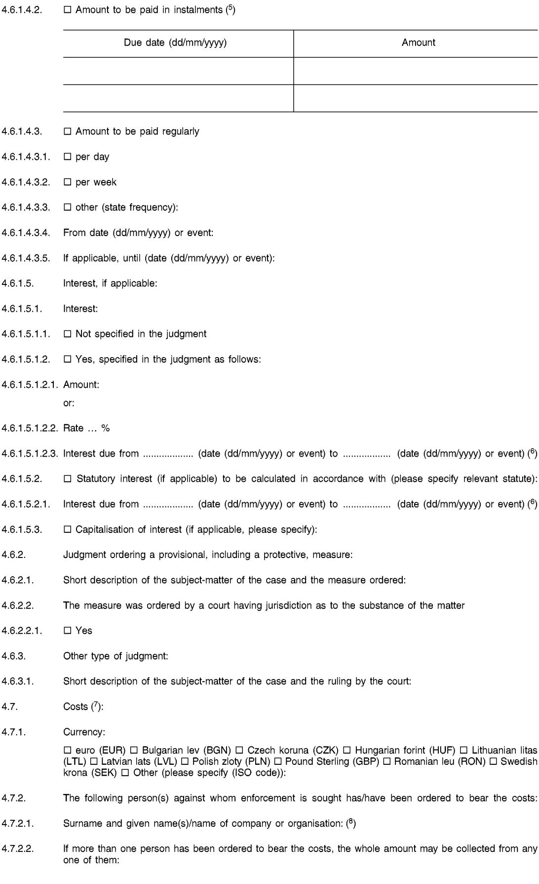

20.12.2012 EN Official Journal of the European Union L 351/25



L 351/26 EN Official Journal of the European Union 20.12.2012



*ANNEX II*

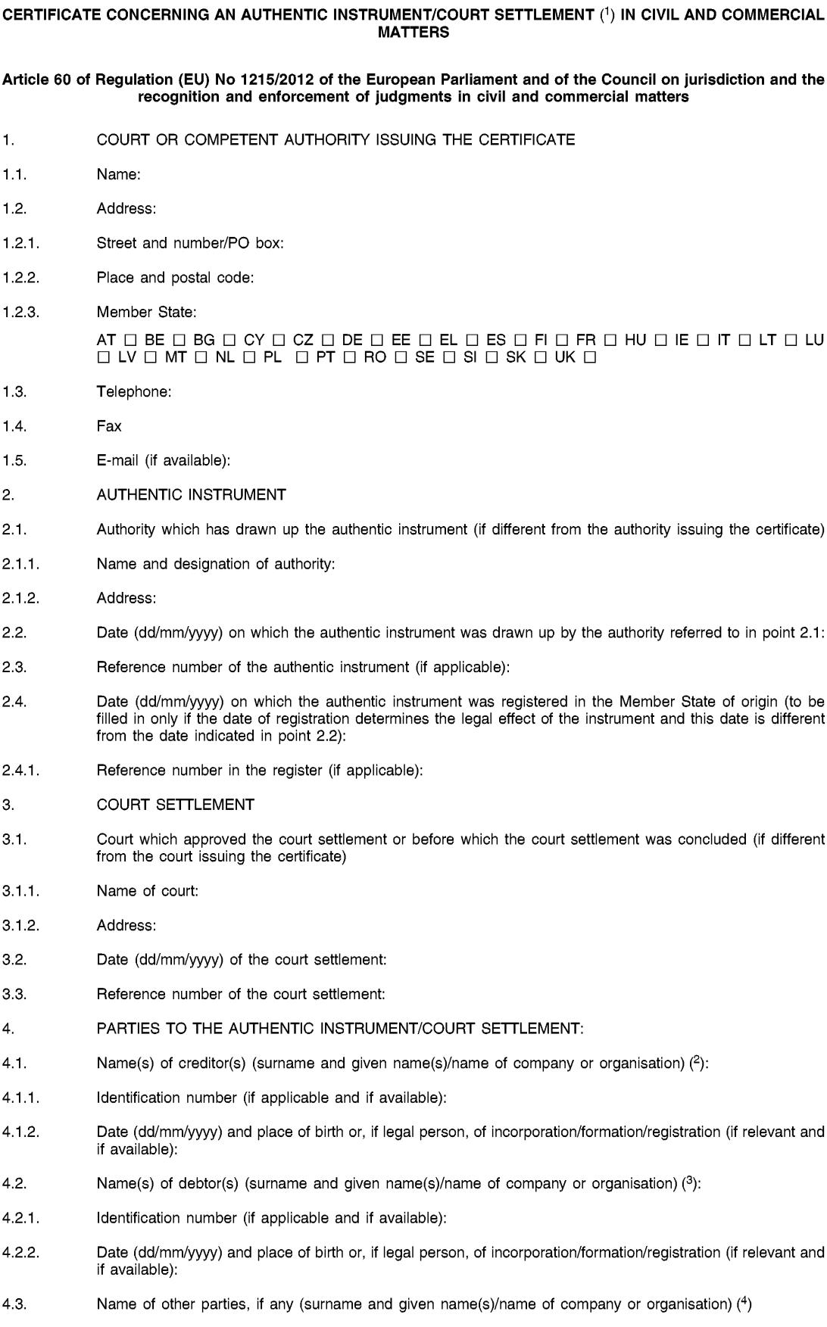

20.12.2012 EN Official Journal of the European Union L 351/27

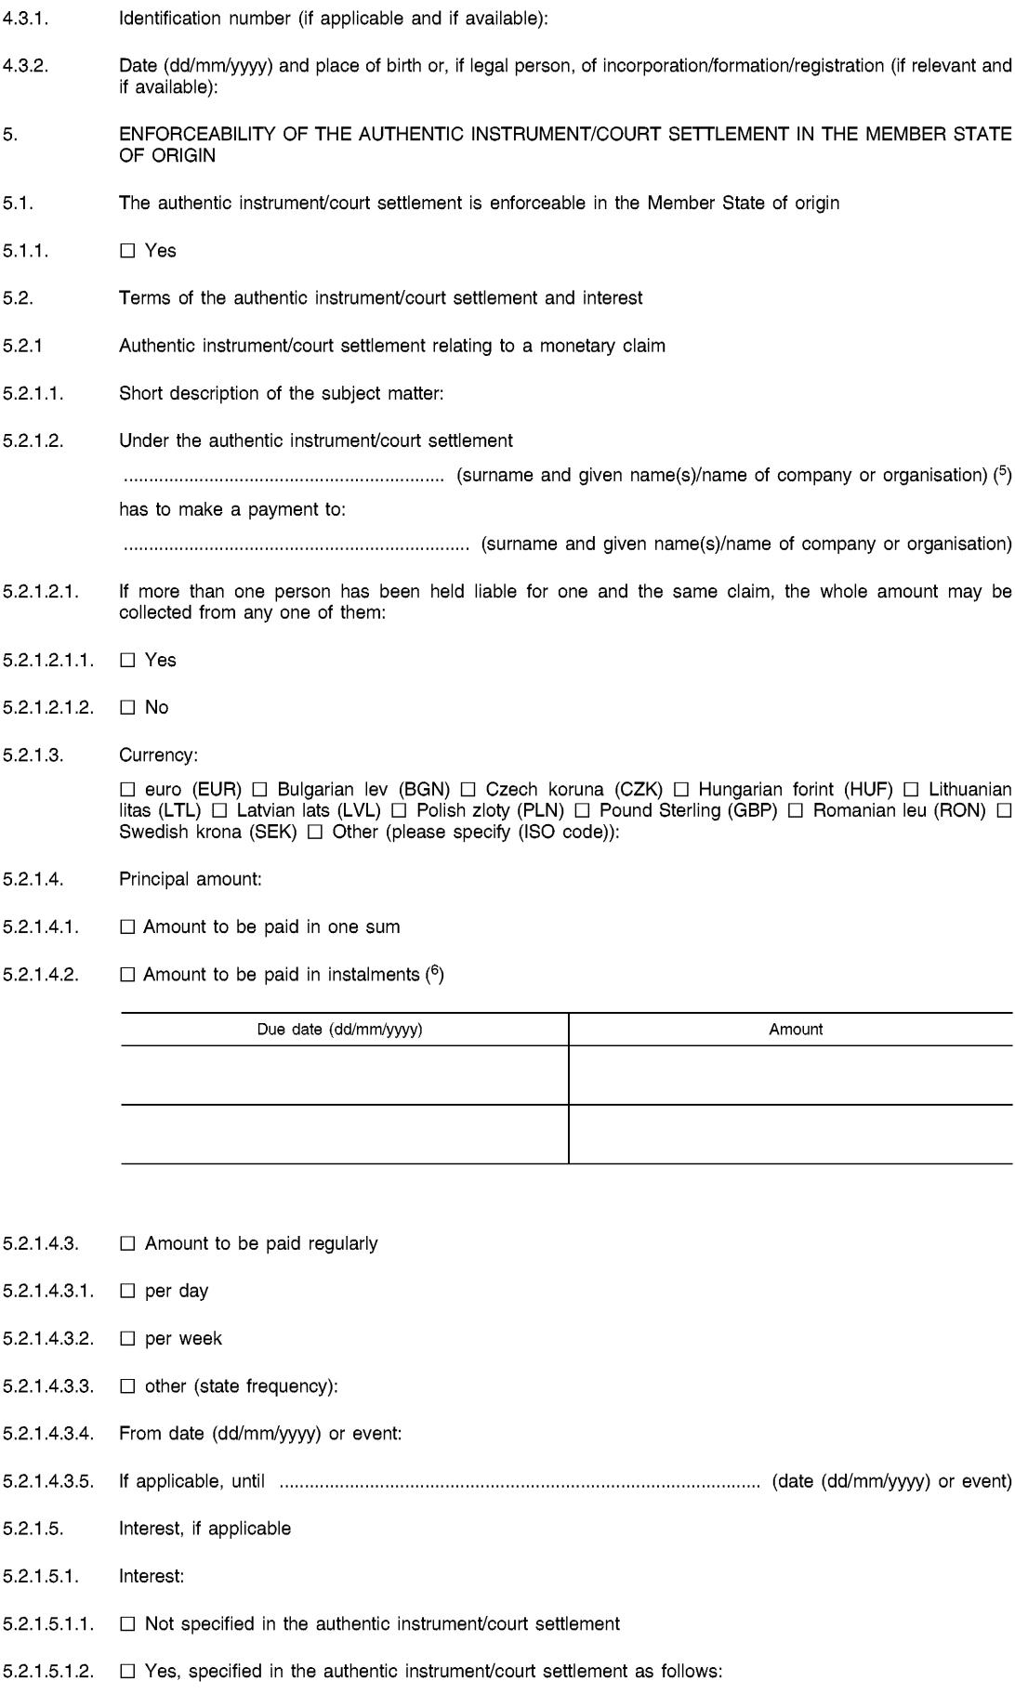

L 351/28 EN Official Journal of the European Union 20.12.2012

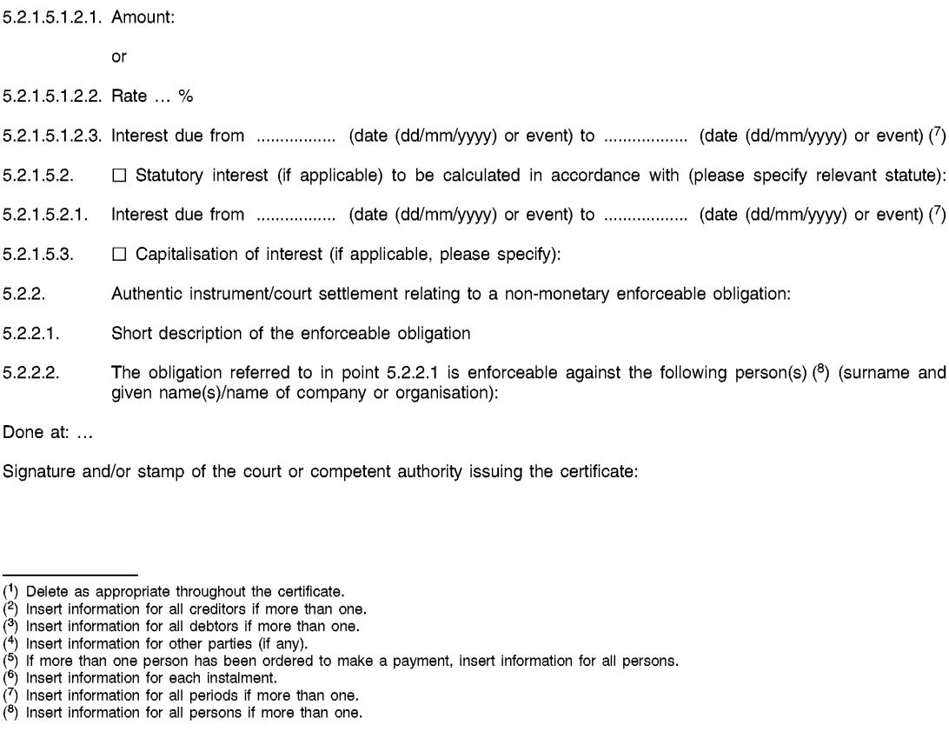

|  |  |  |  |  |  |
| --- | --- | --- | --- | --- | --- |
| 20.12.2012 | EN | Official Journal of the European Union | | | L 351/29 |
|  |  |  |  | |  |
|  |  |  | *ANNEX III* | |  |
|  |  |  | **CORRELATION TABLE** | |  |
|  |  |  |  |  |  |
|  |  | Regulation (EC) No 44/2001 |  | This Regulation |  |
|  |  |  |  |  |  |
|  | Article 1(1) |  |  | Article 1(1) |  |
|  | Article 1(2), introductory words | |  | Article 1(2), introductory words |  |
|  | Article 1(2) | point (a) |  | Article 1(2), points (a) and (f) |  |
|  | Article 1(2), points (b) to (d) | |  | Article 1(2), points (b) to (d) |  |
|  | — |  |  | Article 1(2), point (e) |  |
|  | Article 1(3) |  |  | — |  |
|  | — |  |  | Article 2 |  |
|  | Article 2 |  |  | Article 4 |  |
|  | Article 3 |  |  | Article 5 |  |
|  | Article 4 |  |  | Article 6 |  |
|  | Article 5, introductory words | |  | Article 7, introductory words |  |
|  | Article 5, point (1) | |  | Article 7, point (1) |  |
|  | Article 5, point (2) | |  | — |  |
|  | Article 5, points (3) and (4) | |  | Article 7, points (2) and (3) |  |
|  | — |  |  | Article 7, point (4) |  |
|  | Article 5, points (5) to (7) | |  | Article 7, points (5) to (7) |  |
|  | Article 6 |  |  | Article 8 |  |
|  | Article 7 |  |  | Article 9 |  |
|  | Article 8 |  |  | Article 10 |  |
|  | Article 9 |  |  | Article 11 |  |
|  | Article 10 |  |  | Article 12 |  |
|  | Article 11 |  |  | Article 13 |  |
|  | Article 12 |  |  | Article 14 |  |
|  | Article 13 |  |  | Article 15 |  |
|  | Article 14 |  |  | Article 16 |  |
|  | Article 15 |  |  | Article 17 |  |
|  | Article 16 |  |  | Article 18 |  |
|  | Article 17 |  |  | Article 19 |  |
|  | Article 18 |  |  | Article 20 |  |
|  | Article 19, points (1) and (2) | |  | Article 21(1) |  |
|  | — |  |  | Article 21(2) |  |
|  | Article 20 |  |  | Article 22 |  |
|  | Article 21 |  |  | Article 23 |  |
|  | Article 22 |  |  | Article 24 |  |
|  | Article 23(1) and (2) | |  | Article 25(1) and (2) |  |
|  |  |  |  |  |  |



|  |  |  |  |  |
| --- | --- | --- | --- | --- |
| L 351/30 | EN | Official Journal of the European Union | | 20.12.2012 |
|  |  |  |  |  |
|  |  |  |  |  |
|  |  | Regulation (EC) No 44/2001 | This Regulation |  |
|  |  |  |  |  |
|  | Article 23(3) |  | — |  |
|  | Article 23(4) and (5) | | Article 25(3) and (4) |  |
|  | — |  | Article 25(5) |  |
|  | Article 24 |  | Article 26(1) |  |
|  | — |  | Article 26(2) |  |
|  | Article 25 |  | Article 27 |  |
|  | Article 26 |  | Article 28 |  |
|  | Article 27(1) |  | Article 29(1) |  |
|  | — |  | Article 29(2) |  |
|  | Article 27(2) |  | Article 29(3) |  |
|  | Article 28 |  | Article 30 |  |
|  | Article 29 |  | Article 31(1) |  |
|  | — |  | Article 31(2) |  |
|  | — |  | Article 31(3) |  |
|  | — |  | Article 31(4) |  |
|  | Article 30 |  | Article 32(1), points (a) and (b) |  |
|  | — |  | Article 32(1), second subparagraph |  |
|  | — |  | Article 32(2) |  |
|  | — |  | Article 33 |  |
|  | — |  | Article 34 |  |
|  | Article 31 |  | Article 35 |  |
|  | Article 32 |  | Article 2, point (a) |  |
|  | Article 33 |  | Article 36 |  |
|  | — |  | Article 37 |  |
|  | — |  | Article 39 |  |
|  | — |  | Article 40 |  |
|  | — |  | Article 41 |  |
|  | — |  | Article 42 |  |
|  | — |  | Article 43 |  |
|  | — |  | Article 44 |  |
|  | Article 34 |  | Article 45(1), points (a) to (d) |  |
|  | Article 35(1) |  | Article 45(1), point (e) |  |
|  | Article 35(2) |  | Article 45(2) |  |
|  | Article 35(3) |  | Article 45(3) |  |
|  | — |  | Article 45(4) |  |
|  | Article 36 |  | Article 52 |  |
|  | Article 37(1) |  | Article 38, point (a) |  |
|  | Article 38 |  | — |  |
|  |  |  |  |  |



|  |  |  |  |  |  |
| --- | --- | --- | --- | --- | --- |
| 20.12.2012 | EN | Official Journal of the European Union | |  | L 351/31 |
|  |  |  |  |  |  |
|  |  |  |  |  |  |
|  |  | Regulation (EC) No 44/2001 |  | This Regulation | |
|  |  |  |  |  |  |
|  | Article 39 |  | — |  |  |
|  | Article 40 |  | — |  |  |
|  | Article 41 |  | — |  |  |
|  | Article 42 |  | — |  |  |
|  | Article 43 |  | — |  |  |
|  | Article 44 |  | — |  |  |
|  | Article 45 |  | — |  |  |
|  | Article 46 |  | — |  |  |
|  | Article 47 |  | — |  |  |
|  | Article 48 |  | — |  |  |
|  | — |  | Article 46 |  |  |
|  | — |  | Article 47 |  |  |
|  | — |  | Article 48 |  |  |
|  | — |  | Article 49 |  |  |
|  | — |  | Article 50 |  |  |
|  | — |  | Article 51 |  |  |
|  | — |  | Article 54 |  |  |
|  | Article 49 |  | Article 55 |  |  |
|  | Article 50 |  | — |  |  |
|  | Article 51 |  | Article 56 |  |  |
|  | Article 52 |  | — |  |  |
|  | Article 53 |  | — |  |  |
|  | Article 54 |  | Article 53 |  |  |
|  | Article 55(1) |  | — |  |  |
|  | Article 55(2) |  | Article 37(2), Article 47(3) and Article 57 | | |
|  | Article 56 |  | Article 61 |  |  |
|  | Article 57(1) |  | Article 58(1) |  |  |
|  | Article 57(2) |  | — |  |  |
|  | Article 57(3) |  | Article 58(2) |  |  |
|  | Article 57(4) |  | Article 60 |  |  |
|  | Article 58 |  | Article 59 and Article 60 | | |
|  | Article 59 |  | Article 62 |  |  |
|  | Article 60 |  | Article 63 |  |  |
|  | Article 61 |  | Article 64 |  |  |
|  | Article 62 |  | Article 3 |  |  |
|  | Article 63 |  | — |  |  |
|  | Article 64 |  | — |  |  |
|  | Article 65 |  | Article 65(1) and (2) |  |  |
|  |  |  |  |  |  |



|  |  |  |  |  |  |
| --- | --- | --- | --- | --- | --- |
| L 351/32 | EN | Official Journal of the European Union | | 20.12.2012 | |
|  |  |  |  |  |  |
|  |  |  |  |  |  |
|  |  | Regulation (EC) No 44/2001 |  | This Regulation | |
|  |  |  |  |  |  |
|  | — |  | Article 65(3) |  |  |
|  | Article 66 |  | Article 66 |  |  |
|  | Article 67 |  | Article 67 |  |  |
|  | Article 68 |  | Article 68 |  |  |
|  | Article 69 |  | Article 69 |  |  |
|  | Article 70 |  | Article 70 |  |  |
|  | Article 71 |  | Article 71 |  |  |
|  | Article 72 |  | Article 72 |  |  |
|  | — |  | Article 73 |  |  |
|  | Article 73 |  | Article 79 |  |  |
|  | Article 74(1) |  | Article 75, first paragraph, points (a), (b) and (c), and | | |
|  |  |  | Article 76(1), point (a) | | |
|  | Article 74(2) |  | Article 77 |  |  |
|  | — |  | Article 78 |  |  |
|  | — |  | Article 80 |  |  |
|  | Article 75 |  | — |  |  |
|  | Article 76 |  | Article 81 |  |  |
|  | Annex I |  | Article 76(1), point (a) | | |
|  | Annex II |  | Article 75, point (a) |  |  |
|  | Annex III |  | Article 75, point (b) |  |  |
|  | Annex IV |  | Article 75, point (c) |  |  |
|  | Annex V |  | Annex I and Annex II | | |
|  | Annex VI |  | Annex II |  |  |
|  | — |  | Annex III |  |  |
|  |  |  |  |  |  |

