**Golden Auctions : Booklet**

**1. Initial Idea :**

Web application in which users can create their own auction or partecipate to those of other people by betting a certain price .

**System Objectives :**

* Access to main page, in which trending auctions are available.
* Search for a specific auction.
* Participate to an auction.
* Create their own auction.
* Register and access with its credentials.
* Access to the page containing their active auctions.
* Access to the page containing the auctions in which they are participating.
* Update their credentials.
* Logout from the Application.

**Potential Users :**

* Someone who wants to take part of an auction, with the convenience of doing it from home or other comfortable places, without physical attending it.
* Someone who wants to sell items in a fast and easy way.

**Use Cases :**

* User registers to the system
* User logins to the application
* User accesses the home page to visualize the current available auctions
* User follow an auction
* User participate to an auction
* User create his own auction
* User manage his profile
* User logouts
* User deletes the account

**2. User Stories and Prototypes :**

**Sign-up :**



**Login :**



**Logout :**





**Settings :**





**Homepage :**





**Auction :**



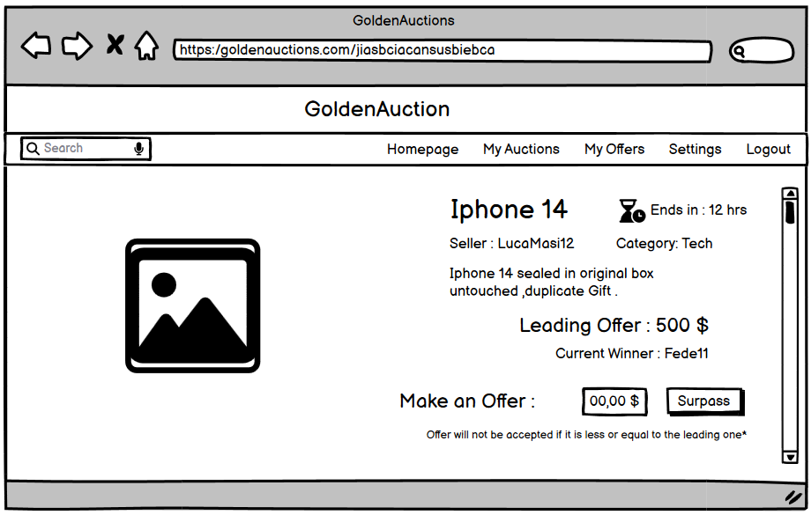

**My Offers :**



**My Auctions :**





**3. Effort estimation :**

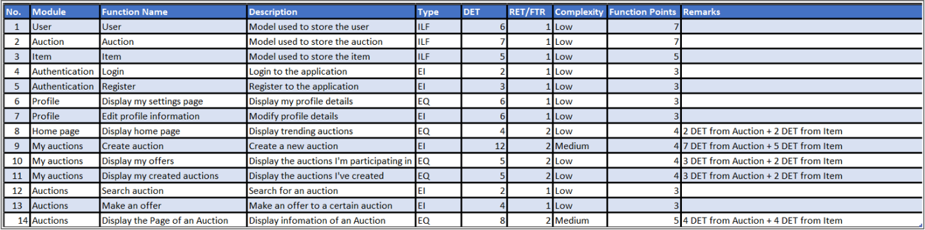

Total of Unadjusted Function Points : 58

Real SLOC : 4812

**4. System Architecture :**

The system architecture is realized by an orchestration of micro-services organized in docker containers that can communicate via Api-Gateaway . **Immagine che contiene schermata, testo, diagramma, linea
**

* **Front-End :** component that displays and manages the interaction of the React Application on Client side.
* **Api-Gateaway :** component that is in charge of orchestrating Microservices. It contacts the two Microservices dealing with User and Auction Management.
* **User Management :** Microservice that manages all the tasks related to the Accounting, like login, register and settings.
* **Auction Management :** With this Microservice is possible to manage the Auctions. Indeed with it we can initialize a new Auction or accede to the data of an already existing one. It uses RabbitMQ to communicate with the Microservice for Offer Management.
* **Offer Management :** It deals with users that surpass an offer in an Auction. It receives the communication of the offer form a Queue managed by RabbitMQ. Each Category of the Objects has a relative Queue, that sends messages to two Workers using a Round-Robin Algorithm.
* **Database :** MySql DB, that stores data about Users, Auctions, and Items that are put up for Auction. Most of our Microservices communicate with it, to create, modify or retrieve cells of the Tables .

**5. Sprint Analytics :**

Total of 5 Sprints in 60 days

**Sprint 1 : 28/11/2023-12/12/2023**

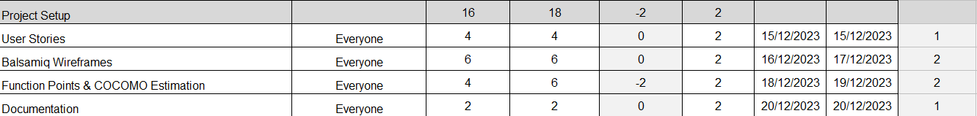

**Sprint 2 : 15/12/2023-20/12/2023**

**Sprint 3 : 21/12/2023-11/01/2024**

**Sprint 4 : 13/01/2024-31/01/2024**

**Sprint 5 : 02/02/2024-16/02/2024**

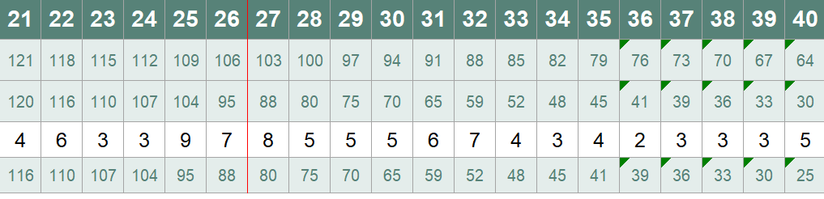**

**Total estimated Hours :** 182

**Completed Hours :** 222

**Remaining Hours :** -40

**Days :** -60

**Average estimated Hours per Day :** 3.03