

**Documentation of Embedded System Architecture Exam**

**The SmarTop**

**Marcello Rosati**

**Francesco Calise**

**INTRODUCTION**

The project consists in creating an object that can simulate the functions of a dice. The initial idea of ​​the project consisted in the creation of an intelligent dice that could simulate the throwing of a dice but managed through an application that regulates its behavior. Subsequently, the idea of ​​converting the object into a coin was considered, in order to make everything more compact and using the two sides of the coin as a display for data visualization. Unfortunately, the required components occupy more space than the structure of a 'small' coin, for this reason the final choice fell on a top. A smart way to play each game that uses a large amount of dice in one easy solution.

**SYSTEM ARCHITECTURE**

The top will consist of:

* accelerometer
* Bluetooth module
* Arduino Nano
* display
* Battery
* Breadboard
* Button

The top is managed by an Arduino nano that processes the messages received by the app thanks to the Bluetooth and sends the results of algorithm to the display.

The movement of the spinning top is managed by an accelerometer which once in motion will start the simulation of the dice roll. Once the simulation is over, if the top does not perceive any movement within the next 30 seconds, the module will go on stand-by to optimize the battery life. All these components are link together with a breadboard and are inside a wooden structure that looks like a top and are balanced so as to allow correct rotation.

**CIRCUITO ELETTRICO**

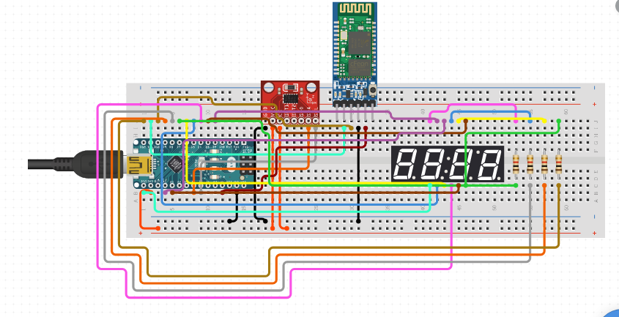

**TUTORIAL**

1. Press button to switch on the SmarTop.
2. In the app :
   1. Connect the bluetooth to the SmartTop called “RandomBot”
   2. Set how many and which dice you want to roll end send it.
3. Spin the tot and wait, the result is on the display!!.
4. After 30 seconds of inactivity the SmarTop goes into standby and you have to press the button to turn it back on.
5. Hold the button for switch off the SmarTop

**WORKFLOW**

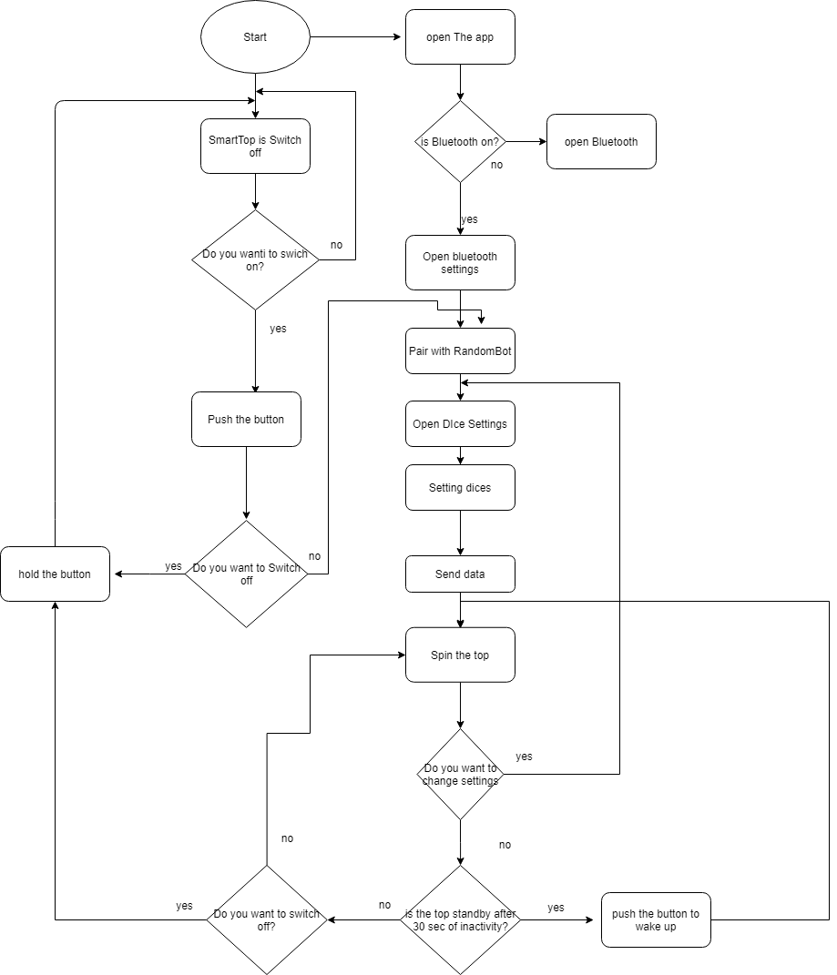

**APP**

The app Is realized using Ionic 5 a complete open source Sdk for hybrid mobile app.

It ‘s dividend in two main Menu:

* Bluetooth Settings that manage the connection of the device with the SmartTop, so the research of active Bluetooth and the pair.
* Roll Settings that manage the roll of the dice, in this section we can choose the type and the quantity of setting dice for the simulation

This is only the first objective that we have proposed but the structure is prepared in such a way as to allow new functionality in future

**SKETCH**

#include <MPU6050.h>

#include <SPI.h>

#include <avr/sleep.h>

#include <avr/power.h>

String input="5,6;3,4;";

double AcX;

double AcY;

double AcZ;

int s=0;

int valueRoll=0;// metterlo nell if dell accelerazione

bool canStart = false;

bool isStarted = false;

void setup()

{

pinMode(2, INPUT_PULLUP);

Serial.begin(9600);

randomSeed(analogRead(999));

Serial.println(">> START<<");

}

void loop()

{

char character;

if(Serial.available()>0)

{

character= Serial.read();

Serial.print(character);

Serial.print("non ci dovevo entrare");

input=input+character;

}

//Serial.print(input);

FunctionsAcc(AcX,AcY,AcZ);

//Serial.print("X :"); Serial.print(AcX);Serial.print("\n");

//Serial.print("Y :"); Serial.print(AcY);Serial.print("\n");

if(AcY < -2000 || AcY >2000){// controllare i paramentri dell accelerazione

canStart = true;

}else{

canStart = false;

isStarted = false;

}

if(canStart && !isStarted ){

s=0;

isStarted =true;

int index = 0;

int quantityDice;

int typeDice;

int otpionalIndex;

for(int x = 0; x < input.length(); x=x+1){

if(input[x] == ','){

quantityDice = input.substring(index,x).toInt();

otpionalIndex =x+1;

}

if(input[x] == ';'){

typeDice = input.substring(otpionalIndex,x).toInt();

valueRoll = valueRoll + RollDice(quantityDice,typeDice);

index = x+1;

}

}

Serial.println(valueRoll);

valueRoll=0;

}

else{

s=s+1;

Serial.print("Timer:");

Serial.println(s);

if (s==30){

Serial.println("sleep");

delay(200);

s=0;

startSleep();

}

}

delay(1000);

}

int RollDice(int quantity,int value){

long result;

int maxvalue;

maxvalue= quantity*value;

result= random(quantity,maxvalue);

return result;

}

void startSleep(void) {

attachInterrupt(digitalPinToInterrupt(2), pin2Interrupt, LOW);

delay(100);

set_sleep_mode(SLEEP_MODE_PWR_DOWN);

sleep_enable();

sleep_mode();

/* Il programma riprende qui. */

sleep_disable();

}

void pin2Interrupt(void) {

detachInterrupt(digitalPinToInterrupt(2));

}

**CONCLUSIONI**

Everything is done,