University of Camerino
Department of Science and Technology
Master Degree in Computer Science


SmarTop Arduino

Documentation for Embedded System Architecture

Group:  Calise Francesco  Rosati Marcello | Tutor  Prof. Andrea Piermartiri

Academic Year 2019/2020

Abstract

The aim of the project consists in creating an object like a Top that can simulate the functions of a dice.
The settings of the Top are controlled via Bluetooth from any Android phone or tablet using a custom application.
The documentation contains a detailed description about the technological choices made on the assignment.
Implementation of the project began first by researching possible technologies and sketching out the features the final product might have.
After getting a clear picture of the desired end product, necessary components were ordered and assembled into a rough prototype.
The Android mobile application and the embedded Arduino code were developed in tandem.
As a result of the project, the costumer received a fully functional SmarTop with App, a smart way to play each game that uses a large amount of dice in one easy solution.

Sommario
Abstract 2
Introduction 4
Requirements analysis 4
Requirements 4
Use Case Diagram 5
Activity Diagram 6
List of Components 7
SmarTop Assembly 9

Introduction

In this project we will build a SmarTop able to show the result of a large quantity and also different type dices, simulating the rolling.
The initial idea of ​​the project consisted in the creation of an intelligent dice that could simulate the throwing of a dice but managed through an application that regulates its behavior. Subsequently, the idea of ​​converting the object into a coin was considered, in order to make everything more compact and using the two sides of the coin as a display for data visualization. Unfortunately, the required components occupy more space than the structure of a 'small' coin, for this reason the final choice fell on a top. So Spin and play!

Requirements analysis

In this chapter we will analyze everything that come first the construction and development phase of SmarTop

Requirements

CODE | TASK | PRIORITY | DESCRIPTION
S-1 | Spin | HIGH | The Top must spin
S-2 | Send Data | HiGH | The top must be setted through an application
B-1 | Battery | HIGH | The Top must have an autonomous charge to allow it to be used without a power cable
A-1 | Android | Low | The application mus be compatible with Android devices
B-2 | Bluetooth | Low | The Android device must connect to the robot via Bluetooth
G-1 | Graphic | Low | The application must have a graphical interface
D-1 | Display | HIGH | Display the result on the top
A-2 | Accelerometer | HIGH | The top must have an accelerometer that perceives the movement, for start the Algorithm
S-3 | SleepMode | Low | To save energy the Arduino go to sleep after 30 sec of inactivity

Use Case Diagram

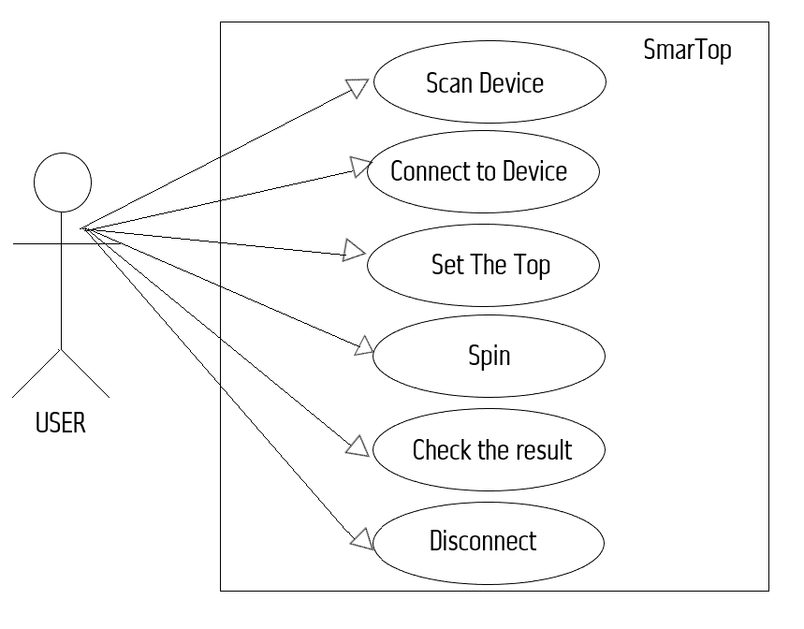

Use Case Name | Scan Device
Actors | User
Initiator | User
Goal | Search all device Bluetooth
Main Scenario | - App is started and the User can scan device

Use Case Name | Connect to device
Actors | User
Initiator | User
Goal | Establishes the connection with the selected Bluetooth module
Main Scenario | - The user select the device he wants to connect to

Use Case Name | Set the Top
Actors | User
Initiator | User
Goal | Send the type and the quantity of the dice to the Top
Main Scenario | - The user select the type and the quantity of the dice to roll
Use Case Name | Spin
Actors | User
Initiator | User
Goal | Spin the top
Main Scenario | - The user must spin the Top for see the result

Activity Diagram

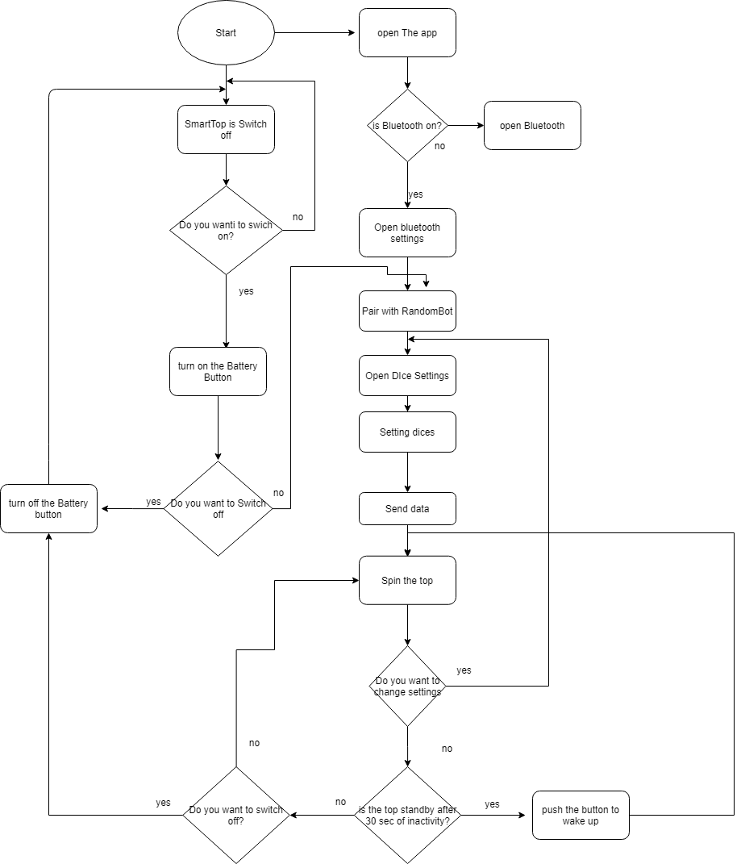

List of Components

- Arduino Uno  - Bluetooth Module  - Accelerometer  - Structure  - Cables for Connection  - Breadboard | - Button  - Battery 18650 x2  - Box for Batteries  - Charger for Batteries  - Display 7 segment 3 digit

Picture | Component | Description
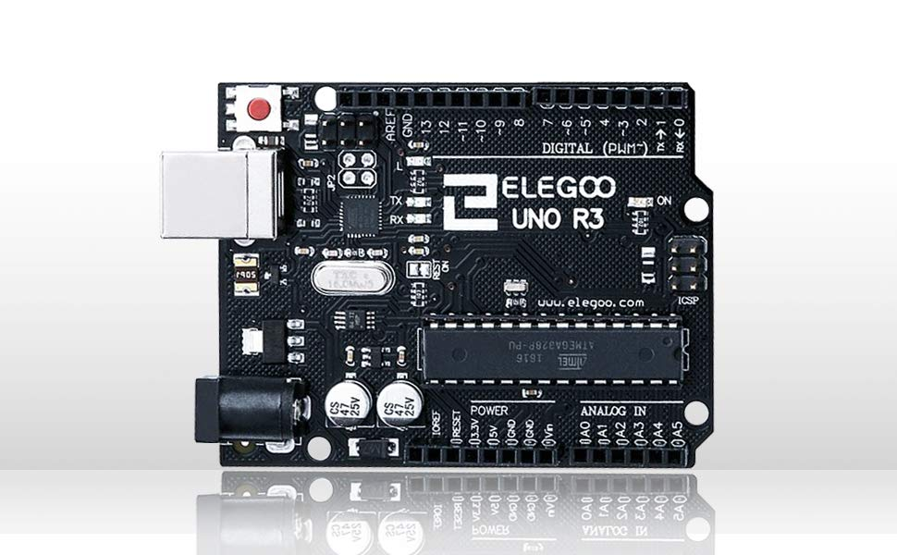 | Arduino Uno | The Arduino UNO is the best board to get started with electronics and coding. If this is your first experience tinkering with the platform, the UNO is the most robust board you can start playing with. The UNO is the most used and documented board of the whole Arduino family.
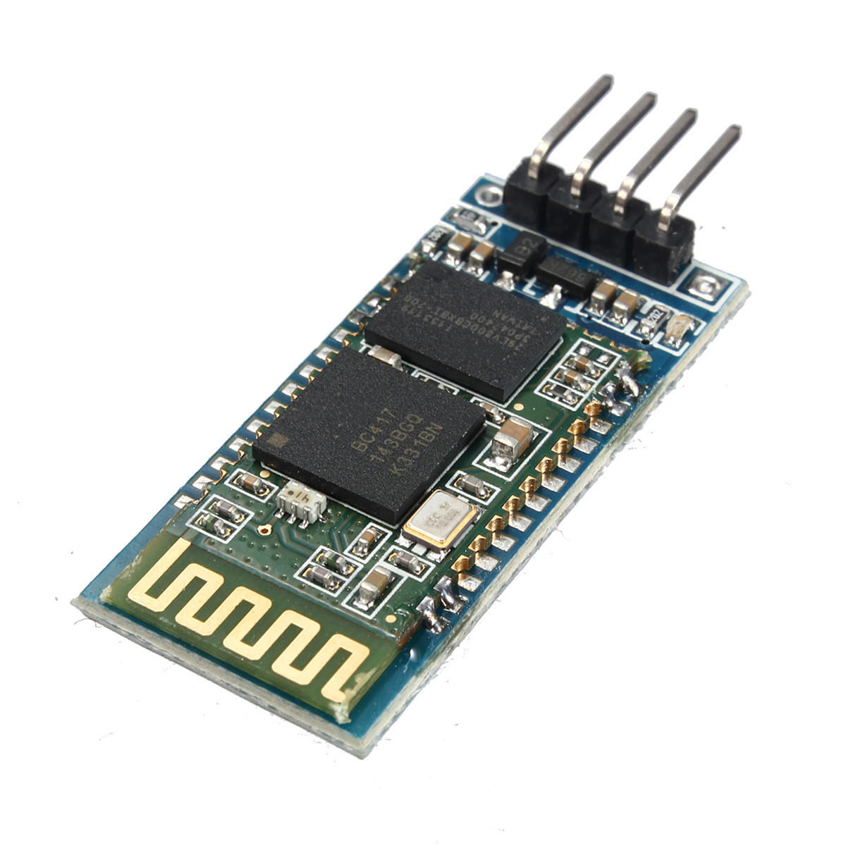 | Bluetooth Module | The HC-06 bluetooth module is a module that transforms a UART/USART port, more commonly known as a serial port, into a Bluetooth port, generally with a SPP(Serial Port Profile) profile, thus becoming a serial via Bluetooth.  Normally this device is used when you want to communicate a microprocessor (Arduino in our Case)with the outside world(whatever the technology can provide with a Bluetooth Connection).
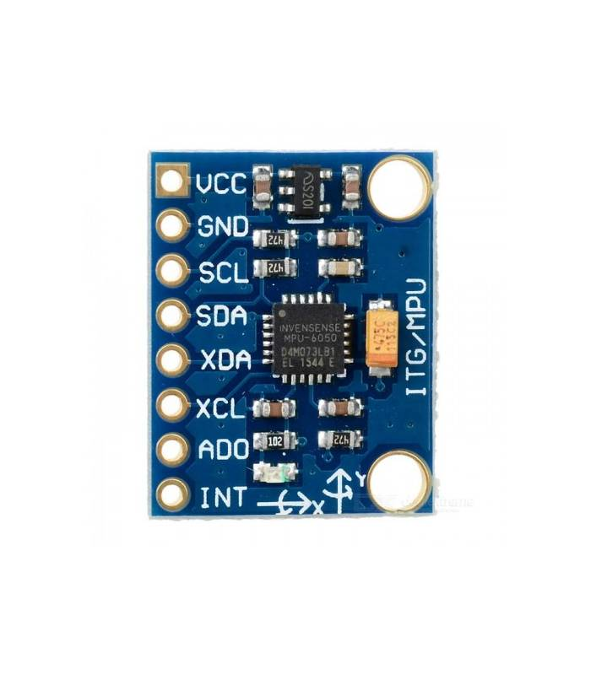 | Accelerometer Module | The InvenSense MPU-6050 sensor contains, in a single integrated, a 3-axis MEMS accelerometer and a 3-axis MEMS gyroscope. With the gyroscope we can measure the angular acceleration of a body on its own axis, while with the accelerometer we can measure the acceleration of a body along a direction. It's very accurate, as it has a 16-bit AD (analog to digital) converter for each channel. So it captures the x, y, and z channels simultaneously. The sensor has a standard I²C communication protocol, therefore easy to interface with the Arduino world.
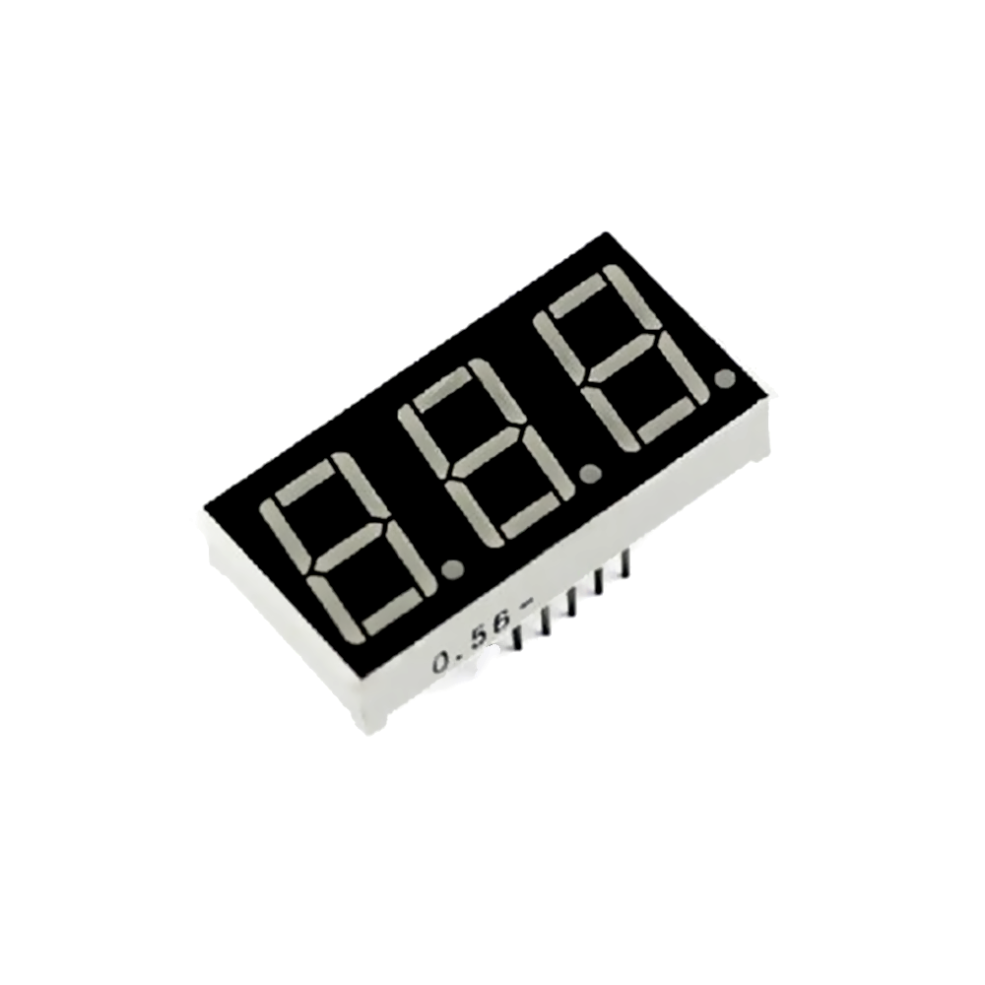 | Display | The seven-segment display is an electronic device capable of displaying 10 numeric digits, and in some cases some alphabetical letters and graphic symbols, by switching on combinations of seven luminous segments.

SmarTop Assembly

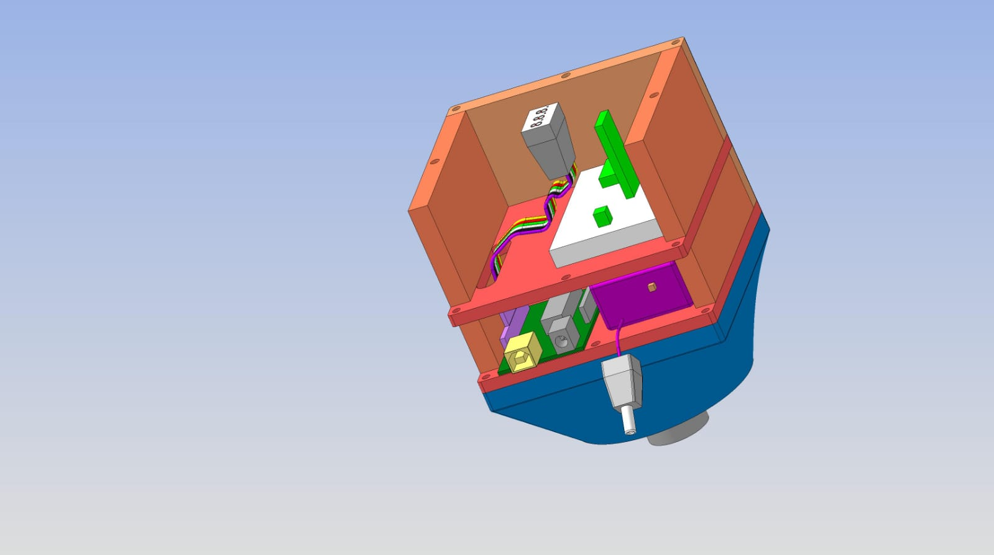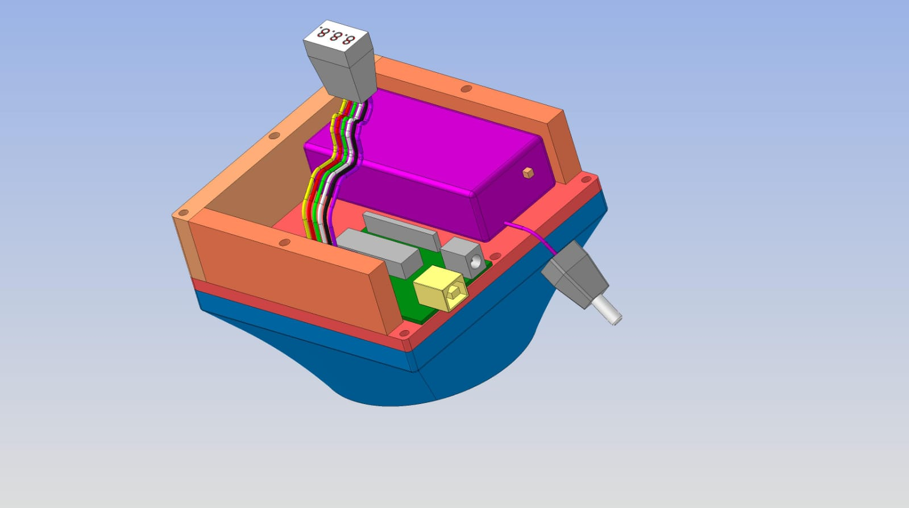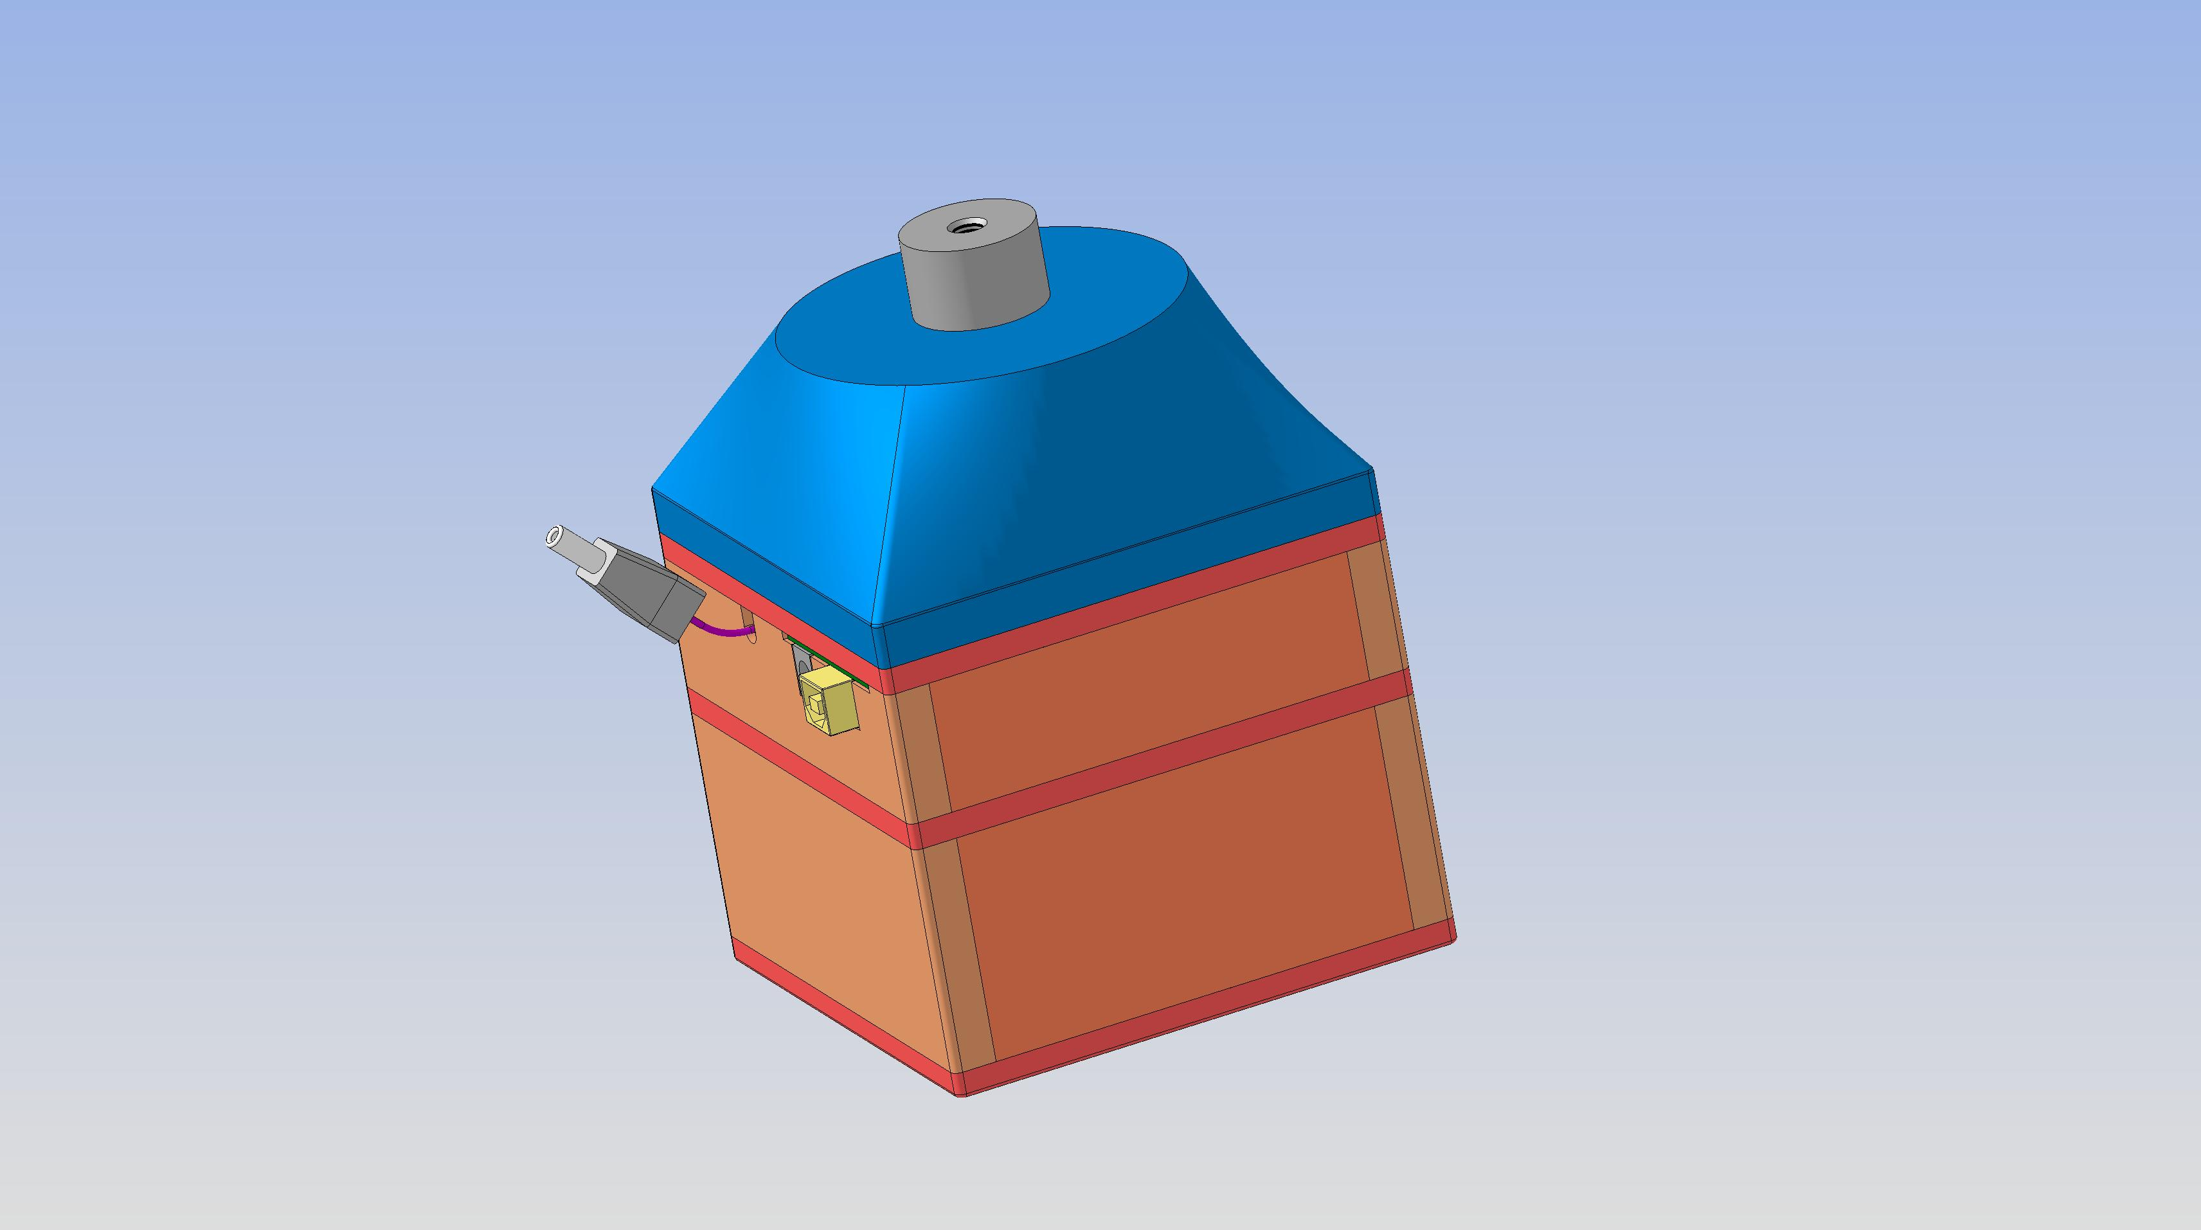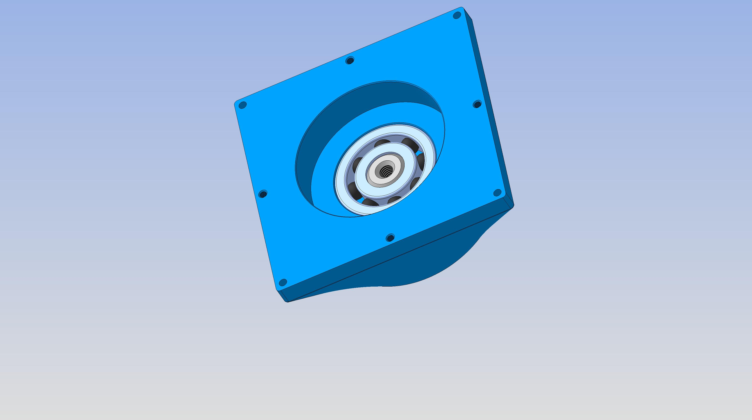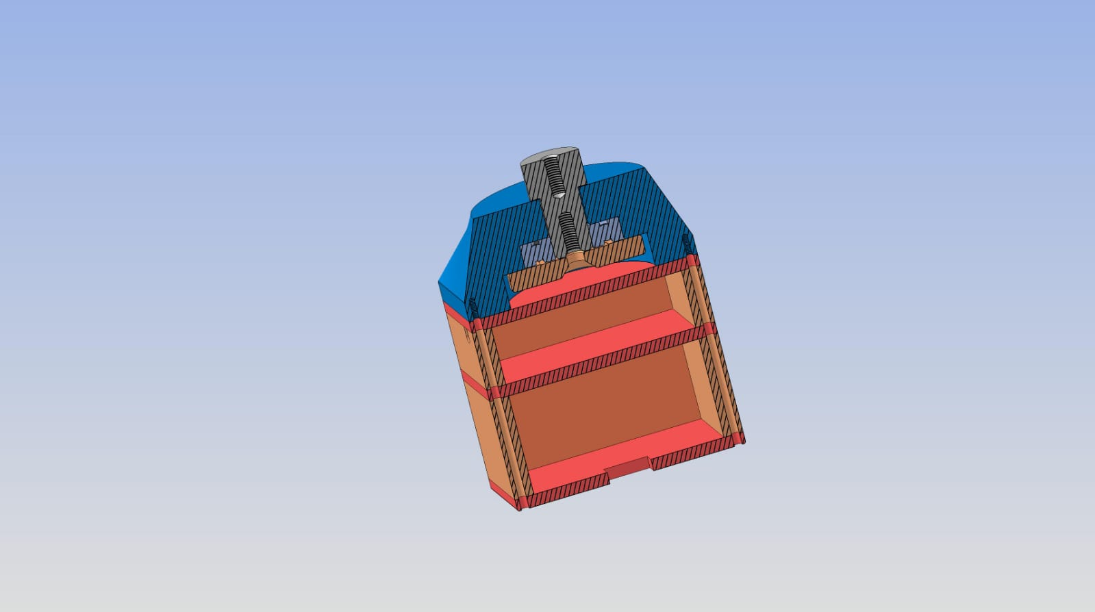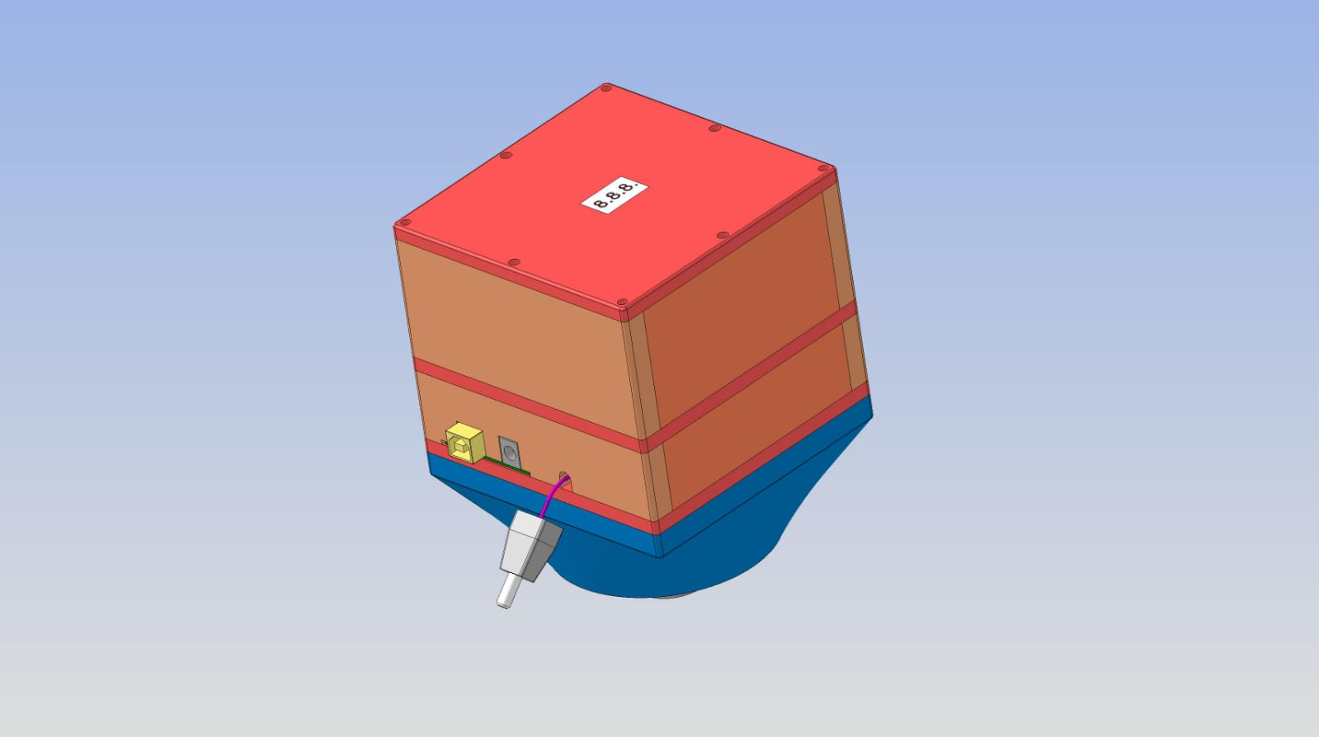

Design

The design part is reffered on illustrating how the requirements are satisfied.

High Level Description

The component of the system consist of:
- An Arduino that perform:

- Function to set the data in the mobile application Via Bluetooth in particularity the quantity and the type of dice must be rolling
- Function to Check the spin of the Top, for starting the simulation of rolling dice
- Function to permite Arduino after inactivity to go in “sleep”, and wakeup with a button
- Function to display the result of the simulation in a display.

- A mobile application that allows:

- The connection to the Bluetooth module connected to Arduino for sending and synchronizing data

High Level Design Diagram

According to the requirements established in the analysis phase, the architecture of our system is represented by the following High Level Desing Diagram.

Microcontreller Input:
Rechargeable Battery: our Top is battery powered. The battery holder with switch provides power to the structure

Breadboard: the breadboard is used to create the circuit and help Arduino

Display: The result of the rolling is shown on the display

Breadboard Input:

Bluetooth: the Bluetooth module is used to exchange information between the SmarTop and our application. We send a custom String to know which are the dice to roll and their quantity.

Button: The button is used to wake up the Arduino after the sleeping mode is active.

Accelerometer: the Accelerometer is used to check when the smarTop is spinning and in this way start the simulation.

Other:

Application: the application works on android and will use our phone’s Bluetooth for the connection with the Top Module.

