PowerEnJoy

## Requirement Analysis and Specification Document

Cattaneo Davide Frontino Francesco El Hariry Matteo

Contents

1. ***Introduction***
   1. Purpose
   2. Scope
   3. Definitions, acronyms, abbreviations
   4. Reference documents
   5. Document overview
2. ***Overall description***
   1. Product perspective
   2. Product functions
   3. User characteristics
   4. Constraints
   5. Assumptions and dependencies
   6. Future possible implementation
3. ***Specific requirements***
   1. External interface requirements
      1. User interfaces
      2. Hardware interfaces
      3. Software interfaces
      4. Communication interfaces
   2. Functional requirements
   3. Non-functional requirements
   4. Performance requirements
   5. Scenarios
   6. UML Models
      1. Use cases
      2. Class diagram
      3. State diagrams
4. ***Overall description***
   1. Alloy
      1. Signatures
      2. Facts
      3. Assertions
      4. Predicates
      5. Alloy model
      6. Generated world
   2. Software and tools used
   3. Team work
5. ***Revision***
   1. Changed assumptions
   2. Modified functional requirements
   3. Modified scenarios
   4. Modified use cases
   5. Modified diagrams
6. ***Introduction***
   1. ***Purpose***
   2. ***Scope***
   3. ***Definitions, acronyms, abbreviations***
   4. ***Reference documents***
   5. ***Document overview***
7. ***Overall description***
   1. ***Product perspective***
   2. ***Product functions***
   3. ***User characteristics***
   4. ***Constraints***
   5. ***Assumptions and dependencies***
   6. ***Possible future implementations***
8. ***Specific requirements***
   1. ***External interface requirements***
      1. ***User interfaces***
      2. ***Hardware interfaces***
      3. ***Software interfaces***
      4. ***Communications interfaces***
   2. ***Functional requirements***
   3. ***Nonfunctional requirements***
   4. ***Performance requirements***
   5. ***Scenarios***
   6. ***UML models***
      1. ***Use cases***

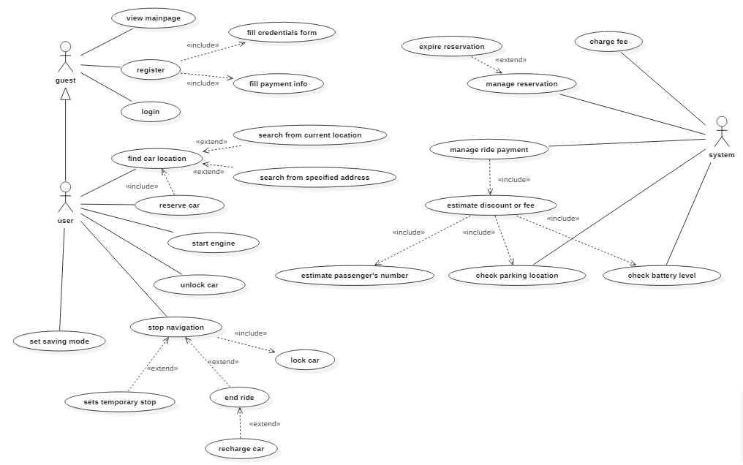

* + - 1. View main page

|  |  |
| --- | --- |
| *Actors* | Guest |
| *Goal* | Allow the visitor to collect information about PowerEnJoy |
| *Input condition* | - |
| *Event flow* | 1. The guest accesses PowerEnJoy web site 2. The guest visits web pages and collects information about the service 3. The guest decides whether to register or leave the web site |
| *Output condition* | - |
| *Exceptions* | - |

* + - 1. Register

|  |  |
| --- | --- |
| *Actors* | Guest, System |
| *Goal* | Allow the visitor to register to PowerEnJoy by submitting a form containing (s)he’s personal data and payment information |
| *Input condition* | - |
| *Event flow* | 1. The guest clicks “Register” in the web page 2. The guest fills and submits (s)he’s personal data and credit card number to the system 3. The system verifies user’s data and releases a password to use PowerEnJoy infrastructures |
| *Output condition* | Guest user is now a Registered user and the system has provided him with a password to access the service |
| *Exceptions* | * User data are not valid * User credit card is not valid |

* + - 1. Login

|  |  |
| --- | --- |
| *Actors* | Guest |
| *Goal* | Allow the guest to fill his credentials and access the system becoming a registered user |
| *Input condition* | - |
| *Event flow* | 1. The guest clicks “Login” in the web page 2. The guest fills in him/her credentials 3. The guest presses the “Login” button |
| *Output condition* | The system sees the guest as registered user |
| *Exceptions* | * Username is invalid * Password is invalid |

* + - 1. Find car location

|  |  |
| --- | --- |
| *Actors* | Registered user, System |
| *Goal* | Allow the user to find a car location |
| *Input condition* | The user is registered to PowerEnJoy and logged in |
| *Event flow* | 1. The user accesses PowerEnJoy app or web site 2. The user selects “Find a car” among all possible actions 3. The user submits the system (s)he’s location. Location may be specified by using user’s current position or by entering a valid address 4. The system looks for cars in the nearby of the specified positions having the status set as “AVAILABLE” |
| *Output condition* | User is provided with a map showing every available car in the nearby of the specified position. Every found car is ensured to be available. |
| *Exceptions* | * Location entered doesn’t exist * Impossible to detect user’s position |

* + - 1. Reserve car

|  |  |
| --- | --- |
| *Actors* | Registered user |
| *Goal* | Allow the user to reserve a car for 1h time |
| *Input condition* | The user is registered to PowerEnJoy, logged in and has already asked the system to find a car |
| *Event flow* | 1. The user selects one of the cars proposed by the system 2. The user presses the button “Reserve” 3. The car status is changed to “BOOKED” |
| *Output condition* | The selected car is reserved for up to 1h and the user receives a PIN to access the car during that time |
| *Exceptions* | * The user is trying to reserve more cars for the same period |

* + - 1. Unlock car

|  |  |
| --- | --- |
| *Actors* | Registered user, System |
| *Goal* | Allow the user to unlock a reserved car and allowing the car access |
| *Input condition* | The car has been reserved and the registered user took less than 1h to use it |
| *Event flow* | 1. The user reaches the car 2. The user unlocks the car using the given PIN (entered in the car unlocking system) 3. The system checks whether the PIN received in input is correct 4. The user has access to the car 5. The system starts charging money to the user |
| *Output condition* | The car is unlocked and ready to start a ride |
| *Exceptions* | * The inserted PIN is invalid |

* + - 1. Set saving mode

|  |  |
| --- | --- |
| *Actors* | Registered user |
| *Goal* | Allow the user to get tips for saving money by applying virtuous behaviors |
| *Input condition* | The car is unlocked |
| *Event flow* | 1. The user presses the button “Saving mode” 2. The system tells the user which could be useful tips to save money at the end of the ride. The user is not bound to that tips and doesn’t necessarily follow them. |
| *Output condition* | - |
| *Exceptions* | - |

* + - 1. Start engine

|  |  |
| --- | --- |
| *Actors* | Registered user, System |
| *Goal* | Allow to user to start the engine and begin his/her ride |
| *Input condition* | The car is unlocked |
| *Event flow* | 1. The user turns the key of the car 2. The system changes the car status from “PARKING” to “ONROAD” |
| *Output condition* | The car is unlocked and the ride has started |
| Exceptions | * Mechanical fault |

* + - 1. Stop navigation

|  |  |
| --- | --- |
| *Actors* | Registered user, System |
| *Goal* | Allow to user to stop his/her navigation for a temporary of definitive stop |
| *Input condition* | The car is unlocked and the car status is set to “ONROAD” |
| *Event flow* | 1. The user chooses whether to park the car or to end his/her ride by clicking the appropriate button shown on the car screen 2. **A)** If the user chooses to park the car, the status is changed to “PARKING” **B)** If the user chooses to end the ride, the status is changed to “AVAILABLE” **C)** If the user chooses to end the ride and recharge the car (s)he has 40 seconds, after the engine is turned off, to plug it in a recharge station. When a car is recharging the status is set to “BATTERYCHARGE”. If the user take more than 40 seconds to plug in the car, the recharge option is discarded and the status is set to “AVAILABLE” 3. In cases **B** and **C**, a payment request is submitted to the system 4. The car is locked by the system as soon as the user: - gets off (cases 2 and 3) - takes more than 40 seconds to plug in the car in the recharge station - plugs in the car in the recharge station |
| *Output condition* | The car is parked, recharging or available |
| *Exceptions* | - |

* + 1. ***Class diagram***
    2. ***State diagrams***

1. ***Overall description***
   1. ***Alloy***
      1. ***Signatures***
      2. ***Facts***
      3. ***Assertions***
      4. ***Predicates***
      5. ***Alloy model***
      6. ***Generated world***
   2. ***Software and tools used***
   3. ***Team work***