PowerEnJoy

## Design Document

Cattaneo Davide El Hariry Matteo Frontino Francesco

Contents

1. ***Introduction***
   1. Purpose
   2. Scope
   3. Definitions, acronyms and abbreviations
   4. Reference documents
2. ***Architectural design***
   1. Overview
   2. High level components and interactions
   3. Component view
   4. Deploying view
   5. Runtime view
   6. Component interfaces
   7. Architectural styles and design patterns
      1. Overall architecture
      2. Protocols
      3. Design patterns
   8. Other design choices
3. ***Algorithm design***
   1. Algoritmo1
   2. Algoritmo2
   3. Algoritmo3
4. ***User interface design***
   1. Mockups
   2. UX diagrams
5. ***Requirements traceability***
6. ***Revision***
   1. Software and tools used
   2. Team work
7. ***Introduction***
   1. ***Purpose***

Purpose of this document is to define and design an architecture on which to rely when developing the software platform.

Addressed to developers, this document contains all the major guidelines to follow while developing the PowerEnJoy system. Both the application and server side architecture are treated in this document.

* 1. ***Scope***

This project aims at designing an electric-car sharing software system.

Car Sharing is a very cost-effective and useful service for anyone who needs a car occasionally. It allows people to use and pay for the car according to their personal use, without the hassle and costs of owning their own vehicle (parking, purchase costs, maintenance, insurance etc.).

The system we will develop is meant for cities which are provided with an efficient amount of parking lots and a wide distribution of electric car-charging platforms throughout the urban areas.

The application must allow the users which are registered to perform several easy and effective operations. Once logged in, the user can find available cars around him/her or in specified locations of the city, and chose the one to reserve.

Afterwards the user, who needs to reach the car before a given time slot expiration, will be able, by unlocking the car using the app, to easily enter the vehicle and drive to his/her destination.

* 1. ***Definitions, acronyms and abbreviations***

Here is a brief description of the most important actors and words used in our system:

* **User:** by user is meant a person already registered in the system, so that has a profile, uses the features provided by the system and performs actions accordingly. (S)He can use all the functionalities described below (see Functional Requirements).
* **Guest:** a guest is a person that probably for the first time accesses the system or that hasn’t already signed up. Guest has less power in the system; his/her actions are limited to access an introduction view and register to the service.
* **System:** is the application core. The software system which will perform all the operations and monitor interactions and be a medium between users and cars.
* **Reservation:** the allocation of a car to a user, which starts when the booking request arrives and ends either when the expiration time ends or when the car is unlocked. In this last case it triggers the start of the first travel so it initiates a ride.
* **Car:** the vehicle used by the users, which contains different sensors and an embedded computer. It has seat sensors to detect passengers, sensor to know battery level and charging actions. The computer, of course, has as main functionality to provide navigation facilities through a GPS system and to send all the relevant data to the main system server.
* **Ride:** conceptually is the use of the car, and it can be identified by the time duration of the user’s journey, from unlocking the vehicle until the final parking (having user selecting “end ride” or “end ride & charge” on the car screen) with the car locked.
* **Travel:** is considered as the ride segment and is identified by a change of the status of the car. More travels can be part of a single ride.
* **Operator:** is a flexible actor in our system. He’s part of a set of people operating under the administrator directions. Their normal tasks are to bring to charging stations cars left with less than 15% battery level, interact with users which call for help during a ride, intervene when necessary (e.g. a wheel brakes during a ride). Their exceptional task can be the case in which they have to go and get back cars taken by the police or cars involved in incidents etc.
* **Administrator:** the administrator of the system is the person allowed to manage eventual unexpected cases (like incidents and damaging situations). He is the person notified every time a problem occurs, and once analyzed the situation (s)he’ll decide how to handle it (call for support, send operators, call the police etc.).
* **Safe Area:** is a part of a set of areas considered safe for parking cars after a ride is over. Temporary stops can be everywhere, but long term parks can only occur in safe areas. They must be very spread and every neighborhood should have at least one.
* **Normal rate:** the charging rate applied when the car engine is ON.
* **Halt rate:** the charging rate applied when the engine is OFF and either the user is inside or (s)he has parked the car in temporary stop mode.
  1. ***Reference documents***

Specification Document:

* Assignments 1 and 2 (RASD and DD).pdf

* Design Part I.pdf and Design Part 2.pdf from lecture slides

Examples documents:  
* Sample Design Deliverable Discussed on Nov. 2

1. ***Architectural design***
   1. 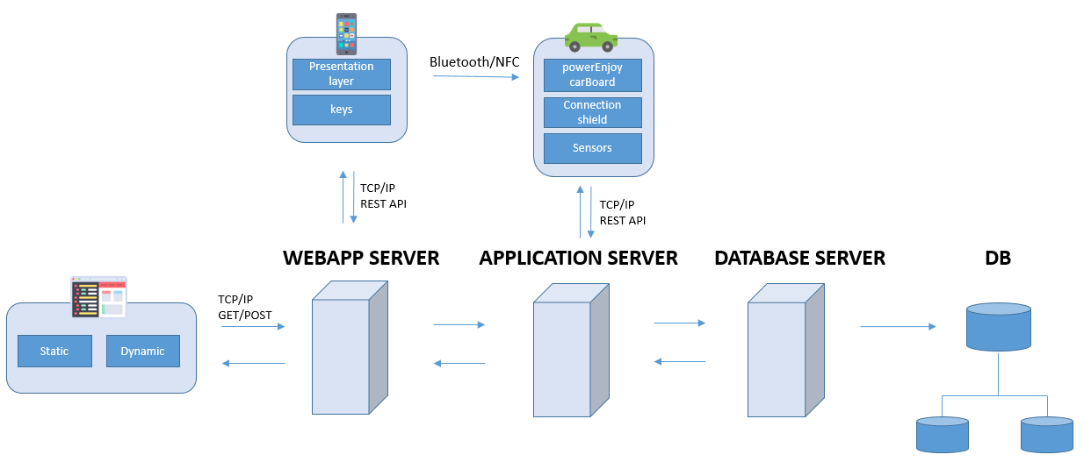***Overview***

A PowerEnjoy user interacts with the system via the client App “PowerEnjoy” installed on his smartphone. That App communicates with the Green Move Center via a 3 g or WiFi channel in order to book vehicles and retrieve the key software that is required to unlock a vehicle booked. The software key is exchanged betweenthe client App Green Move and the Green e-Box via Bluetooth channel; It is used to open/close Concierge (if present), and to enable/disable the vehicles, in order to replace the function of thevehicle key to access the vehicle. Using a Bluetooth/NFC direct communication channel between the user's smartphone and Green e-Box information exchange between these 2 components can take place at any time,

We have decided to implement also a web application for our system. PowerEnJoy’s website will be accessible either as a set of Java Servlet Pages to unregistered users who are seeking information about the platform, or as a private portal for system administrators and staff, who will be able to enter their personal account.

Administrators can manage and edit all data stored into the database, assign tasks to employee and manage car's remote functionality, handling emergencies.

A network of distributed database is chose to guarantee reliability. We have also expected a list of servers divided on all the users and cars. If one server go down, cars and users related to that server will be transferred to another one and the system will keep working with a low performance.

### The storage of data is handled by an Homogeneous Distributed Databases Management System which has identical software and hardware running all databases instances, and appears through a single interface as if it were a single database.

The homogeneous system is much easier to design and manage. The following conditions must be satisfied for homogeneous database:

Choosing this kind of DB system a condition must hold:

* Operating system, data structures, and database application used at each location must be same or compatible.

The main protocol used by our system is TCP/IP.

* 1. ***High level components and interactions***
  2. ***Component view***
  3. ***Class Diagram***

The set of interfaces

-maintenanceFeatures

-assistanceRequest (NOME FIXXARE)

-rideFunctions

-accountFunctions

-carStatus

Are the set of functionality that the system provide to users.

The router class works as a coordinator for the entire system, starting from a methods called through an interface, it suddivide the whole problem in a elementary jobs that will be assigned to the various managers.

UserManager has the task of managing all aspect regarding users and employees like the assignement of the keys used for the unlocking procedure or the check of the users sessions, the authentication and registration process, the update of the personal information and the various queries on the database.

RideManager handles all reservations that are currently active. It also monitors the expiration of those that are not unlocked Within an hour of booking. It also able to manage ride functions, payments and travel management.

CarManager managed all the cars, it updates their status and interacts with remote car functions.

Router will be programmed to garantee security aspects: All the functions are activated only if are authenticated by the user manager.

Scalability and performance are garantee with a parallel execution of the various managars: each managar can be duplicate when requests increase.

* 1. 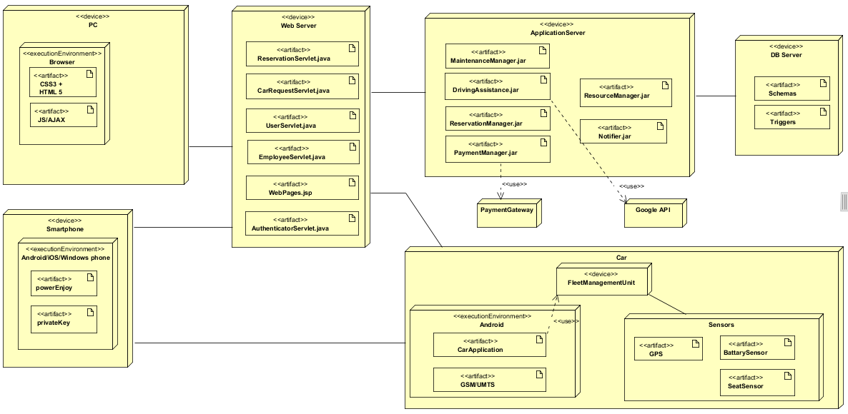***Deploying view***
  2. ***Runtime view***
  3. ***Component interfaces***

The Component Interface, as an architecture-level artifact, is here used to illustrate the technical software architecture as an interconnected model.

Key to this model are two macro-components and two main

The Green Move Center acts both by web front end for users Green Move that back end that provides Application Programming interfaces (APIs) used by Green e-Box to interact with Greens Move Center. The middleware Green Move uses a channel 3 g to enable Move Center and Green and Green-Box to communicate in order to manage your fleet of vehicles. The same channel 3 g isused by Green e-Box for mailing at the Green Move Center, at regular intervals, vehicle information such as diagnostic data, usage statistics, and travel information (for example your current location detected by GPS, vehicle speed, battery charge status). Finally, the Green Move Center can leverage this channel 3 g to add services at every Green and-boxes, loading up these new software modules that provide functions additional to those originally installed on the device. A Green Move user interacts with the systemvia the client App Green Move installed on her smartphone. That App communicates with the Green Move Center via a 3 g or WiFi channel in order to book vehicles and retrieve the key software that is required to unlock a vehicle booked. The software key is exchanged between the client App Green Move and the Green e-Box via Bluetooth channel; It is used to open/close Concierge (if present), and to enable/disable the vehicles, in order to replace the function of the vehicle key to access the vehicle. Using a Bluetooth/NFC direct communication channel between the user's smartphone and Green e-Box information exchange between these 2components can occur at any time, even when you don't have a3 g/WiFi connection between Green and set-top Box and GreenMove Center (for example in an underground car park). The same Bluetooth connection can be used to access, from the client App Green Move, for information on Green e-Box.

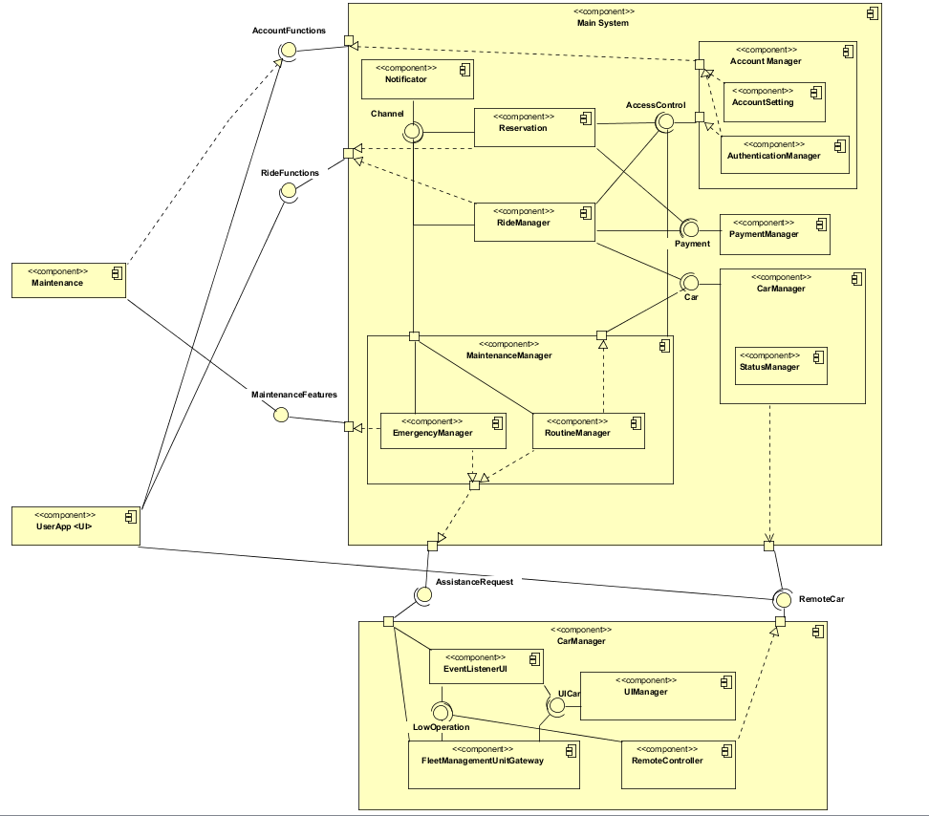

* 1. ***Architectural styles and design patterns***
     1. ***Overall architecture***
     2. ***Protocols***
     3. ***Design patterns***
  2. ***Other design choices***

1. ***Algorithm design***
   1. ***Algoritmo 1***
   2. ***Algoritmo 2***
2. ***User interface design***
   1. ***Mockups***

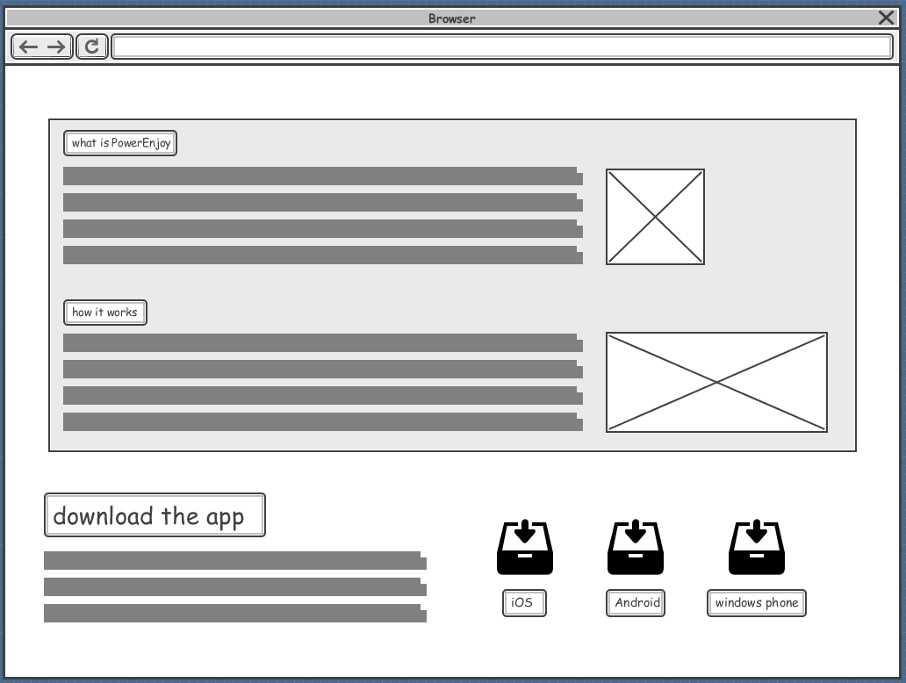

* 1. ***UX diagrams***

1. ***Requirements traceability***

aaa

1. ***Revision***
   * 1. ***Software and tools used***

The following software have been used:

* Microsoft Word (document writing)
  + 1. ***Team work***

Here is reported a compact table showing how the work was brought on by all the members of the group.

|  |  |
| --- | --- |
| *Member* | *Hours of work* |
| Cattaneo Davide |  |
| El Hariry Matter |  |
| Frontino Francesco |  |