Multi-Objective Evolutionary Feature Selection for Efficient Network Intrusion Detection
Research question: To what extent can GA, BPSO, PSO and multi-objective evolutionary feature-selection methods reduce network-traffic dimensionality while maintaining intrusion-detection performance?
Implementation: public GitHub repository (open source and results)
Dataset: UNSW-NB15 - https://research.unsw.edu.au/projects/unsw-nb15-dataset

Abstract
High-dimensional network traffic can increase intrusion-detection cost and expose models to redundant predictors. This study compares Genetic Algorithm (GA), Binary Particle Swarm Optimisation (BPSO), Particle Swarm Optimisation (PSO) and NSGA-II feature selection on UNSW-NB15 using Random Forest (RF), with five random seeds and an equal budget of 300 unique expensive fitness evaluations per method. GA achieved the strongest feature-selection result: test Macro-F1 0.8654 using 10.2 of 42 predictors on average (75.71% reduction), slightly exceeding full-feature RF (0.8642) while reducing false-positive rate from 0.2722 to 0.2548. Full-feature XGBoost achieved the highest absolute Macro-F1 (0.8704). The evidence therefore supports evolutionary feature selection primarily as an efficiency-performance trade-off rather than a guarantee of maximum predictive accuracy.

1. Problem Domain and Research Context
Network intrusion detection is a classification problem in which normal and malicious traffic must be separated from network-flow observations. Feature selection is relevant because IDS datasets can contain redundant or weak predictors that increase model complexity without proportionate predictive benefit. UNSW-NB15 was created to better reflect modern normal and attack traffic than older KDD-family benchmarks [1]. For binary classification, this implementation removes the identifier and attack-category field, leaving 42 raw predictors and the binary label.
Prior work supports evolutionary feature selection for IDS. Khammassi and Krichen [2] formulated feature selection with NSGA-II as a multi-objective wrapper that jointly minimises feature count and maximises classification performance. Almomani [3] compared GA and PSO-based feature selection, while Fang et al. [4] applied GA-based selection to industrial-control intrusion detection. More recent comparative work by Sezgin et al. [5] again shows that different bio-inspired optimisers occupy different accuracy-efficiency regions, motivating an evaluation that reports trade-offs rather than accuracy alone.
Macro-F1 is the primary metric because it gives equal influence to both binary classes. Balanced accuracy, false-positive rate (FPR), feature count, reduction percentage, runtime, inference latency and Jaccard subset stability are secondary measures.

2. Development and Experimental Method

Leakage-safe protocol
The official UNSW-NB15 test partition was isolated from all search and tuning. For each seed {42, 101, 202, 303, 404}, the official training partition was split into stratified training and validation data. Feature search used only training-derived data. Preprocessing was fitted after raw-column selection. After a subset was selected using validation information, official train and validation rows were recombined, the model retrained, and the official test partition evaluated once.

Scalar feature-selection methods
GA, BPSO and PSO optimise F(S) = MacroF1(S) - 0.05 x |S|/42. GA uses binary chromosomes, tournament selection, one-point crossover and bit mutation. BPSO represents inclusion/exclusion directly as binary particles influenced by personal and global best positions. PSO searches continuous [0,1]^42 positions and thresholds them to binary masks. RF is the wrapper classifier.

Fair evaluation-budget modification
Iteration counts are not directly comparable because duplicate candidate masks can cause different numbers of expensive RF fits. A custom UniqueEvaluationBudget therefore counts only previously unseen masks. Cache lookup occurs before budget consumption, and every optimiser is capped at exactly 300 unique expensive evaluations per seed. This modification is central to the experimental fairness argument and also permits a 24-to-300 budget sensitivity analysis.

NSGA-II extension
NSGA-II removes the fixed lambda trade-off and separately maximises validation Macro-F1 while minimising selected-feature ratio. Non-dominated sorting identifies solutions not strictly worse on both objectives, and crowding distance preserves diversity across the Pareto front. One representative solution is chosen using a predeclared validation-only normalised ideal-distance rule before test evaluation. The complete nondominated archive is retained to expose alternative accuracy-dimensionality compromises.

Baselines and evaluation
Four full-feature baselines are used: most-frequent Dummy, Logistic Regression, RF and XGBoost. Each main result is reported over five seeds as mean +/- standard deviation. The 300-evaluation search is compared with a 24-evaluation pilot, and feature frequencies plus Jaccard similarity assess stability. A Friedman test and paired Wilcoxon tests are treated cautiously because five stochastic repetitions provide limited power.
- Primary outcome: official-test Macro-F1.
- Fairness control: 300 unique expensive fitness evaluations per optimiser per seed.
- No official-test result is used to tune search hyperparameters or choose a Pareto representative.
- The Windows prototype is an additional passive implementation layer and is not used to generate benchmark scores.

3. Results
Method | Macro-F1 | FPR | Features | Reduction
XGBoost | 0.8704 +/- .0009 | 0.2576 | 42.0 | 0%
GA + RF | 0.8654 +/- .0040 | 0.2548 | 10.2 | 75.71%
RF | 0.8642 +/- .0007 | 0.2722 | 42.0 | 0%
BPSO + RF | 0.8615 +/- .0064 | 0.2629 | 12.2 | 70.95%
PSO + RF | 0.8598 +/- .0055 | 0.2682 | 11.4 | 72.86%
NSGA-II + RF | 0.8562 +/- .0097 | 0.2715 | 10.6 | 74.76%
Logistic Reg. | 0.8296 +/- .0004 | 0.2812 | 42.0 | 0%
Dummy | 0.3551 | 1.0000 | 42.0 | 0%
Table 1. Five-seed official-test comparison. XGBoost has the best absolute Macro-F1; GA + RF provides the strongest feature-selection trade-off.
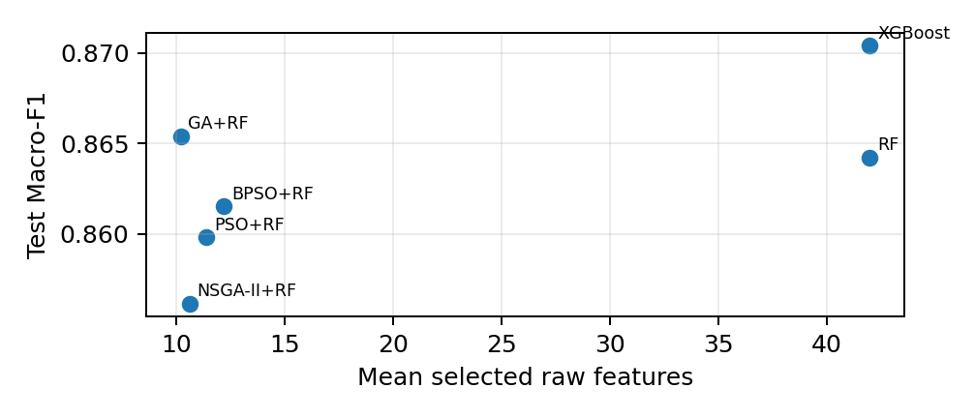
Figure 1. Predictive performance versus mean selected raw-feature count.
GA reduces the mean input from 42 to 10.2 raw predictors while changing RF Macro-F1 from 0.864225 to 0.865394 (+0.001170). FPR falls from 0.272151 to 0.254795 (-0.017357, approximately 1.74 percentage points). Thus the strongest result is not merely compression: predictive quality is preserved and slightly improved while the false-alarm rate decreases.
The budget experiment supports the value of deeper search for GA and BPSO. From 24 to 300 evaluations, GA Macro-F1 increases by 0.004302 while mean features fall from 17.8 to 10.2; BPSO improves by 0.003899 while shrinking from 15.6 to 12.2 features. PSO becomes more compact (14.6 to 11.4) but its test Macro-F1 decreases slightly (-0.000394), showing that more optimisation effort does not guarantee better generalisation.
Feature-frequency analysis identifies ct_srv_dst (0.80 mean frequency), sbytes (0.70), dbytes (0.60), ct_srv_src (0.55) and smean (0.55) as recurrently selected across all four methods. However, complete subsets remain unstable, indicating redundancy and multiple near-equivalent representations.

4. Critical Review
GA is the strongest selected-feature method, but the evidence does not justify claiming that evolutionary selection produces the best classifier overall: full-feature XGBoost remains higher at 0.8704 Macro-F1. The contribution is therefore a trade-off result. GA removes approximately three quarters of the predictors while preserving RF performance and reducing FPR. This is valuable when sensing, preprocessing, memory, latency or interpretability constraints matter, but it does not imply that dimensionality reduction is universally preferable to a stronger full-feature learner.
NSGA-II contributes differently. Scalar GA/BPSO/PSO embed the design choice lambda=0.05, whereas NSGA-II exposes a Pareto set of explicit performance-versus-size alternatives (mean front size 6.4). Its selected ideal-distance solutions nevertheless average only 0.8562 Macro-F1 and have higher variance. The limitation appears partly attributable to decision-policy sensitivity: aggressive compactness can select small validation-efficient subsets that generalise poorly. The Pareto front is therefore more informative than the single selected NSGA-II point.
All optimisers show a material validation-to-test gap: GA 0.0779, BPSO 0.0793, PSO 0.0818 and NSGA-II 0.0835 on average. This is evidence that optimisation performance on a training-derived validation split does not directly transfer to the official test distribution. It should not be labelled conclusively as overfitting without a formal distribution-shift analysis; possible explanations include search selection pressure, stochastic subset instability and train/test distribution differences.
Statistical evidence is also limited. Across five matched seeds the Friedman test is non-significant (p about 0.178), and Holm-corrected pairwise Wilcoxon comparisons do not reach 0.05. GA nevertheless has the highest mean score and beats each alternative feature-selector in four of five paired seeds. With n=5, effect direction, variance and repeated-seed consistency are more informative than a binary significance claim. More independent runs would strengthen inference.
Relative to prior literature, the result agrees with recent evidence that IDS feature-selection algorithms occupy different accuracy-efficiency regions [5] and with earlier work showing that NSGA-II can formulate feature count and detection quality as separate objectives [2]. The present implementation extends that theme through strict unique-evaluation accounting, budget sensitivity, official-test isolation, feature-stability analysis and comparison against strong full-feature baselines.

5. Conclusion
Evolutionary feature selection can substantially reduce UNSW-NB15 dimensionality while retaining competitive intrusion-detection performance. Under the controlled 300-evaluation budget, GA is the strongest feature-selection method: 10.2 of 42 predictors, 75.71% mean reduction, Macro-F1 0.8654 and lower FPR than full-feature RF. BPSO and PSO remain competitive but weaker; NSGA-II provides useful Pareto alternatives but its chosen compromise generalises less consistently. XGBoost remains the best absolute classifier, so the central conclusion is efficiency-performance improvement rather than universal predictive superiority.

Generative AI Reflection
Generative AI was used to explain optimisation concepts, review experimental design, inspect implementation logic, structure analysis scripts and improve report clarity. The experimental measurements were generated by the locally executed Python system rather than by AI. Suggested code and interpretations were checked against program output, the coursework requirements and academic sources. AI-supported text was edited to preserve methodological accuracy, including negative findings such as NSGA-II's weaker selected-solution performance and the absence of statistically significant differences.

References
[1] N. Moustafa and J. Slay, "UNSW-NB15: A comprehensive data set for network intrusion detection systems (UNSW-NB15 network data set)," 2015 Military Communications and Information Systems Conference (MilCIS), pp. 1-6, 2015. doi:10.1109/MilCIS.2015.7348942.
[2] C. Khammassi and S. Krichen, "A NSGA2-LR wrapper approach for feature selection in network intrusion detection," Computer Networks, vol. 172, 107183, 2020. doi:10.1016/j.comnet.2020.107183.
[3] O. Almomani, "A Feature Selection Model for Network Intrusion Detection System Based on PSO, GWO, FFA and GA Algorithms," Symmetry, vol. 12, no. 6, 1046, 2020. doi:10.3390/sym12061046.
[4] Y. Fang, Y. Yao, X. Lin, J. Wang and H. Zhai, "A feature selection based on genetic algorithm for intrusion detection of industrial control systems," Computers & Security, vol. 139, 103675, 2024. doi:10.1016/j.cose.2023.103675.
[5] A. Sezgin, M. Ulas and A. Boyaci, "Multi-Objective Feature Selection for Intrusion Detection Systems: A Comparative Analysis of Bio-Inspired Optimization Algorithms," Sensors, vol. 25, no. 19, 6099, 2025. doi:10.3390/s25196099.
Dataset link: https://research.unsw.edu.au/projects/unsw-nb15-dataset
Implementation repository: https://github.com/FrancescoGuerriero/Multi-Objective-Evolutionary-Feature-Selection-for-Efficient-Network-Intrusion-Detection

