**SPRINT FIVE**

Project Manager: Dr. Blanche Cohen

Scrum Master: Nick Miller

Product Owner: Omar Bitar

Team Members: Dustin Shaver, Francesco Limoni, and Jacob Watters

Introduction

Team 5 is creating a simple drawing program we are naming “Pixel Image Editor” (or PIE for short). It is coded in Ruby, using the FXRuby gem libraries. This program is written specifically for a desktop computer or laptop, not a tablet or mobile device. The GitHub repository link is: https://github.com/FrancescoLimoni/P.I.E

Research Progress and Project Demonstration

The program that is demonstrated in sprint five displays full functionality of the export function, different brush sizes, different colors for brushes and custom color pallet selection.

* **Canvas Module** – The blank canvas where the user will be able to draw. The canvas is resizable with can be saved as a PNG image file.
* **Brush Module** – A side bar with different “brush sizes” for the pixel editing. This ranges from using a brush that is 1 pixel by 1 pixel to some larger size. The buttons are not currently implemented.
* **Color Module** – A side bar with preset color palletes and RGB text inputs for color seting. Eventually, this will be where the user can define their own colors.
* **Toolbar Module** – The toolbar across the top of the screen where the buttons to Save and access program documentation are.
* **Layering Module** – A side bar where the user will organize the different layers to their pixel project.

All of the modules mentioned above then communicate through a Main file, where they are formatted using frames provided in FXRuby. The Layering Module has been pushed back for next sprint, and is considered as an optional feature for the final product.

During the Sprint five presentation, the Project Backlog was described, and the successes and failures of the team to meet those tasks. On the next page is a screenshot of the Project Backlog.

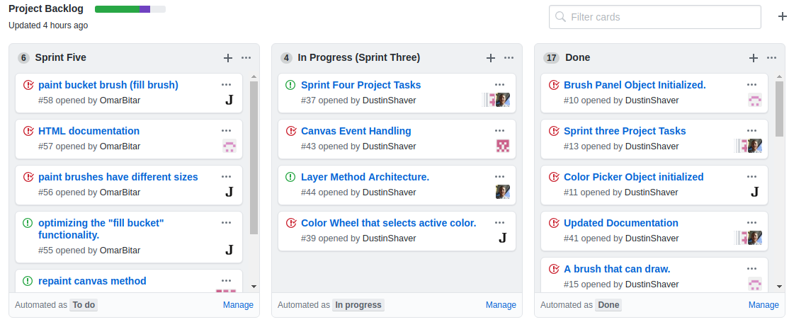

Comparison to Project Plan

Our current version is close to our program concept (the concept art is shown on the next page). Advancements in design and layout have made the program more stylized and functional. So far we are on track to finish the pixel editor by the end of the semester. There are no current plans to scale back the project.

Sprint Retrospective

This last Sprint was successful, we manacled to add two bonus features that were not planned. Inclement weather and conflicting schedules has made coordinating difficult.

Most things went well for the team during the sprint. Most of the team members are now more use to the fxRuby library and how it works, the development relatively smooth with no major bugs or problems generated.

Our team works very well together and can often find solutions to potential tasks very quickly and clearly. We look forward to implementing future functionality in the next sprint.

Hours

|  |  |
| --- | --- |
| Team Member | Hours Worked for Sprint 1 |
| Omar Bitar | 14 hr 0 min |
| Francesco Limoni | 6 hr 0 min |
| Nick Miller | 10 hr 0 min |
| Dustin Shaver | 8 hr 0 min |
| Jacob Watters | 15 hr 0 min |

Tools and Resources

Language used: Ruby - ruby-lang.org/en/

Gem for GUI used: FXRuby - fxruby.org/

IDE for Ruby: Aptana Studio 3 - aptana.com/

Documentation for FXRuby: Online - rubydoc.info/gems/fxruby/Fox/

Book on FXRuby: FXRuby - https://media.pragprog.com/titles/fxruby/tables.pdf

Guide for Scrums and Sprints: The Scrum Guide - https://www.scrumguides.org/docs/scrum

guide/v2017/2017-Scrum-Guide-US.pdf

Repository Hosting: GitHub – github.com/