Community performance curves predict community stability despite interaction effects

Francesco Polazzo§*¹, Til Hämmig^{§1}, Shyamolina Ghosh², Owen L. Petchey¹

¹ Department of Evolutionary Biology and Environmental studies, University of Zurich, Zurich, Switzerland, ² Agricultural and Ecological Research Unit, Indian Statistical Institute, West Bengal, India.
§ The two authors contributed equally to this work
* Corresponding author: Francesco Polazzo, francesco.polazzo@uzh.ch

ORCID: FP: 0000-0003-2092-501. TH: 0009-0004-9469-680X. SG: 0000-0002-5137-9933. OLP: 0000-0002-7724-1633.
Author contributions: FP: Conceptualisation, Formal analysis, Investigation, Methodology, Writing - original draft, Project administration, Visualisation, Software. TH: Conceptualisation, Formal analysis, Investigation, Data curation, Methodology, Writing - review & editing, Visualisation, Software. SG: Methodology, Writing - review & editing. OLP: Conceptualisation, Funding acquisition, Methodology, Project administration, Resources, Supervision, Writing - review & editing.
Competing Interest Statement: None
Funding: This study was founded by the Schweizerischer Nationalfonds zur Förderung der Wissenschaftlichen Forschung project number 320030-231294
Keywords: Diversity – Stability debate, species interactions, response diversity, performance curve,
Open Science Statement: Data and code to reproduce the analysis is available at https://github.com/FrancescoPola/CPCs_predict_CommunityStability, and will be permanently deposited in Zenodo upon publication.

Abstract
Predicting the stability of ecological communities in changing environments is challenging. Classical theory posits that community stability cannot be understood without considering interspecific interactions. A contrasting view is that species’ environmental responses and their variation (response diversity) influence stability to the extent that effects of interspecific interactions can be ignored. Surprisingly, few studies have evaluated the relative importance of interactions versus species’ responses. Moreover, trait-based measures of response diversity often show limited predictability. Here, we introduce community performance curves, the aggregate of species’ performance curves, as a powerful mechanistic link between community composition and stability. This approach reveals that species responses predict most of the variation in community stability in simulated communities, even when the strength of interspecific interactions varies. An experiment with ciliate communities corroborates these findings, while a literature review reveals how rarely both mechanisms are assessed jointly. By moving from summary traits to community performance curves, we reconcile the two perspectives: while species interactions undeniably shape community dynamics, community performance curves are sufficient to predict stability. This provides the opportunity to predict community stability, even when information about the multitude and diversity of interspecific interactions is unavailable.

Introduction
Ecological stability has been a focal research topic since the foundational work linking complexity, interaction strength, and stability ^{1,2}. Classic results identify interspecific interactions and the architecture of interaction networks as primary determinants of population and community dynamics. Interactions can shape whether perturbations are damped or amplified ^{3,4} and can thereby influence community stability ^{2,5}. Empirical and theoretical studies further show that interactions can generate compensatory dynamics and asynchrony among species, reducing variability in aggregate properties such as total biomass ^{6,7}.
A contrasting theme is the importance of how species respond to the environment ^{8,9}. In fluctuating conditions, response diversity, here defined as the variation among species in their responses to environmental drivers ^{10,11}, can promote compensatory dynamics whereby some species decline while others increase, producing asynchrony that stabilises aggregate properties ^{12,13}. This insurance mechanism aligns with portfolio effects and has been invoked to explain why diverse communities can be more stable ¹⁴.
These two perspectives, one of interactions influencing stability, and the other of species’ responses driving stability are not mutually exclusive. Nevertheless, historical and contemporary focus on the importance of species interactions has produced a paradigm whereby ecological stability cannot be explained and understood if interactions are not included in that explanation. Indeed, in a survey of experts, complexity arising from interspecific interactions was consistently ranked highest among the challenges facing studies of response diversity ¹⁵.
Empirical evidence that could overturn this paradigm is scarce and also, as we will show, limited by its methodology. Our literature review shows that very few studies explicitly compare the explanatory power of interactions versus species specific responses for stability, leaving a key evidence gap for assessing stability paradigms that prioritise interaction structure ^{18–20} and those that emphasise environmental response structure ^{8,9,21}.
A key methodological bottleneck is that species’ environmental responses are traditionally characterized by trait moments, such as the community-level mean or variance of a single trait (e.g., thermal optima) ^{22,23}. Because these single traits collapse complex, non-linear responses to the environment into a single value, they frequently predict stability poorly, particularly when interspecific interactions are not simultaneously accounted for ^{24,25}. This reliance on single traits discards the very information essential to predict stability: the breadth, height, asymmetry, and curvature of the performance-environment relationship ^{26,27}. Stability emerges from how these features convert environmental variability into fluctuations in demographic rates ²⁸. Consequently, any moment based on single traits, such as a community’s average thermal optimum, will provide an incomplete picture of a community’s response to environmental change.
To overcome this limitation, we developed an approach that retains all the information in the performance curves of all the species in a community. One could say that this approach treats the species performance curves as a meta-trait: emergent organismal properties integrating multiple underlying traits that jointly determine how species respond to environmental variability. A single thermal performance curve encapsulates many thermal traits (e.g. thermal optimum, activation energy, thermal niche breath) that are commonly used as individual predictive variables.
In our new approach, we aggregate the species performance curves into a community performance curve that quantifies the sum of species performances and thus the community’s expected performance across an environmental gradient. Figure 1 illustrates species and community performance curves, and how the distribution of community performances is jointly influenced by the shape of the community performance curve and the distribution of environmental conditions. The figure also shows how the variability (coefficient of variation, CV) can summarise this combination of community performance curve and environmental influences. A low CV indicates that community performance is relatively independent of environmental conditions, and should predict high community stability (e.g., Fig. 1, a, b, c), whereas a high CV should predict low stability (e.g., Fig. 1, d, e, f).
With this approach, we use simulations and an empirical test to demonstrate that community performance curves offer a tractable and superior predictor of stability that remains robust even in the face of considerable variation in the strength of interspecific interactions.
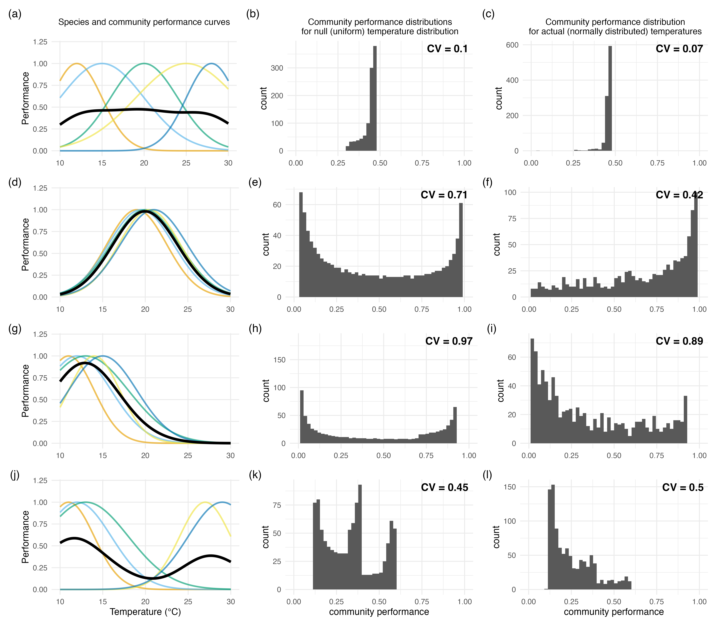
Figure 1. Community performance curves, species performance curves, and temperature driven community performance distributions across four community types.
Panels (a), (d), (g), and (j) show species-specific thermal performance curves (thin coloured lines) together with the community performance curve (thick black line) for four different community structures: (a) a community with widely spaced optima; (d) a community with tightly clustered optima; (g) a community with a right skewed distribution of optima; and (j) a bimodal community. For each community, panels in the second and third columns illustrate how different assumptions about the distribution of environmental temperatures translate into variability in community performance. Panels (b), (e), (h), and (k) show the distribution of community performance values obtained using a null temperature time series that follows a uniform distribution and assumes all environmental states are equally likely, and that can be calculated when there is no information about the actual environmental conditions experienced by a community. Panels (c), (f), (i), and (l) show community performance distributions obtained using an actual temperature time series experienced by communities and that follows a normal distribution and assumes some environmental states are more likely than others. Please note, community performance values in Fig. 1 are calculated only from species performance curves and a set of temperature; no simulations of community dynamics are involved.

Results

Systematic review
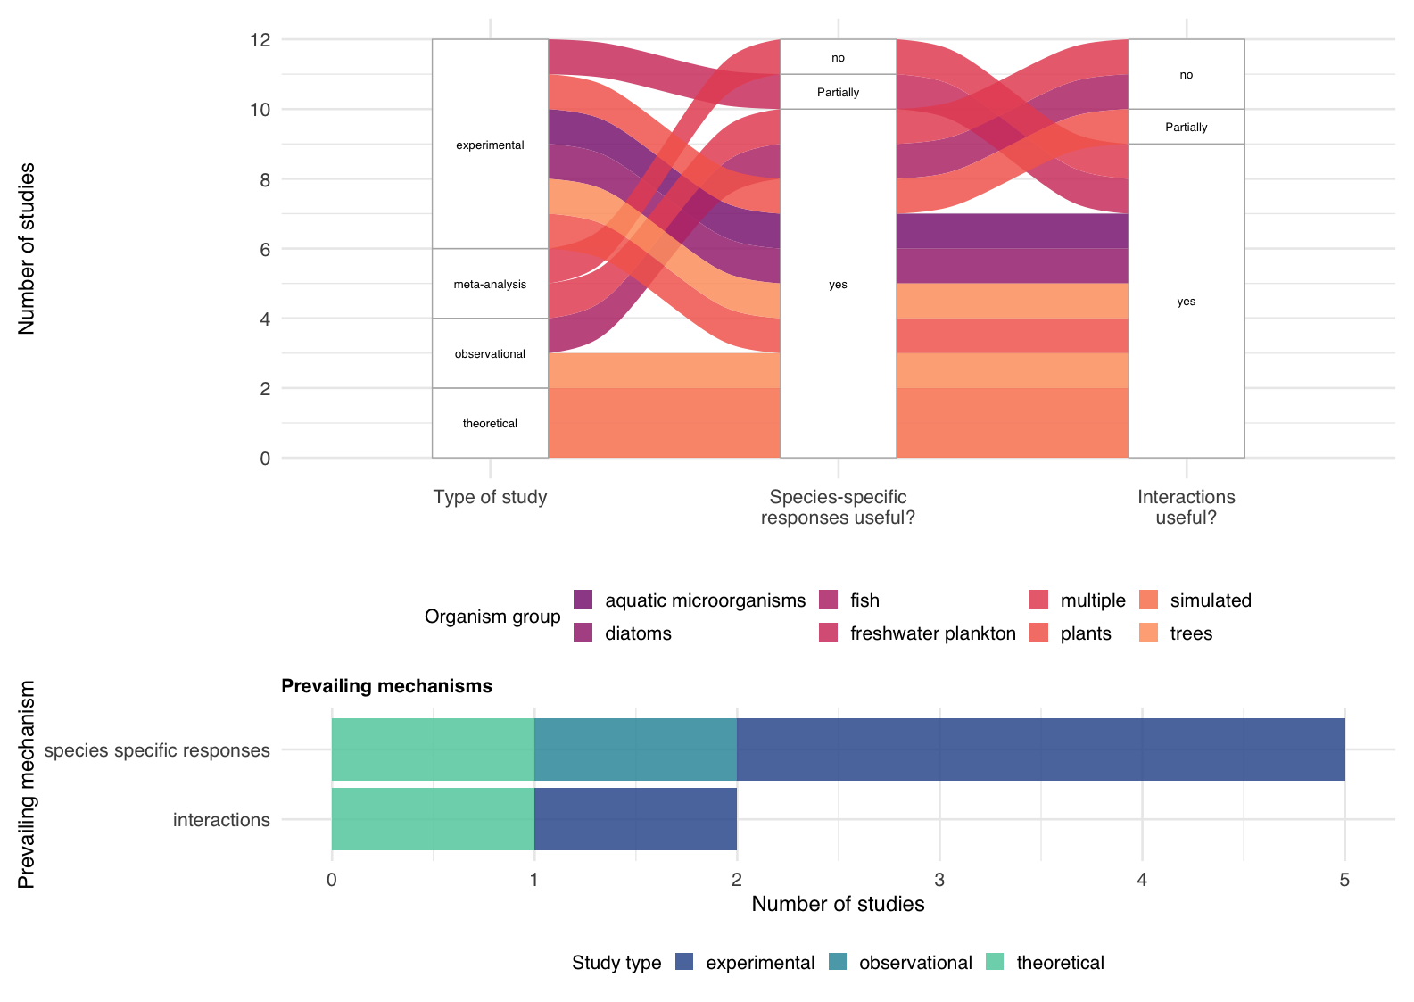
Figure 2. Systematic review: overview of study characteristics and prevailing mechanisms in the literature.
The upper Sankey diagram illustrates the associations between study type (experimental, observational, theoretical, meta-analysis), whether species-specific responses were considered important for stability (yes, partially, no), and whether interactions were considered important for stability (yes, partially, no). Colours indicate organism groups. The lower bar plot summarizes which mechanism was considered prevailing (meaning the mechanism judged to have the stronger influence on stability) among studies that concluded both species-specific responses and interactions were important in the Sankey diagram, grouped by study type.

The systematic review reveals that there is a critical gap in biodiversity–stability research: the relative importance of interactions versus species responses remains largely unresolved because the two have seldom been tested together.
We systematically reviewed studies that examined the importance of species responses and or interspecific interactions for the stability of aggregate community properties. Only 12 studies jointly assessed species-specific environmental responses and interspecific interactions (Fig. 2). Whereas 77 studies addressed either interactions or species responses. Across the 12 studies that addressed both mechanism, seven found that both interactions and species-specific responses were important. Species‑specific responses were found to me more important than interactions in five of these seven studies (Fig. 2, bottom). Of the remaining five, three found that species-specific responses were important and that interactions were not or were partially important, while two found that interactions were more important (Fig. 2, top).

Simulation study
Using a discrete-time Lotka–Volterra framework, we simulated communities across broad gradients of species richness, thermal optima, performance-curve breadth, interaction strength, and environmental temperature regimes to quantify how variation in community performance curves predicts community stability.
Community performance variability (CV of community performance) consistently emerged as the dominant and most reliable predictor of community stability, far outperforming trait-based metrics and remaining robust even under strong interspecific interactions.
Explanatory power (R²) decreased with increasing interaction strength for all metrics, yet the CV of actual community performances still explained ~70% of stability under strong interactions and ~97% when interactions were absent (Fig. 3a). Additional analyses confirmed that community performance variability remained a strong predictor across all interaction regimes (Fig. 3b–d), a result reinforced by a Random Forest model (excellent fit: OOB R² of 0.962), which identified actual community performance variability as the most influential predictor (Fig. 3c–d).
In contrast, trait-based- metrics had lower explanatory power and were more sensitive to interaction strength, declining from ~80% R² without interactions to ~49% under strong interactions (Fig. 3a). The trait-based metric $sd\left(T_{opt,i}\right)$, which measures the amount of interspecific variation in optimum temperature, outperformed $T_{opt,mean}$ (the average of the temperature optima) (Fig. S1). Nevertheless, stability varied widely for the same value of $sd\left(T_{opt,i}\right)$ depending on the breadth of performance curves (Fig. S2). Broader performance curves increased community stability, but of course this effect could not be explained by metrics only using the temperature optima.
The null community performance curve, calculated without using the actual temperature time series, explained more variation in stability than any trait-based metric (Fig. 3a), showing that community performance curves remain highly predictive even when environmental information is absent.

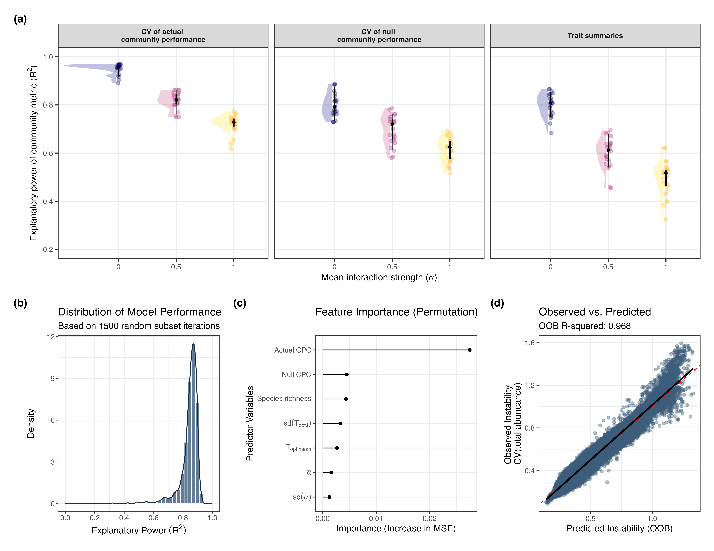
Figure 3. Simulation study: explanatory power of community metrics. (a) Relationship between mean interaction strength $(α)$ and the explanatory power $R^{2 }$of community metrics in predicting (in)stability (coefficient of variation of total abundance). The first two panels correspond to the observed and null community performance metrics, whereas the third shows the explanatory power of the two trait-based metrics. Each point represents a group of simulated communities with identical interaction strengths (α), temperature time series, and mean of species thermal optima, but differing in richness, variation in species thermal optima, mean and variation of thermal performance curve breath, and community replicate. Jitter was added for visibility; colours indicate the value of α. Half violin- shapes summarise the distribution of explanatory power for each interaction strength level within each metric. (b) Robustness of the relationship between the CV of actual community performance and stability, shown as the distribution of the explanatory power ($R^{2 }$) across 1,500 random subsets of the entire simulated data. (c) Predictor importance for community stability ranked by permutation importance derived from a random forest analysis. Higher values represent a greater increase in Mean Squared Error (MSE) when the variable is permuted, indicating higher predictive power. (c) Random forest model diagnostic comparing Observed vs. Out-of-Bag (OOB) predicted stability. The red dashed line represents the 1:1 identity line; the solid black line shows the linear fit ($R^{2 }$ = 0.962). Predictors include species richness, interaction parameters $(α)$, community performance variability metrics, and trait-based metrics.

Empirical study
We applied the community performance curve-based framework to an experimental ciliate system, using species-specific thermal performance curves and measured community biomass under fluctuating temperatures to test whether community performance curve variability predicts empirical community stability.
The empirical study revealed that community performance (null) predicted variability in community biomass across all richness levels (Fig. 4a), explaining 24% of the variation (log₁₀ CV of total abundance; slope = 0.115 ± 0.013 SE, t = 8.76, p < 10⁻¹⁵; R² = 0.24). This indicates that communities with greater variability in community performance also exhibited higher variability in total biomass.
Trait summaries based on species’ thermal optima were weaker predictors of community variability (Fig. 4 b, c). Using $sd\left(T_{opt,i}\right)$, we detected a modest negative association between the standard deviation of species thermal optima and community variability (slope = −0.019 ± 0.015 SE, t = −2.63, p = 0.0091); overall fit was low (R² = 0.028; residual SE = 0.16). In a separate model using ${T_{mean}- T}_{opt,mean}$, the association with community variability was statistically significant and larger than the one between variance of species’ thermal optima (slope = 0.020 ± 0.0034 SE, t =5.68, p < 0.001 R² = 0.11). When we modelled stability as a function of the two trait-based summaries $sd\left(T_{opt,i}\right)$ and $T_{opt,mean}$, the explanatory power was 0.22 (Fig. S3).
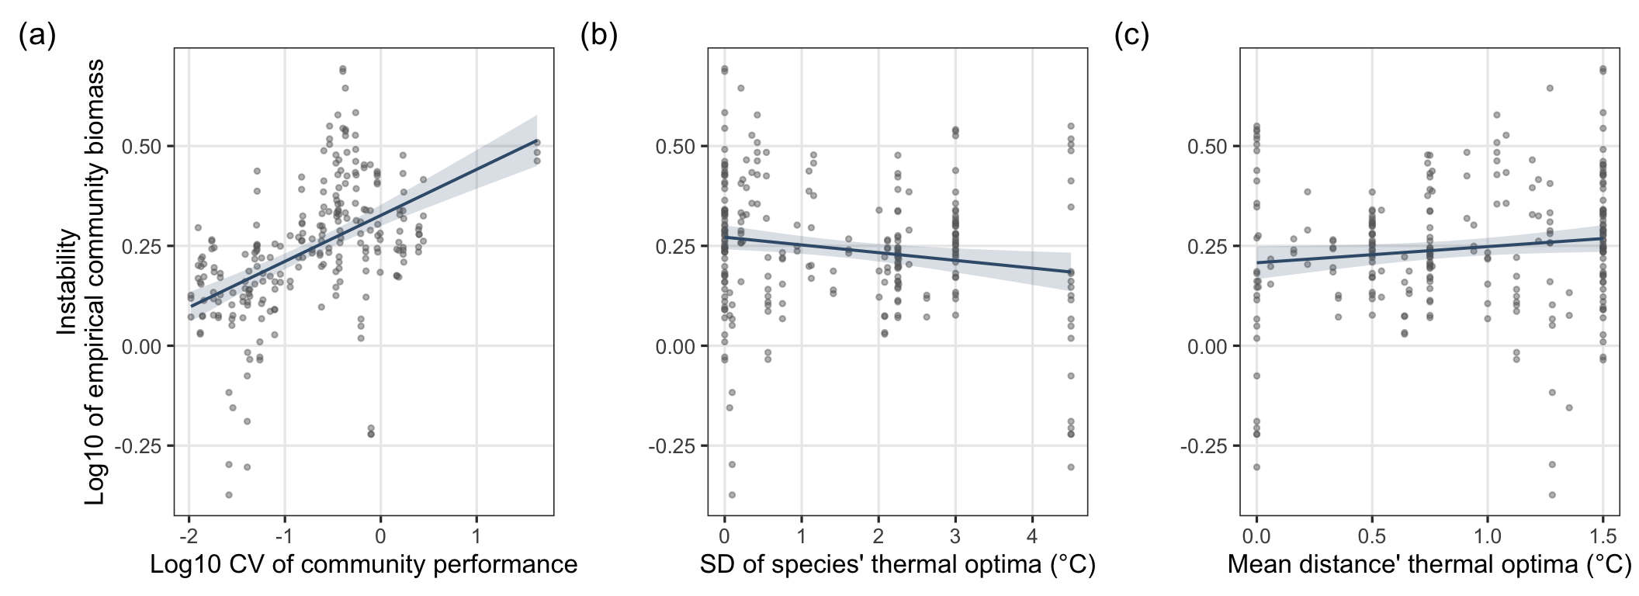Figure 4. Empirical study: Relationships between community biomass variability and community metrics. In all panels the y-axis is instability measured as Log10 coefficient of variation (CV) of total community biomass. (a) instability versus log10 CV of community performance values. (b) Instability versus standard deviation of species’ thermal optima. (c) Instability versus the distance of mean species’ thermal optima to the mean temperature. Solid lines show linear regression fits with 95% confidence intervals.

Discussion
The results of the simulation and empirical study show that species-specific environmental responses can predict large amounts of variability in community stability even in the presence of interspecific interactions. The simulations results allow us to go even further: species responses explain the majority of variation in community stability, even in the presence of large variation in the strength of interspecific interactions. While classical theory has long posited that stability emerges from interspecific interactions ^{1,3}, our simulations and experimental evidence reveal that interactions are not so important that they must be included in explanations of community stability. Moreover, the environmental response structure of the species in a community can predict community stability even when the strength of interspecific interactions is ignored.
Nevertheless, the literature review revealed a prominent systemic omission: few studies have compared the role of species-specific responses and interspecific interactions for community stability. For a century, ecology has been dominated by the view that community stability cannot be understood or explained in the absence of information about, and consideration of, the effects of interspecific interactions ^{1–4,29–31}. However, we suggest that this dominant view results from the lack of comparative studies, granting interaction strength disproportionate importance. From early competition theory ^{29–31} to modern coexistence theory ³², and network approaches ^{1–3}, interaction strength has been treated as the primary mechanism regulating population dynamics and buffering or amplifying environmental variability ^{1,2,4}. We suggest this has biased thinking about the relevance and importance of other determinants of community stability.
Another reason why the role of species environmental responses has been underappreciated is the lack of adequate tools to quantify the role of species’ response. For example, when the role of species’ responses were investigated, they could have been found to be weak drivers not because they are intrinsically so, but rather because they have been operationalised using oversimplified approaches ^{22,24,25,33–36}. By developing and using the community performance curve, we revealed that environmental response structure explains community stability even in the absence of any knowledge of species interactions. That is, a previously unrecognised aggregate descriptor of community performance captures most of the information needed to predict stability, leaving little independent predictive role for detailed interaction structure.
Species’ performance curves integrate multiple physiological and ecological traits, directly capturing how species respond to environmental fluctuations. Aggregating these curves yields a community performance curve that reflects response diversity, complementarity, and dominance in the currency that matters for stability: environmentally driven variation in performance. Within this framework, species-specific responses emerge unequivocally as a key stabilizing mechanism, and aggregated species’ performance curves account for most of the simulated variability in community stability, even when interaction strengths are high.
The power of the community performance curve lies in its ability to unify multiple stabilizing processes. Unlike traditional trait-based approaches, community performance curves retain the information required to predict the covariances that drive asynchrony and the variances that drive population-level stability ^{12,13}. Species with wide, flat performance curves (i.e. broadly tolerant “generalists”) maintain positive performance across environmental gradients and contribute to community stability through their high population stability. They stabilise aggregate community properties regardless of the dynamics of other species ^{21,37}. At the same time, other species with narrower performance curves have lower population stability, but in combination with species with complementary performance curves contribute to community stability via asynchrony in species fluctuations. Critically, both stabilising phenomena contribute to a flatter community performance curve. Thus, the flatness / variability of the community performance curve encodes both the stabilising role of environmentally derived asynchrony and population stability ¹³.
Our empirical evidence from ciliate microcosms supports the idea that lack of appropriate tools has limited the perceived role of environmental responses for community stability. Stability under temperature fluctuations was consistently explained by the variability of aggregated community performance, whereas traditional trait-based descriptors showed limited predictive power. This suggests that a “missing link” in biodiversity–stability theory has been the lack of appropriate tools to quantify the role of species’ environmental responses.
The conclusions from our simulation and empirical studies could be criticised by suggesting that we have constructed and then analysed situations in which species have strong response to the environment, so of course this has high explanatory power. Multiple lines of argument speak against this. First, weak environmental responses play an important role in stabilising communities (weak responses lead to high population stability, which in turn leads to high community stability), and the community performance curve is influenced just as much by weak responses as strong ones. Second, our results were robust to variation in the strength of species responses in the simulations. Third, species responses in the empirical study included strong and weak responses.
Of course, we do not suggest that interactions are unimportant. Our results clearly show that interactions affect population dynamics, the degree of synchrony, and influence the synchrony expected only from species responses (Extended data, Fig. S4, S5, S6). The highest interaction strength treatment even caused species extinction, when otherwise there was coexistence (Extended data, Fig. S4). However, knowledge of interactions and their strength was not required to explain and predict community stability.
In the face of unprecedented and increasing environmental volatility, the ability to forecast ecological stability is a global priority. Our framework rewrites the prevailing paradigm that stability cannot be understood without information about interactions, showing that this constraint originated in what studies have been done, and the methods they used. By moving beyond trait moments and embracing performance-based meta-traits, we provide a tractable and mechanistic path for predicting ecological stability. Crucially, with new methods to derive species performance curves from monitoring data ^{38,39}, this shift can enable the large-scale forecasting of ecosystem stability even when data on interaction strengths is sparse. This would be a key advance for monitoring, conserving, and restoring community and ecosystem stability, providing a basis for sustainable and predictable provision of ecosystem services.

Methods

Systematic review

Database and search strategy
We conducted a search of Web of Science Core Collection on 26 November 2025. The search targeted titles, abstracts, and author keywords using the following Topic Search (TS) string:
TS = (("temporal stabilit*" OR "temporal variabilit*" ) AND (("interaction*" ) AND ("environmental response*" OR "environmental variabilit*" OR "abiotic factor*" OR "species-environment relationship*" OR "response diversity" OR "species* performance*" OR "species respons*" OR "species environment* respons*")))
Asterisks () were used as wildcards to capture word stems (e.g., “stabilit” for “stability/stabilization”), and the Boolean operators were applied as shown to ensure simultaneous coverage of (i) temporal stability/variability, (ii) interspecific interactions, and (iii) species environmental responses.

Search scope and filters
We limited the search to peer-reviewed research articles, meta-analyses, and reviews. Conference proceedings, editorials, book chapters, theses, and non-English records were excluded to ensure consistency of methodological reporting. No temporal restriction was imposed at the search stage; records from all years available in the database at the time of search were eligible. Where Web of Science offered multiple indices (e.g., SCI-EXPANDED, SSCI), we included all indices available within the Core Collection to maximize coverage.

Record management and screening
All records and associated metadata (authors, title, abstract, keywords, journal, year, DOI) were exported from Web of Science and imported into a reference manager for deduplication. Screening proceeded in two stages:
- Title and abstract screening against predefined inclusion criteria:
  - The study must analyse temporal stability or temporal variability of a community or ecosystem property.
  - The study must explicitly evaluate or discuss interspecific interactions (e.g., competition, facilitation, predation, mutualism, food-web/network structure).
  - The study must address species-specific environmental responses or related constructs (e.g., response diversity, species–environment relationships, performance curves/traits linked to abiotic drivers).
Studies focusing solely on spatial stability or environmental gradients without temporal context were excluded.
- Full-text screening to confirm eligibility and extract variables.
Screening was conducted by two reviewers working independently; disagreements were resolved by discussion.

Data extraction
For each included study, we extracted a standardized set of variables:
- Bibliographic: authors, year, journal, DOI.
- System type: aquatic microorganisms, diatoms, freshwater plankton, fish, plants, trees, etc.
- Study type: experimental, observational, theoretical, meta-analysis.
- Temporal metric: how stability/variability was quantified (e.g., CV, variance, autocorrelation, invariability).
- Interactions: type and operationalization (e.g., competition coefficients, network metrics, pairwise interactions, multi-species interactions; empirically measured vs. simulated).
- Species responses: whether species-specific responses were evaluated, and whether they were found important for stability (yes/partially/no) and how (traits, performance/thermal curves, niche models, time-series responses to abiotic variables).
- Conclusion flags: whether the study found interactions useful/important (yes/partially/no); whether species-specific responses were important (yes/partially/no).
- Prevailing mechanism (subset analysis): for studies concluding that both interactions and species responses are important, we recorded which mechanism was judged prevailing (interactions or species-specific responses).

Synthesis and visualization
We summarized categorical variables as counts and proportions across study types and organism groups. To illustrate associations among study type, assessment of species-specific responses, and assessment of interactions, we constructed Sankey diagrams. To evaluate the prevailing mechanism among studies that judged both mechanisms important, we compiled bar plots stratified by study type.

Bias assessment and sensitivity checks
We assessed potential publication bias qualitatively by noting the distribution of study types, taxa, and journals. Sensitivity analyses included: (i) repeating syntheses with reviews/meta-analyses removed; (ii) restricting to empirical studies; and (iii) reclassifying ambiguous cases (e.g., “partially” → “yes” or “no”) to test robustness of conclusions.

Reproducibility
The complete workflow (search query, export settings, raw records, screening decisions) is archived in a version-controlled repository (timestamped 2025-11-26 search). This ensures full reproducibility and allows future updates to the review.

Simulation study
The biomass dynamics of each of the species in a community is simulated with a discrete-time version of the classical Lotka–Volterra model ^{40,41}. The growth in abundance from one time (t) to the next time (t + 1) is given by:

$${r_{i}\left(t\right)=lnN_{i}\left(t+1\right)-lnN_{i}\left(t\right)=r}_{max,i}(T)\left(1-\frac{\sum_{i,j=1}^{i, j= S}{α_{ij}N_{j}(t)}}{K_{i}(T)}\right)$$

Where:
N_{j}(t) is the abundance of the j-th species in the community at time t.
$r_{max,i}(T)$ is the maximum growth rate of species i at temperature T. Maximum growth rate is the growth rate in the absence of any intra- or inter-specific effects. $r_{max,i}\left(T\right)=b_{i}\left(T\right)-d_{i}(T)$
S is the number of species in the community.
$α_{ij}$ is the effect of species j on the growth rate of species i.
K_{i}(T) is the equilibrium abundance of the i-th species in the community in the absence of any inter-specific effects.
Following Vasseur (2020), we let $K_{i}(T)={r_{max,i}(T)}/{\left(β-δ\right)}$ where $β$ and $δ$ are the density-dependence constants for birth rate and death rate, respectively.
To prevent biomasses becoming very small, a unit of biomass is added to the biomass of each species at each time step.

Temperature dependence
As mentioned above, the maximum growth rate of a species depends on temperature. For simplicity, we let birth rate be a Gaussian function of temperature and death rate an exponential function of temperature:
$$b_{i}\left(T\right)=a_{b}e^{{{-\left(T-T_{opt,i}\right)}^{2}}/{s_{i}}}$$

$$d_{i}\left(T\right)=a_{d}e^{z_{i}T}$$
Where:
$a_{b}$ is the birth rate when the environmental temperature (T) is equal to the temperature at which birth rate is greatest ($T_{opt,i}$). This is the height of the Gaussian curve between birth rate and temperature.
$s_{i}$ is the width of the Gaussian curve between birth rate and temperature.
$a_{d}$ is the death rate when T = 0, and $z_{i}$ is the rate at which death rate changes with temperature.

Parameterization and Species Traits
Species differed in thermal optima ($T_{opt,i}$), performance curve breadth ($s_{i}$), and interaction strengths (α_{ij}). Thermal optima were drawn from uniform distributions with specific mean and range to create a community with specific average thermal affinities and degrees of niche overlap. Performance curve breadths were varied to represent differences in thermal tolerance, from narrow specialists to broad generalists. Intraspecific competition was fixed at $α_{ii}=1$, while interspecific coefficients were drawn from a uniform distribution with specified mean and standard deviation that ensured exclusively competitive interactions. The maximum birth rate parameter ($a_{b}$) was set to 0.3 for all species, while death rate ($a_{d}$) was set to zero, making the value of $z_{i}$ irrelevant.

Community Assembly and Experimental Design
We assembled communities with a fully factorial manipulation of the following treatments:
- Species richness: 2, 4, 8, or 16 species.
- Thermal optima: manipulated via the mean (16–24 °C in steps of 2 °C) and
- the range (6–14 °C in steps of 2 °C) of the distribution of species’ thermal optima ($T_{opt,i}$).
- Thermal breadth: controlled by the mean (6, 8, 10, 12, 14) and variance (0, 2, 4, 8, 10) of distribution of the width of the species temperature performance curve ($s_{i}$).
- Interaction structure: varied by altering the mean and variance of the
the distribution of interspecific competition coefficients with the following combinations (0, 0) (no interactions), (0.5, 1) (intermediate strength interactions), (1, 1) (strong interactions.
- Temperature fluctuation time series: five.
There were five replicate communities, giving a total of 187’500 community simulations.
This design allowed us to disentangle the effects of diversity, trait composition, and interaction strength on community stability.

Environmental Variation and Simulation Protocol

Simulations were run for 2,000 time steps. The first 1,000 time steps included constant temperature (20 °C) to allow transients to dissipate. During the following 1,000 time steps temperature varied with a mean of 20 °C, standard deviation of 4 °C, and temporal autocorrelation following a 1/f process with exponent γ=0.8, producing reddened noise typical of many natural systems. This structure ensures that low-frequency fluctuations dominate, creating extended periods of favourable or unfavourable conditions. For each replicate of each treatment combination, there were five realisations of this temperature variation.

Analyses
The following three metric of response diversity were measured.
Community mean of thermal optimum ($\overline{b_{opt,i}}$)
The community mean of thermal optima captures the central tendency of the interspecific variation in the species thermal optima. This is the average of the thermal optimum across all species in a community, i.e. the mean of the temperatures at which individual species reach peak performance. In a community of $S$ species, each with a thermal optimum $T_{opt, i}$, the community mean thermal optimum $T_{opt,mean}$ is calculated as:

$$T_{opt_mean}= \frac{1}{S}\sum_{i=1}^{S}{T_{opt, i}}$$

Because the environmental time series had a mean temperature of 20 °C, we used the absolute deviation of the community mean from this value as a predictor in our models. This quantity reflects how closely the community’s thermal affinity aligns with the prevailing environment, indicating how “adapted” a community is to the environmental conditions it experiences.
Community standard deviation of thermal optima ($sd\left(T_{opt,i}\right)$)
The standard deviation of thermal optima within a community captures the amount of interspecific variation in the thermal optima of species. It is calculated by:
$$\text{sd}\left(T_{\text{opt}}\right)=\sqrt{\frac{1}{S-1}\sum_{i=1}^{S}{{\left(T_{\text{opt},i}-{\overline{T}}_{\text{opt}}\right)}^{2}}}$$

Community performance curve
The community performance curve is calculated as the sum of the species’ performance curves.
$$CommunityPerformance\left(T\right)=\sum_{i=1}^{S}{r_{i}\left(T\right)}$$
Where $r_{i}\left(T\right)$ is the performance curve of species i (intrinsic growth rate of species $i$ at temperature $T)$, and $S$ is the number of species in the community.
Calculating the amount of variation in community performances requires a set of temperatures at which to evaluate the community performances. Let this set of temperatures be denoted by T. Therefore, the set of community performances is CommunityPerformance(T), and the variation in community performances can be calculated as the coefficient of variation (CV) of CommunityPerformance(T).
When T is a set of observed temperatures that a community experiences, we say that CommunityPerformance(T) is the observed set of community performances and the coefficient of variation is the actual CV of actual community performances. When the temperatures that the community experiences are unknown, one can make T a set of uniformly distributed temperatures, in which case we use the term null CV of null community performances.

Community stability
Community stability was calculated as the coefficient of variation of total community abundance.

Analyses of Simulation Outputs
To quantify the explanatory power of trait and performance-curve metrics for community stability, we fitted linear models relating the log₁₀-transformed coefficient of variation (CV) of total community biomass to candidate predictors. Specifically, we modelled:
CV(total abundance) ∼ CV(CommunityPerformance (T))
for both the null and observed performance variability metrics.
Both trait-based candidate predictors were used together in a model of community stability:
CV(total abundance) ∼ $sd\left(T_{opt,i}\right)$ * $T_{opt,mean}$
Where the asterisk (*) indicates that main effects and interaction terms were included.
All models were fitted using ordinary least squares in R (function lm). Model fit was assessed using the coefficient of determination (R²). We fitted these models grouping by interaction strength levels, to see how explanatory power varies depending on interaction strength.

Sensitivity Analysis of Explanatory Power
To evaluate the robustness of the relationship between the actual community performance curve metric and community stability, we performed a sensitivity analysis using a random subsetting procedure. The complete dataset was partitioned into 1,500 random subgroups. For each subgroup, we independently calculated the coefficient of determination (R²) between community performance variability and the coefficient of variation of total community abundance. This iterative process allowed us to generate a distribution of model performance, ensuring that the reported explanatory power was consistent across different random slices of the simulated data and not influenced by specific subset biases.

Random Forest
To identify the multivariate drivers of community instability, we employed a Random Forest (RF) regression using the ranger R package ⁴². The model was trained on the full dataset to predict the coefficient of variation of total abundance using a suite of predictors: community performance variability (Actual and Null), species richness, interaction strengths (mean α, and sd(α)), and thermal trait distributions ($T_{opt,mean}$ and $sd\left(T_{opt,i}\right)$). We used 1,000 trees and calculated variable importance via the permutation method, which quantifies the increase in Mean Squared Error (MSE) when a predictor’s values are randomly shuffled. Model accuracy was determined using the Out-of-Bag (OOB) R².

Empirical study
We used a dataset from a large microcosm experiment where the variability of responses (measured with each of the three metrics used in the simulation study) of five species of aquatic ciliates along a temperature gradient was used to predict community stability in fluctuating environments. Communities were assembled from a pool of five ciliate species at richness levels of 2, 3, or 4 species. For each richness level, three compositions that spanned a gradient of response distributions were selected (low, medium, and high variation), based on species-specific growth responses measured in independent monoculture experiments. Communities were exposed to three fluctuating temperature regimes (18–21 °C, 22–25 °C, 25–28 °C) fully crossed with three nutrient concentrations (0.01, 0.35, 0.75 g/L), with three replicate microcosms per treatment. This factorial design yielded 81 unique community–environment combinations and 243 total microcosms. Community biomass was sampled three times per week using video microscopy, for a total of 60 days. Further details of the experiment can be found in ¹⁶. As the experiment did not have continuous temperature fluctuations, but rather temperature fluctuated between two temperatures every three day, we could not calculate actual community performance curves.

Empirical Analyses
For the empirical microcosm experiment, we applied the same modelling framework. For each community × environment combination, we calculated:
- The log₁₀ CV of total community biomass across time.
- The log₁₀ CV of predicted community performance based on aggregated species thermal performance curves (null).
- The mean and variance of species’ thermal optima, computed for the species present in that community under each environmental treatment (temperature × nutrient combination).

We then fitted the same two linear models as were used in the simulation study, plus two additional models regressing individual trait-based predictors $sd\left(T_{opt,i}\right)$ and $T_{opt,mean}$ to the log10 CV of total community biomass.
All analyses, simulations, and figures were made in R via Rstudio (Rstudio 2020, R version 4.5.0 (2025-04-11))

References
1. May, R. M. Stability and complexity in model ecosystems. Monogr. Popul. Biol. 6, (1973).
2. McCann, K. S. The diversity–stability debate. Nature 405, 228–233 (2000).
3. Allesina, S. & Tang, S. Stability criteria for complex ecosystems. Nature 483, 205–208 (2012).
4. Pimm, S. L. The complexity and stability of ecosystems. Nature 307, 321–326 (1984).
5. May, R. M. Will a large complex system be stable? Nature 238, (1972).
6. Gonzalez, A. & Loreau, M. The causes and consequences of compensatory dynamics in ecological communities. Annu. Rev. Ecol. Evol. Syst. 40, (2009).
7. Tilman, D., Lehman, C. L. & Bristow, C. E. Diversity‐Stability Relationships: Statistical Inevitability or Ecological Consequence? Am. Nat. 151, 277–282 (1998).
8. Ives, A. R., Gross, K. & Klug, J. L. Stability and variability in competitive communities. Science 286, (1999).
9. Ives, A. R. & Hughes, J. B. General Relationships between Species Diversity and Stability in Competitive Systems. Am. Nat. 159, 388–395 (2002).
10. Elmqvist, T. et al. Response diversity, ecosystem change, and resilience. Front. Ecol. Environ. 1, 488–494 (2003).
11. Mori, A. S., Furukawa, T. & Sasaki, T. Response diversity determines the resilience of ecosystems to environmental change. Biol. Rev. 88, 349–364 (2013).
12. Loreau, M. & de Mazancourt, C. Biodiversity and ecosystem stability: A synthesis of underlying mechanisms. Ecol. Lett. 16, 106–115 (2013).
13. Thibaut, L. M. & Connolly, S. R. Understanding diversity–stability relationships: towards a unified model of portfolio effects. Ecol. Lett. 16, 140–150 (2013).
14. Yachi, S. & Loreau, M. Biodiversity and ecosystem productivity in a fluctuating environment: The insurance hypothesis. Proc. Natl. Acad. Sci. U. S. A. 96, 1463–1468 (1999).
15. Ross, S. R. P.-J. et al. Expert-led priorities for a response diversity research agenda in ecology. Oikos e11358 (2026) doi:10.1002/oik.11358.
16. Polazzo, F., Hämmig, T., Petchey, O. L. & Pennekamp, F. The Imbalance of Nature: The Role of Species Environmental Responses for Community Stability. Ecol. Lett. 28, e70224 (2025).
17. Ratzke, C., Barrere, J. & Gore, J. Strength of species interactions determines biodiversity and stability in microbial communities. Nat. Ecol. Evol. 4, 376–383 (2020).
18. McCann, K., Hastings, A. & Huxel, G. R. Weak trophic interactions and the balance of nature. Nature 395, (1998).
19. Rooney, N., McCann, K., Gellner, G. & Moore, J. C. Structural asymmetry and the stability of diverse food webs. Nature 442, 265–269 (2006).
20. Tredennick, A. T., de Mazancourt, C., Loreau, M. & Adler, P. B. Environmental responses, not species interactions, determine synchrony of dominant species in semiarid grasslands. Ecology 98, 971–981 (2017).
21. Carmona, C. P., Bello, F. de, Mason, N. W. H. & Lepš, J. Traits Without Borders: Integrating Functional Diversity Across Scales. Trends Ecol. Evol. 31, 382–394 (2016).
22. Violle, C. et al. Let the concept of trait be functional! Oikos 116, 882–892 (2007).
23. Pinheiro-Silva, L., Gianuca, A. T., De Meester, L. & Declerck, S. A. J. Quantifying the contribution of community trait mean and diversity to ecosystem functioning. Oikos 2025, e11027 (2025).
24. Tatsumi, S., Punwasi, N., Roberto, A. & Cadotte, M. W. Response diversity is key to buffer ecosystem productivity against multiple environmental change drivers. 2023.08.20.554000 Preprint at https://doi.org/10.1101/2023.08.20.554000 (2023).
25. Angilletta, M. J. Estimating and comparing thermal performance curves. J. Therm. Biol. 31, 541–545 (2006).
26. Sinclair, B. J. et al. Can we predict ectotherm responses to climate change using thermal performance curves and body temperatures? Ecol. Lett. 19, (2016).
27. Huey, R. B. & Kingsolver, J. G. Evolution of thermal sensitivity of ectotherm performance. Trends Ecol. Evol. 4, 131–135 (1989).
28. Gause, G. F. The Struggle for Existence. (Baltimore, 1934).
29. Lotka, A. J. Elements of Physical Biology. Nature 116, 461–461 (1925).
30. Volterra, V. Fluctuations in the Abundance of a Species considered Mathematically1. Nature 118, 558–560 (1926).
31. Chesson, P. Mechanisms of Maintenance of Species Diversity. Annu. Rev. Ecol. Evol. Syst. 31, 343–366 (2000).
32. De Bello, F. et al. Functional trait effects on ecosystem stability: assembling the jigsaw puzzle. Trends Ecol. Evol. 36, 822–836 (2021).
33. Dell, A. I., Pawar, S. & Savage, V. M. Systematic variation in the temperature dependence of physiological and ecological traits. Proc. Natl. Acad. Sci. 108, 10591–10596 (2011).
34. Deutsch, C. A. et al. Impacts of climate warming on terrestrial ectotherms across latitude. Proc. Natl. Acad. Sci. 105, 6668–6672 (2008).
35. Lepš, J., Májeková, M., Vítová, A., Doležal, J. & de Bello, F. Stabilizing effects in temporal fluctuations: management, traits, and species richness in high-diversity communities. Ecology 99, 360–371 (2018).
36. Grman, E., Lau, J. A., Schoolmaster Jr., D. R. & Gross, K. L. Mechanisms contributing to stability in ecosystem function depend on the environmental context. Ecol. Lett. 13, 1400–1410 (2010).
37. Brooks, P. R., Browne, M. A., Benedetti-Cecchi, L., Lyons, D. A. & Crowe, T. P. A response-surface approach into the interactive effects of multiple stressors reveals new insights into complex responses. Front. Mar. Sci. 10, (2023).
38. Rogers, T. L. & Munch, S. B. Hidden similarities in the dynamics of a weakly synchronous marine metapopulation. Proc. Natl. Acad. Sci. 117, 479–485 (2020).
39. de Mazancourt, C. et al. Predicting ecosystem stability from community composition and biodiversity. Ecol. Lett. 16, 617–625 (2013).
40. Vasseur, D. A. The impact of temperature on population and community dynamics. in Theoretical Ecology: concepts and applications (eds McCann, K. S. & Gellner, G.) 0 (Oxford University Press, 2020). doi:10.1093/oso/9780198824282.003.0014.
41. Wright, M. N. & Ziegler, A. ranger: A Fast Implementation of Random Forests for High Dimensional Data in C++ and R. J. Stat. Softw. 77, (2017).
42. Rstudio, T. RStudio: Integrated Development for R. Rstudio Team, PBC, Boston, MA URL http://www.rstudio.com/ (2020) doi:10.1145/3132847.3132886.
43. Loreau, M. & de Mazancourt, C. Species Synchrony and Its Drivers: Neutral and Nonneutral Community Dynamics in Fluctuating Environments. Am. Nat. 172, E48–E66 (2008).

Extended Data

Trait-based predictors of stability
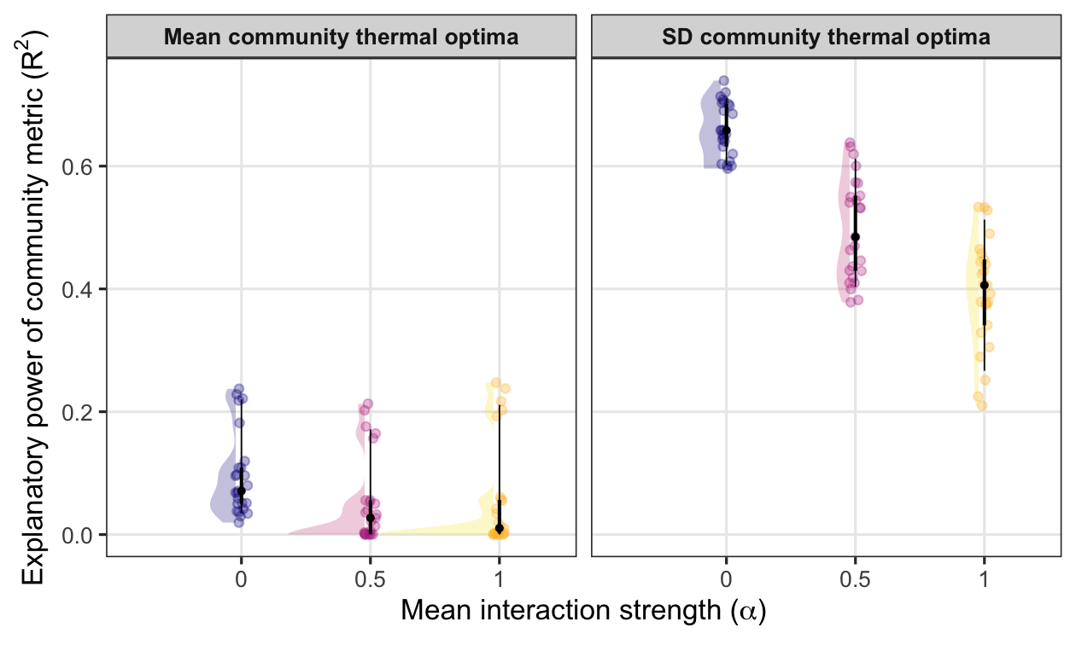
Figure S1. Effect of interaction strength on the explanatory power of stability metrics.
Panels show the explanatory power (R²) of each metric in predicting community stability, expressed as the coefficient of variation of total abundance. The two panels correspond to the two trait-based metrics $sd\left(T_{opt,i}\right)$ and $T_{opt,mean}$. Each point represents a group of simulated communities with identical interaction strengths (α), temperature time series, and mean of species thermal optima, but they differed in richness, variation in species thermal optima, mean and variation of thermal performance curve breath, and community replicate. Jitter was added for visibility; colours indicate the value of α. Half-violin shapes summarise the distribution of explanatory power for each interaction strength level within each metric.

Interaction between trait variability and performance curve breadth
Trait variability alone did not uniquely determine stability. For a given dispersion in thermal optima, outcomes varied widely with the mean breadth of performance curves: broader curves yielded greater buffering, whereas narrow curves increased sensitivity to environmental fluctuations.
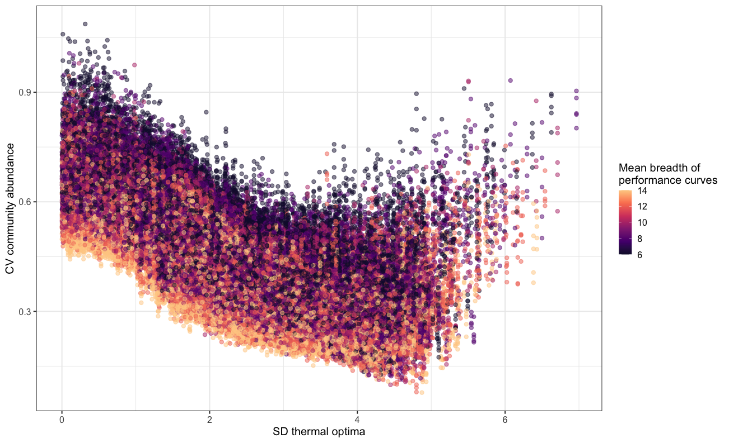
Figure S2. Relationship between trait variability and community stability, modulated by performance curve breadth.

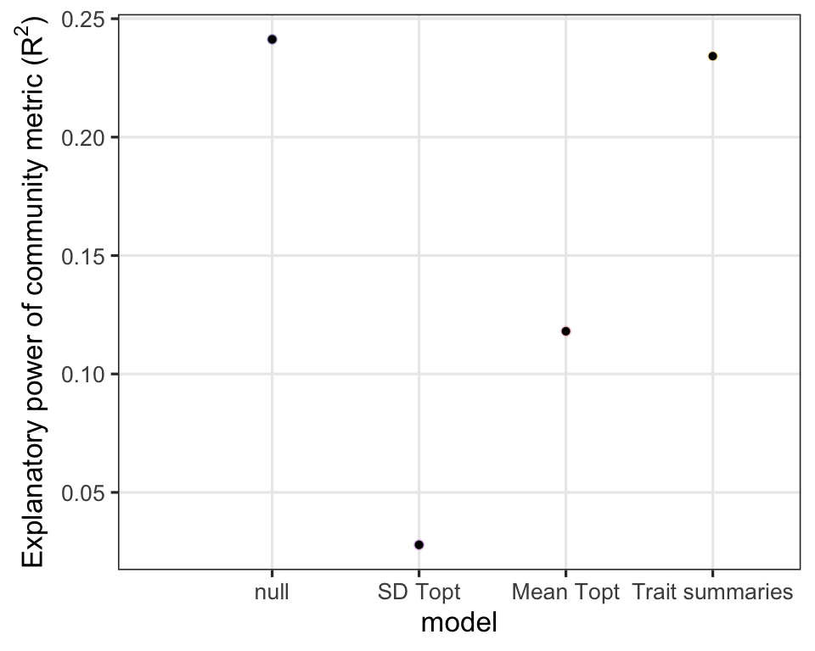
Figure S3. Explanatory power of diversity metrics.
The figure shows the explanatory power (R²) of each metric in predicting community stability, expressed as the coefficient of variation of total biomass for the empirical study. The first column corresponds to the null community performance curve metrics, whereas the second and third show the explanatory power of the two trait-based metrics. The last column shows the explanatory power of the linear model using the two trait-based metrics together, as done for the simulation study.

Effect of interspecific interaction strength on population dynamics and synchrony

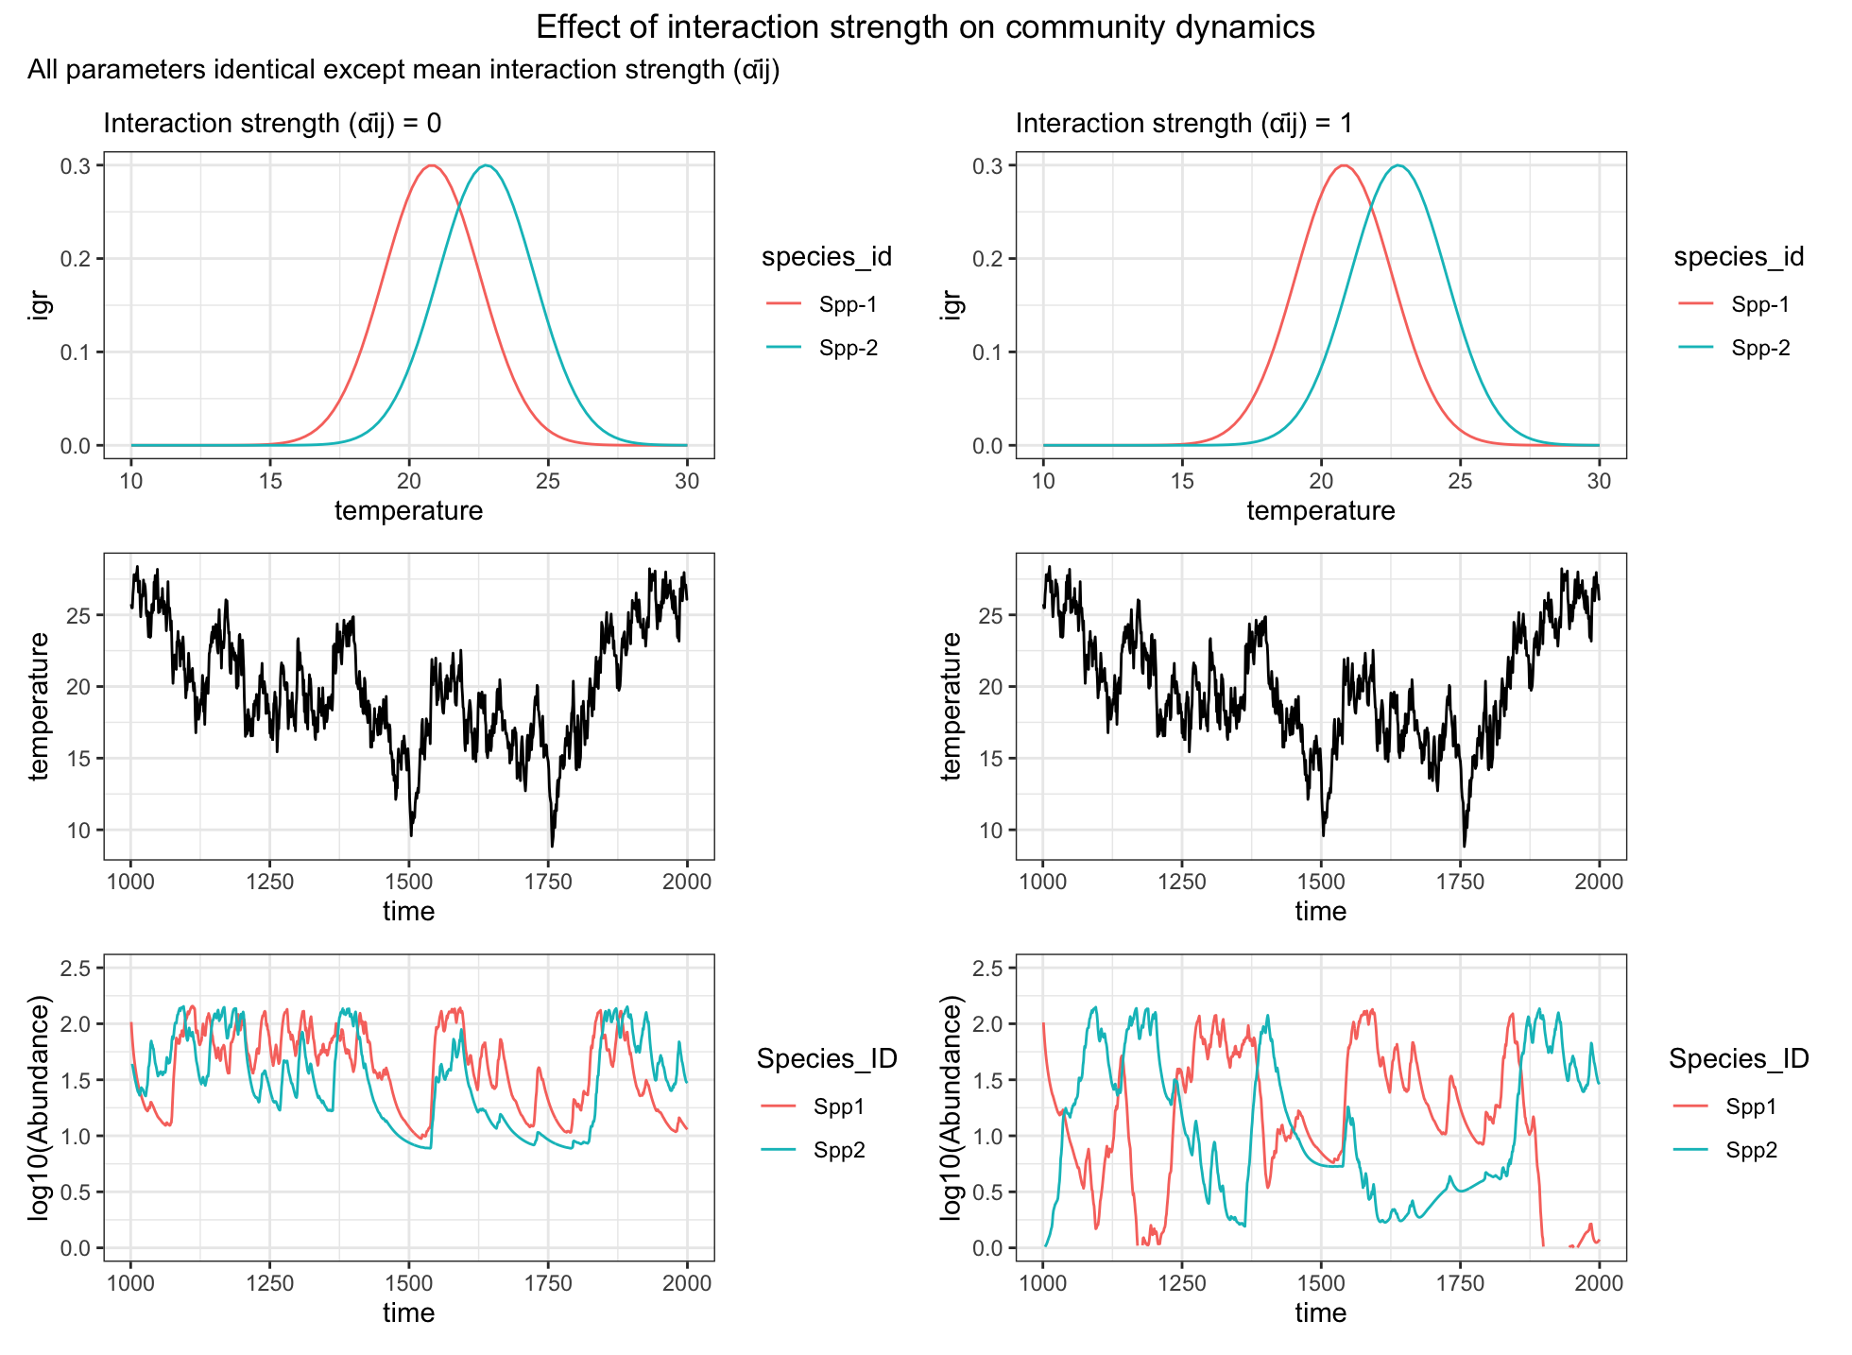
Figure S4. Effect of interspecific interaction strength on species dynamics. Top panels show species growth rates as a function of temperature for two community composed of the same two species. The only difference between the two community is the average interaction strength ($α_{ij}).$ These two-species communities are then exposed to the same temperature time series (middle panels). The bottom panels show species dynamics in absence (left) and with strong (right) competition.

Additional Methods: Asynchrony calculation
Synchrony (ϕ).
We quantified species asynchrony using the Loreau and de Mazancourt metric ⁴⁴, which measures the extent to which species’ temporal fluctuations compensate for one another. For a community of $S$species with abundances $N_{i}(t)$over time, asynchrony ($ϕ$) is calculated as:
$$ϕ=1-\frac{σ_{\text{tot}}^{2}}{\sum_{i=1}^{S}{σ_{i}^{2}}}$$
where $σ_{\text{tot}}^{2}$is the variance of total community abundance and $σ_{i}^{2}$is the variance of species $i$’s abundance. Values range from 0 (perfect synchrony) to 1 (perfect asynchrony). We computed this metric for each simulated community using species abundance time series after transient dynamics had dissipated (time steps 1001–2000).

Calculation of “null” and “actual” synchrony from species performance curves
To evaluate how species’ environmental responses translate into community-level synchrony, we computed two complementary measures: a null synchrony derived directly from species’ performance curves, and an actual synchrony obtained from the simulated abundance time series.

Null synchrony
Null synchrony reflects how similarly species are expected to fluctuate based solely on their thermal performance curves, without any influence of interactions or demographic dynamics. For each species, we evaluated its intrinsic growth rate across the full temperature range experienced in the simulations. We then compared these temperature-dependent performance profiles across species. These temperature-dependent performance profiles were then used to compute synchrony using the Loreau & de Mazancourt⁴⁴ synchrony metric presented above.
Because this calculation uses only performance curves and a uniform temperature distribution, null synchrony reflects the degree to which species’ environmental responses are inherently similar or dissimilar, independent of the actual environmental time series.

Actual synchrony
Actual synchrony was also calculated using the Loreau & de Mazancourt⁴⁴ metric, but here performance curves were evaluated along the realised temperature time series rather than across a uniform grid. For each time step, we computed species’ intrinsic growth rates from their performance curves using the actual simulated temperature at that time. This yielded a time series of performance values for each species.
Synchrony was then calculated from these performance time series. Because this measure incorporates the real sequence of environmental fluctuations, it captures how species' environmental responses covary under the specific conditions they experience, but still isolates environmental forcing, as it does not use species abundances or any effects of interactions.
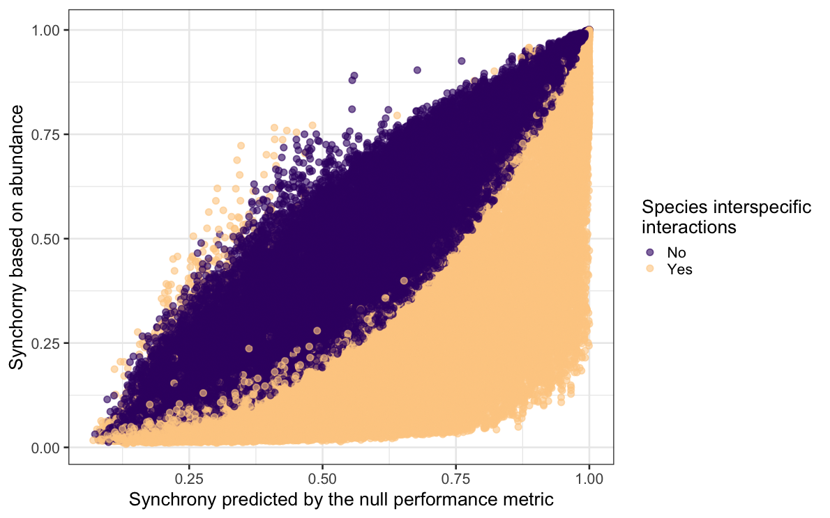
Figure S5. Relationship between synchrony measured based on species’ abundance and synchrony predicted by the null performance metric. Each point represents a species pair. The x-axis shows synchrony values predicted solely from the null performance metric, which assumes that species’ temporal dynamics are driven independently of interspecific interactions and temperature time series. The y-axis shows synchrony estimated directly from simulated species abundance time series. Points are coloured according to whether interspecific interactions were present in the underlying simulations. When interactions are absent (purple), observed synchrony closely follows the null expectation, producing a tight pattern. When interactions are included (orange), realised synchrony often deviates from the null prediction, especially at intermediate levels of predicted synchrony, indicating that biotic interactions can substantially alter species’ temporal covariation.

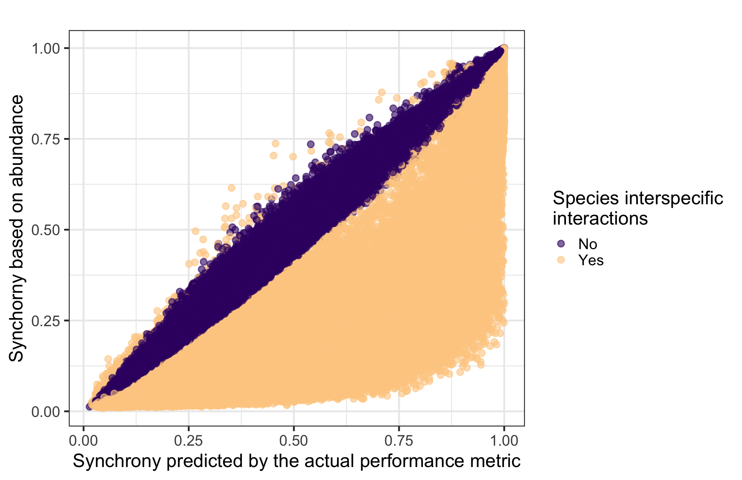
Figure S6. Relationship between synchrony measured based on species’ abundance and synchrony predicted by the actual performance metric.
Each point represents a species pair. The x-axis shows synchrony values predicted solely from the actual performance metric, which assumes that species’ temporal dynamics are driven independently of interspecific interactions, but are dependent on the temperature time series. The y-axis shows synchrony estimated directly from simulated species abundance time series. Points are coloured according to whether interspecific interactions were present in the underlying simulations. When interactions are absent (purple), actual synchrony strongly follows the observed expectation. When interactions are included (orange), realised synchrony often deviates from the actual prediction.

Additional references
43. Loreau, M. & de Mazancourt, C. Species Synchrony and Its Drivers: Neutral and Nonneutral Community Dynamics in Fluctuating Environments. Am. Nat. 172, E48–E66 (2008).

