DF-50

Francesco Tranquillo

13 giugno 2018

## Identity line and Bland-Altman plot

Thanks to the R Package “MethComp”, it has been possible to compare every variable of interest. In the following pages are reported the plots of identity line and Bland-Altman referring to the comparison of the methods (DF-50 and Procyte Idexx)

## Loading required package: nlme

## The following variables from the dataframe  
## "df" are used as the Meth variables:  
## meth: methods   
## item: id   
## repl: replicate   
## y: RBC   
## #Replicates  
## Method 2 #Items #Obs: 468 Values: min med max  
## DF-50 117 117 234 1.58 5.740 30.10  
## Procyte Idexx 117 117 234 1.62 6.425 9.34

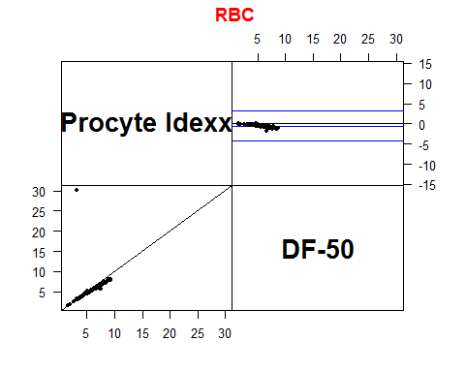

## The following variables from the dataframe  
## "df" are used as the Meth variables:  
## meth: methods   
## item: id   
## repl: replicate   
## y: HCT   
## #Replicates  
## Method 2 #Items #Obs: 468 Values: min med max  
## DF-50 117 117 234 7.6 38.75 151.9  
## Procyte Idexx 117 117 234 9.1 41.00 59.3

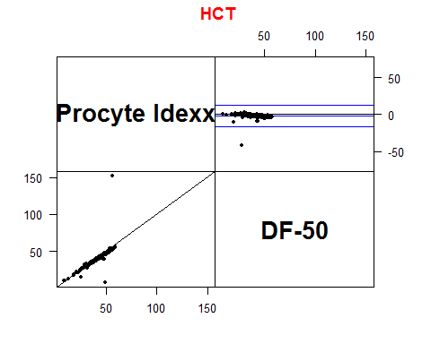

## The following variables from the dataframe  
## "df" are used as the Meth variables:  
## meth: methods   
## item: id   
## repl: replicate   
## y: HGB   
## #Replicates  
## Method 2 #Items #Obs: 468 Values: min med max  
## DF-50 117 117 234 2.7 14.75 189.0  
## Procyte Idexx 117 117 234 2.6 14.60 21.1

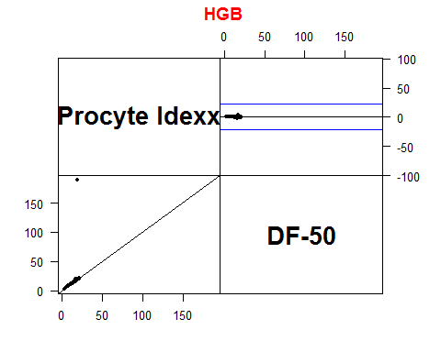

## The following variables from the dataframe  
## "df" are used as the Meth variables:  
## meth: methods   
## item: id   
## repl: replicate   
## y: MCV   
## #Replicates  
## Method 2 #Items #Obs: 468 Values: min med max  
## DF-50 117 117 234 31.0 68.40 77.3  
## Procyte Idexx 117 117 234 56.2 64.75 75.4

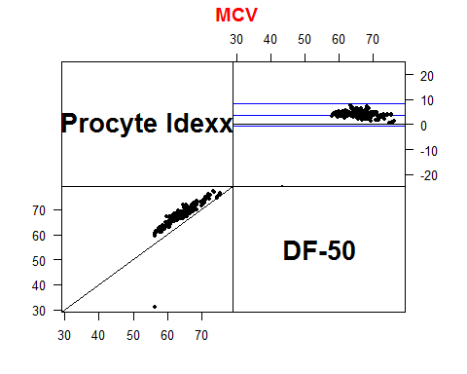

## The following variables from the dataframe  
## "df" are used as the Meth variables:  
## meth: methods   
## item: id   
## repl: replicate   
## y: MCH   
## #Replicates  
## Method 2 #Items #Obs: 468 Values: min med max  
## DF-50 117 117 234 16.7 25.85 61.7  
## Procyte Idexx 117 117 234 16.0 22.90 36.0

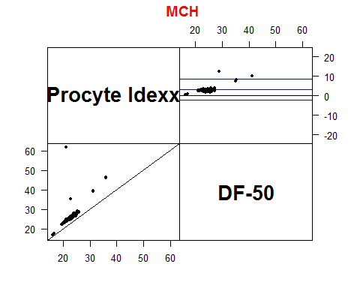

## The following variables from the dataframe  
## "df" are used as the Meth variables:  
## meth: methods   
## item: id   
## repl: replicate   
## y: MCHC   
## #Replicates  
## Method 2 #Items #Obs: 468 Values: min med max  
## DF-50 117 117 234 24.0 37.6 71.5  
## Procyte Idexx 117 117 234 28.6 35.4 60.6

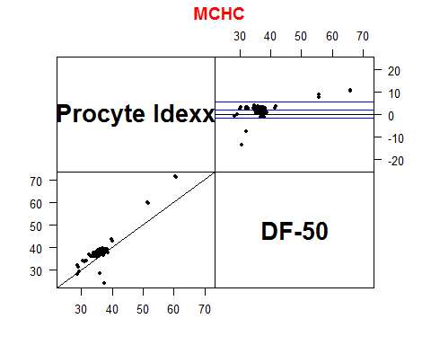

## The following variables from the dataframe  
## "df" are used as the Meth variables:  
## meth: methods   
## item: id   
## repl: replicate   
## y: RDW   
## #Replicates  
## Method 2 #Items #Obs: 458 Values: min med max  
## DF-50 113 113 226 11.03 13.50 39.0  
## Procyte Idexx 116 116 232 14.00 17.45 33.2

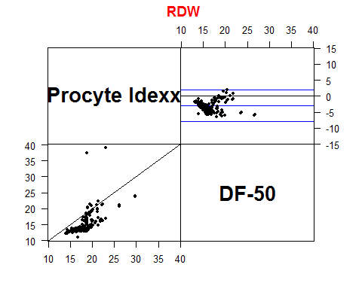

## The following variables from the dataframe  
## "df" are used as the Meth variables:  
## meth: methods   
## item: id   
## repl: replicate   
## y: WBC   
## #Replicates  
## Method 2 #Items #Obs: 468 Values: min med max  
## DF-50 117 117 234 1.43 9.095 39.72  
## Procyte Idexx 117 117 234 0.29 11.890 52.42

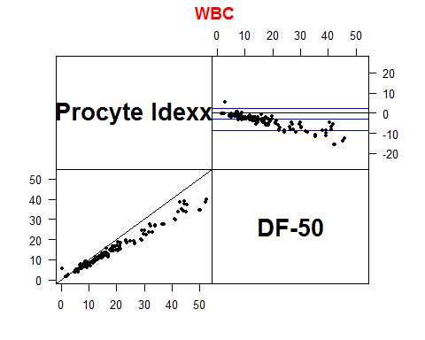

## The following variables from the dataframe  
## "df" are used as the Meth variables:  
## meth: methods   
## item: id   
## repl: replicate   
## y: NEU..   
## #Replicates  
## Method 2 #Items #Obs: 468 Values: min med max  
## DF-50 117 117 234 6.6 75.25 93.8  
## Procyte Idexx 117 117 234 0.9 68.80 98.1

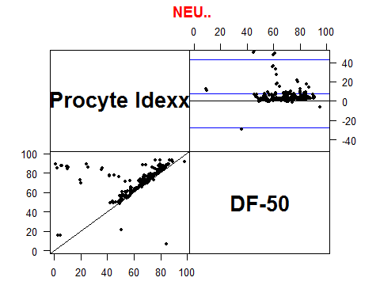

## The following variables from the dataframe  
## "df" are used as the Meth variables:  
## meth: methods   
## item: id   
## repl: replicate   
## y: LYM..   
## #Replicates  
## Method 2 #Items #Obs: 468 Values: min med max  
## DF-50 117 117 234 1.6 12.6 233.5  
## Procyte Idexx 117 117 234 4.1 18.6 84.5

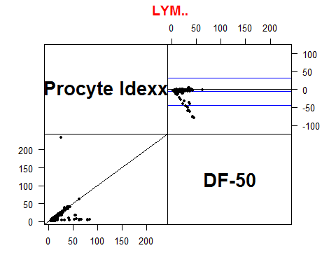

## The following variables from the dataframe  
## "df" are used as the Meth variables:  
## meth: methods   
## item: id   
## repl: replicate   
## y: MONO.   
## #Replicates  
## Method 2 #Items #Obs: 468 Values: min med max  
## DF-50 117 117 234 1.8 6.4 21.6  
## Procyte Idexx 117 117 234 2.2 7.8 36.4

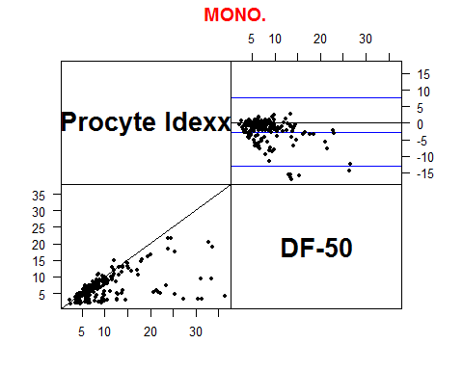

## The following variables from the dataframe  
## "df" are used as the Meth variables:  
## meth: methods   
## item: id   
## repl: replicate   
## y: EOS.   
## #Replicates  
## Method 2 #Items #Obs: 468 Values: min med max  
## DF-50 117 117 234 0.1 2.65 19.1  
## Procyte Idexx 117 117 234 0.0 2.45 19.3

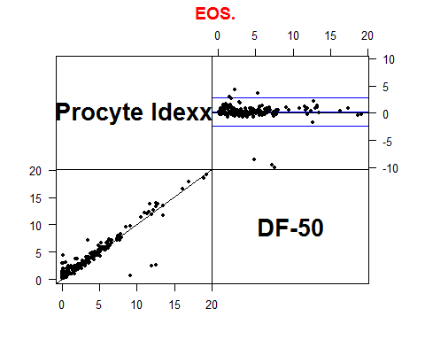

## The following variables from the dataframe  
## "df" are used as the Meth variables:  
## meth: methods   
## item: id   
## repl: replicate   
## y: BASO.   
## #Replicates  
## Method 2 #Items #Obs: 468 Values: min med max  
## DF-50 117 117 234 0.1 0.3 4.6  
## Procyte Idexx 117 117 234 0.0 0.1 4.1

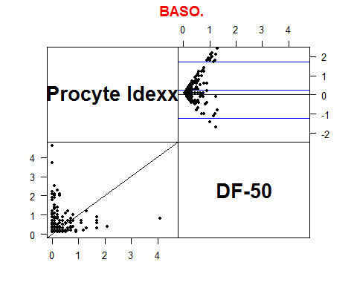

## The following variables from the dataframe  
## "df" are used as the Meth variables:  
## meth: methods   
## item: id   
## repl: replicate   
## y: NEUK.ul   
## #Replicates  
## Method 2 #Items #Obs: 468 Values: min med max  
## DF-50 117 117 234 0.21 6.42 36.43  
## Procyte Idexx 117 117 234 0.05 7.04 46.70

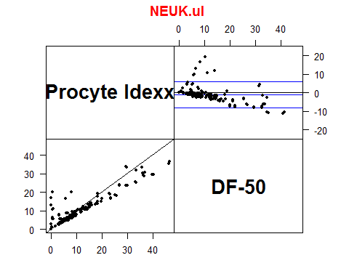

## The following variables from the dataframe  
## "df" are used as the Meth variables:  
## meth: methods   
## item: id   
## repl: replicate   
## y: LYMK.ul   
## #Replicates  
## Method 2 #Items #Obs: 468 Values: min med max  
## DF-50 117 117 234 0.23 1.175 6.12  
## Procyte Idexx 117 117 234 0.09 2.040 20.80

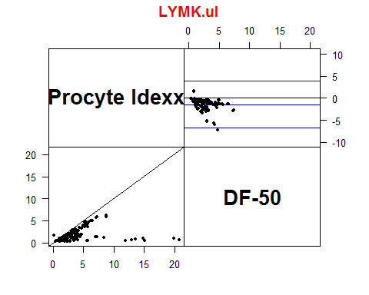

## The following variables from the dataframe  
## "df" are used as the Meth variables:  
## meth: methods   
## item: id   
## repl: replicate   
## y: MONOK.uL   
## #Replicates  
## Method 2 #Items #Obs: 468 Values: min med max  
## DF-50 117 117 234 0.07 0.535 20.30  
## Procyte Idexx 117 117 234 0.04 0.900 11.07

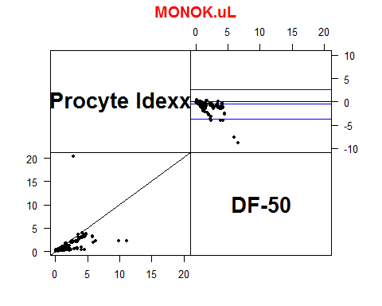

## The following variables from the dataframe  
## "df" are used as the Meth variables:  
## meth: methods   
## item: id   
## repl: replicate   
## y: EOSK.uL   
## #Replicates  
## Method 2 #Items #Obs: 468 Values: min med max  
## DF-50 117 117 234 0 0.255 2.04  
## Procyte Idexx 117 117 234 0 0.300 2.55

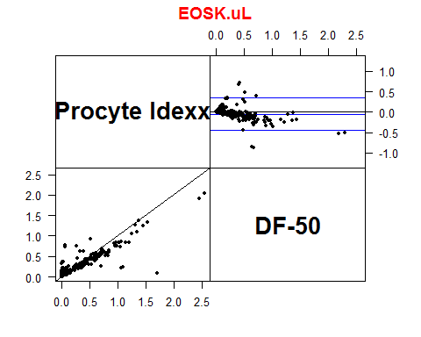

## The following variables from the dataframe  
## "df" are used as the Meth variables:  
## meth: methods   
## item: id   
## repl: replicate   
## y: BASOK.uL   
## #Replicates  
## Method 2 #Items #Obs: 468 Values: min med max  
## DF-50 117 117 234 0 0.03 0.48  
## Procyte Idexx 117 117 234 0 0.02 0.37

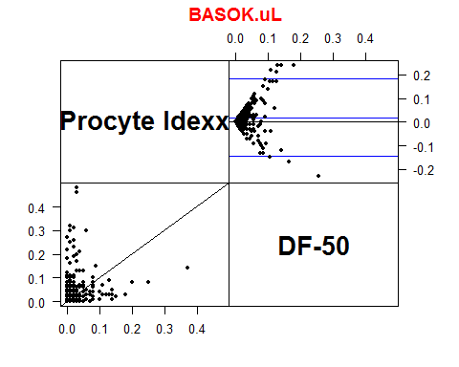

## The following variables from the dataframe  
## "df" are used as the Meth variables:  
## meth: methods   
## item: id   
## repl: replicate   
## y: PLT   
## #Replicates  
## Method 2 #Items #Obs: 468 Values: min med max  
## DF-50 117 117 234 3.17 234.5 1119  
## Procyte Idexx 117 117 234 0.00 297.5 1243

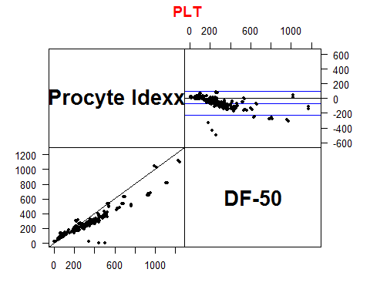

## The following variables from the dataframe  
## "df" are used as the Meth variables:  
## meth: methods   
## item: id   
## repl: replicate   
## y: MPV   
## #Replicates  
## Method 1 2 #Items #Obs: 423 Values: min med max  
## DF-50 0 117 117 234 5.7 9.2 12.2  
## Procyte Idexx 3 93 96 189 7.3 10.1 13.4

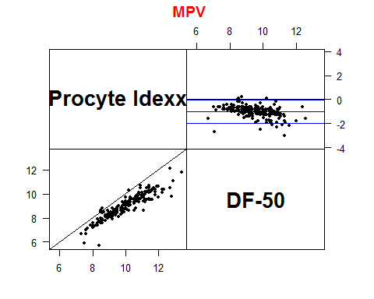

## The following variables from the dataframe  
## "df" are used as the Meth variables:  
## meth: methods   
## item: id   
## repl: replicate   
## y: PDW   
## #Replicates  
## Method 1 2 #Items #Obs: 423 Values: min med max  
## DF-50 0 117 117 234 13.6 15.85 18.3  
## Procyte Idexx 3 93 96 189 8.0 12.50 24.4

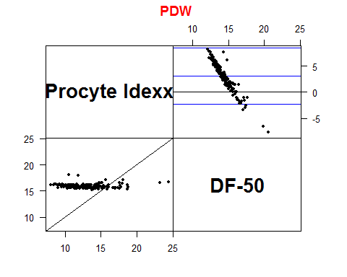

## The following variables from the dataframe  
## "df" are used as the Meth variables:  
## meth: methods   
## item: id   
## repl: replicate   
## y: PCT   
## #Replicates  
## Method 1 2 #Items #Obs: 420 Values: min med max  
## DF-50 0 117 117 234 0.01 0.23 1.07  
## Procyte Idexx 4 91 95 186 0.03 0.35 1.34

