0. Generate dataset push_v1 (3 boxes configurations)
cd pybullet
python3 ds_gen_uniform3.py

Number of action pairs: 3528
Number of no-action pairs: : 1500
Total number of pairs: 5028
Percentage action pairs: 70.16706443914082
Percentage no-action pairs: 29.832935560859188

0. Generate dataset push_v1 (2 boxes configurations)
python3 ds_gen_uniform2.py

Number of action pairs: 1296
Number of no-action pairs: : 648
Total number of pairs: 1944
Percentage action pairs: 66.66666666666666
Percentage no-action pairs: 33.33333333333333

0. Then move the datasets to lsr_ltl/datasets
cd ../lsr_ltl

0. Check which class misses in the dataset (3 boxes configurations)
python3 missing_class3.py

Size training dataset 3500
number of classes 7000
Number of missing classes in the dataset 0

0. Check which class misses in the dataset (2 boxes configurations)
python3 missing_class2.py

Size training dataset 1200
number of classes 2400
Number of missing classes in the dataset 0

0. Plot histogram of recurrence of each class in the training dataset (3 boxes configurations)
python3 plot_hist_classes_dataset3.py

Dataset size 3500
number of classes 7000
number of different classes present in the dataset 504
max 24
min 5
The most repeated class
[[1. 0. 3.]
[0. 0. 0.]
[0. 0. 2.]]
The least repeated class
[[0. 3. 0.]
[0. 1. 2.]
[0. 0. 0.]]
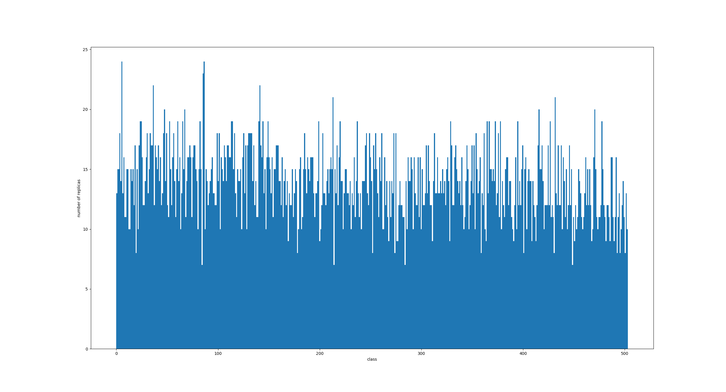

0. Plot histogram of recurrence of each class in the training dataset (2 boxes configurations)
python3 plot_hist_classes_dataset2.py

Dataset size 1200
number of classes 2400
number of different classes present in the dataset 216
size ind 216
max 19
min 4
The most repeated class
[[0. 1. 0.]
[3. 0. 0.]
[0. 0. 0.]]
The least repeated class
[[0. 0. 3.]
[0. 0. 0.]
[0. 2. 0.]]

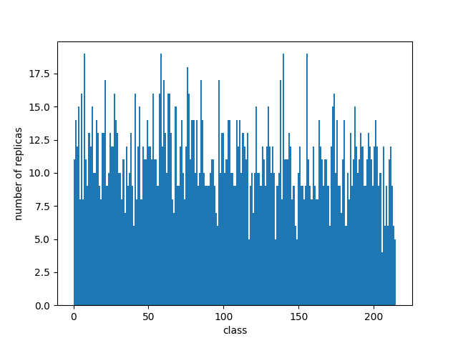

1.1 Prepare train and test datasets for baseline
python3 prepare.py

Train and test datasets sizes: 4600 900

1.2 Train VAE_b (baseline) (gamma = 0)
python3 train_VAE_dev.py --exp_vae=VAE_push_v1_b --cuda=True

'beta_min': 0,
'beta_max': 1,
'beta_max_epoch': 400,
'beta_steps': 100,
'kl_anneal': True,
'gamma_warmup': 0,
'gamma_min': 0,
'gamma_max': 0,
'gamma_steps': 1,
'gamma_anneal': False,
'min_dist': 0.0,
'min_dist_epoch_update': 5,
'min_dist_step': 0.1,
'min_dist_percentile': 0,
'min_dist_reached_nmax': 1,
'min_distance_update_condition': 'gap_positive',
'distance_type': '1',
'epochs': 50,

Epoch 49:
Train loss: 180803.268 recon loss: 180788.487 KL loss: 121.954 dist: 12.610
Valid loss: 180831.577 recon loss: 180816.021 KL loss: 128.291 dist: 12.261
Beta: 1.212121e-01
Gamma: 0.000000e+00
LR: 1.000000e-04
MD: 9.000000e-01
Gap: -4.766644e+01

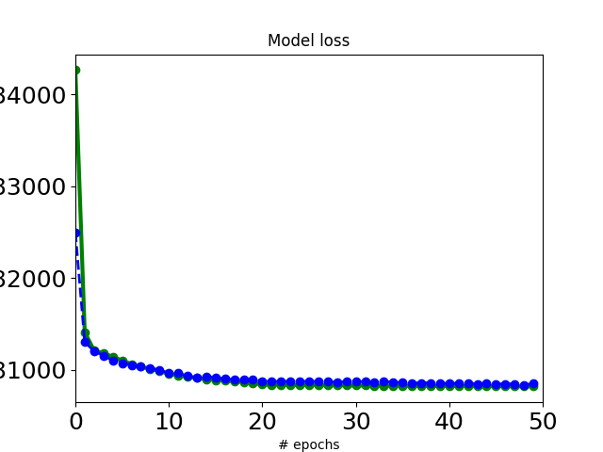

1.3 Evaluate the mean distance between latent action pairs
python3 evaluate_min_dist.py

loaded VAEb
Action pairs
cnt: 4156
dm: 49.736904527959744
min dist: 17.699772
max dist: 102.9221
median dist: 46.91588592529297
No-Action pairs
cnt: 1530
dm: 38.428067730610664
min dist: 3.8568902
max dist: 70.116
median dist: 38.81698989868164

1.4 Set min_dist value in config/VAE_push_v1
vae_opt[´min_dist´]

2.1. Add contrastive pairs to the dataset for the training of the VAE
python3 prepare_contrastive.py

Size of contrastive pairs dataset: 2000
Percentage of no-action pairs counted as action pairs: 0.0 %
Percentage of actually contrastive pairs (2-3 boxes pairs): 38.0 %
Size of push_v1_vae: 7000

2.2 Prepare vae dataset with contrastive pairs for the training
python3 prepare_vae.py
Train and test datasets sizes: 5500 1500

2.3 Train VAE
python3 train_VAE_dev.py --exp_vae=VAE_push_v1 --cuda=True

'beta_min': 0,
'beta_max': 1,
'beta_max_epoch': 400,
'beta_steps': 100,
'kl_anneal': True,
'gamma_warmup': 0,
'gamma_min': 100,
'gamma_max': 100,
'gamma_steps': 1,
'gamma_anneal': False,
'min_dist': 49.736904527959744
'min_dist_epoch_update': 5,
'min_dist_step': 0.1,
'min_dist_percentile': 0,
'min_dist_reached_nmax': 1,
'min_distance_update_condition': 'gap_positive',
'distance_type': '1',

Epoch 124:
Train loss: 181172.522 recon loss: 180940.776 KL loss: 246.270 dist: 1.571
Valid loss: 181166.421 recon loss: 181003.852 KL loss: 239.669 dist: 0.899
Beta: 3.030303e-01
Gamma: 1.000000e+02
LR: 1.000000e-04
MD: 5.073690e+01
Gap: 8.628517e+00

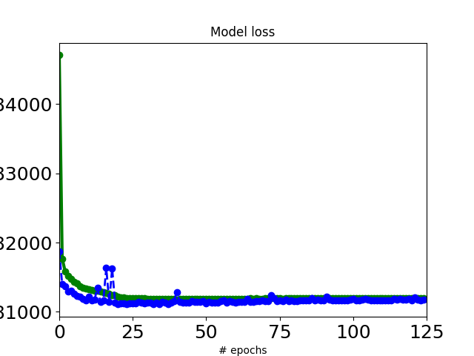
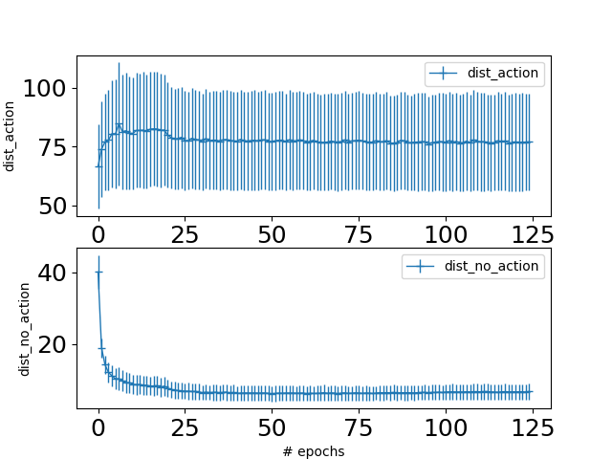

2.4 Evaluate the mean distance between latent action pairs on VAE
python3 evaluate_min_dist_vae.py

Action pairs
cnt: 5451
dm: 76.13055522864815
min dist: 21.892162
max dist: 187.76184
median dist: 70.0679
No-Action pairs
cnt: 1104
dm: 2.0208368108378374
min dist: 0.27704307
max dist: 4.822611
median dist: 1.991593837738037

The train, test and evaluation datasets for the APN are created using the file push_v1.pkl, which contains the full tuple (image1, image2, 1, A, class1, class2). The script pushing_create_pkl_action_new.py creates the lists push_actions and evaluation_push_actions, which contain tuples of the type (t_img1,t_img2,action,t_pick_action,t_place_action).
Finally the actual train and test datasets in the latent space for the APN are genereted in train_APN script.

3.1 Prepare dataset for Apn (Tz)
python3 pushing_create_pkl_action_new.py

Training and Testing - 3815
Validation - 1009

3.2 Train APN
touch models/APN_push_evaluation_results.txt

python3 train_APN_push.py \
--exp_apn=APN_push_L1 \
--seed=98765 \
--generate_new_splits=1 \
--generate_apn_data=1 \
--train_apn=1 \
--eval_apn=1 \
--cuda=True

Epoch 149: [0:00:00.273789]
Train loss: 0.004 inputX: 0.000 inputY: 0.000 inputH: 0.000 outputX: 0.000 outputY: 0.000
Valid loss: 0.010 inputX: 0.000 inputY: 0.000 inputH: 0.000 outputX: 0.000 outputY: 0.000
LR: 1.000000e-03

Validation scores:
{'model_name': 'APN_push_L1_seed98765', 'n_points': 1009, 'random_seed': 98765, 'pickX_avgdisterrror': 0.0, 'pickY_avgdisterrror': 0.0, 'placeX_avgdisterrror': 0.0, 'placeY_avgdisterrror': 0.0, 'total_avgdisterrror': 0.01, 'pickX_score': 1.0, 'pickY_score': 1.0, 'placeX_score': 1.0, 'placeY_score': 1.0, 'coord_score': 1.0, 'pick_score_per': 1.0, 'place_score_per': 1.0, 'total_score_per': 1.0}

4.1 Build LSR and create an example (find a path from start and goal and check actions)
python3 lsr_pushing_example.py --seed=98765 --lable_ls=1 --build_lsr=1 --example=1
python3 lsr_pushing_example.py --seed=98765 --lable_ls=0 --build_lsr=0 --example=1

weight = 1.0
epsilon: 2.9538456797599792
mean_dist_no_ac: 2.093968
std_dist_no_ac: 0.85987777

***********Phase three done*******
Num nodes: 831
Num edges: 1971
Pruning edges with ew < 1
pruned 0 edges ( 0.0 %
Pruning nodes with mearges < 1
pruned 0 nodes ( 0.0 %
pruned 0 isolated nodes
final Graph ************************************
Num nodes: 831
Num edges: 1971

5.1 Detect the nodes whose state is present in the graph several times:
python3 show_replicas.py

Lenght of list after pruning the replicas 720
Number of nodes with at least a replica 85
List of duplicated states:

This means that 0 states on the graph miss

5.2 Plot histogram of recurrence of each class in the graph
python3 plot_hist_classes.py

Each class/state is represented by an unambiguous integer (x-axis), for each class the number of times it occurs is reported (y-axis).

5.3 Check if on the graph there are only valid edge/transition/action:
python3 check_rules_on_graph.py

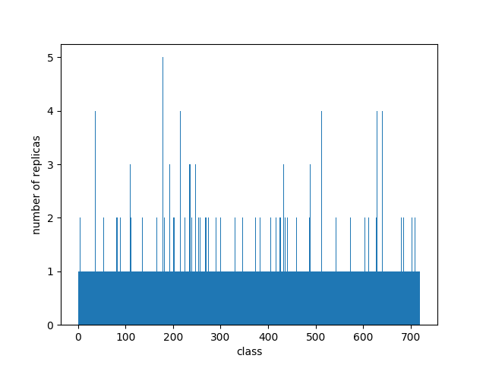

It seems that all the transitions are okay!
There are no edges on the graph that correspond to forbidden actions.

5.4 Compute percentage of valid paths found on the graph (random choice of start and goal node and for it finds all the paths. If a start/goal pair has been already picked, it will not be selected again. Simple paths of length 8 are considered (eventually obtained padding))
python3 analysis_valid_paths_all.py

number of paths: 77598
number of valid paths: 77598
percentage of valid paths: 100.0 %

6.1 Generate dataset of sequences of different lengths for a random start/goal pair (phi1)
python3 pushing_lstm_create_dataset.py

Number of paths with two boxes: 666
Number of paths with three boxes: 1334

6.2 Generate dataset of sequences of different lengths for a random start/goal pair (phi2)
python3 pushing_lstm_create_dataset_adj.py

Number of paths with two boxes: 267
Number of paths with three boxes: 3738

6.3 Define and train the recurrent nn
python3 lstm.py

hidden_dim = 12
n_layers = 4

batch_size = 200
drop_prob=.6

self.lstm = nn.LSTM(embedding_dim, hidden_dim, n_layers, dropout=drop_prob, batch_first=True)
self.dropout = nn.Dropout(0.6)
self.fc = nn.Linear(hidden_dim, output_size)
self.sigmoid = nn.Sigmoid()

K = 10 # number of runs

ltl = "row"
num_elem = 2000
epochs = 200
Mean Test Accuracy: 0.934
Mean Precision: 0.956
Mean Recall: 0.907
Mean Specificity: 0.960
Mean F: 0.931

ltl = "adjacent"
Mean Test Accuracy: 0.936
Mean Precision: 0.946
Mean Recall: 0.934
Mean Specificity: 0.938
Mean F: 0.940

6.4 Define and train the svm classifier
python3 svm.py

For RBF
gamma='scale',C=20
if gamma='scale' (default) is passed then it uses 1 / (n_features * X.var()) as value of gamma

Linear
Mean Test Accuracy: 0.847
Mean Precision: 0.871
Mean Recall: 0.816
Mean Specificity: 0.876
Mean F: 0.842
RBF
Mean Test Accuracy: 0.814
Mean Precision: 0.827
Mean Recall: 0.796
Mean Specificity: 0.830
Mean F: 0.811

ltl = "adjacent"
Linear
Mean Test Accuracy: 0.555
Mean Precision: 0.573
Mean Recall: 0.623
Mean Specificity: 0.480
Mean F: 0.596
RBF
Mean Test Accuracy: 0.618
Mean Precision: 0.637
Mean Recall: 0.645
Mean Specificity: 0.588
Mean F: 0.640

6.5 Define and train the multi layer perceptron
python3 mlp.py

self.layers = nn.Sequential(
nn.Flatten(),
nn.Linear(8 * 64, 4*64),
nn.ReLU(),
nn.Linear(4 * 64, 2*64),
nn.ReLU(),
nn.Linear(2 * 64, 32),
nn.ReLU(),
nn.Linear(32, 4),
nn.ReLU(),
nn.Linear(4, 1),
nn.Sigmoid()
)

K = 10

ltl = "row"
Mean Test Accuracy: 0.804
Mean Precision: 0.811
Mean Recall: 0.793
Mean Specificity: 0.814
Mean F: 0.800

ltl = "adjacent"
Mean Test Accuracy: 0.571
Mean Precision: 0.591
Mean Recall: 0.691
Mean Specificity: 0.430
Mean F: 0.628

6.6 Training with different size of the dataset for ltl=adjacent
python3 lstm.py

num_elem = 3500
Mean Test Accuracy: 0.923
Mean Precision: 0.934
Mean Recall: 0.925
Mean Specificity: 0.920
Mean F: 0.928

num_elem = 3000

Mean Test Accuracy: 0.886
Mean Precision: 0.905
Mean Recall: 0.874
Mean Specificity: 0.899
Mean F: 0.889

num_elem = 2500

Mean Test Accuracy: 0.874
Mean Precision: 0.889
Mean Recall: 0.877
Mean Specificity: 0.872
Mean F: 0.883

num_elem = 2000

Mean Test Accuracy: 0.842
Mean Precision: 0.876
Mean Recall: 0.831
Mean Specificity: 0.857
Mean F: 0.852

6.7 Generate dataset of all simple paths for 500 random start/goal pair
python3 pushing_lstm_create_dataset_all.py

Total number of paths: 59250

6.7 Evaluate precision, recall … for the all simple paths dataset
python3 lstm_evaluation.py

Percentage of valid/not valid paths: 70.71392405063291 % 29.286075949367092 %

Test loss: 0.633
Test accuracy: 0.857
Precision: 0.883
Recall: 0.919
Specificity: 0.706
F: 0.901

6.8 Generate dataset of all simple paths for 3000 random start/goal pair (using best model)
python3 pushing_lstm_create_dataset_shortest.py

Total number of paths: 48752

6.9 Evaluate precision, recall … for the all simple paths dataset
python3 lstm_evaluation_sh.py

Percentage of valid/not valid paths: 68.0874630784378 % 31.91253692156219 %

Test loss: 0.538
Test accuracy: 0.872
Precision: 0.901
Recall: 0.913
Specificity: 0.786
F: 0.907

7.1 Example
python3 example.py

In this example I give start and goal configurations:



start goal

and look for a path that satisfy all the LTLs, in other words the two lstms should return both 1.
Once reached the goal, I remove the red box, obtaining a new start configuration and set another goal.



start goal

Using the same framework and functions, I look for a path that satisfy all the LTLs for the new start and goal pair.
The paths obtained are:

7.2 Example - Trajectory 3-d latent space
python3 plot_latent_space_tsne_traj.py
Number of connected components: 6
Len of each connected component: [605, 77, 73, 72, 2, 2]
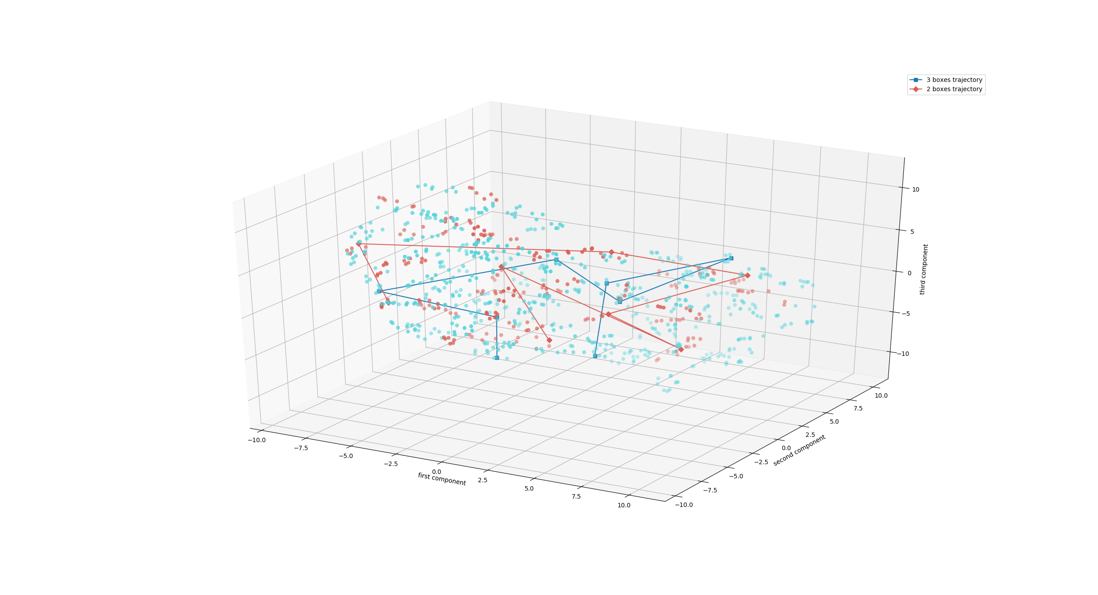

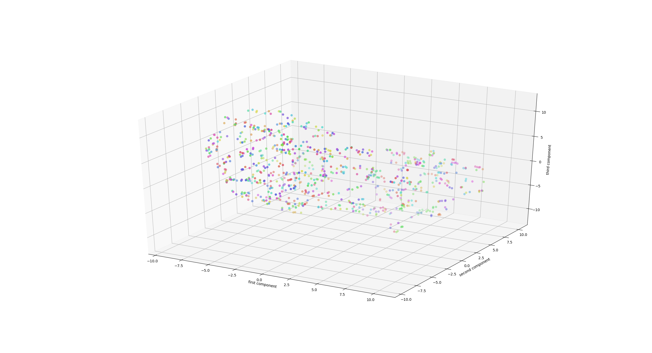

7.2 Example – Pbullet simulation
cd ../pybullet
python3 sim.py

8.1 Generate asymmetric dataset of sequences of different lengths for a random start/goal pair (phi1)
cd ../lsr_ltl
python3 pushing_lstm_create_dataset_asym.py

Number of paths with two boxes: 666
Number of paths with three boxes: 1334
Number of valid paths: 1500
Number of non-valid paths: 500

8.2 Generate asymmetric dataset of sequences of different lengths for a random start/goal pair (phi2)
python3 pushing_lstm_create_dataset_adj_asym.py

Number of paths with two boxes: 267
Number of paths with three boxes: 3738
Number of valid paths: 3069
Number of non-valid paths: 936

→ 76.6292135% valid paths

8.3 Define and train the recurrent nn
python3 lstm_asym.py

ltl = row
Dataset size: 2000
Percentage of valid/not valid paths: 75.0 % 25.0 %

Mean Test Accuracy: 0.933
Mean Precision: 0.958
Mean Recall: 0.952
Mean Specificity: 0.881
Mean F: 0.955

ltl = adjacent
Percentage of valid/not valid paths: 76.625 % 23.375 %

Mean Test Accuracy: 0.888
Mean Precision: 0.902
Mean Recall: 0.956
Mean Specificity: 0.674
Mean F: 0.928

9.1 Generate dataset of flattened image sequences of different lengths for a random start/goal pair (phi1)
python3 pushing_lstm_create_dataset_img.py

size each element : (196608,) which is also the size of embeddingd

Number of paths with two boxes: 332
Number of paths with three boxes: 668

9.2 Define and train the recurrent nn (image path dataset)
python3 lstm_img.py

Couldn´t use GPU because of lack of memory

RuntimeError: CUDA out of memory. Tried to allocate 1.21 GiB (GPU 0; 7.79 GiB total capacity; 4.73 GiB already allocated; 655.19 MiB free; 111.48 MiB cached)

But also with CPU the training is killed:
Killed

Combination of multiple simple LTLs

( A or B ) and C
A eventually lower right
B eventually lower left
C no green box in the center

10.1 Generate dataset of sequences of different lengths for a random start/goal pair (phi1)
python3 pushing_lstm_create_dataset_ABC.py

A

Number of paths with two boxes: 333
Number of paths with three boxes: 667
Total pos: 669
Total neg: 331

B

Number of paths with two boxes: 333
Number of paths with three boxes: 667
Total pos: 673
Total neg: 327

C
Number of paths with two boxes: 333
Number of paths with three boxes: 667
Total pos: 541
Total neg: 459

(A or B ) and C
Number of paths with two boxes: 1000
Number of paths with three boxes: 2000
Total pos: 1505
Total neg: 1495

10.2 Training a lstm for ltl=ABC (1-LSTM method)
python3 lstm_ABC.py

A

Mean Test Accuracy: 0.998
Mean Precision: 1.000
Mean Recall: 0.997
Mean Specificity: 1.000
Mean F: 0.999

B

Mean Test Accuracy: 0.990
Mean Precision: 0.996
Mean Recall: 0.990
Mean Specificity: 0.989
Mean F: 0.993

C

Mean Test Accuracy: 0.904
Mean Precision: 0.911
Mean Recall: 0.915
Mean Specificity: 0.892
Mean F: 0.912

(A or B) and C

num_elem=3000

Mean Test Accuracy: 0.946
Mean Precision: 0.945
Mean Recall: 0.946
Mean Specificity: 0.945
Mean F: 0.945

num_elem = 2000
Mean Test Accuracy: 0.896
Mean Precision: 0.883
Mean Recall: 0.912
Mean Specificity: 0.880
Mean F: 0.897

num_elem=1000

Mean Test Accuracy: 0.777
Mean Precision: 0.736
Mean Recall: 0.837
Mean Specificity: 0.720
Mean F: 0.782

10.3 Training a lstm for ltl = ( A + B ) * C separately (3-LSTMs method)
python3 lstm_A_B_C.py

num_elem = 3000
Test accuracy: 0.909
Precision: 0.903
Recall: 0.917
Specificity: 0.900
F: 0.910

10.1 Generate dataset of sequences of different lengths for a random start/goal pair (row and adj LTL together)
python3 pushing_lstm_create_dataset_row_and_adj.py

Number of paths with two boxes: 2000
Number of paths with three boxes: 4000

10.4 Training a lstm for ltl = row and adjacent together (1-LSTMs method)
python3 lstm_row_adj_all.py

Dataset size: 6000
Mean Test Accuracy: 0.854
Mean Precision: 0.782
Mean Recall: 0.980
Mean Specificity: 0.731
Mean F: 0.870

Dataset size: 5000
Mean Test Accuracy: 0.853
Mean Precision: 0.795
Mean Recall: 0.964
Mean Specificity: 0.737
Mean F: 0.871

Dataset size: 4000
Mean Test Accuracy: 0.836
Mean Precision: 0.771
Mean Recall: 0.958
Mean Specificity: 0.713
Mean F: 0.854

10.5 Training a lstm for ltl = row and adjacent separately (2-LSTMs method)
python3 lstm_row_adj.py

Mean Test Accuracy: 0.806
Mean Precision: 0.925
Mean Recall: 0.666
Mean Specificity: 0.946
Mean F: 0.774

