

# THE STATE UNIVERSITY OF ZANZIBAR

**DEPARTMENT OF COMPUTER SCIENCE AND INFORMATION AND TECHNOLOGY**

**PROJECT TITLE:** DISABILITY MANAGEMENT SYSTEM.

**SUPERVISOR:** DR YAHAYA **ACADEMIC YEAR:** 2024/2025 **PRESENTER NAMES:**

|  |  |
| --- | --- |
| **NAMES** | **REGISTRATION NUMBER** |
| FRANK GODFREY NGOWI | BCS/18/23/014/TZ |
| AMOUR KHALFAN KHAMIS | BCS/18/23/010/TZ |

**Revisions**

|  |  |  |  |
| --- | --- | --- | --- |
| **Version** | **Primary Author(s)** | **Description of Version** | **Date Completed** |
| First Draft | Frank Godfrey Ngowi  Amour Khalfan Khamis | All sections being Filled | 2/01/2025 |

**Review & Approval**

**Requirements Document Approval History**

|  |  |  |  |  |
| --- | --- | --- | --- | --- |
| **Approving Party** | **Version Approved** | **Signature** | **Date** |  |
|  |  |  |  |
|  |  |  |  |

**Requirements Document Review History**

|  |  |  |  |  |
| --- | --- | --- | --- | --- |
| **Reviewer** | **Version Reviewed** | **Signature** | **Date** |  |
|  |  |  |  |
|  |  |  |  |
|  |  |  |  |

1. Introduction 3

**Contents**

1. General Description 4
2. Functional Requirements 6
3. Interface Requirements 7
   1. User Interfaces 7
   2. Hardware Interfaces 7
   3. Software Interfaces 7
4. Performance Requirements 8
5. Other non-functional attributes Error! Bookmark not defined.
   1. Security 9
   2. Binary Compatibility 9
   3. Reliability 9
   4. Maintainability 9
   5. Portability 9
   6. Reusability 9
6. Operational Scenarios 10
7. Preliminary Use Case Models and Sequence Diagrams 11
   1. Use Case Model 11
   2. Sequence Diagrams 12
8. Updated Schedule 13
9. Updated Budget 14
10. Appendices 15
    1. Definitions, Acronyms, Abbreviations 15

# 1. Introduction

#### Introduction

The purpose of this document is to define and describe the requirements of the project and to spell out the system’s functionality and its constraints.

#### Scope of this Document

The customer and the user for the system are doctors, nurses and patients and the developers of the system are the Frank Godfrey Ngowi and Amour Khalfan Khamis. And othis documents contain a lot about our project and other important information of our project.

#### Overview

Disability Management System (DMS) design to develop an integration and distributed web based system for managing people disability assistance service requested.

#### Business Context

The system aims to help different disabled people in financially opportunities and even to increase national income by increasing number of man power by considering even some disabled can perform some financial activities.

# 2. General Description

#### Product Functions

Disability management system allows users to have much access to their sponsors if available also can have access to other disabled people by log in and create his/her profile.

#### Similar System Information

Normally the government and organization uses the manually system to store their record about their transaction and record about disabled person that they have in their stock, so that by using manually methods they can loss their record easily

#### User Characteristics

|  |  |
| --- | --- |
| User type | Activity |
| Disabled person | Information about disability type, collaboration between each other. |
| Sponsors | Choose person to sponsor, financial support. |
| Management Team | Manage disabled people and sponsors according to requirement fitted. |
| IT person | Crosscheck the system setting and maintainance. |

* 1. **User Problem Statement**

Disabled tend to have a lot of discrimination and lack of support currently, thus many of them tend to lose hope of living again thus if system is created can help to giving back hope to disabled and feel happy again.

#### User Objectives

Users can get information about disability people that help the government and other Organization. To make simple ways to help them Medically, Educationally and Economically.

#### General Constraints

The system development and implementation tend to be designed to fit both web and mobile accessibility also tend to send some email notification so as to notify if there could be some important information to be shared

# 3. Functional Requirements

This are some specific features and capabilities that the system should have to meet the users needs.

|  |  |
| --- | --- |
| TYPE OF USER | FUNCTIONAL REQUIRMENT |
| Disabled person | Register on the system by giving personal information like name and  age |
| Sponsors | Register on the system by giving personal information like name and  age |
| Disabled person | Create information about his/her  disability like type and causes. |
| Sponsors | View the information of disabled  person |
| ICT administrator | Manage the access to the system  databases. |
| Sponsors | Check and select the disabled person  to sponsor. |
| Management team | Create information about the disabled  person and his/her sponsor selected. |

# 4. Interface Requirements

* 1. **User Interfaces**

-Our system uses GUI which may include some forms for filling personal information.

-Also our system will be accessible to both desktops and mobile phones

* 1. **Hardware Interfaces**

The program can perform under computers and phones that can have an access to internet and other hardware that are managed by the operating system.

* 1. **Software Interfaces**

The form system may be used to import and export data with Microsoft Excel. This functionality is built in to the user interface.

# 5. Performance Requirements

Our system has got some additional subsystem like databases and many other subsystem thus for better performance thus may require some requirements as follows;

* + 1. Personal Computer full system.
    2. Core processor with 1.9 GHz.
    3. Hard Disk 500 GB and above.
    4. 4 GB of RAM and above.
    5. Flash 8 GB and above.

# 6. Other non-functional attributes

.

* 1. **Security**

The system shall be designed with a level of security appropriate for the sensitivity of information enclosed in the database. More interaction is needed with client about the volatility of the information. Since there are obvious information that is of a high security level such as disability records, and other personal information.

* 1. **Binary Compatibility**

This system will be compatible with any computer and smartphones that has internet connection or later installed (whether PC or Mac), and will be designed with more than one computer in mind.

* 1. **Reliability**

Reliability is one of the key attributes of the system. Back-ups will be made regularly so that restoration with minimal data loss is possible in the event of unforeseen events. The system will also be thoroughly tested by all team members to ensure reliability.

* 1. **Maintainability**

The system shall be maintained by regular checkup and maintenance done by our team and this is most important to any system.

* 1. **Portability**

The system shall be designed in a way that shall allow it to be run on multiple computers with internet connection and desired operating system or later installed.

* 1. **Reusability**

The system should be designed in a way that allows the database to be re-used regularly for the various silent auctions that the organization shall hold.

## 7. Operational Scenarios

Our system has got many operational scenarios thus some of them are;

### Scenario A: Registration

The user shall enter the information needed for example, disabled person can register by name and age and address if needed into the database for its initial construction and evolution. The fields will be completed via a form that will display the data.

### Scenario B: Disability information

The user shall write its all information concerning his disability by type of disability and its causes, this will help so as it can be easy to get some sponsors and easy availability of information and check an appointment if was scheduled either by patient or doctor.

### Scenario C: Database Maintenance

The information received from registration and all disability records are stored in database. Thus the system administrators can have an access to databases, In this case they will need to be able to remove the data that has been entered.

# 8. Preliminary Use Case Models and Sequence Diagrams

This section presents a list of the fundamental sequence diagrams and use cases that satisfy the system’s requirements. The purpose is to provide an alternative, "structural" view of the requirements stated above and how they might be satisfied in the system.

* 1. **Use Case Model**

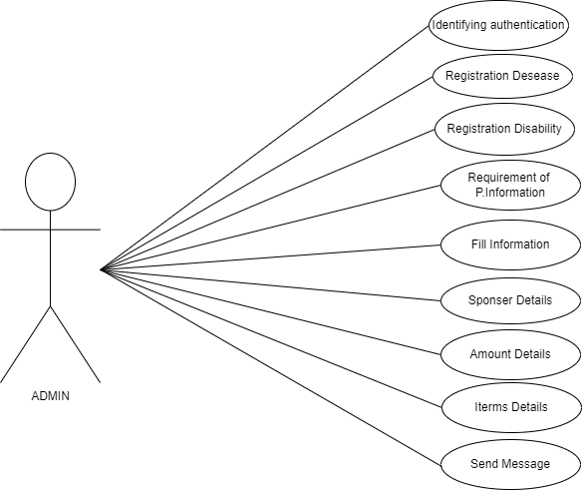

* 1. **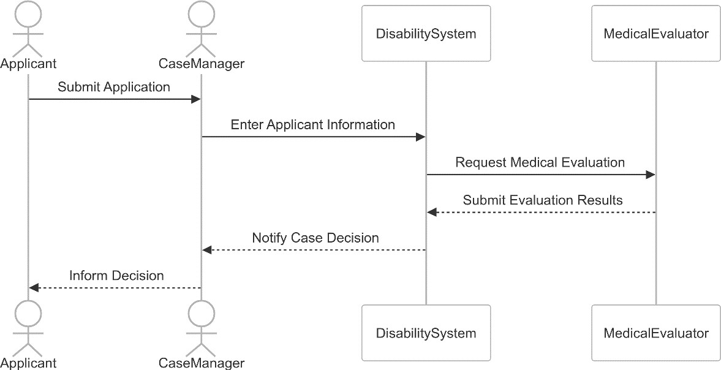****Sequence Diagrams**

# 9. Updated Schedule

The updated GANTT chart

|  |  |  |  |  |  |  |  |  |  |  |  |  |  |  |  |  |  |  |  |  |  |  |  |  |
| --- | --- | --- | --- | --- | --- | --- | --- | --- | --- | --- | --- | --- | --- | --- | --- | --- | --- | --- | --- | --- | --- | --- | --- | --- |
| **Activities** | **WEEK** | | | | | | | | | | | | | | | | | | | | | | | |
| 1-2 | | | | 3-5 | | | | 4-6 | | | | 7-10 | | | | 11-12 | | | | 13-15 | | | |
| Projecttitle formulation |  |  |  |  |  |  |  |  |  |  |  |  |  |  |  |  |  |  |  |  |  |  |  |  |
| Literature review |  |  |  |  |  |  |  |  |  |  |  |  |  |  |  |  |  |  |  |  |  |  |  |  |
| Defining the specification |  |  |  |  |  |  |  |  |  |  |  |  |  |  |  |  |  |  |  |  |  |  |  |  |
| Data collection and analysis |  |  |  |  |  |  |  |  |  |  |  |  |  |  |  |  |  |  |  |  |  |  |  |  |
| Designing |  |  |  |  |  |  |  |  |  |  |  |  |  |  |  |  |  |  |
|  |  |  |  |  |  |
| Programming |  |  |  |  |  |  |  |  |  |  |  |  |  |  |  |  |  |  |  |  |  |  |  |  |

# 10. Updated Budget

An updated budget is attached is

|  |  |  |
| --- | --- | --- |
| **NUMBER** | **ITEM** | **COST** |
| 1 | Stationary | 50,000/= |
| 2 | System creation and Time consumed | 300,000/= |
|  | **Total** | **350,000/=** |

# 11. Appendices

* 1. **Definitions, Acronyms, Abbreviations**

**DMS**: Disability Management System

**RAM**: Random Access Memor