

**THE STATE UNIVERSITY OF ZANZIBAR**

**DEPARTMENT OF COMPUTER SCIENCE AND INFORMATION TECHNOLOGY.**

**PREPARED BY: AHLAM JUMA SAID**

**REGISTRATION NUMBER: BCS/18/23/017/TZ**

**WORK TYPE: ASSIGNMENT ON HTML**

**DEADLINE: 30 APRIL 2025**

**SUBMITTED TO: MR MASOUD H MMANGA**

**1)**

**CODE:**

**<!DOCTYPE html>**

**<html lang="en">**

**<head>**

**<meta charset="UTF-8">**

**<meta name="viewport" content="width=device-width, initial-scale=1.0">**

**<title>Java Program</title>**

**<style>**

**body{**

**background-image:url('images/el.jpeg');**

**background-repeat: no-repeat;**

**background-size: cover;**

**background-position: center;**

**}**

**</style>**

**</head>**

**<body>**

**<h1>MY FIRST JAVA PROGRAM</h1>**

**<pre>**

**public class MyFirstJavaProgram {**

**public static void main(String[] args) {**

**System.out.println("Hello, World!");**

**System.out.println("I am learning Web Development");**

**System.out.println("It is awesome!!");**

**System.out.println("I love programming, it is so much fun");**

**}**

**}**

**</pre>**

**<p>**

**This is a Java program named <b>MyFirstJavaProgram</b>.<br>**

**The program prints four output messages to the user. These are:**

**</p>**

**Hello, World!<br>**

**I am learning Web Development <br>**

**It is awesome!! <br>**

**I love programming, it is so much fun**

**<p>**

**Note: Each message is displayed using the <code>System.out.println()</code> statement in Java.**

**</p>**

**</body>**

**</html>**

**1)**

**OUTPUT**

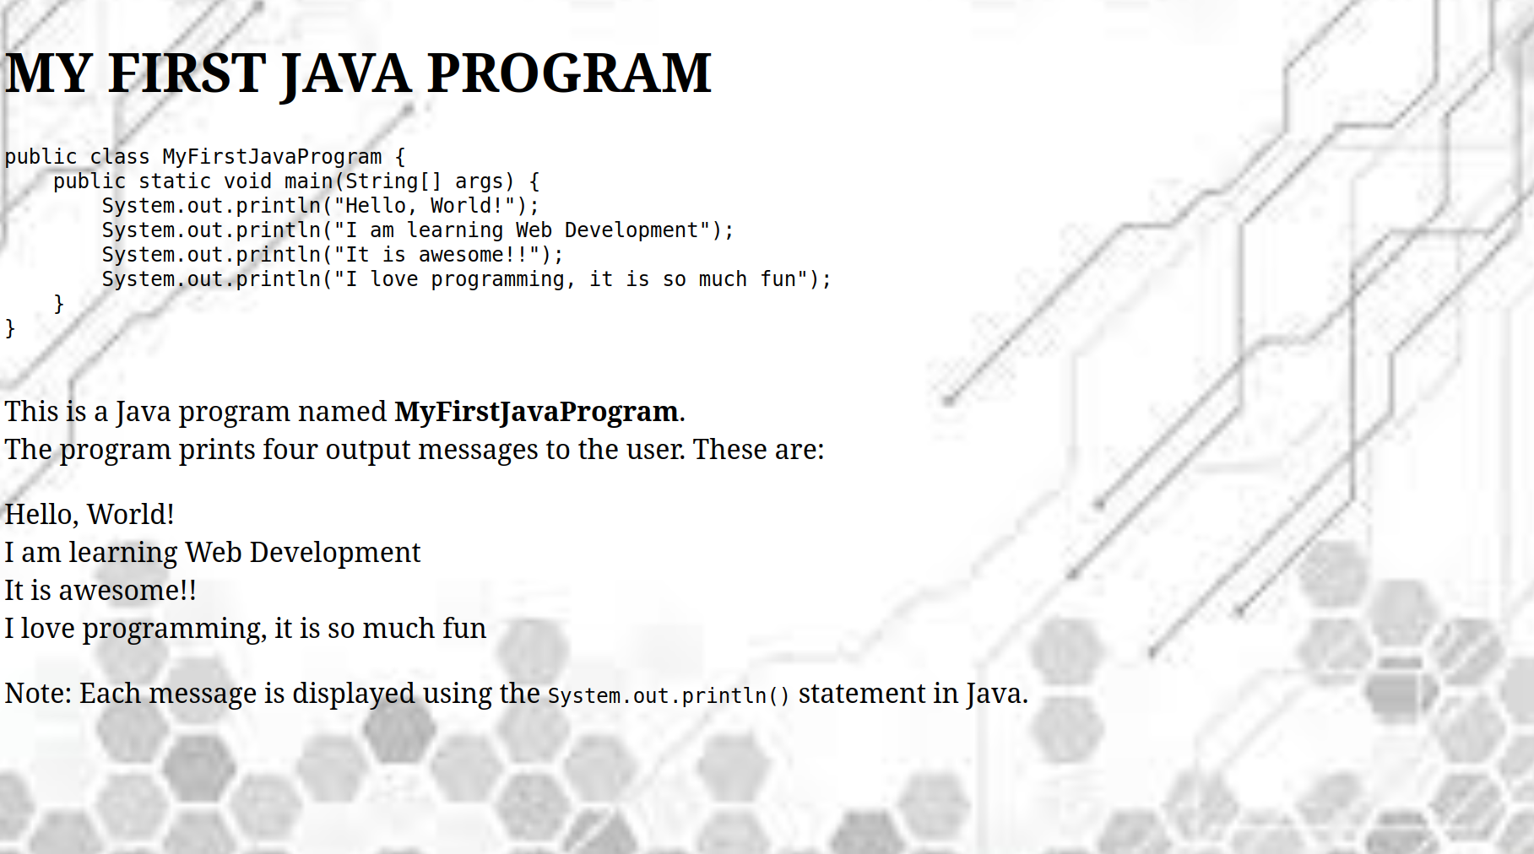

**2 a)**

**CODE:**

**<!DOCTYPE html>**

**<html lang="en">**

**<head>**

**<meta charset="UTF-8">**

**<meta name="viewport" content="width=device-width, initial-scale=1.0">**

**<title>Text tags</title>**

**</head>**

**<body>**

**<center>**

**<h1> <strong> To illustrate text formatting tags</strong></h1>**

**<hr>**

**<marquee behavior="" direction="">This is altermate Marquee text </marquee> <br>**

**<i> This is italized</i> <br><br>**

**This is <u> underlined</u> <br><br>**

**This is <b> bold</b><br><br>**

**This is <em>emphasized</em><br><br>**

**This is <strong> Strong Text</strong><br><br>**

**This is <strike> striked text</strike><br><br>**

**This is <small>computer code</small><br><br>**

**This is <sup>superscript </sup> code <br><br>**

**This is <sub>subscript </sub> code <br><br>**

**This is <big> big text</big><br><br>**

**This is <small>small text</small>**

**</center>**

**</body>**

**</html>**

**2 a) OUTPUT**

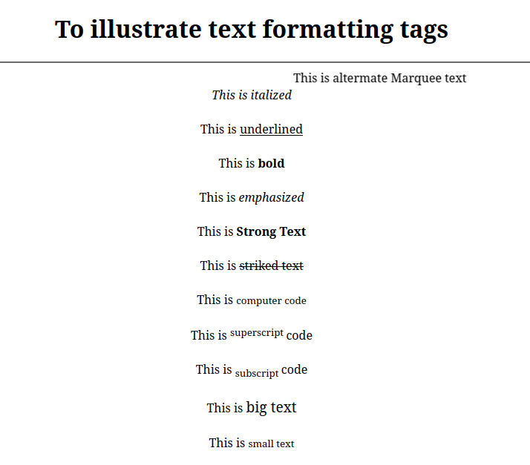

**2 b)**

**CODE:**

**<!DOCTYPE html>**

**<html lang="en">**

**<head>**

**<meta charset="UTF-8">**

**<meta name="viewport" content="width=device-width, initial-scale=1.0">**

**<title>Nested and Difinition List</title>**

**</head>**

**<body>**

**<h1> <strong> <center>To illustrate Nested and Difinition List Tags </center></strong></h1>**

**<hr>**

**<b> An ordered nested list :</b>**

**<ol>**

**<li> Coffee</li>**

**<li> Tea</li>**

**<ol type="a">**

**<li> Black tea</li>**

**<li> Green tea</li>**

**<ol type="i">**

**<li>China</li>**

**<li>Africa</li>**

**</ol>**

**</ol>**

**<li> Milk</li>**

**</ol>**

**<b> A definition List:</b>**

**<dl>**

**<dt>Bangalore</dt>**

**<dd> -Capital City Of Kamataka</dd>**

**<dt>Mumbai</dt>**

**<dd> -Capital city of Maharashtra/dd>**

**</dl>**

**</body>**

**</html>**

**OUTPUT:**

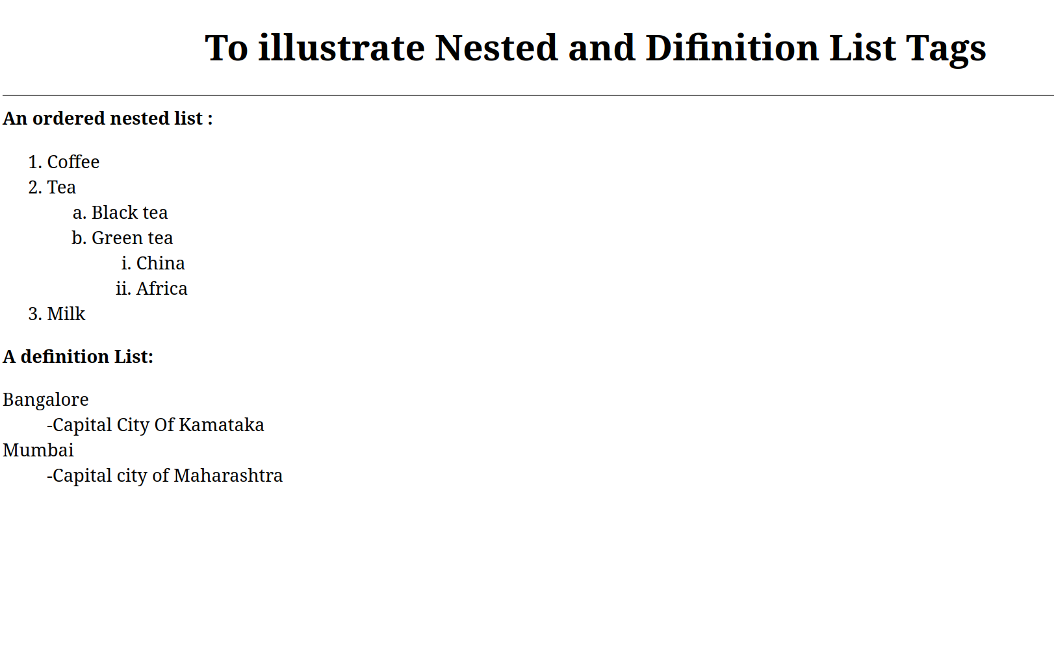

**3)**

**CODE:**

**<!DOCTYPE html>**

**<html lang="en">**

**<head>**

**<meta charset="UTF-8">**

**<meta name="viewport" content="width=device-width, initial-scale=1.0">**

**<title>table</title>**

**<style>**

**table, th, td {**

**border: 1px solid black;**

**border-collapse: collapse;**

**width: 450px;**

**height: 60px;**

**}**

**</style>**

**</head>**

**<body>**

**<center>**

**<table>**

**<tr>**

**<th colspan="4"><b>Table Heading Cell Spanning 4 Columns</b></th>**

**</tr>**

**<tr>**

**<td>Normal cell</td>**

**<td colspan ="2">Cell spanning 2 colomns</td>**

**<td> Normal cell</td>**

**</tr>**

**<tr>**

**<td rowspan="3" bgcolor="gray"> Cell spanning 3 <br>rows with gray<br>(US spelling) <br>background </td>**

**<td> Normal cell</td>**

**<td>Normal cell</td>**

**<td>Normal cell</td>**

**</tr>**

**<tr>**

**<td> Normal cell</td>**

**<td rowspan="2" colspan="2">Cell spanning 2 rows and 2 colomns</td>**

**</tr>**

**<tr>**

**<td>Normal cell</td>**

**</tr> </center>**

**</body>**

**</html>**

**OUTPUT**

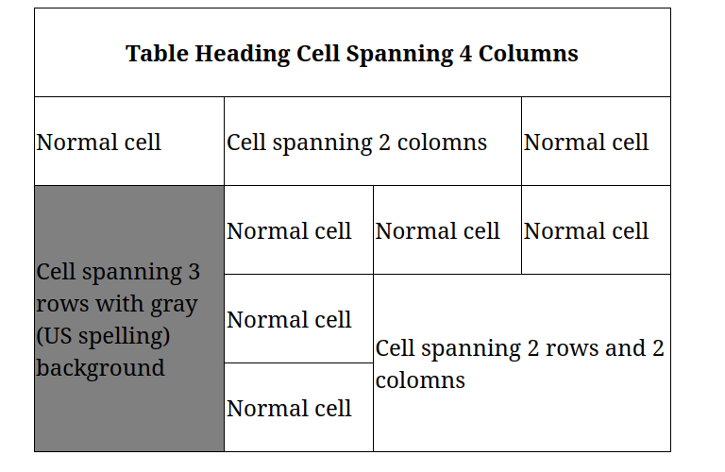

**4)**

**CODE:**

**<!DOCTYPE html>**

**<html lang="en">**

**<head>**

**<meta charset="UTF-8">**

**<meta name="viewport" content="width=device-width, initial-scale=1.0">**

**<title>HTML Form Example -Mozila Firefox</title>**

**</head>**

**<body>**

**<form>**

**<fieldset> <legend>Academic information </legend>**

**Degree**

**<select name="" id="">**

**<option value="">Master of Business Administration</option>**

**</select>**

**<br>**

**StudentID <input type="text" name="StudentID"> <br>**

**Classes Attended**

**<select value="3" size="3">**

**<option >Geography</option>**

**<option> Mathematic</option>**

**<option > English</option>**

**</select>**

**</fieldset>**

**<br>**

**<fieldset> <legend>Personal Details </legend>**

**<label for="fname">First Name </label>**

**<input type="text" name="Fname">**

**<br>**

**<label for="lname">Last Name</label>**

**<input type="text" name="StudentID"> <br>**

**<label for="gender">Gender</label>**

**<input type="radio" name="gender" id="male">**

**<label for="male">Male</label>**

**<input type="radio" name="gender" id="female">**

**<label for="female">Female</label>**

**<br>**

**<label for="email">Email</label>**

**<input type ="email" name="Email">**

**</fieldset>**

**<br>**

**<textarea name="" id="" rows="7" cols="30"> TERMS AND CONDITIONS .....</textarea>**

**<br>**

**<input type="button" value="Send Form">**

**<input type="button" value ="Clear Form">**

**</form>**

**</body>**

**</html>**

**4) OUTPUT**

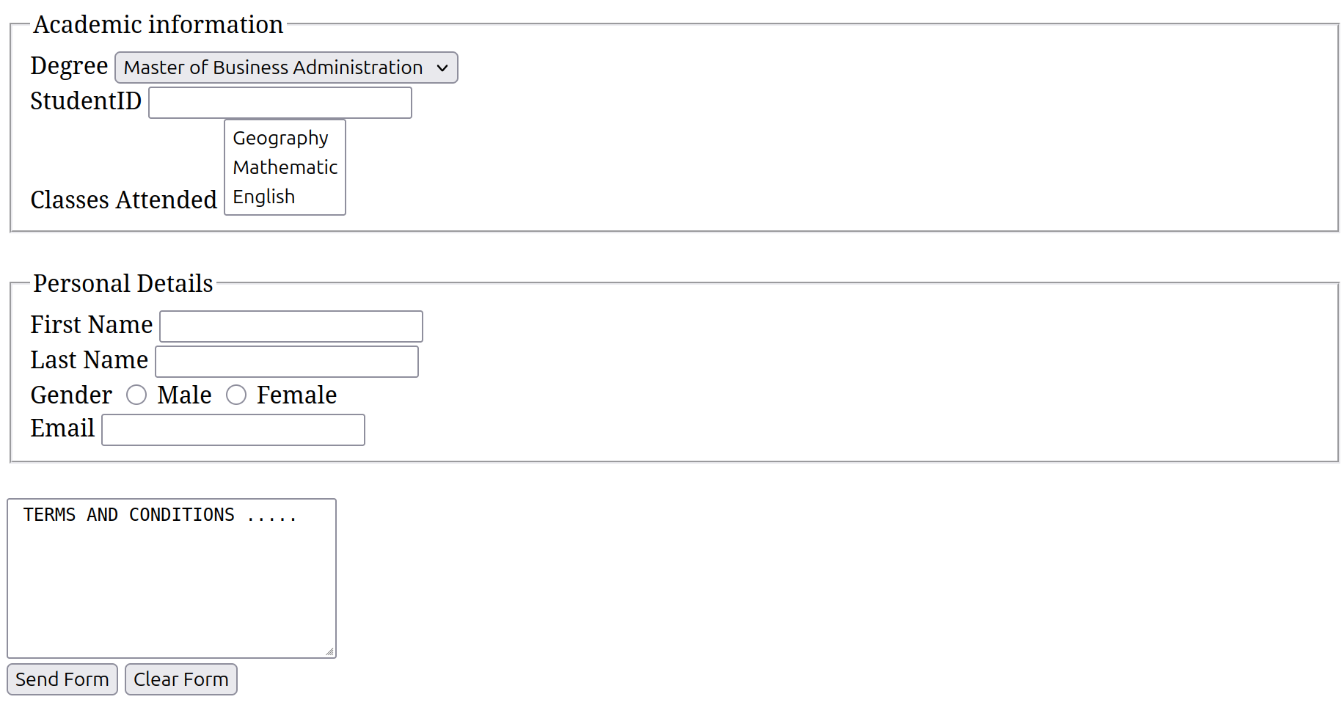

**5)**

**CODE:**

**<!DOCTYPE html>**

**<html lang="en">**

**<head>**

**<meta charset="UTF-8">**

**<meta name="viewport" content="width=device-width, initial-scale=1.0">**

**<title>PIZZA</title>**

**<style>**

**table, th, td {**

**border: 2px solid black;**

**width: 550px;**

**height: 60px;**

**}**

**</style>**

**</head>**

**<body>**

**<center>**

**<table>**

**<tr>**

**<th colspan="2"><b>Pizza Shop 2.0</b></th>**

**</tr>**

**<tr>**

**<td><label for="name">Name</label></td>**

**<td > <input type="text" size="25"></td>**

**</tr>**

**<tr>**

**<td><label for="Pizza">Pizza Topping</label></td>**

**<td><input type="radio" name="pizza topping" id="supreme">**

**<label for="supreme">Supreme</label> <br>**

**<input type="radio" name="pizza topping" id="veg">**

**<label for="veg">Vegetarian</label> <br>**

**<input type="radio" name="pizza topping" id="hawai">**

**<label for="hawai">Hawaiian</label>**

**</td>**

**</tr>**

**<tr>**

**<td> Pizza source</td>**

**<td> <select name="" id="">**

**<option value="">Tomato</option>**

**</select></td>**

**</tr>**

**<tr>**

**<td>**

**Optional Extras**

**</td>**

**<td> <input type="checkbox" value="" >**

**<label for="extrachees">Extra Cheese</label>**

**<input type="checkbox" value="">**

**<label for="free">Gluten Free Base</label>**

**</td>**

**<tr>**

**<td colspan="2">Delivery Instructions:<br>**

**<textarea name="" id="" rows="5" cols="75"> </textarea>**

**</td>**

**</tr>**

**<tr>**

**<td colspan="2">**

**<input type="button" value="Send my Order"></td>**

**</tr>**

**</tr>**

**</body>**

**</html>**

**5)**

**OUTPUT**

