SUBMISSION 3 – SCENARIO (User Perspective)

TEAM MEMBERS
Francis Oladimeji Ajibade
Tammynotonye Jackreece

SCENARIO: Executing the Assignment Compiler Application
This scenario describes the full sequence of operations a user must perform on the UI to successfully create a Test Suite, create Test Cases, attach them to the suite, and execute the Test Suite on student submissions.
Screenshots will be inserted after each step as indicated.

Launching The Application
Open and run the JavaFx Application, Once the JavaFx app opens,The Assignment Compiler home screen appears showing the main menu such as:
  - Test Suite creation section
  - Test Case creation and loading section
  - Execute Test Suite section
  - Results display area
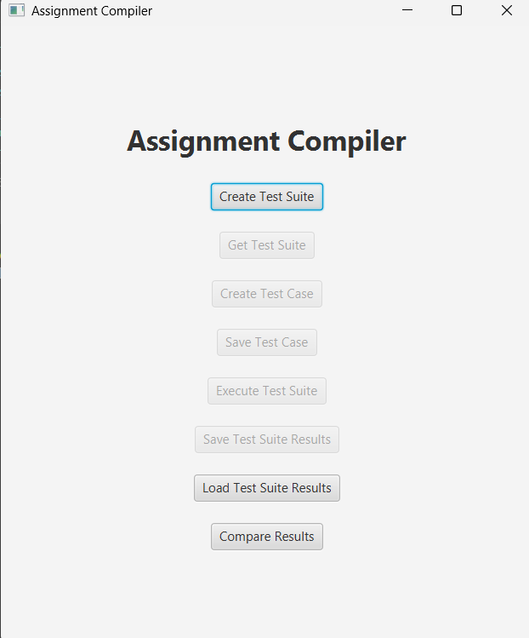

Get Test Suite
For user to get the test suite inorder to check its name or the amount of test case present inside the user can do the following
- Click Get Test Suite
- Enter title of the test suite
- Then the system validates the name and if valid returns the testsuite with a list of testcase it contains
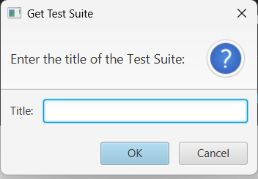
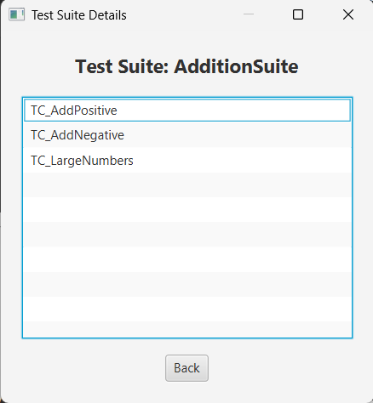

Creating the Test Suite(Required First Step)
- Click the Create Test Suite button.
- A popup appears asking for the title of the Test Suite.
- Enter the title:
For example “AdditionSuite”
- Click Done.
A confirmation message appears, and Test Suite–related actions unlock.
The system now creates a new TestSuite object stored in ListOfTestSuite
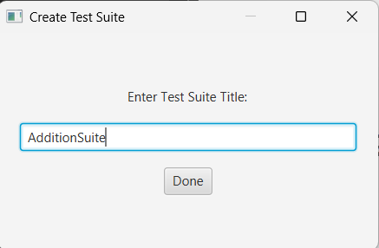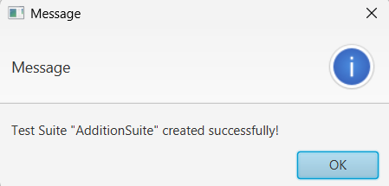

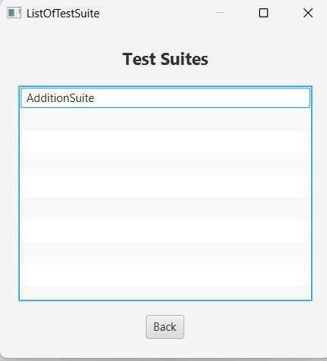

Create Multiple Test Cases (Manually)
- Click the Create Test Case button
- A pop up come up asking for the required fields from the user
For example
Test Case 1- TC_AddPositive
Title: TC_AddPositive
Input: 4 5
Expected Output: 9
- Click Done.
- A success popup appears.
- The List of Test Cases screen opens.
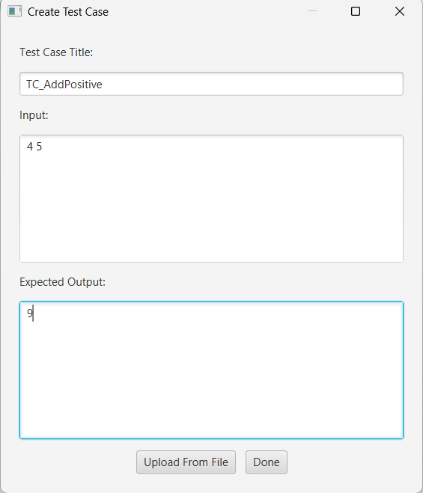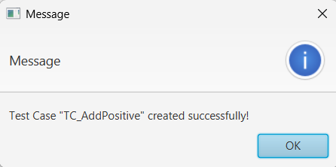

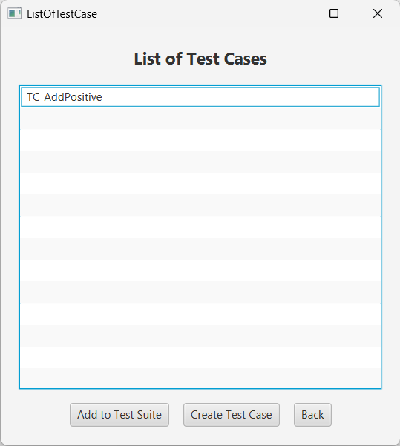
  - Create Additional Test Cases Using the New ‘Create Test Case’ Button
On the ListOfTestCase screen, click Create Test Case again.
Repeat the process:
For example,
TestCase 2- TC_AddNegative
Title: TC_AddNegative
Input: -3 8
Expected Output:5
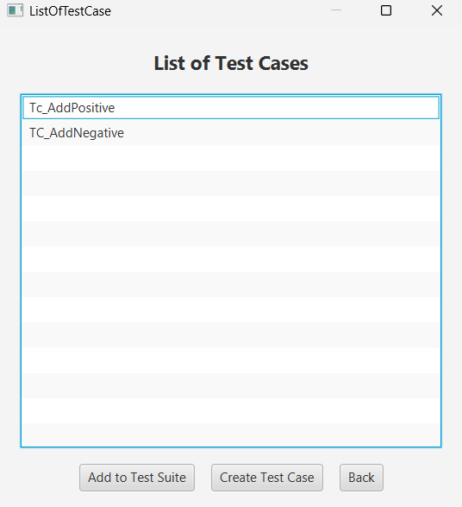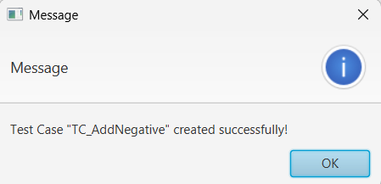

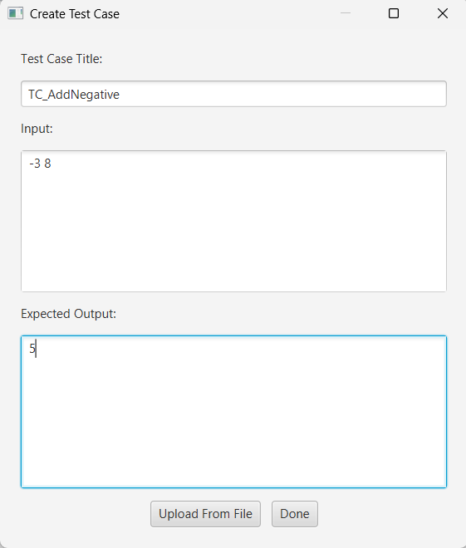
Repeat the process:
For example,
TestCase 3- TC_LargeNumbers
Title: TC_LargeNumbers
Input: 1000000 2000000
Expected Output: 3000000
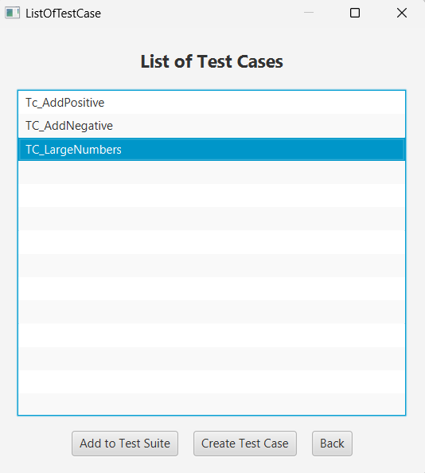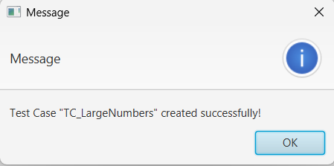

Adding Each Test Case to the Test Suite
Now, attach each Test Case to the Test Suite.
- On the ListOfTestCase screen, click Add to Test Suite.
- A popup appears asking for:
- Test Suite Title: AdditionSuite
- Test Case Title: <the case you want to add>
Add them in this order:

Adding TC_AddPositive
Test Suite Title: AdditionSuite
Test Case Title: TC_AddPositive
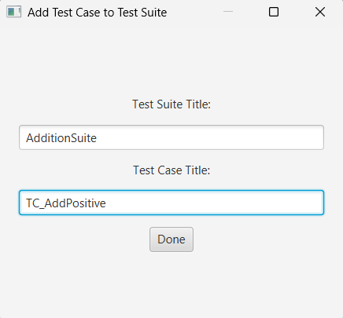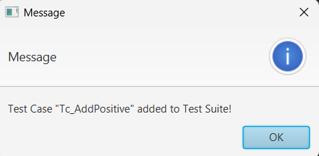
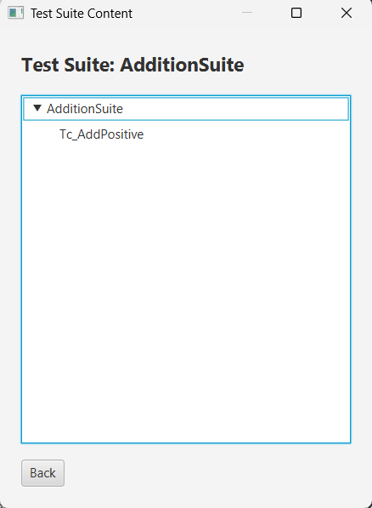

Adding TC_Negative
Test Suite Title: AdditionSuite
Test Case Title: TC_Negative
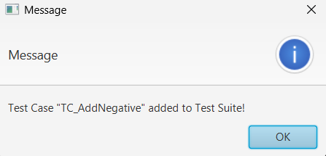
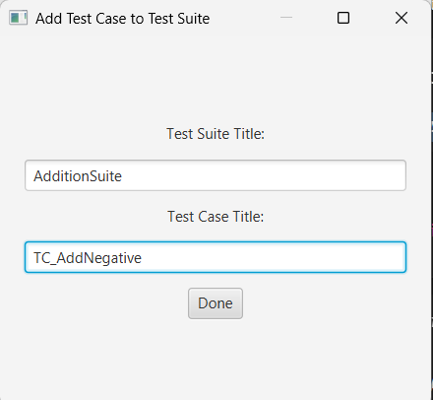

Load a Test Case from a File
To load a test case from a file
Click on the “Create Test Case Button”
And at the bottom of the screen click on the “upload from file “button,
Choose a.txt formatted like this
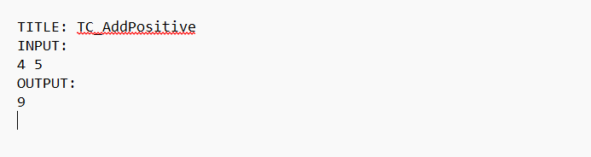
The system parses the file and loads it as a TestCase.
Which can then be added to the testsuite
For exampl

Loading TC_LargeNumbers from testcase file
Test Suite Title: AdditionSuite
Test Case Title: TC_LargeNumbers
For example
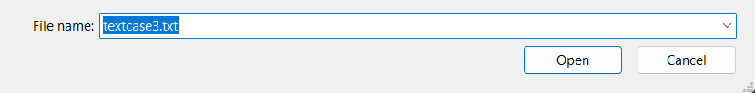
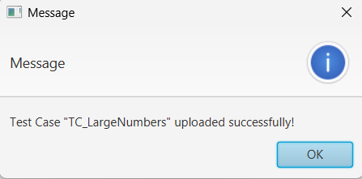

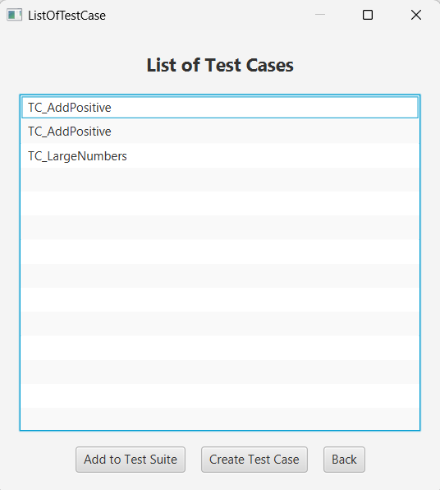

Save Test Case to file
To save the test case to a desired file the user has to do the following:
  - Click the save Test Case Button
  - The system then asks user for the testcase title and the correct filename to store it into
  - The systems shows the file name user chose and the testcase title in a separate screen which has a choose location and save button
  - Which when pressed saves the file and shows a successful message if operation was successful.
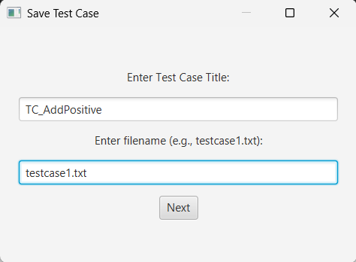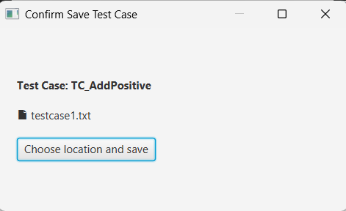

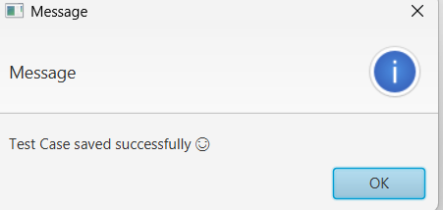

Preparing the Submission Folder
Before executing the Test Suite, ensure the following folder structure exists
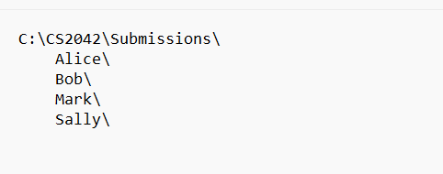
Each Java file must contain one of the provided student programs.
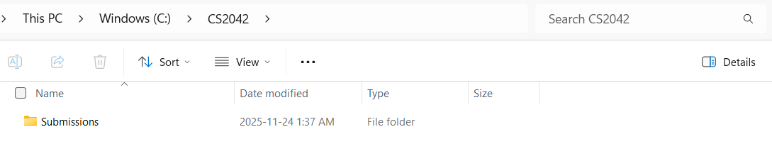
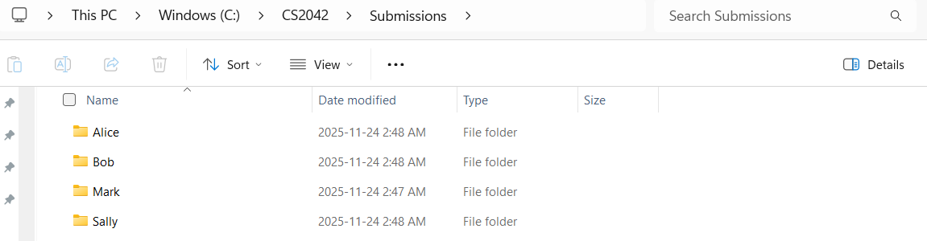

With the java files in each being the same name as the class which contains the main method : for example Bob.java inside the Bob Assignment folder

Executing the Test Suite
•The user enters the test suite name and selects a folder of student submissions, then clicks “Execute Test Suite.”
- The system analyzes each student folder, compiles the Java files, finds the correct main class, runs every test case, and records the results.
- The system displays a class report summarizing pass/fail results or compilation errors for each student.
- The user may then save these results using the “Save Test Suite Results” button.

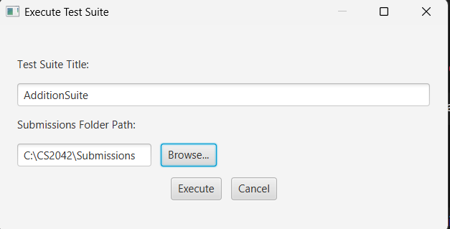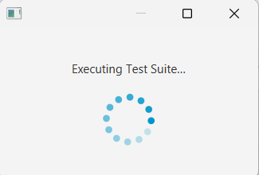

View the Results in the Application
The results table will show something like:
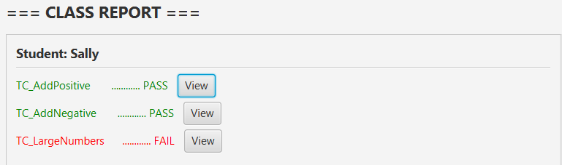

View Expected vs Actual Output for Failures
To view the result details the user can
  - Click on the view button
  - Which then shows the students name the (compilation status(pass or fail) and the expected and actual output comparison
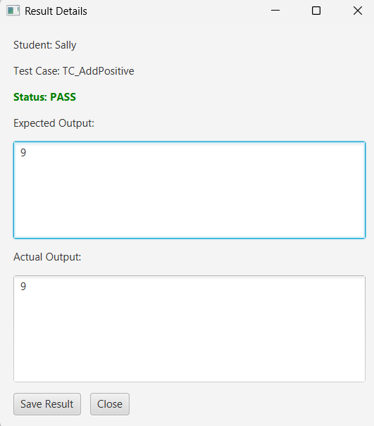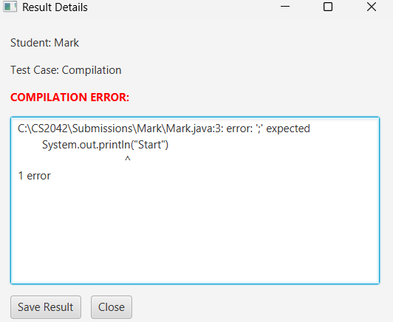

Save Results to File
When the user clicks the save Results button in the results screen
- The system brings up a file loader window so the user can choose were to submit the file
- It updates the user if it was saved successfully
- And finally stores the file containing students result report
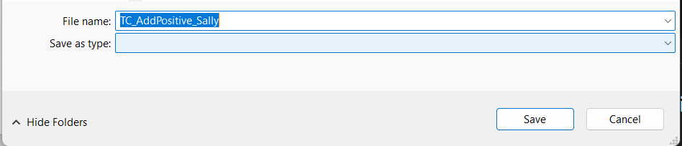
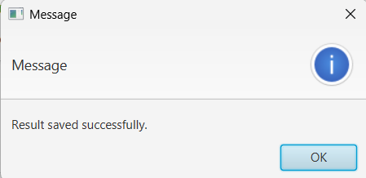
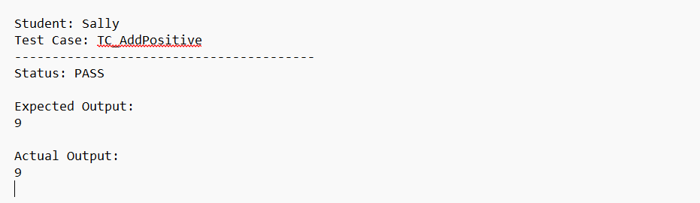

Save Test Suite Result
- When the user clicks the “Save Test Suite Results” button after executing a suite,
The system opens a file chooser window allowing the user to select where the result file should be saved.
- After the user selects a location and confirms, the system saves the complete test suite result (including each student’s compile status, test outcomes, and success rate) into the chosen file.
- The system then displays a message indicating whether the save was successful.
- The saved file can later be reloaded or used for comparing success rates between submissions.
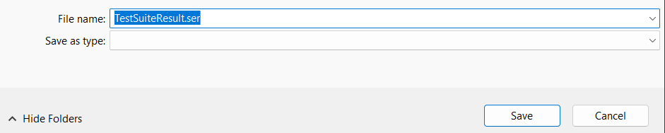

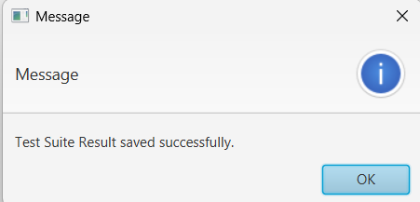

Load Test Suite Result
- When the user clicks the “Load Test Suite Result” button,
the system displays a file chooser window so the user can select a previously saved result file.
- After choosing the file, the system loads (deserializes) the stored results and displays them in a simple, non-editable text area.
- The user can scroll through the displayed summary to view each student’s outcomes and success rate.
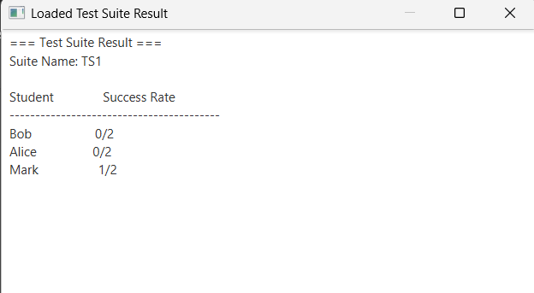

Compare Results
- When the user clicks the “Compare Results” button,
the system opens a window with two file-selection fields.
The user picks two previously saved test suite result files (e.g., Submission 1 vs Submission 2).
- After both files are selected, the system loads them and computes each student’s success rate for each submission.
- The system displays a side-by-side comparison table showing:
  - the student’s name,
  - their success rate in submission 1,
  - and their success rate in submission 2
(or meaningful messages such as NO_COMPILE, NO_RESUB, NO_INITIAL).
- The results are shown in a simple text-based view, as requested.
