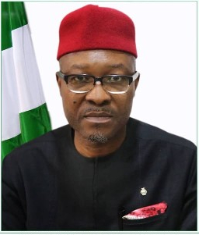

**MR NEBOLISA ANAKO**

**PERMANENT SECRETARY**

**FEDERAL MINISTRY OF POWER**

