**UBER:**

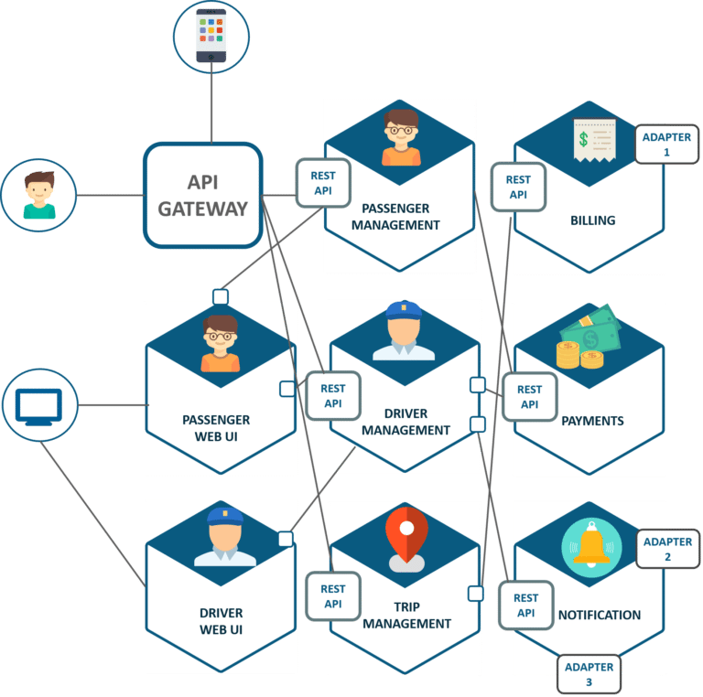

A brief introduction:  
Uber is a system that offers a platform for drivers and passengers to connect, acting as a more down to earth version of a taxi service.

What are they using microservices for:  
Uber uses microservices to perform a range of tasks, ranging from performing API calls between users and servers, connecting drivers to servers etc etc… it uses restful api to manage server side functions including payments, billing, and notifications. Then the using the api they send the information back to the user.

How did they implement the microservices, i.e., what technologies, patterns, et:  
They used Restful apis to separate all individual parts within the system. Instead of having everything as one individual functionality, separating everything allowed for individual parts to be changed without major changes being done to the rest of the service.

Why did they choose a MSA:  
When the time for expansion came, all the features needed to be rebuilt, but development issues came around when testing a massive application just for one feature update.

What successes did they have? What challenges did they have:  
They succeeded in separating all the functions, allowing them to be scaled individually, for example if the need for finding drivers increased, they could individually scale the passenger portion of the service without scaling up the rest of the services.

Do you feel they made a good choice, and why:  
I believe they made a good choice, since the ability to scale individual parts of the service without scaling the rest of the service, allows the service to accommodate for an increase in any individual part of the service, whether it be in influx of passengers or drivers, they can scale any part to server that individual part without modifying the other parts of the server.

**Netflix:**

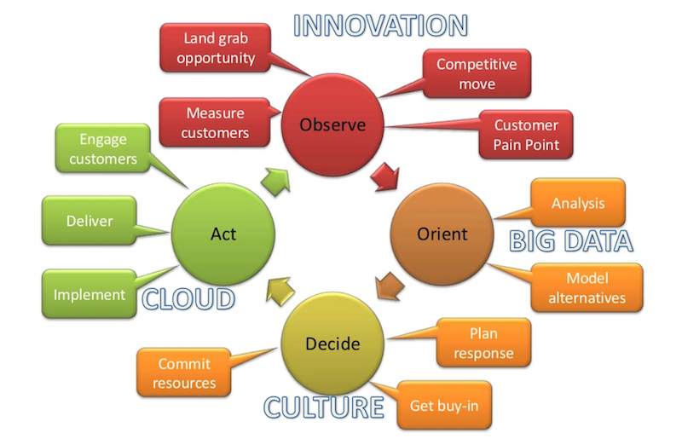

A brief introduction:  
Netflix is a video streaming service that provides it’s users with access to a large library of movies and tv show series. In 2011 they changed to a MSA structure that is being hosted on AWS, but host some of their features on their own servers in order to further optimize certain aspects of the service.

What are they using microservices for:  
They use API’s to separate features, allowing them to separate everything inside their application, from billing to managing videos users watch, they separated everything.

How did they implement the microservices, i.e., what technologies, patterns, et:  
They implement microservices by separating all individual parts of the service then having apis handle the interactions between them all. Then they hosted the majority of functions on AWS, but still host some of the more sensitive functionality on their own servers. The general idea is your app makes na api call to the server then the server fetches the video then redirects you do the video you desire.

Why did they choose a MSA:  
An MSA allowed them to upscale individual parts and implement the service globally with an easier testing phase. Scaling also became easier since individual parts could be scaled up significantly while other parts remained the same, thus introducing flexibility into the system.

What successes did they have? What challenges did they have:  
They had challenges along the way when it came to hosting, which brought upon the partnership between Netflix and amazon, and they now have their own servers hosted around the world to manage their more sensitive functions. The combination of amazon and their own servers provided users around the world with a good experience, providing it with the success it has today.

**Comparison**

|  |  |  |
| --- | --- | --- |
| Name | Netflix | Uber |
| Why | Global scalability | Global scalability |
| Hosting | AWS and own servers | Own servers |
| Technologies | API, AWS, Own servers | Restful API |
| Success? | Already globally dominant | Expanding on a global level |

**Conclusion**

When you compare the success between the two companies, while one would say that Netflix is currently globally dominant with uber receiving resistance trying to scale on a global scale due to each country having laws regarding uber’s services. But the need for Uber on a global scale is increasing day by day, with taxis becoming out dated in certain countries due to cost. Thus at the moment while Netflix is the currently dominant one, in the future, Uber might give it a run for it’s money.