ACIT 1630
Relational Database Design and SQL

Review Questions
Chapter 6

Answer each of the following questions labeling your answers clearly. Save your work in the Desire2Learn Lesson 5 Drop box.

- What is normalization?

- When is a table in 1NF?

- When is a table in 2NF?

- When is a table in 3NF?

- What is a partial dependency? With what normal form is it associated?

- What three data anomalies are likely to be the result of data redundancy? How can such anomalies be eliminated?

- Define and discuss the concept of transitive dependency.

- How do you remove transitive dependency?

- Remove the transitive dependency of the following table:

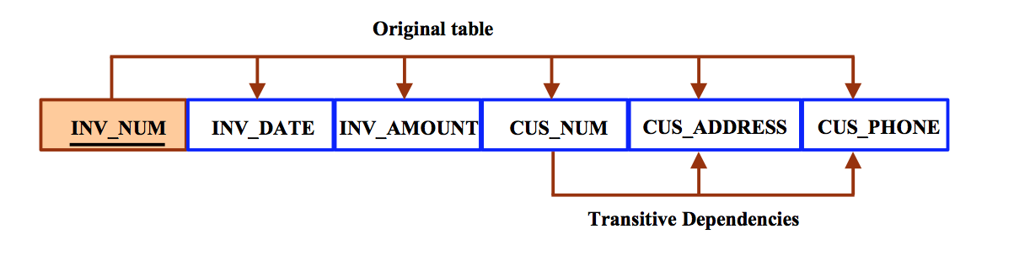

10. What is a surrogate key, and when should you use one?

11. Why is a table whose primary key consists of a single attribute automatically in 2NF when it is in 1NF?

12. How would you describe a condition in which one attribute is dependent on another attribute when neither attribute is part of the primary key?

    - Using the INVOICE table structure shown below, do the following:

Attribute Name | Sample Value | Sample Value | Sample Value | Sample Value | Sample Value
INV_NUM | 211347 | 211347 | 211347 | 211348 | 211349
PROD_NUM | AA-E3422QW | QD-300932X | RU-995748G | AA-E3422QW | GH-778345P
SALE_DATE | 15-Jan-2016 | 15-Jan-2016 | 15-Jan-2016 | 15-Jan-2016 | 16-Jan-2016
PROD_LABEL | Rotary sander | 0.25-in. drill bit | Band saw | Rotary sander | Power drill
VEND_CODE | 211 | 211 | 309 | 211 | 157
VEND_NAME | NeverFail, Inc. | NeverFail, Inc. | BeGood, Inc. | NeverFail, Inc. | ToughGo, Inc.
QUANT_SOLD | 1 | 8 | 1 | 2 | 1
PROD_PRICE | $49.95 | $3.45 | $39.99 | $49.95 | $87.75

a. Write the relational schema, draw its dependency diagram and identify all dependencies, including all partial and transitive dependencies. You can assume that the table does not contain repeating groups and that any invoice number may reference more than one product. (Hint: This table uses a composite primary key.)

b. Remove all partial dependencies, write the relational schema, and draw the new dependency diagrams. Identify the normal forms for each table structure you created.

c. Remove all transitive dependencies, write the relational schema, and draw the new dependency diagrams. Also identify the normal forms for each table structure you created.

d. Draw the Crow’s Foot ERD.

