INFOSYS 704: IT CONSULTANCY
Assignment 1, Deliverable 2 (A1-D2)
Designing the Analysis, Gathering Data, Analysing Data, and Interpreting Results

Organisation: Spark New Zealand — Financial problem domain
Selected process: Annual mobile plan-review and right-planning journey

Prepared by: Rae Huang (UPI: xhua725)
Course: INFOSYS 704 IT Consultancy, 2026 S2 — University of Auckland Business School

Use of Generative AI
Generative AI was used in two ways required by the assignment: as one of the two interviewees analysed in Section 6 (Appendix C, an independent GenAI interview using the same guide as the human interview) and as a design-challenge partner for the TO-BE process in Section 8 (Appendix D). Generative AI was also used as a drafting and formatting assistant — structuring content, polishing expression, and checking APA 7 references. At no point did AI generate the core arguments or substantive content of this report. All hypotheses, the choice of key hypothesis, the interpretation of the two interviews, the selection of the recommended solution, and the final implementation recommendation are the author's own analytical judgements, checked against the source evidence cited throughout. No Spark-internal data, employee statements, or measured results have been fabricated by either the author or any AI tool.

1. Revised A1-D1 Foundations

1.1 Dysfunctional process
The focal process begins when an annual plan review is triggered and ends when the customer stays on the current plan, changes plan, contacts customer care, or defers the decision. The reported replacement design sends a summary without embedding the customer's historical usage and spend or a personalised stay-or-switch recommendation. Customers who need more information must follow a link and compare plan options themselves. This creates an observed information and navigation gap at a commercially important decision point (Commerce Commission, 2025b).
The dysfunction is therefore not that Spark has already been proven to lose revenue through this process. The defensible diagnosis is narrower: the link-only journey transfers information retrieval and plan-comparison effort to the customer, while its effects on review completion, decision quality, retention value, ARPU, complaints, and care demand remain unmeasured.

1.2 SMART problem statement
By 30 June 2027, Spark should establish an FY26 baseline for the annual mobile plan-review funnel and test whether an embedded-information journey improves effective plan-review completion by at least 5 percentage points against the link-only comparison journey. Any rollout should also demonstrate non-inferior 90-day retention value and no material deterioration in segment ARPU or complaint rate.
This statement satisfies each SMART element individually:
- Specific: the annual mobile plan-review/right-planning journey, not the entire customer relationship.
- Measurable: review completion, decision appropriateness, abandonment, retention value, ARPU, and complaints are each observable.
- Achievable: a controlled pilot can compare two journey designs without organisational restructuring.
- Relevant: the process concerns whether customers can make informed, suitable plan decisions and whether Spark can preserve customer value without avoidable harm.
- Time-bound: baseline, pilot, and decision are completed by 30 June 2027.
The 5-percentage-point threshold is a pre-registered improvement target, not a claimed current result. Its commercial adequacy must be checked against the FY26 baseline, implementation cost, and statistical power.

1.3 Issue tree
Figure 1 converts the revised problem structure into a MECE issue tree. The decision-quality branch (H2) is prioritised because both interviews independently identify the customer's interpretation burden and missing embedded evidence as the most actionable mechanism.
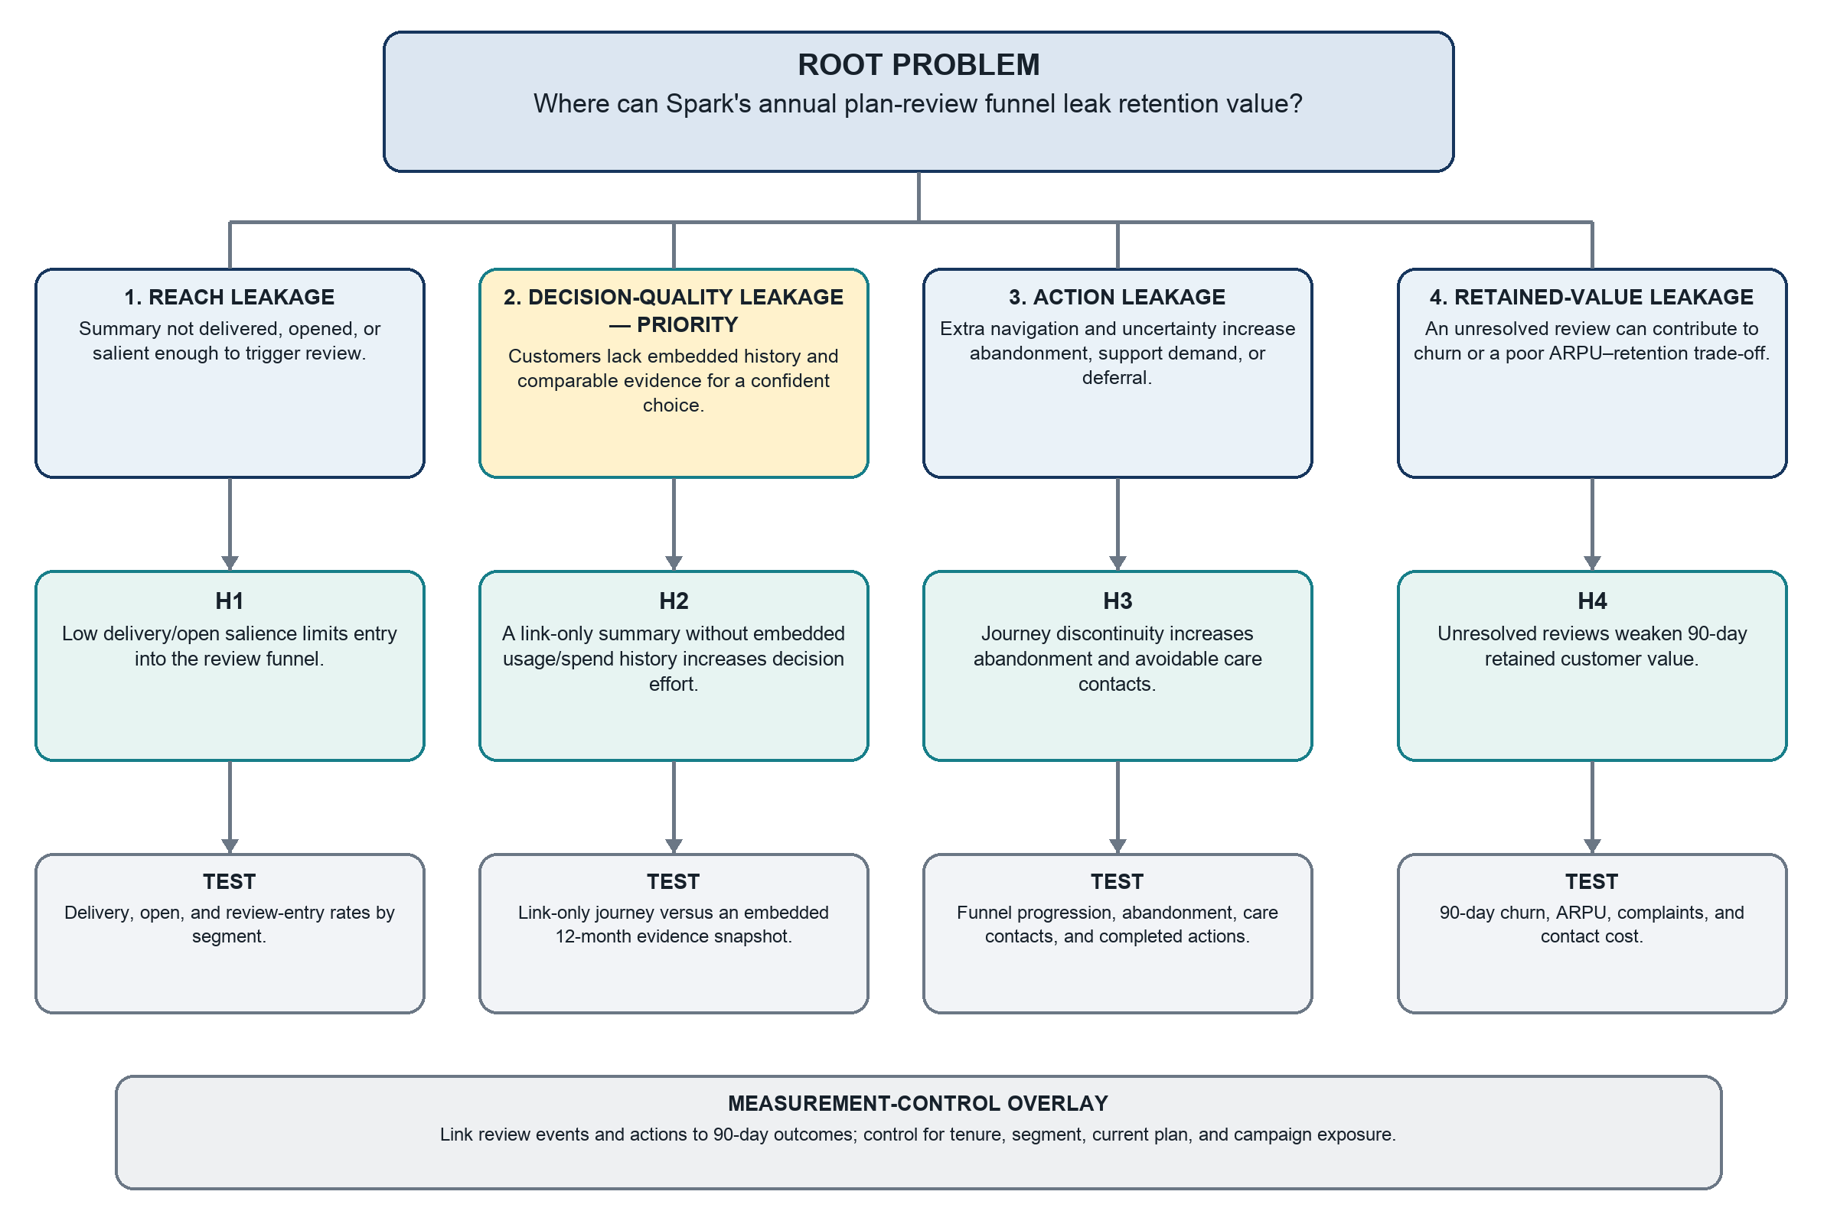
Figure 1. Revised issue tree linking the root problem, issue branches, testable hypotheses and tests.
This tree applies the Lecture 4 and The McKinsey Mind hypothesis-led approach: it decomposes the financial value-leakage question into testable branches and prioritises only analyses that can change the decision (Rasiel & Friga, 2001; University of Auckland, 2026a, slides 65–70). It is MECE at the main-branch level because it separates entering the journey, making the decision, acting on it, and preserving subsequent value. Measurement is treated as an overlay rather than a competing cause.

1.4 Hypotheses
Table 1. Revised hypotheses and decision rules.
ID | Testable hypothesis | Decision rule
H1 | A more salient annual-review reminder increases review entry and completion versus the current trigger. | Support only if the controlled uplift reaches the pre-set threshold and confidence interval; otherwise revise or reject.
H2 — key | Compared with a link-only annual plan summary, the absence of embedded usage/spend history and personalised right-plan guidance materially increases customers' plan-choice difficulty. | For this assignment's qualitative stage, support only if both independent interviews identify this mechanism as material, give concrete reasons, and no stronger rival explanation dominates. A later customer experiment is needed for causal proof.
H3 | Extra navigation in the link-only journey increases abandonment and avoidable care demand. | Support only if funnel/event data show a pre-defined reduction in abandonment or care contacts per completed review after controlling for channel and segment.
H4 | An enhanced review journey produces positive incremental 90-day retention value without materially reducing segment ARPU or worsening complaints. | Support only if retained contribution margin less journey/contact cost is positive and guardrails are met.
H5 | Review-step abandonment is positively associated with 90-day churn after controlling for tenure, segment, current plan, and campaign exposure. | Support only if the adjusted effect is positive and its 95% confidence interval excludes zero; association will not be presented as causation.

1.5 AS-IS model interpretation
The A1-D1 SAP Signavio export is retained only as conceptual input and was fully redrawn for A1-D2. Marker feedback on A1-D1 identified overlapping text, unclear lane boundaries, improper task-to-lane connections and unclear sequence flows. The revised model preserves the valid process content while rebuilding its syntax and layout: Spark's data/plan-review responsibilities, Spark's care/plan-service responsibilities and the customer's responsibilities sit in separate, clearly bounded lanes; every task sits fully within its responsible lane; message flows connect the two pools; gateways and outgoing conditions are labelled; and no text or connector overlaps another element (Figure 2).
The revised model makes the observed gap visible at “Send annual summary”: embedded history and a personalised right-plan recommendation are absent from the message the customer receives. The customer may then follow a link, compare plans manually, contact care, stay, change or defer.
The model retains the evidence labels [O] observed, [H] hypothesised, and [V] to validate, so a reader can see at a glance which steps are drawn from public reporting, which are analytical inference, and which require client-side validation. Public sources do not disclose Spark's internal systems, recommendation rules, exceptions, process owner, or event-data links; these are not invented anywhere in the model.

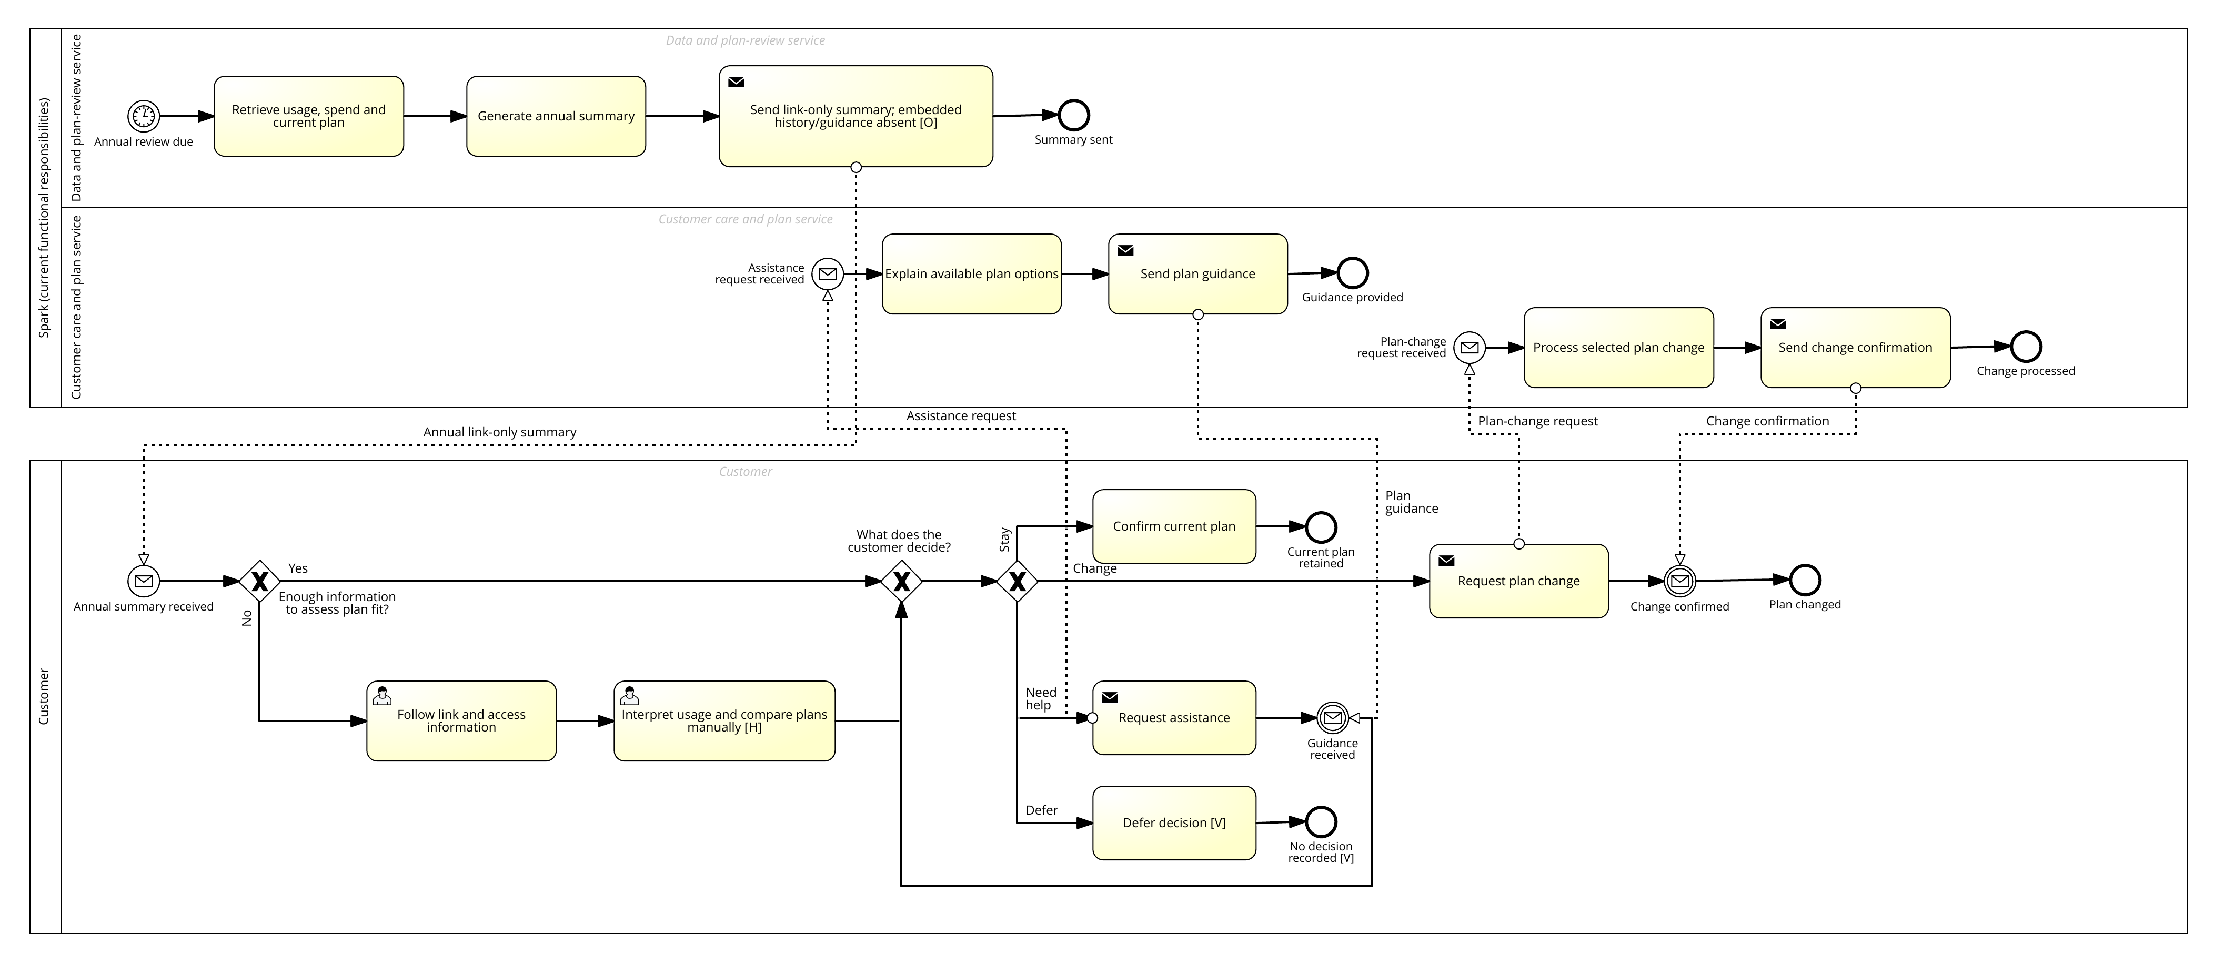
Figure 2a. Revised AS-IS annual mobile plan-review process—overview (SAP Signavio BPMN 2.0).

2. KPI Framework

2.0 Quantified dysfunction and target basis
The available public baseline quantifies the design weakness rather than Spark's internal funnel performance. In the 2024 transparency assessment, Spark's annual summary scored 73%; its Made For You Review used six months rather than a full year of data and lacked sufficient spending detail (Commerce Commission, 2024). The 2025 review then reported that Spark's replacement summaries omitted both embedded historical information and the right-plan recommendation and instead directed customers to a link (Commerce Commission, 2025b). These observations justify testing the dysfunctional information design, but they do not quantify review abandonment or financial loss. The proposed five-percentage-point uplift is therefore a pre-registered pilot target against a contemporaneous comparison, not a claim about the current baseline.

2.1 Major KPI: Effective plan-review completion rate
Definition: Percentage of eligible customers who enter the annual review, reach a recorded stay/change decision within 30 days, and satisfy the appropriate-choice rule.
Formula: customers completing an appropriate review decision within 30 days ÷ eligible customers receiving a review invitation × 100
Appropriate-choice rule: the selected/current plan is consistent with pre-agreed usage, spend, allowance, and customer-preference rules. The rule and tolerances must be approved before analysis; they cannot be defined after seeing results.
SMART target: establish the FY26 baseline and, by 30 June 2027, improve the treatment journey by at least 5 percentage points versus a contemporaneous link-only comparison, subject to adequate sample size and the financial/experience guardrails below.
Why it is the major KPI: it prevents a weak definition of success. Clicks or plan changes alone may rise without helping customers choose appropriately. This KPI combines process completion with decision quality.

2.2 Sub-KPI 1: Review decision-completion rate
Definition: percentage of eligible invited customers with a recorded stay/change decision within 30 days.
Formula: customers recording stay/change within 30 days ÷ eligible invited customers × 100
SMART target: improve by at least 5 percentage points against the link-only comparison by 30 June 2027.

2.3 Sub-KPI 2: Appropriate plan-choice rate among completers
Definition: percentage of customers completing the review whose stay/change decision satisfies the pre-agreed appropriate-choice rule.
Formula: appropriate completed decisions ÷ all completed stay/change decisions × 100
SMART target: be non-inferior to the link-only comparison and seek a 5-percentage-point improvement, with the non-inferiority margin fixed before the pilot.

2.4 Guardrails and diagnostic measures
- 90-day retention value per eligible invited customer;
- segment ARPU;
- complaint rate per 1,000 invited customers;
- care contacts per completed review;
- extra-navigation abandonment rate.
These are not substitutes for the required major KPI and two sub-KPIs. They test whether apparent funnel improvement creates sustainable value without customer or revenue harm.

3. Analysis Work Plan
Prioritisation follows Lecture 4 and Rasiel and Friga's (2001) hypothesis-led work-planning approach: test the decision-quality mechanism first because it is closest to the observed information gap and determines whether an embedded-information solution is worth designing (University of Auckland, 2026a, slides 65–70). Analyses requiring inaccessible internal Spark data are specified transparently as proposed client work, not presented as completed evidence (Table 2).

Table 2. Analysis Work Plan (Lecture 4, slides 65–70).
Priority / hypothesis | Analysis and testing method | Data needed | Likely source | End product | Responsibility | Due date
P1 — H2 decision difficulty | Public-evidence review; two matched semi-structured interviews; deductive and inductive thematic coding; convergence and rival-explanation test. Future client validation: randomised link-only versus embedded-history/recommendation test. | Reported journey design; interview responses on information needs, effort, confidence, trust, and feasibility. Future: variant assignment, journey events, choice outcome. | Commerce Commission and Spark public material; Xuan Zeng; GenAI interview. Future client data explicitly marked unavailable. | Evidence matrix; coded themes; proven/disproven workflow decision; refined H2; experiment specification. | Rae Huang | Guide: 18 Aug; Xuan: 24 Aug; GenAI and synthesis: 26 Aug 2026. Future experiment not conducted.
P2 — H3 action leakage | Map customer steps and failure points; compare abandonment and care demand by journey variant and segment. | Page/event sequence, exits, elapsed time, care contact, final action, channel, segment. | Proposed Spark event and CRM extracts; not available in this assignment. | Funnel visual; abandonment hotspot table; test specification. | Proposed client-side analysis | Not conducted — requires Spark client data.
P3 — H1 reach | Compare delivery, open, entry, and completion across reminder variants and segments. | Eligibility, delivery/open timestamps, reminder variant, entry/completion, segment. | Proposed campaign and event logs; not available in this assignment. | Segment funnel; controlled-test design. | Proposed client-side analysis | Not conducted — requires Spark client data.
P4 — H4 retained value | Estimate incremental 90-day retained contribution margin less journey and contact cost; check ARPU and complaint guardrails. | Churn, margin/ARPU, plan, service cost, contact cost, complaints, treatment, covariates. | Proposed billing, CRM, finance, and complaints data; not available in this assignment. | Value bridge; sensitivity table; rollout threshold. | Proposed client-side analysis | Not conducted — requires Spark client data.
P5 — H5 abandonment/churn association | Cohort analysis and multivariable model; report uncertainty and avoid causal language. | Review events, abandonment point, 90-day churn, tenure, segment, plan, campaign. | Proposed linked event/CRM/billing data; not available in this assignment. | Adjusted-effects table; limitations; causal-test recommendation. | Proposed client-side analysis | Not conducted — requires Spark client data.

4. Data Gathering and Analysis Plan for H2

4.1 Key hypothesis
Compared with a link-only annual plan summary, the absence of embedded usage/spend history and personalised right-plan guidance materially increases customers' plan-choice difficulty.

4.2 Data to collect
- Which information a person needs to assess plan fit.
- Where a link-only journey creates extra steps or uncertainty.
- How embedded history affects effort, understanding, confidence, and trust.
- How a personalised recommendation affects or threatens perceived fairness and control.
- Whether organisational constraints or risks make the proposed mechanism implausible.
- Rival explanations, such as price complexity, low motivation, reminder salience, privacy concern, or general distrust.

4.3 Sources
- Public documentary evidence: Commerce Commission reporting and Spark public reporting. This establishes context and the reported process gap only.
- Human interview: Xuan Zeng, group mate, Organisational problem domain. The participant provides an external analytical perspective, not insider knowledge of Spark.
- GenAI interview: the same semi-structured guide, clearly labelled as simulated stakeholder/expert reasoning rather than factual Spark testimony.
- Future client-side evidence: customer experiment and event data, included as a recommendation but not claimed as collected.

4.4 Collection method
- Use one semi-structured guide for both interviews so questions are comparable.
- Send the guide in advance and pilot it before use.
- Obtain permission to use the group mate's responses in the assignment.
- Preserve Xuan's responses verbatim; do not improve or reconstruct them.
- Ask the same core questions in the same order, using neutral probes only where clarification is required.
- Save the complete human and GenAI transcripts as appendices.
- Keep public facts, interview perceptions, and proposed internal validation data clearly separated.

4.5 Analysis method
- Create a codebook before reviewing answers: information completeness, navigation effort, comparison difficulty, confidence, trust/fairness, organisational feasibility, counterevidence, and KPI implications.
- Code both transcripts independently by question and theme.
- Add emergent codes only when the evidence does not fit the initial codebook; document each addition.
- Build an evidence-convergence matrix showing agreement, disagreement, concrete examples, and evidential limits.
- Search actively for negative cases and rival explanations.
- Decide the hypothesis result using the pre-set rule below.
Decision rule: H2 is qualitatively supported for solution development only if both interviews independently identify missing embedded information and/or personalised guidance as a material contributor to decision difficulty, provide a plausible mechanism, and do not reveal a stronger rival explanation that dominates. If one source contradicts H2 or the evidence is vague, it is classified as mixed/inconclusive and the hypothesis is revised. Interview evidence cannot establish causal or population-level proof; a controlled customer test remains necessary.

4.6 Proposed visualisations
- Hypothesis–evidence convergence matrix: hypothesis component × source × convergence judgement × analytical implication (Table 3, Section 6.2).
- Customer-effort pathway: AS-IS steps with evidence tags at the points where effort or uncertainty arises (Figure 2).
- Rival-explanation table: explanation, supporting evidence, contradictory evidence, and next test (Section 6.2).
- Future validation funnel: invited → entered → decision completed → appropriate choice → 90-day retained value (Section 9.3).
With only two interviews, no percentage chart or frequency claim is used to imply representativeness.

5. Semi-Structured Interview Guide
Use: identical core guide for Xuan Zeng and the GenAI interview. Estimated time: 20–25 minutes. Interviewer: Rae Huang. Purpose: test H2 and identify counterevidence; not to obtain confidential Spark information.
The guide follows the course sequence of beginning with context, moving gradually into process and sensitive governance questions, listening without leading, and closing with an invitation for omitted issues (University of Auckland, 2026b, slides 11–16). The full guide, with all ten sections and twenty-two questions, is reproduced in Appendix A; question numbers below match the transcripts in Appendices B and C.

Section 1 — Consent and evidence boundary
- 1. Do you agree that your answers may be quoted or summarised in my INFOSYS 704 assignment, with your name and stated problem domain?
- 2. Please confirm that your answers reflect your own analysis or general experience and do not contain confidential information from Spark.

Section 2 — Perspective and context
- 3. What is your INFOSYS 704 problem domain, and what perspective does it give you on customer-facing process design?
- 4. Before this interview, how familiar were you with mobile-plan comparisons or annual plan reviews?

Section 3 — Understanding the AS-IS journey
Scenario: a customer receives an annual mobile-plan summary. Historical usage/spend and a personalised stay-or-switch recommendation are not shown in the summary. If the customer wants detail, they follow a link and compare plans themselves.
- 5. In your own words, what would the customer need to do from receiving this summary to making a stay-or-change decision?
- 6. Which step, if any, appears most difficult or uncertain? Why?

Section 4 — Information needs
- 7. What information would you need to judge whether your current mobile plan still fits you?
- 8. Which information should appear directly in the summary, and which could reasonably sit behind a link? Why?

Section 5 — Decision effort and navigation
- 9. How, if at all, would following a separate link affect your willingness or ability to complete the review?
- 10. What other factors might matter more than the extra navigation?

Section 6 — Personalised guidance, confidence, and trust
- 11. How would a personalised stay/change recommendation affect your decision process, if at all?
- 12. What evidence or explanation would make such a recommendation trustworthy?
- 13. What could make personalised guidance feel unfair, intrusive, or commercially biased?

Section 7 — Organisational feasibility and controls
- 14. From an organisational perspective, what capabilities or responsibilities would be needed to provide embedded history and personalised guidance reliably?
- 15. What implementation risks, ownership gaps, staff impacts, privacy concerns, or governance controls should be considered?

Section 8 — Outcomes and measurement
- 16. What observable outcome would best show that the redesigned journey helped customers make a better decision?
- 17. Besides completion, what measure should prevent Spark from declaring success too early?

Section 9 — Hypothesis challenge and alternatives
- 18. The working hypothesis is that missing embedded history and personalised guidance materially increase plan-choice difficulty. What evidence supports this explanation?
- 19. What evidence or alternative explanation could disprove it?
- 20. If only one change could be tested first, what should it be and why?

Section 10 — Closing and prioritisation
- 21. On a scale from 1 (not material) to 5 (highly material), how material is the identified information/guidance gap? Please explain the rating.
- 22. Is there anything important I did not ask?
Neutral probes used where clarification was needed: Could you give a concrete example? What leads you to that view? Under what circumstances would that not be true? Is that based on the scenario, your experience, or an assumption? What evidence would change your mind?

6. Interview Results and Interpretation

6.1 Evidence and method
The same 10-section, 22-question semi-structured guide was used for two interviews. Xuan Zeng responded as a group mate working in the Organisational domain (full transcript, Appendix B). A separate GenAI interview responded from a consumer-decision and service-analytics perspective in an isolated context that did not contain Xuan's transcript (full transcript, Appendix C). Both respondents were told that the scenario was not evidence of Spark's internal operations. The transcripts were coded against the pre-defined themes of information completeness, navigation effort, comparison difficulty, confidence, trust, organisational feasibility, counterevidence and KPI implications. Emergent themes were ownership, incentive alignment, future-usage uncertainty, plan comparability and segment variation.

6.2 Cross-interview findings
Table 3 assesses convergence specifically against priority hypothesis H2. It separates agreement, qualification and rival explanations so that triangulation is not confused with the more detailed interview summary in Table 4.
Table 3. Evidence-convergence matrix for priority hypothesis H2.
H2 component | Xuan Zeng | Independent GenAI | Convergence judgement | Analytical implication
Decision burden is material | Supports | Supports | Strong | Retain H2 as the priority hypothesis.
Separate link is the main cause | Qualified support | Qualified support | Conditional | Treat the link as a contributing mechanism, not the sole cause.
Embedded 12-month snapshot should be tested first | Supports | Supports | Strong | Proceed to an information-first controlled pilot.
Personalised guidance should be in the first release | Qualified | Qualified | Strong caution | Stage guidance after snapshot quality and customer response are validated.
Rival explanations and governance matter | Challenges exclusivity | Challenges exclusivity | Strong | Segment the test and monitor trust, plan complexity, accessibility and data quality.
Table 4. Detailed cross-interview findings by theme.
Theme | Xuan Zeng | Independent GenAI | Interpretation
Primary decision burden | Customers must reconstruct a typical requirement from variable history and compare unlike plans. | Customers must translate past usage into uncertain future need and evaluate trade-offs. | Strong convergence: interpretation and judgement create more difficulty than the click itself.
Effect of the separate link | The link removes momentum when effort and benefit are unknown. | The link adds interruption, authentication and accessibility costs, but may be acceptable if seamless. | The link is a contributing mechanism whose effect depends on destination quality.
Information needed | Twelve-month usage/spend, over/under-use, current terms, annual cost difference and switching constraints. | Typical use, variation, exceptional months, total cost, contract status and comparable alternatives. | Strong convergence on a concise embedded evidence snapshot.
Personalised guidance | Converts analysis into checking, but must show the working and sometimes recommend staying or spending less. | Can reduce effort but risks automation bias and commercial distrust. | Guidance is a possible second-stage intervention, not the safest first release.
Rival explanations | Plan comparability, trust, grandfathered plans and contractual effects. | Plan complexity, benefit size, future uncertainty, status quo and accessibility. | H2 is material but not exclusive; the intervention must be tested by segment.
Governance | Named owner, data standards, versioned rules, frontline visibility and incentive alignment. | Data validation, suitability rules, privacy/security, bias monitoring, human support and auditability. | A sustainable solution needs process ownership and controls, not only a redesigned message.
First test | Embed usage/spend history before adding recommendations. | Embed a concise 12-month snapshot while holding other features constant. | Independent agreement supports a staged information-first pilot.

Both interviews rated the information/guidance gap 4/5. This agreement is analytically useful but is not a population estimate because the evidence consists of one group-mate perspective and one simulated GenAI perspective.

6.3 Hypothesis decision
Decision: H2 is provisionally proven; the workflow proceeds to solution development rather than iterating to another hypothesis.
Against the pre-set qualitative decision rule, H2 is provisionally proven for this assignment's next step; in research terms, it is supported for solution development with material qualifications. Both interviews independently identified the absence of embedded evidence as a material contributor to decision difficulty and described the same mechanism: the customer must find historical data, decide what counts as normal, translate it into future need and compare plans expressed through different attributes. Neither interview identified a rival explanation that wholly displaced this mechanism. The workflow therefore proceeds to solution development rather than iterating to another hypothesis. However, trust, contractual restrictions, plan complexity and future uncertainty may dominate for some customers.
Here, “provisionally proven” is the binary workflow decision required by the assignment; it is not causal or population-level proof. The evidence does not establish that the redesign will create a five-percentage-point uplift, improve retention or raise financial value. It supports designing and testing a solution. The refined testable hypothesis is:
Providing an embedded 12-month usage-and-spend snapshot will reduce annual plan-review decision effort and improve appropriate plan choice compared with a link-only summary; explainable personalised guidance may provide additional benefit, conditional on trust, plan comparability and customer control.
This refinement separates the lower-risk information intervention from the higher-governance recommendation intervention.

7. Data Analysis, Interpretation and Probable Solutions

7.1 External evidence and evidential limits
The interview mechanism is consistent with New Zealand market evidence but should not be presented as direct proof of Spark-specific customer behaviour. The Commerce Commission reported in March 2025 that 31% of mobile consumers had not switched because changing providers required too much effort, while 50% of mobile switchers encountered at least one problem (Commerce Commission, 2025a). The Commission also found that providers needed to improve the information available for customers to judge plan suitability. Spark's 2024 approach had included usage-based recommendations, but the Commission reported in 2025 that Spark had ended the initiative and that the three largest providers were not giving consumers sufficiently clear access to the information needed to make informed plan choices (Commerce Commission, 2024, 2025b).
These findings establish industry-level relevance and the reported design change. They do not reveal Spark's review completion, abandonment, plan-fit, churn, ARPU or complaint outcomes. Those variables remain proposed client-side measures.

7.2 Solution Tree
Figure 3 traces each issue through a supported or testable root cause to a distinct solution pathway. Pathway A is prioritised; B and C are retained as staged or supporting alternatives, while D is a deliberately broad comparator that is rejected as the first implementation.
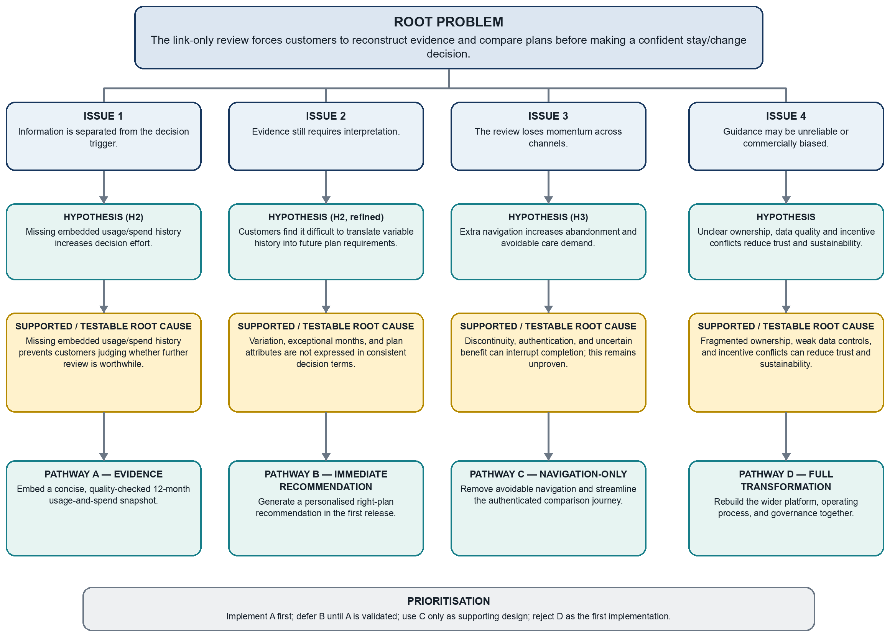
Figure 3. Solution Tree from issues and root causes to four solution pathways.
The first three branches isolate distinct intervention mechanisms: provide evidence, automate interpretation, and reduce navigation friction. Pathway D is retained as a deliberately broader scope comparator rather than a co-deployed component. Table 5 therefore evaluates the same four labelled pathways and shows why Pathway A should be implemented first. This structure follows the course definition of a Solution Tree and its prioritisation by feasibility, cost and impact (University of Auckland, 2026c, slides 39–41).

7.3 Evaluation of solution pathways
Table 5. Evaluation of solution pathways.
Pathway | Expected impact | Feasibility | Main risk | Evidence position | Decision
A. Embedded 12-month snapshot | Directly reduces evidence-retrieval and reconstruction effort | Relatively high — uses information already needed for billing, subject to validation | Incorrect, stale or privacy-sensitive presentation | Strongest convergence across both interviews | Implement first through a controlled pilot
B. Immediate personalised recommendation | Potentially reduces comparison effort further | Medium/low — rules, accountability, explainability and channel support required | Bias, automation reliance, distrust and inappropriate recommendations | Promising but qualified | Defer until Pathway A is validated
C. Navigation-only redesign | May reduce interruption and authentication friction | Medium/high | Treats a secondary friction as the root cause | Both interviews said the click itself was not the main burden | Include only as supporting design
D. Full platform/process transformation | Could address information, comparison and governance together | Low for an initial engagement | Excessive scope, cost and rework before causal evidence | Not justified by two interviews | Reject as first implementation

7.4 Best solution and Rosemann justification
The best immediate solution is a controlled pilot that embeds a concise 12-month usage-and-spend snapshot in the annual plan-review summary, supported by data validation, a clear assistance route and outcome logging. Personalised recommendations remain outside the first release and are considered only after the information intervention satisfies decision-quality and harm guardrails.
This choice follows Rosemann's (2001) process-improvement logic in four ways. First, it applies process-oriented optimisation of the outcome: the annual summary is redesigned around the next process decision rather than functioning as a generic notice (p. 20). Second, it applies activity elimination by removing the customer's non-value work of locating, aggregating and reconstructing information that the provider already holds (p. 21). Third, it uses automation of activities to retrieve validated data, calculate customer-facing indicators and generate the snapshot consistently (p. 24). Fourth, it applies resource-related improvement through end-to-end ownership and a shared evidence view for customer care, reducing handoffs and inconsistent explanations (pp. 26–27). Rosemann also recommends distinguishing achievable short-term and ideal longer-term TO-BE models (p. 27). The information-first pilot is the short-term TO-BE; explainable personalised guidance is the longer-term option after validation.
The selection also reflects Rosemann's process-selection criteria (p. 4). The annual plan review has customer importance, a documented information weakness, and a feasible first redesign. It is therefore more defensible than beginning with a high-risk recommendation engine or full platform rebuild.

8. Proposed TO-BE Process

8.1 GenAI-supported development
A separate GenAI design interview was conducted on 17 August 2026 to challenge the structure, sequence, exceptions, responsibilities, gateways and controls of the selected TO-BE process (full transcript, Appendix D). The interaction added an explicit data-validity gateway, a controlled fallback for incomplete data, consistent information across self-service and customer-care channels, and KPI logging. It also challenged scope creep and confirmed that personalised recommendations should be excluded from the first operational model.

8.2 TO-BE process specification (modelled in SAP Signavio BPMN 2.0, Figure 4)
Process boundary: start when an eligible customer's annual mobile plan review becomes due; end when a stay, change, assisted-review or deferred/no-decision outcome is recorded. Both AS-IS and TO-BE models were built directly in SAP Signavio and passed its BPMN 2.0 Convention Check with no structural errors before being exported as Figures 2 and 4.
Participants: a Spark pool with three functional lanes — Data and plan information; Plan-review service; Customer care — and a separate Customer pool.
Main flow:
- 1. A timer event triggers the annual review for an eligible customer.
- 2. The Data and plan information lane retrieves 12 months of usage, spending, current-plan and relevant contract data.
- 3. The process validates completeness and freshness.
- 4. An exclusive gateway asks: Data valid for customer-facing snapshot?
- 5. If No, the process logs the failure reason, generates a clearly labelled basic summary, includes secure access to available details and offers assistance.
- 6. If Yes, the process calculates customer-facing indicators: typical usage, variability, exceptional months, excess charges and persistent unused allowance.
- 7. The Plan-review service generates and quality-checks the concise snapshot.
- 8. Spark sends the annual summary to the customer by message flow.
- 9. The customer reviews the snapshot; an exclusive gateway asks: Current plan appears suitable?
- 10. If Yes, the customer confirms staying; Spark records the decision.
- 11. If No/unsure, the customer opens a comparison view where alternatives use consistent units and total expected cost.
- 12. An exclusive gateway asks the customer's next action: select another plan, request assistance, or defer.
- 13. If the customer selects a plan, Spark validates eligibility, completes the change and records the outcome. If the customer is not eligible, Spark sends an exception-and-assistance message; a further gateway routes the customer either to a closed “change not completed” outcome or back into plan-change processing once assistance is accepted.
- 14. If assistance is requested, Customer care receives the request, reviews the same snapshot and comparison basis, explains options, and returns the information by message flow. The customer then stays, changes or defers.
- 15. If deferred or if no decision occurs within 30 days, Spark records a deferred/no-decision outcome without forcing a change.
- 16. The process closes the review and records KPI events for completion, appropriate choice and later guardrails.
BPMN controls: sequence flows remain inside a pool; message flows connect Spark and Customer pools. Every task sits fully inside its responsible lane. Gateways and outgoing conditions are labelled. Connectors and labels do not overlap. The diagram shows a normal end event for every resolved outcome.

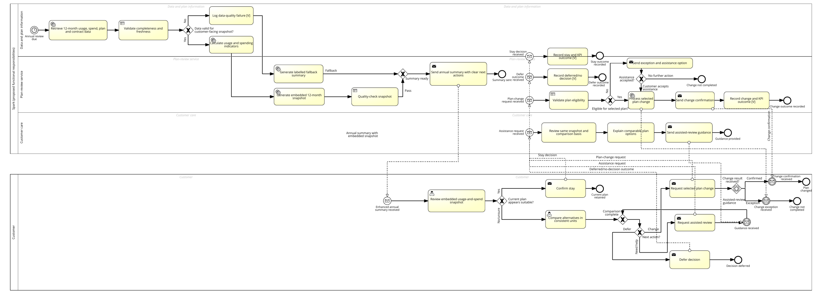
Figure 4a. Proposed TO-BE annual mobile plan-review process—overview (SAP Signavio BPMN 2.0).

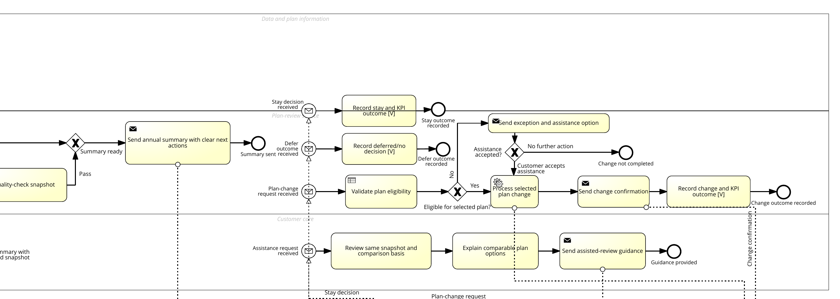
Figure 4b. Enlarged TO-BE view—summary dispatch, KPI recording and change-exception handling.
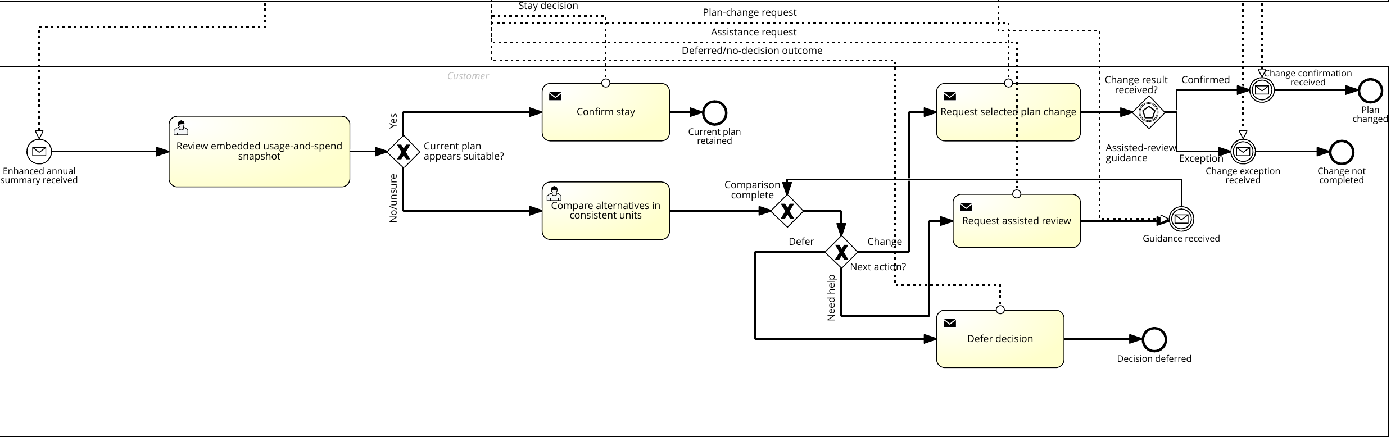
Figure 4c. Enlarged TO-BE view—customer choice, assistance and outcome pathways.

8.3 How the TO-BE improves the dysfunctional process
The TO-BE moves historical evidence from behind the link to the point where the decision starts. The customer no longer has to find and aggregate basic usage and spending data before determining relevance. Validation prevents low-quality data from being presented as dependable evidence, while the fallback path prevents the process from stopping. The comparison and customer-care paths use the same evidence basis, reducing inconsistent explanations. Outcome logging makes the process measurable rather than assuming that sending a summary creates value.
The redesign deliberately retains customer control and avoids interpreting every plan change as success. A customer can stay, switch, seek help or defer. This supports the major KPI because an effective completion requires a recorded and appropriate decision, not merely a click or conversion.

9. Recommendation to Implement

9.1 Structured recommendation narrative
Problem. The link-only annual plan-review journey separates the decision trigger from the historical usage and spending evidence customers need to judge plan fit.
Data. Public evidence documents the information gap and provides industry-level context. In the primary qualitative evidence, both interviews rated the information/guidance gap 4/5, independently identified interpretation and comparison as the main burden, and selected an embedded 12-month evidence snapshot as the first test. These data establish neither population prevalence nor causal effect size.
Insight. The highest-value first move is to reduce evidence-retrieval and reconstruction work without simultaneously introducing the greater trust, governance and attribution risks of automated recommendations. This follows the Lecture 5 storylining sequence and its 80/20 principle: focus the recommendation on the few variables most likely to change the decision (University of Auckland, 2026b, slides 32–35).
Recommendation. Spark should pilot an embedded 12-month usage-and-spend snapshot in the annual mobile plan-review summary before investing in personalised recommendations. The pilot should compare the enhanced summary with the link-only journey while holding recommendation logic and wider navigation changes constant. This isolates the information effect and directly tests the refined H2.

9.2 Key insights driving the recommendation
- The bottleneck is interpretation, not the physical click. Both interviews identified the customer's need to reconstruct a normal usage requirement and compare dissimilar plans as the largest burden.
- Information and recommendation should not be bundled initially. Both interviews selected the snapshot as the first test. Separating the interventions shows whether information visibility creates value before Spark accepts the governance risk of personalised advice.
- Completion alone can reward the wrong behaviour. A redesign may increase switching while producing worse plan fit, regret or complaints. Success therefore requires the combined effective-completion KPI and financial/customer guardrails.
- A customer-facing change requires operating ownership. Data validation, versioned rules, customer-care visibility and accountable process ownership determine whether the improved summary remains reliable over repeated annual cycles.

9.3 Phased implementation
Phase | Main actions | Decision gate
1. Define and prepare | Confirm process owner; define eligible cohort, snapshot fields, appropriate-choice rule, data-quality threshold, privacy/security requirements and KPI event definitions. | Proceed only when fields and rules can be reproduced and audited.
2. Build and test | Create the snapshot pipeline and template; test exceptional cases, accessibility, language, device display and customer-care visibility. | Proceed only if accuracy and usability thresholds are met.
3. Controlled pilot | Randomly compare link-only and embedded-snapshot journeys; pre-register the five-percentage-point target, sample size and guardrails. | Scale only if effective completion improves and guardrails are non-inferior.
4. Monitor and refine | Review segment effects, data failures, assistance demand, reversals, complaints, ARPU and 90-day retention value. | Stop or redesign where detriment or unequal outcomes appear.
5. Consider explainable guidance | Test guidance separately, showing evidence, assumptions, alternatives and the ability to stay, override or defer. | Adopt only if it adds decision quality without trust, fairness or financial harm.
Table 6. Phased implementation plan and decision gates.

9.4 Implementation controls
- Assign one accountable process owner across the annual-review outcome.
- Use one authoritative definition for usage, spend, plan terms and review completion.
- Version all calculation and presentation rules.
- Expose only the minimum customer data needed in the summary and secure detailed information appropriately.
- Give customer care access to the same snapshot and its calculation basis.
- Monitor data-quality failures, complaints, reversals, unexpected bill increases and segment-level outcomes.
- Maintain a customer route to verify, challenge, ignore or defer the review.

9.5 Expected contribution and limitation
The proposed solution is expected to reduce customer evidence-retrieval effort and make the annual review more actionable. Its financial value could arise from lower avoidable care demand, better retention and fewer persistent plan mismatches, but the direction and size of these effects are not established by the available evidence. Some customers may move to cheaper plans, creating a short-term ARPU trade-off. The business case should therefore be based on incremental 90-day retained contribution margin net of journey and contact cost, supported by sensitivity analysis rather than an assumed revenue uplift.

References
Commerce Commission. (2024, November 27). Is your mobile plan right for you? Telcos could do more to tell you. https://www.comcom.govt.nz/news-and-media/news-and-events/2024/is-your-mobile-plan-right-for-you-telcos-could-do-more-to-tell-you/
Commerce Commission. (2025a, March 20). ComCom calls for better switching for consumers. https://www.comcom.govt.nz/news-and-media/news-and-events/2025/comcom-calls-for-better-switching-for-consumers/
Commerce Commission. (2025b, October 2). Spark, 2degrees and One NZ stall on billing transparency. https://www.comcom.govt.nz/news-and-media/news-and-events/2025/spark-2degrees-and-one-nz-stall-on-billing-transparency/
Rasiel, E. M., & Friga, P. N. (2001). The McKinsey mind: Understanding and implementing the problem-solving tools and management techniques of the world's top strategic consulting firm. McGraw-Hill.
Rosemann, M. (2001). Business process lifecycle management [White paper]. Queensland University of Technology.
University of Auckland. (2026a). INFOSYS 704 IT consultancy: Lecture 4 — Framing the problem, AS-IS modelling, designing the analyses [PowerPoint slides].
University of Auckland. (2026b). INFOSYS 704 IT consultancy: Lecture 5 — Gathering the data, analysing the data, interpreting the results [PowerPoint slides].
University of Auckland. (2026c). INFOSYS 704 IT consultancy: Lecture 6 — Process lifecycle [PowerPoint slides].

Appendix A — Semi-Structured Interview Guide
The full ten-section, twenty-two-question guide used identically for both interviewees is reproduced in Section 5 of the main report. It is not duplicated here to avoid redundancy; question numbers in Appendices B and C map directly onto that guide.

Appendix B — Xuan Zeng Interview Transcript (Authentic Group-Mate Evidence)

Header
Assignment: A1-D2. Respondent: Xuan Zeng (Organisational problem domain). Interviewer: Rae Huang — Financial problem domain. Date: 24 August 2026. Format: Written response to the interview guide circulated in advance.
Hypothesis being tested: "Compared with a link-only annual plan summary, the absence of embedded usage and spending history and personalised right-plan guidance materially increases customers' difficulty in choosing a suitable plan."

Section 1 — Consent
Q1. Yes, I'm happy for my answers to be quoted or summarised in your assignment, and for you to identify me as "Xuan Zeng — Organisational problem domain". One small request: if you shorten an answer, please keep the qualifier with it, because a few of my answers are conditional rather than definite.
Q2. Yes, I can confirm that. Everything below is based on the scenario you sent me, publicly available information about the New Zealand telco market, and my own experience as a customer. I don't have any access to Spark's internal systems or data, so nothing here is confidential.

Section 2 — Your perspective
Q3. My problem domain is organisational, so I'm not really looking at this as a design or user-interface issue. My question is whether Spark is set up internally to produce the thing the summary is supposed to deliver. A personalised plan recommendation isn't just a page — someone has to own the rules behind it, someone has to be responsible for the usage data being accurate, and someone has to answer for it when the recommendation is wrong.
My guess is that the summary is link-only not because nobody thought of embedding the data, but because no single team owns the output end to end. When that happens the process tends to default to the easiest version of itself, which is to send a link and let the customer do the work.
That matters for your hypothesis because it changes what "difficulty" is. The customer's difficulty is the symptom. The organisational cause is a handoff nobody owns. If you fix the page but not the ownership, I'd expect it to slide back within a couple of cycles.
Q4. Fairly familiar as a customer, not as someone who works in the industry. I've compared mobile plans for myself and looked across providers when switching. I haven't worked in a telco billing or customer communications team, so anything I say about how these summaries are actually produced is inference rather than observation. I'd treat my answers in Sections 3 to 6 as reasonably grounded, and my answers in Section 7 as reasoning about what would be needed rather than a description of what Spark has.

Section 3 — Current process
Q5. Based on your scenario, I think the customer has to get through roughly eight steps:
- Notice the summary at all, when it's competing with other billing emails they've learned to ignore.
- Open it and work out what it's actually telling them.
- Realise the information they need to decide isn't there.
- Follow the link, and log in if it sits behind a login.
- Find their own usage history — data, minutes, roaming — over enough months to be representative.
- Turn that history into a personal requirement, i.e. "I need about this much data in a normal month".
- Read the plan list and translate the marketing tiers into the same units.
- Compare the two, decide whether the gap is big enough to matter, and act.
Only steps 1, 2, 4 and 8 are things the process actually asks the customer to do. Steps 5, 6 and 7 are analysis that gets quietly handed to the customer, and step 3 is where I think most people give up.
Q6. Step 6 is the hardest by a long way. The other steps take effort but they're mechanical. Step 6 asks the customer to decide what counts as a typical month, what to do about unusual months, and how much spare allowance to pay for just in case. That's a judgement call under uncertainty, not a lookup, and most people have no confident basis for making it.
Step 7 is a close second but for a different reason. Plans aren't designed to be compared on one axis — data, speed caps, hotspot rules, rollover, bundled streaming and family sharing aren't really comparable. So even a customer who knows their usage exactly still can't rank the options without deciding what they value.
The thing I'd point out is that both of the hardest steps are the ones Spark is best placed to do and the customer is worst placed to do. That asymmetry seems like the core of it.

Section 4 — Information requirements
Q7. I'd want six things:
- 12 months of usage by month, for data, calls, texts and roaming, so I can see both the normal level and how much it varies.
- What I actually paid, split into plan charge, overage or add-ons, and one-offs, so I know whether my cost problem is the plan or the exceptions.
- How many months I went over my allowance and how many months I used less than half of it. Those two numbers alone tell me whether I'm on the wrong plan in either direction.
- My current plan's terms written in the same units as my usage, not in marketing language.
- The comparable alternatives in those same units, with the annual cost difference rather than the monthly headline price.
- Anything that makes switching harder — contract end date, device repayment balance, whether a promo rate is about to expire.
The last one matters more than people expect. A recommendation to switch that ignores an outstanding device balance isn't really a recommendation.
Q8. In the summary itself I'd put the 12-month usage picture, the cost split, the over/under counts, and a plain sentence saying what those numbers mean. Those are facts about me that Spark already holds, so I can't see a good reason to make me go and fetch them.
Behind the link I'd leave the full plan catalogue, the terms and conditions, the month-by-month itemisation and the switching mechanics. That's reference material — long, generic, and only needed once the customer has decided to keep going.
The rule I'd use is that the summary should answer "does this need my attention?" and the link should answer "what do I actually do about it?". At the moment the summary answers neither, which is probably why the link ends up feeling like the whole task.

Section 5 — Effort and navigation
Q9. The click itself doesn't cost much. What the link costs is momentum. When the summary arrives the customer has a few seconds of attention and no particular intention. If the summary gives them a conclusion — "you went over your allowance in seven of the last twelve months" — then clicking is purposeful and I think most people would do it. If the summary gives them a link and no conclusion, clicking is a gamble: unknown effort for unknown benefit. That's the kind of trade people usually decline.
So I wouldn't describe it as a navigation cost so much as the task never starting. If you can measure it, I'd expect the drop-off between "opened the summary" and "clicked the link" to be much bigger than the drop-off between "clicked the link" and "finished the review".
Q10. Four things I think would matter more than the extra click:
- Plans not being comparable on one axis, as in question 6. I'd put this first.
- Not wanting to give up the current plan, especially older grandfathered plans. People worry that changing is one-way, and quite often they're right, so the hesitation is rational.
- Not trusting the motive. If the customer assumes the review exists to upsell them, they'll discount it no matter how well it's designed.
- Not knowing the side effects — device repayment, contract terms, whether other lines in the household are affected. Uncertainty about consequences stops more reviews than complexity in the main decision does.
If the redesign only removes the link and doesn't touch these four, I'd expect a real but fairly small improvement.

Section 6 — Personalised guidance and trust
Q11. A recommendation changes the customer's job from analysis to checking, and those are very different. Analysis means building a judgement from raw material, which is slow and easy to abandon. Checking means testing a proposed answer against what you already know, which is quick and which most people will actually do. Even a recommendation the customer ends up rejecting is useful, because it gives them something to react to.
The design implication is that the recommendation has to be disagreeable — the customer needs to see enough of the reasoning to argue with it. If they can't, it isn't checking, it's just an instruction, and instructions from a commercial party tend to get ignored.
Q12. Four things:
- Show the working. "Recommended because you went over your allowance in 7 of 12 months, by an average of 3.2 GB" is trustworthy in a way that "we recommend Plan X" isn't.
- Be willing to recommend something that costs Spark revenue. A system that sometimes says "stay where you are" or "you're paying for more than you use" earns credibility that no amount of design can buy. If every recommendation is an upgrade, customers will notice within one cycle.
- State the assumptions and the period it's based on.
- Show the underlying data and make it clear the customer can ignore it, defer it, or reverse it.
Q13. It would look unfair or biased if:
- Every recommendation is an upsell, or downgrades are technically possible but never actually appear.
- The reasoning is hidden behind "our system suggests", which the customer can't check.
- It uses data the customer didn't expect Spark to be analysing — location, app-level detail, guesses about who else lives with them. Usage volume feels fair because customers know it's used to bill them; behavioural inference doesn't.
- It's framed as urgent or limited-time, which turns a service into a sales pitch.
- It's visibly wrong. One obviously incorrect recommendation would discredit all the later ones, and I think that's much harder to recover from than it is to get right the first time.

Section 7 — Organisational considerations
Q14. This is my domain so I'll be specific. I think four things would be needed, and only one of them is technology.
First, a named process owner for the annual review, accountable for the recommendation being right and not just for the email going out. In most organisations this kind of output falls between marketing, who own the send, billing or data, who own the usage figures, and product, who own the plan list. When three teams own a piece each and nobody owns the result, the output ends up as whatever needs no cross-team agreement — which is a link.
Second, a data capability with defined quality standards: one authoritative source for usage, an agreed definition of a month, documented handling of mid-cycle plan changes, and a stated error tolerance. The recommendation is only as defensible as the weakest of those definitions.
Third, a rule set that is versioned and reviewable rather than a model that quietly drifts. Someone has to be able to answer "why did this customer get this recommendation in March" six months later.
Fourth — and I think this is the one most often missed — the frontline has to be able to absorb the consequences. Better summaries produce more informed customers asking sharper questions. If contact centre staff can't see the same recommendation and the same reasoning the customer is looking at, an improvement upstream creates a failure downstream.
I'd add that Spark is doing this under constraints. Headcount has come down a lot over the last two years and the company split into two divisions in July 2026. That doesn't make this impossible, but any design that needs new roles probably won't survive the business case. The realistic version adds ownership and a rule set to work that is already happening.
Q15. The risks I'd flag, roughly in order of how likely they are:
- Unclear ownership. This is the default failure and I'd assume it's already present.
- Data quality. Records accurate enough for billing may not be accurate enough for advice, because billing tolerates edge cases the customer never sees and advice doesn't.
- Workload. The annual review creates a demand spike, and if the summary is genuinely useful that spike gets bigger, at least in the first cycle.
- Privacy and consent. Using billing data to give advice is a different purpose from using it to bill. Whether that's covered by existing consent is a real question under the Privacy Act 2020 and needs an answer before launch rather than after.
- Governance of the rule set. Without version control and periodic review, a recommendation engine drifts towards whatever the most recent commercial input pushed it towards.
- Incentive conflict. If the team that owns the recommendation is measured on plan revenue, the recommendation will bend regardless of anyone's intentions. I'd flag this hardest because it's invisible in the process design but decides the outcome.

Section 8 — Measuring success
Q16. The result I'd find most convincing is a fall in plan–usage mismatch across the customer base: the proportion of customers whose plan clearly doesn't match their usage, either regularly going over or persistently using a small fraction of it, measured 6 and 12 months after the review. That's an outcome measure, and it says customers ended up on plans that fit, which is the point of the process.
I'd support it with a decision-quality measure: of the customers who acted, how many were still on the chosen plan and not mismatched a year later. A review that produces lots of switching followed by lots of switching back hasn't helped anyone.
Q17. Completion counts will move first, which is exactly why they're risky. Beyond them I'd use three:
- Reversal and complaint rate — plan changes reversed within 90 days, plus contacts referencing the recommendation. This is the guardrail. If it goes up, the recommendation is confidently wrong.
- Share of recommendations that reduce customer spend. If that's close to zero, the process is working as a sales channel and the trust benefit won't last.
- Whether completion is spread evenly across customer segments or concentrated among customers who were already engaged and already on the right plan. A programme that helps the confident and misses everyone else can show a good headline number while the underlying problem stays put.
The main trap is declaring success in the first cycle, because novelty will lift engagement once. The real question is whether cycles two and three hold and whether the mismatch measure actually moved.

Section 9 — Testing the hypothesis
Q18. I'd say the supporting evidence is mostly structural rather than direct, and I'd be upfront about that in your write-up:
- The scenario hands three analytical steps to the party least equipped to do them while the party best equipped already holds the inputs. That's a design fault regardless of what the numbers show.
- Consumer research in New Zealand keeps finding plan comparison to be a friction point, and the Commerce Commission's monitoring shows most mobile customers stay with the same provider for more than five years while a large share of those who do switch hit problems. Long tenure plus switching difficulty is more consistent with people not reviewing than with people being satisfied.
- Spark's reported mobile satisfaction sits below the market average, which is at least consistent with a process that leaves work on the customer's side.
- Behaviourally, defaults are sticky, and effort placed before a decision suppresses that decision far more than the same effort placed after it.
What none of that establishes is size. It supports "materially increases difficulty" as plausible; it doesn't quantify it.
Q19. Three things could disprove it, and I don't think any of them is a straw man:
- A ceiling effect. If most customers are already roughly on the right plan, better information changes very little and the mismatch measure won't move even if engagement does. The hypothesis would then be true about difficulty but not relevant to outcomes.
- Trust rather than information being the real constraint. If customers see the recommendation, understand it, and still say no because they don't believe Spark is acting in their interest, the information gap isn't doing the work. This is my main alternative explanation and I'd test it directly.
- The barrier being contractual rather than cognitive. If device repayment balances or contract terms are what stop people, perfect information changes nothing and the real problem sits in a different process.
One observation that would count against the hypothesis: if some customers already get usage data embedded somewhere, for example in the app rather than the annual summary, and those customers show no better plan fit than everyone else, then the information gap isn't the cause.
Q20. I'd embed the usage and spending history in the summary first, before adding any recommendation.
Two reasons. First, it separates the variables. Your hypothesis has two parts — missing data and missing guidance — and testing them together tells you the bundle worked without telling you which half did it. Doing the data first gives you a clean reading, and the recommendation then becomes a measurable second step.
Second, it's the cheaper and less risky half. Embedding data Spark already holds needs a data feed and a template change. Personalised recommendations need a governed rule set, a privacy position, an accountable owner and a frontline briefing — the four things in my answer to question 14. Building the hard half first, on an untested assumption, is how these projects end up over-scoped and cancelled. If the data-only version moves the mismatch measure, the case for the recommendation makes itself.

Section 10 — Overall assessment
Q21. I'd say 4 out of 5.
Not 5, because I think the gap is a strong contributing cause rather than the only one. Contract friction, trust, and plans not being comparable would each hold back good plan choice even with perfect information, and I don't think the information gap outweighs all three.
Not 3, because the asymmetry is quite one-sided. Spark already holds every input the customer needs and it costs almost nothing to show, and the current design withholds it at exactly the moment the customer is paying attention. When the party who could supply the information cheaply doesn't, and the party who has to reconstruct it expensively is the one asked to, the difficulty isn't accidental — it's produced by how the process is designed. I'd call that material.
Q22. Three things I'd have expected to be asked:
- Ownership and incentives. Your guide asks what capabilities are needed, which is the right question, but I think the harder one is who is accountable for the recommendation being right, and whether their targets allow them to sometimes recommend a cheaper plan. That single question probably predicts the outcome better than any design decision.
- The cost side, which is your domain rather than mine. If this works, some customers move to cheaper plans, so there's a short-term ARPU effect against a longer-term churn and cost-to-serve benefit. Whoever sponsors this internally will be asked about that trade-off in the first meeting.
- Segmentation. The summary as described treats every customer the same. A customer with stable, well-matched usage needs two lines of confirmation; a customer constantly going over needs an intervention. Sending both the same thing means it's over-built for one and under-built for the other, and an average completion rate would hide both.

Appendix C — Independent GenAI Interview Transcript

Header
Assignment: A1-D2. Interviewee: Independent GenAI interviewee — consumer decision and service analytics perspective. Interviewer: Rae Huang — Financial problem domain. Date: 26 August 2026. Format: Written response to the same 10-section semi-structured interview guide used for the group-mate interview.
Independence protocol: generated in a fresh, isolated agent context. The agent received the scenario, hypothesis and 22 questions only. It was not given Xuan Zeng's transcript or any summary of Xuan's answers.
Hypothesis: "Compared with a link-only annual plan summary, the absence of embedded usage and spending history and personalised right-plan guidance materially increases customers' difficulty in choosing a suitable plan."

Section 1 — Consent and evidence boundary
Q1. Yes. My answers may be quoted or summarised in the INFOSYS 704 assignment, provided I am identified as an "Independent GenAI interviewee — consumer decision and service analytics perspective."
Q2. Confirmed. These answers are general analysis based only on the scenario and principles from consumer decision science, service analytics, and responsible digital-service design. I have no access to confidential Spark information, customer records, internal systems, staff views, or measured Spark results. Any claim about likely customer behaviour is an inference to be tested, not an observed Spark fact.

Section 2 — Perspective and context
Q3. I approach customer-facing process design as a decision problem, not merely an information-delivery problem. I look at whether customers can identify the relevant evidence, understand trade-offs, complete the required steps, and reach a decision they can later justify. I also consider behavioural effects such as limited attention, status-quo bias, choice overload, loss aversion, and excessive reliance on automated recommendations. From a responsible-design perspective, a journey should help customers make an informed choice without quietly steering them toward the provider's preferred commercial outcome.
Q4. I am generally familiar with how consumers compare mobile plans: recurring price, data allowance, actual data use, calls and texts, roaming, add-ons, contract conditions, network experience, and the consequences of exceeding an allowance. My limits are important. I do not know Spark's current plan catalogue, annual-summary design, customer segments, link-completion rate, recommendation capability, or applicable implementation constraints. I can identify plausible sources of difficulty and propose tests, but I cannot say how large their effects are without customer evidence.

Section 3 — Understanding the AS-IS journey
Q5. From the scenario, the customer would first need to notice and open the annual summary. They would then need to understand that a plan review is being invited, decide that reviewing it is worth their time, follow the separate link, authenticate or navigate further if required, locate their usage and spending history, interpret whether that history is representative, find the available plans, and compare their current plan against those alternatives.
The customer must then translate past behaviour into future needs. They may need to consider whether recent usage was unusual, whether travel or household circumstances will change, and whether a cheaper plan introduces risks such as excess charges or insufficient data. Finally, they must decide whether to stay or change and complete any switching steps. The journey therefore contains both navigation effort and a more demanding judgement task.
Q6. The hardest step is probably not clicking the link. It is converting usage and spending records into a confident judgement about future plan fit. A customer may see that they used, for example, a certain amount of data, but still not know what allowance gives them a sensible buffer, whether promotional prices are temporary, or how to value features they use occasionally.
The separate link can make abandonment more likely because it interrupts attention, but the hypothesis should not treat navigation as the whole problem. If the linked page is fast, clear, authenticated, and pre-populated, the link may add very little difficulty. Conversely, even a fully embedded summary will not help much if prices, conditions, and trade-offs remain difficult to interpret.

Section 4 — Information needs
Q7. To judge current plan fit, the customer would ideally need:
- Total monthly cost, including recurring fees, add-ons, excess charges, discounts, and one-off items.
- Usage over a meaningful period, preferably showing typical use and variation rather than only an annual average.
- Data, call, text, roaming, and hotspot use where these affect plan suitability.
- Frequency and size of allowance breaches or unused allowance.
- The current plan's price, inclusions, contract status, and relevant expiry dates.
- Comparable alternatives using total expected cost, not just headline price.
- Important differences in coverage, speed, service level, roaming, rollover, sharing, and cancellation terms.
- A way to account for expected changes in future use.
- The uncertainty around any estimated saving or recommendation.
An average alone can mislead. A customer averaging 8 GB per month may have eleven low-use months and one 40 GB travel month. Distribution, peaks, and exceptional events matter.
Q8. The summary should directly show a concise decision snapshot: current-plan cost, recent typical monthly spend, a usage range or simple month-by-month pattern, excess charges or unused allowance, contract status, and one or two clearly comparable options. It should also state the period covered and identify anything likely to distort the history.
Detailed bills, full monthly records, every available plan, technical definitions, and legal terms can reasonably sit behind a link. The principle is that information required to decide whether further investigation is worthwhile should be visible immediately. Information needed only to verify or complete the decision can be one level deeper. Embedding everything would create its own form of overload.

Section 5 — Decision effort and navigation
Q9. A separate link introduces a small but real completion cost. Customers can be distracted between the summary and the comparison page, may distrust the destination, forget credentials, encounter slow loading, or decide the task is not urgent. These effects are likely to be stronger on mobile devices, for customers with accessibility needs, and when the initial message does not show a concrete reason to continue.
However, I would not assume that every separate link is materially harmful. A prominent link leading to a fast, accessible, pre-authenticated page with the customer's information already displayed may be easier than placing a complex comparison inside an email. The effect depends on the quality of the destination and the continuity between the two surfaces.
Q10. Several factors could matter more than the extra navigation:
- Whether the customer trusts the summary and recognises it as genuine.
- Whether prices and plan conditions are genuinely comparable.
- Whether the customer believes changing plans could reduce service quality.
- The size and credibility of the potential benefit.
- Contract restrictions or fear of losing discounts and features.
- Choice overload from too many alternatives.
- Difficulty predicting future usage.
- Low urgency and status-quo bias.
- Accessibility, language, and digital-literacy barriers.
- Whether the customer is the account holder or can authorise a change.
A customer may willingly cross several screens to save a substantial, credible amount. They may ignore a perfectly embedded summary if the benefit is vague or the alternatives feel risky.

Section 6 — Personalised guidance, confidence and trust
Q11. A personalised recommendation could reduce comparison effort by turning raw history into a proposed action, particularly for customers who do not understand plan structures. It could improve confidence if it explains why staying is suitable as readily as it recommends switching.
There is also a danger of automation bias. Some customers may accept a recommendation without understanding assumptions or considering future changes. Others may distrust it precisely because the provider benefits financially from the decision. Personalisation is therefore not automatically better than neutral decision support. A well-designed usage snapshot plus a small set of relevant alternatives may sometimes be more responsible than a definitive "best plan" label.
Q12. A trustworthy recommendation should disclose:
- The historical period and data used.
- The customer behaviours that drove the result.
- Assumptions about future usage.
- Expected monthly and annual cost under each relevant option.
- Whether discounts or promotional prices expire.
- Important feature trade-offs.
- The size of any safety margin for variable usage.
- Circumstances in which the recommendation would change.
- Whether all eligible plans were considered.
- A straightforward way to inspect the calculation or choose different assumptions.
The language should reflect uncertainty. "Based on your last 12 months, this plan is estimated to cost…" is more defensible than "This is your perfect plan."
Q13. Guidance may feel unfair or intrusive if it uses unexpected data, infers sensitive circumstances, gives different customers unexplained offers, or withholds cheaper eligible plans. It may appear commercially biased if the recommendation optimises revenue, promotes longer commitments, emphasises headline discounts, or consistently proposes upgrades while rarely recommending a cheaper plan or staying put.
Trust would also be damaged if customers cannot tell whether the system considered commissions, retention targets, sponsored placements, or expiring promotions. Responsible guidance should optimise an explicitly customer-relevant outcome and disclose the basis of ranking.

Section 7 — Feasibility and controls
Q14. Reliable delivery would require accurate and timely usage, billing, entitlement, contract, and plan-catalogue data; consistent definitions across channels; a comparison method that calculates total expected cost; clear eligibility rules; and an accessible interface that works across devices.
Responsibilities would include validating input data, maintaining current plan rules, testing recommendation logic, approving customer-facing explanations, monitoring unequal outcomes, handling disputes, protecting privacy, and providing a route to human assistance. A recommendation also needs versioning so the provider can reconstruct what data, rules, and offers produced a particular result.
Q15. Important risks and controls include:
- Incorrect or delayed usage data producing unsuitable advice.
- Atypical history, such as travel or temporary hardship, being treated as normal.
- Missing add-ons, family sharing, bundled services, or future price changes.
- Conflicting information across the summary, website, retail, and contact centre.
- Staff being unable to explain or override an automated result.
- Increased support demand when customers question recommendations.
- Excessive collection, retention, or secondary use of behavioural data.
- Exposure of account details through insecure messages or shared devices.
- Ranking logic that favours provider revenue over customer suitability.
- Unequal performance for customers with irregular use, accessibility needs, multiple services, or limited digital skills.
Controls should include data-minimisation rules, secure authentication before exposing sensitive detail, explicit calculation standards, bias and outcome monitoring, representative usability testing, manual review for unusual cases, accessible alternatives, logging, expiry dates on recommendations, and a clear correction and complaints process.

Section 8 — Outcomes and measurement
Q16. The best observable outcome would be improved decision quality, not simply more clicks or plan changes. One practical indicator would combine whether customers choose a plan that fits their subsequent usage and cost with whether they understand and remain satisfied with the choice after an appropriate period.
This could be assessed through later excess charges, avoidable unused allowance, rapid reversal or repeat switching, post-decision regret, and a short comprehension check. No single measure proves that a customer selected the objectively "best" plan, because suitability also includes preferences such as certainty, flexibility, and service features.
Q17. A key guardrail should be customer detriment after the decision. For example, Spark should monitor unexpected bill increases, excess-use charges, loss of valued features, complaints, recommendation reversals, and regret — not just review completion or conversion.
It should also compare outcomes across customer groups. A higher completion rate could conceal worse decisions among people with irregular usage or lower digital confidence. Another essential guardrail is calibrated understanding: customers should know why the option fits and what could make it unsuitable.

Section 9 — Hypothesis challenge and alternatives
Q18. The hypothesis is plausible because the AS-IS design separates the trigger from the evidence needed to act. Customers must incur navigation and interpretation costs before seeing whether a review offers any benefit. Behavioural research generally suggests that each additional step can increase abandonment, while missing personalised context increases the mental effort required to compare options. Embedded history could make the relevance of the task immediately visible, and guidance could translate complex data into a manageable choice.
The two proposed gaps may also interact. Embedded history without interpretation may still confuse customers, while a recommendation without visible evidence may not be trusted. Showing both could improve the continuity from evidence to judgement.
Q19. The hypothesis could be disproved if customers already understand their use, regard the linked page as easy, or primarily stay because switching offers little benefit. It could also fail if the real causes of difficulty are opaque pricing, too many plans, fear of losing benefits, contract restrictions, low trust, or uncertainty about future needs.
Measured evidence against the hypothesis would include no meaningful difference in comprehension, confidence, abandonment, or subsequent plan fit when history and guidance are embedded. Another possibility is that personal recommendations improve completion but worsen decision quality through over-reliance. Effects may also be concentrated in a small segment; stable, low-variance users may find the current process adequate.
The causal effects should be separated with a randomised factorial test rather than evaluated as one bundled redesign. A 2×2×2 design could independently vary:
- Usage and spending snapshot: absent versus embedded.
- Personalised recommendation: absent versus present with rationale.
- Navigation: separate destination versus an inline or same-page comparison.
This produces eight conditions and allows estimation of each feature's effect and their interactions. Outcomes should include opening and completion, comprehension, confidence, time and errors, plan choice, later bill outcomes, regret, complaints, and subgroup differences. The study should avoid treating increased switching as inherently successful.
Q20. If only one change could be tested first, I would test an embedded, concise 12-month usage-and-spending snapshot. It addresses a fundamental evidence gap, is useful whether the customer stays or switches, and carries less risk of commercial steering than an automated recommendation. The snapshot should show typical use, variation, exceptional months, total cost, and excess charges — not merely an annual average.
I would compare it with the existing summary while keeping navigation and recommendation unchanged. That isolates the informational effect. It would not answer every part of the hypothesis, so the later factorial test would still be necessary.

Section 10 — Closing and prioritisation
Q21. I rate the gap 4 out of 5 in likely materiality, with substantial uncertainty. Historical usage and total spending are central to plan-fit decisions, and many customers will struggle to reconstruct them manually. Separating that evidence from the review prompt plausibly increases effort.
I would not rate it 5 because the effect is unlikely to be universal, and personalised guidance may not always improve matters. For some customers, the real barrier will be uncertain future needs, plan complexity, trust, or low financial benefit. Materiality should therefore be demonstrated by segment and decision outcome rather than assumed from overall click rates.
Q22. An important unasked issue is what "suitable plan" means and who gets to define it. Lowest expected price is not always the customer's preferred outcome. Some customers value bill certainty, extra capacity, flexibility, roaming, coverage, or avoiding the stress of monitoring usage.
Before designing recommendations, Spark would need an explicit, customer-legible suitability objective and a way for customers to change its assumptions. Otherwise, personalisation could make the journey easier while quietly narrowing the decision to whatever the provider's model happens to optimise.

Appendix D — GenAI TO-BE Design Transcript

Header
Interviewer: Rae Huang. Interviewee: GenAI process-design assistant. Date: 17 August 2026. Purpose: use GenAI to challenge and flesh out the structure, sequence and controls of the TO-BE process associated with the selected solution. Evidence boundary: the discussion uses the assignment scenario, two interview findings and course concepts. It does not describe Spark's internal systems or measured results.

Prompt 1 — Selected solution and design objective
Rae: The selected solution is to place a concise 12-month usage-and-spend snapshot directly in the annual mobile plan-review summary. Explainable personalised guidance may be added only after the information intervention is validated. What should the TO-BE process achieve?
GenAI: The immediate TO-BE objective should be to remove the customer's need to locate and reconstruct historical evidence before deciding whether a plan review deserves attention. The process should produce a reliable snapshot, present it at the review trigger, preserve customer choice, and record a stay, change, assistance or defer outcome. It should not claim to select the customer's objectively best plan. The first release should therefore improve evidence visibility while keeping the customer's decision authority and existing detailed information channels.

Prompt 2 — Start and end boundaries
Rae: Define clear start and end events.
GenAI: Start with a timer event when an eligible customer's annual review becomes due. End when one of four outcomes is recorded: the customer confirms the current plan, changes plan, requests assisted review, or defers/no decision within the review window. KPI monitoring can follow the end event as a linked measurement process, including 30-day completion and 90-day guardrails.

Prompt 3 — Participants and responsibilities
Rae: Which participants or lanes are needed without inventing Spark's organisation?
GenAI: Use one Spark pool with functional lanes rather than assumed department names: (1) Data and plan information, (2) Plan-review service, and (3) Customer care. Use a separate Customer pool because messages pass between Spark and the customer. Label these as proposed functional responsibilities. Assign end-to-end accountability to a proposed plan-review process owner in the accompanying narrative rather than inventing a current role.

Prompt 4 — Preparation sequence
Rae: What sequence should occur before Spark sends the summary?
GenAI: The timer trigger should initiate retrieval of the customer's 12-month usage, spend, current-plan and relevant contract data. The process should validate completeness and freshness before calculating customer-facing indicators such as typical use, variability, exceptional months, excess charges and persistent unused allowance. The plan-review service should then generate the concise snapshot and run a presentation/quality check before sending it. A gateway is needed after data validation: incomplete or unreliable data must not be presented as dependable guidance.

Prompt 5 — Exception path
Rae: What should happen if data are incomplete or fail the quality threshold?
GenAI: Do not silently calculate a potentially misleading snapshot. Route the case to a controlled fallback: send a clearly labelled basic annual summary with a secure link to available records, state that the snapshot could not be generated, and provide an assistance option. Log the failure reason for remediation. This preserves the annual-review obligation while preventing false confidence and creates evidence for improving data quality.

Prompt 6 — Customer decision sequence
Rae: What should happen after the customer receives the enhanced summary?
GenAI: The customer reviews the embedded snapshot and decides whether the current plan appears suitable. If yes, the customer can confirm staying. If the customer wants alternatives, the process opens a comparison view using consistent units and total expected cost. The customer can select another plan, contact customer care, or defer. Customer care should see the same snapshot and comparison basis so the explanation is consistent across channels. Every branch should converge on recording the outcome rather than forcing a change.

Prompt 7 — BPMN gateways and flows
Rae: Identify the minimum gateways and correct flow types.
GenAI: Use exclusive gateways for: data valid versus invalid; current plan appears suitable versus review alternatives; and customer chooses change, assistance or defer. Sequence flows stay within each pool. Use message flows between Spark and the Customer pool for sending the summary, submitting a decision, requesting assistance and returning assistance. Avoid sequence flows across pools. Label every gateway question and outgoing condition.

Prompt 8 — Controls and transparency
Rae: What controls should be represented or documented?
GenAI: Represent data validation, snapshot quality checking, secure access to detailed information, outcome logging and the assisted-review path. Document additional controls beside the model: a named process owner; versioned calculation rules; defined data-quality thresholds; privacy and security review; frontline access to the same evidence; audit logs; periodic checks for unexpected bill increases, reversals, complaints and unequal segment outcomes. The snapshot should distinguish historical facts from any future estimate.

Prompt 9 — KPI measurement points
Rae: Where should KPI events be captured?
GenAI: Capture eligibility and invitation when the review starts; summary delivery/open and comparison entry during the journey; and stay/change/assistance/defer at closure. Apply the pre-agreed appropriate-choice rule only after the outcome is recorded. Link the cohort to 90-day retention value, ARPU, complaints and reversals as guardrails. These data points support the major KPI, effective plan-review completion, and its two components: decision completion and appropriate choice among completers.

Prompt 10 — Scope challenge
Rae: What should be excluded from the first TO-BE model to keep it feasible and evidence-led?
GenAI: Exclude a definitive personalised "best plan" recommendation, predictive future-usage claims and a complete redesign of Spark's catalogue. The interviews support embedded evidence more strongly and identify higher trust and governance risks for automated recommendations. The first TO-BE should therefore model the validated information intervention. A later ideal-state variant can add explainable guidance after the pilot meets completion, decision-quality and harm guardrails.

Resulting TO-BE design decision
The GenAI challenge retained the selected staged solution and added five material controls: data-validity gating, an explicit fallback path, consistent cross-channel evidence, outcome/KPI logging, and exclusion of automated personalised recommendations from the first release. These refinements are incorporated into the proposed TO-BE process specification in Section 8.

