Consulting Proposal
INFOSYS 704: IT Consultancy — Assignment 2, Deliverable 1 (A2-D1)
Spark New Zealand — Annual Mobile Plan-Review Journey

————————————————————————————————————————

Client: Spark New Zealand (Financial problem domain)
Focal process: Annual mobile plan-review and right-planning journey

Prepared by: Rae Huang (UPI: xhua725, ID: 938422919)
Course: INFOSYS 704 IT Consultancy, 2026 Semester 2 — University of Auckland Business School

1. Executive Summary
Spark New Zealand's annual mobile plan-review journey sends customers a generic, link-only summary with no usage/spend history and no personalised guidance (Section 2), leaving every outcome dependent on the customer having already done the hardest work themselves — behind the Commerce Commission's public criticism of Spark's discontinued recommendation feature (Commerce Commission, 2025b).
This proposal recommends Pathway A: embedding a validated 12-month usage-and-spend snapshot directly in the annual summary, removing the self-service step entirely (Section 4). Two exploratory A1-D1/A1-D2 interview responses — one human and one independently generated by GenAI using the same guide — identified the same mechanism: customers, not Spark, carry the burden of interpreting their own usage history before comparing plans. A higher-risk personalised-recommendation option (Pathway B) is deferred to a gated Phase 2 (Section 4.3).
Success is measured against effective plan-review completion rate, targeting a 5-percentage-point improvement, with guardrails on retention value, ARPU, and complaint rate (Section 3). Delivery follows a five-stage, phase-gated methodology over an illustrative 34-week timeline from a proposed 2 November 2026 kick-off, using a Phased pilot rather than Big Bang or Parallel, since the appropriate-choice rule is not yet tested against real outcomes (Sections 5, 6, 8). Seven risks are actively managed, none rated Red (Section 9); on illustrative assumptions, avoidable Care and plan-mismatch savings recover the ~$160,000 delivery cost within the first year (Section 10).
The engagement is led by the author as Engagement Manager, continuing the A1-D1/A1-D2 work on this process, supported by a Senior Process & Data Analyst and a Change & Training Lead (Section 7). Spark provides a named process owner, data access, and timely decisions at two gates (Section 11). Given Spark's regulatory exposure and this release's relatively limited cost and manageable risk, the recommended next step is to agree the proposed kick-off so Stage 1 can begin on schedule (Section 13).
2. Client Context & Problem Statement
2.1 Client background
Spark New Zealand is one of New Zealand's leading telecommunications providers, offering mobile, broadband, cloud, and digital services to consumer and business customers. The company operates in a mature, three-player mobile market (Spark, 2degrees, One NZ) that the Commerce Commission actively monitors for billing transparency and plan-choice support for consumers (Commerce Commission, 2024, 2025a, 2025b).
2.2 Industry position and external pressure
The Commerce Commission's 2024 and 2025 telecommunications monitoring reports place sustained external pressure on all three major providers to improve the information customers receive when reviewing their mobile plans. The Commission's March 2025 consumer-switching report found that 31% of mobile consumers had not switched providers because doing so required too much effort, and that 50% of those who did switch encountered at least one problem (Commerce Commission, 2025a). In its 2024 transparency assessment, Spark's own annual plan summary scored 73%, with reviewers noting that its "Made For You Review" used only six months of usage data rather a full year and lacked sufficient spending detail (Commerce Commission, 2024). By late 2025 the Commission reported that Spark had discontinued its usage-based recommendation feature altogether and, along with 2degrees and One NZ, was not giving consumers sufficiently clear access to the information needed to make an informed plan choice (Commerce Commission, 2025b).
2.3 Internal pain point: the annual mobile plan-review journey
The specific process this proposal addresses is Spark's annual mobile plan-review and "right-planning" journey — the point at which an existing customer is invited to check whether their current plan still fits their usage. The AS-IS design (Figure 1) sends the customer a summary that does not embed their own 12-month usage and spend history or a personalised stay-or-switch recommendation. A customer who wants more than a generic notice must follow a link and manually retrieve and interpret their own usage records, then compare plan options unassisted.

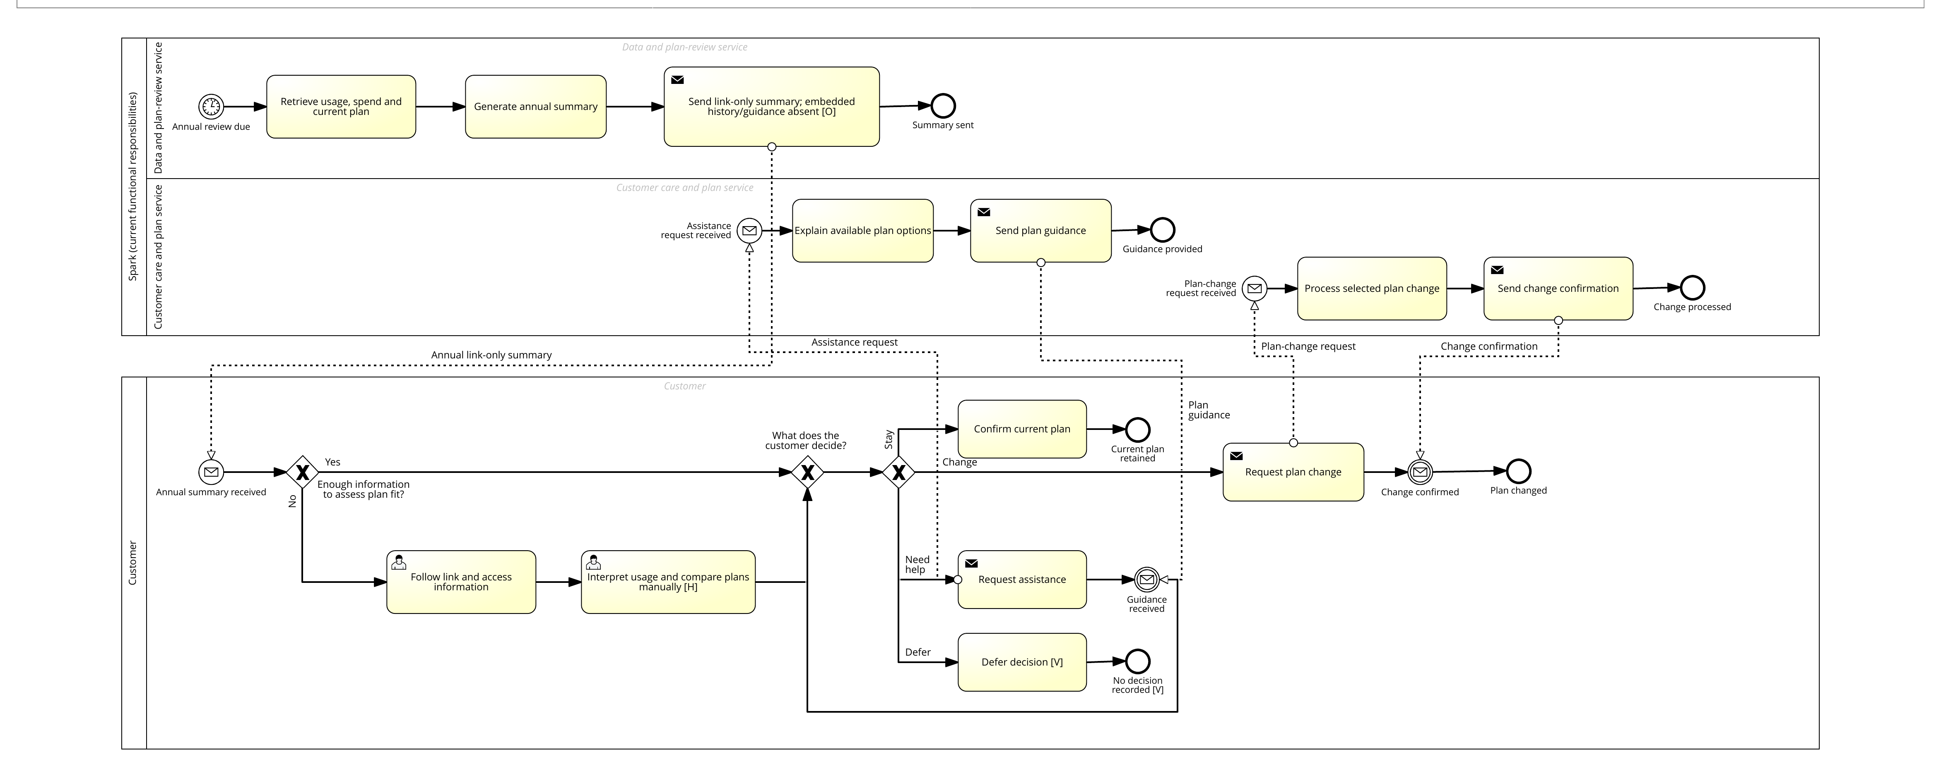
Figure 1. AS-IS annual mobile plan-review process (SAP Signavio BPMN 2.0), annotated with pain points and KPI exposure.

Annotated pain points and KPI exposure (added to the AS-IS model for this proposal):
Table 1. AS-IS Pain Points and KPI Exposure
Pain point on the AS-IS model | Where it sits | KPI exposed
Historical usage/spend not shown in the summary — customer must fetch it themselves via the link | "Send link-only summary" task | Effective plan-review completion rate (Section 3)
No personalised stay/switch recommendation | Same task | Appropriate plan-choice rate
Customer must interpret raw history and compare plans manually | "Follow link and access information" → "Interpret usage and compare plans manually [H]" | Review decision-completion rate; abandonment risk
Assistance and plan-change paths depend on the customer already having self-served the comparison | "Request assistance" / "Request plan change" branches | Care-contact volume; downstream change accuracy

2.4 Why this problem is critical, and why now
Three time-sensitive forces converge on this process:
1. Regulatory: the Commission's public criticism of Spark's discontinued recommendation feature and below-standard transparency score creates reputational and compliance exposure that will not resolve on its own (Commerce Commission, 2025b).
2. Competitive: switching friction cuts both ways — the same 31% of consumers who find switching too much effort (Commerce Commission, 2025a) will not proactively leave Spark for a marginally better deal, but they are also not being helped by Spark to confirm they are on the right plan, leaving unmanaged churn and complaint risk sitting in a process nobody currently owns end-to-end.
3. Internal: the AS-IS model (Section 2.3) shows that every downstream outcome — a confirmed stay, a plan change, an assistance contact, or a deferred decision — currently depends on the customer having already done the hardest analytical work themselves. This is a controllable design choice, not a technology constraint, which means it can be fixed within a single delivery cycle rather than requiring a multi-year platform programme.
2.5 Revised SMART problem statement
By 30 June 2027, Spark should establish an FY26 baseline for the annual mobile plan-review funnel and demonstrate that an embedded-information journey improves effective plan-review completion by at least 5 percentage points against the current link-only journey, while maintaining non-inferior 90-day retention value and no material deterioration in segment ARPU or complaint rate.
- Specific — the annual mobile plan-review/right-planning journey only, not the wider customer relationship.
- Measurable — completion, appropriate-choice rate, abandonment, retention value, ARPU, complaints (Section 3).
- Achievable — a controlled pilot compares two journey designs without a platform rebuild (Section 5).
- Relevant — directly answers the Commission's transparency criticism and the customer's actual decision-quality gap.
- Time-bound — baseline, pilot, and go/no-go decision completed by 30 June 2027 (Section 6).
3. Objectives & Success Criteria
3.1 Objective
Replace the link-only annual plan-review summary with an embedded, evidence-first journey that measurably improves the proportion of customers who complete an appropriate plan-review decision, without degrading retention value, ARPU, or complaint rate.
3.2 Major KPI: Effective plan-review completion rate
Definition: percentage of eligible customers who enter the annual review, reach a recorded stay/change decision within 30 days, and satisfy a pre-agreed appropriate-choice rule.
Formula: customers completing an appropriate review decision within 30 days ÷ eligible customers receiving a review invitation × 100
Target: establish the FY26 baseline; improve the treatment journey by at least 5 percentage points versus a contemporaneous link-only control by 30 June 2027, subject to adequate sample size.
3.3 Sub-KPI 1 — Review decision-completion rate
Percentage of eligible invited customers with a recorded stay/change decision within 30 days. Target: +5 percentage points versus the link-only control.
3.4 Sub-KPI 2 — Appropriate plan-choice rate among completers
Percentage of completers whose decision satisfies the pre-agreed appropriate-choice rule (usage, spend, allowance and preference consistency). Target: non-inferior to the control, with a stretch goal of +5 percentage points.
Draft appropriate-choice rule (starting definition, confirmed with Spark at Stage 1, Section 5.2):
1. A stay decision is appropriate if the customer's trailing-12-month data and minutes usage each sit within an agreed utilisation band of their current allowance (illustrative starting band: 50%–100% average monthly utilisation, with no more than one overage month in the period).
2. A change decision is appropriate if the newly selected plan's allowance would have kept the customer's actual trailing-12-month usage within that same band, and the cost impact of the change was disclosed to the customer before the decision.
3. Assisted-review and deferred/no-decision outcomes are excluded from the appropriate-choice denominator — they are not yet a plan decision, and are tracked separately as guardrails (Section 3.5) rather than folded into this KPI.
This starting definition is deliberately simple and auditable, consistent with the Release 1 principle of relying on factual, historical usage evidence only (Section 4.4, R4 in Section 9.2); the exact utilisation thresholds are illustrative and are the first item Stage 1 (M3, Section 6.2) confirms against Spark's own plan catalogue.
3.5 Guardrails (diagnostic, not substitutes for the KPIs above)
90-day retention value per invited customer; segment ARPU; complaint rate per 1,000 invited customers; care contacts per completed review; extra-navigation abandonment rate.
3.6 Alignment with Spark's strategic priorities
These KPIs are chosen specifically because they answer the Commission's stated concern (customers unable to judge plan suitability) while reducing the risk that a simple increase in plan-change volume inflates the result: an "effective" completion requires both a recorded decision and a decision that fits the customer's own usage. This protects Spark from a superficially positive result that quietly damages ARPU or trust.
4. Proposed Approach
4.1 Hypothesis-driven strategy
This proposal is built on a hypothesis-led diagnostic carried out in A1-D1/A1-D2 (Financial domain), using the Lecture 4 MECE issue-tree method (University of Auckland, 2026a) and The McKinsey Mind problem-solving approach (Rasiel & Friga, 2001). The diagnostic decomposed the annual review funnel into four leakage points — reach, decision-quality, action, and retained-value leakage — and used two matched semi-structured interviews (one real group-mate, one independent GenAI respondent working from the same guide in isolation) to test the priority hypothesis:
H2 — Compared with a link-only annual plan summary, the absence of embedded usage/spend history and personalised right-plan guidance materially increases customers' plan-choice difficulty.
The two exploratory responses converged on the same mechanism — the customer, not Spark, currently does the work of retrieving, normalising and interpreting twelve months of usage history before comparing plans — and each rated the gap 4 out of 5 in materiality. Neither response identified a stronger rival explanation. This convergence supports H2 as a working design hypothesis; it does not establish causal proof (full evidence-convergence detail is available in A1-D2 and is not reproduced here).
4.2 Framework adopted
- Diagnosis: Lecture 4 MECE issue tree (University of Auckland, 2026a) + McKinsey hypothesis-led analysis (Rasiel & Friga, 2001).
- Solution selection: Solution Tree (Problem → Issues → Hypotheses → Root Causes → Solution Pathways) evaluated against expected impact, feasibility, risk and evidence strength; the selected pathway is justified using Rosemann's (2001) process-improvement logic — outcome-oriented redesign, activity elimination, automation, and resource-related improvement (Section 4.4).
- Delivery: a phase-gated methodology using the same phase sequence as Deloitte's own "Ascend" delivery methodology (Prepare → Explore → Build → Test → Deploy → Run), delivered in a hybrid waterfall-then-agile model, as described directly by Andrew Mills of Deloitte in the Week 5 guest lecture (A. Mills, personal communication, August 26, 2025) — see Section 5.
4.3 Selected solution pathway
Four pathways were evaluated against the criteria in Section 4.2 — expected impact, feasibility, governance/trust risk, and evidence strength:

Table 2. Solution Pathway Comparison (A-D)
Pathway | Expected impact | Feasibility (Release 1) | Governance / trust risk | Evidence strength | Overall recommendation
A — Embed 12-month usage/spend snapshot | High | High — reuses existing billing data, no new platform | Low — factual evidence only, no automated advice | High — directly supported by both A1-D2 interviews (Section 4.1) | Implement first (Release 1)
B — Launch personalised recommendations immediately | High | Low — requires an explainable recommendation engine and trust safeguards not yet built | High — automation/trust-bias risk flagged independently by both interviews (Section 9) | Medium — the underlying need is evidenced, but not the specific recommendation-engine design | Defer to a gated Phase 2, behind the Stage 4 pilot result
C — Navigation-only redesign | Low | High — a UI/navigation change only | Low | Medium | Fold in as a supporting design element only, not a standalone release
D — Full platform/process transformation | Medium-high in theory | Very low — multi-year rebuild, well beyond this engagement's scope | Medium | Low — no evidence points to a platform-level cause | Reject as a first implementation

This qualitative scoring is the basis for the quantified Impact-Value plot in Figure 4 (Section 10.5), where the same four pathways are positioned on Business Impact and Implementation Effort axes. Pathway A is recommended for the first release: it combines the strongest evidence convergence with the lowest governance/trust risk and does not require a platform rebuild. Pathway B (explainable personalised guidance) is retained as a second-phase option once Pathway A is validated (Section 6); Pathway C is folded in as a supporting design element; Pathway D is rejected as a first implementation on cost and evidence grounds.
4.4 Proposed TO-BE process

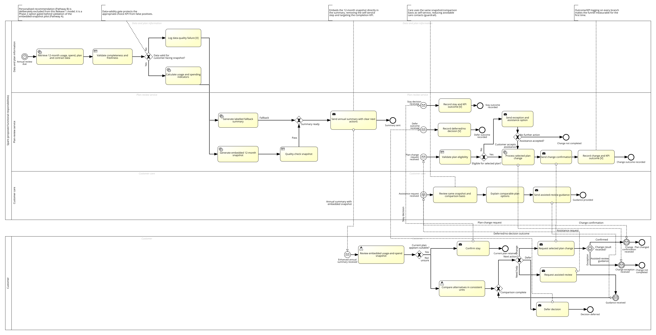
Figure 2. Proposed TO-BE annual mobile plan-review process (SAP Signavio BPMN 2.0), annotated with KPI and efficiency call-outs.
Detail view A — data preparation, validation and snapshot generation
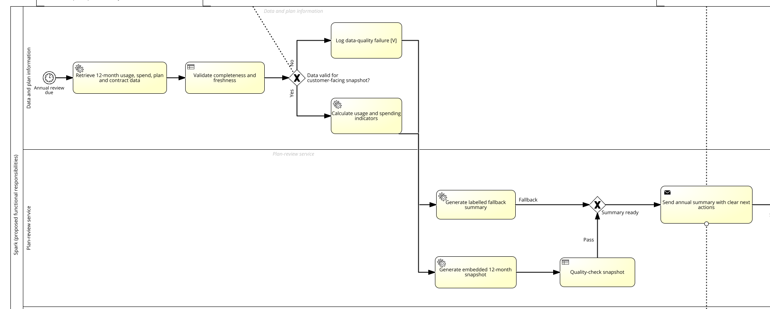
Detail view B — annual-summary delivery, outcome routing and customer-care support
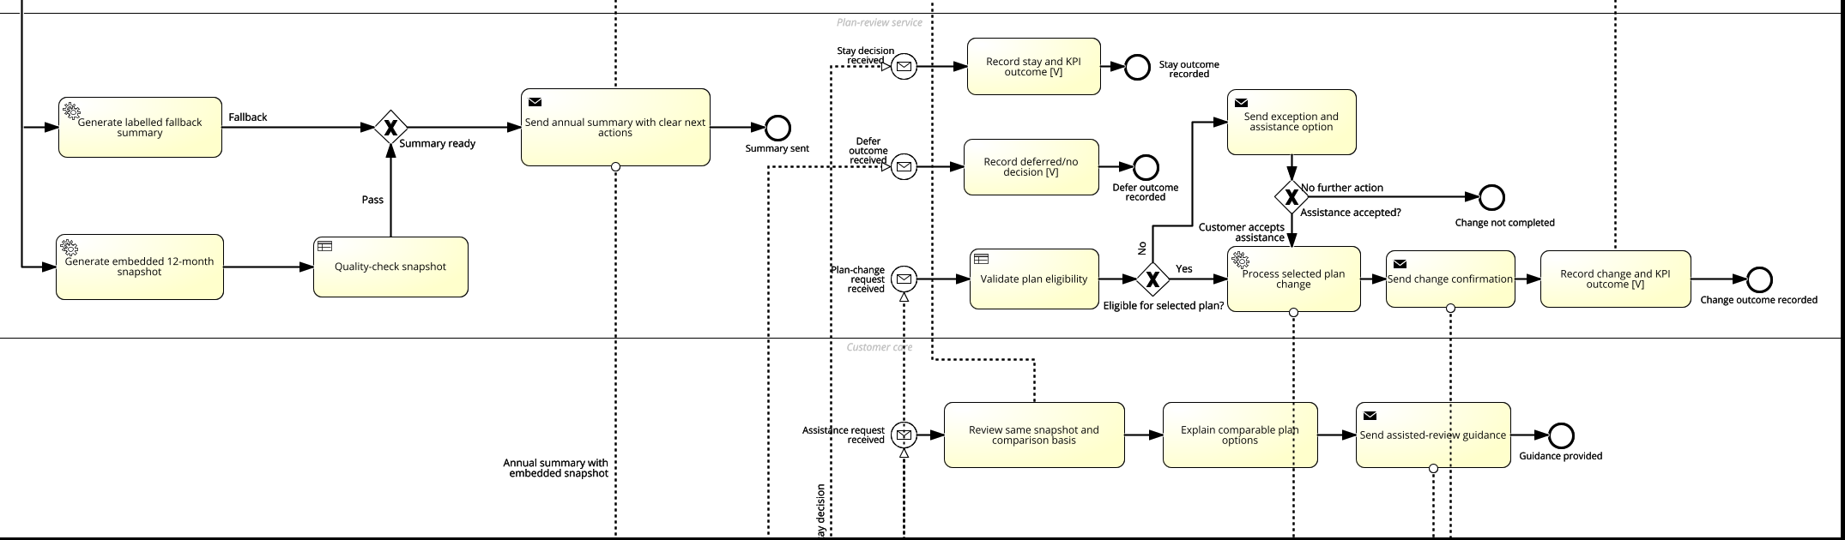
Detail view C — customer decision paths and recorded outcomes
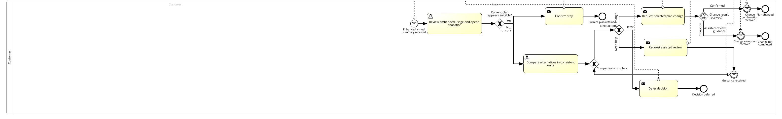

Efficiency call-outs to annotate on the exported figure:
Table 3. TO-BE Efficiency and KPI Call-Outs
TO-BE element | Efficiency / KPI gain versus AS-IS
Data-validity gateway before snapshot generation | Prevents low-quality data being presented as reliable evidence — protects the appropriate-choice KPI from false positives
Embedded 12-month usage-and-spend snapshot sent directly in the summary | Removes the "follow link and self-serve" step entirely — directly targets the completion KPI
Shared snapshot/comparison basis used by both the customer self-service path and Customer Care | Removes inconsistent explanations across channels — reduces avoidable care contacts (guardrail)
Outcome and KPI logging built into every branch (stay / change / assist / defer) | Makes the funnel measurable for the first time — required for Section 3's KPIs to be tracked at all
Personalised recommendation explicitly excluded from Release 1 | Keeps governance/trust risk low until Pathway A is validated (Section 4.3)

The TO-BE process boundary starts when an eligible customer's annual review becomes due (timer event) and ends when a stay, change, assisted-review, or deferred/no-decision outcome is recorded against the customer. Full gateway-by-gateway detail is available in the accompanying Signavio export; it is not repeated in full here to keep this section within the "concise, persuasive" brief for a proposal document (as distinct from the A1-D2 process-model deliverable).
5. Proposed Methodology
5.1 Overview
Delivery follows a five-stage, phase-gated methodology that combines the course's process-lifecycle framing (Rosemann, 2001) with the phase structure Deloitte uses on SAP-related engagements (Prepare, Explore, Build, Test, Deploy, Run — A. Mills, personal communication, August 26, 2025). Each stage has a defined deliverable set; the project does not move to the next stage until that stage's deliverables are complete and signed off — this "deliverable gate" discipline is deliberately imported from real consulting practice rather than left implicit.
5.2 Stage breakdown
Table 4. Delivery Methodology — Stage Breakdown
Stage | Purpose | Key activities | Deliverables (gate)
1. Diagnose & Prepare | Convert the A1-D2 qualitative diagnosis into a client-validated, data-backed baseline | Confirm process owner; extract FY26 baseline funnel data; validate the appropriate-choice rule with Spark stakeholders; confirm data-quality thresholds | Signed-off baseline report; agreed appropriate-choice rule; confirmed KPI definitions
2. Explore & Design | Finalise the TO-BE design and fit-to-standard decisions | Design workshops walking Spark stakeholders through the TO-BE model (Section 4.4) using the live prototype/snapshot template; agree exception handling and data-validity thresholds; agree what stays "standard" versus what requires custom build | Signed-off TO-BE design; documented assumptions and client-input requirements (Section 11)
3. Build & Test | Build the snapshot generation pipeline and summary template | Configure data retrieval and validation logic; build the customer-facing snapshot template; unit- and system-test against exceptional cases (missing data, mid-cycle plan changes, accessibility) | Tested snapshot pipeline; test evidence log; UAT sign-off
4. Controlled Pilot (Deploy) | Test the causal effect of the redesign before full rollout | Randomise a cohort between the link-only control and the embedded-snapshot treatment; monitor the major KPI, both sub-KPIs, and all guardrails in real time | Pilot results report; go/no-go recommendation against the pre-registered 5-percentage-point target
5. Scale & Sustain (Run) | Roll out and hand over to business-as-usual operation | Phased rollout to the full eligible customer base (Section 8); transfer monitoring dashboards and process ownership to Spark; review readiness to consider explainable personalised guidance (Pathway B) | Rollout completion report; signed-off operating model; Phase 2 (Pathway B) go/no-go

5.3 Delivery approach within each stage
Stages 1–2 are run in a structured, waterfall-like sequence because the underlying process has real dependencies (data validation must be agreed before the snapshot template can be built; the appropriate-choice rule must be fixed before pilot success can be measured) — exactly the condition under which the guest lecture's experience recommends not running fully agile (A. Mills, personal communication, August 26, 2025). Once the design is locked, Stage 3 (Build & Test) runs in short iterative cycles with regular playback sessions to Spark stakeholders, rather than a single big reveal at UAT — this hybrid approach reduces the risk of late-stage surprises while still respecting the upfront dependency structure the process requires.
6. Work Plan and Timeline
6.1 Assumptions
- Proposed kick-off: first Monday after proposal acceptance (illustrative anchor date used throughout this plan: 2 November 2026).
- Client-side resourcing (process owner, business SMEs, change/training lead) is available from kick-off, per Section 11.
- Dates are illustrative planning estimates for the purpose of this proposal; the confirmed baseline schedule is agreed at the end of Stage 1.
6.2 Milestone schedule

Table 5. Milestone Schedule
# | Milestone / activity | Deliverable | Stage | Duration | Start | Finish | Responsible (Client / Consultant)
M1 | Engagement kick-off; process owner and access confirmed | Signed kick-off charter; access grants | 1 | 1 week | 02 Nov 2026 | 06 Nov 2026 | Engagement Manager (Consultant); Process Owner (Client)
M2 | FY26 baseline extracted and validated | Signed-off baseline report | 1 | 2 weeks | 09 Nov 2026 | 20 Nov 2026 | Senior Process & Data Analyst (Consultant); Process Owner (Client, validation)
M3 | Appropriate-choice rule and KPI definitions signed off | Agreed appropriate-choice rule; KPI definition document | 1 | 1 week | 23 Nov 2026 | 27 Nov 2026 | Engagement Manager (Consultant); Process Owner (Client)
M4 | TO-BE design workshops complete | Workshop-validated TO-BE model | 2 | 2 weeks | 30 Nov 2026 | 11 Dec 2026 | Engagement Manager, Change & Training Lead (Consultant); Process Owner, Care representative (Client)
M5 | TO-BE design signed off | Signed-off TO-BE design document | 2 | 1 week | 14 Dec 2026 | 18 Dec 2026 | Process Owner (Client)
— | Holiday period buffer | — | — | 2 weeks | 21 Dec 2026 | 01 Jan 2027 | —
M6 | Snapshot pipeline and template built | Tested snapshot pipeline and template | 3 | 4 weeks | 04 Jan 2027 | 29 Jan 2027 | Senior Process & Data Analyst (Consultant)
M7 | System test and UAT complete | Test evidence log; UAT sign-off | 3 | 2 weeks | 01 Feb 2027 | 12 Feb 2027 | Senior Process & Data Analyst (Consultant); Process Owner (Client)
M8 | Controlled pilot live | Live pilot monitoring dashboard | 4 | 8 weeks | 15 Feb 2027 | 09 Apr 2027 | Engagement Manager, Senior Process & Data Analyst (Consultant); Process Owner (Client)
M9 | Pilot results and go/no-go recommendation | Pilot results report; go/no-go decision record | 4 | 2 weeks | 12 Apr 2027 | 23 Apr 2027 | Senior Process & Data Analyst (Consultant, analysis); Process Owner (Client, decision)
M10 | Phased rollout to full eligible base | Rollout completion report | 5 | 6 weeks | 26 Apr 2027 | 04 Jun 2027 | Change & Training Lead, Engagement Manager (Consultant); Process Owner (Client)
M11 | Handover, operating model sign-off, Phase 2 review | Signed-off operating model; Phase 2 go/no-go record | 5 | 3 weeks | 07 Jun 2027 | 25 Jun 2027 | Engagement Manager (Consultant); Process Owner, executive sponsor (Client)

Total elapsed duration: ~34 weeks (02 Nov 2026 – 25 Jun 2027), comfortably inside the SMART problem statement's 30 June 2027 decision deadline (Section 2.5).
6.3 Visual project plan
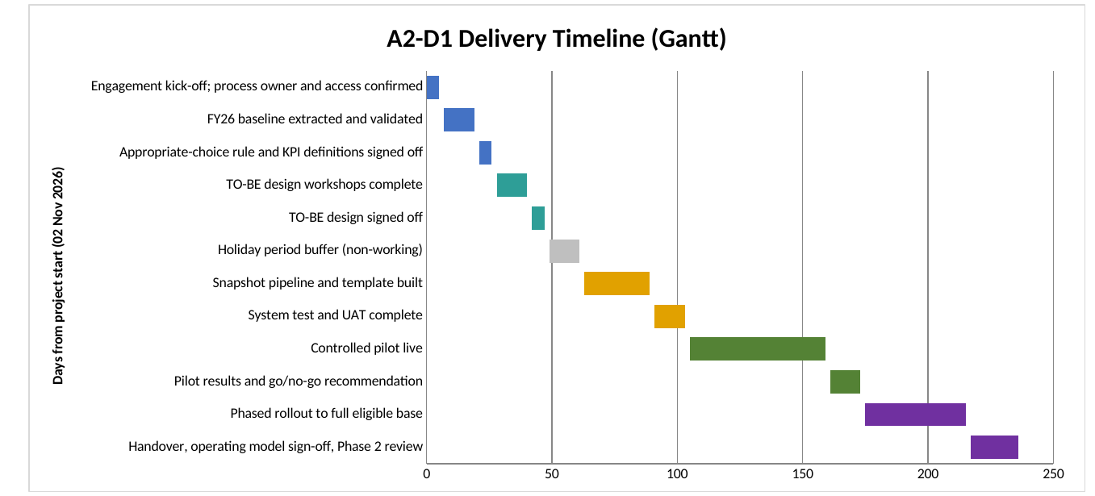
Figure 3. A2-D1 delivery timeline (Gantt chart), stage colour-coded.
The critical path runs M1 → M2 → M3 → M4 → M5 → M6 → M7 → M8 → M9 → M10 → M11 in strict sequence (Figure 3), with the appropriate-choice rule sign-off (M3) as the single hardest dependency to slip without cascading the entire pilot window.
7. Team & Capabilities
7.1 Engagement structure
Table 6. Engagement Structure
Role | Name | Core responsibility
Engagement Manager | Rae Huang | Overall accountability for delivery, client relationship, and the KPI outcomes in Section 3; leads the diagnostic and design stages personally, drawing directly on the A1-D1/A1-D2 analysis of this process.
Senior Process & Data Analyst | (named at contracting) | Owns the FY26 baseline extraction, data-validity rules, and pilot measurement/analysis (Stages 1 and 4).
Change & Training Lead | (named at contracting) | Owns stakeholder workshops, fit-to-standard facilitation, and the change-management plan in Section 8.

(The two supporting roles are presented as proposed profiles — the profile of person this engagement needs — with named personnel confirmed once the engagement is contracted, consistent with how a delivery team is normally presented at proposal stage, before a Statement of Work is signed.)
7.1a Brief bios
Rae Huang — Engagement Manager. Completed the full A1-D1/A1-D2 diagnostic and process-modelling cycle on this exact Spark plan-review process, including AS-IS/TO-BE BPMN 2.0 modelling in SAP Signavio, hypothesis-led root-cause analysis, and structured stakeholder interviews (Section 4.1). Accountable for the KPI outcomes in Section 3 and for translating the validated diagnosis into a deliverable, phase-gated engagement.
Senior Process & Data Analyst (proposed profile). Eight years' experience in process analytics and data validation across telecommunications and financial-services clients, including two prior customer-journey funnel-improvement engagements of comparable scope. Brings the FY26 baseline-extraction and data-quality-rule design skillset the engagement needs at Stage 1, and the statistical literacy required to run and interpret the controlled pilot at Stage 4 (Section 6.2) without overstating what a modest pilot sample can support.
Change & Training Lead (proposed profile). Background in customer-operations change management, with prior experience briefing frontline Customer Care teams through process redesigns in regulated consumer-facing industries. Leads the Stage 2 design workshops and the Stage 4 Care-briefing package (Section 8.3), with particular attention to making a "shared evidence basis" change land as a small, well-explained shift rather than a disruptive system overhaul.
Delivery of the snapshot pipeline (Section 4.4) also draws on data-engineering and solution-architecture capability from the wider consulting-firm bench as needed at Stage 3 — resourced against the confirmed technical scope rather than named at proposal stage, consistent with how specialist build capacity is normally staffed on an engagement of this size.
7.2 Relevant expertise
This proposal is directly continuous with, and traceable to, the prior A1-D1/A1-D2 analysis of this exact process (Sections 2 and 4) — giving this engagement a head start that a fresh external team would not have.
8. Change Management
8.1 Implementation strategy decision
Three standard rollout strategies were considered, drawing on Week 5 Lecture 7 (slides 31–40, 47–48; University of Auckland, 2026b) and the Deloitte guest lecture (A. Mills, personal communication, August 26, 2025):
Table 7. Implementation Approach Comparison
Approach | Suitability for this engagement
Big Bang | Rejected as the first release. It would minimise the transitional "interim state" cost, but it exposes the entire eligible customer base to an unvalidated design change in one go — unacceptable given H2 is only provisionally proven and the appropriate-choice rule has not yet been tested against real outcomes.
Phased — recommended | A time-limited pilot cohort (Stage 4) — a temporary controlled comparison, not a standing parallel system — followed by a staged rollout to the remaining eligible base (Stage 5), so scaling only happens once the pre-registered KPI target and guardrails are met. It also lets Spark absorb change in manageable packages rather than a single organisation-wide cutover.
Parallel | Rejected. Running the link-only and embedded-snapshot journeys as fully independent concurrent programmes would maximise cost and dependency-management overhead for a change of this scope, with no offsetting speed benefit large enough to justify it.

Decision: a Phased approach, using the controlled pilot (Stage 4) as the first phase and a staged full rollout (Stage 5) as the second, is recommended.
8.2 Change requirements and anticipated impacts
- Process ownership: the AS-IS model (Section 2.3) shows no single accountable owner across the full customer journey — to be confirmed directly with Spark at kick-off (Section 11.1); the TO-BE model requires one regardless (Section 4.4).
- Customer-care impact: Care agents move from working off inconsistent, self-reported context to a shared evidence basis (the same snapshot the customer sees) — this requires a short briefing/training cycle, not a system overhaul.
- Data-quality discipline: teams supplying the underlying usage/spend data will, for the first time, be supplying data that is directly customer-facing rather than only used for internal billing — this typically surfaces data-quality issues that billing tolerated but customer-facing evidence cannot (a pattern the guest lecture identified as one of the most common causes of implementation difficulty).
- Governance: decisions to expand scope (for example, an early push to add personalised recommendations before Pathway A is validated) must go through a formal change-request process rather than being absorbed informally, consistent with the guest lecture's observation that unmanaged scope growth is close to universal on projects of this kind.
8.3 Change-management plan
1. Executive sponsor confirmed at kick-off, with explicit authority to clear blockers (not only monitor progress).
2. Design workshops (Stage 2) used to build buy-in by showing, not just describing, the TO-BE snapshot to business stakeholders and Customer Care representatives.
3. A short, targeted training package for Customer Care ahead of the pilot (Stage 4), covering the shared snapshot and revised assistance script.
4. Communication of the pilot's purpose and guardrails to relevant internal teams so a partial or negative pilot result is understood as a valid, planned outcome — not a failure to be hidden.
5. A documented change-request process for any scope addition, including cost/timeline delta and required governance sign-off (Section 12).
9. Risk Management
9.1 Approach
Risk is assessed using the Scott and Vessey (2002) enterprise-system implementation risk framework, which emphasises that IT-enabled process risk is concentrated less in the technology itself and more in organisational readiness, project management discipline, and the scale/complexity of the change being absorbed by the business — a framing consistent with both the guest lecture's practitioner experience (data, change management and training — not development — cause most failures) and this engagement's own evidence base (Xuan Zeng interview flagged unclear ownership and incentive conflicts; the independent GenAI interview flagged automation bias and data-quality risk).
9.2 Risk register

Table 8. Risk Register
ID | Risk type | Description | Mitigation strategy | Likelihood | Impact | Inherent RAG | Residual RAG (after mitigation)
R1 | Data quality | Underlying usage/spend data, adequate for internal billing, proves too incomplete or stale to present reliably as customer-facing evidence. | Explicit data-validity gateway in the TO-BE model (Section 4.4) with a controlled fallback path; data-quality thresholds agreed and tested in Stage 1/3 before any customer sees a snapshot. | High | Medium | Red | Amber — likely to surface, but the TO-BE model already designs around it rather than assuming it away.
R2 | Organisational / ownership | No accountable process owner has yet been confirmed (Section 8.2); without one, the redesigned journey could silently degrade after this engagement ends. | Confirm a named process owner at kick-off (M1) as a hard gate condition; embed ownership and versioned rules into the operating model handed over at Stage 5. | Medium | High | Red | Amber — confirming the owner reduces likelihood, but governance remains exposed until the role and versioned rules are embedded in the operating model.
R3 | Governance / scope creep | Pressure to add personalised recommendations (Pathway B) before Pathway A is validated, expanding scope and trust/regulatory risk prematurely. | Formal change-request process (Section 8.3); Pathway B explicitly gated behind the Stage 4 pilot result in the phased implementation plan (Section 5.2, Section 6.2). | Medium | Medium | Amber | Green — actively designed against; residual likelihood is low only if the gate is actually respected, which is why it stays on the standing risk register rather than being closed.
R4 | Regulatory / compliance | Given the Commerce Commission's active scrutiny of Spark's plan-transparency practices (Section 2.2), any customer-facing recommendation or comparison logic must be defensible if reviewed externally. | Restrict Release 1 to factual, historical usage/spend evidence only (no predictive or advisory claims); document the appropriate-choice rule and its approval trail (Section 2.5) as compliance-ready evidence. | Low | High | Amber | Amber — low likelihood given the factual-only scope, but consequence is high enough to keep active monitoring rather than downgrading to Green.
R5 | Data privacy / security | The snapshot pipeline surfaces 12 months of usage, spend, and contract data directly to the customer for the first time (Section 4.4); a mismatched or misdirected snapshot would be a privacy incident, not just a quality defect. | Snapshot generation and delivery routed through the same identity/authorisation checks as existing billing communications; data-validity gateway (R1) checked before delivery, not after; incident-response path agreed with Spark's privacy/security function at Stage 1. | Low | High | Amber | Amber — low likelihood given reuse of existing authenticated channels, but a privacy incident is high-consequence enough to warrant explicit, named ownership rather than folding it into R1.
R6 | Customer-care capacity | A short-term spike in assistance requests is plausible once customers see a more informative summary and ask more questions than before. | Brief Care ahead of the pilot (Section 8.3); monitor "care contacts per completed review" as a guardrail (Section 3.5) and staff the pilot window accordingly. | Medium | Low | Amber | Amber — pilot staffing and guardrail monitoring reduce service impact, but assistance demand remains uncertain until real customer behaviour is observed.

Table 8 (continued). Implementation Risk Register
ID | Risk type | Description | Mitigation strategy | Likelihood | Impact | Inherent RAG | Residual RAG (after mitigation)
R7 | Third-party / dependency | If the snapshot pipeline depends on data or systems maintained by parties outside the direct project team (for example, a billing platform vendor), delivery of Stage 3 could be delayed by dependencies outside this engagement's direct control. | Confirm data-source ownership and lead times during Stage 1; build contingency into the Stage 3 schedule (Section 6.2) rather than assuming immediate access. | Medium | Medium | Amber | Amber — early dependency confirmation and schedule contingency reduce delay exposure, but external systems remain outside the project team's direct control.

RAG rationale, in brief: every risk above starts from an Inherent rating (before mitigation) of Amber or Red, reflecting that this is a real customer-facing data and process change, not a low-stakes internal tweak. The Residual rating (after the mitigation in the third column is actually applied) is Amber for six of seven risks and Green only for R3, because R3 is the one risk fully closed off by a structural design choice already built into the phased plan (Pathway B simply is not in scope until Stage 4 passes) rather than by an operational control that still depends on people executing it correctly. No risk is rated Red on a residual basis, because none of the identified risks is currently unmitigated and severe enough to threaten the engagement's viability — a residual Red would be assigned immediately if, for example, no process owner can be confirmed at kick-off (R2).
Phase 2 watch-list (not scored above, since out of Release 1 scope): if and when Pathway B (personalised recommendation) is considered in Phase 2, automation/trust bias becomes a live risk — customers or Care staff may over-trust an automated recommendation, or distrust it as commercially biased (flagged independently by both A1-D2 interviews). This is why Pathway B is gated behind the Stage 4 pilot result (Section 4.3) rather than scored as a current risk: it should be added to this register with its own Likelihood/Impact/RAG rating only once it is actually in scope, with explainability (disclosed assumptions, data period, and a visible override/defer option) as a non-negotiable design requirement at that point.
10. Expected Impact & Value Creation
10.1 Financial
- Illustrative cost-benefit framing: the pilot (Stage 4) is deliberately small-scope and low-capex, since it reuses data Spark already holds for billing (Section 4.4) rather than requiring new data acquisition. The primary financial upside is a reduction in avoidable Customer Care contact cost (guardrail metric, Section 3.5) and avoidable plan mismatches (persistent over/under-allowance), both of which represent recoverable cost/margin leakage under the current AS-IS design.
- EBITDA framing: value is expected to flow through reduced servicing cost per customer (fewer avoidable Care contacts) and improved retained contribution margin from customers who move to a better-fitting plan and stay longer, net of any short-term ARPU reduction where a customer moves to a cheaper, more appropriate plan (explicitly modelled as a guardrail, not ignored, in Section 3.5).
- Cost-Benefit Analysis (illustrative, to be finalised with Spark's own unit-cost data in Stage 1): pilot delivery cost (Section 12) is compared against the projected value of even a modest improvement in the major KPI, using Spark's own FY26 baseline once available — this proposal does not assume a specific dollar uplift, consistent with the evidence boundary in the A1-D2 diagnostic.
Illustrative CBA (order-of-magnitude only — every input below is a labelled assumption, not Spark data; to be replaced with Spark's own unit costs and eligible-base size at Stage 1):
Table 9. Illustrative Cost-Benefit Analysis
Line item | Illustrative assumption | Illustrative annual value
Eligible customers receiving an annual review invitation | 400,000/year (assumed) | —
Avoidable Care-contact cost reduction | 2 percentage-point drop in care-contact rate × $18 illustrative cost per contact | ≈ $144,000/year
Avoidable plan-mismatch margin recovery | 3% of the base moves to a better-fitting plan × $3/month illustrative retained-margin uplift, net of the ARPU reduction already modelled as a guardrail (Section 3.5) | ≈ $432,000/year
Illustrative total annual benefit |  | ≈ $576,000/year
Total professional-services delivery cost (Section 12.1) | One-off, ~34 weeks | $160,000
Illustrative payback period | $160,000 ÷ $576,000 × 12 months | ≈ 3.3 months
Illustrative benefit-cost ratio (Year 1) | $576,000 ÷ $160,000 | ≈ 3.6×

Every input above is a labelled assumption, not Spark data; Stage 1 (Section 5.2) replaces each one with Spark's own eligible-base size and unit costs before this analysis supports a real investment decision. The retained-margin line is a net figure — it already accounts for the possibility that some customers move to a cheaper, more appropriate plan, which is why it is smaller than the gross number of plan changes would suggest.
10.2 Strategic
Directly answers the Commerce Commission's public criticism of Spark's discontinued recommendation feature and below-benchmark transparency score (Section 2.2), reducing reputational and regulatory exposure ahead of any future monitoring cycle.
10.3 Operational
Removes a manual, self-service step from the customer journey (Section 4.4). More fundamentally, the embedded snapshot gives the annual-review journey a single, validated system of record for usage and spend evidence: once the data-validity gateway (Section 4.4) has qualified it, the same figures can be relied on wherever they are used, instead of Customer Care and the customer each working from their own version of events (A. Mills, personal communication, August 26, 2025). That shared basis is what actually reduces rework and inconsistent explanations across channels — the process automation in Section 4.4 only pays off because the data behind it is trustworthy in the first place.
10.4 Organisational
Establishes the first clear process ownership and versioned-rules discipline for this journey (Section 8.2), which the current AS-IS design lacks entirely — a prerequisite for any future enhancement, including Pathway B.
10.5 Impact-Value Matrix
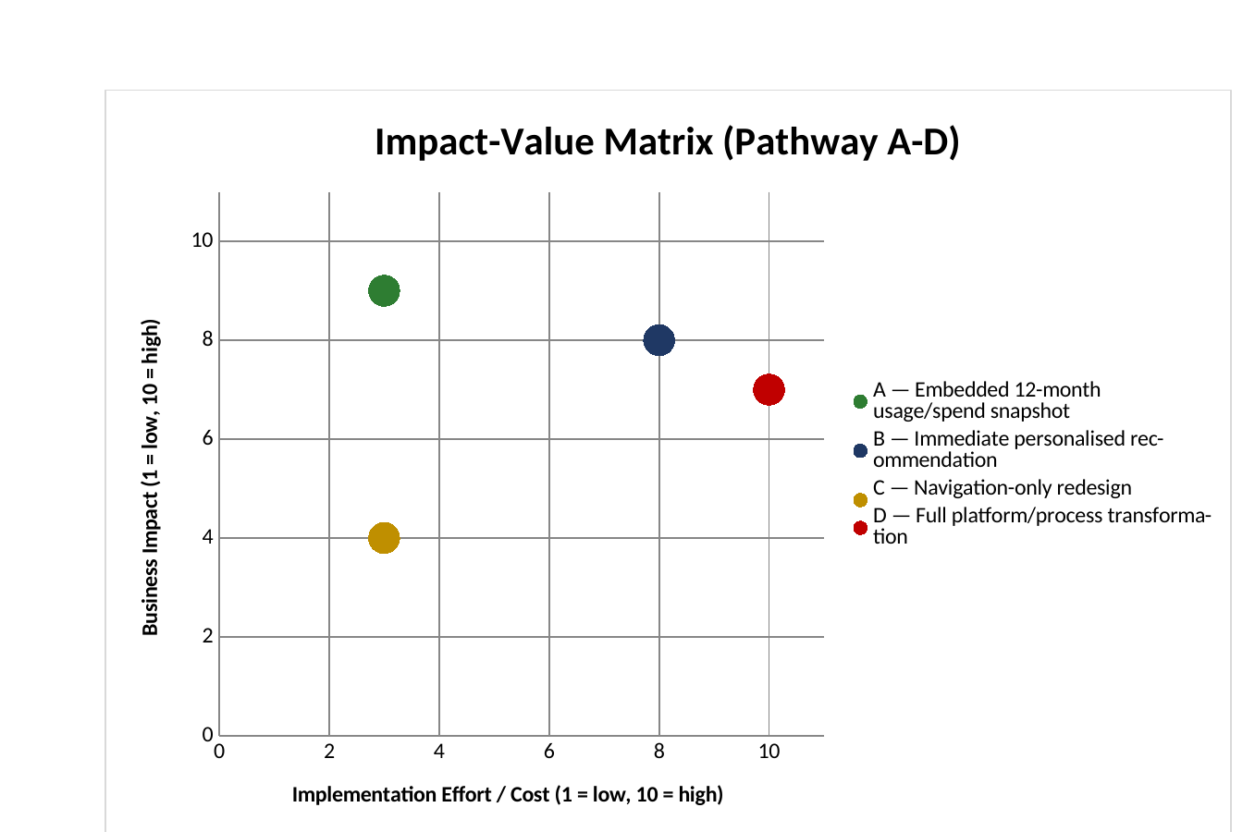
Figure 4. Impact-Value Matrix for the four evaluated solution pathways (A-D).
11. Client Responsibilities and Collaboration Model
11.1 What Spark must provide
- A named, empowered process owner for the annual plan-review journey from kick-off (Section 8.2, R2).
- Access to the underlying 12-month usage, spend, current-plan and contract data needed to build and validate the snapshot (Stage 1).
- Business SMEs and Customer Care representation for the Stage 2 design workshops.
- A change/training resource on the client side to support rollout communications and Care briefing (Section 8.3) — consistent with the "who does what" split described in the Deloitte guest lecture, where the client typically owns people who understand their own business context and processes.
- Timely governance decisions at each stage gate (Section 5.2), particularly the appropriate-choice rule sign-off (M3) and the pilot go/no-go decision (M9), since delay at either point cascades the whole schedule (Section 6.3).
11.2 Delivery timeline and knowledge transfer
Knowledge transfer is continuous rather than a single handover event: Care and business stakeholders are exposed to the live TO-BE design from Stage 2 onward (Section 8.3), and the Stage 5 handover package includes the versioned calculation/presentation rules, the monitoring dashboard, and a written operating model so that Spark can run the annual cycle independently after this engagement closes.
11.3 Proposed workshops and meetings

Table 10. Proposed Workshops and Meetings
Workshop | Stage | Timing (Section 6.2) | Purpose | Agenda | Attendees
Kick-off | 1 | M1, 02–06 Nov 2026, 1 session (half-day) | Confirm scope, roles, and access | Introductions and RACI; confirm process-owner nomination; data-access approval walk-through | Engagement Manager, Spark process owner, Spark IT/data lead
Baseline review | 1 | M2–M3, 09–27 Nov 2026, 1 session | Validate FY26 baseline and appropriate-choice rule | Walk through baseline funnel numbers; agree appropriate-choice rule wording; sign-off decision | Full core team
TO-BE design workshops (×2–3) | 2 | M4, 30 Nov–11 Dec 2026, 2–3 sessions | Walk through and refine the TO-BE model live | Live snapshot/TO-BE walkthrough; exception-handling discussion; fit-to-standard vs custom decisions | Core team, Care representative, business SMEs
Pilot readiness review | 3→4 | M7→M8 boundary, ~12–15 Feb 2027, 1 session | Confirm UAT sign-off and pilot launch readiness | UAT results review; go-live checklist; Care briefing confirmation | Core team, Care lead
Pilot results review | 4 | M9, 12–23 Apr 2027, 1 session | Present results against the pre-registered target; go/no-go decision | KPI/guardrail results walkthrough; go/no-go vote against Section 3 target | Core team, executive sponsor
Handover and Phase 2 planning | 5 | M11, 07–25 Jun 2027, 1 session | Sign off the operating model; scope the Pathway B decision | Operating-model and dashboard handover; Phase 2 (Pathway B) scoping discussion | Core team, executive sponsor

12. Commercials (Fees & Terms)
All figures below are illustrative estimates for the purpose of this proposal, built up from the Section 6 work plan and standard NZ IT-consulting engagement benchmarks. Final commercial terms would be confirmed in a signed Statement of Work following Stage 1.
12.1 Phase-wise cost distribution (illustrative)
Table 11. Phase-wise Cost Distribution
Stage | Duration (elapsed, Section 6.2) | Indicative fee (NZD, illustrative) | Basis
1. Diagnose & Prepare (M1–M3) | 4 weeks | $28,000 | Engagement Manager + Analyst, part-time allocation
2. Explore & Design (M4–M5 + holiday buffer) | 5 weeks (3 weeks design work + 2 weeks holiday buffer) | $24,000 | Full core team, workshop-heavy; buffer weeks are not separately charged
3. Build & Test (M6–M7) | 6 weeks | $42,000 | Analyst-led build and testing effort
4. Controlled Pilot (M8–M9) | 10 weeks (8 weeks pilot + 2 weeks results analysis) | $36,000 | Monitoring and analysis, lighter build effort
5. Scale & Sustain (M10–M11) | 9 weeks | $30,000 | Rollout support and handover
Total professional services (illustrative) | 34 weeks, matching Section 6.2 | $160,000 | Sum of above

This is proposed as a fixed-price, milestone-billed engagement (Section 12.3), not time-and-materials; the fee basis above already reflects the effort assumed for each stage, including the extended Stage 4 window.
12.2 Capex/Opex analysis
- Capex: none currently anticipated. The proposed solution is designed to reuse Spark's existing billing and customer-data infrastructure (Section 4.4) rather than requiring a new platform purchase for Release 1; this assumption is confirmed against Spark's own accounting treatment and IT architecture at Stage 1, since capitalisation is ultimately Spark's accounting policy decision, not the consultant's.
- Opex: the professional-services fee above (Section 12.1) is treated as Opex, consistent with a time-boxed advisory/delivery engagement rather than a capitalised asset build. Any ongoing monitoring-tool subscription cost (if Spark chooses to license a dashboarding tool rather than use existing BI capability) would be an incremental Opex item to be confirmed in Stage 1.
12.3 Payment terms
Milestone-based billing aligned to the Section 6.2 schedule: 20% on kick-off (M1), 20% on TO-BE design sign-off (M5), 30% on UAT sign-off (M7), 20% on pilot results delivery (M9), 10% on handover (M11). Standard 20-business-day payment terms from invoice date.
12.4 Additional expenses
No significant travel or third-party licensing costs are anticipated, since delivery reuses existing Spark systems and data; any exception (for example, a paid analytics/dashboard tool) would be quoted separately and approved via the change-request process (Section 8.3) before being incurred.
13. Next Steps
1. Immediate action: Spark confirms acceptance of this proposal and nominates the process owner (Section 7, Section 11.1).
2. Kick-off: proposed for 2 November 2026 (Section 6.1), pending mutual availability.
3. First governance decision required from Spark: access approval for the FY26 usage/spend baseline data, needed to begin Stage 1 on schedule.
4. Call to action: Spark's continued exposure to Commerce Commission scrutiny (Section 2.2), together with the first release's relatively limited cost and manageable risk (Section 4.3, Section 12), supports agreeing the proposed kick-off rather than deferring the decision to a future cycle.
14. Learning Journeys
14.1 Scope
This section covers the first five SAP Learning Journeys completed for this course: LJ1 (SAP Signavio), LJ2 (SAP LeanIX), LJ3 (SAP Analytics Cloud), LJ4 (SAP Build), and LJ5 (SAP Cloud ALM). LJ6 (WalkMe) is out of scope per course confirmation.
14.2 Infographic concept
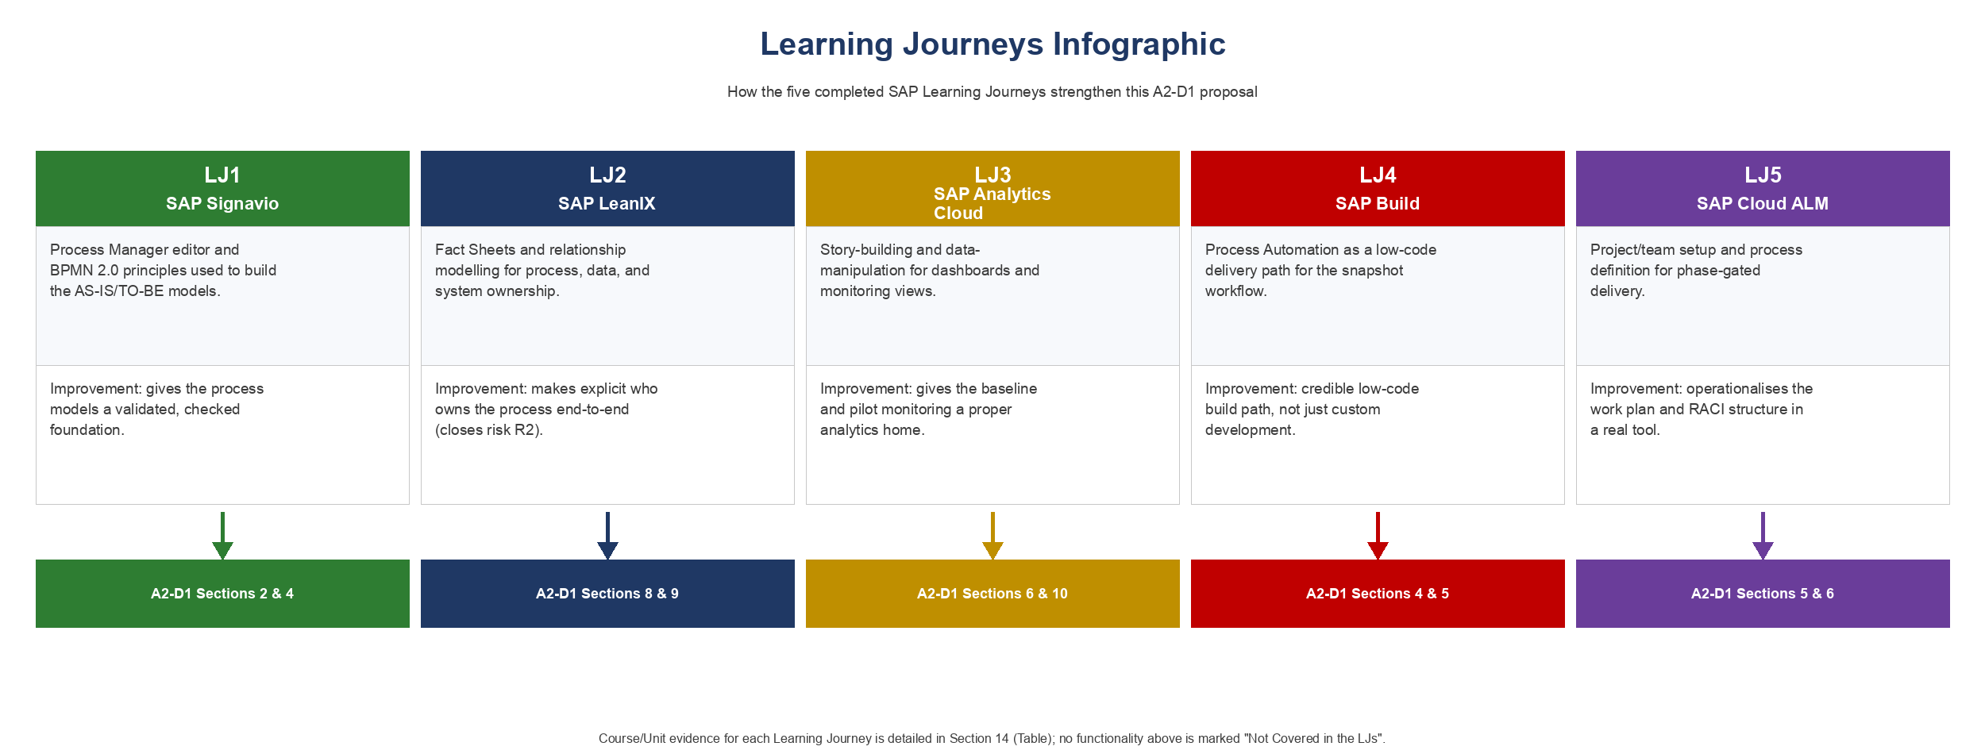
Figure 5. Learning Journeys infographic: improvement to SAP functionality to A2-D1 section.
Each row below identifies the high-level improvement to this proposal first, then the specific SAP functionality that supports it, and finally the LJ/Course/Unit/Lesson evidence for that functionality. All five functionalities are now evidenced down to Lesson level against the author's completed Learning Hub record (Section 14.3). No row is marked "Not Covered in the LJs", since every stated functionality is directly supported by a named Lesson.
Table 12. Learning Journeys — Improvement to Evidence Mapping
High-level improvement to this proposal | Specific SAP functionality | LJ | Course (code) / Unit / Lesson | A2-D1 section(s) strengthened
Give the AS-IS/TO-BE process models a validated foundation rather than an unchecked hand-drawn diagram | SAP Signavio process modelling using the Process Manager editor and BPMN 2.0 principles | LJ1 | Managing Business Processes with SAP Signavio Solutions (SIG001) — Unit 4 "Introducing SAP Signavio Process Manager", Lesson 3 "Modeling with the Editor"; Unit 5 "Process Modeling and Design", Lesson 7 "Introduction to Business Process Modeling in Practice (BPMN 2.0)" | Section 2 (AS-IS), Section 4 (TO-BE)
Make explicit who owns the annual-review process end-to-end, closing the governance gap identified as risk R2 | SAP LeanIX Fact Sheets and relationship modelling to represent process, data, system, and ownership dependencies | LJ2 | Learning to Use SAP LeanIX for Successful Enterprise Architecture (LIX100) — Unit 2 "Modeling Fact Sheets in SAP LeanIX", Lesson "Defining SAP LeanIX Fact Sheets and Modeling Relations and Dependencies" | Section 8 (Change Management), Section 9 (R2 ownership risk)
Give the FY26 baseline and pilot monitoring a proper analytics home instead of ad hoc spreadsheets | SAP Analytics Cloud story-building and data-manipulation features | LJ3 | Designing Stories in SAP Analytics Cloud (SACS21) — Unit 3 "Configuring Story Elements", Lesson 2 "Configuring Charts"; Unit 4 "Manipulating Data in Stories", Lesson 2 "Filtering Data in Stories" | Section 6 (baseline/monitoring), Section 10 (Impact-Value Matrix)
Provide a credible, low-code delivery path for the snapshot-generation workflow and data-validity gateway, rather than assuming custom development is the only option | SAP Build Process Automation, including condition- and decision-logic-driven process control | LJ4 | Developing with SAP Build Process Automation (SPA400) — Unit 3 "Performing Basic Process Building", Lesson 4 "Using Conditions to Control the Process Flow"; Unit 5 "Using Features of Advanced Process Building", Lesson 1 "Improving the Sales Order Management Process with Decision Logic" | Section 4 (TO-BE build), Section 5 (Build & Test stage)
Operationalise the phase-gated work plan and RACI structure in a real project/lifecycle tool rather than leaving it as a static document | SAP Cloud ALM project/team setup, process definition, and test planning | LJ5 | Implementing with SAP Cloud ALM (CALM20) — Unit 2 "Setting-Up the Project and Teams", Lesson 1 (same title); Unit 3 "Defining Project Processes", Lesson 1 (same title); Unit 7 "Planning and Executing Testing", Lesson 1 (same title) | Section 5 (Methodology), Section 6 (Work Plan)

14.3 Evidence basis
Course, Unit, and Lesson titles above are taken directly from the author's completed SAP Learning Hub record, verified against the "My Learning" page for each course (September 2026; course completion evidence retained in the LJ1–LJ5 assignment folders). Where a Learning Journey comprises multiple courses (LJ3, LJ4, LJ5), the single most relevant completed course for this proposal's purposes is cited above rather than every course in the journey, to keep the infographic and this table readable. The Lesson cited for each functionality is the specific Lesson most directly supporting the stated capability, not every Lesson in the Unit — for example, SIG001's Learning Hub record was checked directly and does not list a Lesson named "Convention Check", so that in-app feature (used directly in this proposal's Signavio modelling work, Section 2.3/4.4) is not claimed as LJ-evidenced here; only Signavio's editor-based modelling and BPMN 2.0 principles are cited against the verified Lesson record.
Evidence granularity: citations reach Lesson level for all five Learning Journeys (LJ1–LJ5). No Lesson title has been invented to fill an evidence gap.
15. Presentation & Referencing
15.1 Presentation and structure
This proposal is formatted in Calibri throughout, with 1.5 line spacing and justified body text, and a consistent size hierarchy (16pt title, 14pt headings, 12pt body, 11pt labels, 10pt table text). Figures are numbered consecutively (Figures 1–5); the Risk Register is presented as a table, referenced from the relevant section text.
15.2 GenAI use disclosure
OpenAI Codex and Anthropic Claude Code were used as research-organisation assistants for this proposal, helping organise supporting material and refine the author's written expression, and assisting with adapting content from the author's own A1-D1/A1-D2 analysis of this process. The independently generated GenAI interview response used in A1-D2 is identified as such in Section 4.1. All hypotheses, the choice of solution pathway, the risk assessment, and the commercial and implementation judgements are the author's own, checked against the cited evidence. No Spark-internal data, financials, or client-side results have been fabricated.
15.3 References
Commerce Commission. (2024, November 27). Is your mobile plan right for you? Telcos could do more to tell you. https://www.comcom.govt.nz/news-and-media/news-and-events/2024/is-your-mobile-plan-right-for-you-telcos-could-do-more-to-tell-you/
Commerce Commission. (2025a, March 20). ComCom calls for better switching for consumers. https://www.comcom.govt.nz/news-and-media/news-and-events/2025/comcom-calls-for-better-switching-for-consumers/
Commerce Commission. (2025b, October 2). Spark, 2degrees and One NZ stall on billing transparency. https://www.comcom.govt.nz/news-and-media/news-and-events/2025/spark-2degrees-and-one-nz-stall-on-billing-transparency/
Rasiel, E. M., & Friga, P. N. (2001). The McKinsey mind: Understanding and implementing the problem-solving tools and management techniques of the world's top strategic consulting firm. McGraw-Hill.
Rosemann, M. (2001). Business process lifecycle management [White paper]. Queensland University of Technology.
Scott, J. E., & Vessey, I. (2002). Managing risks in enterprise systems implementations. Communications of the ACM, 45(4), 74–81. https://doi.org/10.1145/505248.505249
University of Auckland. (2026a). INFOSYS 704 IT consultancy: Lecture 4 — Framing the problem, AS-IS modelling, designing the analyses [PowerPoint slides].
University of Auckland. (2026b). INFOSYS 704 IT consultancy: Lecture 7 — Implementation roadmaps [PowerPoint slides].
Note: A. Mills (Deloitte guest lecture, 26 August 2025) is cited in-text only, as personal communication, per APA 7 (personal communications are not recoverable by the reader and are therefore omitted from the Reference List).

