INFOSYS 704 — A1-D1
Spark New Zealand Operational Analysis
Residential Broadband Fault Diagnosis, Escalation and Resolution
Name: Ryan Li
UPI: ali409
Student ID: 693997238
Company: Spark New Zealand Limited
Analytical lens: Operational
Date: 10 August 2026

1. Company Overview
Spark New Zealand Limited is a New Zealand telecommunications and digital-services provider whose material assets and operations are in New Zealand. Its portfolio spans mobile, broadband, voice, cloud, IT services, procurement and partner solutions. Spark reported NZ$3.725 billion of operating revenues and other gains for the year ended 30 June 2025. At 31 December 2025 it reported 3,632 total full-time-equivalent roles, 2.591 million mobile connections and 649,000 broadband connections: 417,000 fibre, 212,000 wireless and 20,000 copper. Connections are services rather than a count of unique people, and FTE is a workforce measure rather than employee headcount. The scale matters operationally because even a modest failure or rework rate can affect many customer interactions (Spark New Zealand, 2025a, 2026a).
Spark states its purpose as ‘to help all of New Zealand win big in a digital world’ and its vision as ‘It’s better with Spark’ (Spark New Zealand, 2025a, pp. 10, 14). In the SPK-30 strategy, that vision is also presented as the company’s FY30 strategic ambition, centred on a better network and better customer experiences. Spark does not label a separate conventional mission statement in the cited corporate material. For this analysis, Spark’s purpose is treated as its mission-equivalent because it identifies whom Spark serves and the outcome it seeks to enable, without inventing a separate corporate claim. The strategy refocuses capital and management attention on core connectivity while simplifying and optimising activities beyond the core. Technology and AI, people and culture, financial discipline and Sustainable Spark are the stated enablers (Spark New Zealand, 2025a, 2025b).

2. Products, Services and Customers
Spark serves residential households, small and medium-sized enterprises, and large enterprise and government customers. Its connectivity products include mobile, fibre, copper and fixed-wireless broadband; its broader portfolio includes cloud, security, collaboration, service management and IT products (Spark New Zealand, 2025a, 2026a). The operational analysis in this report deliberately narrows from that portfolio to residential broadband after-sales service. It covers the period from a customer perceiving service degradation and initiating a Spark self-check to either stable restoration confirmed by the customer or a continuing issue that re-enters diagnosis and escalation. Billing, new installation, plan review and general mobile service are outside this process boundary.
Residential broadband is an appropriate focus because it combines a high-volume consumer service with several technologies and operating boundaries. A customer experiences one retail relationship with Spark, but the underlying path may include fibre or copper access supplied by an LFC, Spark fixed-wireless infrastructure, home-network equipment, a digital diagnostic service, frontline support and network operations. The operational requirement is therefore not simply to repair a device. It is to identify the correct domain, preserve evidence, coordinate the responsible actor and keep the customer informed across a process whose technical structure may be invisible to them.

3. Stakeholder Ecosystem
The ecosystem is not a simple retailer–customer relationship. Residential customers depend on their home devices, Wi-Fi, modem or optical network terminal, Spark’s retail channels, Spark’s network and operational teams, and—depending on the fault domain—external network and technology partners. Four local fibre companies operate in New Zealand: Chorus, Enable, Northpower and Tuatahi First Fibre. Nokia manages day-to-day monitoring and support for Spark’s network through global delivery resources and a New Zealand NOC, while Spark retains strategy, design engineering, critical-incident oversight and complex operations. Infosys, HPE and Microsoft support parts of Spark’s IT and cloud delivery model. Regulators and dispute-resolution bodies shape service-quality expectations, while employees, management and shareholders influence resources and priorities (Commerce Commission, 2026a; Spark New Zealand, 2025a).
Stakeholder interests are related but not identical. Customers value rapid restoration, understandable advice and credible updates. Frontline staff need usable context and diagnostic guidance; specialists need evidence sufficient to locate the fault domain; network and wholesale partners need correctly formed referrals; managers need cost, capacity and service-quality measures; and regulators expect transparent retail service quality. Spark remains accountable for the retail relationship even when an external party performs part of the technical work. As synthesised in Figure 1, the ecosystem analysis therefore points to end-to-end visibility and handoff quality as operating requirements, not reasons to transfer responsibility away from the customer-facing organisation.
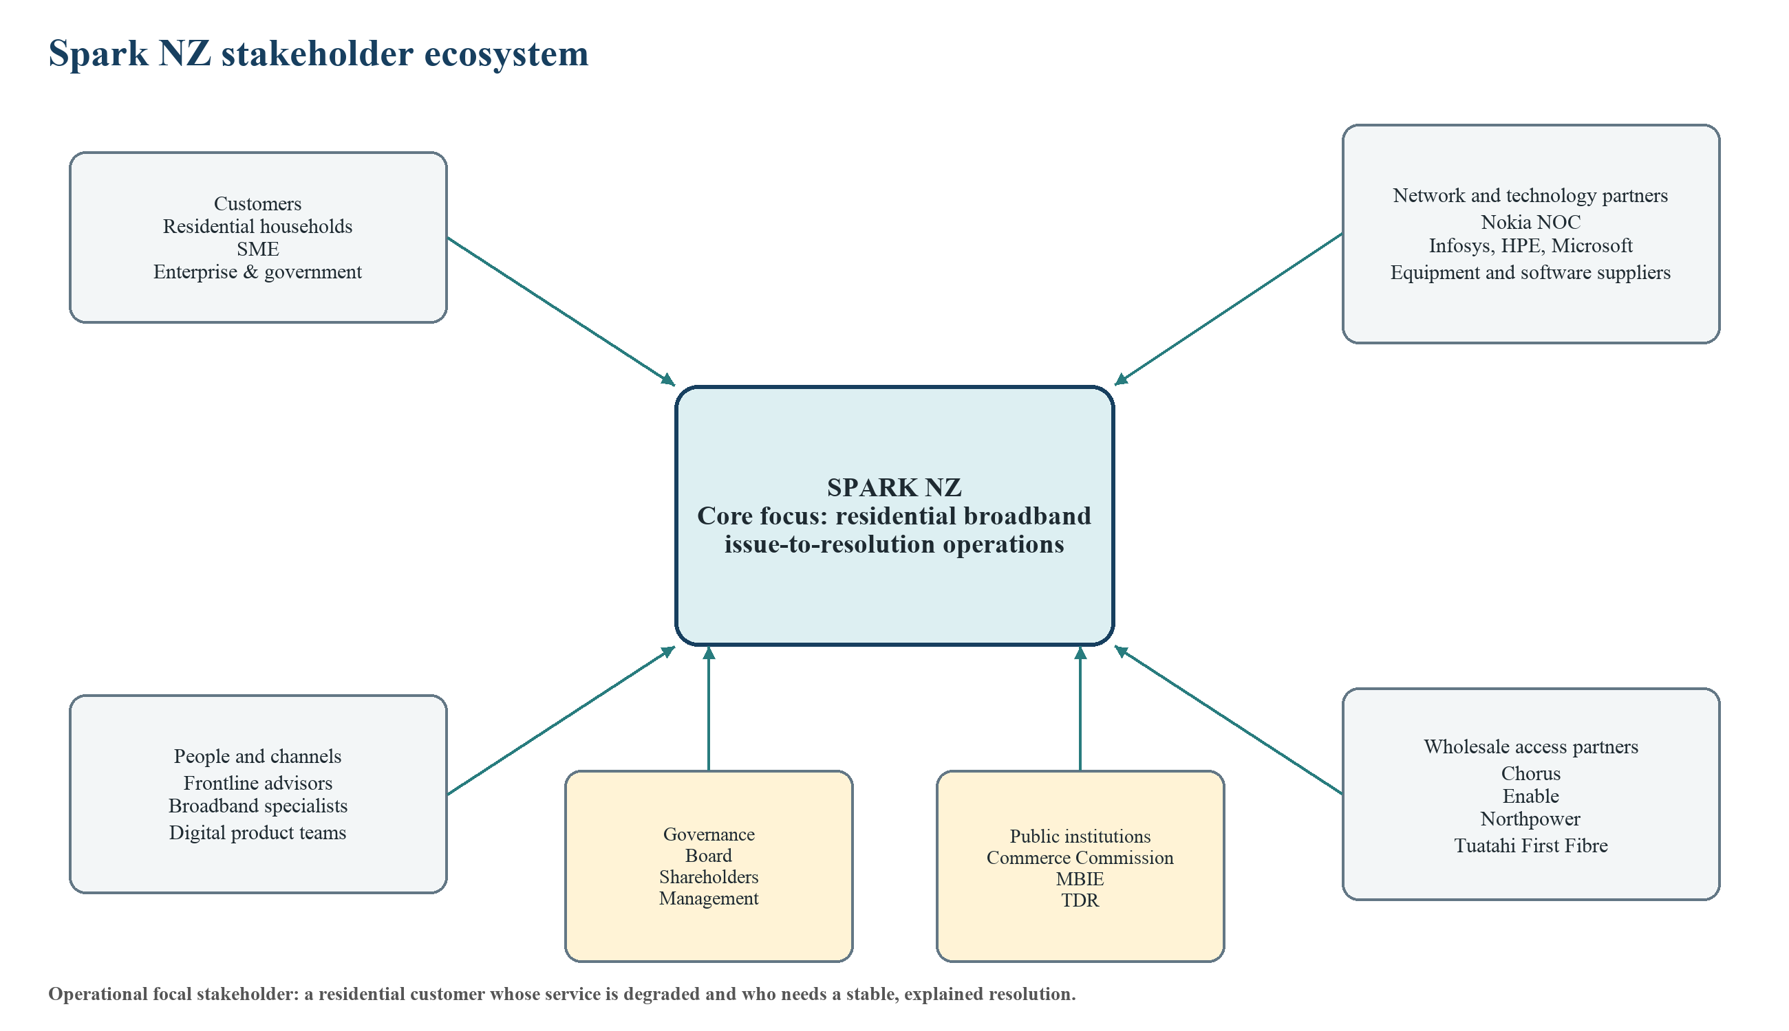
Figure 1. Spark NZ stakeholder ecosystem
Note. Author-developed synthesis of Spark and Commerce Commission disclosures. The operational focal stakeholder is the residential broadband customer.

4. Porter’s Five Forces Analysis
The Commerce Commission reports more than 100 retail service providers in New Zealand, although the market has a small number of large operators and a long tail of smaller firms. At June 2025 the national broadband market was moderately concentrated: the largest three providers held 68%, the largest five held 82%, and the HHI was 1,782. The urban residential segment was more concentrated, with CR3 of 72%, CR5 of 89% and HHI of 2,007. The Commission also notes that bundling, brand, service quality and switching friction increasingly shape retail competition. These conditions support Table 1, while Figure 2 synthesises the forces around Spark’s differentiation and retention challenge (Commerce Commission, 2026a).
Table 1. Porter’s Five Forces assessment
Force | Assessment | Operational implications
Rivalry | High | Large providers, smaller challengers, energy/TV bundles and declining concentration intensify comparison on price, performance and service quality.
Buyer power | Moderate | Households can compare and switch, but switching friction and bundle complexity limit power. Poor resolution still creates retention risk.
Supplier power | Moderate | Spark depends on spectrum, equipment, Nokia operations support and regulated LFC access. Regulation and multiple suppliers constrain, but do not remove, dependency.
Threat of new entrants | Moderate | Brand, spectrum, networks and support scale are barriers; wholesale access and digital/energy bundles allow retail entry.
Threat of substitutes | Moderate and increasing | Fibre, fixed wireless, satellite and mobile data can substitute for one another in some locations and use cases.

Overall, rivalry is high enough that reliability and the quality of problem resolution are strategically material. Supplier and entry forces are moderated by regulation and investment requirements, but this does not insulate Spark from customers comparing service experiences or from smaller providers competing through bundles and differentiated propositions. Operational service quality is therefore not merely a cost-centre issue; it helps defend a differentiation position and customer retention.
The forces also interact. Wholesale access enables retailers without national fixed infrastructure, while mobile and satellite technologies broaden substitution and entry options. At the same time, large providers retain advantages in brand, bundled mobile/broadband offers, operational data and network investment. This combination makes customer resolution a useful competitive lever: it is difficult to imitate consistently because it depends on connected systems, staff capability and partner governance, yet it is visible to customers when a service problem occurs. The relevant competitive question is therefore not only how quickly Spark can acquire customers, but how reliably its operating model protects trust after failure.
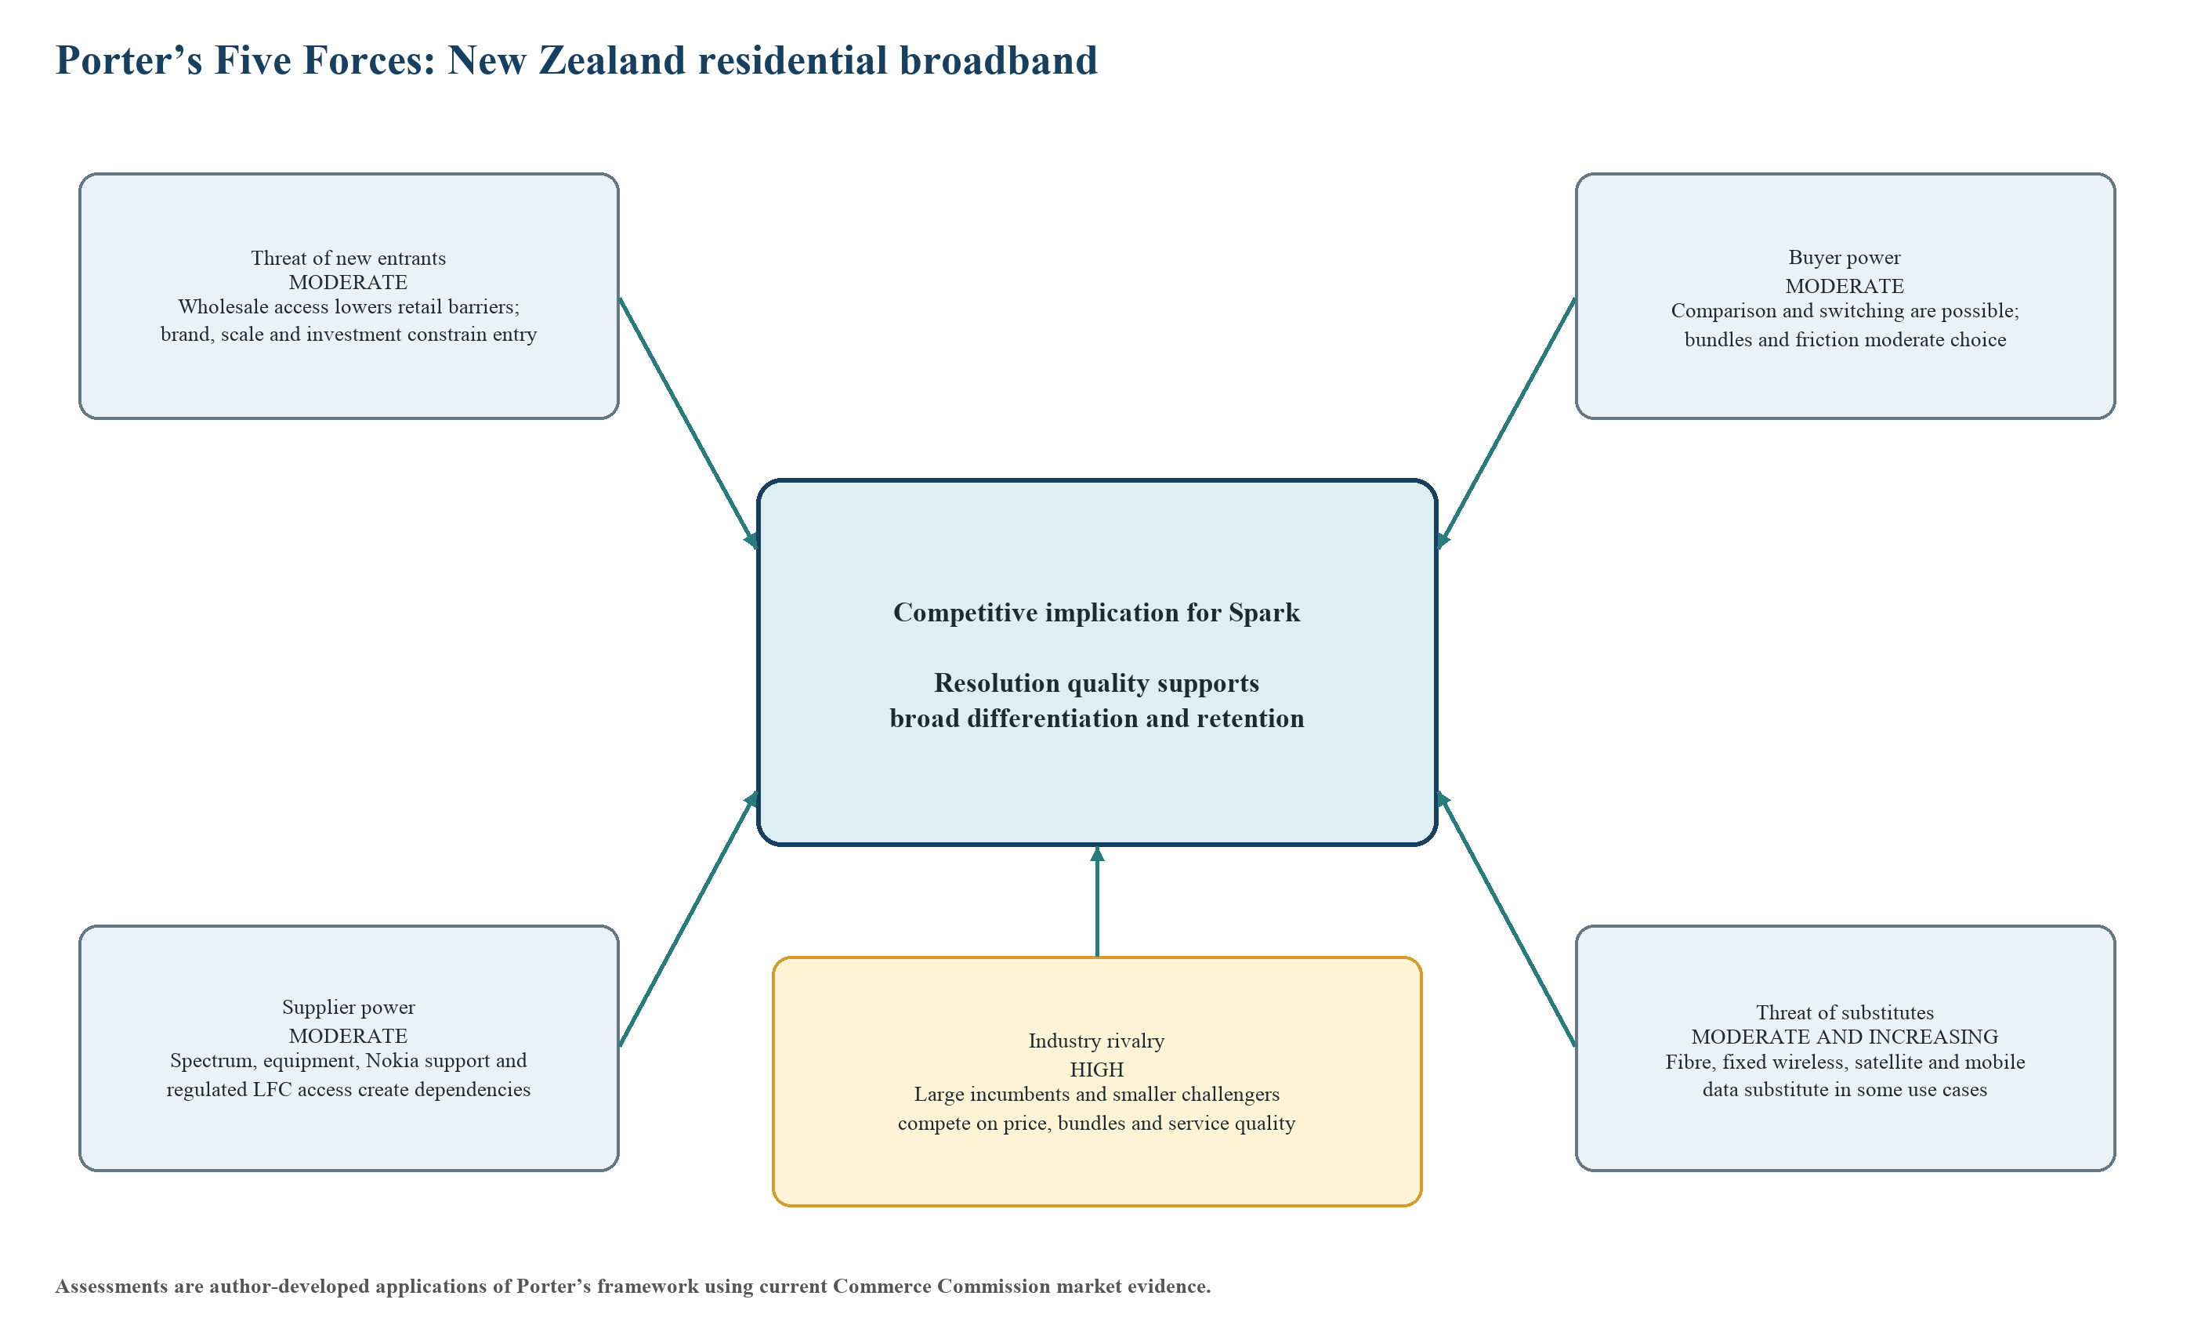
Figure 2. Porter’s Five Forces model for New Zealand residential broadband
Note. Author-developed application of Porter’s framework using Commerce Commission (2026a) market evidence. The model summarises the table; assessments are analytical judgments, not classifications issued by the Commission.

5. Porter’s Generic Strategy
Spark’s current direction is best interpreted as broad differentiation rather than pure cost leadership or a narrow focus strategy. The company intends to invest in network and customer experiences designed to differentiate Spark, maintain strong positions in premium segments, reward loyal customers and use digital journeys and AI to improve service. Cost discipline, simplification and global technology partnerships are important supporting capabilities, but the customer-facing proposition remains better connectivity and a better experience rather than the lowest price. Figure 3 locates this interpretation within Porter’s generic-strategy matrix. This is an analytical application of Porter’s framework; Spark does not itself label SPK-30 as a Porter generic strategy (Porter, 1980; Spark New Zealand, 2025b).
The principal risk is strategic inconsistency. If simplification and productivity are pursued by reducing touchpoints without improving information quality, customers may experience lower cost but more rework, weaker advice or less visible ownership. Conversely, a differentiated service does not require unlimited human handling: well-designed self-service can be differentiating when it resolves simple cases and carries evidence into assisted support. The operational design must therefore combine efficiency with resolution quality. Measures should test whether automation removes avoidable effort while preserving escalation, explanation and accountability for complex cases.
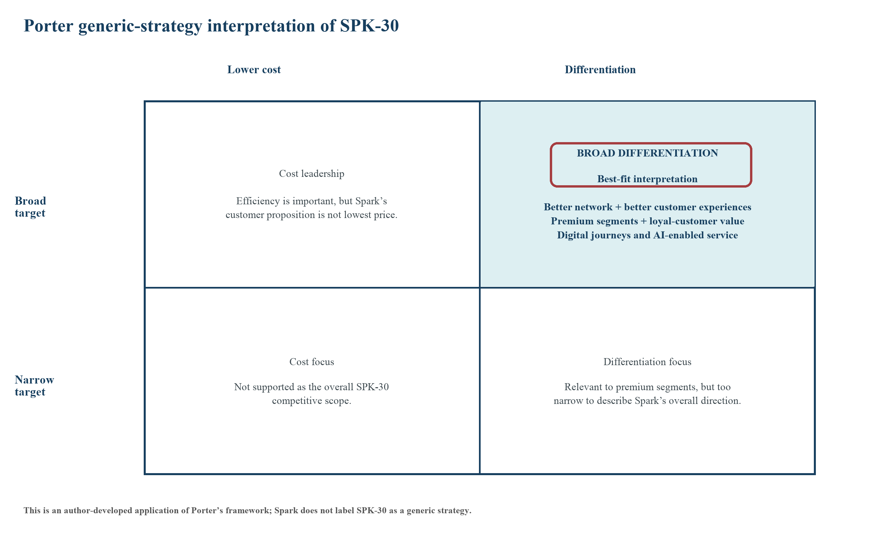
Figure 3. Porter generic-strategy matrix applied to SPK-30
Note. Author-developed interpretation of Spark’s disclosed SPK-30 direction using Porter (1980). Spark does not itself label SPK-30 as a Porter generic strategy.

6. Porter Value Chain
A telecommunications value chain translates inputs such as spectrum, wholesale access, equipment, software and partner capability into provisioned connectivity and ongoing service. For Spark, primary activities are supplier/network inputs, connectivity operations, service and channel delivery, marketing and sales, and after-sales service. Supporting activities are infrastructure and governance, people capability, technology development, and procurement/partner governance. Figure 4 locates the focal process at the intersection of connectivity operations, digital/contact-centre delivery and after-sales service, while showing its dependence on technology and partner governance. A weakness at one handoff can therefore travel across the value chain: missing diagnostic context increases frontline effort, uncertain routing delays specialist work, and incomplete partner status limits customer communication (Porter, 1985).
Value should be measured at the system level rather than optimised locally. A self-check with a high completion rate may still destroy value if unresolved cases reach advisors without its evidence. A frontline team may reduce average handling time by transferring cases earlier, while total resolution time rises in specialist queues. A partner may meet its own response target while the customer receives no meaningful update. Relevant measures therefore include end-to-end elapsed time, first-route accuracy, context completeness, handoff waiting, repeat contact, reopen and customer satisfaction alongside local productivity. This avoids rewarding one activity for moving work downstream.
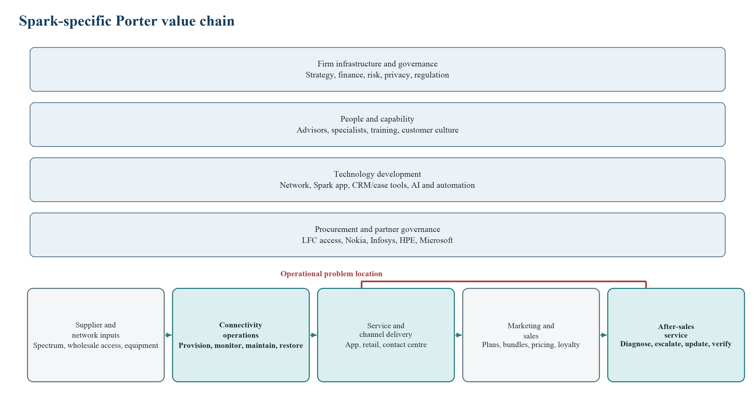
Figure 4. Spark-specific Porter value chain
Note. Author-developed application of Porter’s value-chain framework to Spark’s disclosed operating model.

7. AS-IS Rich Picture
Figure 5 places the customer’s home environment, Spark’s digital and assisted channels, customer-operations data, network-operations data and wholesale access status in one Rich Picture. Spark publicly documents a Check Connection tool that checks the connection from its network to the modem, lists home-network problems and supplies instructions; customers can also run guided checks with an advisor. Spark’s Outage Assist can notify eligible ADSL, VDSL and fibre customers of detected outages and provide continuity through eligible Spark mobile services, but it excludes wireless broadband and several managed or enterprise segments. The public evidence confirms capabilities and roles, not the exact internal case path (Spark New Zealand, n.d.-a, n.d.-b).
Four amber tensions are therefore shown as analytical propositions rather than facts: context may need reconstruction across channels; unsuccessful diagnosis may lead to reclassification; ownership and status may wait across organisational boundaries; and incomplete update or confirmation may produce recontact. The Rich Picture is useful because the problem is socio-technical: it involves customer behaviour, home equipment, digital systems, staff judgement, operational data and multiple organisations rather than a single defective task (Checkland & Poulter, 2006).
The picture also separates service continuity from fault resolution. Outage Assist can reduce the immediate impact for eligible customers, and a useful update can reduce uncertainty, but neither action necessarily removes the technical cause. Conversely, a network may be technically restored while the customer’s home environment remains unstable or the customer is unaware of recovery. The process outcome must therefore combine technical status, communicated status and customer-observed stability. Treating any one of these as sufficient would risk premature closure or misleading performance measurement.
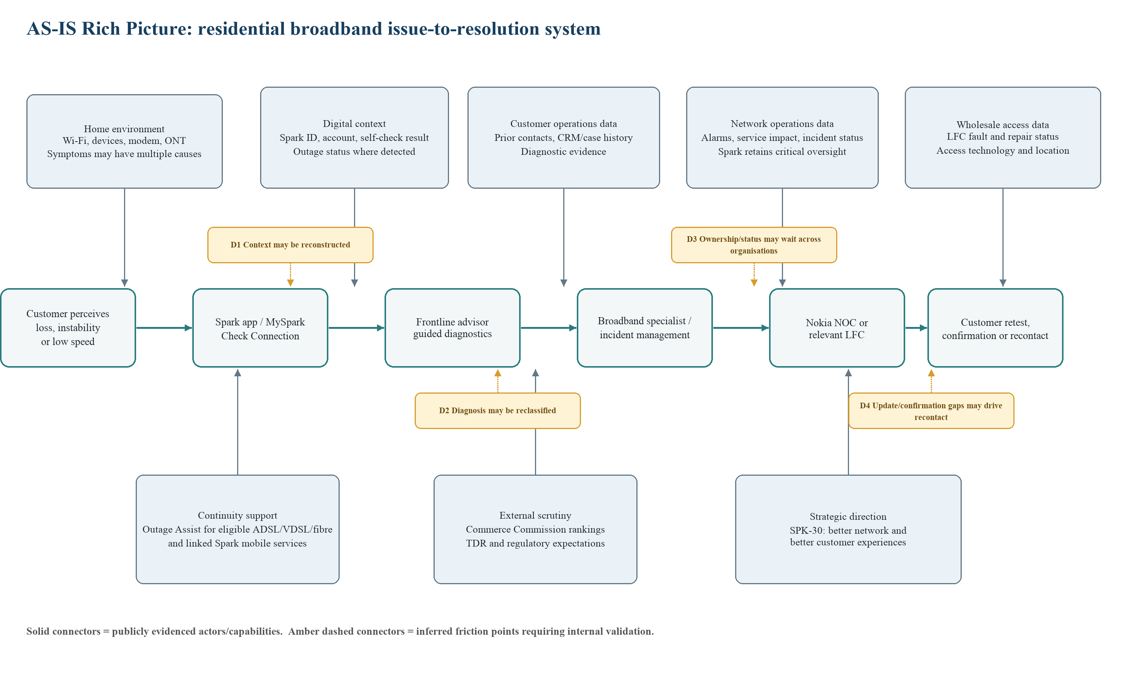
Figure 5. AS-IS Rich Picture
Note. Solid relationships reflect publicly evidenced actors or capabilities; amber dashed tensions are inferences that require internal validation.

8. Business Needs
The primary business need is an integrated and measurable residential broadband issue-to-resolution operating process that preserves relevant context across self-service, frontline support, specialists and external network partners; distinguishes home-network, Spark-network and access-network causes; provides meaningful progress information; and verifies stable restoration before final closure. This need is narrower than ‘improve customer service’ because it specifies the operating system and the customer outcome required.
Measurability is part of the need, not an afterthought. Each case should have a traceable identity, technology and fault-domain history; timestamps for material channel, queue and partner events; a current owner/status; communication events; and a recorded outcome. This does not mean every system must be replaced or that every customer must follow one channel. It means the operating model must produce enough shared information to reconstruct the customer journey and distinguish active work from waiting. Without that evidence, Spark could see local activity volumes but still be unable to identify where end-to-end delay or repeat demand originates.
Table 2. Ranked enabling business needs
Rank | Enabling business need | Operational result sought
1 | Context continuity | Identity, prior contacts and diagnostic evidence are available at the next point of work.
2 | Diagnosis and routing accuracy | The likely fault domain is identified and routed correctly at the earliest reasonable point.
3 | Ownership and status visibility | Spark can see the current owner, queue/status and material progress across internal and partner work.
4 | Timely updates and restoration confirmation | The customer receives meaningful progress information and confirms stable service before final closure.

Table 2 ranks the enabling needs by causal dependency. A case cannot be diagnosed well if its context is incomplete; it cannot be routed well if diagnosis is weak; ownership and status cannot be made visible if the route and handoffs are unclear; and customer updates or closure cannot be reliable without usable status and a defined outcome. The four enabling needs therefore form one coherent problem rather than four unrelated initiatives.

9. Problem Classification
The focal problem is operational. It concerns a repeatable, day-to-day service process that converts an individual report of degraded broadband into diagnosis, routing, restoration, communication and closure. It crosses functions and organisations, but the unit of analysis is still a process instance and its flow performance. Strategic choices explain why customer experience matters, and organisational arrangements influence responsibility, yet the immediate question is how work, information and waiting move through the AS-IS process. That makes operational process analysis the appropriate classification.
It is not primarily a strategic problem because the selected analysis does not decide which markets Spark should enter or which overall proposition it should pursue. It is not primarily an organisational problem because it does not begin by redesigning reporting lines or culture. Those dimensions create constraints and may later supply remedies, but the evidence needed now is event-level: what happened to a case, in what order, under whose ownership, with what information and with what customer result. That evidence orientation further supports the operational classification.

10. Dysfunctional Process
Spark’s residential broadband issue-to-resolution process is identified as dysfunctional at the customer-outcome level because published results show a material gap against a credible service-quality range; the internal causes and affected process variants remain to be validated. In the Commerce Commission’s December 2025 residential broadband rankings, 43% of Spark respondents reported at least one issue during the preceding six months. Among Spark respondents who had experienced an issue, 41% were satisfied with how long resolution took and 52% rated staff as helpful and knowledgeable; both latter results used a Spark broadband sample of n = 371. The methodology defines these satisfaction results as the proportion scoring 4 or 5 on a five-point scale and describes 75%–85% as a good customer-satisfaction range (Commerce Commission, 2026b, 2026c).
Figure 6 visualises the published survey results and their methodological boundary. The 43% result is a survey measure covering reliability, speed, pricing, billing, installation and other reported issues; it is not a technical broadband-fault rate. The 41% and 52% measures describe customers’ perceptions after an issue, not direct proof that any specific internal step failed. Spark also reports improvements such as in-app authentication, AI identification of repeat interactions and Outage Assist usage (Spark New Zealand, 2026b). Those capabilities show an active improvement programme, but they do not by themselves demonstrate that end-to-end resolution is consistently effective. Taken together, the published customer outcomes provide sufficient evidence to identify the process as dysfunctional at the customer-outcome level, while D1–D5 remain hypotheses until internal case and event data are analysed (Commerce Commission, 2026b, 2026c).
A dysfunctional process need not fail every case. It is sufficient that the process produces avoidable variation, delay, rework or customer harm often enough to undermine its purpose. Here the intended purpose is not merely to close a ticket; it is to restore usable service and provide competent, timely help. Evidence should therefore be triangulated across customer survey results, operational event logs and stakeholder observations. Survey data establishes material customer concern, process data locates where variation occurs, and staff or partner input explains rules and exceptions that timestamps alone may not reveal.
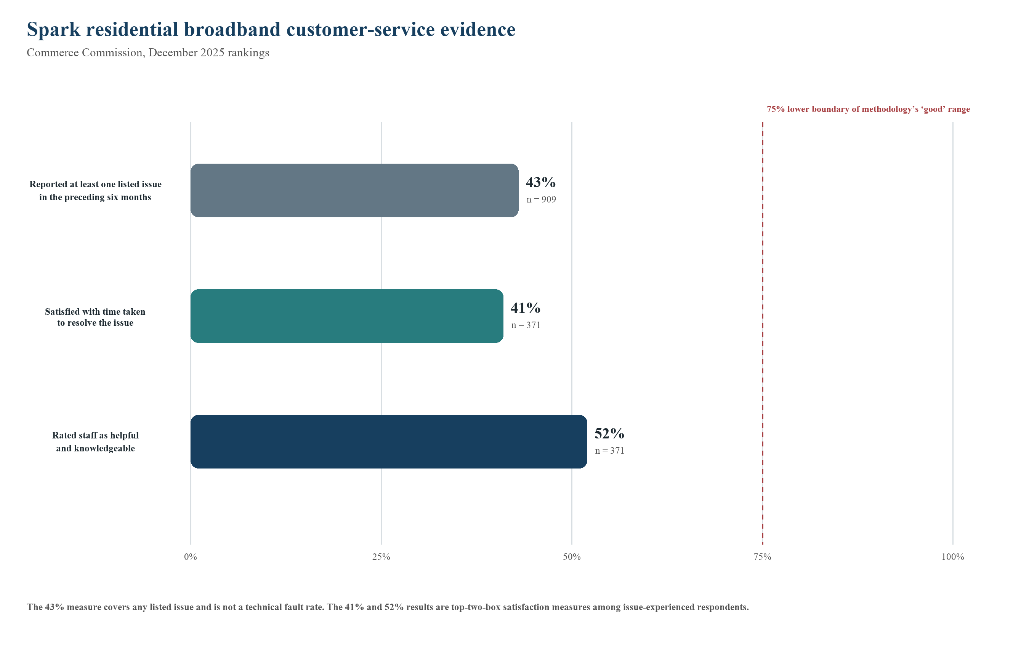
Figure 6. Published customer-service evidence supporting process investigation
Note. Author-redrawn from Commerce Commission (2026b, 2026c). The 43% issue-experience measure uses n = 909 and covers any listed issue; the 41% resolution-time satisfaction and 52% staff helpfulness/knowledge measures each use n = 371 and are top-two-box results. The 75% line is the lower boundary of the methodology’s 75%–85% ‘good’ range, not a Spark commitment.

11. SMART Objective
Proposed SMART objective: Using the Commerce Commission’s December 2025 residential broadband rankings as the baseline, Spark should, by 30 June 2030, increase the proportion of residential broadband customers who experienced an issue and were satisfied with the speed of resolution from 41% to at least 75%, and the proportion satisfied with staff helpfulness and knowledge from 52% to at least 75%, measured using a comparable survey population, question wording, scoring and weighting method.
Table 3 tests the objective against each SMART criterion. The objective is specific to the residential issue-to-resolution experience, measurable through two defined outcomes, relevant to SPK-30’s better-customer-experience ambition and time-bound to Spark’s FY30 horizon. The 75% threshold is a proposed consulting target based on the lower boundary of the Commission methodology’s 75%–85% ‘good’ range. It is not a target announced or committed to by Spark, and it should not be confused with the 80% favourable benchmark used in a different Commerce Commission tracking report. Maintaining like-for-like measurement is essential because a changed survey window, sample or question would weaken the baseline comparison (Commerce Commission, 2026d; Doran, 1981).
Governance should pair the external outcome with leading process measures rather than manage to the survey alone. Quarterly or monthly internal measures could track context completeness, first-route accuracy, handoff waiting, update coverage, confirmation and repeat contact, while the independent customer measure remains the final outcome. This balances accountability and learning: teams receive faster feedback on controllable process behaviour, but cannot declare success solely because a local efficiency metric improves. Any later revision of the 75% level should be documented as a governance decision and applied consistently to both outcomes.
Table 3. SMART objective test
SMART element | How the objective satisfies it
Specific | Residential broadband customers who experienced an issue; speed of resolution and staff helpfulness/knowledge.
Measurable | 41% and 52% December 2025 baselines; proposed minimum 75% for both; comparable top-two-box measurement.
Achievable | Stretch target anchored to the lower boundary of the methodology’s 75%–85% good range; feasibility must be tested through the hypothesis analysis.
Relevant | Directly supports SPK-30’s better customer experience and core-connectivity priorities.
Time-bound | 30 June 2030, aligned to the FY30 strategy horizon.

12. Customer Journey Mapping
Customer Journey Mapping is the primary framing technique because the SMART objective is expressed in customer perceptions of resolution speed and staff helpfulness. Figure 7 follows six stages: recognise the issue; self-check; assisted support; diagnose and route; resolve and update; and verify and close. It joins customer actions, touchpoints, potential pain points and operational needs without pretending that the customer sees internal organisational boundaries. This is more suitable than a purely internal flowchart for revealing where waiting, repeated explanation or unclear status can shape the final experience (Rosenbaum et al., 2017).
This selection also applies the problem-framing approach introduced in INFOSYS 704 Lecture 4 and the TMM course materials: customer-visible stages, operational dependencies and evidence needs are made explicit before possible causes are tested. The artefact therefore functions as an analytical bridge from the Rich Picture and SMART outcome to the issue tree, rather than as a decorative description of touchpoints (Reddy, 2026; Rasiel & Friga, 2001).
OODA is used only as an auxiliary logic. ‘Observe’ captures symptoms and diagnostic evidence; ‘Orient’ classifies the likely fault domain; ‘Decide’ selects guidance, Spark/Nokia or LFC action; and ‘Act’ applies remediation, communicates and retests. If customer confirmation shows the issue persists, the loop returns to observation and orientation. This secondary lens explains why preserved evidence and fast feedback are valuable, but it does not replace the customer journey as the main analytical artefact.
Each journey stage suggests a measurement pair. Entry should combine customer effort with successful context capture; self-check should combine completion with useful resolution or evidence transfer; assisted support should combine handling effort with diagnostic quality; routing should combine speed with correct-first destination; resolution should distinguish active repair from queue/status waiting; and closure should combine technical restoration with customer confirmation and absence of near-term recontact. Pairing efficiency and quality measures prevents a stage from appearing successful merely because it finishes quickly or passes work onward.
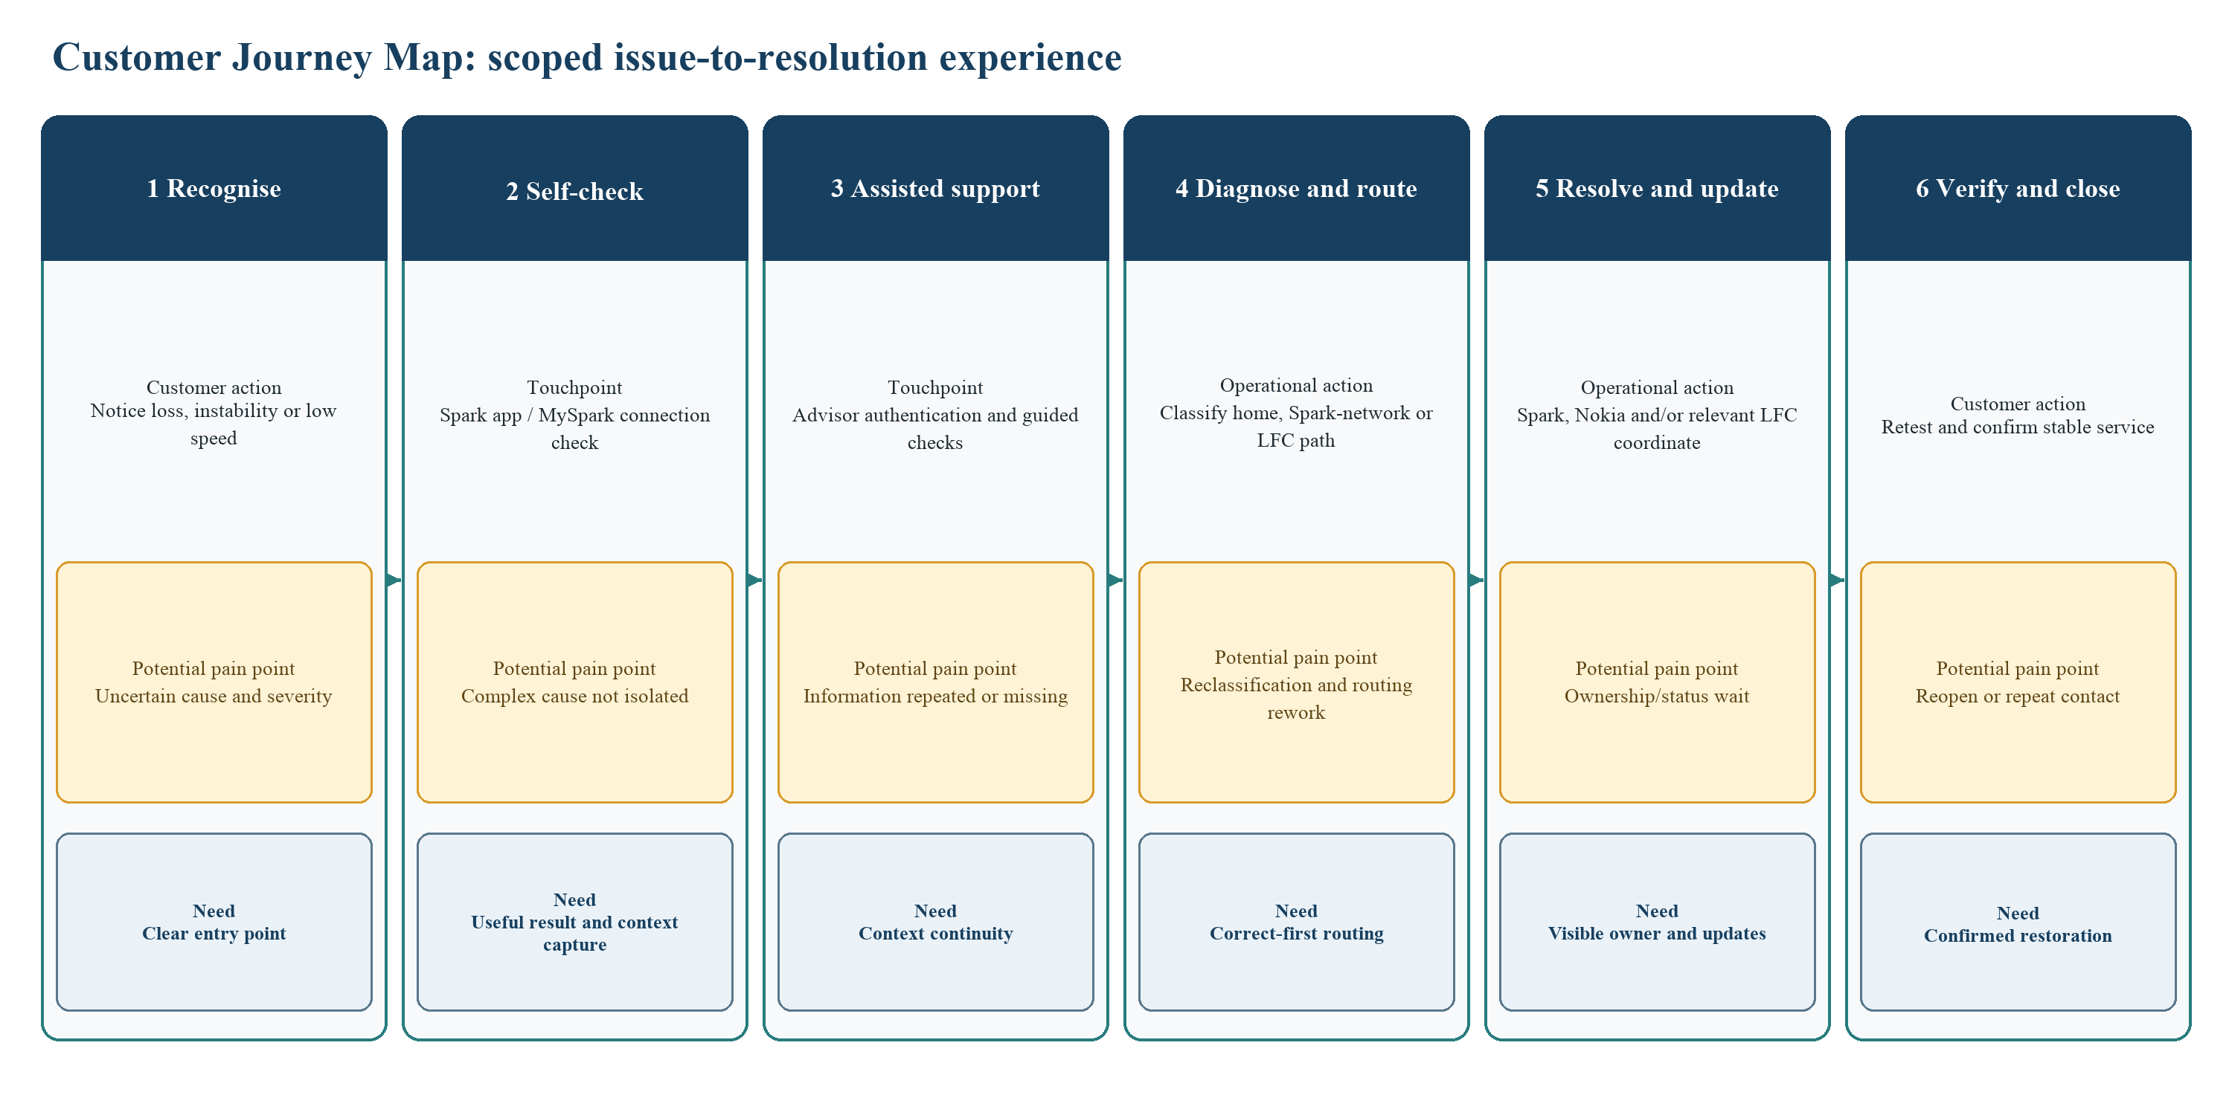
Figure 7. Customer Journey Map
Note. Potential pain points are analytical propositions requiring internal validation.

13. MECE Issue Tree
Figure 8 decomposes the root problem by non-overlapping process stages: B1 access and context; B2 diagnosis and routing; B3 resolution and cross-organisational handoffs; and B4 communication, verification and closure. The branches are collectively exhaustive for the defined boundary because every case must enter with context, be diagnosed and routed, receive a resolution path, and produce communication and an outcome. They are mutually exclusive at the first level because each branch represents a different stage and data question. Lower-level leaves distinguish official evidence, reasoned inference and data gaps. This prevents public evidence that a capability exists from being mistaken for proof that it performs well in every case (Minto, 2009).
The first-level decomposition follows the issue-tree discipline introduced in INFOSYS 704 Lecture 4 and the TMM course materials; Minto (2009) provides additional support for structuring non-overlapping questions under one governing problem. Keeping the same four branches in the hypotheses and BPMN annotations protects coherence and makes each inference traceable to a required internal data test (Reddy, 2026; Rasiel & Friga, 2001).
MECE applies to diagnostic questions, not every physical cause. Cases may traverse branches: incomplete context can cause wrong routing and a delayed handoff. Each branch remains distinct and measurable. Analysis should test direct and sequential effects without double-counting any waiting interval across extracts.

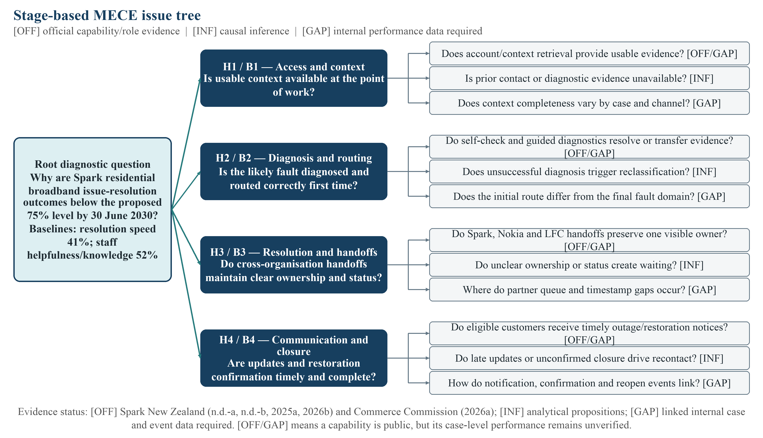
Figure 8. Stage-based MECE issue tree
Note. The root restates the proposed SMART outcome. [OFF] capability and role evidence is drawn from Spark New Zealand (n.d.-a, n.d.-b, 2025a, 2026b) and Commerce Commission (2026a); [INF] denotes an analytical proposition; [GAP] requires linked internal case and event data. The four branches map directly to H1–H4 and BPMN D1–D5.

14. Testable Hypotheses
Table 4 translates the four issue-tree branches into comparisons that Spark could test with linked self-service, CRM/case, contact-centre, incident, partner and customer-feedback data, following the hypothesis discipline introduced in INFOSYS 704 Lecture 4 and TMM (Reddy, 2026; Rasiel & Friga, 2001). Each hypothesis specifies a comparison group, outcome direction and relevant controls. The formal analysis deliberately does not impose unsupported numerical cut-offs such as a 20% handling-time difference or a universal statistical-significance threshold. Support or falsification should depend on the observed effect, confidence interval, practical materiality, data quality and robustness after controls.
Table 4. Testable hypotheses and decision logic
Hypothesis | Comparison | Metrics and expected direction | Controls | Support / falsification logic
H1 — Access/context | Cases requiring repeated authentication or manual context reconstruction, compared with otherwise similar cases where identity and diagnostic history are available at first handling. | Longer handling time and more near-term repeat contact. | Severity, channel, access technology, outage scope, customer segment and prior-contact count. | Supported if adjusted estimates consistently indicate material extra effort/recontact; weakened or falsified if estimates are negligible, reversed or explained by controls.
H2 — Diagnosis/routing | Cases rerouted or reclassified after initial diagnosis, compared with similar cases resolved on the first operational route. | Longer elapsed time to resolution and lower post-case satisfaction. | Severity, fault domain, access technology, channel, region, partner involvement and case complexity. | Supported if rerouting independently predicts worse time/satisfaction; weakened or falsified if no robust difference remains.
H3 — Handoffs | Multi-organisation cases with unclear ownership or status gaps, compared with severity-matched single-owner or continuously visible cases. | More queue/status waiting and longer elapsed resolution time. | Severity, outage size, technology, partner, field dispatch, region and time of day. | Supported if ownership/status gaps account for material elapsed delay after controls; weakened or falsified if observed delay lies elsewhere.
H4 — Communication and closure | Cases with late/missing material updates or without explicit stable-restoration confirmation, compared with timely-updated and confirmed cases. | More recontact/reopen and lower satisfaction. | Severity, total resolution time, outage scope, channel, technology, customer segment and case complexity. | Supported if communication/confirmation status predicts the outcomes after controls; weakened or falsified if it does not.

H1 and H2 primarily test information continuity and decision quality; H3 tests elapsed time created at organisational boundaries; H4 tests whether communication and confirmation influence repeat demand and satisfaction. Severity, technology, outage scope, channel, region, customer segment and case complexity should be controlled where available. If required fields are not consistently recorded, that data-quality weakness is itself a finding about process measurability rather than permission to infer the result.
The analysis should begin descriptively before using causal language. A process-mining view can establish common variants, rework loops, ownership changes and elapsed-time distributions. Matched comparisons or regression can then test H1–H4, with sensitivity checks for missing fields and extreme outages. Results should be segmented where the operating model differs materially, especially fibre, copper and wireless broadband, and known area outages versus individual faults. A hypothesis may be supported in one segment and falsified in another; that result would favour a targeted improvement rather than a universal redesign.

15. SAP Signavio BPMN 2.0 AS-IS Model
The BPMN 2.0 collaboration diagram was created in SAP Signavio and saved in Shared documents > INFOSYS_704_S2_2026_Folder > LAB 2 (2-4PM) > Ryan.Li_ali409_SparkNZ_lab2 under the title ‘Spark NZ Residential Broadband Fault Diagnosis, Escalation and Resolution AS-IS’. It contains four participant pools: Residential broadband customer; Spark NZ; Nokia NOC; and Chorus/relevant LFC. The Spark pool contains three lanes: Digital self-service/Spark app; Frontline customer support; and Broadband specialist/incident management. Sequence flows remain within participants and message flows cross participant boundaries (Object Management Group, 2014).
The model starts when a customer perceives degradation, initiates a connection check and receives a result. A self-service, known-outage or assisted-support route follows. Assisted cases retrieve context, conduct guided diagnostics and either communicate a home-network resolution or hand the unresolved case to a specialist. The specialist determines whether Spark-network analysis, involving the Nokia-managed NOC where applicable, or access-network action through the relevant LFC is required. The Nokia/NOC and LFC alternatives converge through an explicit XOR merge before one ‘Consolidate diagnosis, ownership and restoration status’ activity; Spark then updates the customer. The model ends only after stable restoration is confirmed; a continuing issue loops back as recontact and reclassification. Five text annotations identify D1–D5 as inferred AS-IS dysfunctions requiring internal validation. No unsupported timer, SLA or TO-BE control has been inserted.
Figure 9a presents the full collaboration model. Figure 9b enlarges customer and digital self-service paths; Figure 9c shows frontline diagnosis, communication and closure; and Figure 9d isolates the Spark–Nokia–LFC handoffs and XOR merge. Pools make organisational responsibility explicit, while message flows show that Spark cannot use an internal sequence flow to command a customer, Nokia or an LFC. Two message-start paths in the Spark process distinguish a self-check request from an assisted-support request. Exclusive gateways show decision points without assuming simultaneous partner work. The model can later be refined with event types, data objects and verified exception rules, but the submitted AS-IS view preserves the currently supportable boundary and avoids presenting proposed controls as existing practice.

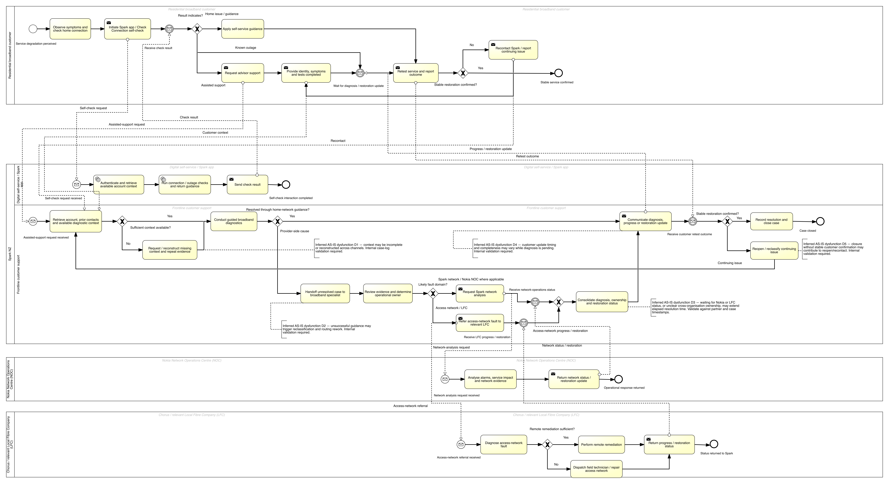
Figure 9a. SAP Signavio BPMN 2.0 — Residential Broadband Fault Diagnosis, Escalation and Resolution AS-IS
Note. Actual SAP Signavio model extracted as vector content from the current saved editor state on 10 August 2026 and rasterised at high resolution for this report. Inferred dysfunction annotations require validation against Spark’s internal case and incident data.

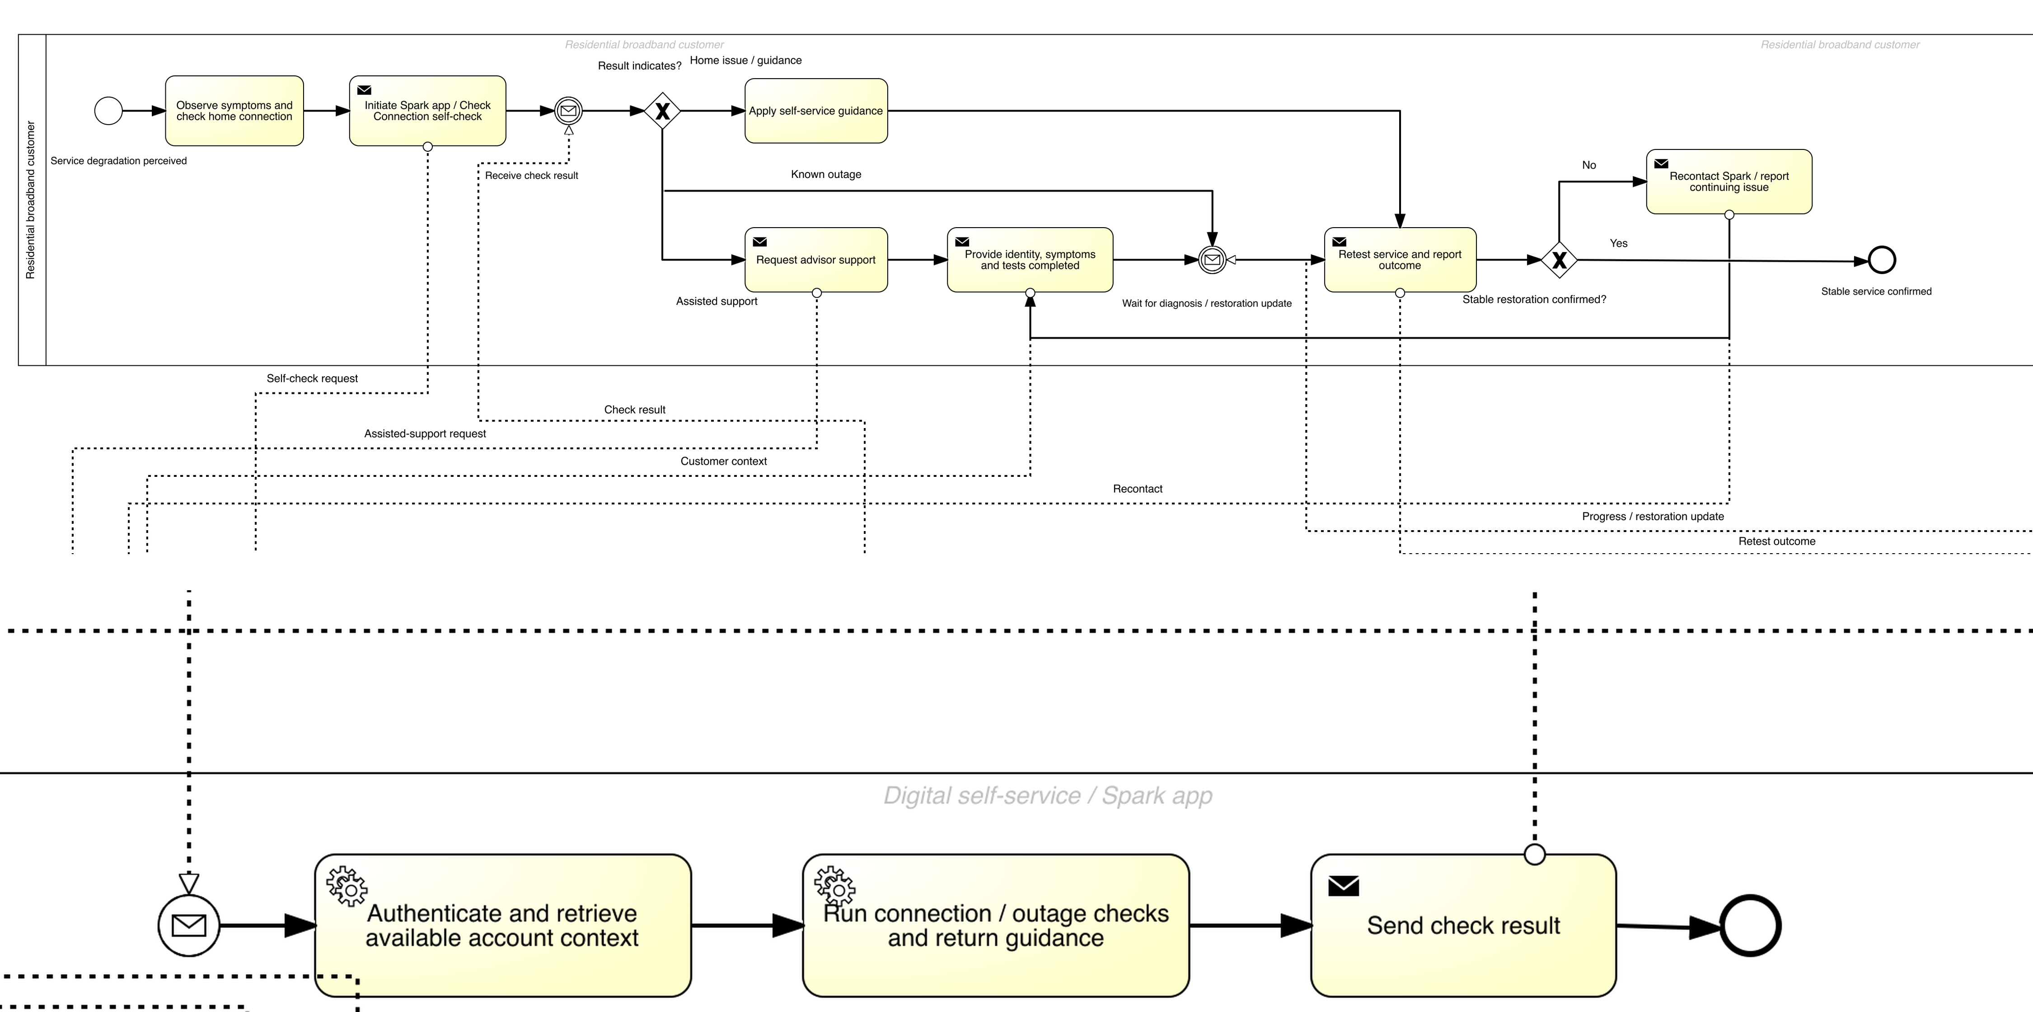
Figure 9b. Enlarged customer and digital self-service detail
Note. Two enlarged extracts of the same current Signavio model are stacked for readability. The upper panel shows customer actions, connection checking, self-service and assisted-support choices, and retest; the lower panel enlarges the digital self-service tasks and related message flows.

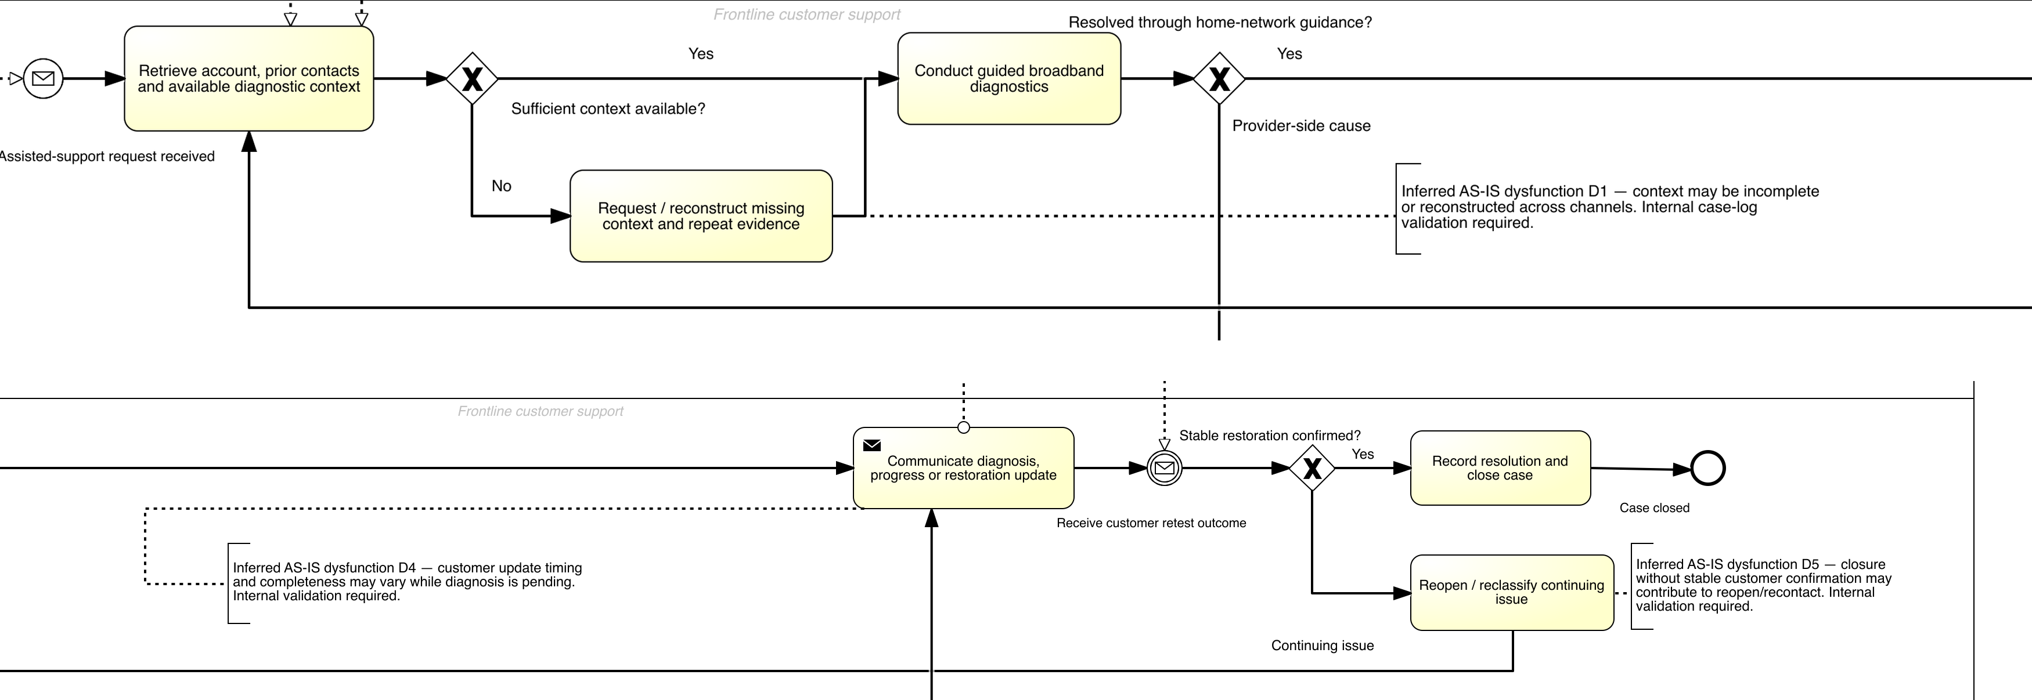
Figure 9c. Enlarged frontline diagnosis, communication and closure detail
Note. Two enlarged extracts of the same current Signavio model are stacked for readability. The upper panel shows context retrieval and guided diagnosis; the lower panel shows communication, customer confirmation, closure and recontact. D1, D4 and D5 are analytical inferences requiring internal validation.

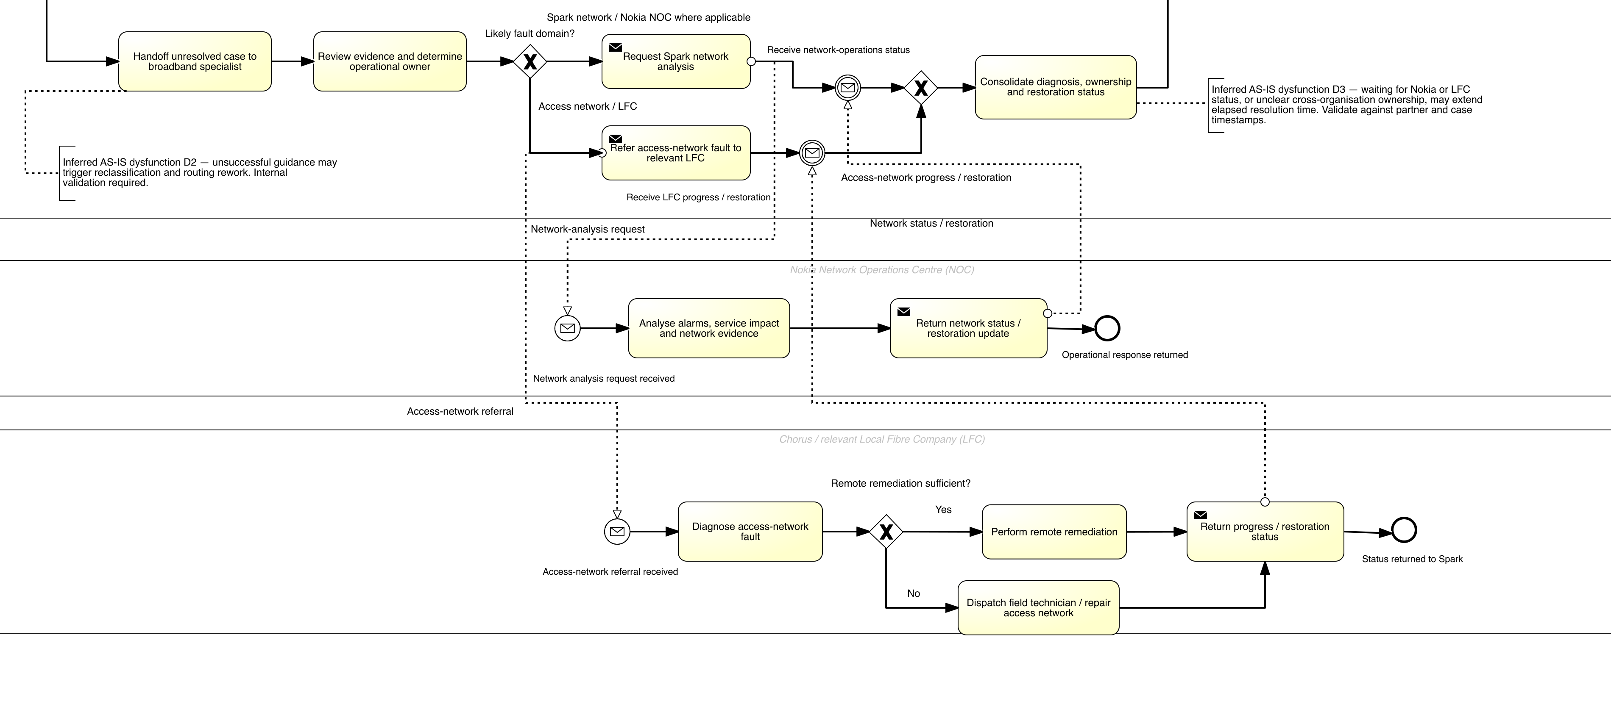
Figure 9d. Enlarged Spark–Nokia–LFC diagnosis, handoff and consolidation detail
Note. Enlarged extract of the same current Signavio model. It shows the Spark specialist path, Nokia NOC and relevant LFC participants, their message flows, and the explicit XOR merge before the single consolidation activity. D2 and D3 are analytical inferences requiring internal validation.

Conclusion
The analysis uses one problem boundary throughout. The SPK-30 differentiation logic makes customer experience strategically relevant; the value chain locates the issue across operations, service and technology/partner support; the Rich Picture defines the socio-technical system; the business need specifies the required operating capability; the SMART objective defines measurable customer outcomes; the journey map identifies experience-sensitive stages; the issue tree generates four testable hypotheses; and the Signavio model shows where those hypotheses touch the AS-IS flow. The next analytical step is not to redesign the process immediately, but to validate H1–H4 with linked case and event data, confirm the actual Spark–Nokia–LFC operating rules, and only then prioritise improvement options.
The principal limitation is evidence access. Public sources establish company scale, strategic direction, customer outcomes, self-service capabilities and partner roles, but they do not reveal complete internal routing logic or event-level performance. The report manages this limitation by labelling inference, avoiding arbitrary thresholds and preserving falsification paths. A strong final decision should therefore be based on what internal evidence shows, not on forcing the organisation to fit the initial issue tree. If another dominant cause emerges, the coherent framework can be revised while retaining the same customer outcome and process boundary.

References
Checkland, P., & Poulter, J. (2006). Learning for action: A short definitive account of soft systems methodology and its use for practitioners, teachers and students. Wiley.
Commerce Commission. (2026a). 2025 telecommunications monitoring report. https://www.comcom.govt.nz/assets/Uploads/2025-Telecommunications-Monitoring-Report-29-June-2026.pdf
Commerce Commission. (2026b). Customer service and billing rankings – December 2025. https://www.comcom.govt.nz/assets/Uploads/Customer-Service-and-Billing-Rankings-December-2025.pdf
Commerce Commission. (2026c, February 26). Consumer satisfaction metrics: Methodology & guide – December 2025. https://www.comcom.govt.nz/assets/Uploads/Consumer-Satisfaction-Metrics-Methodology-Guide-December-2025.pdf
Commerce Commission. (2026d). Telecommunications consumer satisfaction monitoring report: July–December 2025. https://www.comcom.govt.nz/about-us/research/telecommunications-research/telecommunications-consumer-satisfaction-monitoring-report-julydecember-2025/
Doran, G. T. (1981). There’s a S.M.A.R.T. way to write management’s goals and objectives. Management Review, 70(11), 35–36.
Minto, B. (2009). The pyramid principle: Logic in writing and thinking (3rd ed.). Financial Times Prentice Hall.
Object Management Group. (2014). Business process model and notation (BPMN), version 2.0.2. https://www.omg.org/spec/BPMN/2.0.2
Porter, M. E. (1980). Competitive strategy: Techniques for analyzing industries and competitors. Free Press.
Porter, M. E. (1985). Competitive advantage: Creating and sustaining superior performance. Free Press.
Rasiel, E. M., & Friga, P. N. (2001). The McKinsey mind: Understanding and implementing the problem-solving tools and management techniques of the world’s top strategic consulting firm. McGraw Hill.
Reddy, S. (2026). Week 2 704 2026 lecture 4 V3 [PowerPoint slides]. University of Auckland Canvas.
Rosenbaum, M. S., Otalora, M. L., & Ramírez, G. C. (2017). How to create a realistic customer journey map. Business Horizons, 60(1), 143–150. https://doi.org/10.1016/j.bushor.2016.09.010
Spark New Zealand. (n.d.-a). Check your connection. Retrieved August 8, 2026, from https://www.spark.co.nz/help/internet/troubleshoot/fixmybroadband/
Spark New Zealand. (n.d.-b). Stay connected during an outage. Retrieved August 8, 2026, from https://www.spark.co.nz/help/internet/manage/outage-assist/
Spark New Zealand. (2025a). Annual report FY25. https://investors.sparknz.co.nz/FormBuilder/_Resource/_module/gXbeer80tkeL4nEaF-kwFA/doc/FY25_Annual_Report.pdf
Spark New Zealand. (2025b, September 11). Spark releases FY30 strategy and update on Chair succession. https://investors.sparknz.co.nz/AnnouncementDetailsHandler.ashx?id=2197014&module=eOfdHyYr5ESZHJxq5j-E9Q
Spark New Zealand. (2026a). H1 FY26 detailed financials. https://investors.sparknz.co.nz/FormBuilder/_Resource/_module/gXbeer80tkeL4nEaF-kwFA/doc/H1-FY26-Detailed-Financials.pdf
Spark New Zealand. (2026b, February 18). H1 FY26 results summary. https://investors.sparknz.co.nz/DownloadFile.axd?file=Announcements%2FNZX%2F20260218%2F462497.pdf

