INFOSYS 704 A2 D1

Consulting Proposal
Spark NZ Residential Fibre Fault Resolution
Prepared for the Chief Executive Officer of Spark NZ
Name: Ryan Li
UPI: ali409
Student ID: 693997238
Company: Spark New Zealand Limited
Analytical lens: Operational
Date: 17 September 2026

1 Executive Summary
To avoid committing NZ$154,008 to an unverified intervention, I recommend a six-week diagnosis of Spark NZ residential fibre fault resolution, capped at NZ$36,846 excluding GST. This first decision leaves NZ$117,162 uncommitted. Diagnosis compares information, routing, handoff and communication explanations and selects the least costly intervention supported by episode evidence.
Public evidence justifies investigation but does not establish a cause. The Commerce Commission reports 36% satisfaction with Spark’s resolution speed across mobile and broadband. Spark also reports improved interaction NPS and already offers diagnostics and outage notifications. These measures are not a residential fibre baseline; the proposal tests gaps in existing service.
The conditional plan covers 24 delivery weeks in one region with one principal partner, including diagnosis, design, pilot, evaluation and handover. If handoff hypothesis H3 is supported, P1 will test a named case owner, explicit acceptance and escalation against comparable episodes. A provisional target is 15% lower median restoration time without worsening P90. Missing outcomes, reopened cases and additional handling effort will be monitored. At least 90% of sampled episodes must be reconstructable before progressing; other causes can lead to P2, P3 or P6 instead.
The full planning cash ceiling is NZ$154,008, plus NZ$43,200 in client staff opportunity cost. The base scenario releases 1,000 staff hours annually with an annual net cash shortfall of NZ$1,750 after recurring costs. Diagnosis therefore buys evidence for a stop, adapt or proceed decision; it does not justify the full investment. Ryan Li will lead operations, supported by Rae Huang in finance, Francis Lee in strategy and Xuan Zeng in organisational change. I request a sponsor discussion and provisional kickoff on 28 September 2026; later phases require separate approval and a revised business case.

2 Client Context and Problem Statement
Spark describes itself as New Zealand’s largest telecommunications company. FY26 broadband revenue was NZ$596 million and broadband connections fell 4.8% (Spark New Zealand Limited, 2026b, pp. 7, 16). These broadband trends do not establish fault-related customer losses.
Spark’s fibre guidance separates customer and modem responsibilities from the local fibre company’s access installation and optical network terminal ownership (Spark, n.d.-b). Partner handoffs are therefore a diagnostic boundary, not a proven cause.
The scope is residential fibre fault contact through verified stable restoration. Billing, installation, plan changes, mobile, wireless broadband and enterprise services are excluded. Agree the region, principal partner and eligible fault classes at initiation. Devices, home Wi-Fi, diagnosis quality and network faults remain alternative explanations.
Spark’s June 2026 public rankings report 36% satisfaction with resolution speed and 46% with staff knowledge and helpfulness. These rounded top-two responses on a five-point scale combine mobile and broadband, with n = 795 and observations from July 2025 to June 2026 (Commerce Commission, 2026a, 2026b). They are neither technical restoration rates nor comparable fibre or A1 baselines.
Spark reports FY26 consumer and SME interaction NPS of +42, up two points, alongside refreshed digital channels and internal AI assistants (Spark New Zealand Limited, 2026a, pp. 21–22). The measures cover different experiences. Existing connection checks and Outage Assist mean that diagnostic or communication changes must demonstrate additional value (Spark, n.d.-a, n.d.-c).
A1 prioritised handoffs (H3), alongside context rebuilding (H1), routing (H2) and communication (H4). Discussion with Francis Lee challenged the analysis but supplied no Spark operational evidence. The hypotheses require case-log validation. Figure 1 covers assisted fibre episodes, drawing on available self-service history. Validate this reconstruction with the process owner; omissions do not prove absent controls.

Figure 1 Reference AS-IS process and candidate failure points
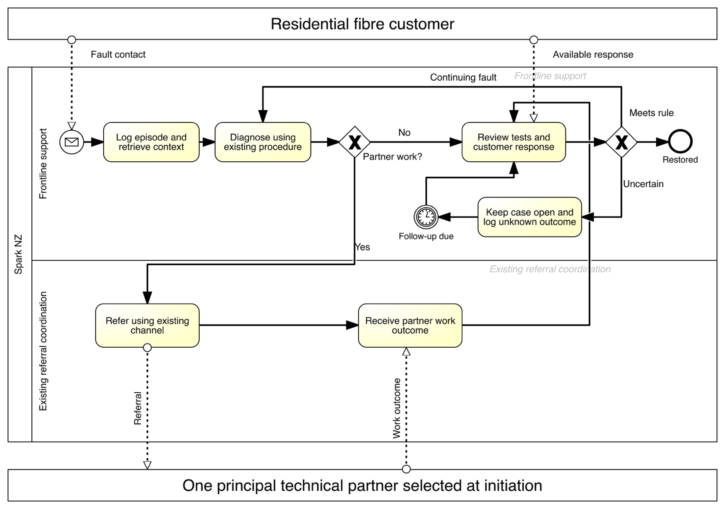
Author’s Signavio model, adapted from the A1 process analysis for this proposal and to be validated during diagnosis. H1 context rebuilding, H2 routing, H3 handoff delay and H4 communication are competing hypotheses. No internal baseline or causal finding is claimed. K1 median/P90 time to stable restoration; K2 recontacts per episode; K3 first routing accuracy; K4 referral-to-acceptance delay. Measure both cohorts consistently; retain unknown outcomes. Proposed targets are in proposal Table 1. Partner work is abstracted; the shared outcome rule is a measurement requirement, not a claim about current Spark practice.

3 Objectives and Success Criteria
The engagement aims to identify the main avoidable source of customer effort, test a proportionate response and leave Spark with a repeatable measurement and ownership process. This supports service experience and operational productivity while limiting investment before validation. All numeric thresholds below are proposed planning targets to be reviewed at the end of diagnosis, before pilot results are visible.
Table 1 Measures and provisional decision thresholds
Measure | Definition and baseline | Proposed success criterion
Data readiness | Linked episode identifiers, diagnosis, routing, handoff and outcome timestamps. Baseline unavailable. | At least 90% of eligible sampled episodes reconstructable by week 6. Otherwise repair measurement or stop.
K1 Restoration time | Elapsed hours from earliest recorded fault/contact to stable restoration; median and P90. Report unknown onset and incomplete episodes separately. | If H3 is supported, target 15% lower median than the adjusted comparison, with no worsening P90.
K2 Recontacts | Additional customer-initiated contacts divided by eligible episodes. Also record timely promised updates and customer understanding. | If H4 is supported, target 15% fewer recontacts and 90% timely updates. Assess understanding separately.
K3 First routing | Episodes correctly routed first time divided by episodes with reviewed routing and cause. Report unknown classifications. | If H2 is supported, target a 10-percentage-point increase in correct first routing.
K4 Acceptance delay | Elapsed hours from referral sent to explicit acceptance by a named receiving owner. Show median/P90 and missing or pending acceptance. | For P1, test whether delay falls and mediates K1 improvement. Set any numerical target at G1 using the baseline and partner agreement.
Service and adoption | Same episode reopened within 7 days; serious service/privacy incidents; staff proficiency. | No material deterioration; investigate a reopening increase over 2 percentage points. All pilot staff complete a practical check.
Ryan and Spark’s analyst will define the KPIs. At week 2, the service owner approves stable restoration: a successful technical retest plus customer confirmation where obtainable. Apply one rule to both cohorts. Retain unreachable, unresolved and reopened cases; ticket closure is not recovery. Report uncertainty, missing outcomes and cohort sizes.

4 Proposed Approach
I adopt A1’s stage-based MECE issue tree with Customer Journey Mapping (Rosenbaum et al., 2017). H1 tests context reconstruction; H2 routing; H3 handoff; H4 communication and confirmation. These are distinct diagnostic questions, not independent causes; journey mapping connects them to customer touchpoints. Compare outcomes, activities and resources without double-counting delay, reject unsupported or infeasible options, then assess incremental value, affordability and reversibility against business as usual.
At G1, Ryan presents supporting and contrary evidence; Rae checks value, Francis strategic fit and Xuan adoption. Figure 2 illustrates P1 only if H3 is supported. P2, P3 and P6 remain independent alternatives. The sponsor can stop, change the candidate or approve a revised scope and estimate.
Table 2 Reassessment of the A1 options
Candidate | Evidence that would favour it | Limitation and decision
P1 Governance | Useful information exists, but ownership or escalation is unclear. | Test case ownership and an acceptance playbook. P1 may be sufficient on its own.
P2 Status integration | Responsibilities work but unavailable or delayed partner status causes avoidable work. | Use the smallest approved link. Interface access and maintenance may outweigh benefits.
P3 Communication | Customers recontact because messages lack timely, usable next steps. | Improve existing notifications. This may reduce effort without shortening physical repair.
P4 Minimum combination | Two or more controls are complementary and each has an incremental case. | Add only necessary elements of P1 to P3. Do not assume a hybrid is optimal.
P5 Structural change | Contractual or organisational structure prevents workable local improvement. | Defer insourcing or restructuring to a separately authorised strategic case.
P6 Diagnosis and routing | Initial information or rules cause wrong classification and avoidable rerouting. | Test intake checks, routing rules and error feedback.

Figure 2 Conditional TO-BE process
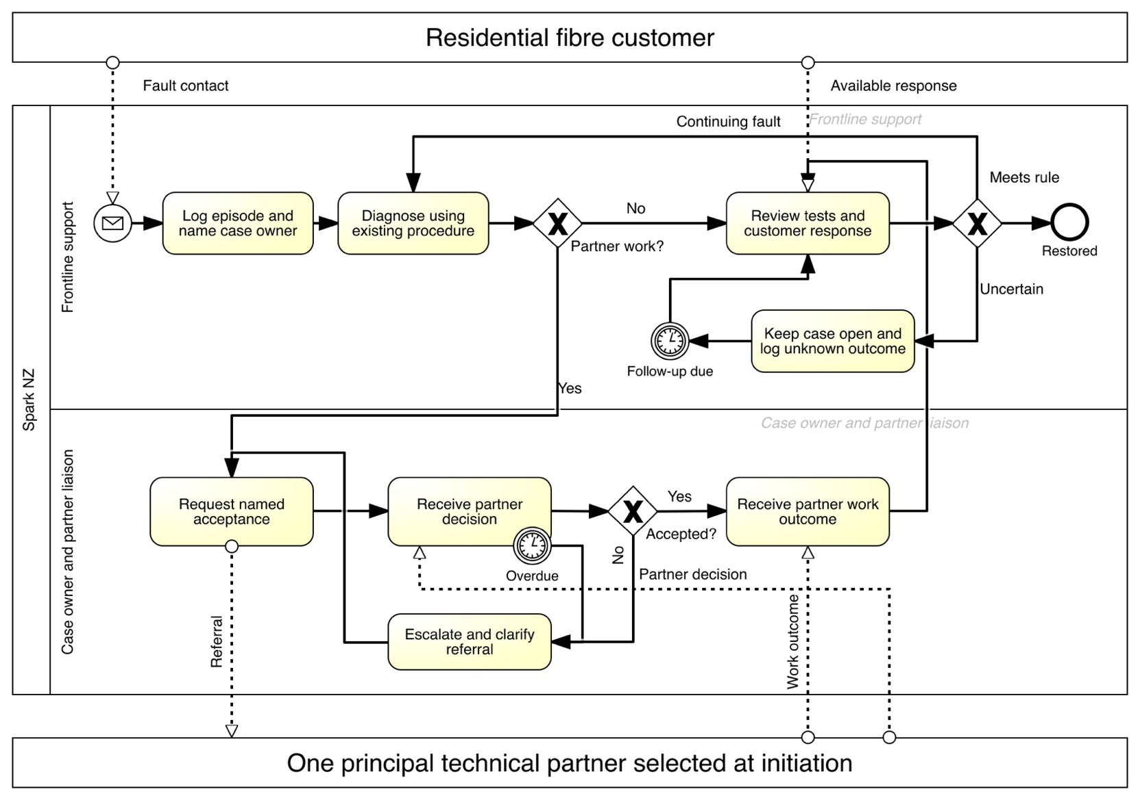
Author’s Signavio export: P1 is conditional on H3 and G1/G2 approval. Rejected/incomplete referrals are clarified and resent; overdue decisions escalate at a partner-agreed interval, not a measured SLA. P2/P3/P6 remain alternatives. Validate ownership and acceptance-delay benefits. K1: median/P90 stable restoration; K2: recontacts per episode; K3: first routing accuracy; K4: referral-to-acceptance delay. Baselines unavailable; use consistent cohort measures and retain unknown outcomes. Targets: Table 1.

5 Proposed Methodology
I use a stage-gated diagnostic and pilot methodology: diagnosis tests the cause (G1); design specifies and rehearses the selected intervention (G2); a bounded pilot tests feasibility and outcomes (G3); evaluation reassesses value (G4); and handover transfers ownership (G5). Each gate can stop or reshape the next phase. Diagnosis combines process walkthroughs, interviews and a deidentified sample from the most recent 8 to 12 weeks. Include completed and unresolved episodes, stratified by fault type, severity, dispatch and partner involvement. Case review tests the local mechanism; the initial discovery sample is not a powered causal estimate.
Design translates the selected option into revised BPMN, role responsibilities, a minimum data dictionary and a testable operating procedure. Review the data needed for each message or integration. Use existing systems or a controlled manual workflow where feasible. A shared status sheet that changes work is itself an intervention and must not be introduced into the comparison group as if it were neutral measurement.
Mills (2025, 23:55–24:20, 29:09–33:03) links delivery stages to accepted deliverables and recommends an integrated design with early business playbacks when teams depend on one another. I apply this within the selected pilot scope: walk the complete Spark–partner–customer episode at week 7, then demonstrate normal, overdue, rejected and reopened cases at week 9. These can be manual rehearsals using existing tools. Before G2, the service owner accepts the process, responsibilities, data rules, test evidence and staff readiness. Any conditional acceptance records the unfinished work, risk, owner and approval.
The pilot will use a concurrent comparable queue or a staggered team rollout where operationally feasible. Agree allocation and contamination controls before launch. Analyse changes relative to the comparison, accounting for case mix, seasonal effects and pre-existing trends. At G1, set an enrolment cutoff no later than week 18 and a common follow-up rule for both cohorts, allowing seven days after restoration to assess reopening. G3 checks data readiness; follow-up may continue during evaluation. At week 6, the analyst will use baseline variability and cluster structure to set a feasible sample requirement. At the analysis cutoff before G4, retain unresolved episodes as right-censored observations and report missing data and uncertainty. If follow-up is insufficient for reliable median, P90 or reopening comparisons, report feasibility findings only.
Evaluation compares service results, adoption effort and verified economic value with the agreed criteria. If several controls are tested together, conclusions concern that bundle; they do not establish which component caused the result or that the bundle outperforms every alternative. Handover provides editable process models, the KPI dictionary, an owner runbook and the next investment recommendation.

6 Work Plan and Timeline
The plan contains 24 delivery weeks across 27 calendar weeks. The proposed kickoff is 28 September 2026, with a planning pause from 21 December 2026 to 10 January 2027 and handover ending 4 April 2027. These dates and the pause are assumptions requiring sponsor agreement. Customer fault service continues throughout; the project pauses new experimental enrolment while following already enrolled episodes. The earlier A1 18-month concept remains a possible later roadmap rather than an approved extension.
Table 3 Activities, responsibilities and milestones
Phase and dates | Deliverable and gate | Consultant and client responsibility
W1 to W6  28 Sep to 8 Nov 2026 | Validate AS-IS, establish definitions and baseline, compare P1 to P6. G1: approve a supported mechanism and affordable design or stop. | Ryan leads; Rae costs; Francis challenges scope; Xuan interviews. Client process owner grants access and validates findings.
W7 to W10  9 Nov to 6 Dec 2026 | Selected TO-BE, test plan, data agreement and staff practice. G2: service, security and partner readiness signed off. | Ryan and Xuan lead; client platform lead implements approved changes; service owner accepts tests.
W11 to W18  7 Dec 2026 to 21 Feb 2027  Includes pause | Run bounded pilot, weekly service review and incident log. G3: complete data and decide whether evaluation is credible. | Ryan oversees operations; Xuan coaches staff. Client team leader controls live service; partner liaison manages dependencies.
W19 to W22  22 Feb to 21 Mar 2027 | Impact estimate, updated business case and limits. G4: stop, adapt, retain locally or commission a separate scale case. | Rae and Francis lead value review; Ryan validates operations. Client Finance verifies cash effects; sponsor decides.
W23 to W24  22 Mar to 4 Apr 2027 | Runbook, training materials, editable models and benefits ownership. G5: operational owner accepts handover. | Ryan and Xuan transfer knowledge; client service owner accepts ongoing operation and measurement.
Table 4 allocates the planning workload to specific outputs. Each row identifies its predecessor and the client contribution needed to complete it. Consultant hours include preparation, analysis, meetings and documentation, not only meeting duration. Table 13 shows the same hours by phase and consultant, with fees calculated from the stated rates. These are prospective work allowances, to be revised at G1; they are not observed productivity data.
Table 4 Task outputs, dependencies and planned effort
Task and timing | Output and acceptance | Responsible contributors | Consultant / client hours
D1 W1 to W1  After Kickoff | Agree scope, eligible episodes and access owners; approve the data request. | Ryan and Xuan  Client: Sponsor and service owner | 56 / 40
D2 W1 to W2  After D1 access approval | Confirm event dictionary and sample extraction; approve the common restoration rule. | Ryan and Rae  Client: Analyst and security lead | 48 / 40
D3 W2 to W4  After D2 usable extract | Walk cases and interview staff; record evidence for and against H1 to H4. | Ryan and Xuan  Client: Frontline staff and partner liaison | 68 / 60
D4 W5 to W6  After D3 | Compare P1 to P6, sample feasibility and revised cost. G1 accepts evidence or stops. | Ryan with all leads  Client: Sponsor, analyst and Finance | 36 / 20
S1 W7 to W7  After G1 approval | Play back the selected end-to-end process and exceptions; agree roles and partner rules. | Ryan and Xuan  Client: Service owner and partner liaison | 56 / 30
S2 W8 to W9  After S1 | Test the existing-tool workflow or approved prototype; week 9 playback records defects. | Ryan and Xuan  Client: Platform lead and pilot staff | 72 / 50
S3 W10 to W10  After S2 defects resolved | Verify training, comparison design, service safeguards and rollback. G2 permits live use. | Ryan and Xuan  Client: Service owner and security lead | 40 / 20
PL1 W11 to W12  After G2 approval | Start the bounded pilot and daily reviews; monitor additional handling effort. | Ryan and Xuan  Client: Operations team leader | 72 / 40
PL2 21 Dec to 10 Jan  After PL1 | During the proposed pause, follow enrolled cases without new enrolment; retain outcomes. | Ryan and Xuan  Client: Operations team leader | 16 / 20
PL3 W13 to W17  After PL1 and restart review | Continue comparable enrolment and weekly checks of service, adoption and missing data. | Ryan and Xuan  Client: Team leader, analyst and liaison | 104 / 80
PL4 W18 to W18  After PL3 | Confirm enrolment cutoff and audit follow-up. G3 assesses data readiness and whether planned comparisons remain credible. | Ryan and Rae  Client: Analyst and service owner | 40 / 20
E1 W19 to W20  After G3 data review | Estimate adjusted service effects, uncertainty, workload and cash-conversion evidence. | Rae and Ryan  Client: Analyst and Finance | 72 / 40
E2 W21 to W22  After E1 | Review value and limits. G4 chooses stop, adapt, local retention or a separate scale case. | Rae and Francis  Client: Sponsor and Finance | 72 / 40
HO1 W23 to W23  After G4 disposition | Finish the accepted operating guide, editable models, KPI dictionary and owner training. | Ryan and Xuan  Client: Service owner and analyst | 44 / 24
HO2 W24 to W24  After HO1 | Client demonstrates exception handling and benefits review; G5 accepts handover. | Ryan and Xuan  Client: Service owner | 28 / 16
The pause stops new experimental enrolment and scheduled delivery, while 16 consultant hours and 20 client hours remain allocated within the pilot totals for following enrolled cases. Routine customer fault service continues. If that coverage is inadequate, the sponsor must approve a revised plan before the pause. The gates govern project phases; they do not themselves constitute a phased operational rollout.
Figure 3 Gantt chart of all 15 tasks and approval gates
Task | 1 | 2 | 3 | 4 | 5 | 6 | 7 | 8 | 9 | 10 | 11 | 12 | H1 | H2 | H3 | 13 | 14 | 15 | 16 | 17 | 18 | 19 | 20 | 21 | 22 | 23 | 24
D1 | ■
D2 | ■ | ■
D3 |  | ■ | ■ | ■
D4 |  |  |  |  | ■ | ■
S1 |  |  |  |  |  |  | ■
S2 |  |  |  |  |  |  |  | ■ | ■
S3 |  |  |  |  |  |  |  |  |  | ■
PL1 |  |  |  |  |  |  |  |  |  |  | ■ | ■
PL2 |  |  |  |  |  |  |  |  |  |  |  |  | ■ | ■ | ■
PL3 |  |  |  |  |  |  |  |  |  |  |  |  |  |  |  | ■ | ■ | ■ | ■ | ■
PL4 |  |  |  |  |  |  |  |  |  |  |  |  |  |  |  |  |  |  |  |  | ■
E1 |  |  |  |  |  |  |  |  |  |  |  |  |  |  |  |  |  |  |  |  |  | ■ | ■
E2 |  |  |  |  |  |  |  |  |  |  |  |  |  |  |  |  |  |  |  |  |  |  |  | ■ | ■
HO1 |  |  |  |  |  |  |  |  |  |  |  |  |  |  |  |  |  |  |  |  |  |  |  |  |  | ■
HO2 |  |  |  |  |  |  |  |  |  |  |  |  |  |  |  |  |  |  |  |  |  |  |  |  |  |  | ■
Gate |  |  |  |  |  | G1 |  |  |  | G2 |  |  |  |  |  |  |  |  |  |  | G3 |  |  |  | G4 |  | G5
Each column is one calendar week; numbers identify delivery weeks. H1–H3 are the proposed pause from 21 December 2026 to 10 January 2027. PL2 follows enrolled cases during the pause without new enrolment. The 24 delivery weeks span 27 calendar weeks, from 28 September 2026 to 4 April 2027.
Task outputs, predecessors, responsible contributors and hours are in Table 4. G1: 8 November 2026; G2: 6 December 2026; G3: 21 February 2027; G4: 21 March 2027; G5: 4 April 2027. Gate approval controls commitment to the next phase; the pause and restart review remain client-agreed planning assumptions.

7 Team and Capabilities
The proposed consulting team combines operational, financial, strategic and organisational capabilities. The profiles below state the capabilities assumed for this hypothetical engagement and the outputs each role owns. Ryan leads delivery and coordinates the specialists. Spark supplies or approves implementation, security and statistical support where required.
Table 5 Proposed team and assumed capability profiles
Person and role | Assumed project capabilities and contribution
Ryan Li  Engagement Manager and Operational lead | Planning profile: service process analysis, BPMN modelling and cross-organisation delivery coordination. Leads diagnostic evidence, process design, scope control and gate preparation.
Rae Huang  Financial lead | Planning profile: activity-based costing, scenario analysis and benefits verification. Reconciles phase fees, recurring costs and evidence of realised cash savings.
Francis Lee  Strategic lead | Planning profile: service strategy, option appraisal and investment governance. Challenges strategic fit, scope boundaries and the case for retaining or expanding the intervention.
Xuan Zeng  Organisational lead | Planning profile: stakeholder engagement, adoption design and operational training. Plans staff participation, practical readiness checks and transfer of process ownership.

8 Change Management
I recommend a bounded pilot first, followed by any separately approved expansion. Mills (2025, 37:13–50:34) compares big bang, phased and parallel implementation against organisational capacity, risk tolerance, the desired pace of value and cost. Big bang can reduce interim arrangements and repeated testing but exposes more users at once. Phasing allows smaller releases and learning between them, with additional coordination and later scale benefits. Parallel releases may shorten elapsed time but increase competing resource demands and dependencies. Given the unverified mechanism and partner readiness here, one limited operational release is proportionate; there is no commitment to a national rollout.
The course also stresses the change burden and post-implementation stabilisation associated with deployment choices (Sundaram, 2026, slides 31–40, 47–48). I translate that into early staff participation, practical readiness checks, monitored use and an explicit handover. The five project phases in Section 6 describe delivery work; operational phasing means releasing to limited users before considering additional groups. Mills uses parallel to mean overlapping implementation releases, not simply running old and new records side by side (2025, 43:37–43:50).
During diagnosis, Xuan will map affected frontline staff, team leaders, network specialists and partner contacts. A workshop will identify changes in discretion, workload and accountability. Staff will practise normal, overdue, misrouted and reopened cases before launch. Readiness requires a named service owner, partner acknowledgement of responsibilities, a successful practical check for every pilot staff member and a tested recovery procedure.
Before live use, short shadow checks will verify records and messages without changing the comparison workflow. This is a proposed quality control, distinct from parallel implementation. During the first two live delivery weeks, the client team leader will hold daily 15-minute reviews, then move to weekly reviews if service is stable. Feedback must capture additional handling effort as well as adoption. A serious service or privacy incident suspends the affected change. The service owner restores the previous procedure while preserving open cases, customer updates and incident evidence.
At handover, transfer ownership of the process, exception queue, training and monthly benefits review to Spark. Short-term project completion is not enough: the service owner must be able to explain the measures, run an exception scenario and update the operating guide without the consultants.

9 Risk Management
Scott and Vessey (2002, pp. 75–77) distinguish four interacting levels: external business context, organisational context, information systems context and the enterprise systems project. I use these levels to locate risks and connect responses. For example, a change in partner cooperation is an external risk that may require a smaller project scope, not simply faster technical work. The register maps this framework to the proposed engagement.
The RAG scoring is my planning convention. Likelihood and impact each use 1 for low, 2 for moderate and 3 for high. Their product determines Red at 6 to 9, Amber at 3 to 4 and Green at 1 to 2. High impact means a serious service or data incident, an invalid investment decision or loss of a necessary delivery condition. Ratings are initial judgements, not measured probabilities; the original framework does not supply these numeric thresholds.
Table 6 Initial risk register and response
Risk and type | Initial RAG and rationale | Mitigation owner and trigger
R1 Wrong causal explanation  ES project scope | Red 3 × 3 = 9  No internal baseline; choosing P4 early could fund the wrong control. | Ryan: retain competing hypotheses and comparison cases. Do not pass G1 without supporting episode evidence.
R2 Incomplete or inconsistent records  IS context data | Red 3 × 2 = 6  Missing timestamps or changed endpoints can distort apparent improvement. | Client analyst and Ryan: common dictionary and sample audit. If reconstruction is below 90%, repair measurement or narrow scope.
R3 Partner access or accountability unavailable  External business cooperation | Red 2 × 3 = 6  The project does not control partner contracts or systems. | Client partner liaison: agree responsibilities and minimum access before G2. Use a narrower authorised option or stop.
R4 Staff burden or workarounds  Organisational context skills and process | Amber 2 × 2 = 4  Extra administration can remove expected savings. | Xuan and client team leader: practical training, weekly feedback and total handling time measurement. Simplify steps when work shifts rather than falls.
R5 Service interruption or incorrect message  IS context fit and project testing | Red 2 × 3 = 6  A small configuration error can affect live customers. | Client service owner: sandbox test, limited rollout and rollback drill. Suspend affected change after a serious incident.
R6 Unnecessary customer data exposure  IS context data and access | Red 2 × 3 = 6  Cross organisation data access increases exposure. | Client security lead: minimise fields, approve access and retention, use deidentified analysis. Reject unapproved transfers before G2.
R7 Benefits do not justify cost  Organisational strategy and IS sponsorship | Red 3 × 2 = 6  The base case has negative net cash benefit. | Rae and sponsor: release funding by phase. Revalidate volumes, minutes and cash conversion; stop or narrow the proposal when value is insufficient.
R8 Seasonal or partner availability delay  External context and project schedule | Amber 2 × 2 = 4  The pilot spans the year-end period. | Ryan and partner liaison: confirm the proposed pause and comparable observation windows. Rebaseline the schedule without hiding lost sample coverage.
Review Red risks weekly with the sponsor and before every funding gate. A mitigation plan does not automatically lower a rating: the owner must show evidence such as approved access, a passed test or a reconciled sample. Record residual likelihood, impact, action due date and the accepting client owner in the live register.

10 Expected Impact and Value Creation
Operational value depends on the selected mechanism: shorter avoidable waiting, fewer repeated explanations, better first routing or fewer unnecessary contacts. Organisational value is clearer ownership and a procedure staff can sustain. Strategic value is better evidence for where to invest in service experience. These benefits should be reported even when financial savings are weak, but the sponsor must explicitly judge whether they justify the cost.
Figure 4 Impact and value matrix
Customer impact / financial value | Lower or unverified cash value | Higher cash value if verified
Higher direct customer impact | B1 Faster stable restoration: test K1 and K4; no cash benefit assumed. | B2 Fewer avoidable recontacts: test K2; cash value requires reduced expenditure after recurring costs.
Lower direct customer impact | B4 Clear accountability and staff capability: an enabling benefit, not a cash saving. | B3 Less rework and handling effort: convert released hours to cash only where Finance verifies lower expenditure.
Positions are provisional author judgements about benefits, not measured option scores. Higher customer impact means a direct effect on restoration or recontacts; lower means an enabling benefit. Higher financial value is conditional on positive verified cash savings after recurring costs. The combined base case remains negative. Pilot evidence can move or remove any benefit.
Table 7 Value evidence and accountability across four dimensions
Dimension | Benefit and evidence | Accountable review | When
Operational | B1/B2/B3: episode timestamps, K1–K4, reopenings and total handling effort; compare eligible cohorts. | Ryan + client service owner | G1 baseline; G3/G4 evaluation
Financial | B2/B3: time saved, cash-conversion evidence and recurring Opex. Count each minute once. | Rae + client Finance | G4; monthly after handover
Organisational | B4: named owner coverage, acceptance records, staff proficiency and exceptions. | Xuan + operations team leader | G2 readiness; G5 handover
Strategic | B1–B4: evidence for stop, adapt, local retention or a separate scale case; affordability and service alignment. | Francis + sponsor | G1 and G4 decisions
B1–B4 identify benefits in this matrix; they are distinct from the P1–P6 intervention options. Baselines and target feasibility require client validation.
The workbook calculates released hours as annual eligible episodes × total minutes saved per episode ÷ 60. Capacity value equals those hours × loaded staff cost. Gross cash savings equal capacity value × the proportion demonstrably converted into lower expenditure. Deduct recurring Opex to obtain annual net cash benefit. Minutes must include new administrative work, and the same saving must not be counted again as both fewer contacts and reduced handling time.
Table 8 Illustrative benefit scenarios in NZD excluding GST
Driver or result | Downside | Base | Upside
Annual eligible episodes | 6,000 | 12,000 | 24,000
Minutes saved per episode | 2 | 5 | 8
Loaded staff cost per hour | 55 | 65 | 75
Cash realisation share | 0% | 25% | 50%
Annual hours released | 200 | 1,000 | 3,200
Annual gross capacity value | 11,000 | 65,000 | 240,000
Annual recurring Opex | 12,000 | 18,000 | 24,000
Annual net cash benefit | (12,000) | (1,750) | 96,000
Three-year net cash benefit | (190,008) | (159,258) | 133,992
Cash payback after handover | Not reached | Not reached | 1.60 years
Every input in Table 8 is a planning assumption, not Spark data or a forecast. This constant-volume comparison covers three full operating years after handover, with no discounting, inflation or ramp-up, and charges the full NZ$154,008 project cash ceiling at the outset. A small regional pilot cannot establish these annual footprints. The following sensitivities examine incremental EBITDA and workload growth; no attributed churn reduction or revenue growth is valued.
In the base case, 12,000 × 5 ÷ 60 = 1,000 hours, worth NZ$65,000 of capacity. A 25% cash conversion yields NZ$16,250, below NZ$18,000 recurring Opex. After including NZ$43,200 of client time, the three-year net resource value is also negative at NZ$56,208. Cash savings are part of capacity value and must not be added to it. The upside case supports a possible investment, but is not evidence of one. Diagnosis should test whether a narrower intervention or defensible customer service benefit changes this conclusion.
Table 9 Incremental EBITDA sensitivity in NZD excluding GST
Period and scope | Illustrative impact | Condition
Diagnosis only | −36,846 | If the full diagnosis ceiling is incurred and expensed; assumes no benefit during diagnosis.
Full conditional engagement | −154,008 | If the full project ceiling is incurred and expensed; includes diagnosis; assumes no implementation-period benefit.
Annual steady state | Downside −12,000; base −1,750; upside +96,000 | Realised operating expense savings less recurring Opex; capacity released without lower expense is excluded.
These are incremental project estimates, not a forecast of Spark’s company-wide EBITDA. The Opex assumption makes incurred implementation costs an EBITDA expense; unused reserve is not an expense. Steady-state EBITDA equals the modelled net cash benefit only if savings are actual reductions in operating expense and cash and expense recognition occur in the same period. Capitalisation, accruals or working-capital timing would require a separate reconciliation. Existing client time is an opportunity cost, not an additional accounting expense unless extra spending occurs.
Table 10 Episode-volume growth sensitivity in NZD excluding GST
Annual growth | Episodes: Year 1 | Year 2 | Year 3 | Year 3 net cash | Three-year net cash
0% | 12,000 | 12,000 | 12,000 | −1,750 | −159,258
5% | 12,000 | 12,600 | 13,230 | −84 | −156,780
10% | 12,000 | 13,200 | 14,520 | +1,663 | −154,221
Planning sensitivities use V_{t} = 12,000 × (1 + g)^{t−1} and annual net cash = V_{t} × 5 ÷ 60 × NZ$65 × 25% − NZ$18,000. The horizon is three full operating years after handover. Three-year net cash sums annual benefits and deducts NZ$154,008 once; displayed results are rounded to whole dollars after calculation. Time saved, cash realisation and recurring Opex stay at base assumptions. Higher fault volume is additional workload, not evidence of revenue growth or service improvement; higher support costs would reduce these results. All three growth cases remain negative, reinforcing the need for a smaller justified scope.

11 Client Responsibilities and Collaboration
Spark should nominate an executive sponsor, service owner, analyst, platform lead, security lead and partner liaison by kickoff. These are required client roles; names have not been supplied. The service owner remains accountable for live operations and prioritisation. The consultants analyse and recommend; they cannot change partner contracts, production access or customer commitments unilaterally.
Table 11 Collaboration schedule and agendas
When and format | Agenda and required outcome | Participants
Before kickoff  Document exchange | Agree scope and nominate owners. Approve access, fields, retention and sample extraction. | Sponsor, service owner, security lead, Ryan
Week 1  90-minute workshop | Walk one normal and one difficult episode. Confirm process boundary, partner interface and competing explanations. | Frontline staff, partner liaison, Ryan, Xuan
Week 2  60-minute data session | Agree episode identity, stable restoration, missing outcome treatment and comparison design. | Client analyst, service owner, Ryan, Rae
Week 7 and week 9  Two 90-minute playbacks | First walk the selected end-to-end process; then demonstrate normal and exception cases. Record decisions, defects and acceptance evidence. | Service owner, frontline staff, partner liaison, Ryan, Xuan
Weekly during pilot  30-minute review | Review service exceptions, workload, access issues and customer feedback. Assign actions and due dates. | Client team leader, liaison, Ryan, Xuan
Each gate  60-minute decision meeting | Review evidence, unresolved risks and phase costs. Record approve, adapt or stop and the responsible owner. | Sponsor, service owner, Finance, consulting leads
Weeks 23 to 24  Two 90-minute sessions | Practise exceptions, explain the workbook, transfer editable models and agree monthly benefits review. | Service owner, analyst, team leader, Ryan, Xuan
The planning allowance is 540 client staff hours across the engagement: 160 in diagnosis, 100 in design, 160 in pilot, 80 in evaluation and 40 in handover. The workbook values this at an assumed NZ$80 per hour, or NZ$43,200 of opportunity cost. The client should confirm capacity and include implementation support within that allocation, or reprice the scope before approval. Delayed access moves the gate; it does not justify substituting invented data.
Mills (2025, 1:01:57–1:04:45) makes customer and consultant responsibilities part of resource planning. Here, the service owner is accountable for operations and gate evidence; Ryan coordinates the analysis and deliverables; specialist client leads perform authorised data, platform and security work. The sponsor resolves blocked access, unavailable staff and partner escalation. Ryan circulates workshop decisions and unresolved issues for the relevant owners to confirm. These role commitments must be agreed at kickoff and checked before each phase.

12 Commercials
The proposed engagement uses time and materials within separately approved phase ceilings. Planned consultant effort is 824 hours: Ryan 328 hours at NZ$160, Rae 160 hours at NZ$140, Francis 112 hours at NZ$140 and Xuan 224 hours at NZ$140. These are scenario billing rates, not the students’ actual pay. The NZ$140 rate is informed by a local supplier’s public project consulting starting price; its scale and scope differ from a Spark engagement (Prodigi Technology Services Limited, n.d.-a, n.d.-b). The engagement manager premium, hours and allowances are author estimates.
The full NZ$154,008 is a conservative, conditional planning ceiling for the diagnosis and possible later engagement. It is not a quotation for P1 or a recommendation to spend the whole amount. At G1, rebuild the remaining task hours, tool allowance and recurring Opex around whichever minimum intervention the evidence supports. Tables 4 and 13 make the task hours and all phase fees auditable. For example, diagnosis allocates 96 Ryan hours and 112 other consultant hours: 96 × NZ$160 + 112 × NZ$140 = NZ$31,040. This follows Mills’s scope, responsibility, effort and rate approach to estimating (2025, 1:00:36–1:06:11), without borrowing his ERP project prices.
Table 12 Phase costs in NZD excluding GST
Phase | Fees | Allowance | 15% reserve | Cash ceiling
Diagnosis | 31,040 | 1,000 | 4,806 | 36,846
Design | 24,800 | 4,000 | 4,320 | 33,120
Pilot | 34,400 | 5,000 | 5,910 | 45,310
Evaluation | 21,120 | 1,000 | 3,318 | 25,438
Handover | 10,560 | 1,000 | 1,734 | 13,294
Total | 121,920 | 12,000 | 20,088 | 154,008
The NZ$12,000 project allowance covers approved prototype tools, test support and incidental expenses. All project cash is provisionally treated as Opex; planned cash Capex is zero because no capital asset purchase is proposed. Finance must assess any later development or procurement under Spark’s accounting policy before commitment. National rollout, major integrations, hardware and partner contract changes require a new scope and price.
Table 13 Phase effort and fee calculation
Phase | Ryan h | Rae h | Francis h | Xuan h | Total h | Fee NZ$
Diagnosis | 96 | 40 | 32 | 40 | 208 | 31,040
Design | 64 | 32 | 24 | 48 | 168 | 24,800
Pilot | 96 | 32 | 24 | 80 | 232 | 34,400
Evaluation | 48 | 40 | 24 | 32 | 144 | 21,120
Handover | 24 | 16 | 8 | 24 | 72 | 10,560
Total | 328 | 160 | 112 | 224 | 824 | 121,920
Planning allocations from the task workbook. Each phase fee equals Ryan hours × NZ$160 plus other consultant hours × NZ$140. Roles are assigned part time across the delivery weeks; G1 will re-estimate the selected scope.
Annual support Opex is a separate planning estimate after handover. The downside, base and upside allowances are respectively 80, 120 and 160 support hours at an assumed NZ$100 per hour, plus NZ$4,000, NZ$6,000 and NZ$8,000 for tools and hosting. This gives NZ$12,000, NZ$18,000 and NZ$24,000 annually. Support covers workflow administration, exception review and refresher training. These are author estimates, not supplier quotations or measured Spark costs. Validate the chosen option and any incremental cash spend at G1; existing staff capacity or unused licences may change the cost classification and total.
The diagnosis ceiling funds 208 consultant hours, evidence reconstruction, process walkthroughs, option comparison and the G1 decision. It limits initial commitment to NZ$36,846 while leaving NZ$117,162 of the full ceiling unauthorised. Its purpose is to avoid selecting an unsupported intervention and identify whether a smaller existing-tool change is sufficient. The value of that information has not been monetised; approval depends on the sponsor considering the diagnostic outputs useful enough to justify their cost. A negative or inconclusive result is a valid reason to stop.
Proposed payment terms are monthly invoices for approved actual hours and receipted expenses, payable within 30 days and capped at the authorised phase amount. Applying Mills’s budget guidance (2025, 1:06:21–1:06:53), Rae will review actual hours, committed expenses and the forecast cost to complete each week. Work that would exceed the cap pauses until scope is reduced or a variation is approved. The 15% reserve is an author planning assumption under sponsor control, not a fixed-price margin or a percentage recommended by Mills. Unused hours and reserve are not automatically billed; a stop decision ends uncommitted future work.
Consistent with Mills’s discussion of assumption-based pricing and controlled scope change (2025), each variation states its reason, expected benefit, additional effort, cost, schedule effect, affected dependencies and approving owner before work begins. Client access and staffing assumptions are recorded at kickoff. A material failure of those assumptions triggers replanning. These proposed commercial terms remain subject to client agreement.

13 Next Steps
I request a sponsor discussion to authorise the diagnostic phase up to NZ$36,846 excluding GST and nominate the required client owners. The provisional kickoff is Monday 28 September 2026. Before that meeting, confirm the region and partner, approve the data request and agree access to frontline staff. At kickoff, settle the definition of an eligible episode, the client time allocation and the proposed year-end pause.
The week 6 decision will present an evidence-backed choice among governance, integration, communication, diagnosis and routing, a minimum combination or no further intervention. If the supported problem can be addressed more cheaply within existing operations, recommend that route. Approve design and pilot only when expected customer and operational value, affordability and delivery readiness justify the next commitment.

14 Learning Journeys and Application
The five Learning Journeys inform the proposal’s development and testing. Figure 5 connects their functions to proposal sections. The locations below were checked against official SAP material on 15–17 September 2026; lesson numbers indicate their order within the unit, excluding quizzes. The process figures were prepared in Signavio and the schedule and cost calculations reconciled in Excel. Other product uses are potential applications, conditional on client technology and a justified need.
Figure 5 Five Learning Journeys supporting the proposal
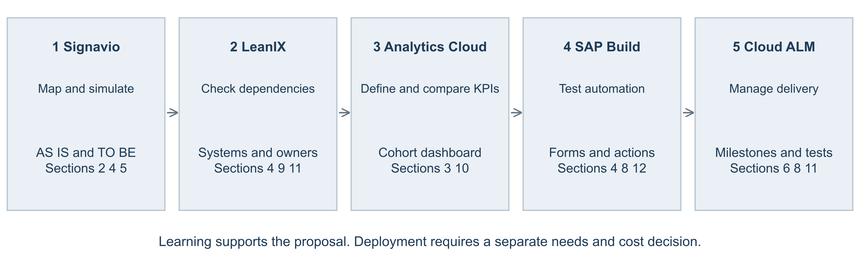
This infographic is an author mapping. Detailed course, unit and lesson references follow. Existing client technology and a verified use case determine any later deployment.

14.1 SAP Signavio
Learning Journey and course: Managing Business Processes with SAP Signavio Solutions. Unit 4: Introducing SAP Signavio Process Manager. Lesson 3: Modeling with the Editor (SAP, n.d.-e) supports the AS-IS and conditional P1 TO-BE models in Sections 2, 4 and 5. Separate copies preserve the A1 models. Model review should trace the normal, rejected or incomplete, overdue and unknown-outcome paths with the service owner, using syntax and modelling-convention checks as supporting controls.
The same course and unit, Lesson 7: Performing Simulations (SAP, n.d.-f), supports a later comparison of process alternatives using validated time, frequency, resource and cost inputs. Simulation would test sensitivity to acceptance delays and workload before live use. No Spark-calibrated simulation or measured reduction in waiting time is claimed.

14.2 SAP LeanIX
Learning Journey: Learning to Use LeanIX for Successful Enterprise Architecture. Course: Learning to Use SAP LeanIX for Successful Enterprise Architecture. Unit 2: Modeling Fact Sheets in SAP LeanIX. Lesson 2: Defining SAP LeanIX Fact Sheets and Modeling Relations and Dependencies (SAP, n.d.-b). Use a dependency inventory to identify case systems, partner interfaces, information owners and the consequences of an integration choice in Sections 4, 9 and 11. The journey and course have different official titles; this mapping identifies the relevant learning location rather than claiming a configured client repository.

14.3 SAP Analytics Cloud
Learning Journey: Becoming a Certified Data Analyst in SAP Analytics Cloud. Course: Designing Stories in SAP Analytics Cloud. Unit 3: Configuring Story Elements. Lesson 2: Configuring Charts (SAP, n.d.-a). Design a dashboard for the KPI definitions in Section 3 and the comparisons in Section 10. Separate pilot and comparison cohorts, show median and P90, and make missing outcomes visible. A chart should use verified case data; public satisfaction percentages cannot be substituted for internal episode measures.

14.4 SAP Build
Learning Journey: Developing with SAP Build – From Apps to Automation. Course: Developing with SAP Build Process Automation. Unit 3: Performing Basic Process Building in SAP Build Process Automation. Lesson 3: Digitalizing User Interactions with Forms (SAP, n.d.-c) supports a potential referral form with required evidence, a named recipient and an explicit acceptance or rejection response. In Sections 4 and 8, test normal submissions, missing information and rejected referrals during process playbacks. Section 12 uses the prototype scope to estimate incremental tool, implementation and support costs.
For actions, the same course’s Unit 5: Using Features of Advanced Process Building in SAP Build Process Automation, Lesson 2: Encapsulating the APIs of Remote Systems Using Actions Projects (SAP, n.d.-d), supports a small authorised interface prototype if P2 or P3 is justified. Test failed requests, duplicate updates and recovery before G2. API access, implementation effort and ongoing support remain unverified; an existing-tool or manual option may be preferable. Neither prototype is presented as a deployed Spark solution.

14.5 SAP Cloud ALM
Learning Journey: Transforming for Success with SAP Cloud ALM. Course: Implementing with SAP Cloud ALM. Unit 2: Setting-Up the Project and Teams. Lesson 1: Setting-Up the Project and Teams (SAP, n.d.-h) supports named responsibilities and project milestones in Sections 6, 8 and 11. Each gate should have an owner, due date and recorded acceptance evidence. The Excel plan demonstrates the proposed schedule; no Cloud ALM tenant is claimed to be configured.
For testing, the same course’s Unit 7: Planning and Executing Testing, Lesson 1: Planning and Executing Testing (SAP, n.d.-g), supports test preparation, execution and defect tracking. At G2, require evidence for normal processing, rejected or incomplete referrals, overdue decisions, unknown outcomes and rollback. The client service owner accepts results only after material defects are resolved; this links the proposed system functionality to service safeguards and handover.

References
Commerce Commission. (2026a, August 18). Consumer satisfaction metrics: Methodology & guide – June 2026. https://www.comcom.govt.nz/assets/Uploads/Consumer-Satisfaction-Metrics-Methodology-Guide-June-2026.pdf
Commerce Commission. (2026b). Customer service and billing rankings – June 2026. https://www.comcom.govt.nz/assets/Uploads/Customer-Service-and-Billing-Rankings-June-2026.pdf
Mills, A. (2025, August 26). Guest lecture Andrew Mills INFOSYS 704 [Video]. University of Auckland. Panopto. https://auckland.au.panopto.com/Panopto/Pages/Viewer.aspx?id=b95c7f4e-914b-486b-bc74-b4b200627d8a
Prodigi Technology Services Limited. (n.d.-a). All our pricing, no meetings required. Retrieved September 15, 2026, from https://prodigi.nz/pricing
Prodigi Technology Services Limited. (n.d.-b). Prodigi business terms. Retrieved September 15, 2026, from https://prodigi.nz/legal/prodigi-business-terms
Rosenbaum, M. S., Otalora, M. L., & Ramírez, G. C. (2017). How to create a realistic customer journey map. Business Horizons, 60(1), 143–150. https://doi.org/10.1016/j.bushor.2016.09.010
SAP. (n.d.-a). Configuring charts. Retrieved September 15, 2026, from https://learning.sap.com/courses/designing-stories-in-sap-analytics-cloud/configuring-charts_ca6acc40-01e5-4f3b-8d7f-1ce8747a628c
SAP. (n.d.-b). Defining SAP LeanIX fact sheets and modeling relations and dependencies. Retrieved September 15, 2026, from https://learning.sap.com/courses/learning-to-use-sap-leanix-for-successful-enterprise-architecture/defining-sap-leanix-fact-sheets-and-modeling-relations-and-dependencies_ce548272-cbab-4d1d-b94b-77d5c13c3935
SAP. (n.d.-c). Digitalizing user interactions with forms. Retrieved September 17, 2026, from https://learning.sap.com/courses/developing-with-sap-build-process-automation/digitalizing-user-interactions-with-forms_d0e78947-8cff-45f0-9b85-d82c1ed0394e
SAP. (n.d.-d). Encapsulating the APIs of remote systems using actions projects. Retrieved September 15, 2026, from https://learning.sap.com/courses/developing-with-sap-build-process-automation/encapsulating-the-apis-of-remote-systems-using-actions-projects_d102638b-94d7-4c2e-9547-bb344e9aa9de
SAP. (n.d.-e). Modeling with the editor. Retrieved September 17, 2026, from https://learning.sap.com/courses/managing-business-processes-with-sap-signavio-solutions/the-editor-quick-n-easy-modeling_fd121490-31f9-4229-a10a-8a3a68972fa3
SAP. (n.d.-f). Performing simulations. Retrieved September 15, 2026, from https://learning.sap.com/courses/managing-business-processes-with-sap-signavio-solutions/basic-simulation_fbe67690-eb99-4861-9773-2b05c0144e79
SAP. (n.d.-g). Planning and executing testing. Retrieved September 17, 2026, from https://learning.sap.com/courses/implementing-with-sap-cloud-alm/planning-and-executing-testing_ef46a49b-9885-4aaa-841d-5ac9c80a3681
SAP. (n.d.-h). Setting-up the project and teams. Retrieved September 15, 2026, from https://learning.sap.com/courses/implementing-with-sap-cloud-alm/setting-up-the-project-and-teams_eee6ae76-7b22-4393-844d-be56ec4fe45a
Scott, J. E., & Vessey, I. (2002). Managing risks in enterprise systems implementations. Communications of the ACM, 45(4), 74–81. https://doi.org/10.1145/505248.505249
Spark. (n.d.-a). Check your connection. Retrieved September 15, 2026, from https://www.spark.co.nz/help/internet/troubleshoot/fixmybroadband
Spark. (n.d.-b). Set up fibre. Retrieved September 17, 2026, from https://www.spark.co.nz/help/internet/set-up/fibre-internet
Spark. (n.d.-c). Stay connected during an outage. Retrieved September 15, 2026, from https://www.spark.co.nz/help/internet/manage/outage-assist/
Spark New Zealand Limited. (2026a, August 20). Spark annual report FY26. https://investors.sparknz.co.nz/FormBuilder/_Resource/_module/gXbeer80tkeL4nEaF-kwFA/doc/FY26_Annual_Report.pdf
Spark New Zealand Limited. (2026b). Spark New Zealand FY26 results summary. https://investors.sparknz.co.nz/FormBuilder/_Resource/_module/gXbeer80tkeL4nEaF-kwFA/doc/H2FY26_Results_Presentation.pdf
Sundaram, D. (2026). INFOSYS 704: IT consultancy, lecture 7 – Implementation roadmaps [PowerPoint slides]. University of Auckland, Canvas. https://canvas.auckland.ac.nz/courses/143335/files/18259667

Use of Generative AI
I used OpenAI Codex to help review the assignment requirements and sources, compare options, and refine the wording, formatting and layout. I directed and confirmed the scope, evidence boundaries and conditional intervention. Public facts are cited; planning inputs and unverified internal information are labelled. No generated interview, Spark measurement or professional experience is presented as evidence. I remain responsible for the submitted argument and final review.

