INFOSYS 704: IT Consultancy
A1-D1 — Identifying Business Needs
and Framing the Problem
Spark New Zealand: Mobile Plan-Review and Right-Planning Process
Rae Huang | UPI: xhua725
Financial Problem Domain

Executive Summary
Spark's annual mobile plan-review journey has an Operational information gap whose financial significance still needs to be measured. Mobile is Spark's largest gross-margin contributor, and the company's share of New Zealand mobile subscribers fell from 41% to 39% between June 2024 and June 2025. H1 FY26 mobile service revenue grew 1.6%, while pay-monthly and prepaid connections declined 0.3% and 2.6% respectively (Commerce Commission, 2026; Spark New Zealand Limited, 2026). Those figures show why the process deserves attention, although they do not tell us whether plan review affected the result.
The process concern is independently observed. Spark paused annual summaries in February 2025 and planned replacements without the prior personalised stay-or-switch recommendation or embedded historical information. The Commerce Commission later concluded that Spark's right-planning progress had stalled, even though Spark retained an 80% overall transparency score (Commerce Commission, 2025, 2026). Under the reported replacement design, customers would need to follow a link for details and compare increasingly varied offers themselves at a critical retention moment.
Financial is the primary problem domain, with Operational and Strategic factors treated as drivers. Five Forces and strategy models provide the wider context. The rich picture and BPMN show where customers face extra work in the reported replacement journey, and the Lecture 4 / McKinsey issue tree sets up the analysis for A1-D2. The practical question is whether a lower-effort, evidence-based review improves plan choice and 90-day retention while maintaining segment ARPU and complaint performance.

1. Company and Industry Context

1.1 Company overview, purpose and vision
Spark New Zealand is the country's largest telecommunications company, serving individuals and households, small and medium businesses, government, and large organisations. Its network and services reach almost every New Zealander, and it reported more than 2.6 million mobile connections in FY25 (Spark New Zealand Limited, 2025a). Spark does not label a separate mission in its FY25 report; its purpose—"to help all of New Zealand win big in a digital world"—serves as the mission-level statement (Spark New Zealand Limited, 2025a, p. 11). Its FY30 vision/ambition, "It's better with Spark", converts that purpose into two customer-facing promises: a better network and better customer experiences (Spark New Zealand Limited, 2025a, pp. 14–16; 2025b, p. 1).
SPK-30 refocuses investment on core connectivity. Mobile, broadband and business connectivity contribute approximately 80% of group gross margin and are the priority for capital allocation. Spark also intends to improve digital journeys and use AI to present the right offer to the right customer at the right time (Spark New Zealand Limited, 2025b). The selected plan-review process therefore sits inside both Spark's economic core and its stated customer-experience ambition.

1.2 Products and services
Customer segment | Principal products and services | Value delivered
Individuals and households | Spark and Skinny mobile; broadband; devices; content and related digital services | Everyday connectivity, access and convenience
SMEs | Mobile and broadband; locally operated Business Hubs; digital productivity support | Reliable operations, mobility and accessible advice
Enterprise and government | Managed data and networks; collaboration; IoT; cloud, data and AI; service management | Secure, resilient and scalable digital operations
Wholesale / partners | Network access and messaging-related services | Platform reach and network utilisation

The portfolio summary is based on Spark's official FY25 reporting (Spark New Zealand Limited, 2025a). This report focuses on consumer and SME pay-monthly mobile customers. They represent a meaningful part of the business while keeping the process narrow enough for detailed analysis, consistent with the course's process-selection guidance (University of Auckland, 2026a).

1.3 Customers, suppliers and partners
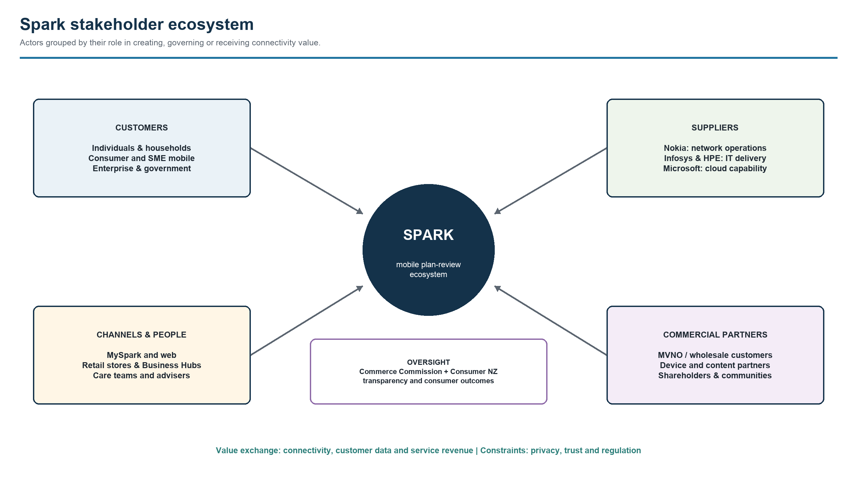
Figure 1. Spark stakeholder ecosystem. Source: author analysis based on Spark New Zealand Limited (2025a).
The map separates customers from delivery channels, suppliers and oversight stakeholders. Nokia, Infosys, HPE and Microsoft support Spark's network, IT and cloud capability; care teams, MySpark, web and Business Hubs turn that capability into service. The Commerce Commission and Consumer NZ influence transparency expectations. In practice, the journey depends on the customer data available, what digital channels show and the support offered by care teams. Privacy, trust and consumer-protection expectations shape each of these.

1.4 Industry analysis: Porter’s Five Forces
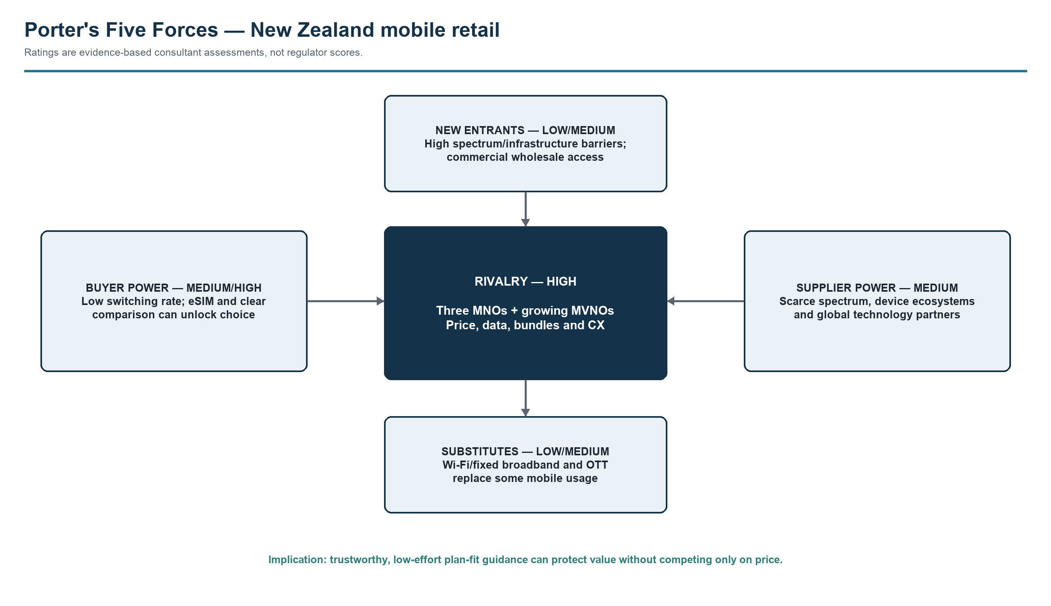
Figure 2. Porter's Five Forces for New Zealand mobile retail. Source: author analysis based on Commerce Commission (2026).
Rivalry is high despite structural concentration. The national retail mobile market had an HHI of 3,289 and the three MNOs held 96.8% of subscribers in 2025. Yet MVNO share rose to 3.2%, MVNOs acted as price leaders, and competition increasingly centred on data allowances, speed tiers, bundles and service quality (Commerce Commission, 2026). Buyer power is medium-to-high: only 7% of users changed provider in the preceding 12 months, but eSIM and clearer comparison can lower switching friction and make latent choice actionable. New-entry threat remains low-to-medium because nationwide coverage requires spectrum, infrastructure and scale, while wholesale access is commercially negotiated. Supplier power is medium: spectrum is scarce, device ecosystems are concentrated, and Spark's own strategy identifies Nokia, Infosys, HPE and Microsoft as important global delivery partners (Spark New Zealand Limited, 2025a). Functional substitution is low-to-medium because Wi-Fi/fixed broadband and over-the-top calling or messaging can replace some mobile usage, but not ubiquitous mobile access.
Price remains important, although it does not explain the whole competitive problem. In a complex market, trustworthy plan-fit guidance may reduce customer effort, demonstrate fairness and support retention. For Spark, that is part of the service experience as well as a way to protect value.

1.5 Strategy model: broad differentiation
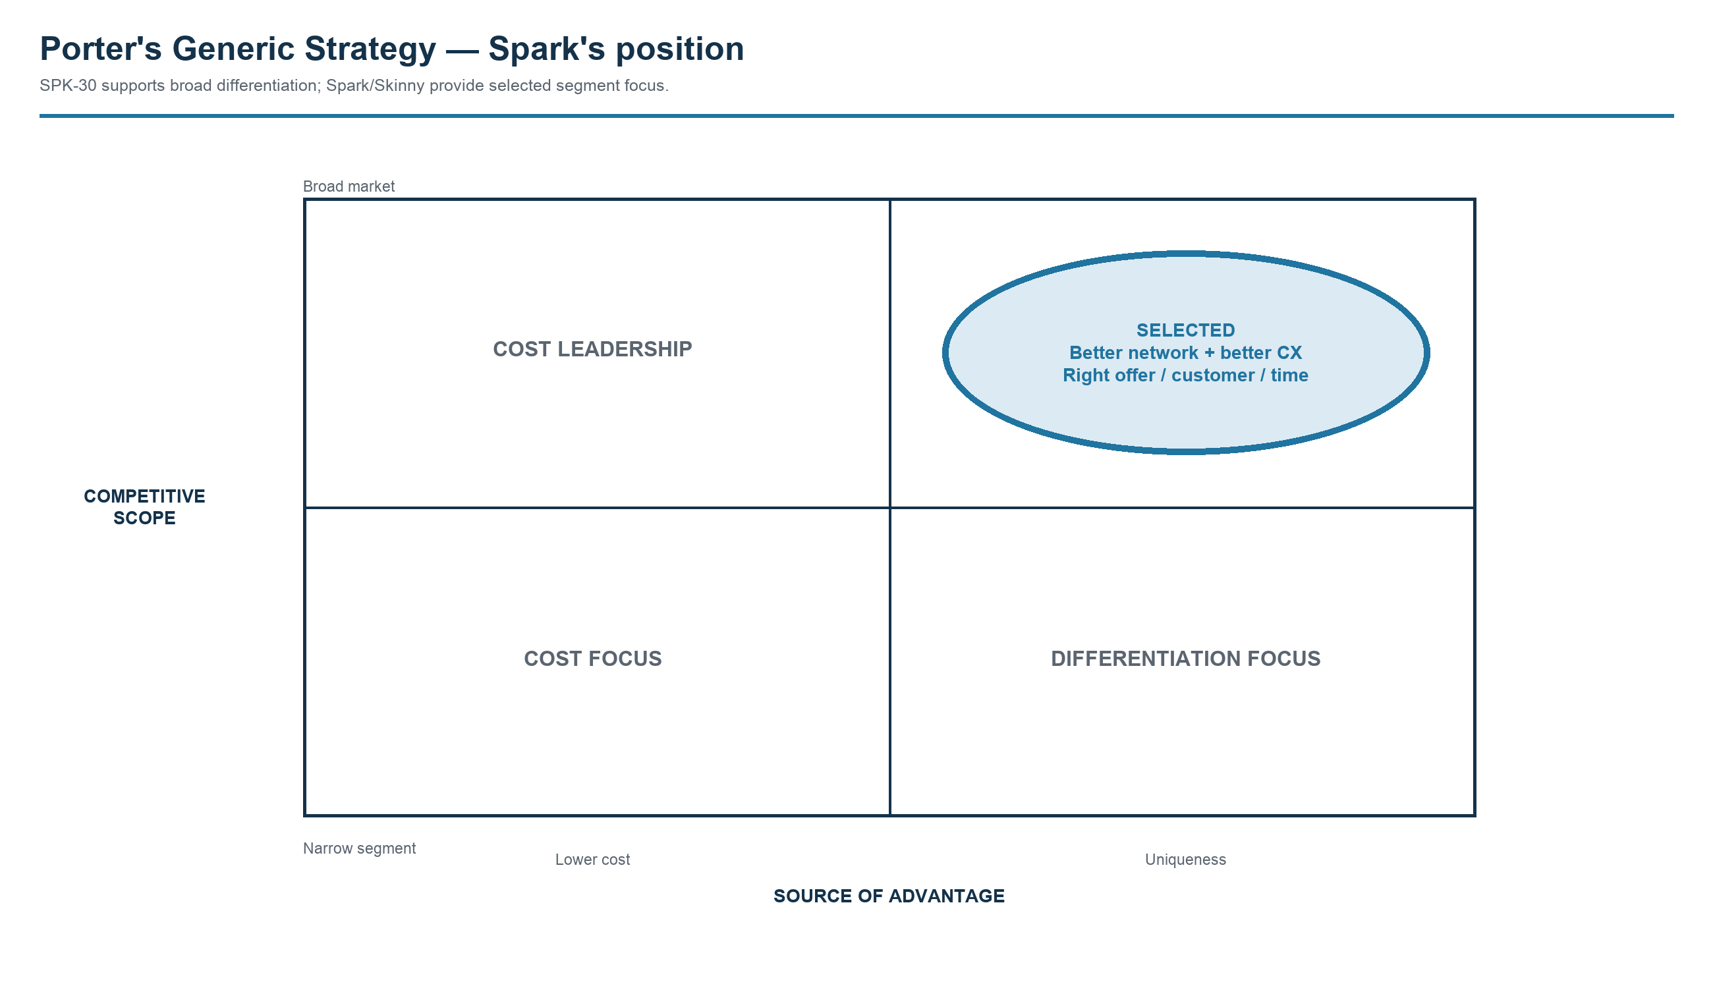
Figure 3. Porter's Generic Strategy applied to Spark. Source: author analysis based on Porter (1980) and Spark New Zealand Limited (2025b).
Spark's selected generic strategy is broad differentiation. SPK-30 centres on reliable connectivity and a better end-to-end customer experience, including digital journeys and loyalty recognition. Spark and Skinny provide some segment focus, but at group level the offer depends more on trusted connectivity and service than on being the lowest-cost provider. Removing useful direction from the plan-review journey sits uneasily with that position. Evidence-based right-planning would put Spark's customer data to use when customers are deciding whether their plan still represents value.

1.6 Porter value chain
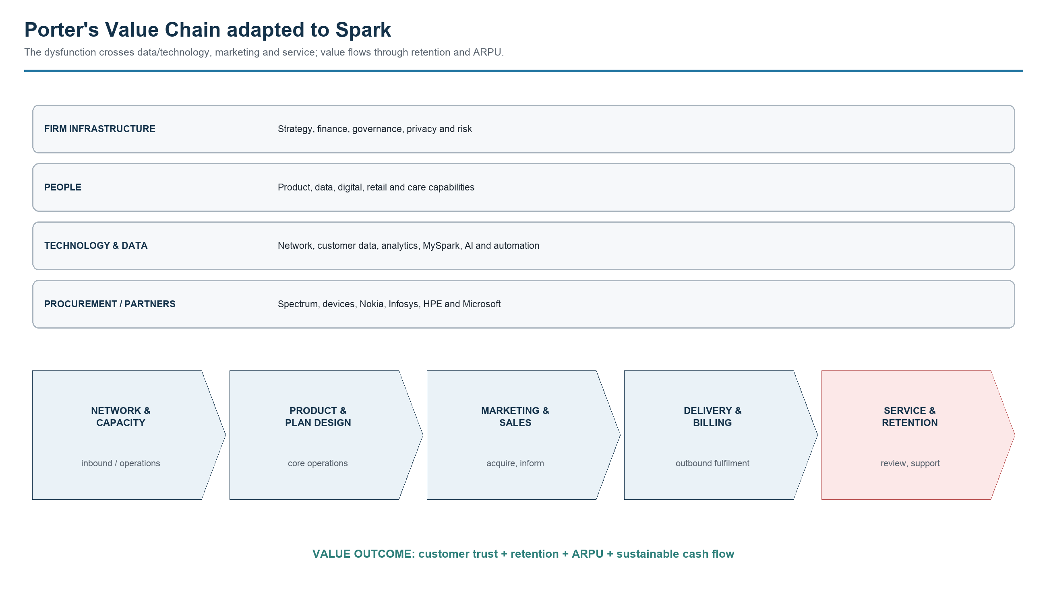
Figure 4. Porter's Value Chain adapted to Spark. Source: author analysis based on Porter (1985) and Spark New Zealand Limited (2025a, 2025b).
The adapted primary activities map to Porter's canonical chain as follows: network/capacity and product/plan design form inbound and core operations; marketing and sales create demand; delivery and billing perform service fulfilment (the telecom equivalent of outbound logistics); and service/retention supports customers after activation. Technology and data create usage and spend information, while partners and people enable the chain. If the review omits embedded history and a personalised recommendation, the chain does not convert existing data capability into customer or financial value. The management question is whether fixing that hand-off improves retention and appropriate plan selection at acceptable ARPU.

2. Business Needs and AS-IS Situation

2.1 AS-IS rich picture
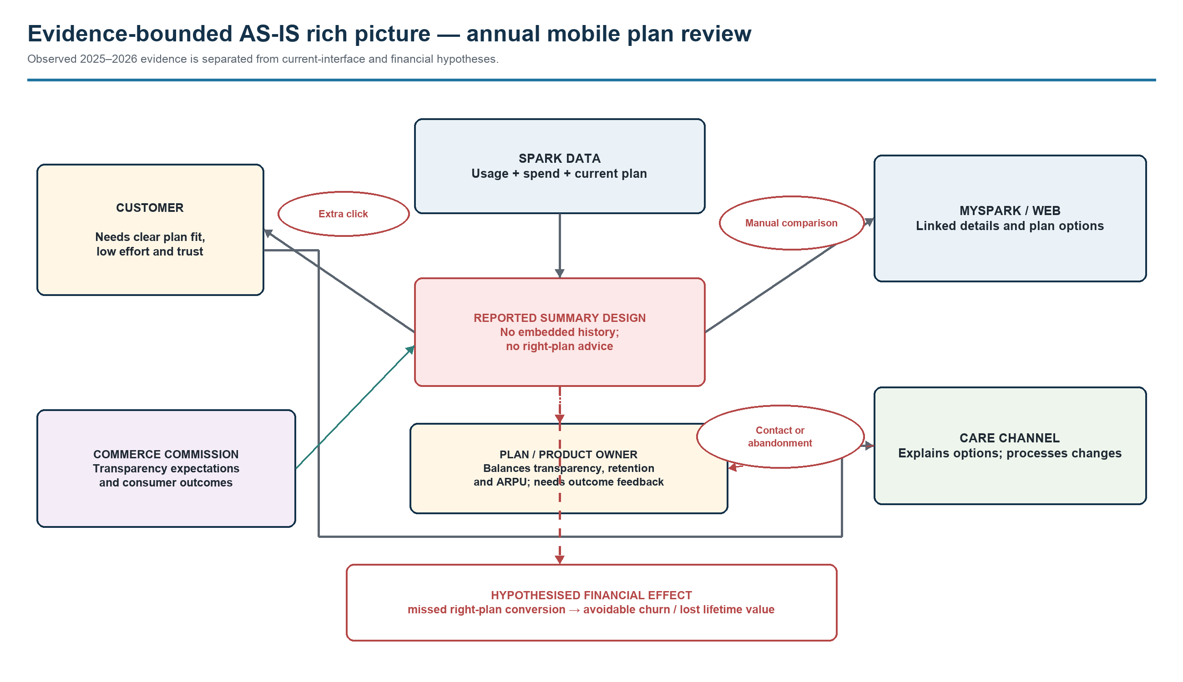
Figure 5. AS-IS rich picture of the annual mobile plan-review situation. Solid flows are evidence-backed; dashed red effects are hypotheses. Source: author analysis based on Commerce Commission (2025, 2026).
The central tension is informational asymmetry. Providers necessarily process usage and spend data for billing and summaries; however, Spark's replacement design reported in October 2025 was expected to omit embedded historical information and personalised direction, and the Commission's 2026 report concluded that right-planning progress appeared to have stalled. Customers were directed to follow a link for details, creating additional retrieval and comparison effort (Commerce Commission, 2025, 2026). The precise live 2026 interface and any resulting contact, abandonment, churn or plan conversion remain to be validated rather than asserted.

2.2 Prioritised business needs
Priority | Business need | Justification and measure
1 — outcome | Protect mobile retention value | Mobile is economically core. Measure review completion, appropriate plan change, 30/90-day churn and ARPU.
2 — customer prerequisite | Reduce plan-fit decision effort | Reported replacement gap: embedded history and personalised recommendation were expected to be absent. Measure clicks, abandonment, completion time and care contacts.
3 — measurement prerequisite | Establish closed-loop outcome measurement | Link review events to plan changes, complaints, churn and ARPU; otherwise the journey cannot learn.
4 — guardrail | Maintain trust and transparency | Align with regulator expectations; monitor plan-review complaints and perceived clarity.
5 — enabler | Enable consistent channel support | Present the same evidence to customers and care staff; monitor first-contact resolution and repeat contacts.

Retention value is ranked first. Better information and reliable event linkage are needed to see whether the process improves it. Trust protects against harmful optimisation, while consistent support helps customers who move between digital and care channels. The five needs are connected, but the first three determine whether the financial case can be demonstrated.

3. Problem Framing and Analysis Design

3.1 Problem type: Financial
The reported concern is Operational/customer-transparency: under the October 2025 replacement design, additional information retrieval would replace embedded history and personalised direction. This report adopts Financial as the primary lens because the decision concerns retention value, connection volume, ARPU and customer lifetime value in Spark's largest gross-margin business. H1 FY26 mobile service revenue was $499 million, up 1.6%; pay-monthly connections were 1.203 million, down 0.3%; prepaid connections were 1.077 million, down 2.6%; and pay-monthly ARPU increased 5.0% to $46.23 (Spark New Zealand Limited, 2026). Strategic and Organisational factors remain secondary or to validate; no financial loss is treated as proven.
Domain | Classification | Justification / example
Financial | Primary problem ownership | Potential loss of retention value; measured through connections, churn, ARPU, contribution margin and lifetime value.
Operational | Direct process driver | Extra navigation, manual comparison and possible care contact would increase effort in the reported replacement journey.
Strategic / competitive | Material consequence | The gap conflicts with broad differentiation and SPK-30 customer-experience positioning.
Organisational | Enabling question, not proven dysfunction | Cross-functional ownership and outcome measurement require validation; no public evidence supports an organisational-failure claim.

3.2 Dysfunctional process and evidence boundary
The selected process is the annual mobile plan-review journey from review trigger to a customer's stay, change or contact decision. It is important because it occurs at a natural retention moment and uses data Spark already possesses. It is dysfunctional in a specific, independently observed way: Spark paused annual summaries in February 2025; the replacement was expected without the earlier personalised right-plan recommendation and without embedded historical information (Commerce Commission, 2025). The Commission's 2026 report states that Spark's progress on right-plan recommendations appears to have stalled, although Spark retained an 80% overall transparency score.
Statement | Status | Use in this report
The October 2025 replacement design was expected to omit embedded history and personalised right-plan advice | Verified public report | Defines the reported process gap; the live 2026 interface remains to be checked.
Spark mobile share moved from 41% to 39% between June 2024 and June 2025 | Verified fact | Establishes material context, not causation.
The process creates avoidable churn or missed retention value | Unverified hypothesis | Test with matched cohorts or an experiment.
Spark lacks internal outcome tracking | Unknown | Do not assert; validate with process owners and data teams.

Market share can move for many reasons, including pricing, promotions, plan mix, service quality and measurement changes. It cannot, on its own, establish the financial effect of the plan-review process. Financial impact is therefore treated as a hypothesis to be tested against customer-level evidence.

3.3 SMART problem statement
Observed problem: In October 2025, Spark's replacement annual mobile summary was expected to omit embedded historical usage/spend and the previous personalised stay-or-switch recommendation; the Commerce Commission's 2026 monitoring report assessed that right-planning progress had stalled. The financial effect on retention value has not yet been quantified.
SMART problem statement: In October 2025, Spark's replacement annual mobile summary was expected to remove embedded historical usage/spend and the previous personalised guidance from annual plan reviews, increasing decision effort for eligible consumer and SME pay-monthly customers. By 30 June 2027, Spark should establish a validated FY26 baseline and reduce any associated performance gap so that review completion improves by at least 5 percentage points against a suitable comparison journey, with 90-day retention value non-inferior or better and no deterioration in segment ARPU or complaint rates.
The customer group, process and deadline are explicit. Completion and financial outcomes can be compared with a validated FY26 baseline, while retention, ARPU and complaints prevent a narrow optimisation of clicks alone. The five-point threshold is a working value for analysis rather than an authorised Spark commitment. A1-D2 should confirm statistical power, implementation cost and acceptable guardrail tolerances with Spark.

3.4 Framework selection and justification
The selected framework is a MECE, hypothesis-driven issue tree adapted from Lecture 4 and The McKinsey Mind. Lecture 4 requires problems to be decomposed into mutually exclusive, collectively exhaustive branches, then converted into hypotheses that determine the minimum analysis needed to prove or disprove them. It explicitly uses profitability as revenue versus cost and customer churn as a diagnostic-tree example (University of Auckland, 2026a, slides 7–11; Rasiel & Friga, 2001).
A generic profitability tree would be too broad for this process. Five Forces and Generic Strategy are useful for context, but neither shows where the plan-review journey may lose value. The issue tree therefore traces the customer journey from engagement through plan-fit assessment and action to the value retained after the decision. Closed-loop measurement sits across the branches because it affects what can be demonstrated rather than how customers behave. Every branch points to a specific test or dataset.

3.5 MECE issue tree
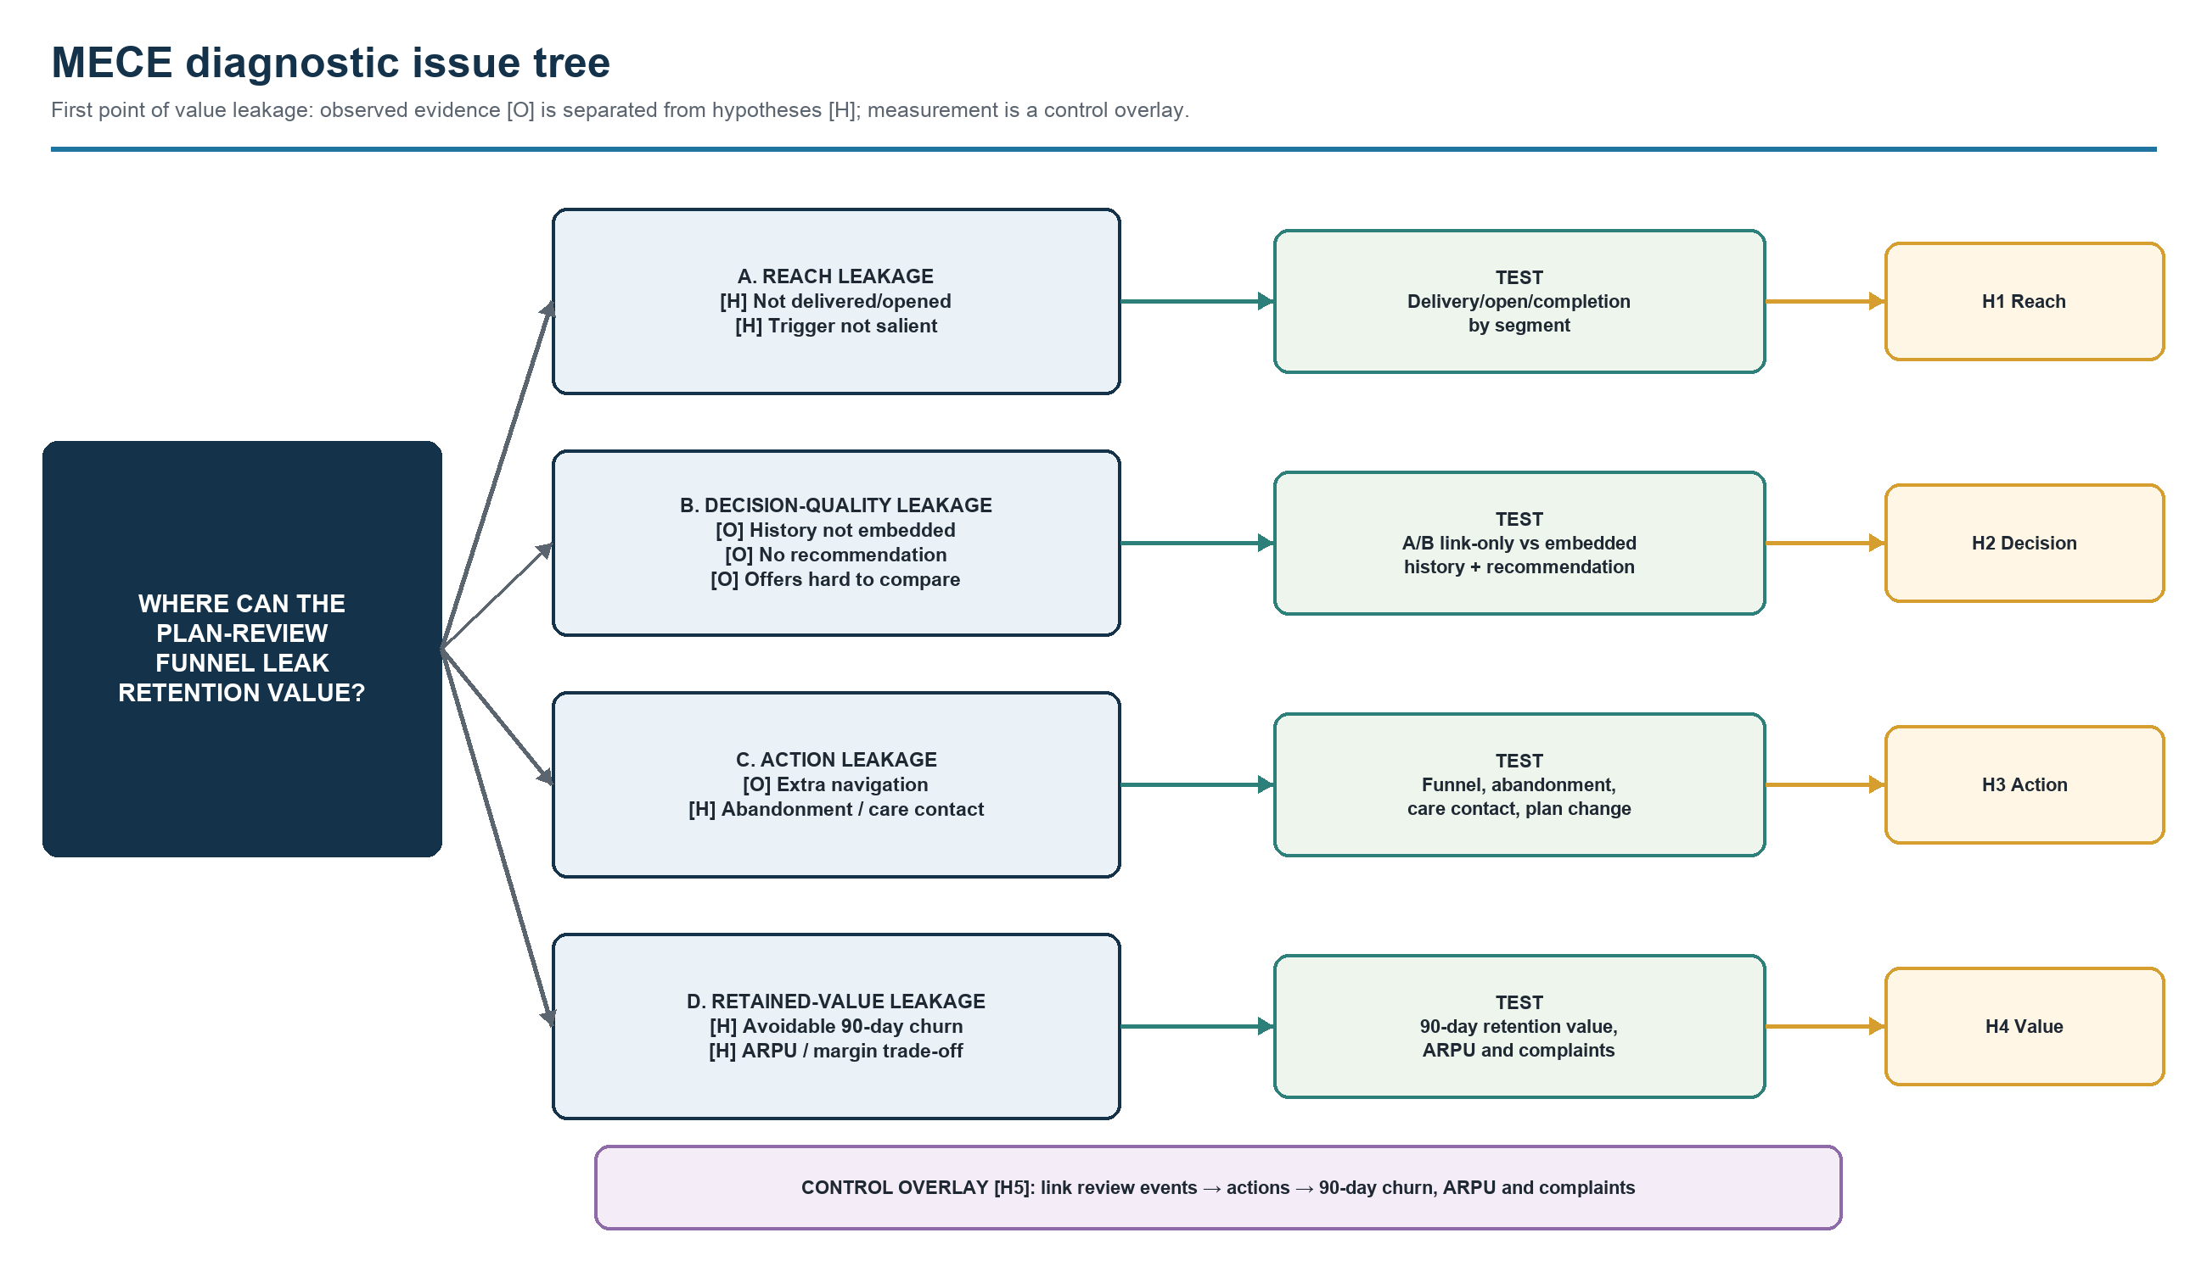
Figure 6. MECE diagnostic issue tree and linked tests. Source: author analysis adapted from University of Auckland (2026a) and Rasiel and Friga (2001).
The tree places each possible cause at the earliest point where value may be lost. Some customers may never engage with the review; others may struggle to judge plan fit or abandon an intended action. Retained value is measured after the decision. Event linkage appears beneath the tree because it is a measurement issue, not a customer behaviour. Labels [O] and [H] separate public evidence from points that still require testing.

3.6 Testable hypotheses and analysis
ID | Hypothesis | Minimum test and decision rule
H1 | A randomised salient reminder increases review completion by at least 5 percentage points versus no reminder. | Customer-level A/B test among eligible recipients; support only if the lower bound of the 95% CI is at least +5 percentage points.
H2 | Embedding historical usage/spend plus a recommendation increases completion and appropriate plan choice versus link-only. | A/B test. “Appropriate” means the selected plan matches a pre-registered usage/spend fit rule; require at least a five-point completion uplift without lower fit.
H3 | Removing the extra navigation step reduces abandonment and care contacts per completed review by at least 10% relative. | Journey funnel plus contact-reason analysis; reject unless both the directional effect and pre-set materiality threshold are met.
H4 | The enhanced right-planning journey creates positive incremental 90-day retention value without reducing segment ARPU. | A/B or phased rollout; retained contribution margin less journey/contact cost must be positive, with non-inferior ARPU and complaint guardrails.
H5 | After controlling for tenure, segment, plan and campaign, review-step abandonment is positively associated with 90-day churn. | Linked event-log model; support only if the abandonment coefficient is positive and its 95% CI excludes zero. Association is not treated as causation.

The financial test uses incremental retention value: contribution margin retained because of the treatment, minus journey and contact costs. ARPU and complaints remain guardrails, so an increase in clicks or plan switches alone would not count as success.

3.7 AS-IS SAP Signavio process model
The process starts with an annual trigger and the use of customer usage, spend and current-plan data. In the replacement design reported in October 2025, Spark would send a summary without embedded history or a personalised right-plan recommendation. The customer would then decide whether the summary was sufficient. If more detail was needed, the customer would follow a link, retrieve the information and compare plans manually. The journey could end with the customer staying, requesting a plan change or contacting care before making a decision.
Model boundary and validation: this is a customer-facing conceptual AS-IS. Public sources do not identify Spark's internal system names, recommendation rules, process owner, exception flows or whether review events are linked to churn and ARPU. Those elements are deliberately not invented. A1-D2 should validate them through process-owner interviews, event-log inspection and data-dictionary review. The SAP Signavio model uses two participant pools, two Spark role lanes, message flows, start/end events, tasks, exclusive gateways and labelled sequence flows so the observed dysfunction and unverified paths are syntactically visible.

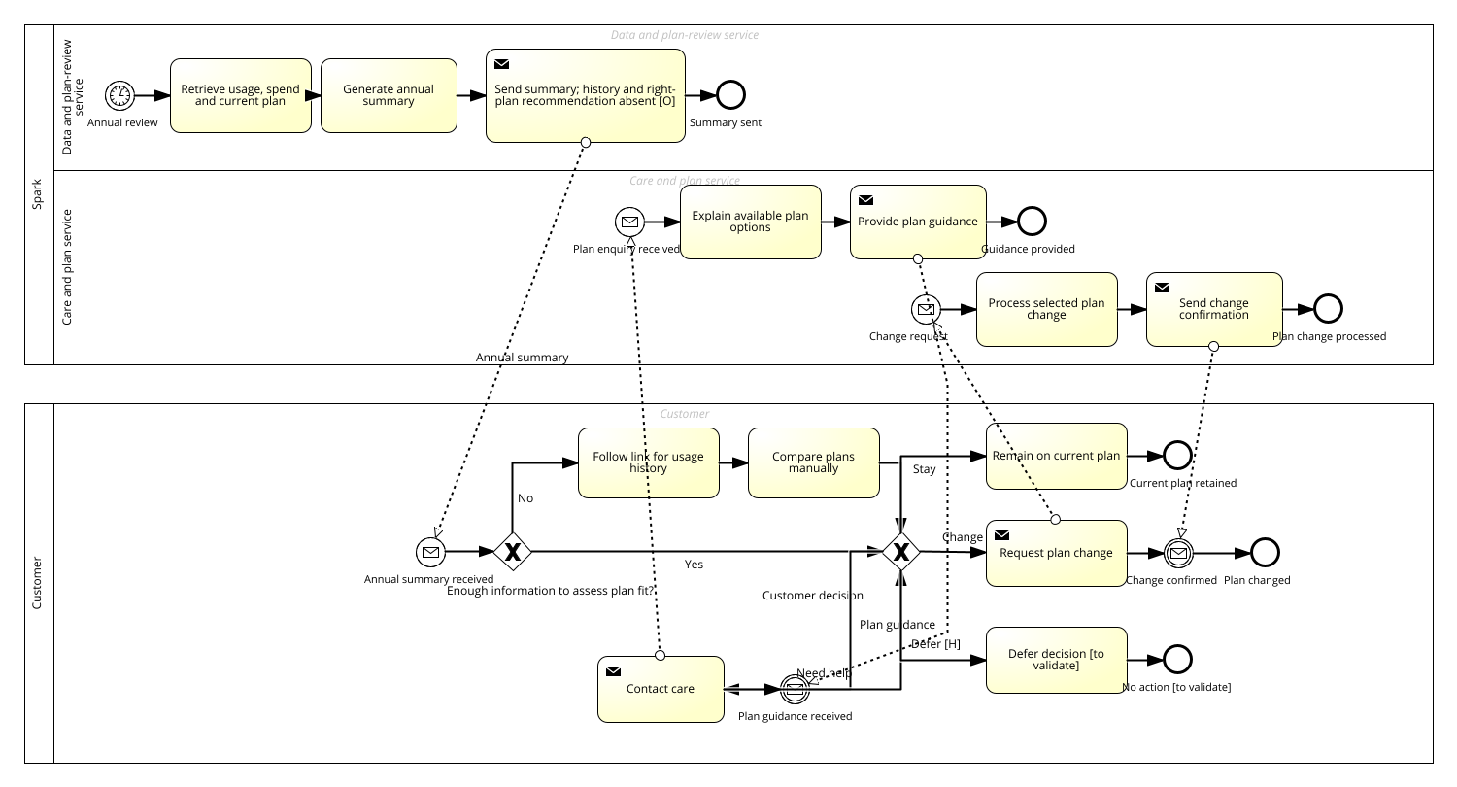
Figure 7. Full AS-IS process overview — SAP Signavio export. Figures 7a–7d enlarge the same export for label-level review. [O] marks the externally observed information gap; [H] and “to validate” mark unverified paths. Source: author model based on Commerce Commission (2025, 2026).

Figures 7a–7d are overlapping enlarged panels from the same SAP Signavio export. Read the Spark lanes first, then the Customer lane, from left to right.
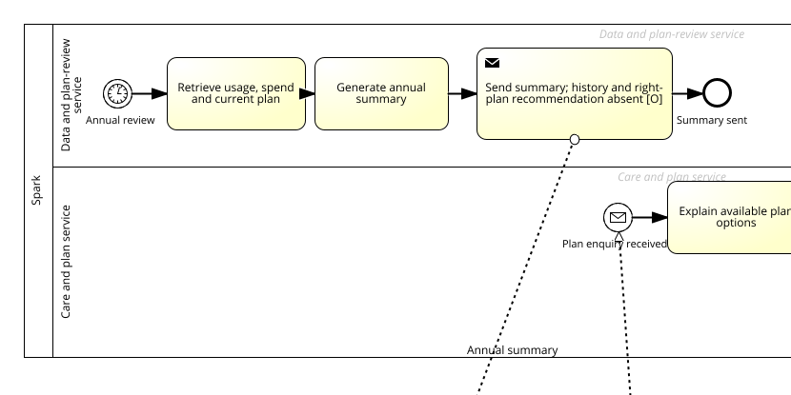
Figure 7a. SAP Signavio export — Spark lanes, left panel.
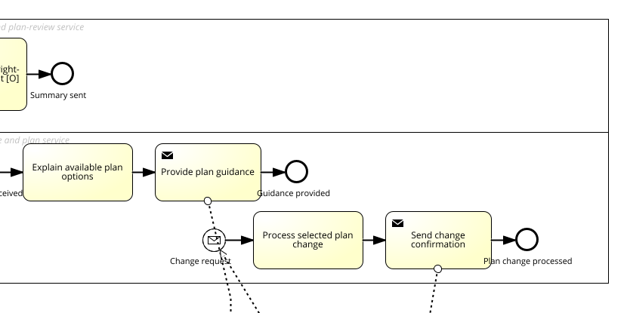
Figure 7b. SAP Signavio export — Spark lanes, right panel.

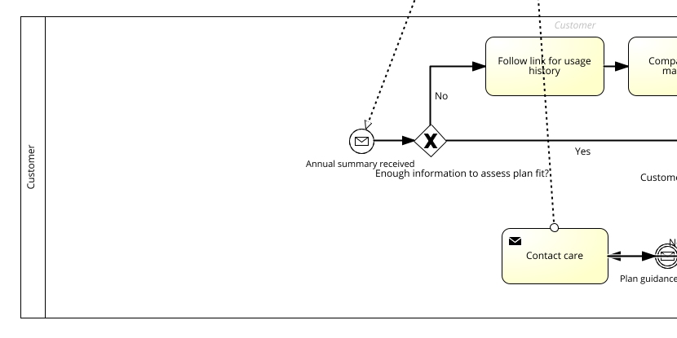
Figure 7c. SAP Signavio export — Customer lane, left panel.
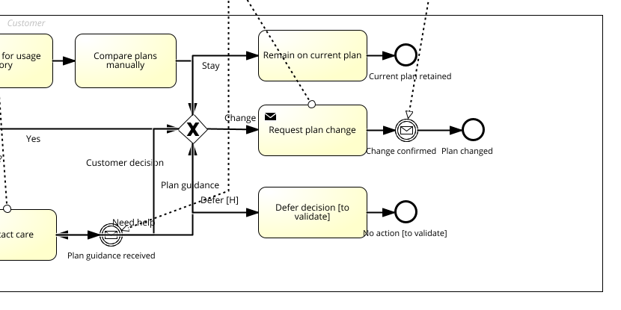
Figure 7d. SAP Signavio export — Customer lane, right panel. [O] marks the externally observed information gap; [H] and “to validate” mark unverified paths. Source: author model based on Commerce Commission (2025, 2026).

4. Conclusion
The plan-review journey is a manageable part of Spark's wider retention problem. Commerce Commission evidence points to a specific weakness in the replacement design: customers may have to assess plan fit without the embedded history and personalised guidance that previously supported the decision. Mobile is central to Spark's margin and service strategy, so even a modest link with avoidable churn could matter. That link has not been demonstrated, and it remains the main question for the next stage.
A1-D2 should begin with FY26 baselines and link review events to later customer outcomes. A comparison between an embedded-information treatment and the reported link-only journey could then test 90-day retention value, ARPU, complaints and contact cost. The results would indicate whether the transparency problem is commercially material enough to justify redesign.

References
Commerce Commission. (2025, October 2). Spark, 2degrees and One NZ stall on billing transparency.
https://www.comcom.govt.nz/news-and-media/news-and-events/2025/spark-2degrees-and-one-nz-stall-on-billing-transparency/
Commerce Commission. (2026). 2025 telecommunications monitoring report.
https://www.comcom.govt.nz/assets/Uploads/2025-Telecommunications-Monitoring-Report-29-June-2026.pdf
Porter, M. E. (1980). Competitive strategy: Techniques for analyzing industries and competitors. Free Press.
Porter, M. E. (1985). Competitive advantage: Creating and sustaining superior performance. Free Press.
Rasiel, E. M., & Friga, P. N. (2001). The McKinsey mind: Understanding and implementing the problem-solving tools and management techniques of the world's top strategic consulting firm. McGraw-Hill.
Spark New Zealand Limited. (2025a). FY25 annual report.
https://www.spark.co.nz/content/dam/spark/documents/pdfs/governance/FY25_Annual_Report.pdf
Spark New Zealand Limited. (2025b, September 11). Spark releases FY30 strategy and update on Chair succession.
https://investors.sparknz.co.nz/DownloadFile.axd?file=Announcements%2FNZX%2F20250911%2F451842.pdf
Spark New Zealand Limited. (2026). H1 FY26 results summary.
https://investors.sparknz.co.nz/DownloadFile.axd?file=Announcements%2FNZX%2F20260218%2F462497.pdf
University of Auckland. (2026a). Framing the problem, AS-IS modelling, designing the analyses [PowerPoint slides]. INFOSYS 704: IT Consultancy.

