INFOSYS 704 —— A1-D2
Designing Analysis Gathering Data Analysing Data and Interpreting Results
Spark New Zealand Operational Analysis
Residential Broadband Issue-to-Resolution Process

Name Ryan Li
UPI ali409
Student ID 693997238
Company Spark New Zealand Limited
Analytical lens Operational
Date 27 August 2026

EXECUTIVE SUMMARY

This individual report continues the operational analysis established in A1-D1. The focal process is Spark New Zealand’s residential broadband issue-to-resolution process, from a customer’s first report or self-check through diagnosis, routing, restoration, communication and customer-confirmed stable service.
Published Commerce Commission results support a firm customer-outcome judgement: Spark’s 41% satisfaction with resolution speed and 52% satisfaction with staff helpfulness and knowledge are materially below the Commission methodology’s 75%–85% ‘good’ range (Commerce Commission, 2026a, 2026b). Public evidence does not identify the internal cause. The report therefore tests, rather than assumes, H3: discontinuous ownership or material status gaps in multi-organisation cases may add handoff waiting and extend end-to-end resolution time.

The proposed major KPI is an author-developed Residential Broadband Issue-Resolution Satisfaction Index. Its equal-weighted baseline is 46.5%, calculated from the two published components, and is labelled unvalidated because it combines two separate survey items rather than a Commission-defined composite. The proposed target is at least 75% by 30 June 2030, with a non-compensation gate requiring both components independently to reach at least 75%. These are consulting proposals, not Spark commitments or Commerce Commission metrics. Operational measures such as acknowledgement time, visible owner/status coverage, waiting share, recontact and stable-confirmation coverage remain diagnostic measures that require internal baselines.

The analysis plan links issue episodes across self-service, customer-support, incident, partner-communication and customer-outcome records. It begins with data-quality and process-mining analysis before matched or model-based comparison of comparable multi-organisation cases. The interview component uses the same nine-section guide with strategic group member Francis Lee and a GenAI analytical respondent. Both respondents converge on H3 as a plausible operational priority while also identifying case complexity, misrouting and communication as alternative explanations. Their agreement supports the analytical priority of H3 but cannot establish an internal Spark cause without linked case and event evidence.
On this evidence, the candidate best pathway is a bounded pilot of Cross-Organisation Broadband Resolution Orchestration: one persistent Spark customer-case accountability role, a standard handoff packet, explicit partner acknowledgement, normalised status events, customer-update triggers and stable-restoration confirmation. The solution addresses Rosemann’s (2001) outcome, activity-flow and resource perspectives and is more complete than governance-only, technology-only or communication-only alternatives. An 18-month staged plan begins with validation and contains stop-or-pivot gates before integration and scale.

REVISED A1-D1 ANALYTICAL BASELINE

Process boundary and dysfunction judgement
The selected process begins when a residential broadband customer perceives degradation and initiates a Spark self-check or assisted-support contact. It ends only when stable restoration is confirmed by the customer an unresolved or unstable result returns the same episode to diagnosis and escalation. Billing new installation plan review general mobile service and enterprise-managed services remain outside scope. The boundary is operational because it follows work information waiting and responsibility through a repeatable service episode rather than deciding Spark’s corporate portfolio or organisation structure.
The process is classified as dysfunctional at the customer-outcome level. In the Commerce Commission’s December 2025 residential broadband rankings, 43% of Spark respondents reported at least one listed issue in the preceding six months. Among Spark respondents who had experienced an issue, 41% were satisfied with the time taken to resolve it, and 52% rated staff helpfulness and knowledge positively; the latter two measures each used a Spark broadband sample of n = 371. The methodology defines satisfaction as a top-two-box response of 4 or 5 on a five-point scale and describes 75%–85% as a ‘good’ range (Commerce Commission, 2026a, 2026b).

The evidence boundary is material. The 43% result covers reliability, speed, price, billing, installation and other issues; it is not a technical-fault rate. The 41% and 52% results are customer perceptions, not event-log evidence, and do not prove that Spark, Nokia or an LFC failed a specific handoff. The defensible conclusion is therefore two-level: the customer-outcome dysfunction is established, while D1–D5 and H1–H4 remain explanations requiring linked internal data. Spark’s public Check Connection and Outage Assist capabilities, together with its reported use of AI to identify repeat customer interactions and escalate complex cases for faster resolution, indicate active efforts to improve service operations (Spark New Zealand, n.d.-a, n.d.-b; Spark New Zealand Limited, 2026). However, these initiatives do not demonstrate consistent end-to-end resolution or establish H3’s proposed causal mechanism.

1.2 Problem statement and SMART objective

Problem statement Spark’s residential broadband issue-to-resolution process produces customer-reported resolution-speed and staff-support outcomes below a credible service-quality range while public evidence does not reveal which process variants information discontinuities routing decisions partner handoffs or closure practices create the gap.

Proposed SMART objective: Using the Commerce Commission’s December 2025 residential broadband rankings as the baseline, Spark should, by 30 June 2030, increase the proportion of residential broadband customers who experienced an issue and were satisfied with resolution speed from 41% to at least 75%, and the proportion satisfied with staff helpfulness and knowledge from 52% to at least 75%, measured with a comparable survey population, wording, scoring and weighting method (Commerce Commission, 2026a, 2026b).

The objective is specific to residential broadband customers who experienced an issue, measurable through two defined top-two-box outcomes, relevant to SPK-30’s better-customer-experience ambition (Spark New Zealand Limited, 2025c), and time-bound to FY30. The lower boundary of the Commission’s ‘good’ range makes 75% a transparent stretch level, but feasibility must be tested (Commerce Commission, 2026a). The objective and deadline are proposed by this report and have not been announced by Spark.

1.3 Revised issue tree and hypotheses

The stage-based issue tree retains the A1-D1 boundary and four mutually distinct first-level questions

B1 —— Access and context Is identity prior contact and diagnostic evidence available when the next actor begins work
B2 —— Diagnosis and routing Is the likely fault domain identified and routed correctly at the earliest reasonable point
B3 —— Resolution and cross-organisation handoffs Is ownership and technical status visible while Spark Nokia or a relevant LFC acts
B4 —— Communication verification and closure Are material updates delivered and stable restoration confirmed before final closure

The corresponding hypotheses are

H1 —— Cases requiring repeated authentication or context reconstruction will show more handling effort and near-term repeat contact than comparable context-complete cases.
H2 —— Rerouted or reclassified cases will show longer elapsed resolution time and lower post-case satisfaction than cases resolved on the first appropriate route.
H3 —— Among otherwise comparable multi-organisation issue episodes discontinuous ownership or material status gaps will show more handoff waiting and longer time to customer-confirmed stable resolution than episodes with continuously visible ownership and status.
H4 —— Cases with late or missing material updates or no explicit stable-restoration confirmation will show more recontact or reopen and lower satisfaction than timely-updated and confirmed cases.

H3 is prioritised because it directly connects the cross-organisation operating boundary to end-to-end waiting, but prioritisation is not proof. Public evidence confirms Nokia’s day-to-day monitoring and support role and Spark’s retained strategy and critical-incident roles; the Commerce Commission separately describes LFC infrastructure owners supplying wholesale services to retail service providers. These sources do not disclose case-level ownership, message or queue performance (Commerce Commission, 2026c; Spark New Zealand Limited, 2025b).

Figure 1. Revised stage-based issue tree
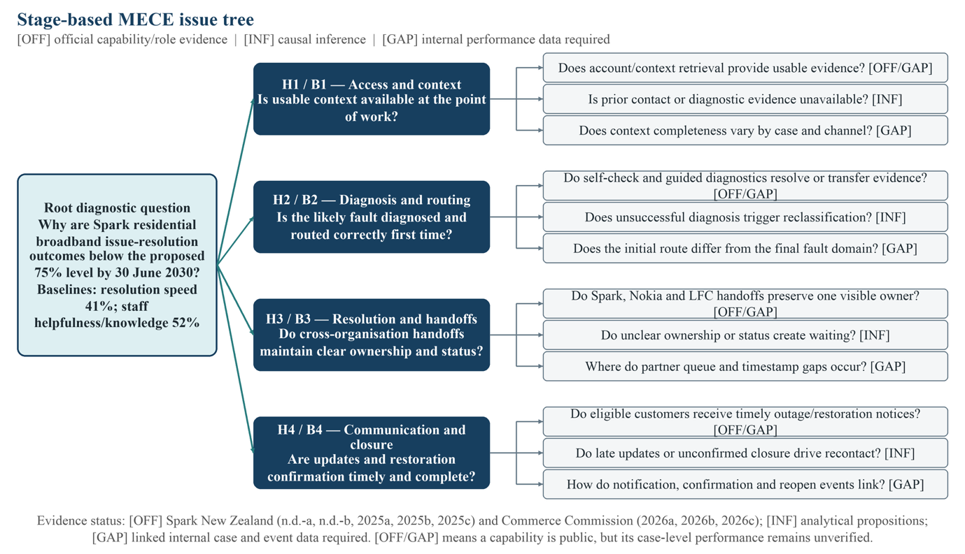 The issue tree retains the four branches B1–B4 and H1–H4.
Note. [OFF] indicates public role or capability evidence; [INF] indicates an analytical proposition; [GAP] requires linked internal case and event data.

1.4 Revised AS-IS process model

The retained AS-IS SAP Signavio collaboration model uses four participant pools: Residential broadband customer, Spark NZ, Nokia NOC and Chorus/relevant LFC. Spark contains digital self-service, frontline support and broadband specialist/incident-management lanes. Sequence flows remain within participants, and message flows cross organisational boundaries. The process begins with perceived degradation and ends only after stable restoration is confirmed. The Nokia and LFC alternatives currently converge before Spark consolidates diagnosis, ownership and restoration status. Five annotations identify inferred dysfunctions D1–D5; each is an analytical proposition, not a verified internal finding.

Figure 2. SAP Signavio BPMN 2.0 AS-IS —— Spark NZ Residential Broadband Fault Diagnosis Escalation and Resolution
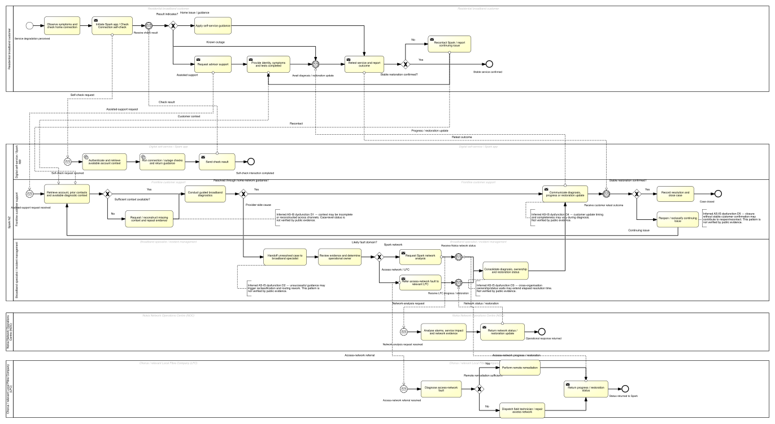
Note. The model records public actors and an inferred process structure. It does not assert unsupported SLAs or internal status controls. The current XOR is appropriate only if Nokia and an LFC are mutually exclusive routes; an episode requiring both would need an inclusive or explicit sequential variant.

KPI ARCHITECTURE

2.1 Major KPI

Residential Broadband Issue-Resolution Satisfaction Index = 0.5 × resolution-speed satisfaction + 0.5 × staff-helpfulness/knowledge satisfaction.

Baseline = (41% + 52%) / 2 = 46.5%.
Proposed target = at least 75% by 30 June 2030.
Non-compensation gate = both component sub-KPIs must independently be at least 75%.

The index is an author-developed and unvalidated executive roll-up. Neither Spark nor the Commerce Commission publishes this aggregate and equal weighting is a consulting choice. It cannot be used as the causal test of H3. Its only defensible use is to show a headline customer-outcome direction while the two components remain visible.

2.2 Two SMART sub-KPIs

Sub-KPI 1 —— Resolution-speed satisfaction. Baseline 41% proposed target at least 75% by 30 June 2030 population is Spark residential broadband respondents who experienced an issue measurement must preserve comparable survey wording scoring and weighting.

Sub-KPI 2 —— Staff helpfulness and knowledge satisfaction. Baseline 52% proposed target at least 75% by 30 June 2030 same population and comparability requirements.

The measures are specific numeric and time-bound. They are relevant to the problem and broader customer-experience ambition. Achievability is a hypothesis to test not a claim. The published 43% issue-experience result is not a third sub-KPI because it covers heterogeneous issues and does not isolate technical resolution.

2.3 Diagnostic and leading measures

Internal baselines are required before targets are chosen for end-to-end time to stable restoration at P50/P75/P90 handoff acknowledgement time owner/status visibility coverage status-gap duration partner waiting versus active repair incomplete or rejected handoff rate ownership changes and bounce-backs first-route accuracy material-update coverage stable-confirmation coverage and recontact/reopen. These measures test mechanisms and support pilot governance. They do not replace the two customer-outcome sub-KPIs.

ANALYSIS WORK PLAN
Lecture 4 requires the hypothesis to determine the analysis, and the work plan to connect the issue, analysis, data source and end product (Reddy, 2026a). The plan therefore starts with data feasibility rather than a preferred solution.

Workstream 1 —— Validate episode linkage and field quality.
Hypothesis/question Can complete issue episodes and H3 events be measured
Analysis source inventory identifier linkage timestamp completeness event-order checks missingness by technology partner and channel.
Data sources Spark app/self-service logs CRM and case records contact-centre events specialist/incident records Nokia and LFC references communication and closure records.
End product data-quality heatmap linkage funnel agreed event dictionary and analysis-ready cohort.
Decision if linkage is inadequate classify H3 as indeterminate and recommend a limited data-capability remedy before causal claims.

Workstream 2 —— Map actual variants and waiting.
Hypothesis/question Where do ownership changes rework and elapsed time occur
Analysis process mining variant frequency ownership-change and bounce-back mapping decomposition of active work queue handoff and customer-dependent time.
End product discovered process map variant table and stacked P50/P75/P90 time decomposition.

Workstream 3 —— Test H3 within comparable partner-involved cases.
Analysis compare continuously visible and gap-affected multi-organisation episodes matching or multivariable/survival analysis controls for severity outage scope access technology partner field dispatch region timing and complexity.
End product adjusted effect plot with confidence intervals empirical distribution/box plots partner-technology heatmap and sensitivity table.
Decision support H3 only if gaps are measurable sufficiently present and consistently associated with practically material extra waiting after controls.

Workstream 4 —— Challenge H3 and alternatives.
Analysis separate mass outages extreme cases fibre/copper/wireless field dispatch and missing-data assumptions test whether delay sits in active repair H2 rerouting H4 communication or customer availability.
End product competing-explanation matrix and segment-specific conclusion.

Workstream 5 —— Evaluate a bounded pilot.
Analysis controlled before-and-after design staged rollout or difference-in-differences if assumptions are credible monitor mechanism outcome and harm indicators.
End product pilot scorecard control charts and stop/pivot/scale recommendation.

DATA GATHERING AND ANALYSIS PLAN FOR H3

4.1 Key hypothesis and unit of analysis

H3 is the key proposition. The unit of analysis is a linked issue episode not a ticket call or partner reference in isolation. The episode begins at the first issue report or self-check and ends at customer-confirmed stable restoration. Open or unconfirmed cases are right-censored rather than treated as completed.

4.2 Required data

Use pseudonymised episode service and customer identifiers to link access technology relevant LFC and partner known-outage flag fault domain severity region channel time/day field dispatch case complexity initial and final route every owner queue and status change handoff sent received acknowledged and accepted timestamps request-more-information events first substantive partner action progress and restoration events customer-update events retest and stable confirmation closure recontact/reopen and post-case satisfaction.

Operational definitions must be agreed before results are viewed. Handoff acknowledgement wait is sent-to-accepted time. Status-gap duration is time with null unknown or inconsistent owner/status or between request and accepted status. Visibility coverage is the share of episode time with both a valid accountable Spark customer-case owner and a visible current technical actor/status. Partner waiting is separated from active diagnosis or repair. A missing timestamp is first a data-quality gap not automatically a real operational delay.

4.3 Sources and collection method

The proposed collection method is a privacy-reviewed extract from Spark’s self-service/app CRM/case contact-centre specialist/incident partner-interface communication closure/reopen and survey systems. Partner references must be mapped to the Spark episode ID. Obtain an event dictionary and data-owner confirmation for every timestamp. Use only fields necessary for the analysis and pseudonymise identifiers before the analytical dataset is created. Interview and process-owner input should explain rules and exceptions but must not overwrite the event evidence.

4.4 Analysis method and visualisation

The sequence is linkage and missing-data audit process-mining variant discovery elapsed-time decomposition unadjusted distributions matched comparison or multivariable/survival analysis sensitivity and segment analysis then pilot evaluation. The primary comparison stays within multi-organisation cases. Single-owner cases are a secondary benchmark because partner involvement is confounded with complexity.

Planned visuals are a discovered process map handoff funnel stacked active-versus-waiting chart empirical cumulative distribution or box plots adjusted effect plot with confidence intervals partner/technology heatmap and pilot control chart. H3 is weakened or falsified if gaps are rare adjusted effects disappear or reverse or delay is mainly active repair dispatch outage or H2 misrouting. If linkage is too incomplete the conclusion is indeterminate.

SEMI-STRUCTURED INTERVIEW GUIDE
The same nine-section, 18-question core guide is used with Francis Lee and the GenAI respondent. Respondent-specific probes are allowed. The design follows Lecture 5: begin with broad and less sensitive context; listen without leading; probe the basis of claims; paraphrase; avoid tangents; and end with an open question (Reddy, 2026b).

Section 1 —— Opening and shared context role evidence boundary and strategic significance.
Section 2 —— Problem and outcome evidence meaning and limits of 41% 52% 43% and the proposed index.
Section 3 —— H3 mechanism ownership status and legitimate versus avoidable waiting.
Section 4 —— Alternative explanations and negative cases.
Section 5 —— Required data comparison and analytical method.
Section 6 —— Governance technology communication hybrid and structural solution pathways.
Section 7 —— TO-BE accountability exceptions and implementation sequence.
Section 8 —— Governance change privacy partner and segment risks.
Section 9 —— KPI implications provisional judgement and open close.

The complete guide, consent script and neutral probes are provided in Appendix A. Francis participated as a strategic group member rather than a Spark internal fact witness. Consent, recording and transcript-review details are reported with the interview record in Appendix B.

INTERVIEWS AND ANALYSIS AGAINST THE HYPOTHESES

6.1 Interview execution and integrity boundary

Respondent 1 was Francis Lee, a group member responsible for the strategic lens. The interview was conducted in person on the University of Auckland campus on 24 August 2026 and lasted approximately 28 minutes. Francis consented to recording, naming, quotation and inclusion of the transcript.
The recording was transcribed and lightly edited for readability without changing meaning. Francis reviewed the transcript and confirmed that it represented his answers. The interview record is provided in Appendix B.
Respondent 2 was an OpenAI Codex GenAI analytical respondent interviewed on 19 August 2026. It was instructed to answer the same core guide, distinguish public evidence from inference, propose falsification conditions and avoid claiming access to Spark’s internal operations. Its full question-and-answer record is in Appendix C. GenAI is not a fact witness; its value is to challenge logic, expose data needs and generate alternatives for critical evaluation.

6.2 Analytical coding and synthesis method

Both transcripts are coded in a respondent-by-theme matrix with columns for H3 mechanism customer/outcome link competing explanations required data solution criteria implementation risks KPI implications and evidence basis. Deductive codes come from H3 and the issue tree. Inductive codes capture unexpected explanations and negative cases. Each claim is tagged as direct experience reasoned inference or externally sourced claim. Agreement is not counted as validity and theme frequency is not treated as causal evidence.

6.3 GenAI interview findings

The GenAI provisionally supported H3 as a priority for operational testing not as a proven Spark root cause. It identified a plausible mechanism a Spark customer-case accountability role may persist while Nokia or an LFC performs technical action and delay may arise if acknowledgement acceptance current technical owner or status is not visible. It distinguished genuine gap time from active diagnosis and repair and warned that missing timestamps can indicate poor logging rather than real unowned time.

The respondent supplied strong negative-case logic. H3 should be weakened if ownership/status gaps are rare if their adjusted association with waiting disappears after severity outage technology partner field dispatch and complexity controls or if elapsed time is mainly active technical repair. H3 is indeterminate if episode linkage or event quality is inadequate. Competing explanations included H2 rerouting outage complexity dispatch home-network conditions customer availability and H4 communication or closure.

On solutions the GenAI rejected a technology-only interpretation. It argued that integration could automate ambiguous accountability and that communication automation could make a stalled process more visible without removing the stall. It therefore preferred a small hybrid pilot combining role clarity handoff standards and sufficient event visibility with stop/pivot conditions after validation.

6.4 Francis Lee interview findings

Francis framed residential broadband issue resolution as strategically relevant because it connects Spark’s published network and customer-experience direction, but he repeatedly separated public evidence from interpretation: “Everything after that is me joining the dots” (F. Lee, personal communication, August 24, 2026). He agreed that 41% resolution-speed satisfaction and 52% staff-helpfulness/knowledge satisfaction establish a customer-outcome dysfunction, while neither result identifies the failed internal step. He treated the 46.5% index only as an author-developed executive roll-up and retained both components and the 75% non-compensation gate.

On H3, Francis described a plausible gap between Spark’s continuing customer accountability and a partner’s technical action. He suggested distinguishing an actionable case owner from a monitoring role by testing whether that owner can escalate, receives status events and is measured on end-to-end restoration. His strongest competing explanation was case complexity combined with wrong initial routing, with communication and closure as a further alternative.

Francis prioritised linked issue-episode data: persistent episode identifiers, owner/status histories, handoff sent and accepted timestamps, waiting versus active-work time, technology, partner and severity controls, closure, recontact and customer outcomes. He argued that data definitions should be fixed before analysis and that missing timestamps may indicate a logging problem rather than real operational waiting.

For the solution, Francis preferred a bounded and reversible hybrid pilot rather than a platform-first programme. He proposed one partner or region, a manually assigned Spark case owner, a minimum handoff packet, explicit acknowledgement and a shared status record before costly integration. His decision logic was concise: “And if it doesn’t move them, we’ve spent very little finding that out” (F. Lee, personal communication, August 24, 2026). He supported H3 as a priority for testing, not as a proven Spark root cause.
Evidence-basis note. Francis’s answers are reasoned strategic interpretations of public sources and the report framework, not direct evidence of Spark’s internal operating process.
Negative evidence. Francis identified H2 misrouting, case complexity, active repair, H4 communication and weak data linkage as credible reasons to weaken or leave H3 indeterminate.
Transcript status. The lightly edited transcript was reviewed and confirmed by Francis; see Appendix B.

6.5 Cross-respondent synthesis and hypothesis decision

Both respondents support H3 as a priority for operational testing. They converge on the distinction between persistent Spark customer-case accountability and partner technical-action ownership, the need to separate waiting from active repair, the importance of linked episode data and the value of a bounded hybrid pilot. Their agreement is analytical convergence, not independent confirmation of Spark’s current practice.
The respondents differ in emphasis. The GenAI supplied a broader formal falsification and modelling structure; Francis placed greater weight on strategic proportionality, early go/no-go governance and a manual minimum viable pilot. Francis also elevated H2 misrouting as the next hypothesis if H3 does not hold. These differences refine rather than overturn the issue tree: H3 remains prioritised, while H2 and H4 are retained as explicit competing explanations and Phase 0 becomes a mandatory validation gate.
Final interview-level decision: H3 is provisionally supported as a priority for operational investigation and a bounded pilot.
The available evidence establishes an outcome-level dysfunction but not a cause-level conclusion.

The distinction protects the report from treating two external analytical interviews as proof of an internal process condition. If the interview decision is supportive the report proceeds to a conditional solution pilot. If H3 is weakened the issue tree should iterate to the strongest supported hypothesis. If it is indeterminate the immediate recommendation should be limited to data and measurement capability.

SOLUTION TREE ROOT CAUSE AND BEST PATHWAY

7.1 Solution tree

Problem Slow or inconsistent residential broadband issue-to-resolution customer outcomes.
Issue B3 resolution and cross-organisation handoffs.
Hypothesis H3 ownership/status discontinuity adds waiting and extends stable resolution.
Candidate root causes
RC3.1 No persistent accountable Spark customer-case owner during partner work.
RC3.2 No consistently complete and accepted minimum handoff packet.
RC3.3 Partner status events and ownership changes are not normalised or visible end-to-end.
RC3.4 Exception and customer-update triggers are disconnected from partner status.
RC3.5 A technical restoration signal and customer stable-confirmation are not linked.

Solution pathways
P1 Governance only RACI accountable owner and handoff playbook.
P2 Technology only status/event integration and dashboard.
P3 Communication only automated customer updates.
P4 Hybrid Cross-Organisation Broadband Resolution Orchestration governance plus standard handoff and targeted status/update/closure controls.
P5 Structural change replacement insourcing or a new organisation.

Figure 3. Candidate solution tree
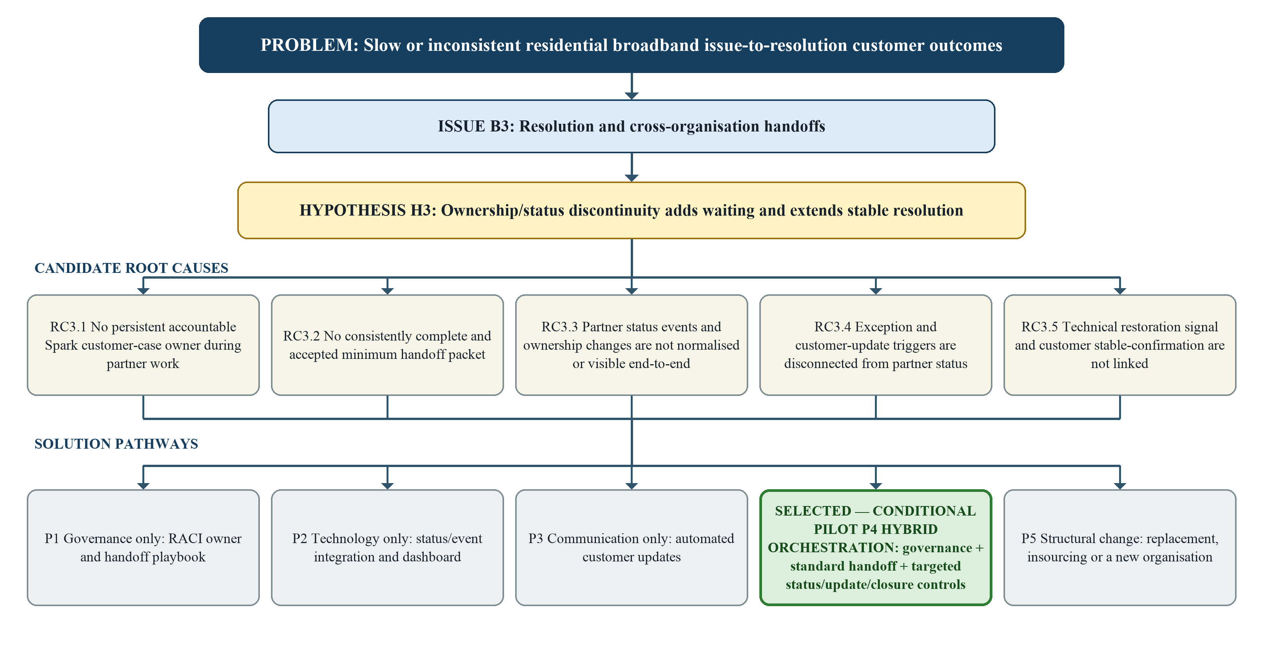
Note. Root causes remain candidates until linked internal case/event data and pilot evidence are analysed. P4 is the conditionally selected pilot pathway, subject to Phase 0 validation of H3.

7.2 Pathway evaluation

Rosemann (2001) treats process improvement across outcomes, activity flow and resources, and requires relevance, feasibility, constraints and implementation horizon to be considered. Lecture 6 additionally uses impact, feasibility and cost for prioritisation (Reddy, 2026c). This report combines those criteria as an analytical application; it does not claim Rosemann supplied a numeric weighted formula.

P1 Governance only —— Outcome coverage is moderate because accountability may improve customer confidence. Activity impact is moderate because a handoff playbook can reduce ambiguity but rules may not remain visible at scale. Resource feasibility is high and reversibility strong. Evidence risk is moderate. It is a useful pilot component not a complete end state.

P2 Technology only —— Outcome coverage is moderate. Activity visibility could improve but integration may digitise ambiguous rules and cannot by itself assign accountability. Resource and technical feasibility are medium to low before interfaces and partner data-sharing are validated. Evidence risk and cost are higher.

P3 Communication only —— Outcome coverage is narrow. Timely updates may improve transparency and H4 outcomes but the pathway does not remove H3 waiting or rework. Feasibility is relatively high yet the root-cause fit is weak.

P4 Hybrid orchestration —— Outcome coverage is high because it connects accountability progress visibility and customer-confirmed restoration. Activity-flow fit is high because it standardises handoff acceptance separates waiting from active work and creates exception loops. Resource fit is high to moderate because it clarifies roles and uses staged integration rather than assuming a new department or wholesale system replacement. It is reversible and scalable if piloted. Evidence risk remains so selection is conditional.

P5 Structural change —— Potential impact is high but relevance and feasibility are low without evidence that organisational structure outsourcing or supplier choice is the dominant cause. Cost implementation time and irreversibility are disproportionate.

7.3 Preferred solution

The preferred pathway is a bounded pilot of P4 Cross-Organisation Broadband Resolution Orchestration. It is selected because it most directly addresses the candidate mechanism across Rosemann’s (2001) three improvement perspectives while remaining divisible into a low-regret governance minimum and later integration. Governance-only and technology-only pathways each address only part of the mechanism; communication-only treats a customer-visible symptom; structural change exceeds the current evidence.

The recommendation is conditional not proven. Phase 0 must first establish that H3 is measurable and materially related to waiting. If H3 fails the programme must pivot to the supported cause. This safeguards against designing a sophisticated solution for the wrong problem.

SAP SIGNAVIO BPMN 2.0 TO-BE PROCESS

8.1 GenAI contribution and TO-BE model content

To support development of the preferred TO-BE process, the GenAI respondent was asked to examine its structure, sequence and operational details, including controls and exception logic. Responses to Questions 12 and 13 in Appendix C informed the distinction between persistent Spark customer-case accountability and partner technical-action ownership, explicit handoff acceptance and request-for-information paths, partner status updates, customer retesting and same-case reopening. The four-pool collaboration structure retained the participant boundary established in the AS-IS analysis. These GenAI inputs were critically reviewed against that boundary and BPMN 2.0 collaboration rules before Figure 4 was constructed and checked in SAP Signavio.
Participants remain Residential broadband customer, Spark NZ, Nokia NOC and Chorus/relevant LFC. The Spark pool contains Digital self-service/Spark app and Frontline customer support lanes. Accountable resolution coordination is represented as work within the Spark process rather than an asserted existing department.
The process begins when the customer perceives degradation and uses self-check or requests assisted support. Spark retrieves available account, prior-contact and diagnostic context, reconstructs missing context where necessary and merges those diagnostic paths before guided diagnosis. If a provider-side cause is indicated, Spark assigns an accountable case owner, retains the episode context, validates the minimum handoff packet and selects the technical actor. Nokia or the relevant LFC receives the complete packet and checks completeness before analysing the network or access-network fault. Each partner publishes its owner, progress and restoration status back to Spark.
Nokia and LFC status messages return through separate message events and converge before Spark records the current technical owner/status and consolidates restoration. Spark sends a material-status or update-due communication and obtains the customer’s retest outcome. Stable service is recorded and the case closes only after confirmation; if instability remains, the same case reopens with context retained and is reclassified. No unsupported numerical SLA is encoded.
Following BPMN 2.0 collaboration rules, sequence flows remain inside each pool and message flows cross participant boundaries (Object Management Group, 2014). A diagnostic XOR merge prevents duplicated inflow to guided diagnosis, and a separate XOR merge converges the Nokia and LFC branches before common Spark consolidation. The exclusive partner routing remains a design assumption that must be validated; if one episode can require both partners, an inclusive or explicit sequential design should replace it.

Figure 4. SAP Signavio BPMN 2.0 TO-BE —— Cross-Organisation Broadband Resolution Orchestration
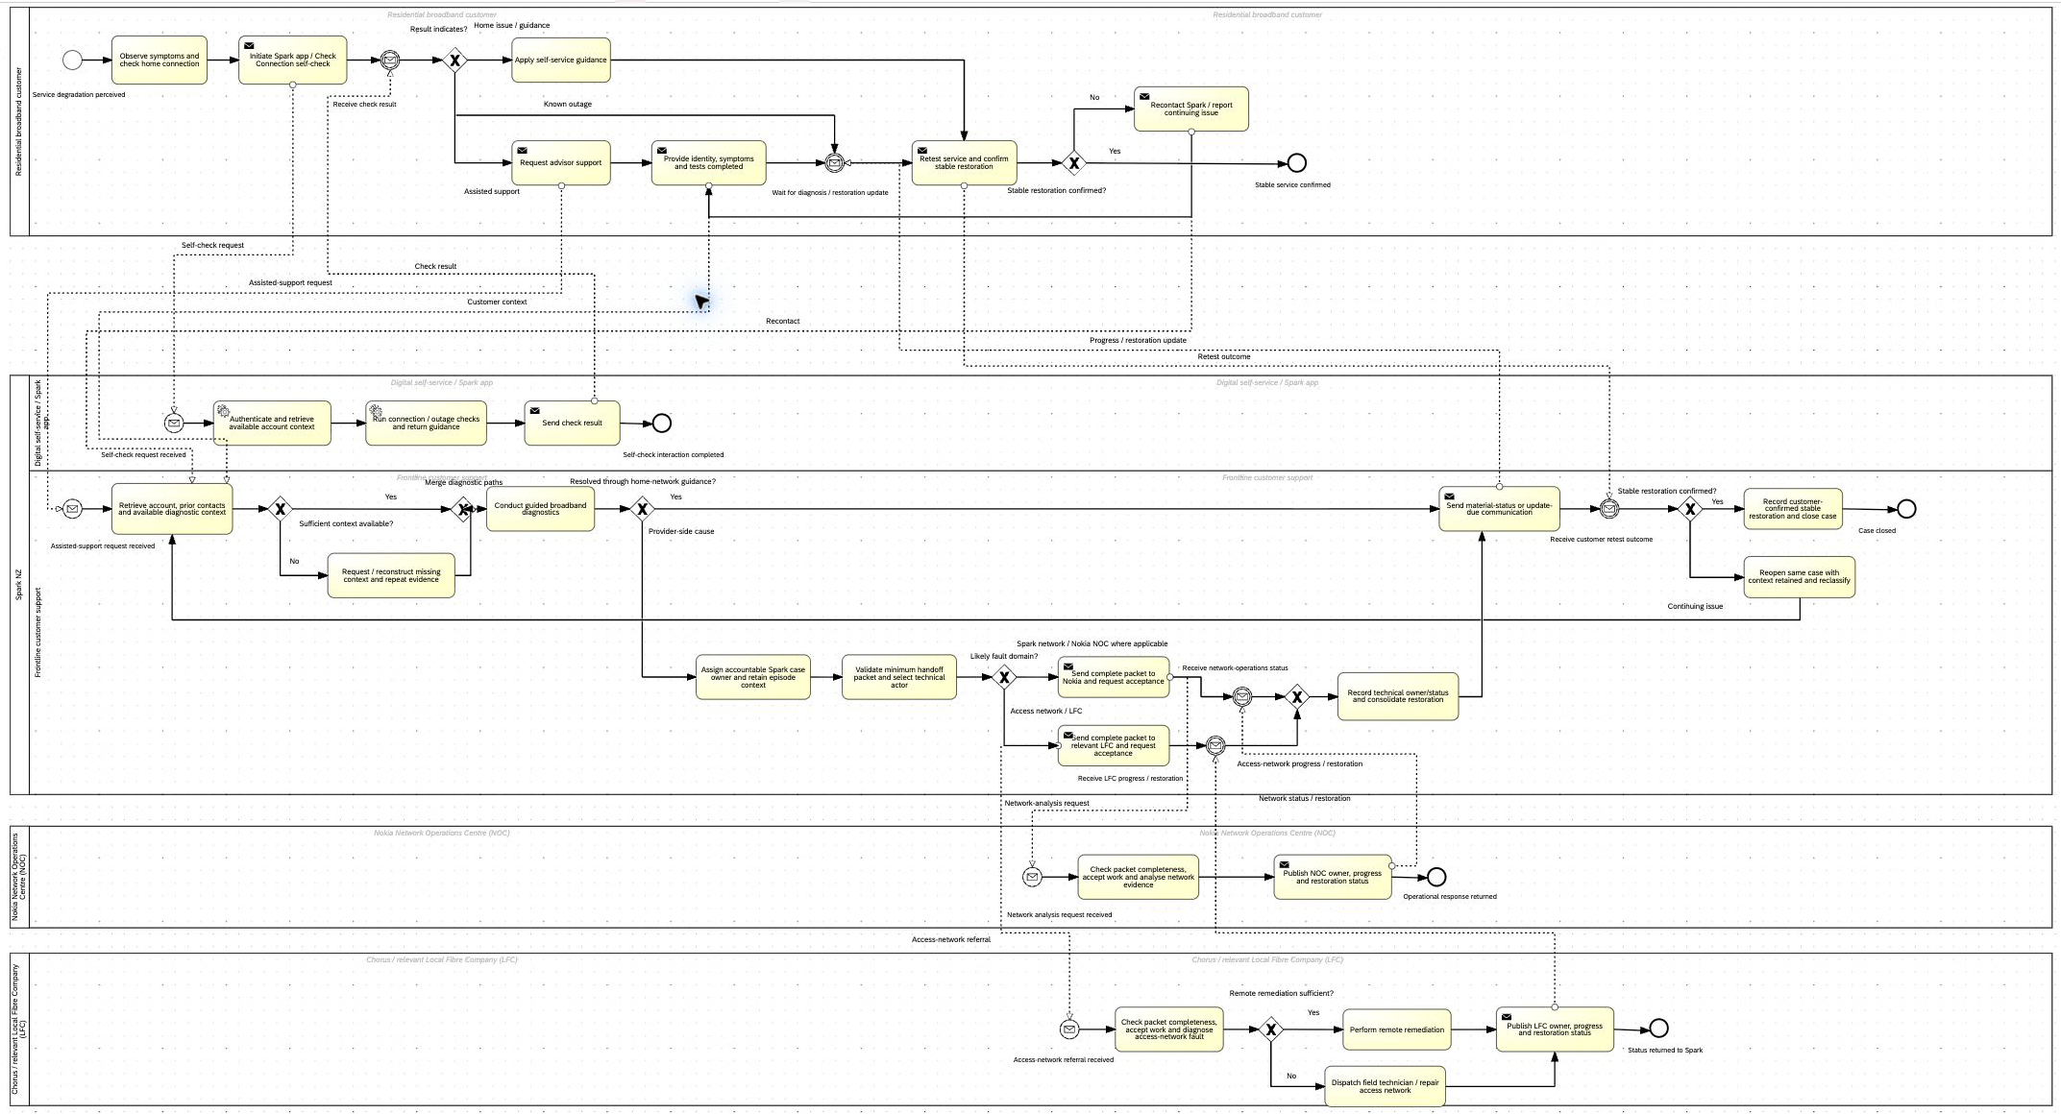
Note. Complete model overview. Proposed controls are a consulting design, not a claim about Spark’s present systems or commitments. No unverified SLA threshold is shown.

Figure 4 (continued). Enlarged detail — Cross-organisation handoff, partner-action, status-return and consolidation controls
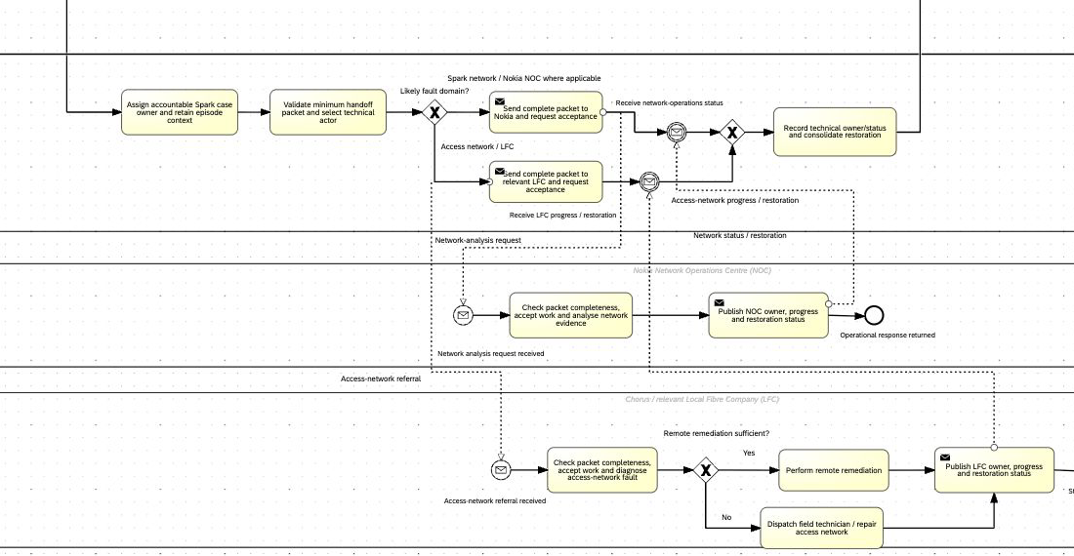
Note. Enlarged detail of the same SAP Signavio model; no process content has been added or removed.

8.2 Expected improvement logic

Retained episode context should reduce reconstruction and rework. The accountable Spark case owner and separate technical-action owner should prevent customer accountability from disappearing during partner work. A minimum packet and explicit acceptance should make incomplete handoffs visible. Published partner owner/progress/restoration status and material-update controls should reduce unobserved waiting and improve meaningful communication. Stable confirmation and same-case reopen should reduce premature closure and support learning.
These are causal propositions for a pilot. Orchestration cannot guarantee shorter physical repair time or fix every staff-capability problem. Benefits must be demonstrated through waiting decomposition, recontact/reopen and customer outcomes. The control design is also consistent with the New Zealand Telecommunications Forum Customer Care Code requirements to keep complainants informed, record outcomes and cooperate with third parties. The Code is an industry design precedent, not proof that every technical-fault case follows the proposed flow (New Zealand Telecommunications Forum, 2023).

RECOMMENDATION AND IMPLEMENTATION

9.1 Structured recommendation

Problem published resolution-speed and staff-support satisfaction remain below a credible good range.
Insight the customer outcome is established but H3 is only a plausible and testable mechanism at a documented cross-organisation boundary.
Recommendation validate H3 then pilot the minimum viable Cross-Organisation Broadband Resolution Orchestration design on a bounded multi-organisation segment.
Expected effect reduce avoidable unowned/status waiting and handoff rework improve accountability and status-informed customer communication and create traceable evidence for scale decisions.

9.2 Eighteen-month phased plan

Phase 0 —— Validate and design months 0–3. Confirm the episode model event definitions partner rules data linkage privacy and data-sharing basis baseline and proposed RACI. Test H3. Stop or pivot if H3 is not supported. Deliver an agreed measurement dictionary data-quality assessment and pilot design.

Phase 1 —— Governance/MVP pilot months 4–8. Select a bounded segment for example one fibre/LFC route plus applicable Nokia cases. Introduce one accountable Spark case role a minimum handoff packet acknowledgement and exception rules. Limited/manual integration is acceptable. Train affected roles and capture baseline/pilot measures.

Phase 2 —— Integration and controlled evaluation months 9–14. Add validated status-event integration alerts customer-update and closure controls. Compare with an appropriate control or baseline adjust for mix and monitor privacy staff effort message quality and premature closure.

Phase 3 —— Refine and scale months 15–18. Scale only if the mechanism and customer/operational outcomes improve without unacceptable harm. Standardise governance and partner agreements retain segment-specific variants and begin continued benefits monitoring through FY30.

9.3 Governance and safeguards

Proposed roles are: an executive sponsor; an end-to-end process owner; accountable resolution-coordination responsibility; a platform/data owner; Nokia and LFC partner leads; privacy/security representatives; and frontline/specialist representatives. These are proposed responsibilities, not assertions about Spark’s current job titles. End-to-end metrics should prevent local optimisation, such as reducing handling time by transferring unresolved work.

Safeguards include data minimisation and pseudonymisation explicit partner access and retention rules validated event definitions human escalation for complex or vulnerable-customer cases fibre/copper/wireless segmentation stop/pivot conditions monitoring of staff effort message quality and premature closure and no enterprise-scale automation before the process is understood.

9.4 Success and decision gates

Gate 1 —— Data readiness sufficient episode linkage and event completeness to test H3.
Gate 2 —— Mechanism ownership/status gaps are measurable and associated with material waiting after controls.
Gate 3 —— Pilot operation handoff acceptance visible status and same-case closure function without harmful workload or customer effects.
Gate 4 —— Benefit diagnostic measures improve and customer outcomes move in the expected direction using comparable instruments.
Gate 5 —— Scale benefits feasibility privacy and partner governance justify broader deployment.

CONCLUSION

The report preserves one process boundary from the A1-D1 diagnosis through KPI design, data planning, interviews, solution selection, TO-BE modelling and implementation. Published customer results justify a firm outcome-level dysfunction judgement, while H3 remains a falsifiable cause-level proposition. Francis and the GenAI respondent provisionally support H3 as an analytical priority and converge on a bounded hybrid pilot, but linked internal case and event evidence remains necessary for causal confirmation. The recommendation therefore retains explicit validation, stop, pivot and scale gates.

REFERENCES

Commerce Commission. (2026a). Consumer satisfaction metrics: Methodology & guide – December 2025. https://www.comcom.govt.nz/assets/Uploads/Consumer-Satisfaction-Metrics-Methodology-Guide-December-2025.pdf

Commerce Commission. (2026b). Customer service and billing rankings – December 2025. https://www.comcom.govt.nz/consumers/compare-customer-service-for-mobile-and-broadband-providers/previously-published-rankings/

Commerce Commission. (2026c, June 29). 2025 telecommunications monitoring report. https://www.comcom.govt.nz/regulated-industries/telecommunications/monitoring-the-telecommunications-market/annual-monitoring-report/

New Zealand Telecommunications Forum. (2023, June 15). Customer care code. https://www.tcf.org.nz/wp-content/uploads/Documents-Customer-Care-Code.pdf

Object Management Group. (2014). Business process model and notation (BPMN), version 2.0.2. https://www.omg.org/spec/BPMN/2.0.2

Reddy, S. (2026a). Week 2 704 2026 lecture 4 V3 [PowerPoint slides]. University of Auckland Canvas.

Reddy, S. (2026b). Week 3 704 2026 lecture 5 V4 [PowerPoint slides]. University of Auckland Canvas.

Reddy, S. (2026c). Week 4 704 2026 lecture 6 V3 [PowerPoint slides]. University of Auckland Canvas.

Rosemann, M. (2001). Business process lifecycle management [White paper]. Queensland University of Technology.

Spark New Zealand. (n.d.-a). Check your connection. Retrieved August 19, 2026, from https://www.spark.co.nz/help/internet/troubleshoot/fixmybroadband/

Spark New Zealand. (n.d.-b). Stay connected during an outage. Retrieved August 19, 2026, from https://www.spark.co.nz/help/internet/manage/outage-assist/

Spark New Zealand Limited. (2025a). Annual report FY25. https://investors.sparknz.co.nz/FormBuilder/_Resource/_module/gXbeer80tkeL4nEaF-kwFA/doc/FY25_Annual_Report.pdf

Spark New Zealand Limited. (2025b, May 19). Spark announces new strategic network partnership with Nokia [Market release]. https://investors.sparknz.co.nz/DownloadFile.axd?file=Announcements%2FNZX%2F20250519%2F443553.pdf

Spark New Zealand Limited. (2025c, September 11). Spark releases FY30 strategy and update on Chair succession [Market release]. https://investors.sparknz.co.nz/AnnouncementDetailsHandler.ashx?id=2197014&module=eOfdHyYr5ESZHJxq5j-E9Q
Spark New Zealand Limited. (2026, February 18). H1 FY26 results summary. https://investors.sparknz.co.nz/DownloadFile.axd?file=Announcements%2FNZX%2F20260218%2F462497.pdf

APPENDIX A —— SEMI-STRUCTURED INTERVIEW GUIDE

Opening and consent explain the purpose Francis’s strategic group-member role and the distinction between coursework analysis and Spark internal fact. Confirm voluntary participation recording naming and quotation consent.

- Could you describe your responsibility for the strategic part of our Spark NZ work and the perspective you bring?
- How significant is residential broadband issue resolution for Spark’s customers and broader direction?
- What do the 41% resolution-speed satisfaction and 52% staff-helpfulness/knowledge results suggest, and what do they not prove?
- Is the author-developed 46.5% index useful, and what cautions are required?
- What mechanism could connect ownership or status gaps across Spark, Nokia and an LFC to customer-perceived delay?
- What is a genuine ownership/status gap rather than legitimate diagnosis or repair?
- What alternative explanations could account for slow or inconsistent resolution?
- What evidence would weaken, disprove or leave H3 indeterminate?
- What episode, event, customer, technology and partner data should be linked?
- What comparison and analysis would be persuasive?
- How would you compare governance-only, technology-only, communication-only, hybrid and structural pathways?
- Which hybrid controls are necessary, and which might be excessive?
- Where should accountability and exception loops sit in a TO-BE process?
- What would a credible 18-month validation pilot and scale path look like?
- Which stakeholders and proposed governance responsibilities are needed?
- What privacy, partner-change and segment safeguards should be built in?
- Which operational and customer measures would show whether the pilot is improving the process?
- Should H3 be provisionally supported, weakened or treated as indeterminate, and is there anything important I forgot to ask?
The interview guide in Appendix A was used for both respondents, with neutral follow-up probes where clarification was needed.

APPENDIX B —— FRANCIS LEE INTERVIEW TRANSCRIPT

Interview metadata
Participant: Francis Lee
Role: Strategic-lens group member
Interviewer: Ryan Li
Date: 24 August 2026
Location and mode: In person, University of Auckland campus
Duration: Approximately 28 minutes

Consent and transcript note. Francis consented to recording, naming, quotation and inclusion of the transcript. The transcript was lightly edited to remove fillers and improve readability without changing meaning. Francis reviewed and confirmed the transcript.

Ryan Q1. Can you quickly walk me through what you’ve been doing on the strategic side of our Spark NZ work, and what perspective you’re bringing to this?
Francis A1. My side has been Spark’s strategic direction, mainly what SPK-30 says about better networks, better customer experiences and a sharper focus on core connectivity. When you ask me an operational question, I am asking whether the process issue is strategically material and whether the proposed response aligns with Spark’s stated direction. I cannot see Spark’s internal fault systems or partner workflow. Everything I say is an external analytical view based on public information and the course framework.

Ryan follow-up. Which part is actually in Spark’s published material, and which part is you joining the dots?
Francis. The published part is thinner than it sounds. SPK-30 and the annual results contain the network and customer-experience language, and the Commerce Commission numbers are published. Everything after that is me joining the dots: fault resolution is where those things meet and may be strategically material. Spark has not said “issue resolution is a strategic priority” in those words, so the first part is evidence and the second is a hypothesis to test.

Ryan Q2. Why does residential broadband issue resolution matter for the customer and the business?
Francis A2. Broadband is an ongoing service, so a customer’s strongest test of the relationship may be when something goes wrong. Reliable recovery can build trust; repeated explanations or vague updates can erode the value of network investment. It looks strategically relevant because Spark is positioning around better customer and network experiences rather than only price. I would not say one poor resolution automatically causes churn; customer-level evidence is required.

Ryan follow-up. What evidence would you want before calling that link more than plausible?
Francis. Ideally, customer-level data would show whether a customer disconnected or changed plan within a defined period after an issue episode, compared with similar customers and controlled for contract end dates, price changes and competitor activity. A second-best option is case-closure satisfaction linked to later customer behaviour. The current aggregate survey data cannot establish that link.

Ryan Q3. What do 41% resolution-speed satisfaction and 52% staff-helpfulness and knowledge suggest, and what do they not prove?
Francis A3. They indicate a customer-outcome gap because both are below the Commerce Commission methodology’s 75%–85% good range. That supports treating the process as dysfunctional at the outcome level and investigating it. They do not identify which internal step failed. They are customer-reported top-two-box results, not event-log evidence. The separate 43% measure covers a broad range of issues, so it is not a technical fault rate. The results justify the analysis but do not prove H3.

Ryan follow-up. If the gap is real but H3 does not hold, where would you go next?
Francis. H2, diagnosis and routing. A wrong first route or repeated diagnosis creates customer-perceived delay without a partner handoff. H4 would be the next alternative because a case can be restored reasonably and still score badly if the customer was not kept informed.

Ryan Q4. Is the author-developed 46.5% index useful, and what cautions are required?
Francis A4. It can be a simple executive roll-up, but equal weighting is the report author’s judgement, not a Commission method or Spark KPI. The index can hide a weak component, so 41% and 52% must remain visible and each should independently clear the proposed 75% threshold. The 75% is a consulting target based on the lower boundary of the good range, not a target Spark has announced.

Ryan Q5. What mechanism could connect an ownership or status gap to customer-perceived delay?
Francis A5. Once more than one organisation is involved, Spark may still own the customer relationship while another party performs the technical work. If the handoff is not acknowledged, the current technical owner or case status may be unclear, so time can pass before Spark knows whether work has started or what to tell the customer. Repeated partner requests for information add waiting. A Spark person who remains the customer-case owner would keep accountability visible while Nokia or an LFC performs technical work. This is credible, but public sources do not prove that it occurs today.

Ryan follow-up. How would you distinguish someone who watches the case from someone who can actually move it?
Francis. I would use three tests: can the person change priority or escalate without asking someone else; are status events pushed to them or must they chase; and are they measured on end-to-end restoration or only their queue? If all three answers are no, it is a monitoring role with a better title. I cannot determine Spark’s current position from outside.

Ryan Q6. What counts as a genuine status or ownership gap rather than legitimate technical work?
Francis A6. Define the gap before seeing the results, for example sent-to-accepted handoff time or any period with no valid accountable Spark owner and no visible technical actor or status. Active diagnosis, field work and repair must be separated from waiting. Missing timestamps are ambiguous because the work may have occurred without being logged, so the first finding may be data quality rather than operational delay.

Ryan follow-up. Which definitions must be fixed before analysis?
Francis. Define what starts the episode, what counts as an accepted handoff, what counts as active work versus waiting and what closes the case. Closure should mean customer-confirmed stable restoration, not only a technician marking it complete. Partner leads should also confirm the definitions because Nokia and different fibre companies may log events differently.

Ryan Q7. What else could explain slow or inconsistent resolution?
Francis A7. Fault severity and complexity may dominate. Fibre cuts, mass outages, site access and field dispatch create elapsed time that may be unavoidable. Wrong initial routing or repeated diagnosis points to H2. Home-network conditions and customer availability also matter. H4 applies if communication and confirmation drive dissatisfaction even when repair time is reasonable. Several explanations may operate together and H3 may matter only in a particular segment.

Ryan Q8. What evidence would weaken, disprove or leave H3 indeterminate?
Francis A8. H3 is weakened if ownership/status gaps are rare or comparable cases show no meaningful extra waiting. It is challenged if the adjusted relationship disappears after controlling for outage size, partner, technology and field dispatch, or if elapsed time is mainly active repair. It is indeterminate if cases cannot be linked or timestamps are inadequate. Indeterminate must not be presented as supported just because the theory is plausible.

Ryan follow-up. If H3 is indeterminate because the data is unavailable, what should management do?
Francis. Treat the data limitation as the finding. A proportionate response is a small instrumentation remedy, such as a persistent case ID and handoff-acknowledgement timestamps, with a fixed review point rather than the full orchestration programme. If Spark cannot see where time goes across a partner boundary, that is a governance gap worth addressing, but it does not prove H3.

Ryan Q9. What data should be linked to test H3?
Francis A9. The unit should be one complete issue episode from first self-check or contact to customer-confirmed stable restoration, with open cases treated as censored. Required fields include pseudonymised episode, service and customer identifiers; technology, partner, region, severity, outage scope, fault domain and field dispatch; owner, queue and status events; handoff sent, received, acknowledged and accepted times; information requests and first substantive partner action; progress and restoration events; and customer updates, retest, closure, recontact, reopen and satisfaction. The linkage should avoid unnecessary personal information.

Ryan follow-up. What is genuinely necessary for the first pilot?
Francis. The minimum is an episode ID that survives the handoff, owner/status events with timestamps, handoff sent and accepted times, closure and recontact, plus technology, partner and severity for reasonable comparison. Satisfaction linkage, fault-domain detail and dispatch records strengthen the analysis but should not block an initial pilot. Actual availability must be checked before promising any field.

Ryan Q10. What comparison and analysis would be persuasive?
Francis A10. Compare comparable multi-organisation cases with continuously visible ownership/status against cases with a defined gap. Single-owner cases are only a secondary benchmark because partner cases may be more complex. Start with linkage and missing-data checks, then process maps and active-work-versus-waiting decomposition. Report median, 75th and 90th percentiles, then use matching or regression/survival analysis to adjust for severity, outage, technology, partner, dispatch and complexity. A bounded pilot should then test whether controls move the operational measures.

Ryan Q11. How do the five solution pathways compare?
Francis A11. Governance-only controls may be quick and reversible but may not remain visible at scale. Technology-only integration may improve data while automating unclear accountability. Automated communication improves transparency but may leave a stalled case untouched. Structural replacement or insourcing is disproportionate before internal evidence exists. The hybrid has the strongest logic because it combines accountability, activity-flow controls and supporting information, but it should be a conditional pilot rather than an enterprise programme.

Ryan follow-up. What is the smallest hybrid that could be tested without building a platform?
Francis. Use one region or one fibre partner. Assign a named case owner manually when the handoff goes out, use a handoff template with mandatory acknowledgement and maintain a shared status log. A spreadsheet-level trial is sufficient; no integration build or new team is necessary. If the ownership gap is real, the trial should affect acknowledgement time and the share of cases with no visible owner. If it does not, little has been spent learning that.

Ryan Q12. Which hybrid controls are necessary and which may be excessive?
Francis A12. Start with a persistent case ID, one accountable Spark customer-case owner, a minimum handoff packet and explicit partner acknowledgement. Normalised status events and customer-update triggers make the ownership useful, and stable-restoration confirmation closes the loop. Avoid promising real-time integration or a new department before the pilot proves it is needed; the first trial can be manual or use limited integration on existing tools.

Ryan Q13. Where should accountability and exception loops sit in the TO-BE process?
Francis A13. Spark should establish visible customer-case accountability before the external handoff, while Nokia or an LFC remains the technical-action owner. The receiving partner should check completeness and either accept the handoff or request specified information. An update-due event can trigger escalation and a meaningful customer update without inventing a public SLA. When restoration is reported, Spark consolidates status and asks the customer to retest. If service remains unstable, the same case should reopen or be reclassified with context retained. The route must also verify whether Nokia and an LFC are always alternatives because XOR would be wrong if both can be involved.

Ryan Q14. What would a credible 18-month implementation path look like?
Francis A14. Months 0–3 should validate H3, event definitions, data linkage, partner rules, privacy and the baseline, ending with an explicit stop-or-pivot decision. Months 4–8 should pilot governance and the minimum handoff process on a bounded route. Months 9–14 can add status integration, alerts, customer-update and closure controls. Months 15–18 refine and scale only if evidence shows benefit and acceptable risk. External outcome monitoring can continue through FY30.

Ryan follow-up. Which phase provides a firm decision, and who should decide whether to scale?
Francis. The first go/no-go occurs at the end of months 0–3, once the baseline shows whether ownership gaps are common enough to justify a pilot. The later scale decision should sit with an executive sponsor accountable for the customer outcome end to end, not only the platform or partner-management function.

Ryan Q15. Which stakeholders and governance roles are needed?
Francis A15. The pilot needs an executive sponsor, an end-to-end process owner, a resolution-coordination responsibility, platform and data owners, privacy and security input, frontline and specialist representatives and partner leads from Nokia and the selected LFC. Governance must use end-to-end measures because local teams can reduce handling time by transferring work while the customer’s total resolution time worsens. Escalation paths must be explicit.

Ryan Q16. What safeguards should be built in?
Francis A16. Minimise personal data and clarify partner access. Validate the process before automating it. Segment the pilot because fibre, copper and wireless cases differ. Preserve human escalation for exceptional cases and vulnerable customers. Monitor staff workload, low-value messaging and premature closure. Keep the design reversible until causal evidence is stronger.

Ryan Q17. Which measures would show whether the pilot is improving the process?
Francis A17. Track end-to-end time to stable restoration at the median and tail, handoff acknowledgement time, owner/status gap duration and prevalence, partner waiting versus active repair, incomplete handoffs, first-route accuracy, update coverage, stable-confirmation coverage and recontacts/reopens. Internal baselines are required before setting operational targets. Longer-term outcomes remain satisfaction with resolution speed and staff helpfulness/knowledge. The 46.5% roll-up should not be used to claim that H3 caused any improvement.

Ryan follow-up. Which measures test the mechanism, which are customer outcomes and which are guardrails?
Francis. Mechanism measures are handoff acknowledgement, owner/status gap duration and prevalence, and waiting versus active repair. Outcomes are end-to-end stable-resolution time and the two public survey measures. Guardrails include incomplete handoffs, update coverage, recontact and reopen, which help detect gaming or unintended effects.

Ryan Q18. Where does that leave H3: provisionally supported, weakened or indeterminate?
Francis A18. On public evidence and process logic, I provisionally support H3 as a priority for testing, not as a proven Spark root cause. The organisational interfaces are documented and the mechanism is plausible, but we do not know how common the gaps are, how much delay they cause or what controls already exist. The strongest competing explanation is case complexity combined with wrong initial routing. Linked event data showing where elapsed time goes after an external handoff would most change my judgement.

APPENDIX C —— GENAI STAKEHOLDER INTERVIEW TRANSCRIPT

Interaction metadata
Tool/model: OpenAI Codex
Date: 19 August 2026
Purpose: Required GenAI stakeholder-style analytical interview using the same core guide.

Researcher instruction. Answer the same 18-question semi-structured guide as an external analytical respondent. Do not claim access to Spark’s internal systems. Separate evidence from inference, identify alternatives and state what would falsify H3.
Ryan Q1. Could you explain the analytical perspective you are bringing to this interview, including what you can assess from public evidence and what you cannot know without Spark's internal case and event data?
GenAI A1 I am an external analytical respondent. I can assess the coherence of the hypothesis published evidence data design and proposed controls. I cannot attest to Spark’s actual case flow staff behaviour partner performance or internal event data.

Ryan Q2. How significant is residential broadband issue resolution for Spark's customers and broader strategic direction, and what evidence would be needed before linking service-recovery performance to retention or financial outcomes?
GenAI A2 It is strategically plausible because broadband is a continuing service and SPK-30 emphasises better network and customer experiences. Service recovery can affect trust but retention or financial effects require customer-level evidence.

Ryan Q3. How should the published 41% resolution-speed satisfaction, 52% staff-helpfulness/knowledge satisfaction and separate 43% issue-experience result be interpreted? What do they establish, and what can they not reveal about the internal process?
GenAI A3 They establish a customer-outcome gap against the methodology’s good range. They do not identify the failed internal step. The separate 43% result is a broad issue measure not a technical fault rate.

Ryan Q4. Is the author-developed 46.5% equal-weighted index a useful headline measure? What limitations follow from its construction, and how should it relate to the proposed 75% target and the two underlying measures?
GenAI A4 Only as an author-developed headline. Equal weighting is unvalidated so the two components must remain visible and both must individually reach the proposed 75%. The target is not a Spark commitment.

Ryan Q5. What operational mechanism could plausibly connect discontinuous ownership or status visibility across Spark, Nokia and an LFC to customer-perceived delay, and which parts of that mechanism remain inference rather than established fact?
GenAI A5 Customer accountability may remain with Spark while technical action sits with Nokia or an LFC. If acceptance current technical owner or status is not visible work may wait or information may be requested again. This is plausible but not publicly proven.

Ryan Q6. How should a genuine ownership or status gap be operationally defined and distinguished from legitimate diagnosis or active repair time, particularly when event logging is missing or incomplete?
GenAI A6 Define it before analysis using accepted events sent-to-accepted wait unassigned accountable-owner time or time without a visible current technical status. Keep active diagnosis and repair separate. Missing logging is ambiguous.

Ryan Q7. What alternative explanations for slow or inconsistent resolution should be tested alongside H3, and under what conditions might those explanations account for more delay than ownership or status discontinuity?
GenAI A7 Severity mass outage field dispatch access technology wrong routing home-network conditions customer availability and communication or closure can dominate. H3 may be segment-specific or weaker than H2/H4.

Ryan Q8. What empirical findings would weaken or falsify H3, and what data limitations would require the result to be treated as indeterminate rather than supported?
GenAI A8 Rare gaps no adjusted association a reversed effect or delay concentrated in active repair would weaken it. Inadequate linkage makes the result indeterminate rather than supported.

Ryan Q9. What case, event, customer, technology, routing and partner data should be linked to reconstruct a complete issue-to-resolution episode and test H3?
GenAI A9 Link the complete issue episode with technology partner severity outage route owner/status histories handoff and information-request events active work progress updates restoration confirmation reopen and satisfaction.

Ryan Q10. What sequence of data-quality, process-mining and comparative analyses would provide a persuasive test of H3 while controlling for case mix and checking whether results differ by segment?
GenAI A10 Begin with data quality and process mining then compare visible and gap-affected multi-organisation cases with mix controls. Use single-owner cases secondarily. Apply sensitivity and segment checks and then evaluate a bounded pilot.

Ryan Q11. How would you compare governance-only, technology-only, communication-only, hybrid and structural pathways in terms of mechanism coverage, feasibility, scalability and evidence risk?
GenAI A11 Governance is quick but may not scale technology can automate ambiguity communication treats a symptom structural change is disproportionate. A small hybrid has the best root-cause coverage if validation supports H3.

Ryan Q12. If H3 is validated, which controls form the minimum viable response, which should be introduced only after further evidence, and which options would be excessive for the current problem?
GenAI A12 Start with one episode ID accountable Spark customer-case owner standard minimum packet and explicit partner acceptance. Add status normalisation update triggers and stable confirmation only as validated. Avoid assuming a new department or full platform replacement.

Ryan Q13. Where should customer-case accountability, technical-action ownership, handoff acceptance, partner status updates, customer retest and same-case reopen logic sit within the TO-BE process?
GenAI A13 Assign Spark customer accountability before external handoff let the partner accept or request information retain current technical ownership/status trigger escalation or updates without invented thresholds consolidate restoration retest and reopen the same case if unstable. Validate whether Nokia and LFC can both participate.

Ryan Q14. What would a credible 18-month implementation and evaluation pathway look like, including initial validation, a bounded pilot, staged integration and stop, pivot or scale gates?
GenAI A14 Months 0–3 validate H3 and data. Months 4–8 run a governance/MVP pilot. Months 9–14 add integration and controlled evaluation. Months 15–18 scale only after benefit and safeguard gates.

Ryan Q15. Which stakeholder groups and governance responsibilities would be needed to sponsor, operate, measure and oversee the pilot without inventing unsupported current Spark job titles?
GenAI A15 Proposed responsibilities include sponsor end-to-end process owner resolution coordination platform/data privacy/security frontline/specialists and partner leads. Avoid inventing current Spark titles.

Ryan Q16. What privacy, security, partner-access, staff-workload, segment-equity and premature-closure safeguards should be built into the proposed pilot?
GenAI A16 Minimise and pseudonymise data validate partner access segment technologies preserve human escalation monitor workload and premature closure and keep stop/pivot authority.

Ryan Q17. Which mechanism measures, customer outcomes and guardrail measures should be monitored, and at what point would it be appropriate to set internal performance targets?
GenAI A17 Use P50/P75/P90 stable-resolution time acknowledgement visibility/gap duration active-versus-waiting share handoff rejection route accuracy update/confirmation coverage and reopen. Set targets only after internal baselines. Retain 41% and 52% as the two external outcomes.

Ryan Q18. Based on the current evidence, should H3 be provisionally supported as a testing priority, weakened or treated as indeterminate? What is the strongest competing explanation, and what additional evidence would most change your judgement?
GenAI A18 Provisionally support H3 as a priority for operational testing not as a proven Spark root cause. The strongest competing explanation is case complexity combined with initial misrouting. Linked event data showing where post-handoff time is spent would most change the judgement.

APPENDIX D —— FINAL INTERVIEW SYNTHESIS MATRIX

Theme: H3 mechanism.
GenAI: The distinction between persistent customer-case accountability and technical-action ownership is plausible; missing acceptance or visible status may add waiting.
Francis: Agreed with the mechanism and proposed escalation, status-push and end-to-end measurement tests for a genuinely actionable case owner.
Decision: Convergent analytical support for prioritising H3; no claim that the mechanism currently exists inside Spark.

Theme: Competing explanations.
GenAI: Severity, outage scale, dispatch, routing, home-network conditions, customer availability and H4 communication/closure may dominate.
Francis: Identified case complexity and wrong initial routing as the strongest alternative, with H4 communication as a further explanation.
Decision: Preserve H2 and H4 as explicit alternatives; weaken H3 if controlled analysis attributes delay mainly to active repair or misrouting.

Theme: Data and falsification.
GenAI: Link complete issue episodes with owner/status/handoff, active-work, waiting and customer-outcome events; inadequate linkage makes H3 indeterminate.
Francis: Prioritised a persistent episode ID, handoff sent/accepted timestamps, owner/status history, waiting-versus-active-work decomposition and minimum segment controls.
Decision: Linked internal case/event data remain the causal evidence requirement. Definitions must be fixed before analysis.

Theme: Solution and implementation.
GenAI: Use a conditional hybrid pilot combining accountable ownership, handoff standards, status visibility, customer updates and stable confirmation.
Francis: Prioritised a manual minimum viable pilot on one partner or region, with early go/no-go governance and low sunk cost.
Decision: Proceed only through a bounded, reversible pilot after the Phase 0 data-readiness and H3 validation gate.

APPENDIX E —— GENERATIVE AI USE DECLARATION

I used OpenAI Codex to support the design of the semi-structured interview guide, provide the required GenAI stakeholder-style response, review the TO-BE BPMN structure, help me locate source material, suggest structural and wording improvements, and correct grammar. I checked external claims against cited sources, critically evaluated all AI outputs, conducted the interview with Francis Lee, selected the final analytical approach, constructed and verified the SAP Signavio model, and remain responsible for all submitted content. The relevant GenAI interview prompt and responses are reproduced in Appendix C.

