INFOSYS.704 | IT CONSULTANCY
Assignment 1, Deliverable 1

Identifying Business Needs and Framing the Problem
Loss of Institutional Knowledge in Spark New Zealand's Employee Exit and Handover Process

Prepared for: Spark New Zealand Limited
Prepared by: Xuan Zeng
Problem domain: Organisational

Note on scope and evidence. This report is scoped to the organisational domain. Section 2.1 classifies the strategic, operational and financial problems Spark also faces, as the assignment requires, but only the organisational problem is taken further. Spark is listed on the NZX and ASX, so its financial results, workforce numbers, strategy and structure are public and are cited throughout. The internal design of its offboarding process is not published. Where this report describes that process it is drawing an inference from the outcomes that can be observed, and it says so; those inferences are what the hypotheses in Section 2.6 are written to test.

1. Identifying Business Needs

1.1 Company Overview, Vision and Mission
Spark New Zealand Limited (NZX/ASX: SPK) is the largest telecommunications and digital services provider in New Zealand. The company was known as Telecom New Zealand until it rebranded to Spark in 2014, and it now sells mobile, broadband, cloud and IT services to consumer, business, enterprise and government customers. At 30 June 2025 it employed approximately 3,847 full-time equivalent staff (Spark New Zealand, 2025a).
Spark states its purpose as “Awhinatia ngā tangata katoa o Aotearoa, kia matomato te tipu i te ao matihiko”, which it translates as helping all New Zealanders succeed in a digital world. Its vision is set out in SPK-30, a five-year strategy released in September 2025 that narrows the company back onto its connectivity core. The FY30 ambition is expressed through the brand promise “It's better with Spark”, which rests on three commitments: a better network, better customer experiences, and better financial performance (Spark New Zealand, 2025a, 2025b).
The company has been under sustained cost pressure. From 2024 Spark committed to taking around NZ$50 million out of its labour cost base (Radio New Zealand, 2024), and headcount has fallen from roughly 5,300 to approximately 3,800, a reduction of about 28%. The programme is now delivering financially: in the first half of FY26 revenue declined by about 1%, while EBITDAI rose 10.3% to NZ$448 million and net profit after tax rose 83% to NZ$64 million on NZ$51 million of net cost savings (Spark New Zealand, 2026a). On 31 July 2026 Spark then separated its operations into two divisions, Connectivity and Digital Services, and opened a strategic review of Digital Services expected to conclude in the first half of FY27 (Business Scoop, 2026; New Zealand Herald, 2026).
Two things follow from this position and shape the rest of the report. Profit is being recovered by removing cost rather than by growing revenue, and the organisation now expected to deliver the FY30 ambition is considerably smaller than the one that set it.

1.2 Products and Services
Table 1. Spark's portfolio by operating division (Spark New Zealand, 2025a, 2026a)
Division | Offering | Description
Connectivity | Mobile and broadband | Postpaid and prepaid mobile under the Spark and low-cost Skinny brands; fibre, fixed-wireless and copper-replacement broadband.
Connectivity | Business and wholesale | Managed networks, voice and IoT for business and government, and network access sold to MVNOs.
Digital Services | Cloud and IT services | Cloud, data centres, systems integration and cyber security.
Group | Spark Foundation | Charitable arm focused on digital equity.

1.3 Customers, Suppliers and Partners
Figure 1 maps Spark's stakeholders. Spark's customers are contested rather than captive: mobile customers can move provider at little cost, and enterprise and government buyers cut discretionary IT spending quickly when budgets tighten. On the supply side the tightest dependency is expertise rather than equipment, since the network and the older parts of the technical estate are operated by a relatively small group of specialists. The internal stakeholder group is itself unsettled, having absorbed a 28% reduction in headcount, with Digital Services staff now facing roughly six months of uncertainty while the review runs. The group that delivery depends on most is also the group under the most pressure.
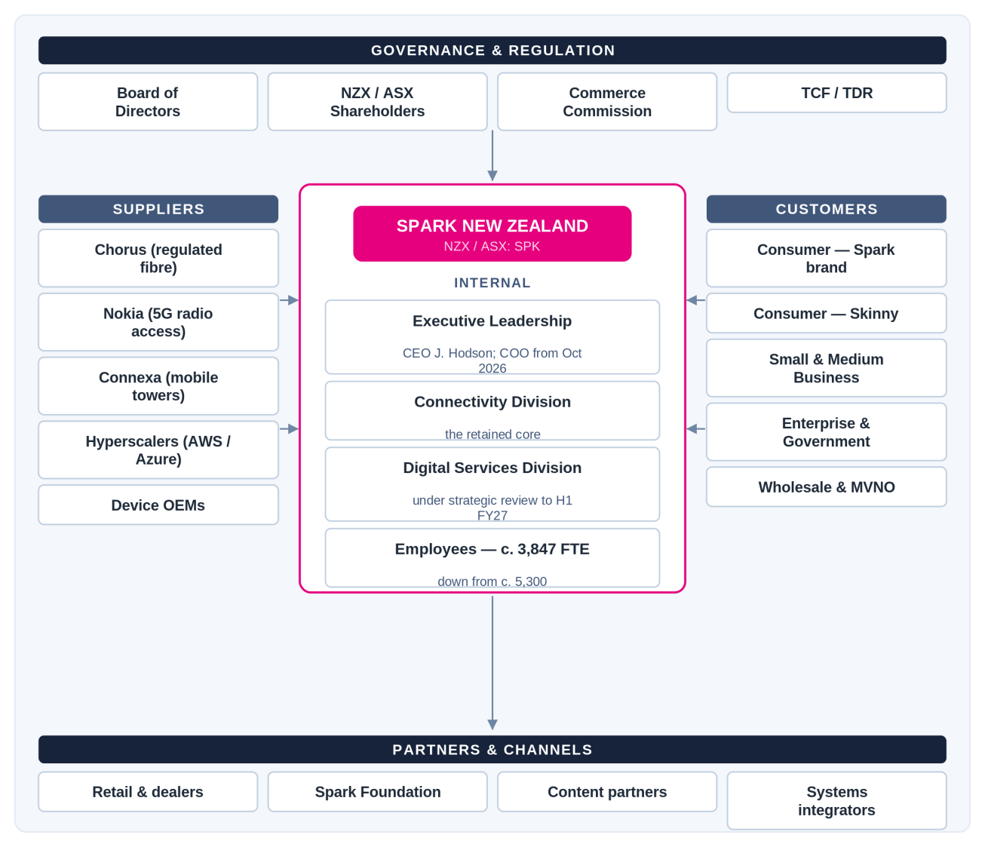
Figure 1. Spark New Zealand stakeholder map.

1.4 Industry Analysis
Porter's (1985) five forces model is used here because the question is why Spark has so little room to protect margin, and the model is designed to explain how industry structure sets the profitability available to a firm. Figure 2 applies it.
The structure is not favourable. Rivalry is high: Spark, One NZ and 2degrees together control about 97.5% of the mobile market (Commerce Commission, 2025), the market is saturated, and any growth has to be taken from a competitor. Buyer power is moderate to high. Switching is easy in principle, but 61% of mobile customers have stayed with the same provider for more than five years and half of those who do switch run into at least one problem (Commerce Commission, 2025), so the sharper pressure comes from business buyers: Spark's IT services revenue fell by around 15% in one reported period as public sector spending was cut and private investment deferred (Reseller News, 2024). Supplier power is moderate to high, since Chorus is a regulated near-monopoly for fibre input and hyperscalers are supplier and competitor at the same time. New entry is a limited threat, but substitutes are significant; Starlink overtook Spark as the largest rural broadband provider, lifting its share of the rural market from 19% to 27% in the year to June 2025 (Commerce Commission, 2025).
This matters for the rest of the report. Industry structure leaves Spark with very little pricing power, so if margin cannot be recovered from price it has to be recovered from cost. The NZ$50 million labour cost-out is a reasonable response to that pressure, and the organisational problem examined in Section 2 is a consequence of how it was carried out.
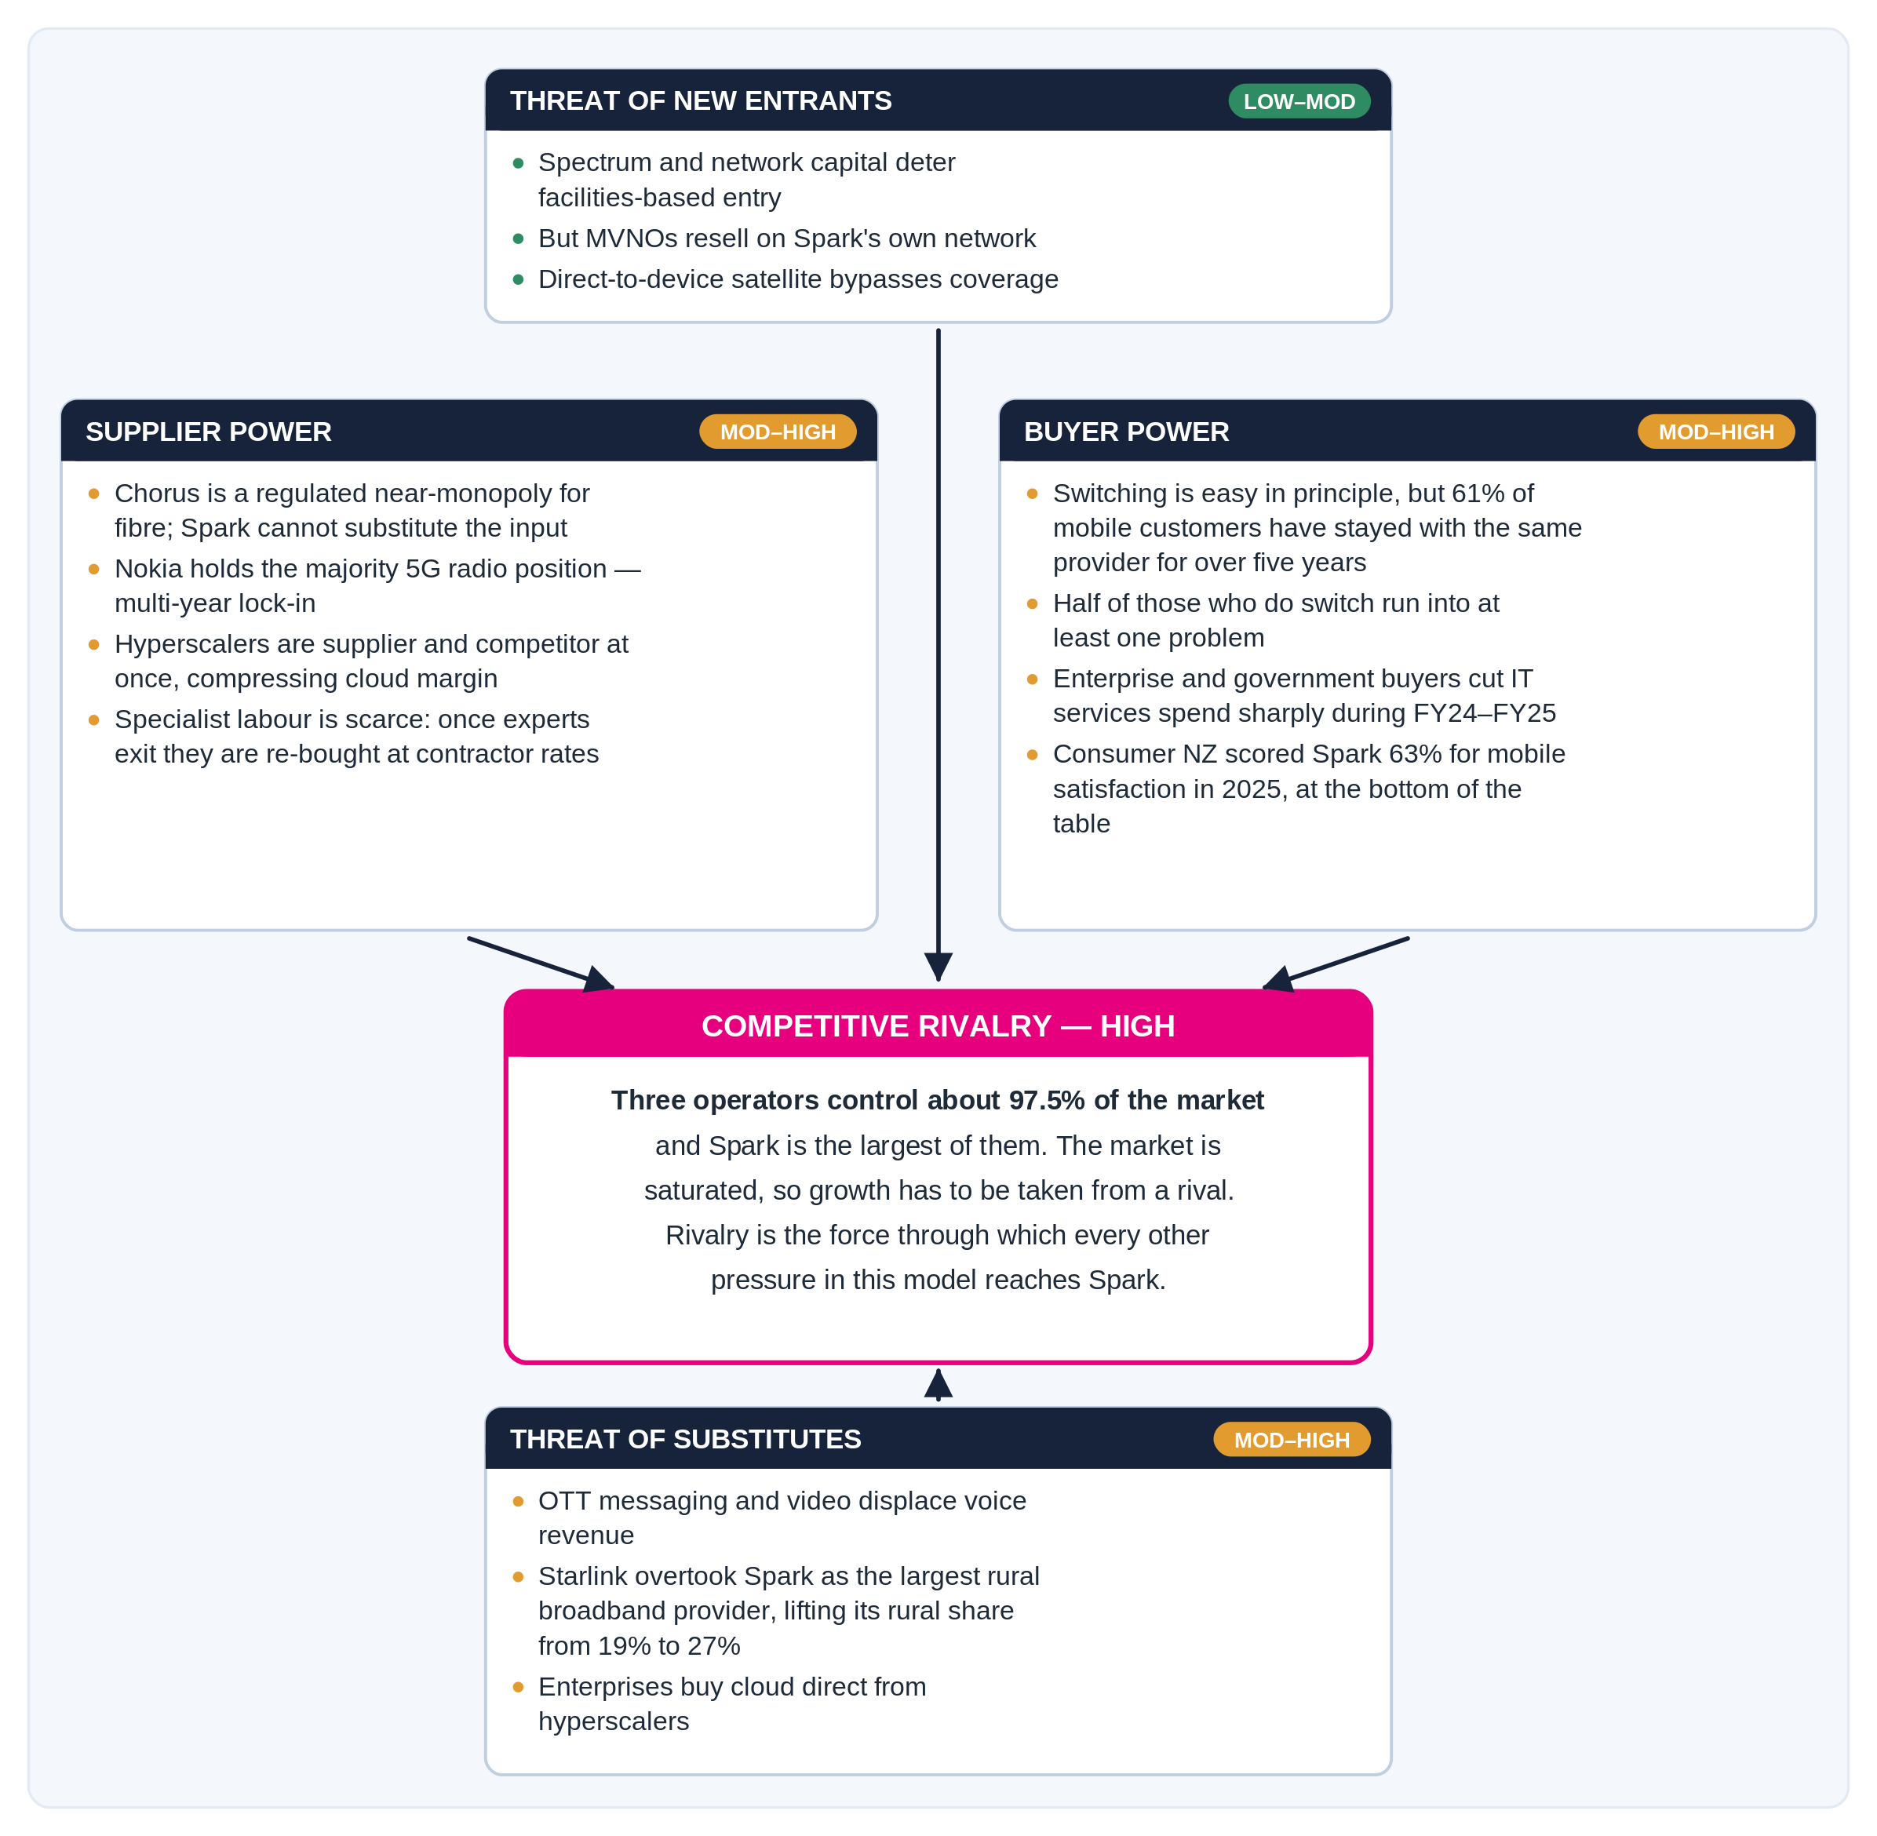
Figure 2. Porter's five forces applied to Spark New Zealand.

1.5 Modelling the Business Strategy
Porter's (1985) generic strategies model is used in Figure 3 because his warning about firms that pursue differentiation and cost leadership at the same time describes the position Spark is currently managing.
Spark's intended position is broad differentiation. SPK-30 promises national scale, the best network and a better customer experience, and the company continues to invest in 5G and in satellite-to-mobile services. The observed position is less clear. Profit growth in the first half of FY26 came from cost savings rather than revenue, and Consumer NZ's 2025 survey scored Spark at 63% for mobile satisfaction, placing it at the bottom of the table alongside One NZ (Consumer NZ, 2025). For comparison, the Commerce Commission recorded overall telecommunications satisfaction of 69% in June 2025 (Commerce Commission, 2025). A company that claims to differentiate on experience but is rated below the market average on that experience is not, on this evidence, differentiating successfully.
Spark therefore appears to be funding a differentiation promise using cost-leadership behaviour. Given the industry structure described in Section 1.4 this is a defensible short-term response, but it only holds if the cost reduction leaves the capability that produces the differentiation intact.
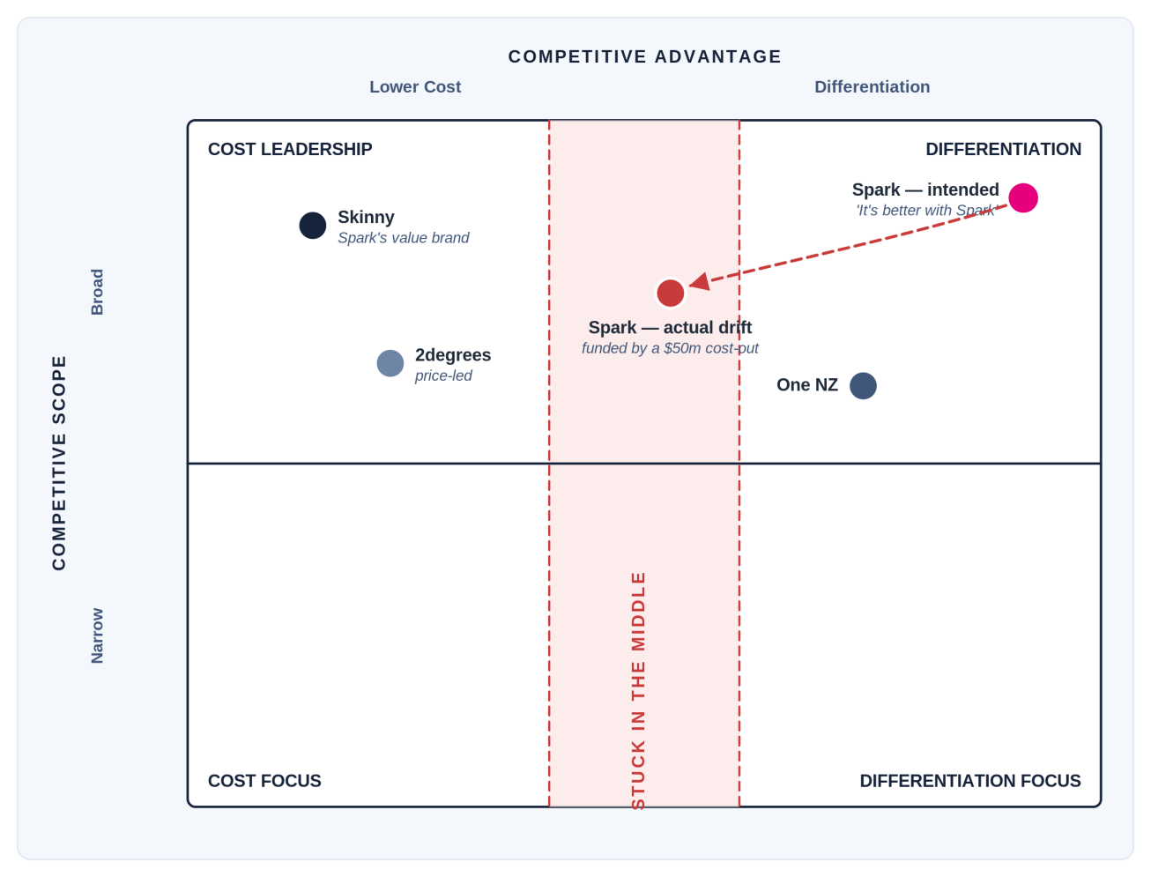
Figure 3. Spark's position against Porter's generic strategies, showing intended position and observed drift.

1.6 Modelling the Value Chain
Porter's (1985) value chain is used in Figure 4 to map where Spark's competitive advantage is actually produced. The differentiation the company promises is created in Operations and in Service: network reliability, provisioning, fault restoration and customer support. These activities depend almost entirely on the knowledge held by the people performing them, and that knowledge is supplied by one support activity, human resource management.
Human resource management has absorbed a 28% reduction in headcount, yet there is no public evidence that the way knowledge moves from an exiting employee to a remaining one has changed. The other support activities were actively managed through the cost reduction; the capability pipeline appears not to have been. This is why human resource management is marked in Figure 4 as the location of the dysfunction examined in Section 2.
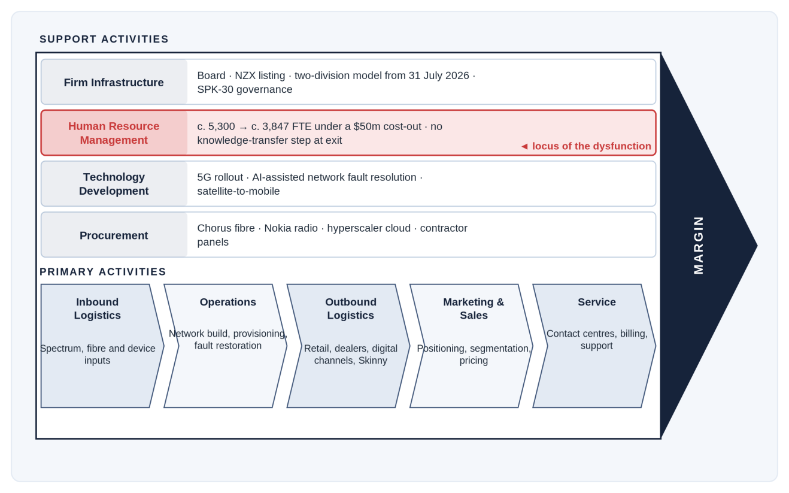
Figure 4. Porter's value chain for Spark, with human resource management identified as the location of the dysfunction.

1.7 Rich Picture of the AS-IS Situation
Figure 5 sets out the actors, systems, process steps and pain points in the current situation, in order to show a relationship that the individual figures do not. Cost pressure sets a savings target, roles are released to meet it, and the transfer of knowledge is left to the individuals involved without a template or any check that it happened. System access closes on the last day whether or not the transfer is complete. The team that inherits the work then restores service more slowly, and the capability is eventually bought back through contractors at higher rates, which erodes the saving the target was set to deliver.
The loop reinforces itself rather than correcting, which is why the situation is unlikely to resolve on its own. The July 2026 divisional split is likely to make it worse in the short term, because teams have to re-form across a new boundary and the number of handovers increases.
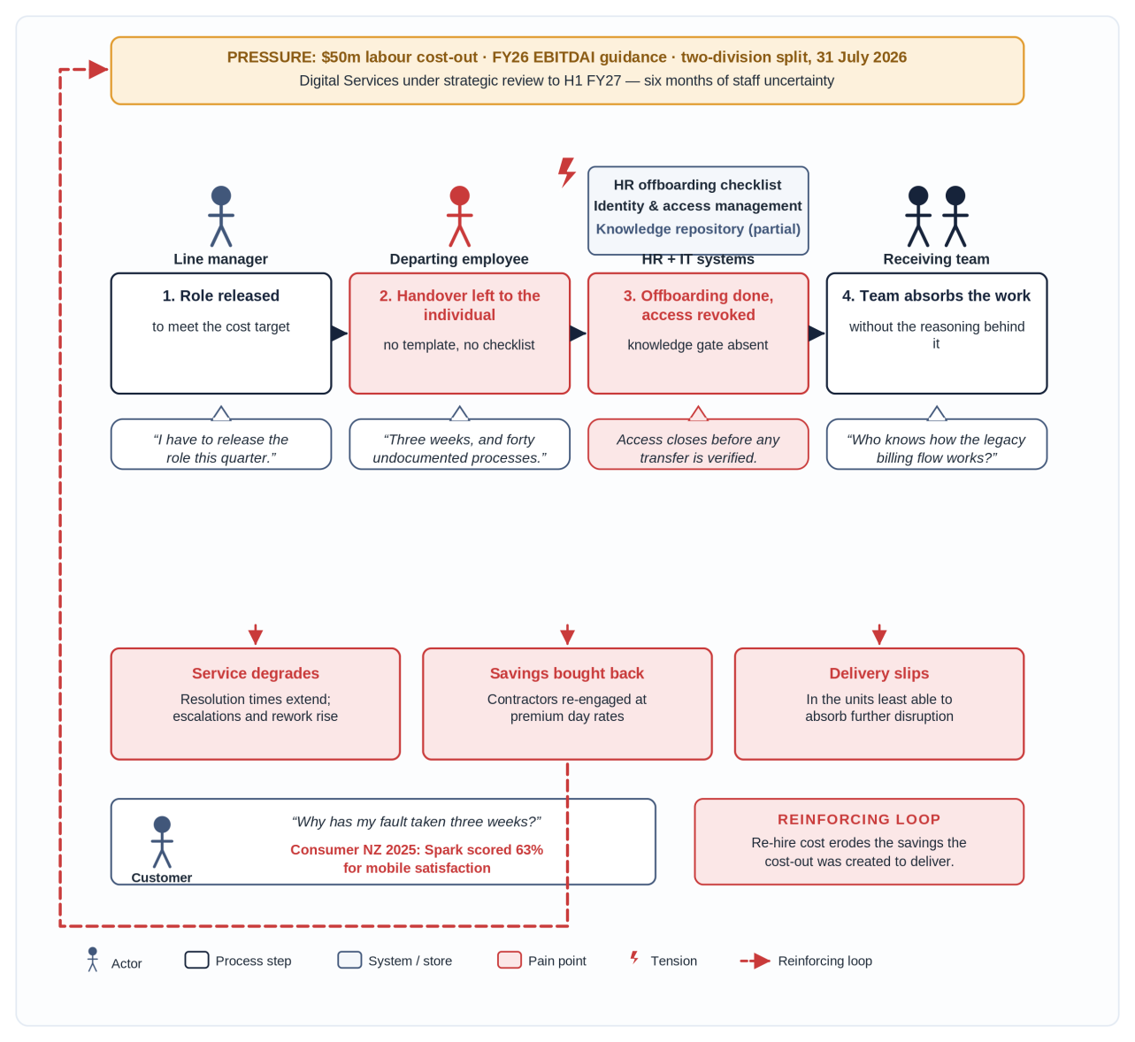
Figure 5. Rich picture of the AS-IS situation, showing the reinforcing loop between cost reduction and capability loss.

1.8 Statement of Business Needs
Table 2 sets out the business needs that follow from Sections 1.1 to 1.7, ordered by urgency and by the strength of the evidence behind them.
Table 2. Prioritised business needs
ID | Business need | Priority | Basis
BN1 | Protect operational capability while the cost reduction is completed, so that FY26 guidance is met without service getting worse. | High | §1.4, §1.5, §1.7
BN2 | Retain critical knowledge through the divisional transition, which increases the number of handovers. | High | §1.1, §1.7
BN3 | Make capability retention measurable, so that knowledge loss is visible before it becomes a service failure. | High | §1.6, §1.7
BN4 | Retain Digital Services staff through the uncertainty preceding the review outcome in H1 FY27. | Medium | §1.1, §1.3
BN5 | Reduce reliance on contractors engaged at premium rates to recover capability the company has already paid to release. | Medium | §1.7
BN6 | Bring customer-facing service performance back to at least the market average, in support of SPK-30. | Medium | §1.5

2. Framing the Problem

2.1 Identifying and Justifying the Problem Type
Business needs in a consulting engagement are usually classified as strategic or competitive, operational, organisational, or financial. Spark shows all four, and Table 3 sets them out with the evidence for each.
Table 3. Classification of the problems facing Spark New Zealand
Problem type | How it appears at Spark | Evidence
Strategic / competitive | The intended broad-differentiation position is drifting toward the middle of Porter's matrix, because a differentiation promise is being funded by cost-leadership behaviour. | SPK-30 narrows the company back to its connectivity core after a broader digital services ambition.
Operational | Customer-facing service performance sits below the market average, with mobile satisfaction at the bottom of the provider table. | Consumer NZ (2025) scored Spark at 63%, against overall market satisfaction of 69% (Commerce Commission, 2025).
Financial | Profit is being recovered by removing cost rather than by growing revenue, while a higher-margin growth line contracts. | H1 FY26 revenue down about 1% with NPAT up 83% on NZ$51m of savings; IT services revenue down about 15%.
Organisational | A 28% reduction in headcount, a new divisional structure and a leadership change were carried out without a visible mechanism for retaining the capability that leaves with departing staff. | Headcount c. 5,300 to c. 3,800; divisional split of 31 July 2026; Digital Services review running to H1 FY27.
These four are not equally important as causes. The organisational problem sits upstream of the other three. Reducing headcount by 28% without a capability-retention mechanism weakens the operational capacity that produces service quality; weaker service quality undermines the differentiation the strategic position depends on; and buying the lost capability back through contractors consumes the savings the financial case relied on. Working on the organisational problem should therefore relieve pressure on all three, whereas working on any one of the others on its own would leave the mechanism producing them in place. The remainder of this report develops the organisational problem.

2.2 Identifying and Justifying the Dysfunctional Process
The dysfunctional process is Spark's employee exit and knowledge handover process, running from the decision to disestablish a role or the receipt of a resignation through to the point where the departing employee's work is absorbed by the rest of the organisation.
Table 4 assesses this process against the criteria commonly used to decide whether a process is a candidate for redesign (Davenport, 1993; Hammer & Champy, 1993).
Table 4. Assessment of the process against process-selection criteria
Criterion | Assessment | Evidence or reasoning
Is the process broken? | Yes | Knowledge is not reliably transferred, and service outcomes fell over the same period as the headcount reduction.
Is redesign likely to succeed? | Probably | It needs a check and a measure inside an existing workflow rather than new headcount or new systems. Adoption by line managers is the main risk, which H4 tests.
Does it affect strategic direction? | Yes | SPK-30 depends on network reliability and customer experience, both of which are delivered by retained expertise.
Does it affect customer satisfaction? | Yes | Consumer NZ scored Spark at 63% for mobile satisfaction in 2025, at the bottom of the provider table.
Is it out of date? | Partly | The administrative parts of offboarding work. What is missing is any knowledge component, and that has not changed through a 28% reduction.
Is it below best practice? | Yes | There is no visible criticality assessment, capture template or completion measure, none of which is an unusual control.
Does it matter for productivity? | Yes | Receiving teams appear to rebuild knowledge by trial and escalation rather than doing the work directly.
Would savings be visible? | Yes | They would show as reduced contractor and re-engagement spend against the FY26 baseline.
Is the return likely to be high? | Yes | A low-cost process change set against premium contractor day rates.
The process is the direct cause of the failure to meet BN1, BN2 and BN5, and the absence of a completion measure is the gap identified in BN3. It is dysfunctional in a specific sense: it reliably produces an outcome opposed to its purpose. Offboarding exists to release an employee while keeping the organisation able to operate. At Spark it releases the employee, and capability released in order to save cost is then bought back at contractor rates.
It is worth being explicit about what is and is not established here. The public record shows the scale of the exits and the decline in service outcomes. It does not disclose how offboarding is designed internally. Four propositions are inferred from the pattern of outcomes and tested in Section 2.6: handover is delegated to line managers with no mandated template; no criticality assessment identifies roles that are single points of knowledge; handover is not a gated step, so access is revoked before transfer is verified; and no measure of completion exists.

2.3 Problem Statement
A problem statement should describe the client's core problem concisely and factually, and should be specific, measurable, achievable, relevant and time-bound.
Problem. Spark's employee exit and knowledge handover process does not reliably transfer institutional knowledge from departing employees to the teams that inherit their work. Across a reduction in headcount from roughly 5,300 to about 3,800, handover has been managed informally, with no mandated capture step and no measure of completion. The resulting loss of capability produces rework, longer fault resolution and contractor spend at premium rates, which erodes the NZ$50 million labour saving the programme was set up to deliver.
Target. Reach at least 90% verified handover completion for roles assessed as critical, and reduce capability-related contractor and re-engagement spend by 25% against the FY26 baseline, within twelve months of implementation and before the Digital Services review concludes in H1 FY27.
Table 5. Assessment against the SMART criteria
Criterion | How the statement meets it
Specific | One process, one failure mode, and one population of roles.
Measurable | At least 90% verified handover completion for critical roles, and a 25% reduction in capability-related contractor and re-engagement spend against the FY26 baseline.
Achievable | A check and a measure inside an existing workflow, requiring no new headcount or technology, which is consistent with the cost discipline currently in force.
Relevant | Addresses BN1, BN2, BN3 and BN5, and protects the differentiation promise identified in §1.5.
Time-bound | Twelve months from implementation, tied to the conclusion of the Digital Services review in H1 FY27.

2.4 Framework for Framing and Structuring the Problem
Two candidate frameworks were considered for structuring the diagnosis. The MIT90s model (Scott Morton, 1991) balances strategy, structure, management processes, technology and individuals and roles within a surrounding culture. It suits technology-enabled change, but it treats people as a single element, which is too coarse for a problem whose mechanism sits between skills, systems and accountability.
The McKinsey 7-S framework (Waterman, Peters & Phillips, 1980) was adopted instead. It separates staff, skills, systems, style and shared values into distinct elements, which is the level of detail this problem needs, and its central argument, that performance depends on all seven elements staying aligned, describes what has happened at Spark.
Table 6. The McKinsey 7-S framework applied to Spark New Zealand
Element | Status | Evidence
Strategy | Changed deliberately | SPK-30 narrows the company to its connectivity core and sets the FY30 ambition.
Structure | Changed deliberately | Separated into Connectivity and Digital Services divisions on 31 July 2026.
Staff | Changed deliberately | Headcount reduced from c. 5,300 to c. 3,800 under the NZ$50m cost-out.
Style | Changed deliberately | Leadership changes accompanied the restructure, with cost discipline the dominant emphasis.
Systems | Not adjusted | Offboarding appears to remain an administrative checklist covering payroll, assets and access, with no knowledge step and no completion measure.
Skills | Eroded, not rebuilt | Specialist and legacy-system knowledge has left with departing staff, and no capability-rebuilding programme is on the public record.
Shared values | Under strain | A promise of “better” is being asked of a workforce reduced by 28%, part of which faces an unresolved divestment decision.
Four of the seven elements were changed deliberately and at the same time. Three, namely systems, skills and shared values, were left to adjust on their own. The framework holds that this combination is what produces underperformance, and it places the misalignment in the same place that Sections 1.6 and 1.7 identified. The issue tree in Section 2.5 then breaks down why the misalignment persists, and the hypotheses in Section 2.6 make each branch testable, following the hypothesis-driven approach described by Rasiel and Friga (2001).

2.5 Issue Tree
Figure 6 breaks the problem down. The four first-level branches are intended to be mutually exclusive and collectively exhaustive: each addresses a distinct link in the chain, and knowledge lost at exit has to fail at one of them. Either it left too quickly to be transferred, or it was never captured, or it was captured but could not be used, or nobody was answerable for capturing it. An alternative decomposition by individual and organisational factors was considered and rejected, because the same failure recurs across different people, business units and types of exit, which points to the design of the process rather than to individual capability.
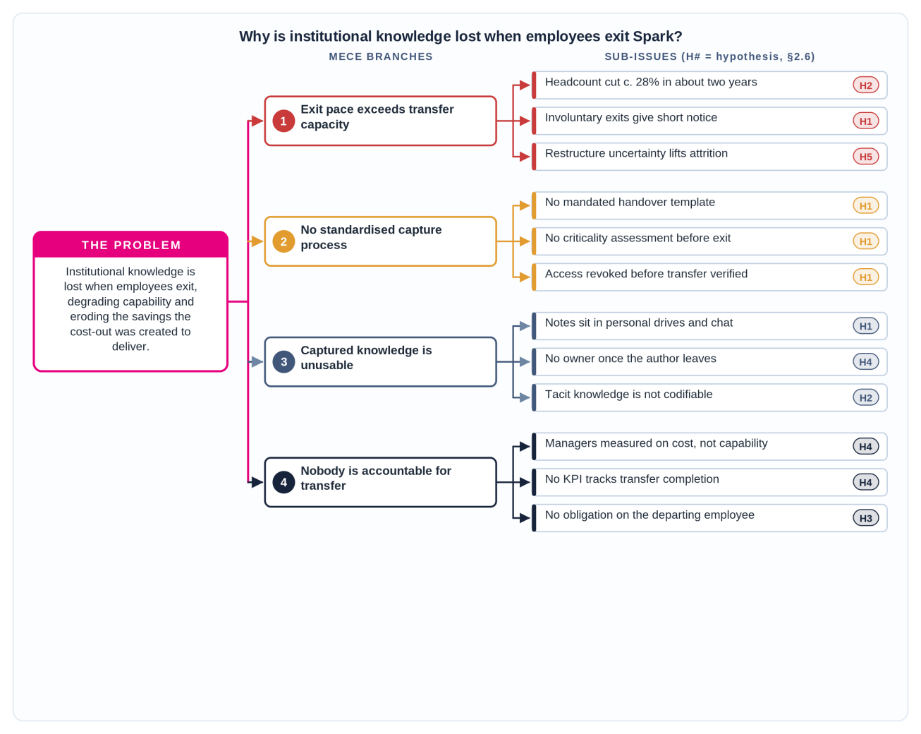
Figure 6. Issue tree for the loss of institutional knowledge at employee exit.
Table 7. Evidence supporting each branch
Branch | Supporting evidence | Status
1 Exit pace exceeds transfer capacity | Headcount reduced by about 28% over roughly two years; the July 2026 split adds further transitions; the Digital Services review runs to H1 FY27. | Established
2 No standardised capture process | Inferred from outcomes: service quality declined over the reduction period and no capability programme appears on the public record. | Tested by H1
3 Captured knowledge is unusable | Inferred from outcomes, and consistent with the systems and skills misalignment identified in Table 6. | Tested by H1, H2
4 No accountability for transfer | Inferred from outcomes. Where no measure exists, a failure of this kind stays invisible to management. | Tested by H4

2.6 Hypotheses
Each hypothesis below is testable and rests on an assumption that can be checked quickly before any detailed analysis begins, which avoids spending effort on a hypothesis that was never going to be provable (Rasiel & Friga, 2001).
Table 8. Hypotheses, branch addressed, proposed test and underlying assumption
ID | Hypothesis | Br. | Proposed test | Assumption to check first
H1 | More than half of the roles disestablished under the cost-out had no documented, verified handover before the employee's final day. | 2, 3 | Review offboarding records; interview line managers who released roles. | Offboarding records exist and can be retrieved.
H2 | Business units that absorbed the largest reductions show proportionally larger increases in resolution time, escalations and rework. | 1, 3 | Compare headcount reduction by unit against service performance data, FY24 to FY26. | Service data is broken down by business unit.
H3 | At least 30% of the labour savings realised have been offset by contractor or re-engagement spend to recover lost capability. | 4 | Analyse contractor spend against realised savings by unit and period. | Contractor spend can be separated into capability recovery and project work.
H4 | No KPI tracks knowledge transfer completion, and no manager's objectives refer to capability retention. | 4 | Review the KPI framework and a sample of manager objectives; interview the people function. | The KPI framework and objectives are accessible to the engagement.
H5 | Staff in Digital Services report a materially higher intention to leave than staff in Connectivity. | 1 | Compare engagement and intention-to-leave data by division; interview Digital Services staff. | Engagement data is reported separately by division.
H1 carries the framing, because it tests whether the failure is one of process design rather than of individual performance. If it holds, the problem is systemic and a process remedy is justified. If it does not, the analysis moves to H2 and H3 to establish whether the loss is of tacit knowledge that documentation cannot carry, or of capacity in the teams receiving the work.

2.7 AS-IS Process Model
Figure 7 models the current process in SAP Signavio using BPMN 2.0. Four lanes are shown: the line manager, the departing employee, the people function and the receiving team. Once the exit is confirmed and responsibilities are reallocated, handover and administrative offboarding run in parallel and are joined before system access is revoked.
Three features of the model carry the dysfunction. The handover task has no template and no completion criterion, so its output depends entirely on the individual. The timer boundary event attached to the verbal handover shows that the notice period can end before the handover does, and in an involuntary exit that window is set by employment process rather than by how complex the knowledge is. The offboarding gateway only asks whether the administrative checklist is complete and loops back to payroll and asset return, so revoking access is triggered by a date rather than by readiness. The receiving team therefore begins with the work but not the reasoning behind it, and the branch ending in a contractor engagement is where the cost identified in Section 1.7 is incurred.
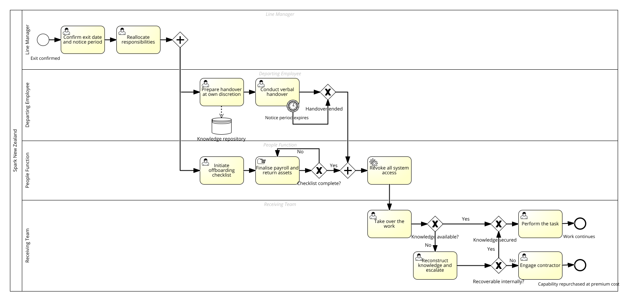
Figure 7. AS-IS employee exit and knowledge handover process, modelled in SAP Signavio (BPMN 2.0).

References
Business Scoop. (2026, July 31). Spark restructure separates digital services from connectivity. https://business.scoop.co.nz/
Commerce Commission. (2025). Annual telecommunications monitoring report. New Zealand Commerce Commission. https://www.comcom.govt.nz/
Consumer NZ. (2025). Best and worst mobile providers in 2025. Consumer New Zealand. https://www.consumer.org.nz/
Davenport, T. H. (1993). Process innovation: Reengineering work through information technology. Harvard Business School Press.
Hammer, M., & Champy, J. (1993). Reengineering the corporation: A manifesto for business revolution. HarperBusiness.
New Zealand Herald. (2026). Spark puts digital services division on the block, reaffirms guidance. https://www.nzherald.co.nz/
Porter, M. E. (1985). Competitive advantage: Creating and sustaining superior performance. Free Press.
Radio New Zealand. (2024). Spark plans to cut $50m from labour costs. https://www.rnz.co.nz/
Rasiel, E. M., & Friga, P. N. (2001). The McKinsey mind: Understanding and implementing the problem-solving tools and management techniques of the world's top strategic consulting firm. McGraw-Hill.
Reseller News. (2024). Spending cuts and deferred investment see Spark's IT services revenue drop. https://www.reseller.co.nz/
Scott Morton, M. S. (1991). The corporation of the 1990s: Information technology and organizational transformation. Oxford University Press.
Spark New Zealand. (2025a). Annual report FY25. https://investors.sparknz.co.nz/
Spark New Zealand. (2025b). SPK-30 strategy. https://investors.sparknz.co.nz/
Spark New Zealand. (2026a). H1 FY26 results. https://investors.sparknz.co.nz/
Waterman, R. H., Peters, T. J., & Phillips, J. R. (1980). Structure is not organization. Business Horizons, 23(3), 14–26.

