Monitoring Task
Task Description:
Install Prometheus and Grafana on a Linux EC2 machine, connect Prometheus to Grafana, and create a dashboard to view metrics.

File Architecture:
Creating the EC2 machine through Terraform and installing the Prometheus and Grafana using the UserData.
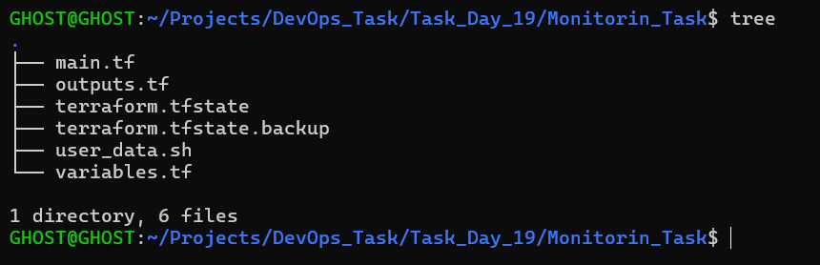
Outputs.tf
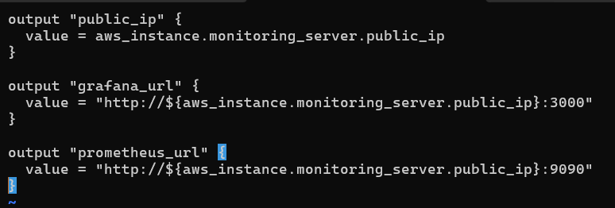
Variables.tf
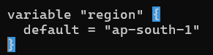

Main.tf
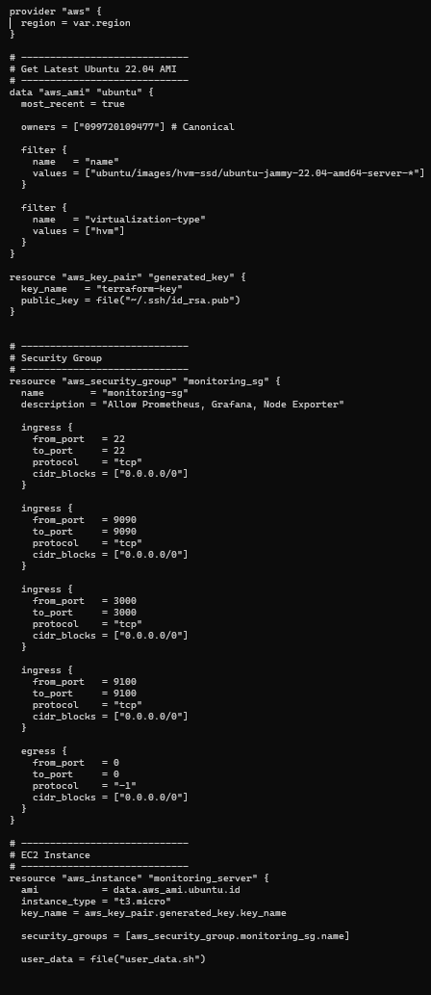
User_data.sh
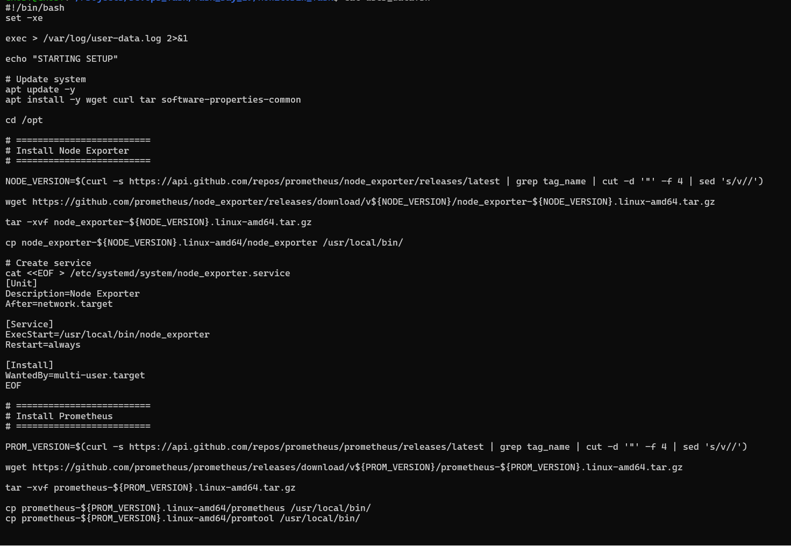
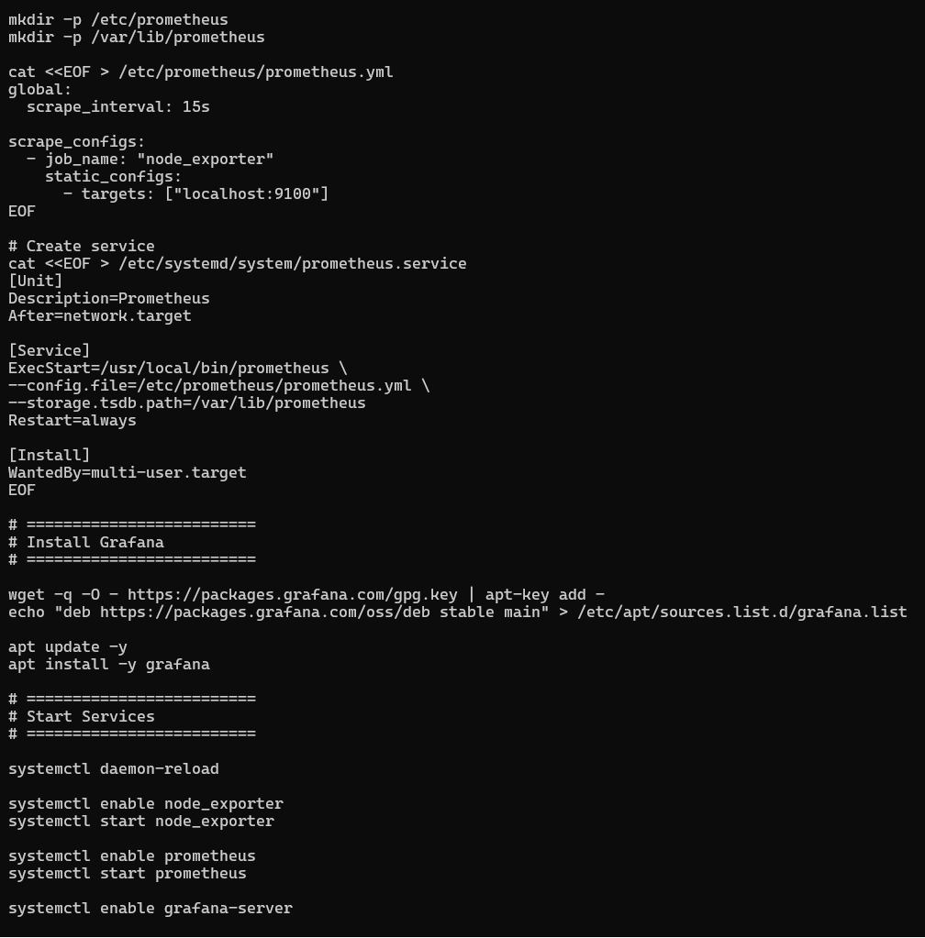
Building an EC2 Instance and deploying Prometheus and Grafana using User Data script:
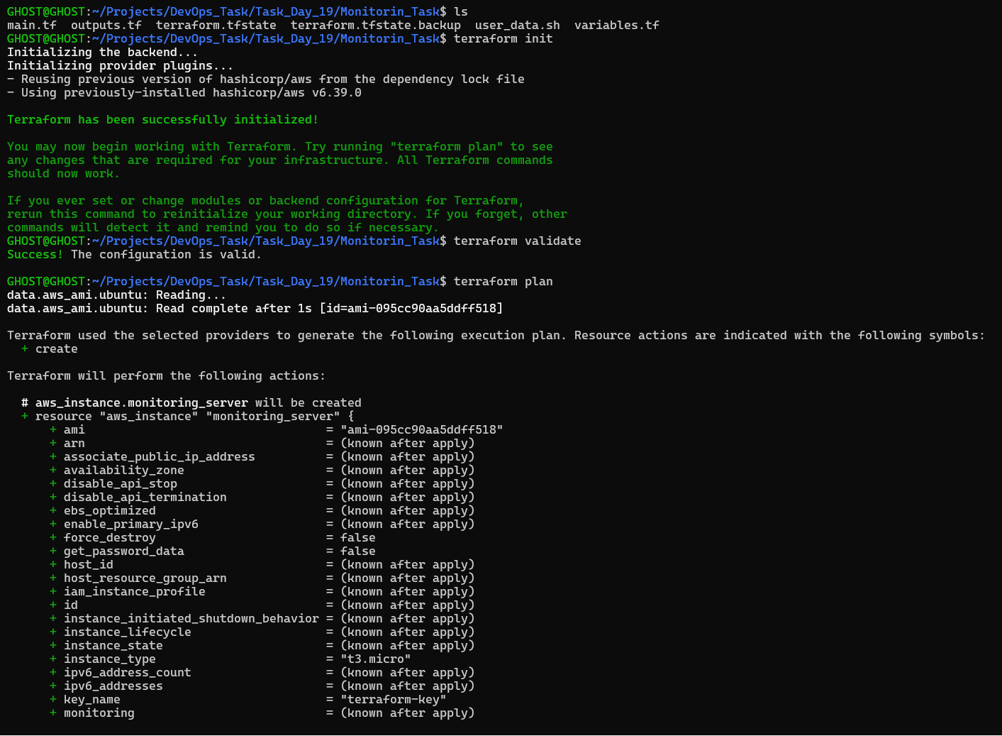
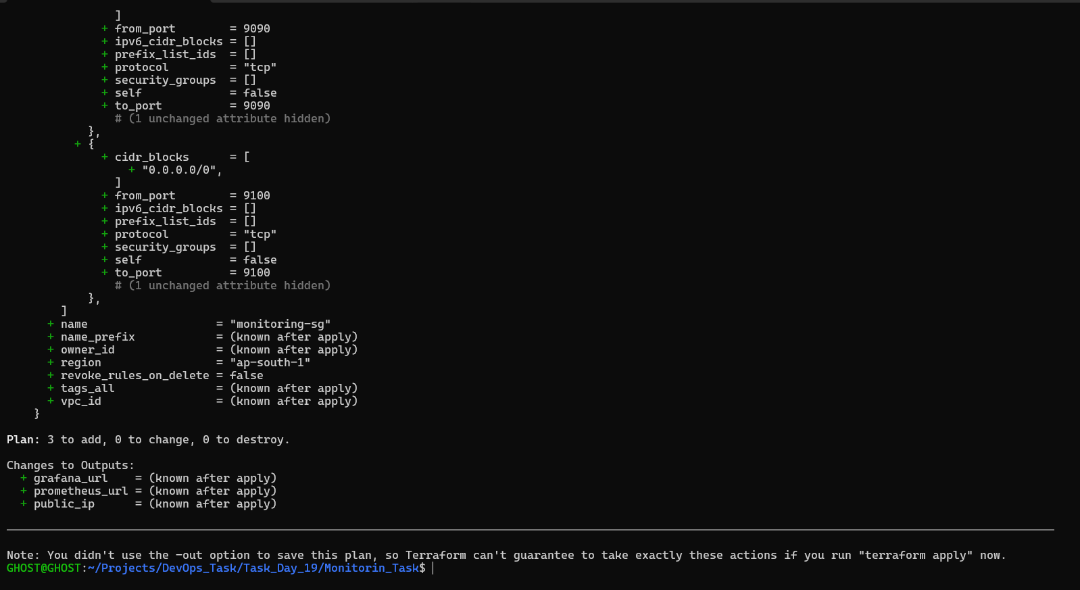
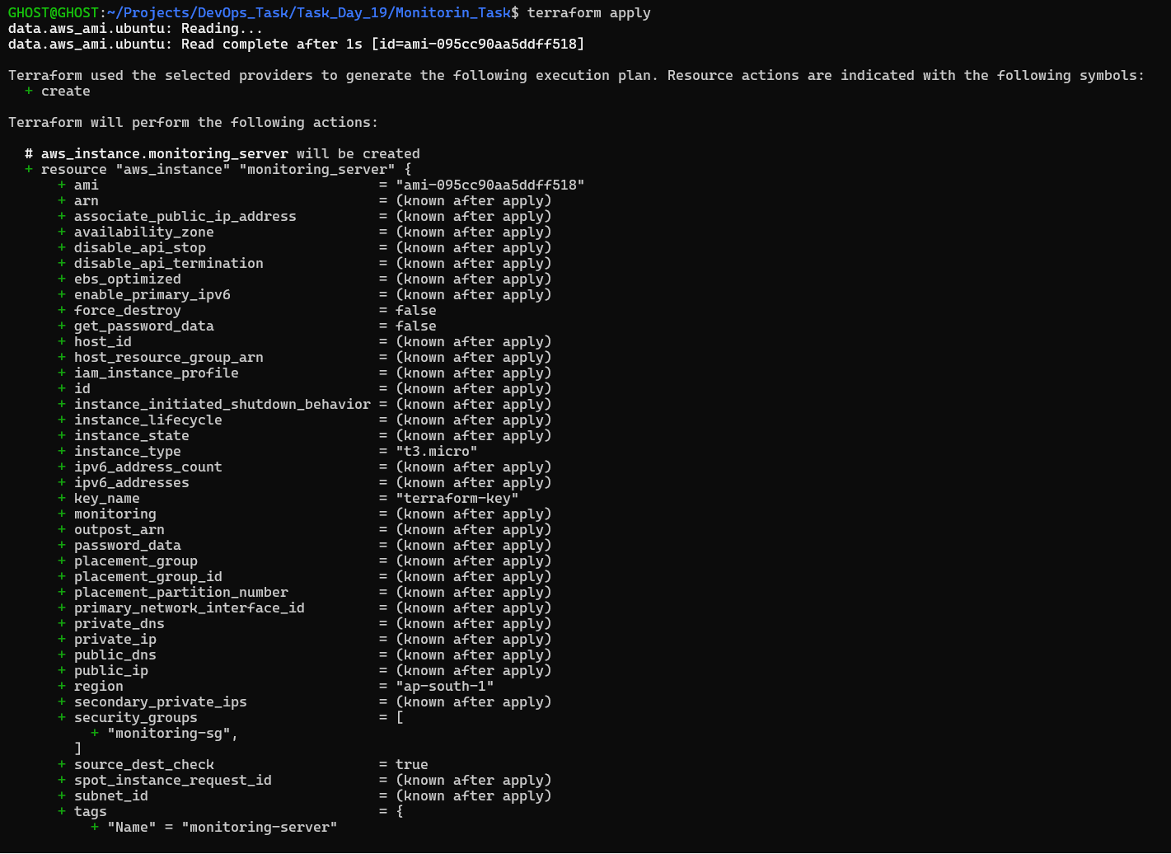

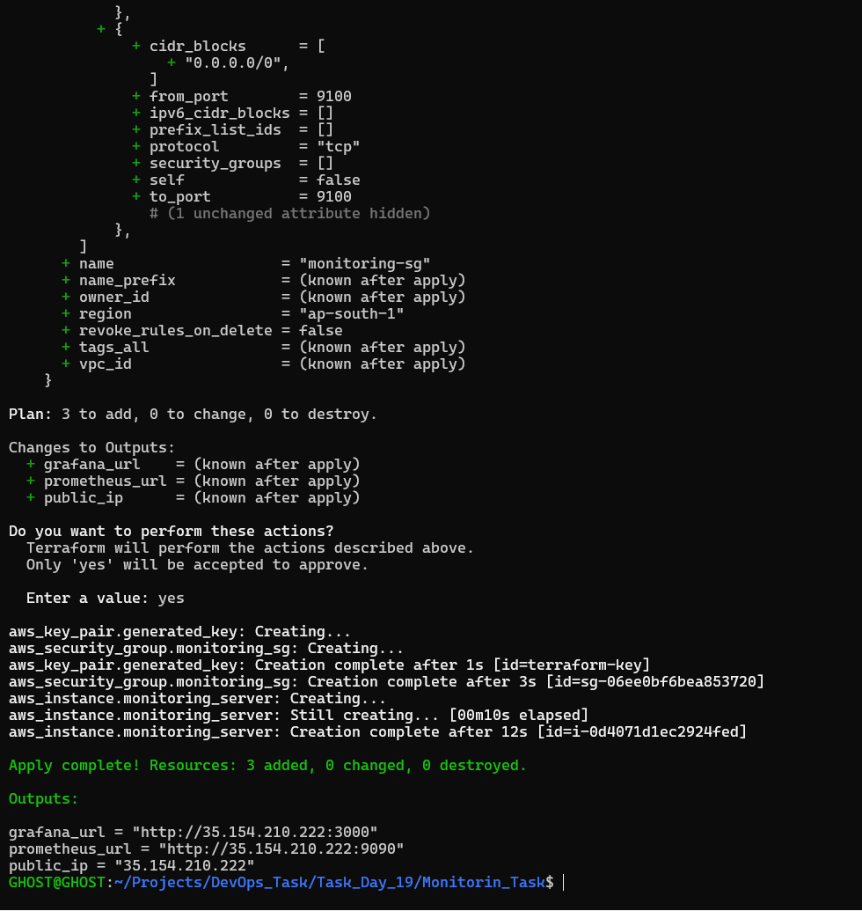
After creating the EC2 using Terraform, Verifying the created EC2 and All the services:
EC2 Created Successfully: 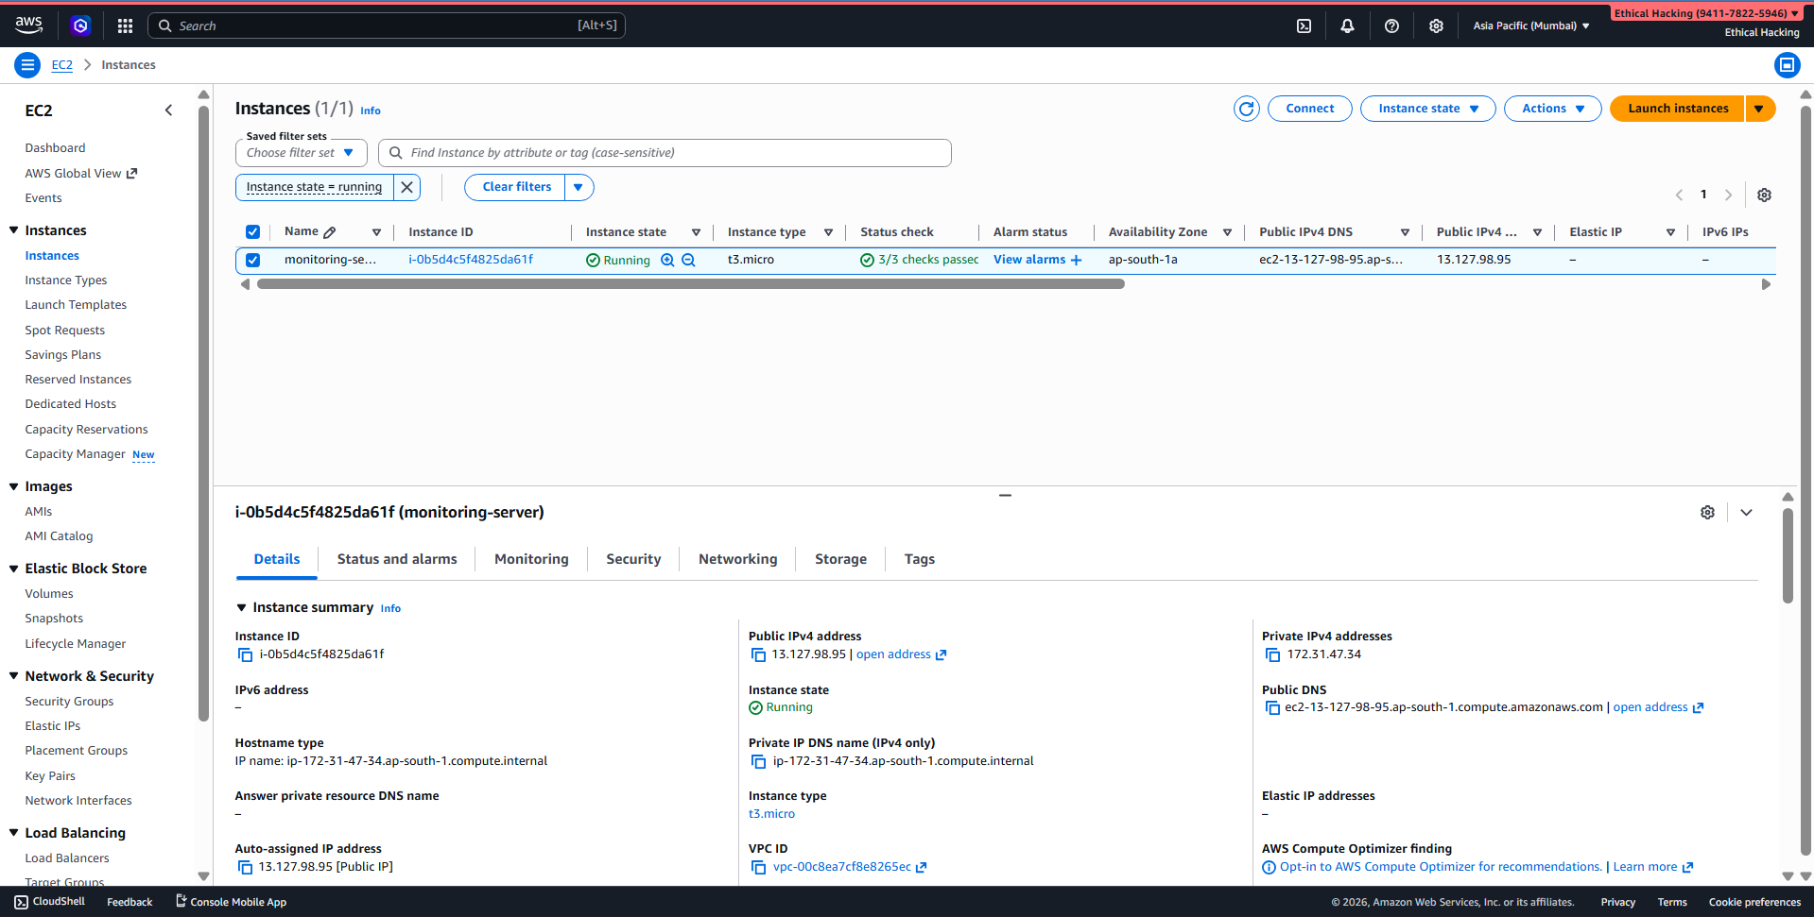
Prometheus Working Fine:
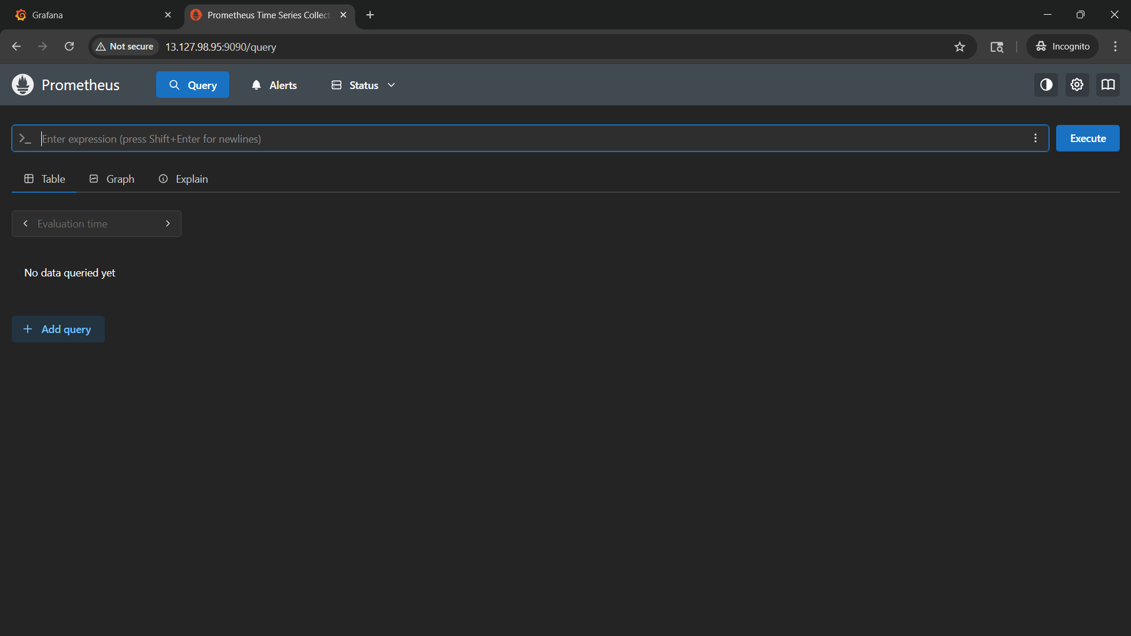

Node Exporter:
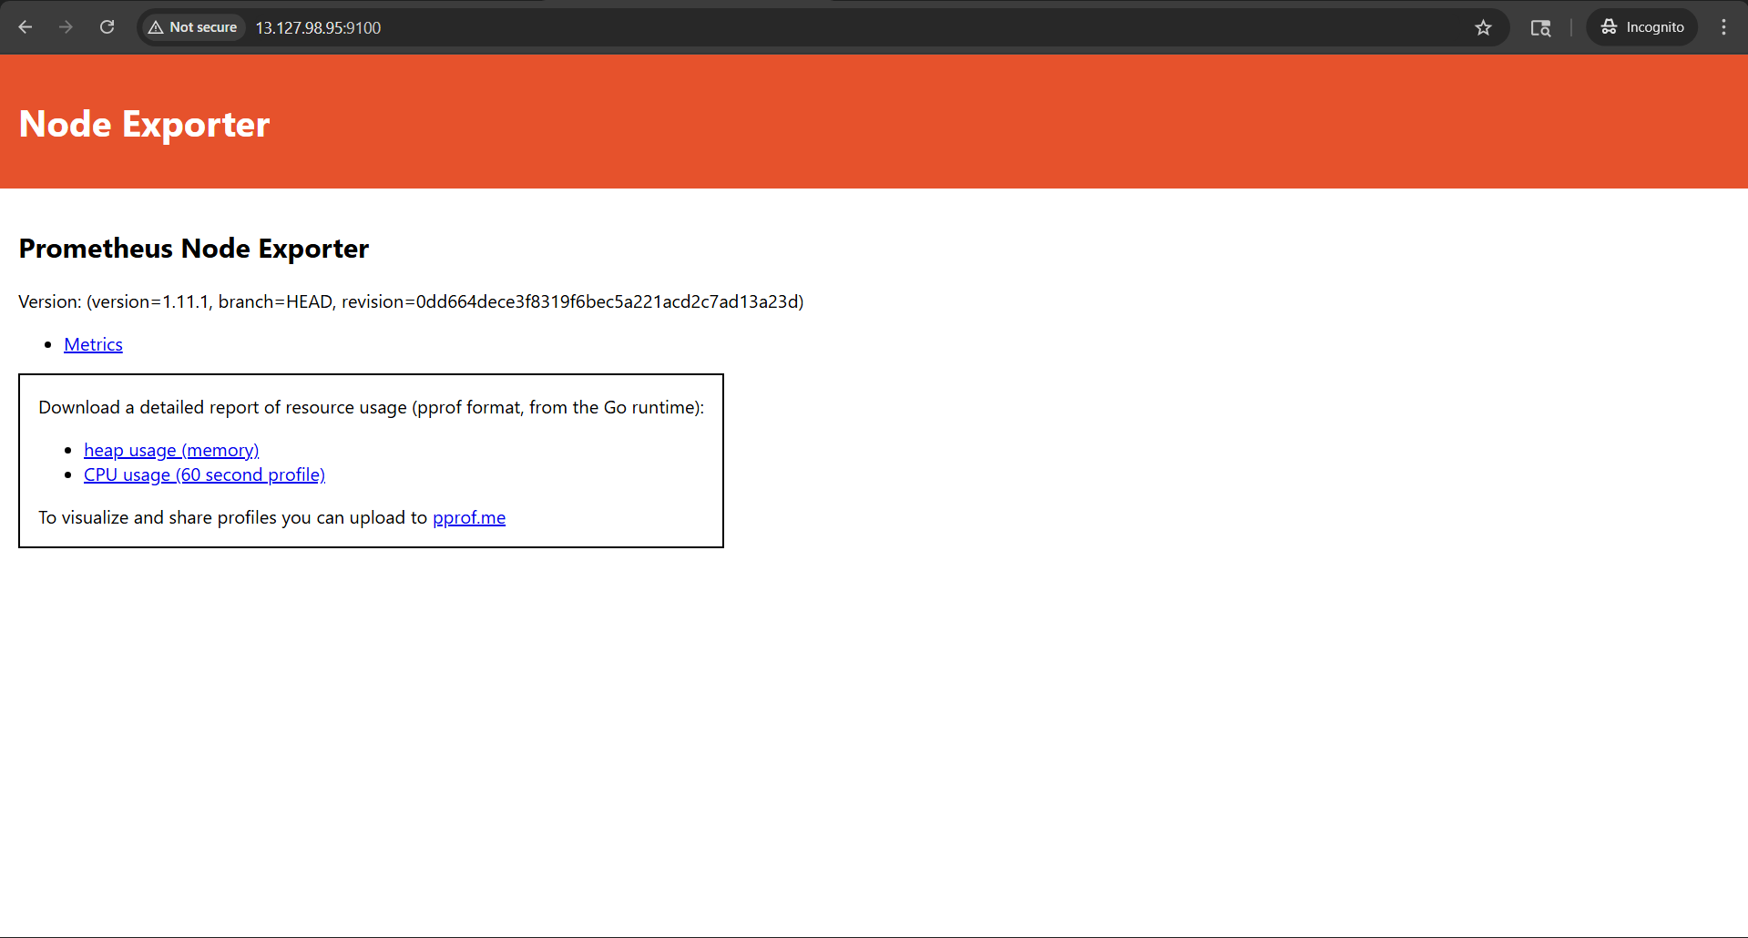
Grafana Working Fine:
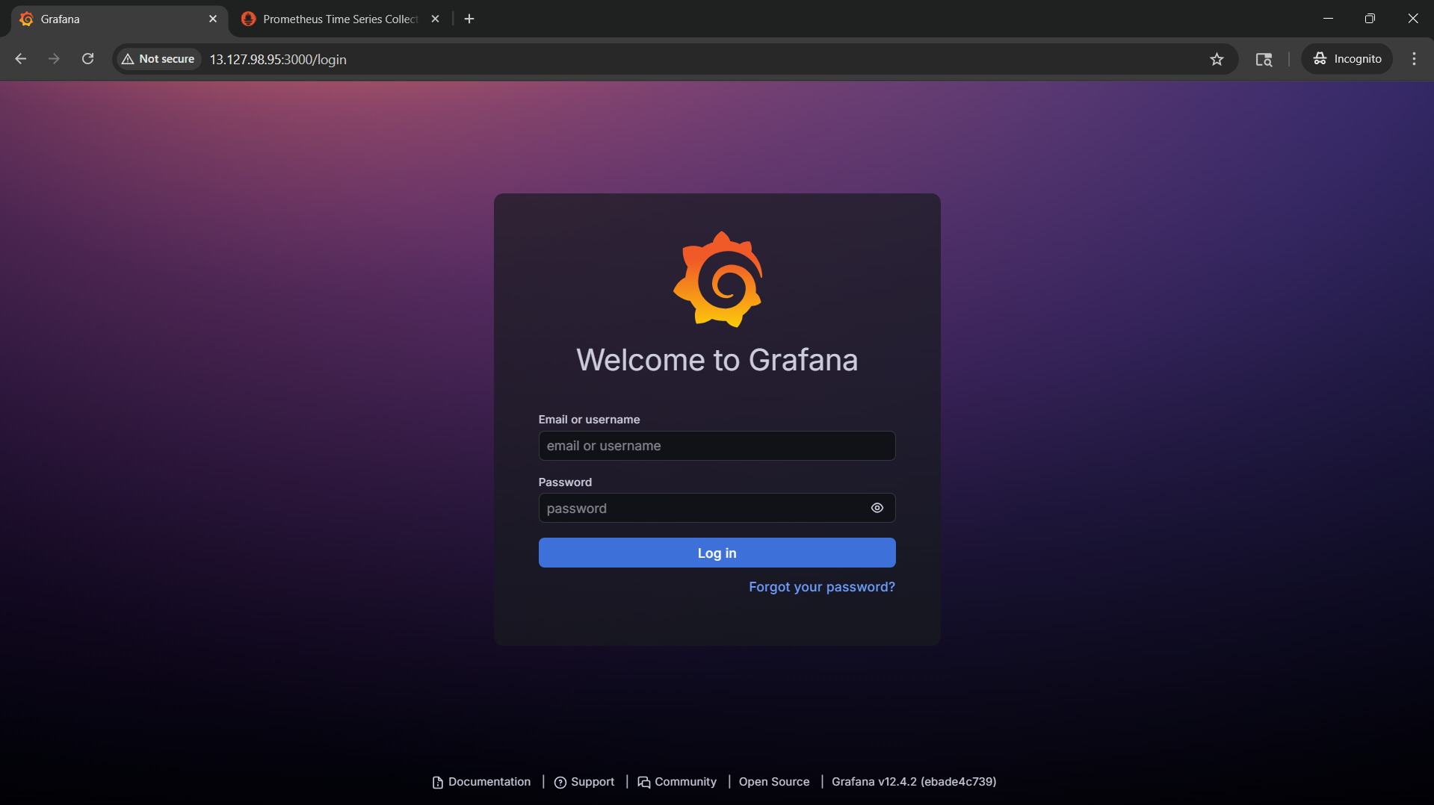

Connecting Grafana with Prometheus to get the data:
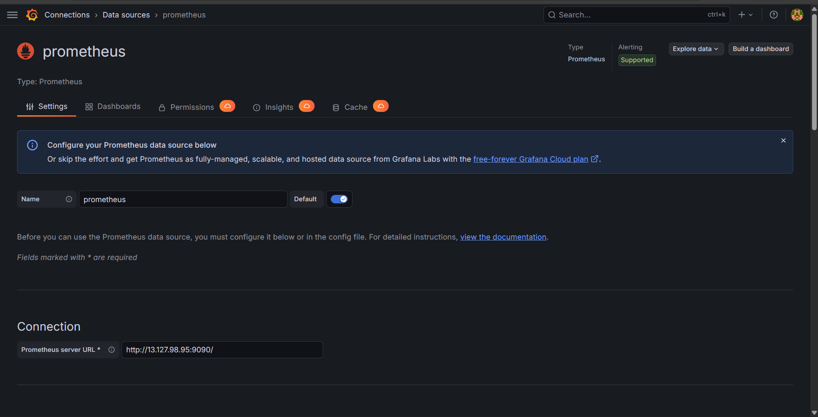

Final Working Dashboard imported from Grafana:
