**Eastern Visayas State University**

**Bachelor of Science in Information Technology**

**IT 313 – Advanced Database System**

**Safety Reporting System**

**User Manual**

**Submitted by:**

Francis Jonel Balagusa

Jhullana Marie Cabradilla

Richard Josh Martinez

**BSIT 3C**

**Submitted to:**

Mrs. Sarah Jane L. Cabral

**Admin Guide**

**Homepage**

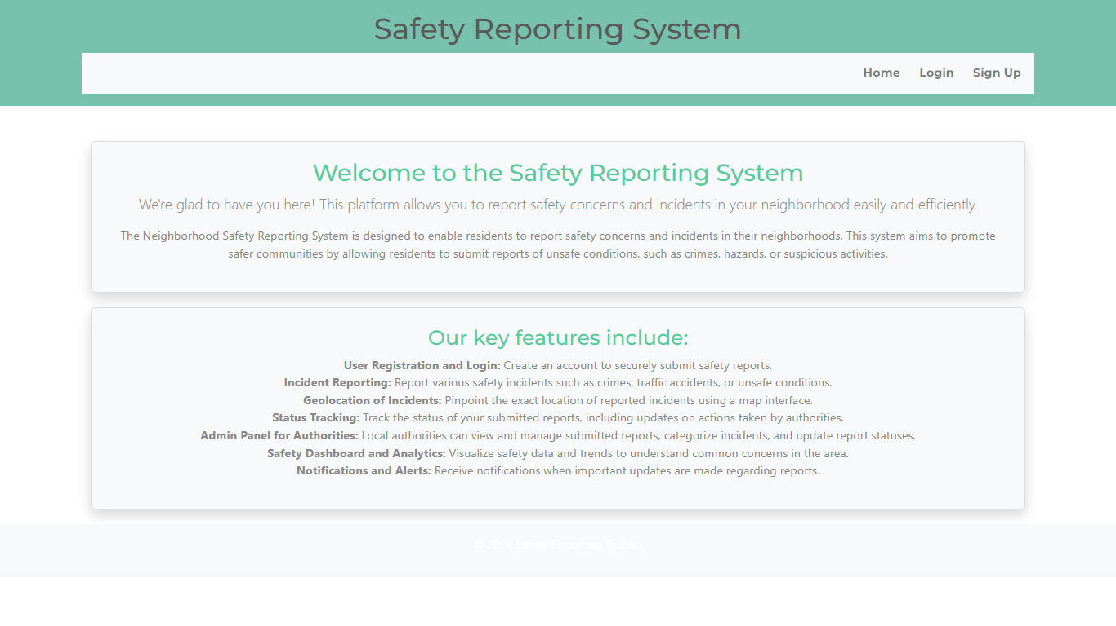

**Logging in**

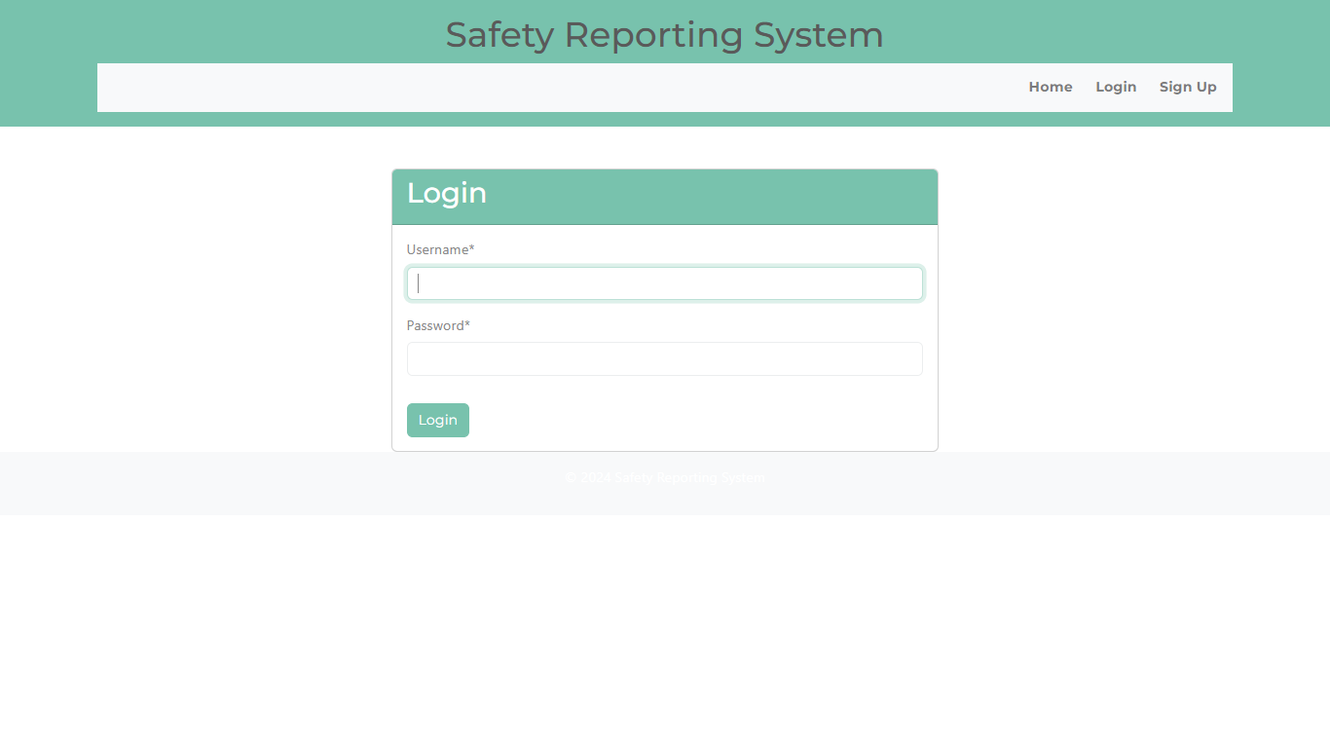

**Signing Up** - If you don’t have an account, then you need to sign up first.



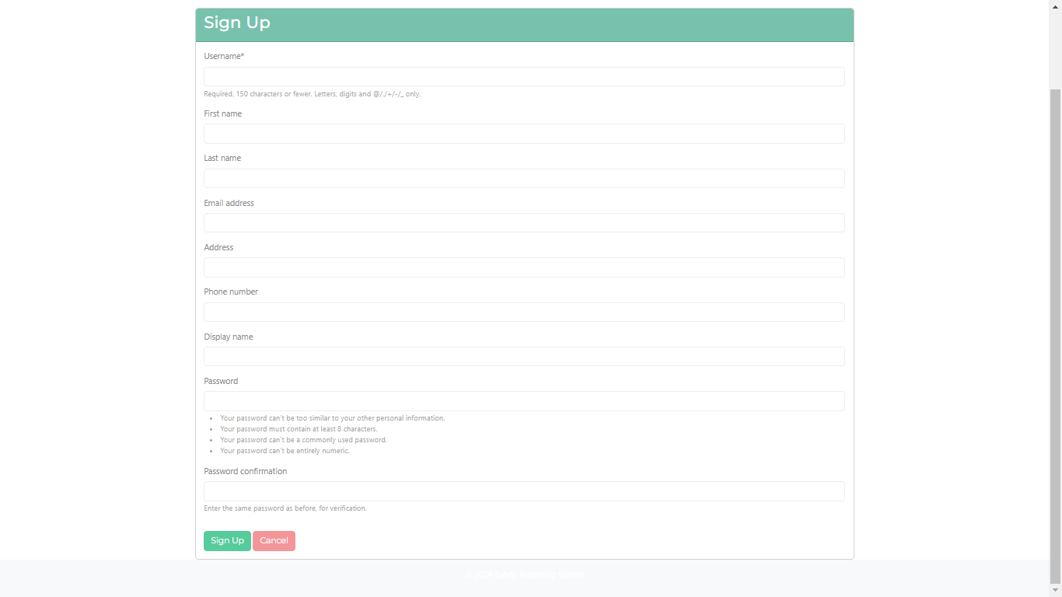

**Admin DashBoard**

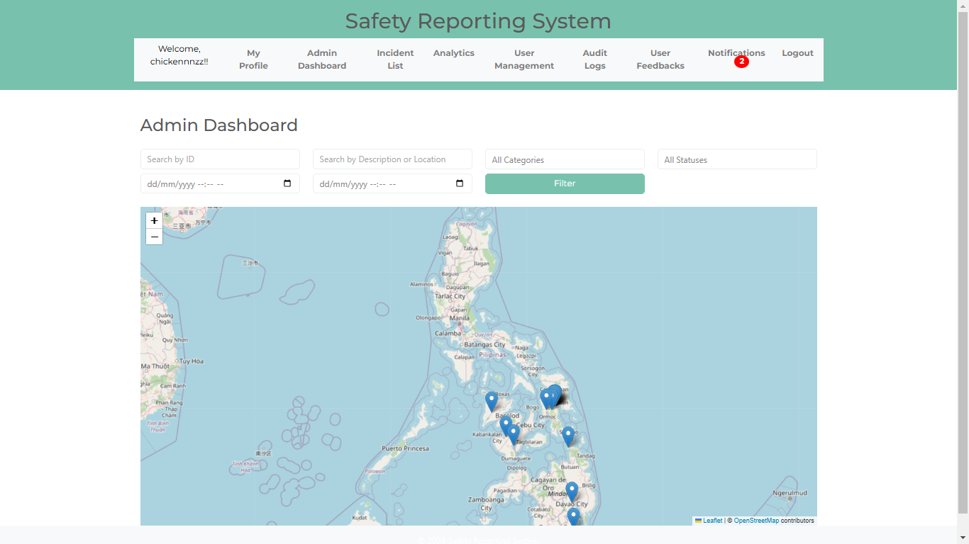

* This is the admin dashboard where you can search the ID, Location, categories, status, and the date.

**Admin Profile**

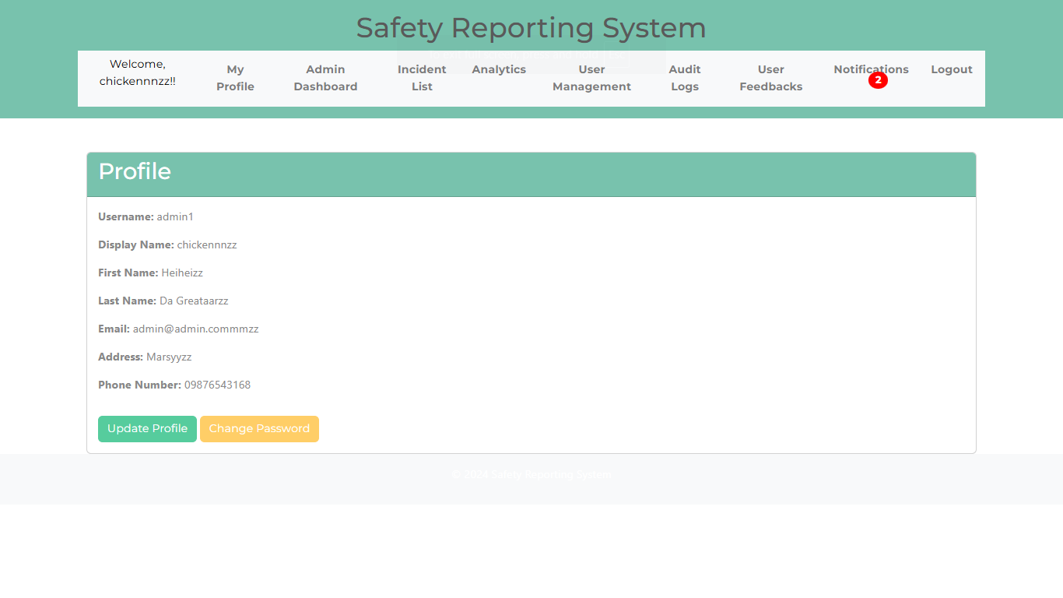

* We will see in here your profile information. You can also update your information by clicking the “Update Profile” button or change your password by clicking the “Change Password” button.

**Incident Reports**

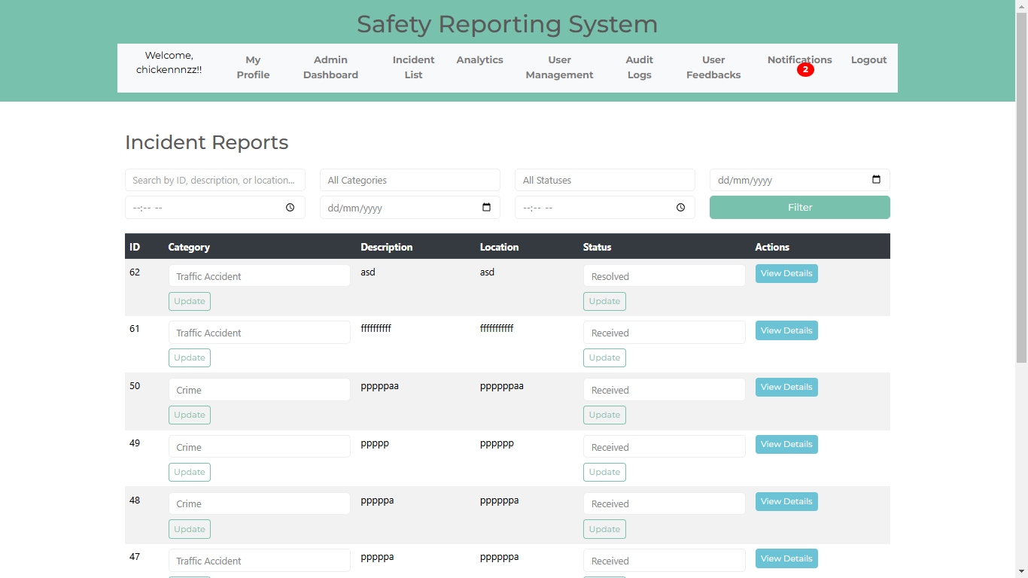

* In here, the admin can view the details of the incident. The admin can also update the category and the status.

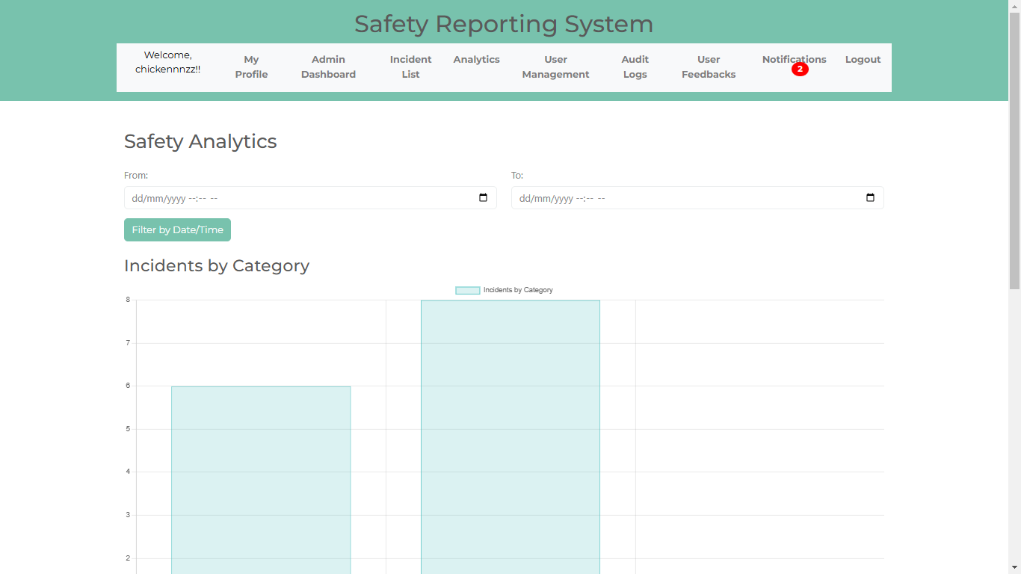**Analytics** – here we can see what accident has the most casualties through safety analytics.

**User Management**

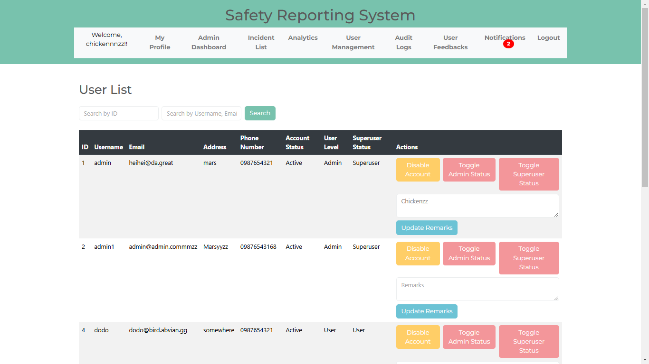

* here we can see the accounts of the admins and users.

**Audit Logs** – in here, the admin can see who log in and out of the system.

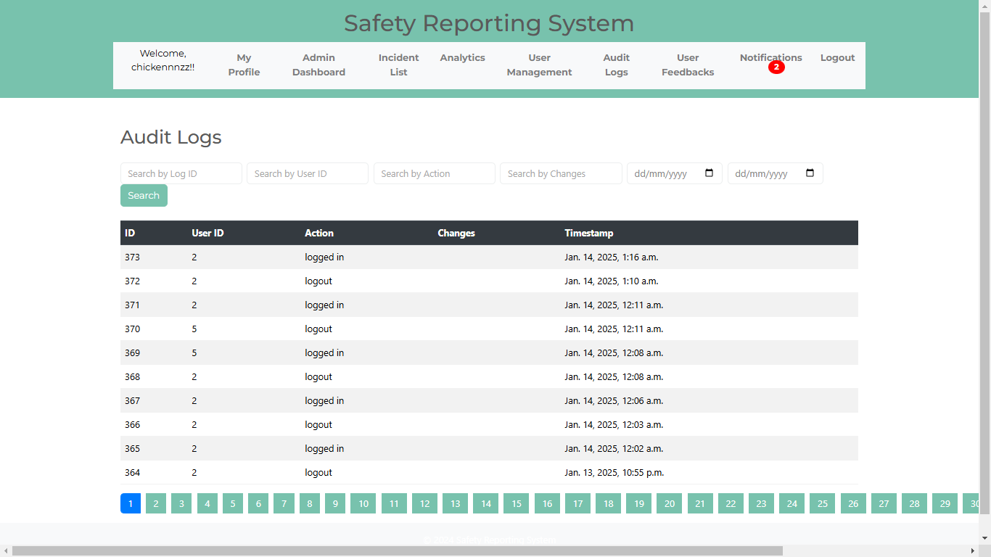

**User Feedback –** In this part, the admins can see the feedbacks of their users

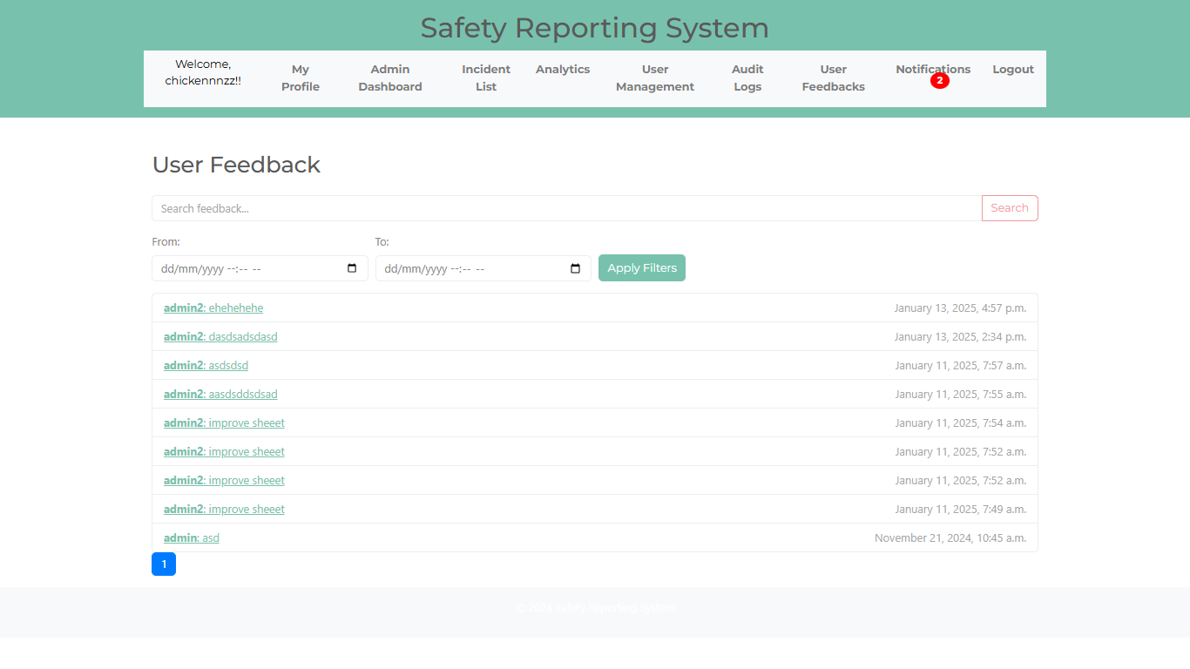

**Notifications** – in here, the admin will be notified when there is someone who reported an accident.

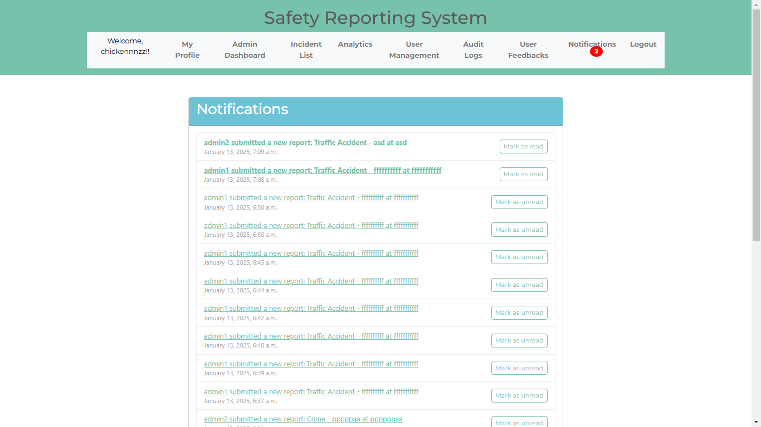

**User Guide**

**User Dashboard**

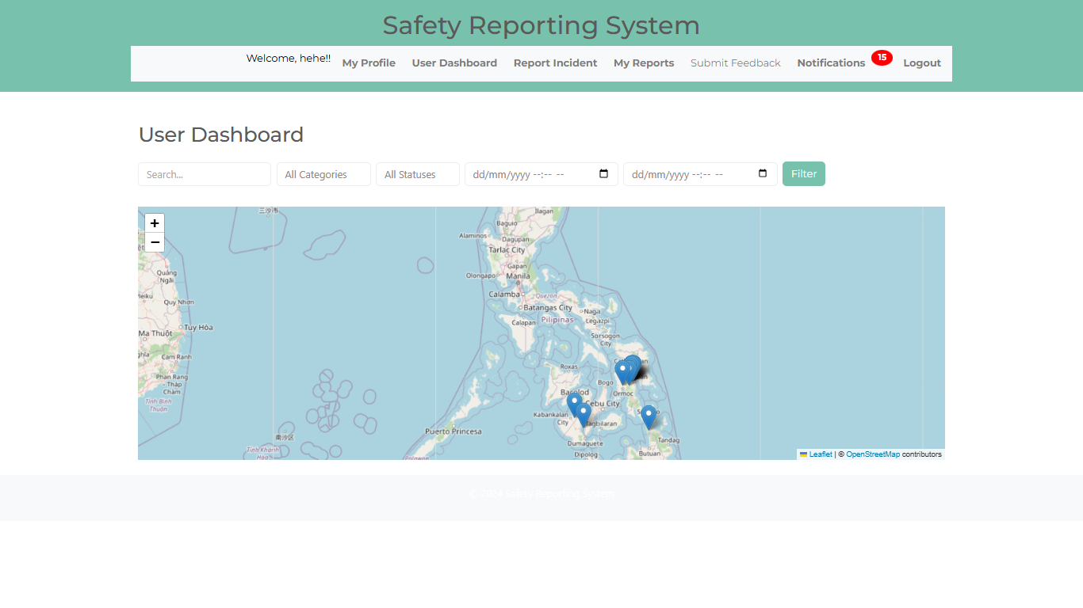

* Just like the admins dashboard, you can search here if you want to know if there are accident in the time and date, categories, or status you’ll search.

**Users Profile** – in here, the user will see the information they’ve input when they sign up.

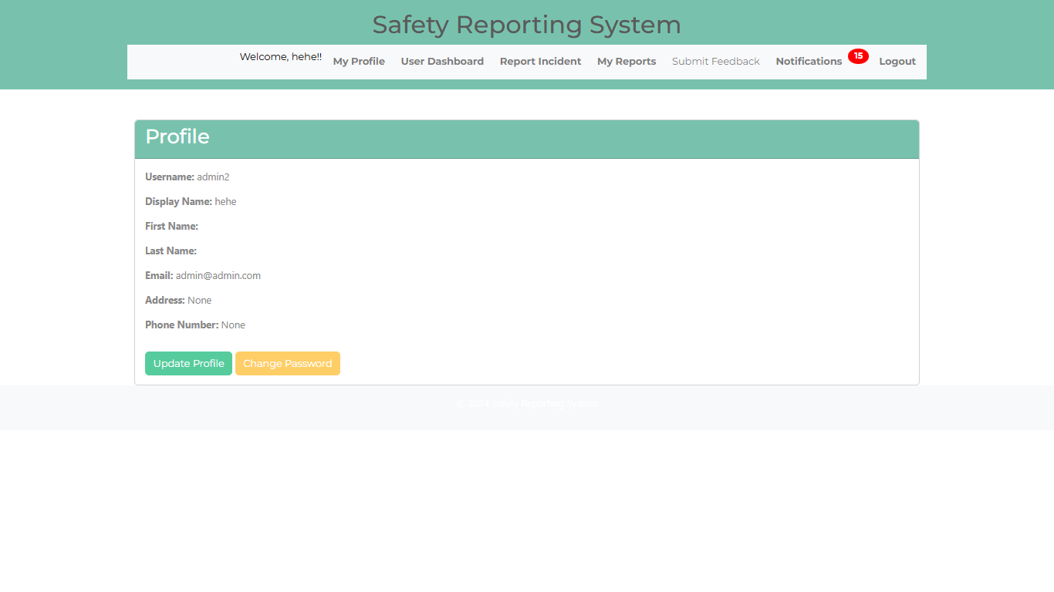

**Incident Report** – In here, the user can report an accident by categorizing what accident occur and their description about the accident.

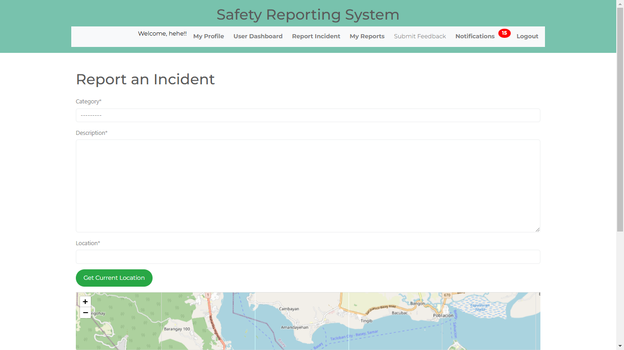

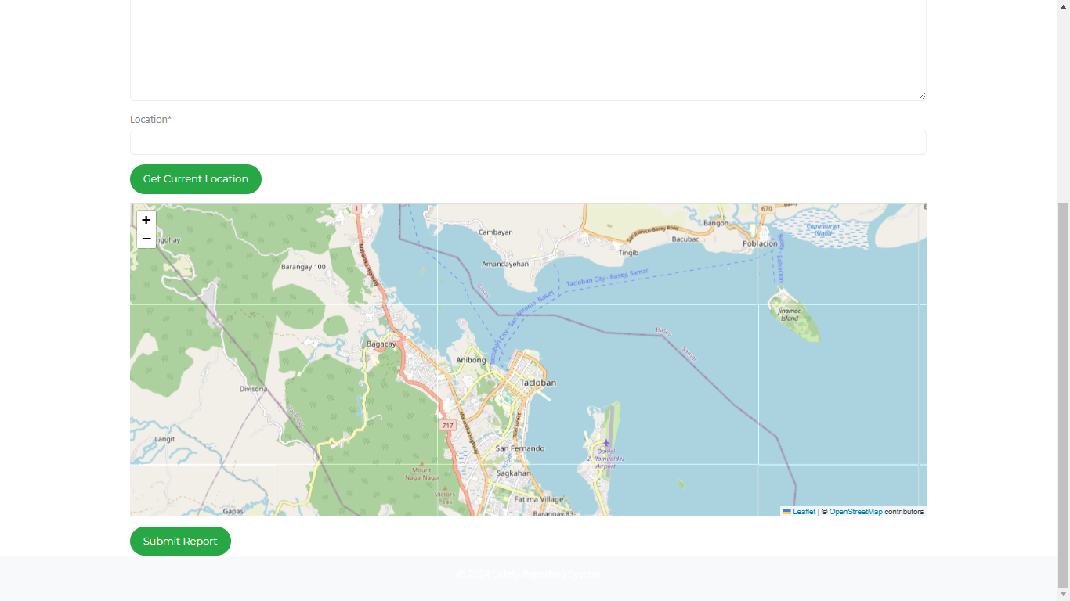

* The user can locate the accident using the map. If the accident happened on the users current location, then he/she can click the “Get Current Location” button and then submit the report.

**My Reports**

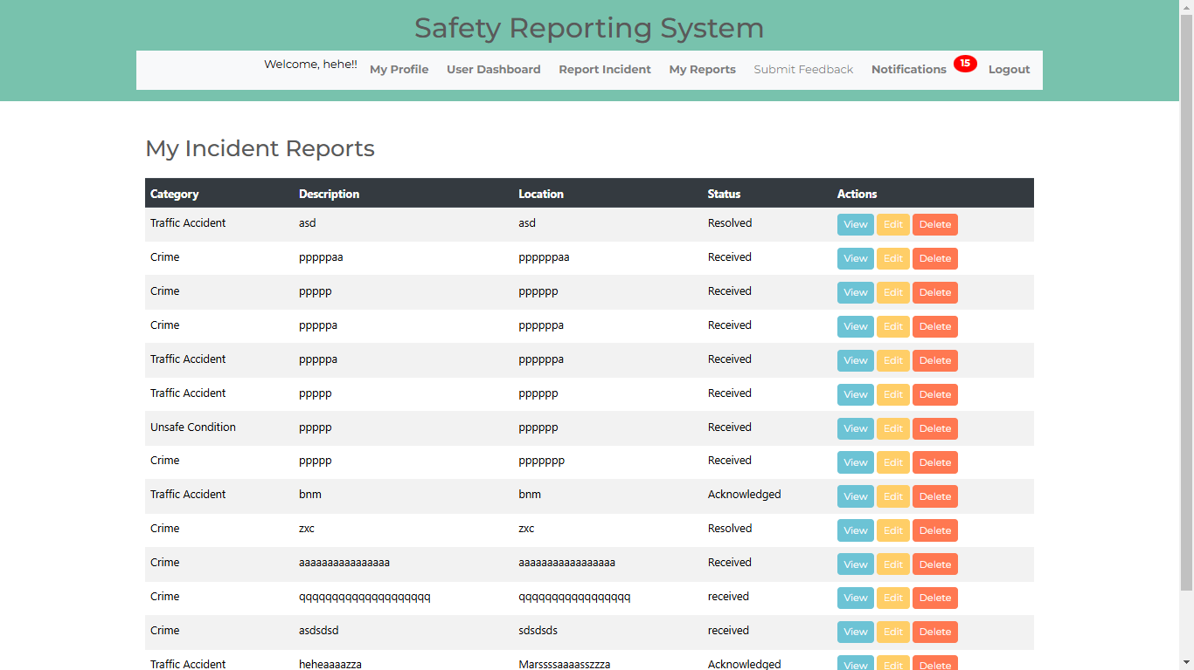

* In here, the user will see the reports he/she submitted. The user can also view, edit, and delete the report he/she submitted.

**Submitting Feedback**

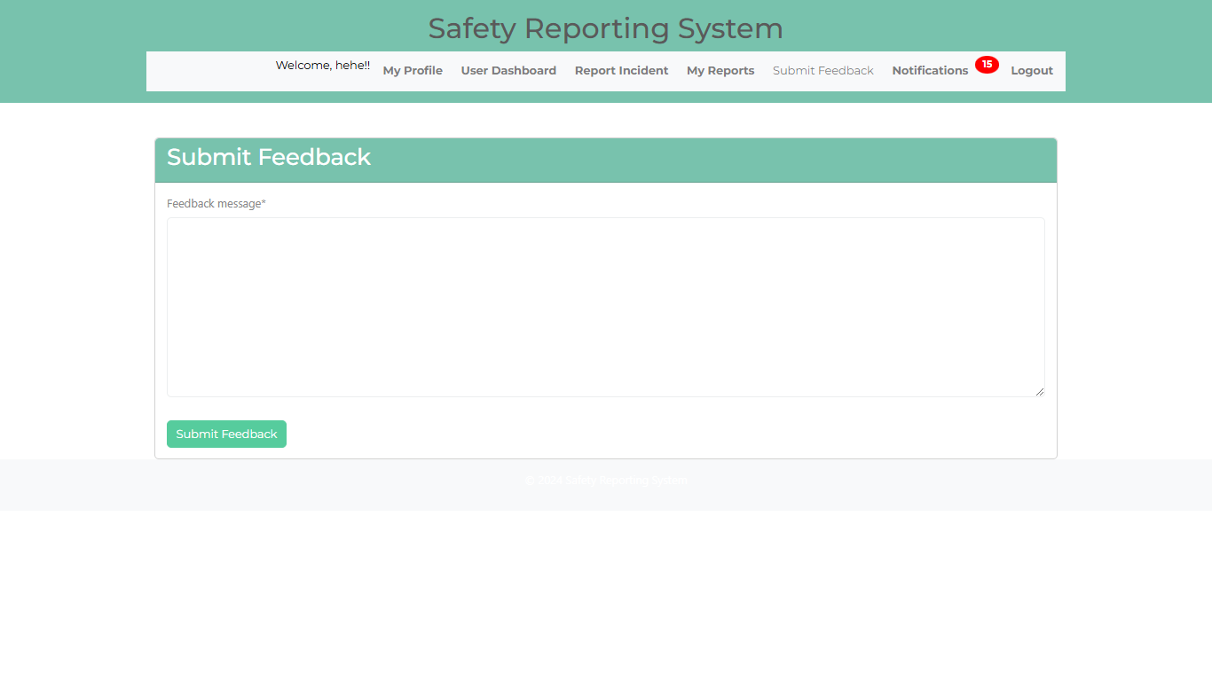

* In here, the user can submit a feedback message.

**Notifications** – In here, the user will receive a notification if the status of the accident he/she reported are being processed.

